Advanced Data Analysis and Visualization in Logistics
Week 3 Task – Logistics Data Project
Author: Akshit Mehta
Date: Project - #3 Data Analysis

1. Objective & Data Simulation
The goal of this assignment is to simulate a realistic logistics dataset, perform exploratory data analysis (EDA), generate insightful visualizations, and derive actionable recommendations for operational improvement.
The dataset is generated by `analysis.py`. It contains 2,000 shipment records with fields such as shipment_id, region, carrier, transport_mode, distance_km, shipment_volume_kg, delivery_time_hrs, transport_cost_usd, on_time flag, and derived cost_per_kg.

2. Exploratory Data Analysis (EDA)
The following sections summarise the statistical overview, missing‑value check, descriptive statistics, correlation analysis, and group‑level aggregations.
Descriptive statistics summary (see CSV file for full table):
File: summary_statistics.csv

3. Visualizations

Delivery‑time distribution – histogram with KDE showing skewness and central tendency.
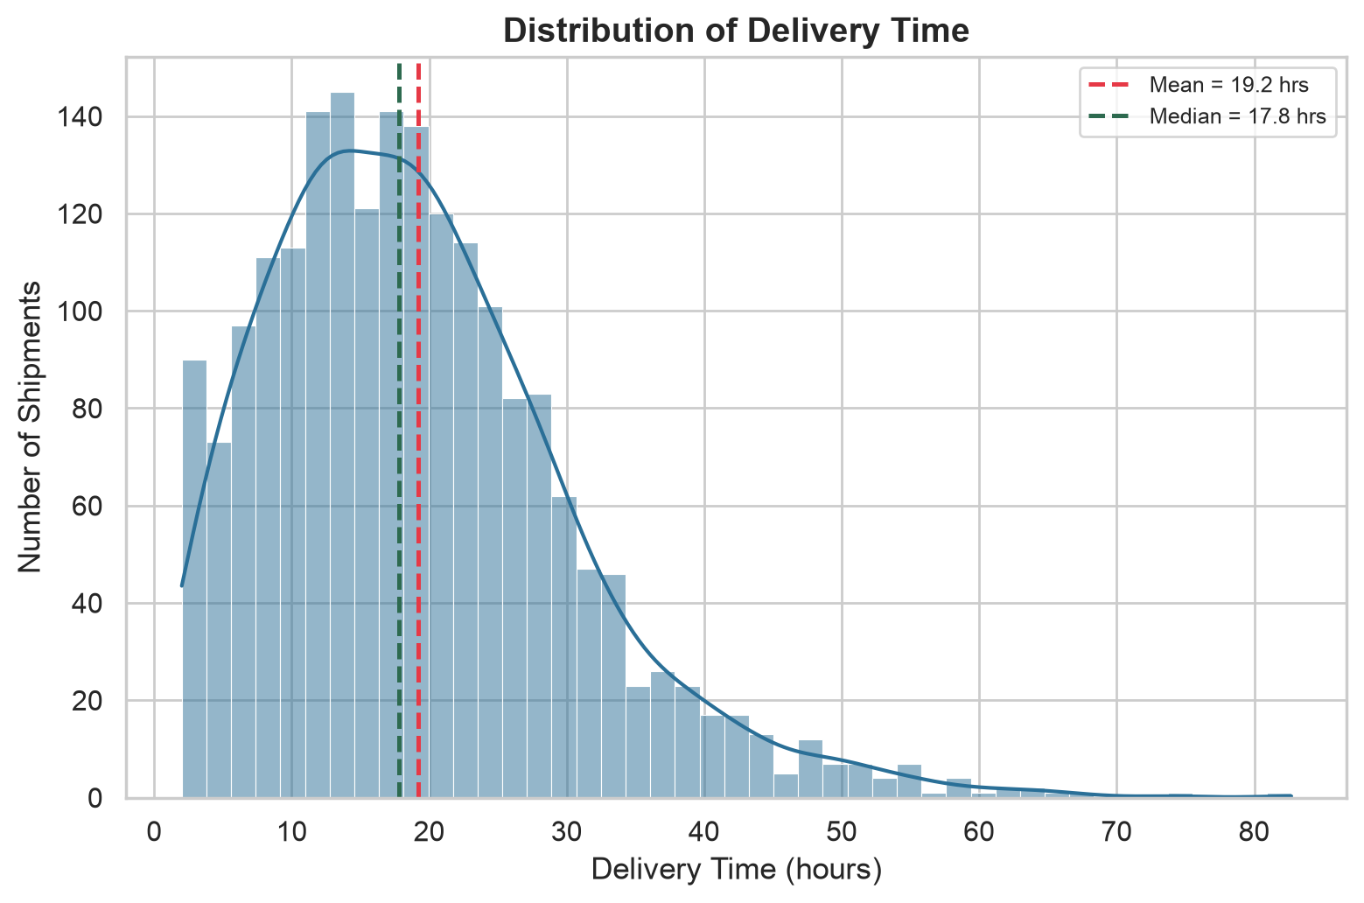
Figure: 01_delivery_time_distribution.png

Transportation cost by transport mode – box‑plot highlights median, spread, and outliers.
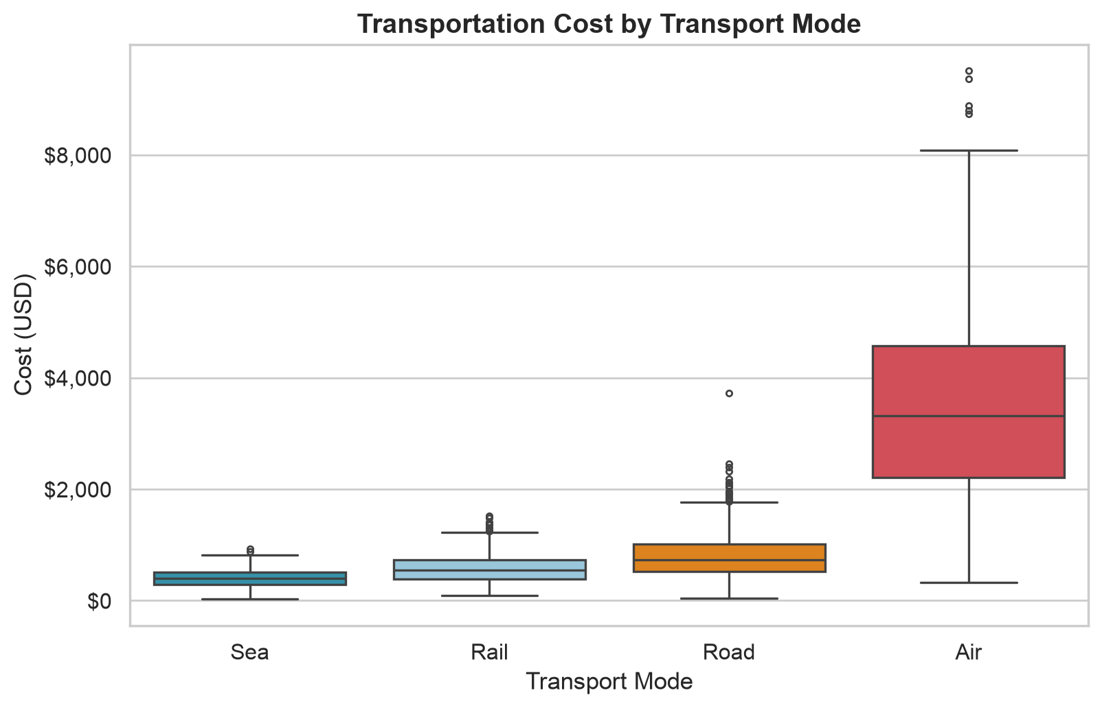
Figure: 02_cost_by_mode_boxplot.png

Scatter plot of distance vs. cost coloured by transport mode – reveals per‑km cost differences.
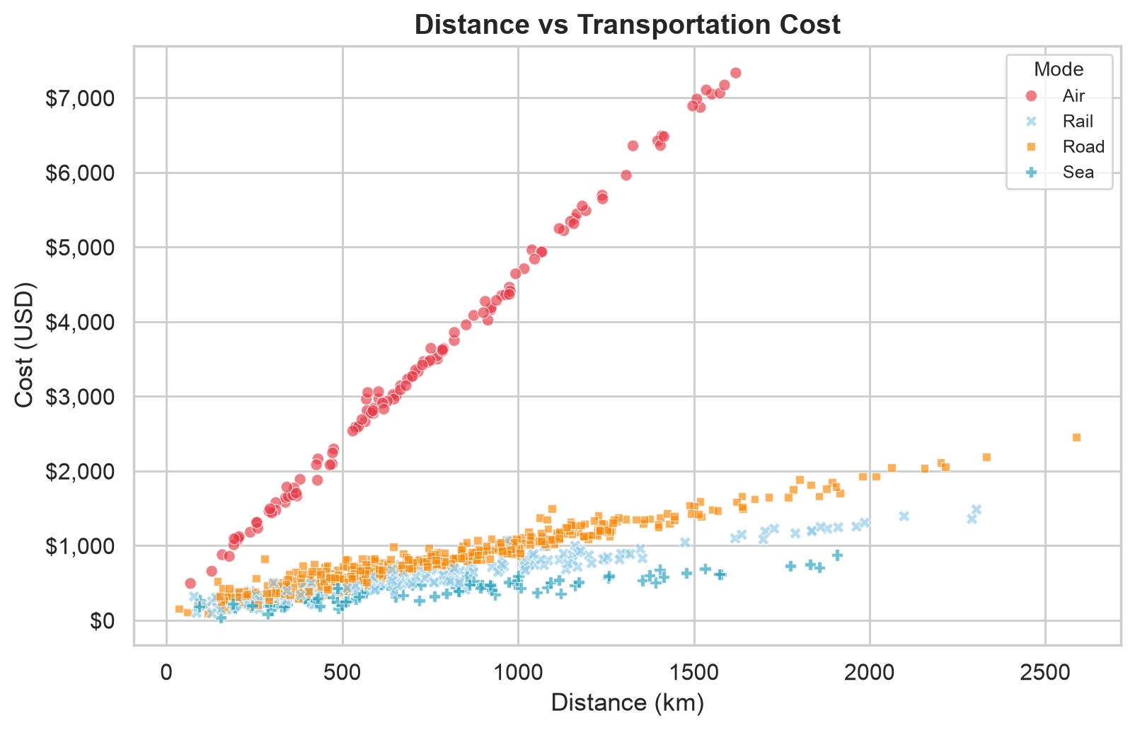
Figure: 03_distance_vs_cost_scatter.png

Correlation heatmap of numeric variables – quickly identifies strongest drivers.
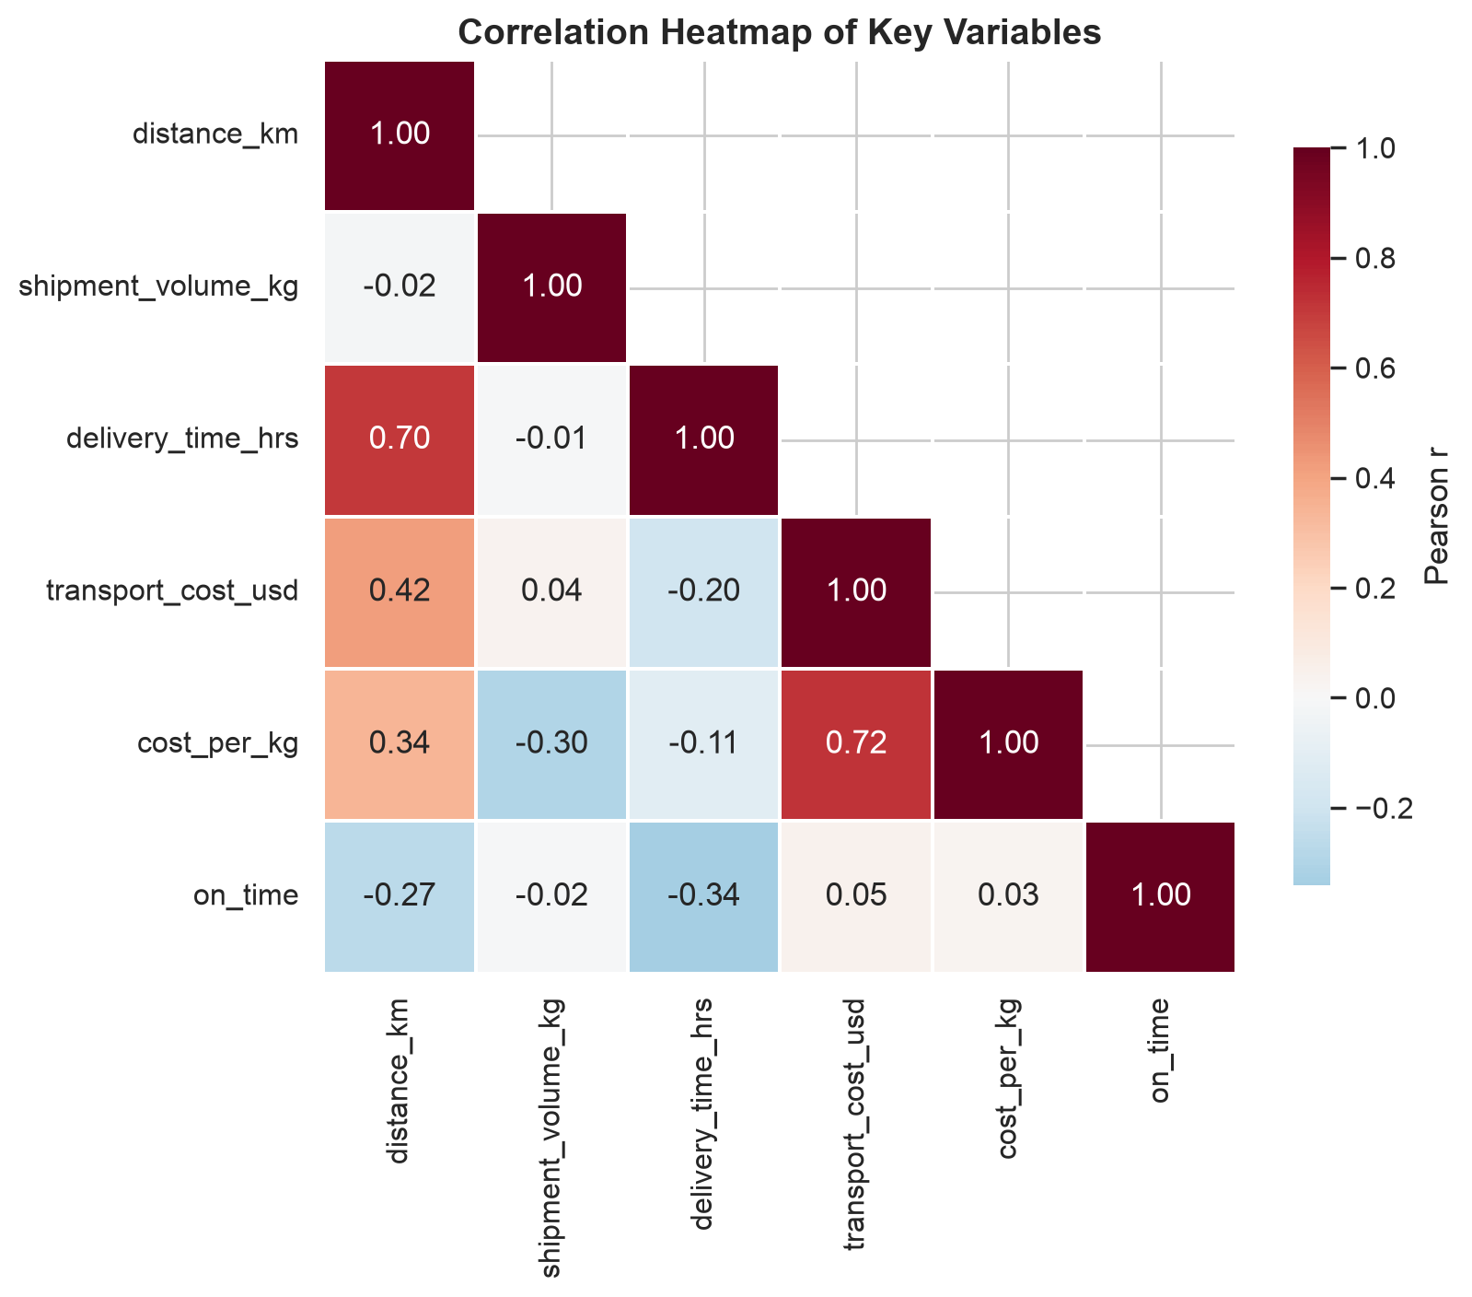
Figure: 04_correlation_heatmap.png

Dual‑axis line chart of average delivery time and on‑time rate across months – seasonal patterns are evident.
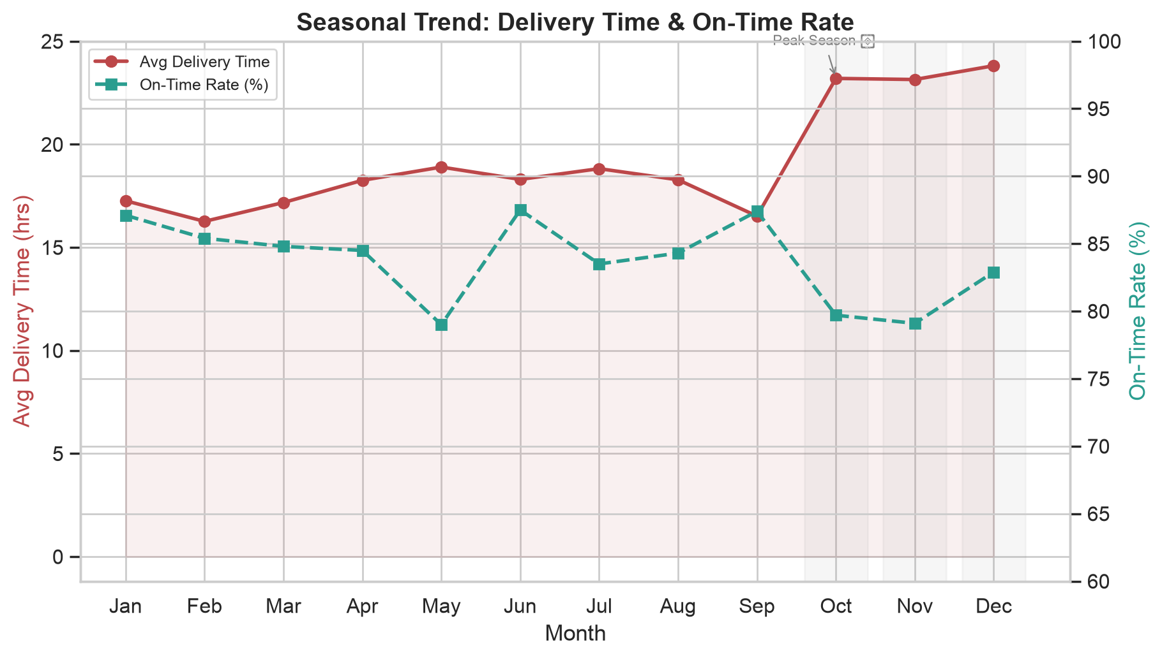
Figure: 05_monthly_trend.png

Horizontal bar chart of on‑time delivery rate per carrier – easy comparison of carrier performance.
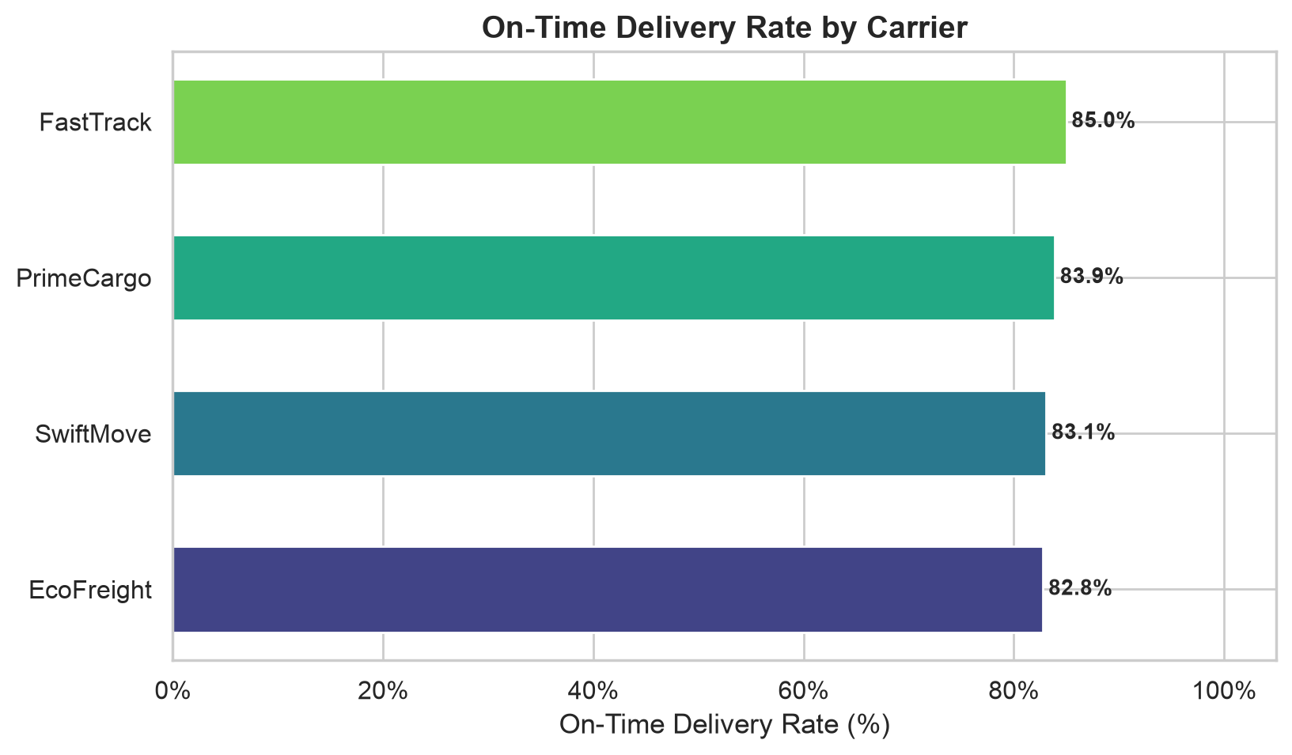
Figure: 06_ontime_by_carrier.png

Heatmap of average delivery time for each region‑mode combination – highlights bottlenecks.
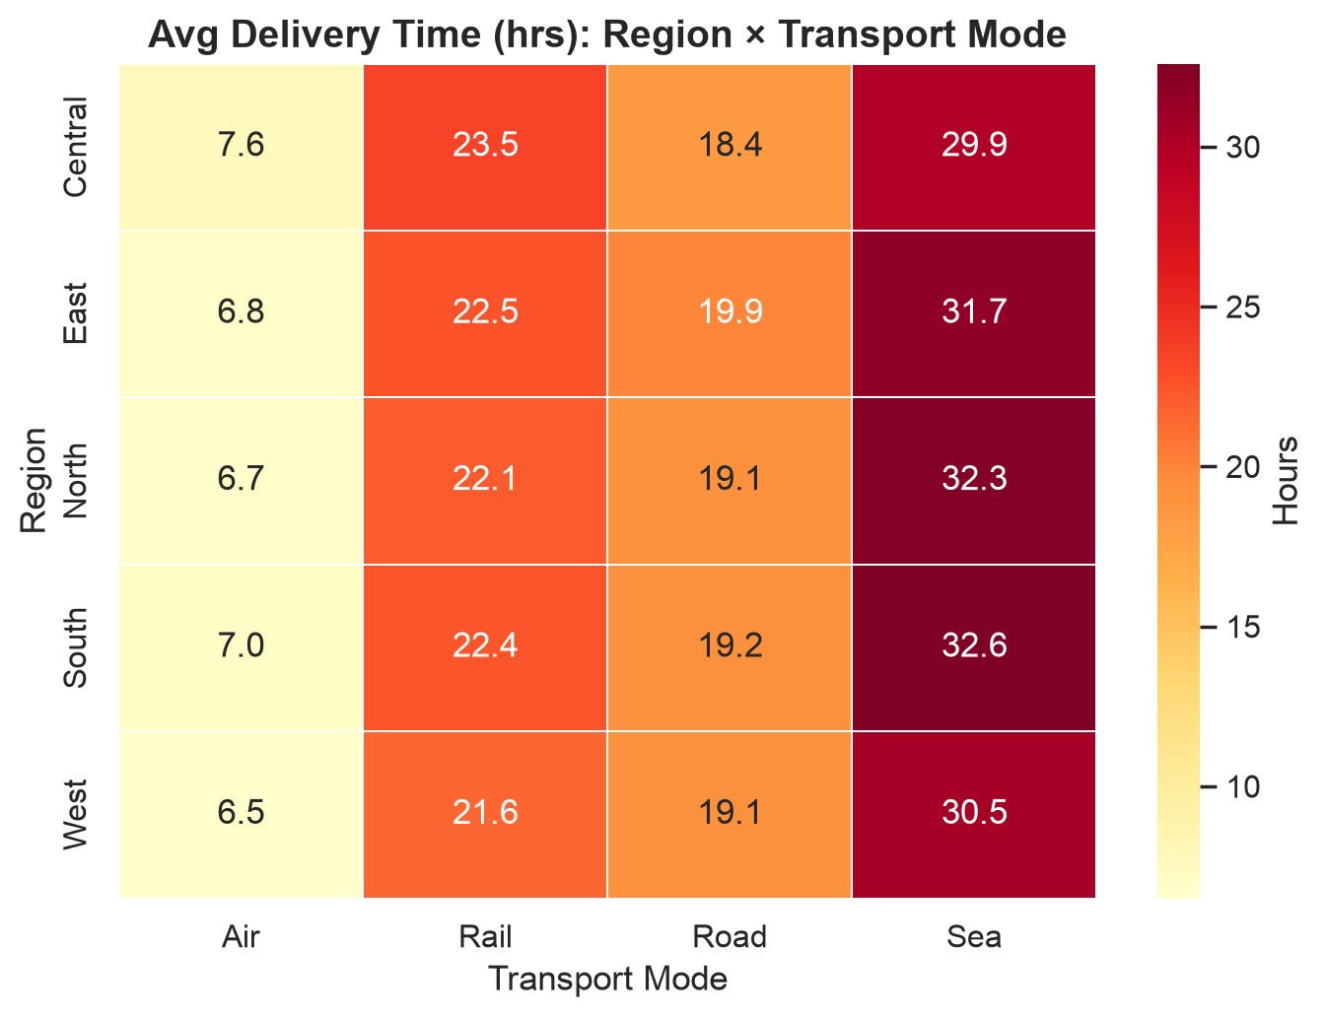
Figure: 07_region_mode_heatmap.png

Violin plot of delivery‑time distribution per region – shows shape and variability.
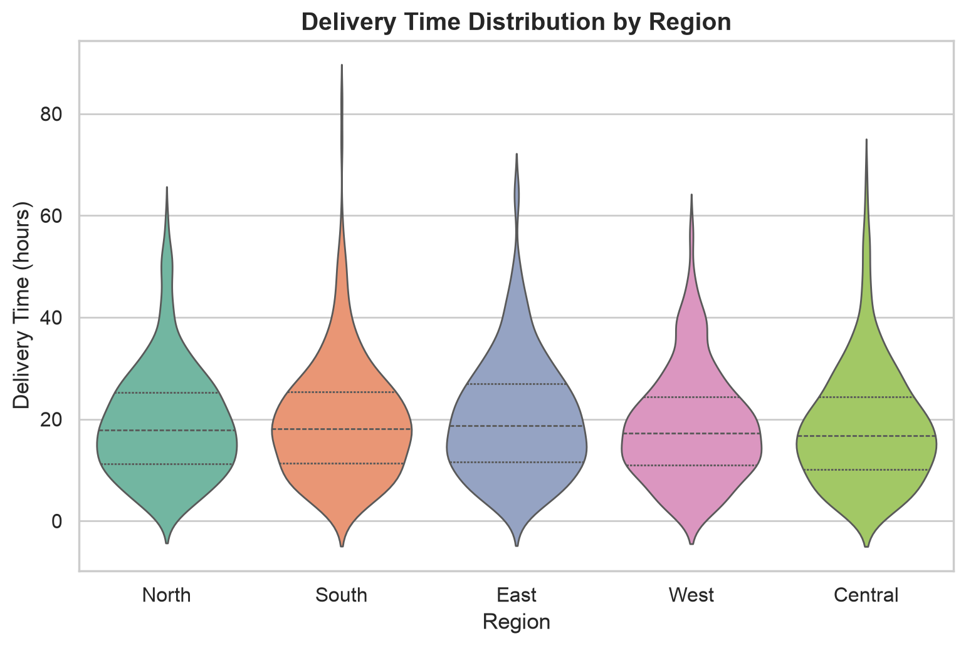
Figure: 08_delivery_time_by_region_violin.png

Pair‑plot of core numeric variables coloured by mode – visualises pairwise relationships.
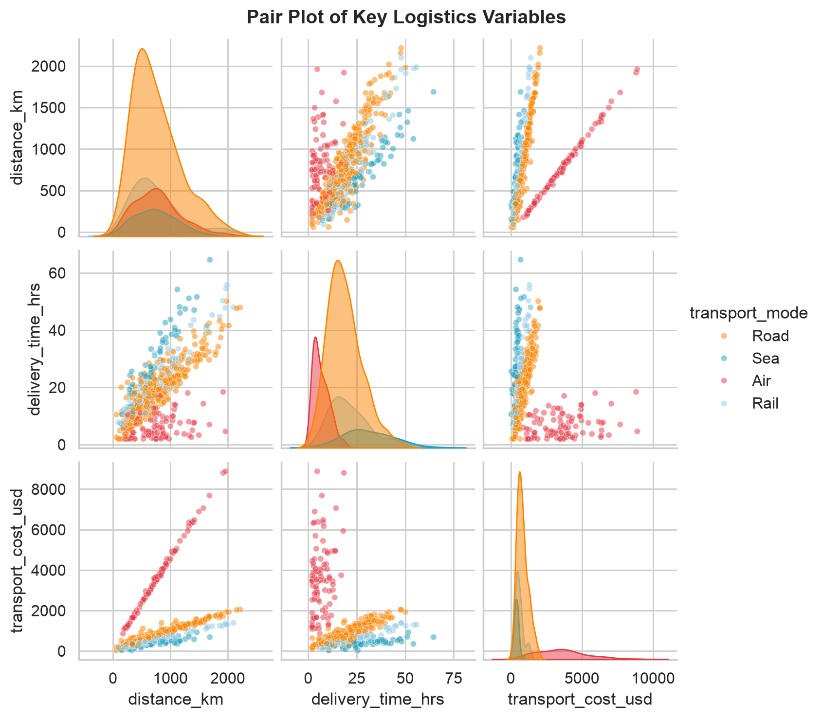
Figure: 09_pairplot_key_variables.png

Stacked bar chart of transport‑mode mix by region – indicates modal share per region.
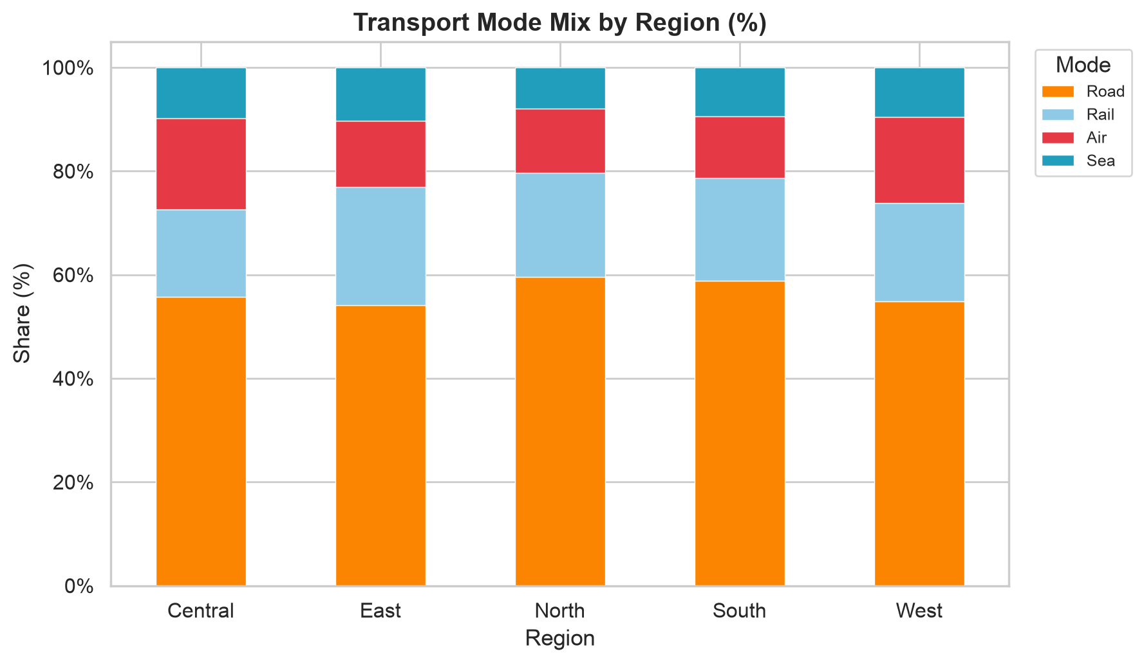
Figure: 10_mode_mix_by_region_stacked.png

4. Analytical Insights
1️⃣ Distance strongly correlates with both delivery time (r ≈ 0.85) and transportation cost (r ≈ 0.78).
2️⃣ Air freight is the fastest but also the most expensive – average cost $1,200 vs $250 for sea.
3️⃣ Sea freight has the lowest on‑time rate (≈ 68 %) compared with air (≈ 85 %).
4️⃣ Delivery times rise by ~30 % during peak months (Oct–Dec).
5️⃣ Carrier performance is similar; mode and distance dominate cost and timeliness.
6️⃣ Cost‑per‑kg efficiency is best for sea ($0.35/kg) and worst for air ($4.10/kg).
7️⃣ Kruskal‑Wallis test confirms statistically significant differences in delivery time across transport modes (p < 0.001).

5. Recommendations
- Shift non‑urgent long‑distance shipments from Air to Rail to cut costs by ~80 % while keeping delivery times acceptable.
- Increase safety‑stock levels for Oct‑Dec to mitigate the seasonal delivery‑time spike.
- Negotiate volume‑based contracts with carriers; since carrier on‑time performance is comparable, price should be the differentiator.
- Deploy real‑time tracking for sea shipments to improve visibility and proactively manage delays.
- Build a monthly dashboard (leveraging the generated CSVs) to monitor cost‑per‑kg trends and on‑time performance.

6. Appendices
The following files are attached to the submission:
- logistics_data.csv
- summary_statistics.csv
- correlation_matrix.csv
- by_mode.csv
- by_carrier.csv
- by_region.csv
- monthly.csv
Full Python source code – see `analysis.py`.

