DISCUSSION NOTES & DECISIONS

2014-10-29

1) From the list of desirable model characteristics, these subset are the easier ones that we can use to rank model proteins:
- # of PDBs available for each protein:

- PDB IDs corresponding to Uniprot Accession Number
- can be ranked as log function (log(# of PDB))
- Source: Uniprot XML file
- # of PDBs that are expressed in E.coli:

- respresenting ease of E.coli expression
- # of ligands:

- We decided to not to look for corresponding known ligands of each PDB file, but to pool ligands together that correspond to one protein (one Uniprot Accession Number)
- We will only use one binding data base source. ChEMBL, PubCHEM or BindingDB. Must decide which one is more useful.
- Ligands must bind to the same domain on the model protein (Since we couldn't find a way to check for this systematicly, as a starting point we decided to limit our set with single domain proteins. And then later in the future check our final candidate data set's ligands to make sure they bind the same domain)
- can be represented as weighed sum for ranking: a(range) + b(log(std_dev))
- # of BioAssays:

- from Pfam database (pfam.xfam.org)
- binding domain information available for some but not all entries

- range of Kd, standart deviation of Kd:

- we can also monitor variance or standart deviation of Kd so that resulting value is less susceptible to outliers
- We should decide is IC50 information also acceptable when Kd is not present

2) Initial restrictions we decided on to start with :
- soluble protein
- only proteins with single domains
- only ligands with known Kd values

3) Possible model systems to manually investigate characteristics:
- protein methyl transferases
- cruzain
- lyzozyme
- carbonic anhydrase
- ubiquitin ligases
- aspartyl protease (protonation state change)
- thrombin
- trypsin
- kinase
- trypsin-benzimide analogs
- cytochrome c peroxidase
- IL-2
- Hsp82

2014-10-31

What kind of binding assays we can do?
- Flourescence
    - Flourescent probe necessary
    - We must check if any of the binding molecules are flourescent
    - Example flourescent scaffold:
            - quinoline, quinazoline scaffold
    - Smart search for flourescent scaffold - is this possible ?
- ITC
    - ligands must be soluble compounds because we will use a concentrated injection source
    - how to predict solubility?
    - lots of protein necessary (mg)
- SPR - Surface Plasmon Resonance
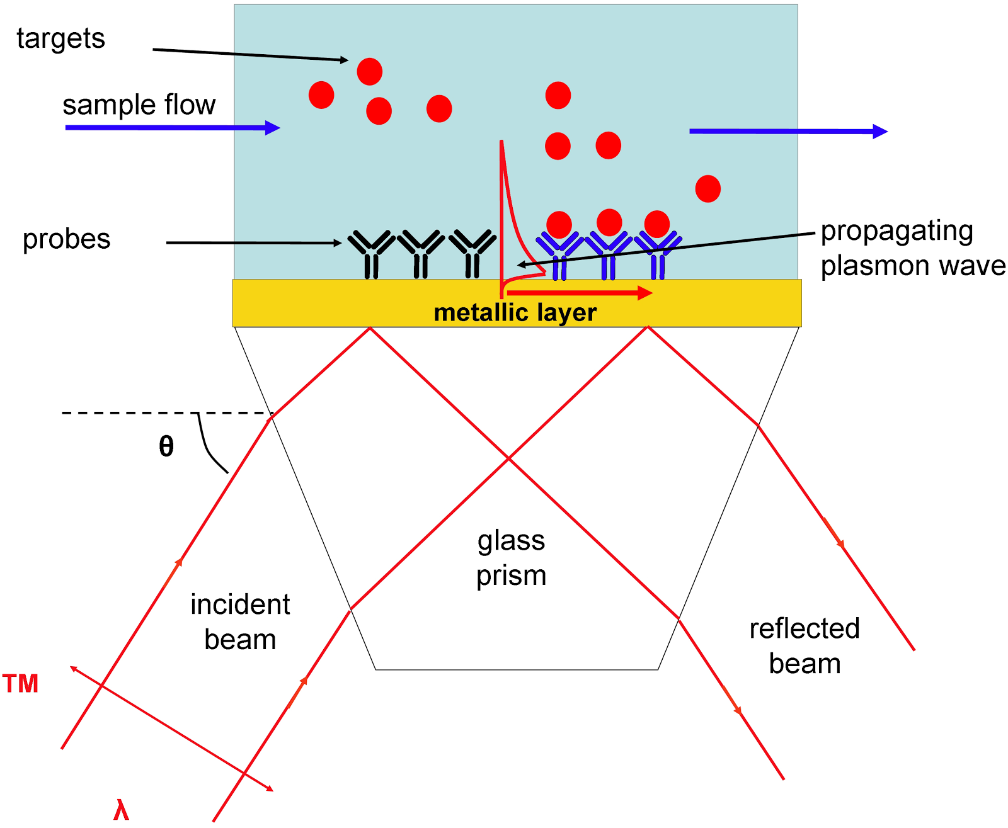

you fit curves of association and dessociation to single exponentials and determine kON and kOFF

if you plot max values of RU vs ligand concentration, you can determine Kd
recquires 100 ug protein
hexahistidine tags on N terminus used for protein purification can be used to attach protein to surface
ligand will flow
6 x 6 plates
- Metals

Ranking function elements
For each Uniprot Accession Number
- # of PDBs with E.coli expression (log)
- # of ligands in BindingDB
- # of measurement (# BioAssay from PFAM website)
- standart deviation of effective DG (or standart dev of logKd)
- # of publications (from NCBI Gene- how Danny does this)

Initial limiting criteria (Maybe?)
- Only single domain proteins
- We will only use BindingDB for ligands
- trust: DG > app Ki >> IC50, EC50 but in the beginning we can pool down all these as
effective DG

ROADMAP
- bindingDB validation set ---> list of Uniprot accession numbers
- uniprot numbers ---TargetExplorer --->
  - PDB files -- extract info for
    - cofactors
    - ligands
    - mutations
    - constructs
    - ions
  - take ligands form BindingDB -- extract info for
    - ligand identifier -----> can we buy? price? (Zinc, MolPort, eMolecules)
    - structure
    - smiles
    - flourescence?
    - affinity
  - expression info from somewhere, can we buy the proteins
  - publications from NCBI gene
Put it all together as one datafile.
2014-11-11
Ranking function elements
For each Uniprot Accession Number
- # of PDBs with E.coli expression (log)
- # of ligands in BindingDB
- # of measurement (# BioAssay from PFAM website)
- standart deviation of effective DG (or standart dev of logKd)
- # of publications (from NCBI Gene- how Danny does this)

ROADMAP
- bindingDB validation set ---> list of Uniprot accession numbers
- uniprot numbers ---TargetExplorer --->
  - PDB files -- extract info for
    - cofactors
    - ligands
    - mutations
    - constructs
    - ions
  - take ligands form BindingDB -- extract info for
    - ligand identifier -----> can we buy? price? (Zinc, MolPort, eMolecules)
    - structure
    - smiles
    - flourescence?
    - affinity
  - expression info from somewhere, can we buy the proteins
  - publications from NCBI gene

Put it all together as one datafile.
---
ROADMAP STEP 1
Download whole BindingDB data set

Old file used in TargetExplorer was BindingDB_All.tab.gz

Now there are sdf (2D or 3D) and tab-separated value (TSV) files. You can open sdf files in Pymol. 2D sdf files have 2D chemical structures. 3D sdf file 3D chemical conformations.

Search:
-biopython sdf parser
-RDkit chemiinformatics software

If you download sdf file form a validation data set, different ligands come in Pymol frames. Sdf file entries are separated by $$$$ at the end of each

in bindingDB database ligand-target pair identifier is “BindingDB reactant_set_id”

CONVERTING PDB TO UNIPROT ACCESSION # (ACC)
OLD VERSION OF UNIPROT
obsolete.uniprot.org
ID mapping --- from: PDB --- to:ACC----

NEW UNIPROT
uniprot.org
Upload Lists section
--- from: PDB --- to:ACC----

you can upload a list if pdb’s at once (for the code it is mort probably as string)

- To find the example code: uploadlists > help> programmatic access
http://www.uniprot.org/help/uploadlists
http://www.uniprot.org/help/programmatic_access

querying the database mapping service using python:
import urllib,urllib2
url = 'http://www.uniprot.org/mapping/'
params = {
'from':'ACC',
'to':'P_REFSEQ_AC',
'format':'tab',
'query':'P13368 P20806 Q9UM73 P97793 Q17192'
}
data = urllib.urlencode(params)
request = urllib2.Request(url, data)
contact = "" # Please set your email address here to help us debug in case of problems.
request.add_header('User-Agent', 'Python %s' % contact)
response = urllib2.urlopen(request)
page = response.read(200000)

as html adress: this is what urlencode does
mapping/?from=”PDB”to=”ACC”

using targetExplorer

import targetexplorer
import targetexplorer.PDB
import targetexplorer.uniprot
targetexplorer.Uniprot.get_uniprot_mapping(‘PDB’, ‘ACC’, [write pfb id here])

2014-11-17
Step 1 OUTPUT:
20 out of 815 PDB ID’s map to more than one Uniprot ACC (since there are multiple proteins in the same crystal)

DATA STRUCTURE
- we need relational data base model (like sql)

TARGET(Uniprot ID)
Expression System (we will deal with E.coli expression subset)
constructs
--------- -- PDB ID PDB link ligands cofactors mutations
-------------
--------------
crystal structures vs NMR structures (BMRB database for NMR structures)
Isoforms (is there another Uniprot ID for this)
Domains (which domain ligand binds to - ADVANCED PROBLEM)
Can we buy the protein?
Annotations
Interesting features
References, Citations of protein
PFAM classification “Asparty protease”, “kinase”
Disease relationship
Wikipedia link

Ligands
identifier (SMILES or InChI)
effective Kd measurement type(Kd, Ki, IC50) measurement method (ITC, SPR ...)
Reference, citation, source for Kd info
Can we buy? Cost?(ZINC, eMolecules)
Flourescence and wavelenght(nm): SMARTS substructure search for quinoline, quinazoline, indole etc…
charge, tautomers, ions, pKas ---> check chemicalize website

Ligand statistics: Kd range, distribution, standart deviation

- To find ligands in PDB files → “ligand expo”

2015-01-12

- model_systems github repository - write proper README.md files
“
#Scripts for exploring model protein ligand binding systems.
## Manifest
-manifest of all files and directories
“
* Each directory must have its README.md
* In Github if you click on Raw botton then you see the source of Read me file
example read me file: https://github.com/choderalab/pymbar-examples/tree/master/parallel-tempering-2dpmf

Markdown cheat sheet:
https://github.com/adam-p/markdown-here/wiki/Markdown-Cheatsheet

To preview:
http://markdownlivepreview.com/

- Database version of model_systems can be developed by creating a branch in Github

- Eventually, bash script must be written to generate everything to create the database

- I will use ChEMBL to gather ligand information
This task has the highest priority
Useful python packages may be:
biopython
bioservices (https://github.com/cokelaer/bioservices)

- Run everything so far to assemble all the information for BindingDB Validation Set
You can use cluster to run this.
Create an interactive login or use bach script to send job to cluster (1 CPU job, 5 days time limit)
Use: time python script name
So that we can learn about how long the job takes. It records start and ending times.

- Gather all these meeting notes together to create a reference for future direction

- Current database model:
Flask SQLAlchemy

UNIPROT
id
acc
(PDB relationship)

PDB
id
pdb_id
in_bindingDB_validation_set
ecoli_exp
sequence
method
uniprot (Foreign Key)
(HET relationship)

HET
id
3_letter_code
name
smiles
inchi
PDB (Foreign Key)
2015-1-22
CURRENT STATE
Step0-Step4: run for all BindingDB Validation Set
Step10-Step11: run for Uniprot ACCs coming from BindingDB Validation Set
* About 25 out of 175 Uniprot ACC's don't have records in ChEMBL database
Two manual interventions made which are descibed in: model_systems/other_files/manual_interventions_to_model_systems_database_building.odt

FUTURE DIRECTION
There may be a NSF proposal: “understanding biophysics of ligand recognition”, “mining for different binding systems that can teach us things”
- Must gather all the information together into a database.
- Eventually run for all proteins in Uniprot
- Automate script running procedure or convert all scripts o functions.

It is possible to use shell scripts to automate running different steps of code
--------
#!/user/bash
./script1 >& script1.out
./script2 > …
…
--------

- Calculate Kd range and DDG of binding
95% conf intervals, mean, standart deviation
- Count number of HETS in each PDB, PDB per ACC

- Create some histograms
#PDB vs ACC
#HET in each PDB vs PDB
#bioassays vs ACC
#unique chemicals in bioassays vs ACC
#approved drugs vs ACC
#Kd range vs ACC
- Change Step5-Step9 scriots so that they output to database or to a DataFrame
- Find a way to stich DataFrames togetehr
- Find a way to do SMART based search for flourescent scaffolds for each chemical
- How to check solubility of each compound?
- eventually rank the systems
- Write tests!
- Write python scripts to get rid off manual intervention to input database
- old pdb ID to new PDB ID mapping (after step0)
- write try/ecxept option to pass Uniprot ACC's that don't have records as ChEMBL targets

