**Business Problem**

In recent years, both city hotels and resort hotels have grappled with a significant surge in booking cancellations. This predicament has led to a slew of challenges for these establishments, resulting in diminished revenue streams and suboptimal room occupancy rates. Consequently, the paramount objective is to curtail cancellation rates, thus enhancing their operational efficiency and bolstering revenue generation. This report aims to provide comprehensive business counsel to tackle this pressing issue.

The central focus of this report revolves around two key aspects: the in-depth analysis of hotel booking cancellations and the exploration of other factors that exert no significant influence on their business but impact early revenue generation.

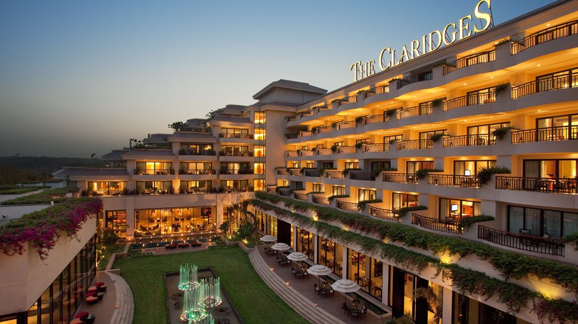

1. Assumptions
2. 1. No unusual occurrences between 2015 and 2017 will have a substantial impact on the data used.
3. 2. The information is still current and can be used to analyze a hotel’s possible plans in an efficient manner.
4. 3. There are no unanticipated negatives to the hotel employing any advised technique.

4. The hotels are not currently using any of the suggested solutions.

5. The biggest factor affecting the effectiveness of earning income is booking cancellation.

6. cancellation result in vacant rooms for the booked length of time

7. clients make hotel reservation the same year they make cancellation.

**Research Question**

What are the variables that affect hotel reservation cancellations?

How can we make hotel reservation cancellation better ?

How will hotels be assisted in making pricing and promotional decisions?

**Hypothesis**

**Hypothesis**

1. more cancellation occur when prices are higher.
2. when there is a longer waiting list, customers tend to cancel more frequently.
3. the majority of clients are coming from offline travel agents to make their
4. reservations.

**Analysis and findings**

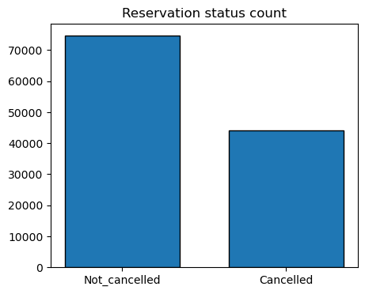

The accompanying bar graph shows the percentage of reservation that are canceled and those that are not. It is obvious that there are still a significant number of reservations that have not been canceled. There are still 37% of clients who canceled their reservation, which has a significant impact on the hotels’ earnings.

**Reservation status in different hotels**

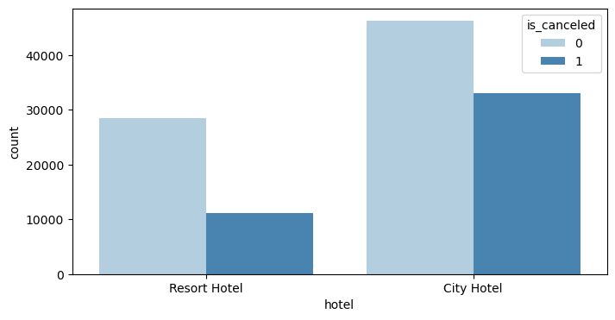

In comparison to resort hotels, city hotels have more bookings its possible that resort hotels are more expensive then those in cities.

N

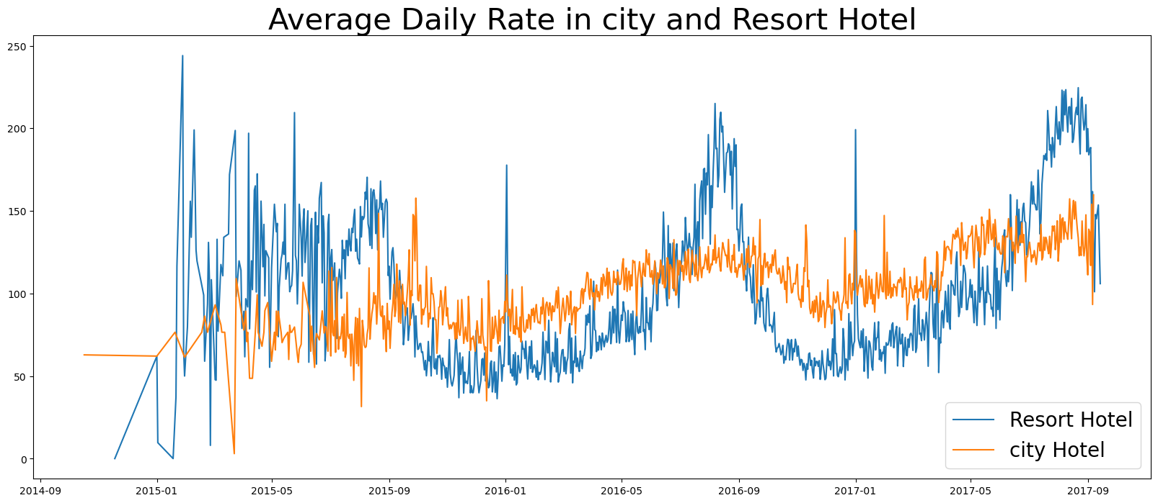

The line graph above shows that, on certain days, the average daily rate for a city hotel is less than that of a resort hotel ,and on other days, it is even less. It goes without saying that weekends and holidays may see a rise in resort hotel rates.

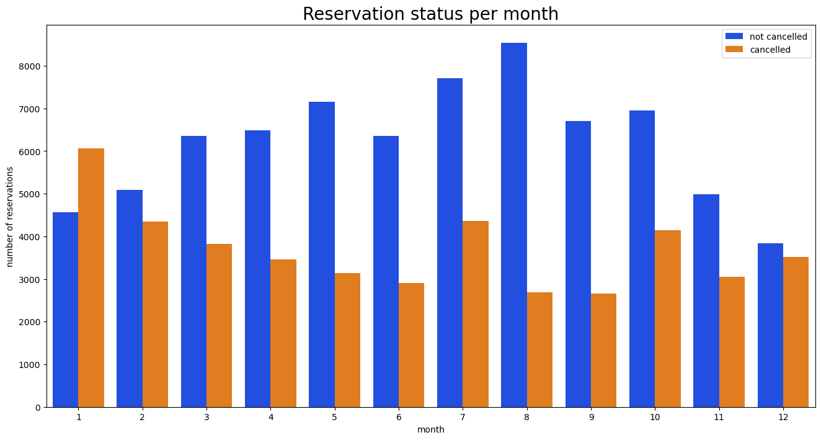

We have developed the grouped bar graph to analyze the months with the highest and lowest reservation levels according to reservation status. As can be seen ,both the number of confirmed reservation and the number of canceled reservation are largest in the month of augest. Whereas January is the month with the most canceled reservations.

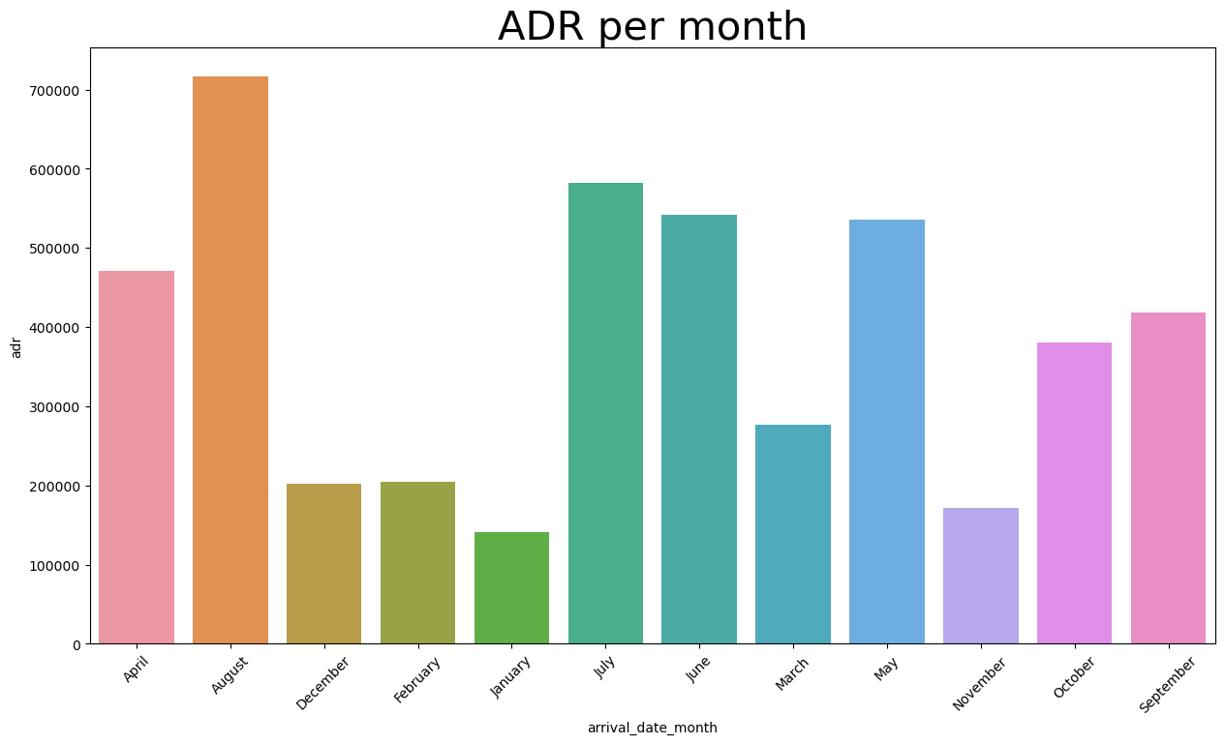

This bar graph demonstrate that cancellations are most common when price are greatest and are least common when they are lowest. Therefore, the cost of the accommodation is solely responsible for the cancellation.

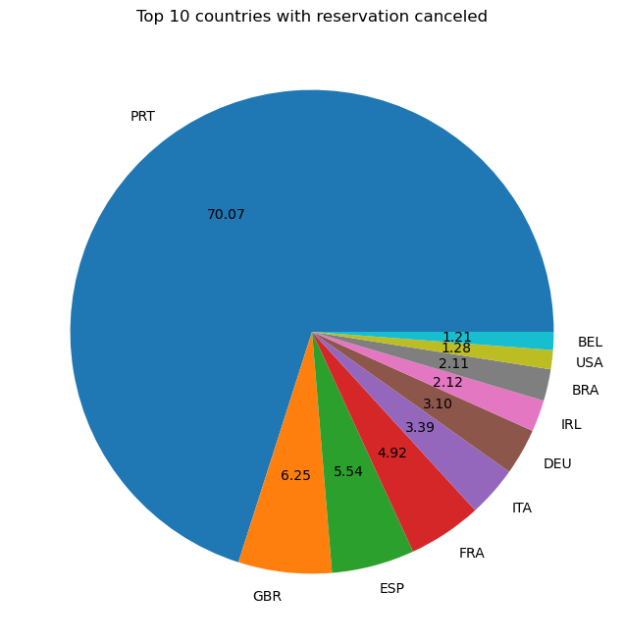

Lets check the area from where guests are visiting the hotels and making reservations. Is it coming from direct or groups, online or offline Travel agents? Around 46% of the clients come from online travel agencies, whereas 27% come from groups. Only 4% of clients book hotels directly by visiting them and making reservation.

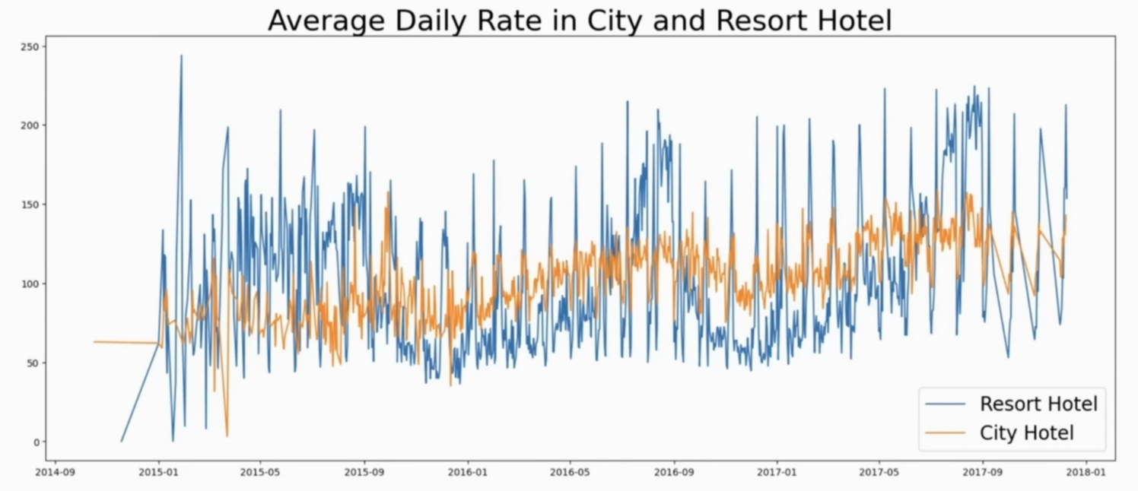

As seen in the graph, reservation are canceled when the average daily rate is higher than when it is not canceled. It clearly proves all the above analysis, that the higher price leads to higher cancellation.

**Suggestions**

1. Cancellation rates rise as the price does. In order to prevent cancellations of reservations,