AUSTO MOTOR COMPANY
Marketing Campaign Analytics Report
Prepared by: Mehul Bhochiya
Role: Data Analyst
Dataset: austo_automobile.csv
Date: July 2026

Table of Contents
- 1. Executive Summary
- 2. Business Background & Objective
- 3. Dataset Overview (Technical Summary)
- 4. Data Quality Assessment & Preparation
- 5. Univariate Analysis
- 6. Bivariate & Relationship Analysis
- 7. Validating Stakeholder Observations
- 8. Spending Analysis by Customer Category
- 9. Effect of Partner's Employment on Purchase Price
- 10. Customer Segmentation Strategy
- 11. Conclusion & Recommendations

1. Executive Summary
Austo Motor Company manufactures SUV, Sedan, and Hatchback vehicles and wants to sharpen its marketing campaign using data on 1,581 recent customers. This report cleans and examines that data, tests three claims made by the marketing team, and translates the findings into concrete targeting recommendations.
The key findings are summarised below:
- Sedan is the most purchased body type (44%), followed by Hatchback (37%) and SUV (19%).
- Buying data is dominated by married customers (91%) and male customers (79%); this skew should be treated as a data-collection characteristic, not necessarily a true reflection of market demand.
- When compared fairly (as a share of each gender's own purchases), women favour SUVs far more than men do the opposite of what the marketing team assumed.
- Age and Salary are the strongest drivers of purchase price; whether a partner is employed has virtually no effect on how much a customer spends.
- Married women are the highest-value segment by average spend, while single men form the largest budget/entry-level segment.
Section 11 converts these findings into specific, actionable recommendations for the marketing team.

2. Business Background & Objective
Austo Motor Company's board raised concerns about the effectiveness of the current marketing campaign and commissioned an analytics review of customer purchase data. The objective of this study is to understand who is buying which type of vehicle, what factors influence that choice and the amount spent, and how the marketing team can use these patterns to target customer groups more precisely rather than running a one-size-fits-all campaign.
The analysis is organised in the same order as the questions raised by the business: a technical profile of the dataset, a data-quality review, feature-by-feature exploration, relationships between variables, a fact-check of three claims made by team members, a spend analysis by gender and loan status, the effect of a working partner on price, and a segmentation of customers by gender and marital status.

3. Dataset Overview (Technical Summary)
This section captures the technical profile of the dataset that a database administrator or engineer would need before integrating it into a reporting pipeline.

3.1 Size and Structure
Property | Value
Number of records (rows) | 1,581
Number of attributes (columns) | 14
Duplicate records | 0 (none found)
File format | CSV (comma-separated values)
Grain of the data | One row per customer / purchase transaction

3.2 Attribute Dictionary
# | Attribute | Data Type | Description
1 | Age | Integer | Age of the customer in years
2 | Gender | Text (category) | Male / Female
3 | Profession | Text (category) | Salaried or Business
4 | Marital_status | Text (category) | Married or Single
5 | Education | Text (category) | Graduate or Post Graduate
6 | No_of_Dependents | Integer | Number of dependents supported by the customer
7 | Personal_loan | Text (category) | Whether the customer holds a personal loan (Yes/No)
8 | House_loan | Text (category) | Whether the customer holds a home loan (Yes/No)
9 | Partner_working | Text (category) | Whether the customer's partner is employed (Yes/No)
10 | Salary | Integer | Customer's annual salary (INR)
11 | Partner_salary | Decimal | Partner's annual salary; 0 where partner does not earn
12 | Total_salary | Integer | Household income (Salary + Partner_salary)
13 | Price | Integer | Price of the vehicle purchased
14 | Make | Text (category) | Vehicle type purchased: SUV, Sedan or Hatchback

3.3 Statistical Summary of Numeric Fields
Statistic | Age | Dependents | Salary | Partner Salary | Total Salary | Price
Count | 1,581 | 1,581 | 1,581 | 1,581 | 1,581 | 1,581
Mean | 31.9 | 2.46 | 60,392 | 19,234* | 79,626 | 35,598
Std. Dev. | 8.4 | 0.94 | 14,675 | 19,670* | 25,546 | 13,634
Min | 22 | 0 | 30,000 | 0 | 30,000 | 18,000
25% | 25 | 2 | 51,900 | 0 | 60,500 | 25,000
50% (Median) | 29 | 2 | 59,500 | 25,100 | 78,000 | 31,000
75% | 38 | 3 | 71,800 | 38,100 | 95,900 | 47,000
Max | 54 | 4 | 99,300 | 80,500 | 171,000 | 70,000
*Computed after cleaning (missing Partner_salary values imputed) — see Section 4.
4. Data Quality Assessment & Preparation
Before drawing any conclusions, the data was checked for duplication, inconsistent category labels, and missing values. The checks and the treatment applied are documented below so the cleaning steps are fully reproducible.

4.1 Duplicate Records
No duplicate rows were found in the dataset — all 1,581 records are unique.

4.2 Inconsistent Category Labels
The Gender field contained two misspelled variants of “Female” — “Femal” and “Femle” — in addition to the correct “Male” and “Female” labels. These were standardised to “Female” before any analysis was performed.
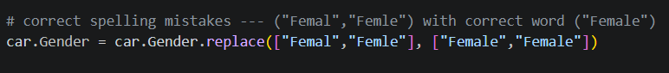

4.3 Missing Values
Attribute | Missing Values | % of Records | Treatment Applied
Gender | 53 | 3.4% | Imputed with the mode, “Male”
Partner_salary | 106 | 6.7% | Derived as Total_salary − Salary
All other attributes | 0 | 0.0% | No treatment required

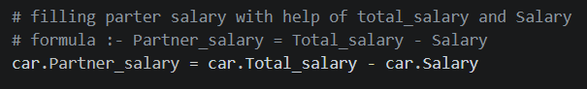

4.4 Notes and Caution on the Cleaning Approach
- Filling missing Gender values with the mode (“Male”) is a reasonable default, but it slightly increases the existing male/female imbalance in the data. Any conclusion drawn specifically about the size of the gender gap in Section 5 and Section 7 should be read with this in mind.
- Deriving Partner_salary as Total_salary minus Salary is mathematically exact given the other two fields are complete, so this treatment introduces no additional uncertainty.

4.5 Dataset After Cleaning
Field | Categories Before Cleaning | Categories After Cleaning
Gender | Male, Female, Femal, Femle, (missing) | Male (1,252), Female (329)

5. Univariate Analysis
This section explores each variable on its own to understand the shape of the customer base before looking at relationships between variables.

5.1 Categorical Variables

Vehicle Make
Make | Count | Share
Sedan | 702 | 44.4%
Hatchback | 582 | 36.8%
SUV | 297 | 18.8%

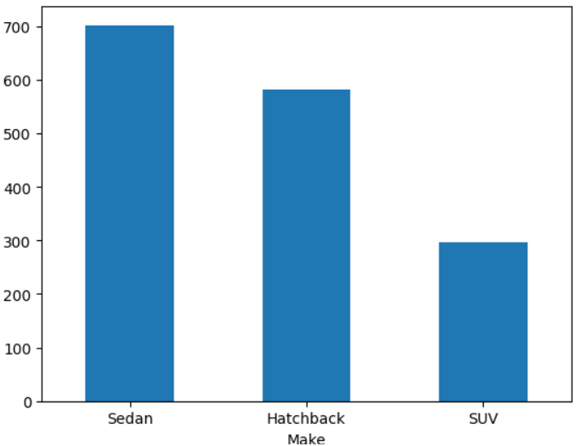
Observation: Sedan is the company's volume leader, purchased by 44% of customers, while SUV is the smallest segment at just under 19%. Because SUVs typically carry the highest price tag (see Section 8), this is also the segment with the most room to grow through targeted campaigns.

Gender
Gender | Count | Share
Male | 1,252 | 79.2%
Female | 329 | 20.8%

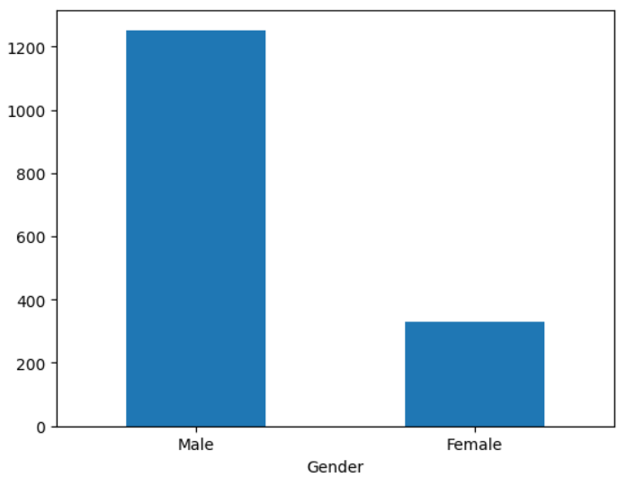
Observation: Male customers outnumber female customers by roughly 4 to 1. This imbalance should be treated as a characteristic of how the data was collected rather than proof that women buy far fewer cars — Section 7 revisits this point using proportions instead of raw counts.

Profession
Profession | Count | Share
Salaried | 896 | 56.7%
Business | 685 | 43.3%

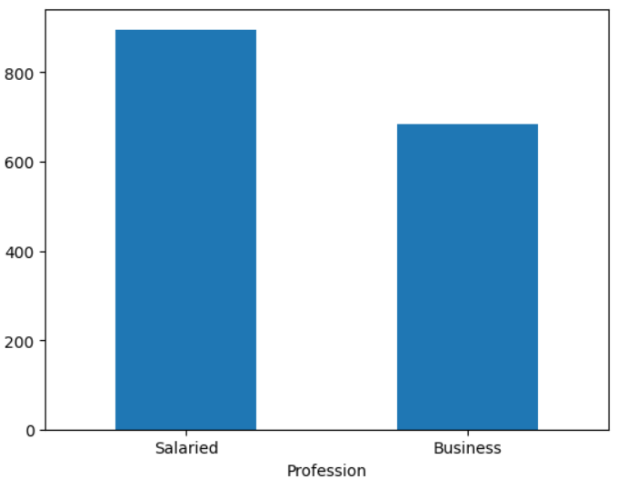
Observation: Salaried customers make up a modest majority of buyers. The two groups are close enough in size that profession-based campaigns should be sized similarly rather than favouring one group by default.

Marital Status
Marital Status | Count | Share
Married | 1,443 | 91.3%
Single | 138 | 8.7%

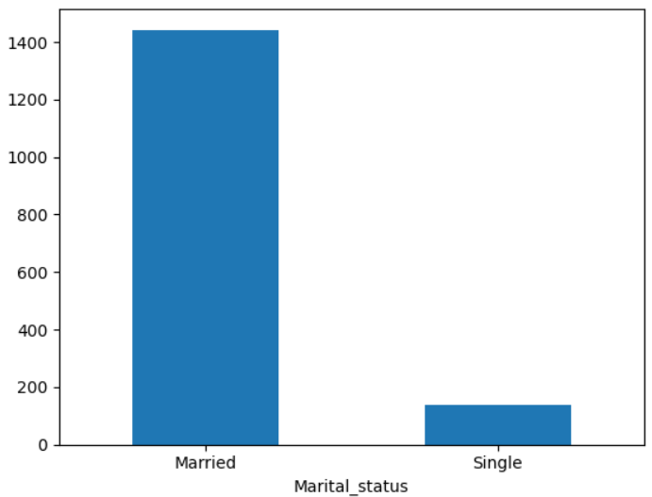
Observation: The overwhelming majority of Austo's customers are married. Campaigns aimed at single buyers (Section 10) are working with a much smaller pool and should expect proportionally smaller reach.

Education
Education | Count | Share
Post Graduate | 985 | 62.3%
Graduate | 596 | 37.7%

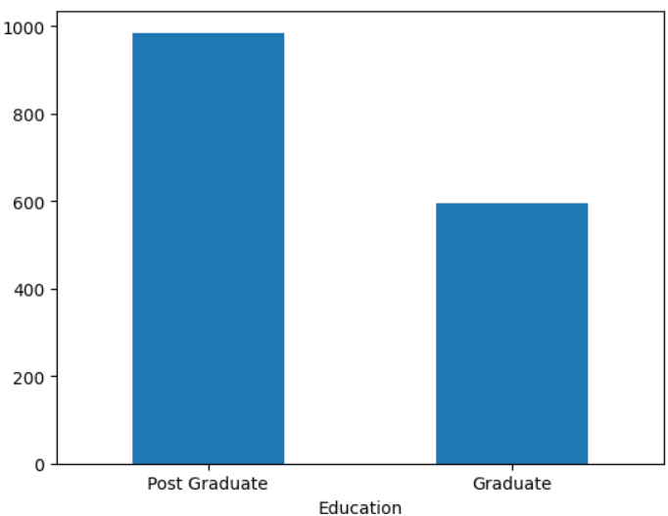
Observation: Post-graduate customers form the larger group. Education level tracks closely with the Salary and Profession fields, so it is unlikely to add much predictive power on its own.

Personal Loan
Personal Loan | Count | Share
Yes | 792 | 50.1%
No | 789 | 49.9%

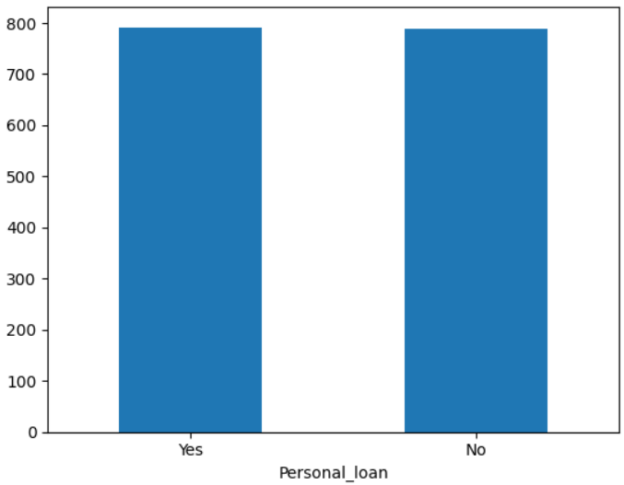
Observation: Customers are split almost exactly in half between those with and without a personal loan, so this field on its own does not separate the customer base into meaningfully different-sized groups.

House Loan
House Loan | Count | Share
No | 1,054 | 66.7%
Yes | 527 | 33.3%

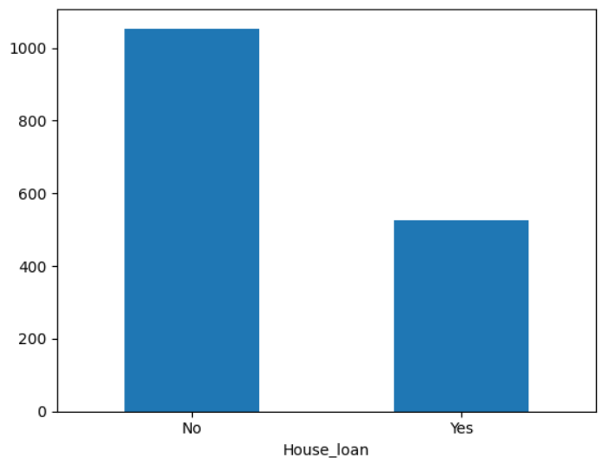
Observation: Two-thirds of customers do not carry a home loan, suggesting most car purchases are not being made alongside an active mortgage commitment.

Partner Employment Status
Partner Working | Count | Share
Yes | 868 | 54.9%
No | 713 | 45.1%

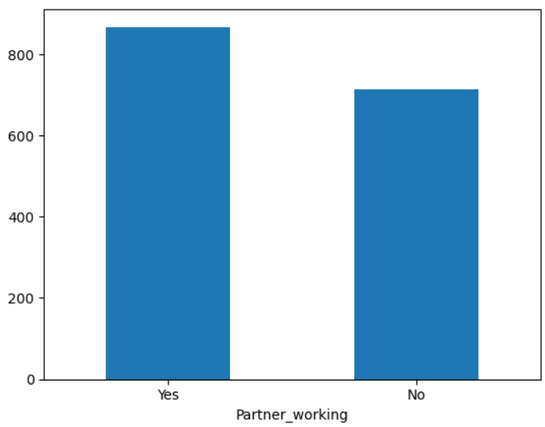
Observation: A little over half of customers has an employed partner. As shown in Section 9, this factor turns out to have almost no bearing on how much a customer spends on their vehicle.

5.2 Numerical Variables

Age
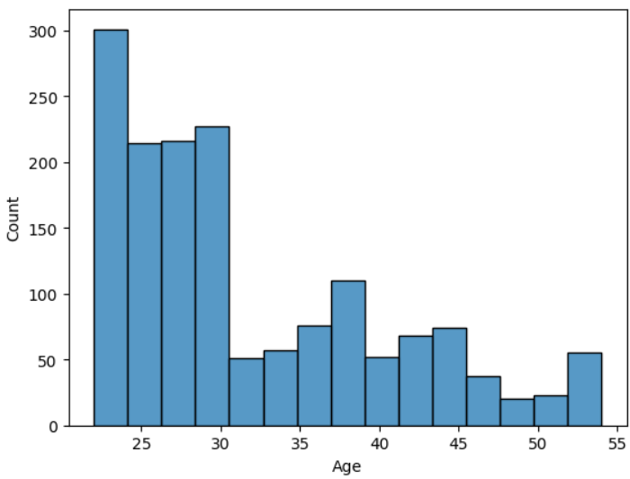
Observation: Customer age is right-skewed: the median age is 29 and 61% of all customers (958 of 1,581) are between 20 and 30 years old. Austo's current buyer base therefore skews young, which should shape the tone and channel choice (e.g. digital-first) of any new campaign.

Number of Dependents

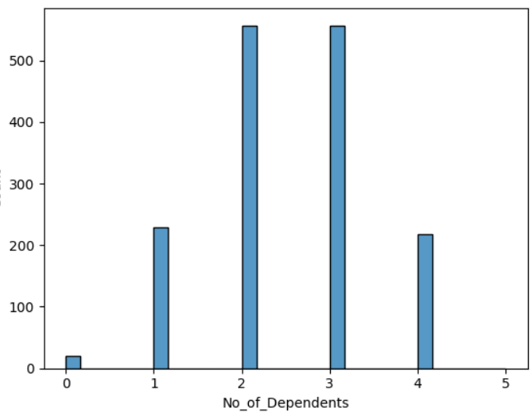
Observation: Most customers support 2 or 3 dependents (70% of the base combined), consistent with the earlier finding that the customer base is predominantly married. Very few customers (1.3%) have zero dependents.

Salary

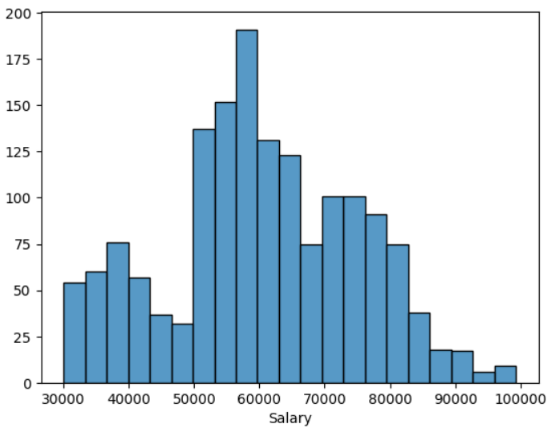
Observation: Salary is moderately spread, with a median of 59,500 and a middle 50% of customers earning between 51,900 and 71,800. There is a long right tail of high earners up to 99,300, who are prime candidates for premium vehicle offers.

Partner Salary

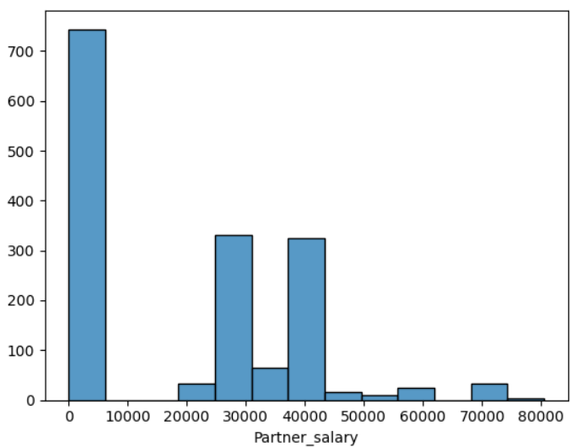
Observation: Partner salary is heavily concentrated at 0 (single-income households) for a large share of customers, with the remainder spread up to 80,500. This bimodal pattern is the reason Total_salary, not Partner_salary alone, is the more reliable measure of household purchasing power.

Total Household Salary
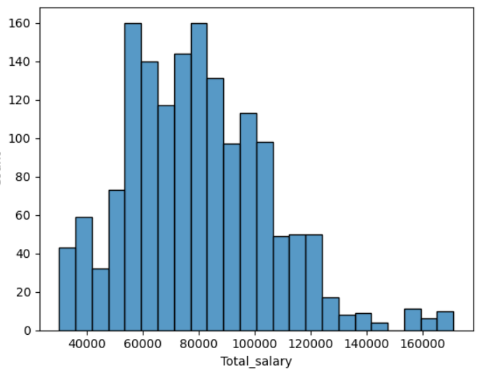
Observation: Household income has a median of 78,000 and a wide spread up to 171,000, reflecting the mix of single- and dual-income households already seen in the Partner_salary distribution.

Vehicle Price

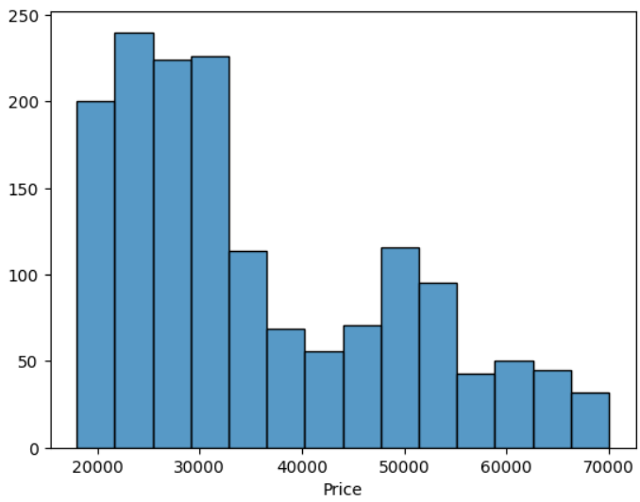
Observation: Price is right-skewed: the median purchase is 31,000, but a cluster of high-value SUV purchases (up to 70,000) pulls the mean up to 35,598. This confirms SUV buyers as the highest-value customer group in the current base.

6. Bivariate & Relationship Analysis
This section looks at how pairs of variables move together, which is essential for identifying which customer attributes actually predict the choice of vehicle and the price paid.

6.1 Gender vs. Vehicle Make
Gender | Hatchback | SUV | Sedan | SUV Share (within gender)
Female | 15 | 173 | 141 | 52.6%
Male | 567 | 124 | 561 | 9.9%
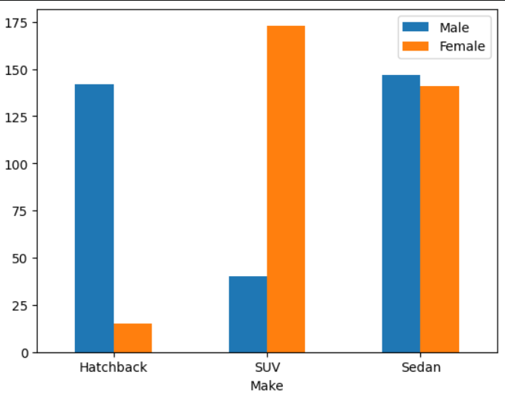
Observation: Read as a share of each gender's own purchases, SUV is by far the top choice for women (53%) while it is the least common choice for men (10%). Raw counts alone are misleading here because there are roughly four times as many male customers in the data - proportions are the fair basis for comparison, and they tell the opposite story to the raw totals.

6.2 Profession vs. Vehicle Make
Profession | Hatchback | SUV | Sedan | Sedan Share (within profession)
Business | 290 | 89 | 306 | 44.7%
Salaried | 292 | 208 | 396 | 44.2%

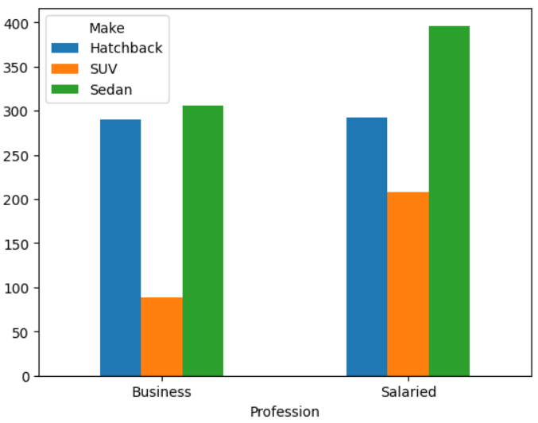
Observation: Sedan is the top choice for both professions, and at almost identical rates (44.7% for Business vs. 44.2% for Salaried) - profession does not meaningfully separate Sedan buyers. The real difference is in SUVs: Salaried customers choose an SUV more than twice as often as Business customers (23.2% vs. 13.0%), making Profession a much better signal for SUV targeting than for Sedan targeting.

6.3 Marital Status vs. Vehicle Make
Marital Status | Hatchback | SUV | Sedan
Married | 498 | 281 | 664
Single | 84 | 16 | 38

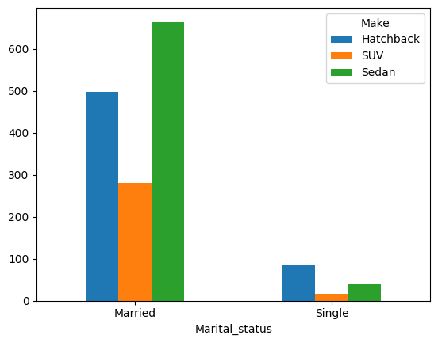
Observation: Married customers show a fairly even spread across all three body types (35% Hatchback, 19% SUV, 46% Sedan), while single customers lean heavily toward Hatchback (61%) and rarely buy an SUV (12%) — consistent with single buyers typically purchasing a first, budget-friendly car.

6.4 Education vs. Vehicle Make
Education | Hatchback | SUV | Sedan
Graduate | 220 | 117 | 259
Post Graduate | 362 | 180 | 443

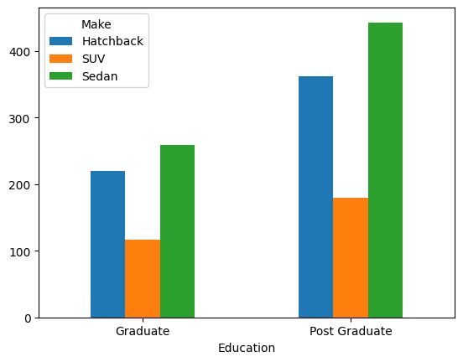
Observation: The mix of vehicle types purchased by Graduates and Post Graduates is very similar in proportion, so education level adds little extra signal once Profession and Salary are already known.

6.5 Personal Loan vs. Vehicle Make
Personal Loan | Hatchback | SUV | Sedan
No | 291 | 181 | 317
Yes | 291 | 116 | 385

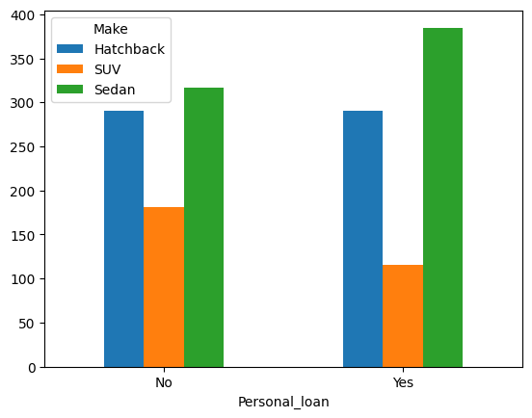
Observation: Customers without a personal loan are noticeably more likely to buy an SUV (22.9% vs. 14.6% for those with a loan), which fits with SUVs being the highest-priced body type - customers already repaying a loan appear to favour cheaper vehicles.

6.6 House Loan vs. Vehicle Make
House Loan | Hatchback | SUV | Sedan
No | 347 | 275 | 432
Yes | 235 | 22 | 270

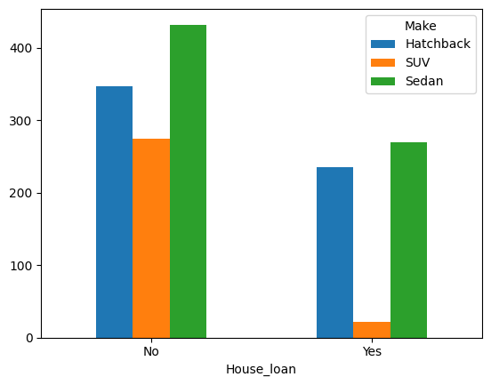
Observation: The pattern is even sharper for home loans: customers with an existing house loan almost never buy an SUV (4.2% vs. 26.1% for those without one). Existing debt obligations appear to be one of the strongest brakes on SUV purchases in the whole dataset.

6.7 Partner Employment vs. Vehicle Make
Partner Working | Hatchback | SUV | Sedan
No | 281 | 144 | 288
Yes | 301 | 153 | 414

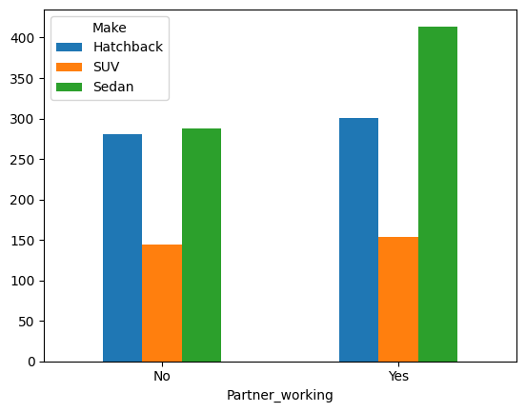
Observation: The distribution of vehicle types is almost identical whether or not the partner is employed, foreshadowing the Section 9 finding that partner employment has little influence on either the type of car bought or the price paid.

6.8 Number of Dependents vs. Vehicle Make
Dependents | Hatchback | SUV | Sedan
0 | 15 | 5 | 0
1 | 11 | 34 | 184
2 | 181 | 87 | 289
3 | 256 | 117 | 184
4 | 119 | 54 | 45

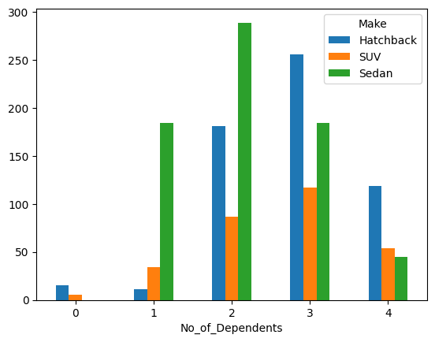
Observation: Sedan dominates among customers with exactly one dependent (80% of that group), while customers with three or four dependents shift markedly toward Hatchback - likely a practical, budget-conscious response to a larger family and higher day-to-day expenses.

6.9 Comparison between all the Numerical Variables
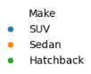
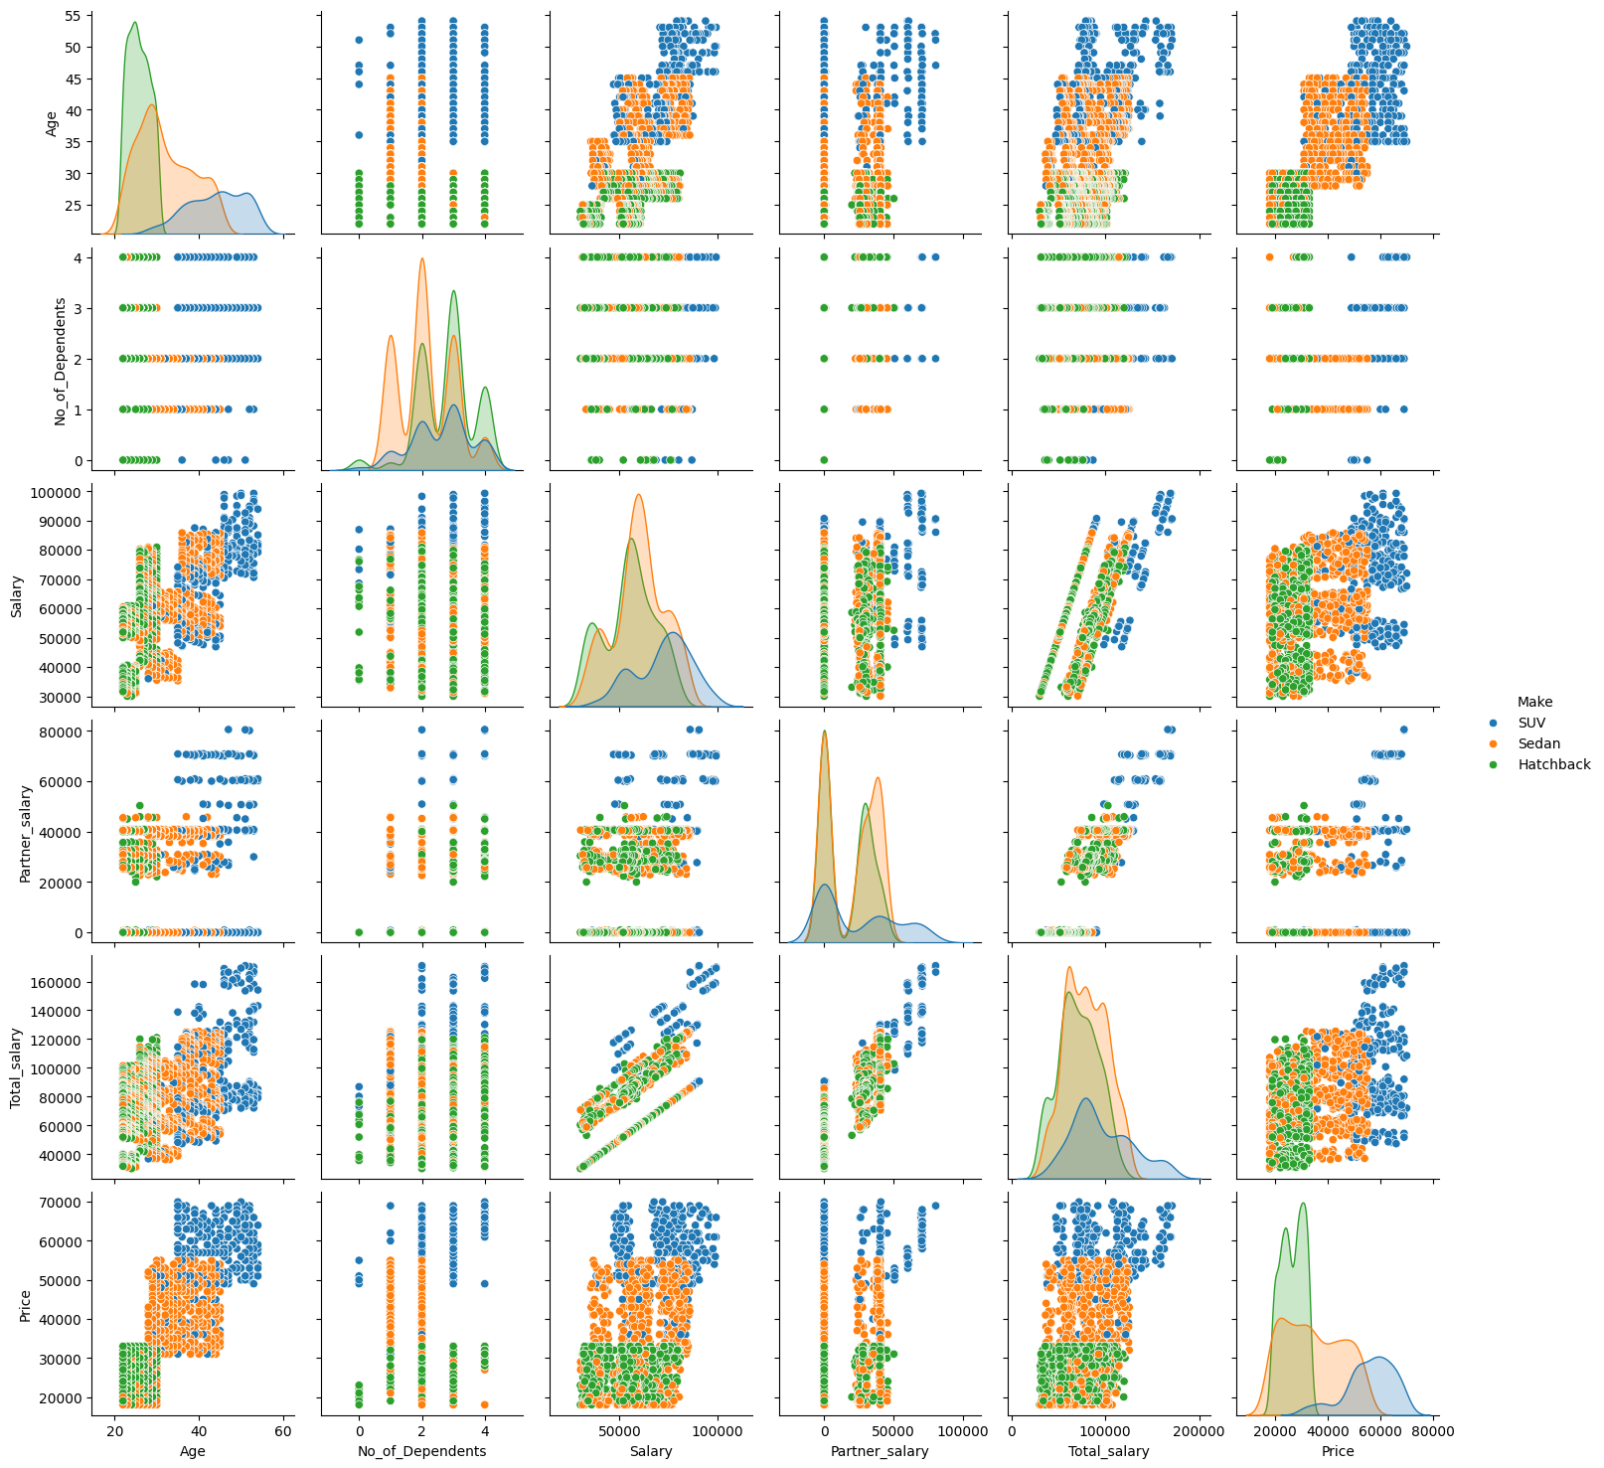

7. Validating Stakeholder Observations
Three members of the marketing team shared their impressions of who buys what. Each claim is checked against the data below, using proportions rather than raw counts wherever group sizes differ, since raw counts alone can be misleading when one group is much larger than another.

7.1 “Men prefer SUV by a large margin, compared to women” - Steve Roger
Gender | Hatchback | SUV | Sedan | SUV Share (within gender)
Female | 15 | 173 | 141 | 52.6%
Male | 567 | 124 | 561 | 9.9%

Three Different Samples
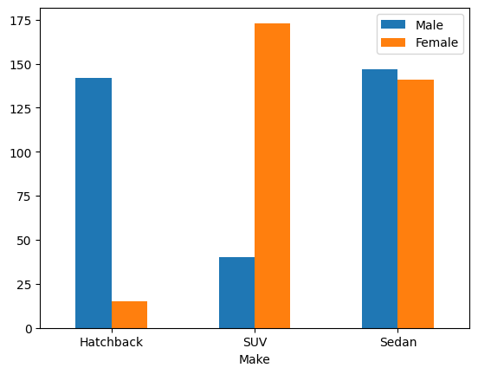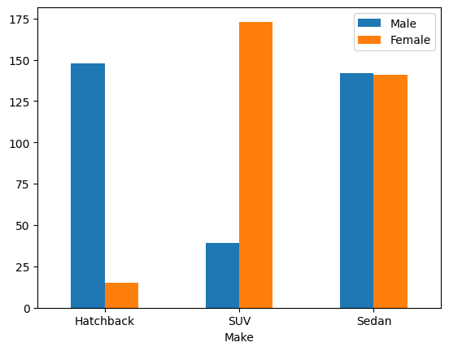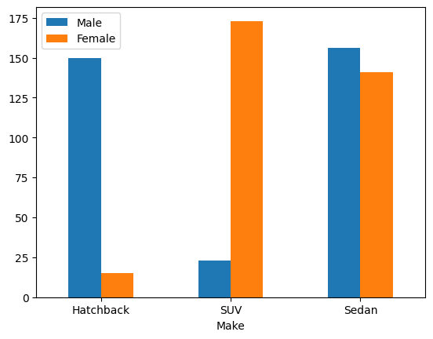
Comparison Between 3 samples for SUV
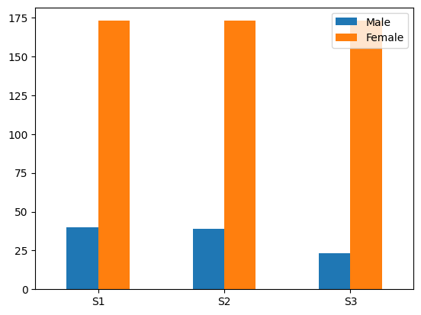
Verdict: Disagree.
The data shows the opposite. Once purchases are measured as a share of each gender's own totals - the fair way to compare groups of very different sizes 52.6% of female customers chose an SUV, compared to only 9.9% of male customers. For better analysis use sampling to confirm output. Comparison is shown in the above Graph. Steve Roger's claim is not supported by the data; if anything, women show a stronger preference for SUVs than men do.
7.2 “A salaried person is more likely to buy a Sedan” - Ned Stark
Profession | Hatchback | SUV | Sedan | Sedan Share (within profession)
Business | 290 | 89 | 306 | 44.7%
Salaried | 292 | 208 | 396 | 44.2%

Verdict: Not supported — partially disagree.
Sedan is indeed the single most popular body type for salaried customers, but it is equally the most popular choice for business customers, and at almost the same rate (44.2% vs. 44.7%). Profession therefore does not meaningfully separate Sedan buyers from non-Sedan buyers. The genuine difference between the two groups is elsewhere: salaried customers are more than 1.8x as likely as business customers to buy an SUV (23.2% vs. 13.0%). A more accurate statement would be that salaried customers are distinctly more inclined toward SUVs, not that they are distinctly more inclined toward Sedans.
7.3 “A salaried male is an easier target for an SUV sale over a Sedan sale” Sheldon Cooper
Make | Count (Salaried Males) | Share
Sedan | 305 | 45.4%
Hatchback | 277 | 41.2%
SUV | 90 | 13.4%
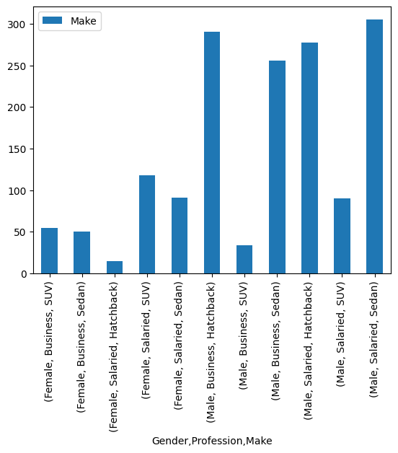
Verdict: Disagree.
Among salaried male customers specifically, Sedan is the clear top choice at 45.4%, followed by Hatchback at 41.2%, with SUV a distant third at 13.4%. A salaried male customer is more than three times as likely to buy a Sedan as an SUV. Sheldon Cooper's claim does not hold: for this specific sub-group, Sedan is easier to sell. SUV is not easier to sale.
8. Spending Analysis by Customer Category
This section looks at how much money different customer groups actually spend, which is a more direct measure of commercial value than purchase counts alone.

8.1 Spend by Gender
Gender | Customers | Total Spend | Average Spend
Female | 329 | 1,56,95,000 | 47,705
Male | 1,252 | 4,05,85,000 | 32,416

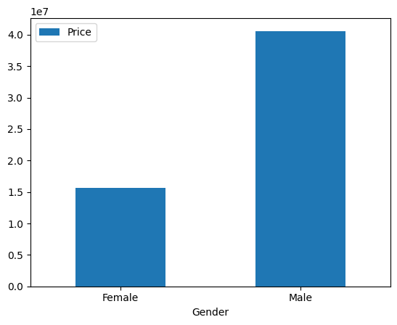
Observation: Female customers, while only 21% of the customer base, spend 47% more per person on average than male customers (47,705 vs. 32,416). This lines up with the earlier finding that women favour the pricier SUV segment. For the business, this means women are a small-volume but high-value segment: worth a dedicated premium campaign even though the addressable audience is smaller.

8.2 Spend by Personal Loan Status
Personal Loan | Customers | Total Spend | Average Spend
No | 789 | 2,89,90,000 | 36,743
Yes | 792 | 2,72,90,000 | 34,457

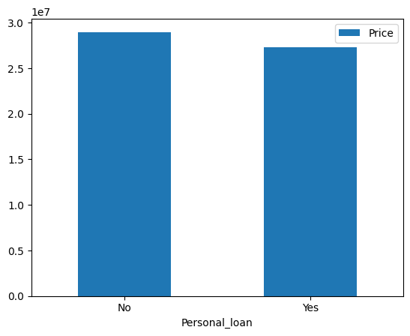
Observation: Customers who are already repaying a personal loan spend about 6% less on their vehicle on average (34,457 vs. 36,743). This is a modest but consistent effect, in line with the Section 6 finding that loan holders lean toward cheaper body types. For financing offers, this suggests loan-free customers are the better segment to target with premium/high-price upsell messaging, while existing loan holders may respond better to affordable, EMI-friendly offers.

9. Effect of Partner's Employment on Purchase Price
Partner Working | Customers | Average Price
No | 713 | 36,000
Yes | 868 | 35,267
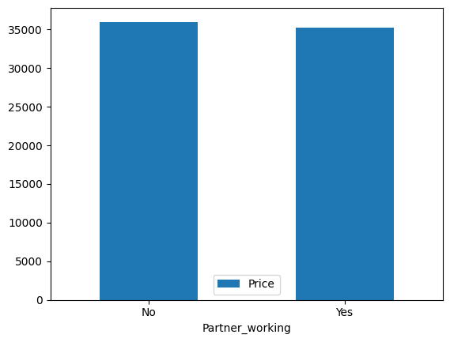

Make-wise Average Price by Partner Employment Status
Partner Working | Hatchback | SUV | Sedan
No | 26,324 | 56,174 | 35,354
Yes | 26,615 | 55,497 | 34,082
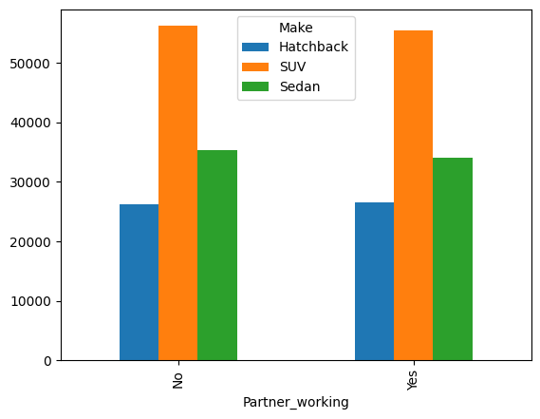
Observation: The overall average price is virtually identical regardless of whether a customer's partner is employed (36,000 vs. 35,267), and this holds true within every individual vehicle category as well - the differences are within 1–2% and are not commercially meaningful. Having a working partner does not lead to the purchase of a higher-priced car. This means Partner_working is not a useful variable for identifying high-value prospects; Age and Salary (Section 6.9) remain the far stronger predictors and should be prioritised in any lead-scoring model.

10. Customer Segmentation Strategy
To design targeted campaigns, customers were grouped by Gender and Marital Status - the two fields the business asked us to segment on. Vehicle preference and average spend were then examined within each of the four resulting groups.
Segment | Customers | Hatchback | SUV | Sedan | Avg. Price
Married Male | 1,136 | 42.6% | 10.1% | 47.3% | 32,526
Married Female | 307 | 4.6% | 54.1% | 41.4% | 47,919
Single Male | 116 | 71.6% | 7.8% | 20.7% | 31,345
Single Female | 22* | 4.5% | 31.8% | 63.6% | 44,727

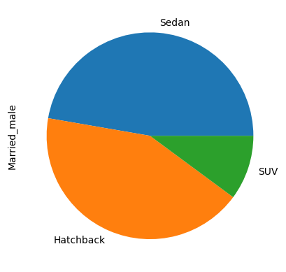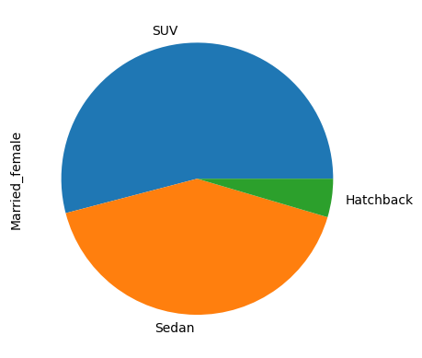
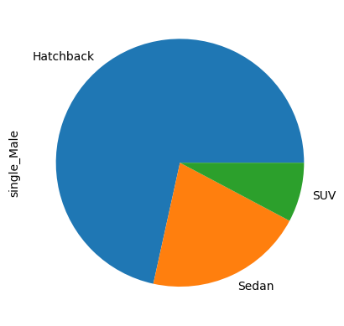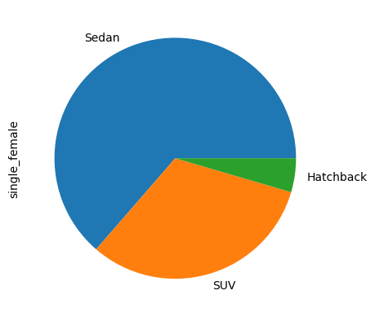

10.1 Segment Profiles

Segment 1 - Married Male (largest segment, 72% of the customer base)
Fairly evenly split between Sedan (47%) and Hatchback (43%), with low SUV uptake (10%). This is the core, value-conscious family-buyer segment and the anchor of overall sales volume.

Segment 2 - Married Female (highest average spend, 47,919)
Strongly favours SUV (54%) and Sedan (41%), almost never buying a Hatchback. This is the premium segment: fewer customers, but by far the highest spend per customer.

Segment 3 - Single Male (entry-level segment)
Dominated by Hatchback (72%), with the lowest average spend of any segment (31,345). Likely first-time or budget buyers.

Segment 4 - Single Female (small sample, directional only)
Leans toward Sedan (64%) with a relatively high average spend (44,727), but with only 22 customers in this group, this pattern should be validated with more data before committing significant campaign budget to it.

10.2 Recommended Targeting by Segment
Segment | Recommended Focus | Suggested Message
Married Male | Sedan & Hatchback, volume campaigns | Reliability, family space, running cost / value for money
Married Female | SUV & Sedan, premium campaigns | Safety, comfort, status, premium features and financing
Single Male | Hatchback, entry-level / first-car campaigns | Affordability, low EMI, styling, easy financing
Single Female | Sedan, small pilot campaign | Test messaging on a small scale before scaling spend

11. Conclusion & Recommendations
Bringing together the findings from every section, the following recommendations are proposed to make Austo's marketing campaign more precisely targeted:

11.1 Key Takeaways
- Compare groups using proportions, not raw counts, whenever group sizes are unequal - doing so reversed the conclusion on gender and SUV preference (Section 7.1).
- Sedan is the default top choice across almost every customer group; it is Profession, House Loan, and Number of Dependents that shift customers toward or away from SUV and Hatchback specifically.
- Age and Salary are the strongest available predictors of purchase price (correlations of 0.80 and 0.41); Partner_working has essentially no predictive value (Section 9) and should not be used as a targeting criterion.
- Married women are the highest-value segment per customer, while single men are the highest-volume entry-level segment - these call for very different campaign messaging (Section 10.2).
- Existing loan obligations (personal or house) are associated with lower spend and a lower likelihood of buying an SUV, making debt-free customers the better audience for premium upsell.

11.2 Recommended Actions
- Launch a dedicated premium SUV/Sedan campaign aimed at married women, emphasising safety, comfort, and financing options rather than price.
- Run an affordable, EMI-focused Hatchback campaign for single, younger buyers as an entry point into the Austo brand.
- Prioritise salaried customers without an existing house loan for SUV upsell campaigns, since both factors are independently associated with higher SUV uptake.
- Retire partner-employment status as a segmentation or lead-scoring variable; replace it with Age and Salary, which carry the real predictive signal.
- When repeating this analysis in future, capture Gender at the point of sale rather than leaving it blank, to avoid relying on imputation for a variable that materially affects the segmentation strategy.

11.3 Limitations
- 53 Gender values (3.4% of records) were imputed using the mode; genuine values could shift the precise percentages in Sections 5.1, 6.1 and 7.1 slightly, though the direction of the findings is unlikely to change given the size of the effect observed.
- The Single Female segment (22 records) is too small to generalise confidently and is flagged as directional only.
- The dataset represents completed purchases only; it does not capture prospects who considered Austo and bought elsewhere, so it cannot speak to conversion rate or lost sales.

