ALL CKA EXAM QUESTIONS

**Author: Mehul Solanki Date: 27-OCT-2024 Version: 1.0**

|  |  |  |
| --- | --- | --- |
| *Author* | *Date* | *Comments* |
| Mehul Solanki | 27-Oct-2024 | This document will be using for exam preparation only. |

Document History

*Contact Details*  
  
Name : Mehul Solanki  
Phone : +919879729795  
Email : er.mehulsolanki1887@gmail.com  
LinkedIn : https://in.linkedin.com/in/mehulsolanki1887

Table of Contents

1. CKA-QUESTIONS-KODE KLOUD (LIGHTNING LAB – 1) 4

2. CKA-QUESTIONS-KODE KLOUD (MOCK EXAM -1) 8

3. CKA-QUESTIONS-KODE KLOUD (MOCK EXAM -2) 12

4. CKA-QUESTIONS-KODE KLOUD (MOCK EXAM -3) 17

5. CKA-QUESTIONS-HIGHSKY 23

6. CKA-QUESTIONS(YOUTUBE) 32

7. CKA-QUESTIONS-KILLERSHELL 34

8. COMMAND 35

9. CKA-QUESTIONS-KODE KLOUD (MOCK EXAM SERIES-1) 38

**Table of Figures**

**No table of figures entries found.**

# CKA-QUESTIONS-KODE KLOUD (LIGHTNING LAB – 1)

Upgrade the **current version of kubernetes from 1.30.0 to 1.31.0** exactly using the kubeadm utility. Make sure that the upgrade is carried out one node at a time starting with the **controlplane nodes**. To minimize downtime, the deployment gold-nginx should be rescheduled on an alternate node before upgrading each node.

Upgrade **controlplane node** first and drain **node node01** before upgrading it. **Pods for**

**gold-nginx** should run on the **controlplane node** subsequently.

Solutions

**MasterNode**

1. cat /etc/*release*
2. vim /etc/apt/sources.list.d/kubernetes.list (Change version in the file)
3. apt-get update
4. apt-cache madison kubeadm
5. apt-get install kubeadm=1.31.0-1.1
6. kubeadm version
7. kubeadm upgrade plan v1.31.0
8. kubeadm upgrade apply v1.31.0
9. kubectl get nodes
10. kubectl drain controlplane --ignore-daemonsets
11. apt-cache madison kubeadm
12. kubectl get nodes
13. apt-get install kubelet=1.31.0-1.1
14. systemctl daemon-reload
15. systemctl restart kubelet
16. kubectl get nodes
17. kubectl uncordon controlplane

**WorkerNode**

1. ssh node01
2. cat /etc/*release*
3. vim /etc/apt/sources.list.d/kubernetes.list (Change Version in the file)
4. apt-get update
5. apt-cache madison kubeadm
6. apt-get install kubeadm=1.31.0-1.1
7. kubeadm upgrade node
8. kubeadm version
9. kubectl get nodes
10. ssh controlplane
11. kubectl drain node01 --ignore-daemonsets
12. ssh node01
13. apt-get install kubelet=1.31.0-1.1
14. systemctl daemon-reload
15. systemctl restart kubelet
16. ssh controlplane
17. kubectl get nodes
18. kubectl uncordon node01
19. kubectl get nodes

Print the names of all deployments in the **admin2406** namespace in the following format:

**DEPLOYMENT** **CONTAINER_IMAGE** **READY_REPLICAS** **NAMESPACE**

<deployment name> <container image used> <ready replica count> <Namespace>

The data should be sorted by the increasing order of the deployment name.

Example: **DEPLOYMENT** **CONTAINER_IMAGE** **READY_REPLICAS** **NAMESPACE**

**deploy0** **nginx: alpine** **1** **admin2406** Write the result to the file **/opt/admin2406_data**.

Solutions

**Run the below command to get the correct output:**

1. kubectl get deployment -o custom-columns=DEPLOYMENT:.metadata.name,CONTAINER_IMAGE:.spec.template.spec.containers[].image,READY_REPLICAS:.status.readyReplicas,NAMESPACE:.metadata.namespace --sort-by=.metadata.name -n admin2406 > /opt/admin2406_data

A kubeconfig file called **admin**. kubeconfig has been created in **/root/CKA**. There is something wrong with the configuration.

* Troubleshoot and fix it.
* Fix **/root/CKA/admin.kubeconfig**

Solutions

**Make sure the port for the kube-apiserver is correct. So, for this change port from 4380 to 6443.**

**Run the below command to know the cluster information:**

1. kubectl cluster-info --kubeconfig /root/CKA/admin.kubeconfig

Create a new deployment **called nginx-deploy**, with **image nginx:1.16** and **1 replica**.

Next upgrade the deployment to **version 1.17 using rolling update**.

* Image: **nginx:1.16**
* Task: **Upgrade the version of the deployment to 1:17**

Solutions

**Make use of the kubectl create command to create the deployment and explore the --record option while upgrading the deployment image.**

**Run the below command to create a deployment nginx-deploy:**

1. kubectl create deployment nginx-deploy --image=nginx:1.16
2. kubectl set image deployment nginx-deploy nginx=nginx:1.17 --record
3. kubectl rollout history deployments nginx-deploy

A new deployment called **alpha-mysql** has been deployed in the alpha namespace. However, the pods are not running. Troubleshoot and fix the issue. The deployment should make use of the persistent volume **alpha-pv** to be mounted at **/var/lib/mysql** and should use the environment variable **MYSQL_ALLOW_EMPTY_PASSWORD=1** to make use of an **empty root password**.

**Important**: **Do not alter the persistent volume**.

Troubleshoot and fix the issues

Solutions

**Use the command kubectl describe and try to fix the issue.**

**Solution manifest file to create a pvc called mysql-alpha-pvc as follows:**

1. kubectl get pod -n alpha
2. kubectl describe pod alpha-mysql -n alpha
3. vim pvc.yaml

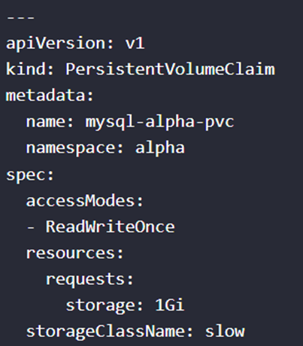

1. kubectl apply -f pvc.yaml

Take the **backup of ETCD** at the location **/opt/etcd-backup.db** on the controlplane node.

Troubleshoot and fix the issues.

Solutions

1. cat /etc/kubernetes/manifests/etcd.yaml | grep file
2. ETCDCTL_API=3 etcdctl -h
3. ETCDCTL_API=3 etcdctl --endpoints=127.0.0.1:2379 --cacert=/etc/kubernetes/pki/etcd/ca.crt --cert=/etc/kubernetes/pki/etcd/server.crt --key=/etc/kubernetes/pki/etcd/server.key snapshot save /opt/etcd-backup.db
4. ETCDCTL_API=3 etcdctl --endpoints=127.0.0.1:2379 --cacert=/etc/kubernetes/pki/etcd/ca.crt --cert=/etc/kubernetes/pki/etcd/server.crt --key=/etc/kubernetes/pki/etcd/server.key --write-out=table snapshot status /opt/etcd-backup.db

Create a pod called **secret-1401** in the **admin1401** namespace using the **busybox image**. The container within the **pod** should be called **secret-admin** and should sleep for **4800 seconds**.

The container should mount a **read-only** secret volume called **secret-volume** at the path **/etc/secret-volume**. The secret being mounted has already been created for you and is called **dotfile-secret**

Solutions

**Use the command kubectl run to create a pod definition file. Add secret volume and update container name in it.**

**Alternatively, run the following command:**

1. kubectl run secret-1401 -n admin1401 --image=busybox --command sleep 4800 --dry-run=client -o yaml > pod.yaml

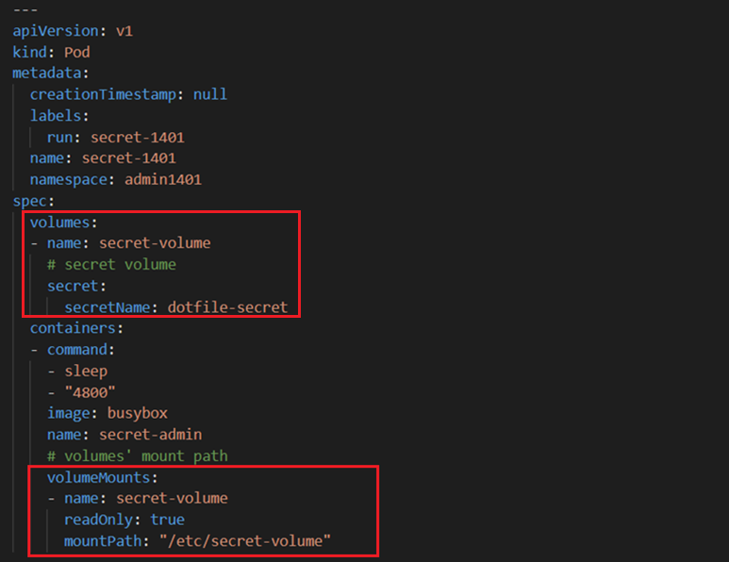

1. Refer documents and add lines as per above.

# CKA-QUESTIONS-KODE KLOUD (MOCK EXAM -1)

1. Deploy a pod named **nginx-pod** using the **nginx:alpine image**.

* Name: **nginx-pod**
* Image: nginx:alpine

Solutions

1. kubectl run nginx-pod --image=nginx:alpine

Deploy a **messaging pod** using the **redis:alpine** image with the labels set to **tier=msg**

* Pod Name: **messaging**
* Image: **redis:alpine**
* Labels: t**ier=msg**

Solutions

1. kubectl run messaging --image=redis:alpine --labels=tier=msg
2. kubectl get pods --show-labels
3. Create a **namespace** named **apx-x9984574**.

* Namespace: apx-x9984574

Solutions

1. kubectl create ns apx-x9984574

Get the list of nodes in **JSON** format and store it in a file at **/opt/outputs/nodes-z3444kd9.json.**

Solutions

1. kubectl get nodes -o Json > /opt/output/nodes-z3444kd9.jason

Create a service **messaging-service** to expose the messaging application within the cluster on **port 6379**.

* Service: **messaging-service**
* Port: **6379**
* Type: **ClusterIp**
* **Use the right labels**

Solutions

1. kubectl expose pod messaging --type=ClusterIP --port=6379 --labels=messaging=service --name=messaging-service
2. kubectl get svc --show-labels

Create a deployment named **hr-web-app** using the image **kodekloud/webapp-color** with **2 replicas**.

* Name: **hr-web-app**
* Image: **kodekloud/webapp-color**
* Replicas: **2**

Solutions

1. kubectl create deployment hr-web-app --image=kodecloud/webapp-color --replicas=2

Create a static pod named **static-busybox** on the controlplane node that uses the **busybox image** and the command **sleep 1000**.

* Name: static-busybox
* Image: busybox

Solutions

1. kubectl run static-busybox --image=busybox --command sleep 1000 --dry-run=client -o yaml > /etc/kubernetes/manifests/static-busybox.yaml

Create a **POD** in the finance namespace named **temp-bus** with the image **redis:alpine**.

* Name: **temp-bus**
* Image Name: **redis:alpine**

Solutions

1. kubectl run temp-bus --image=redis:alpine -n finance

A new application **orange** is deployed. There is something wrong with it. Identify and fix the issue.

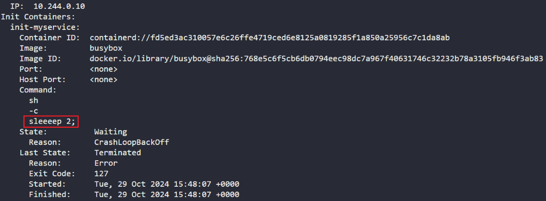

Expose the **hr-web-app** created in the previous task as a service named **hr-web-app-service**, accessible on **port 30082** on the nodes of the cluster.

* The web application listens on **port 8080**.
* Name: **hr-web-app-service**
* Type: **NodePort**
* Endpoints: **2**
* Port: **8080**
* NodePort: **30082**

Solutions

1. kubectl expose deploy hr-web-app --type=NodePort --port=8080 --name=hr-web-app-service --dry-run=client -o yaml > hr-web-app-service.yaml

Use **JSON PATH** query to retrieve the **osImages** of all the nodes and store it in a file **/opt/outputs/nodes_os_x43kj56.txt**.

* The **osImage** are under the **nodeInfo** section under status of each node.

Solutions

1. kubectl get nodes -o jsonpath='{.items[*].status.nodeInfo.osImage}' > /opt/outputs/nodes_os_x43kj56.txt

Create a Persistent Volume with the given specification: -

* Volume name: **pv-analytics**
* Storage: **100Mi**
* Access mode: **ReadWriteMany**
* Host path: **/pv/data-analytics**

Solutions

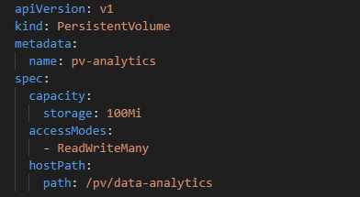

# CKA-QUESTIONS-KODE KLOUD (MOCK EXAM -2)

1. Take a backup of the **etcd** cluster and save it to **/opt/etcd-backup.db**.

Solutions

1. cat /etc/kubernetes/manifests/etcd.yaml | grep file
2. ETCDCTL_API=3 etcdctl -h
3. ETCDCTL_API=3 etcdctl --endpoints=127.0.0.1:2379 --cacert=/etc/kubernetes/pki/etcd/ca.crt --cert=/etc/kubernetes/pki/etcd/server.crt --key=/etc/kubernetes/pki/etcd/server.key snapshot save /opt/etcd-backup.db
4. ETCDCTL_API=3 etcdctl --endpoints=127.0.0.1:2379 --cacert=/etc/kubernetes/pki/etcd/ca.crt --cert=/etc/kubernetes/pki/etcd/server.crt --key=/etc/kubernetes/pki/etcd/server.key --write-out=table snapshot status /opt/etcd-backup.db
5. ETCDCTL_API=3 etcdctl --endpoints=127.0.0.1:2379 snapshot restore --cacert=/etc/kubernetes/pki/etcd/ca.crt --cert=/etc/kubernetes/pki/etcd/server.crt --key=/etc/kubernetes/pki/etcd/server.key --data-dir=/var/lib/etcd-backup /opt/etcd-backup.db
6. ETCDCTL_API=3 etcdctl snapshot restore --data-dir=/var/lib/etcd-backup /opt/etcd-backup.db

Create a Pod called **redis-storage** with **image: redis:alpine** with a Volume of type emptyDir that lasts for the life of the Pod.

* Pod named **'redis-storage'** created
* Pod **'redis-storage'** uses Volume type of **emptyDir**
* Pod **'redis-storage'** uses **volumeMount** with **mountPath = /data/redis**

Solutions

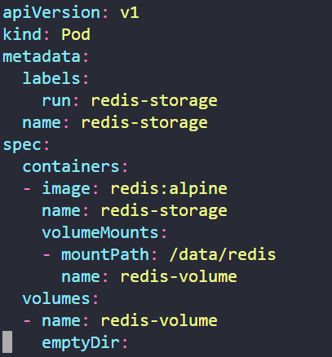

Create a new pod called **super-user-pod** with image **busybox:1.28**. Allow the pod to be able to set **system_time**.

* The container **should sleep for 4800** seconds.
* Pod: **super-user-pod**
* Container Image: **busybox:1.28**
* Is **SYS_TIME** capability set for the container?

Solutions

1. kubectl run super-user-pod --image=busybox:1.28 --command sleep 4800 --dry-run=client -o yaml > server-user-pod.yaml

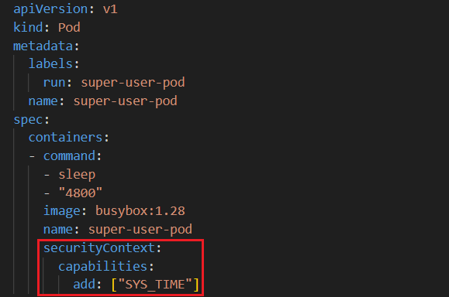

A **pod** definition file is created at **/root/CKA/use-pv.yaml**. Make use of this manifest file and mount the persistent volume called **pv-1**. Ensure the pod is running and the **PV** is **bound**.

* mountPath: **/data**
* persistentVolumeClaim Name: **my-pvc**
* **persistentVolume Claim** configured correctly
* pod using the correct **mountPath**
* pod using the **persistent volume claim**?

Solutions

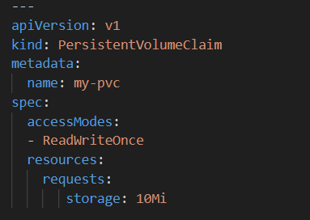

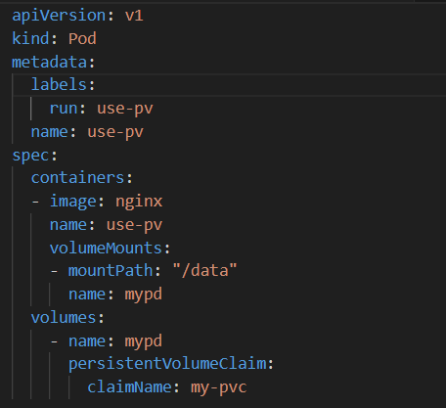

Create a new deployment called **nginx-deploy**, with **image nginx:1.16** and 1 replica. Next upgrade the deployment to **version 1.17** using rolling update.

* Deployment : **nginx-deploy**. Image: **nginx:1.16**
* Image: **nginx:1.16**
* Task: **Upgrade** the version of the deployment to **1:17**
* Task: **Record** the changes for the **image upgrade**

Solutions

1. kubectl create deploy nginx-deploy --image=nginx:1.16 --replicas=1
2. kubectl set image deploy nginx-deploy --image=nginx:1.17 --record
3. kubectl rollout history deployments nginx-deploy

Create a new user called **john**. Grant him access to the cluster. **John** should have permission to create, **list, get, update** and **delete pods** in the development namespace. The private key exists in the location: **/root/CKA/john.key** and csr at **/root/CKA/john.csr**.

* **Important Note**: As of **kubernetes 1.19**, the CertificateSigningRequest object expects a signerName.
* Please refer the documentation to see an example. The documentation tab is available at the top right of terminal.
* CSR: **john-developer** Status:**Approved**
* Role Name: **developer**, namespace: **development**, Resource: **Pods**
* Access: User '**john**' has appropriate permissions

Solutions

1. openssl genrsa -out john.key 2048
2. openssl req -new -key john.key -out john.csr -subj "/CN=john"
3. cat john.csr | base64 | tr -d "\n" (Get the n code value)

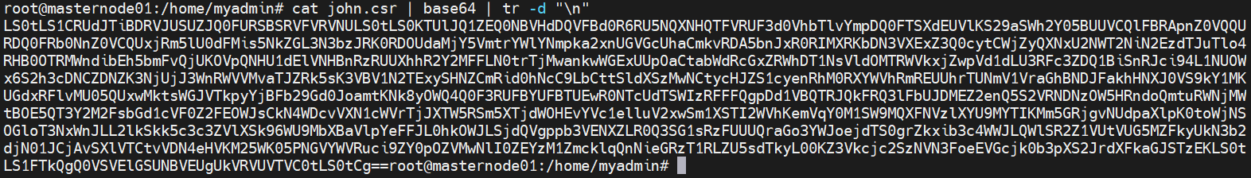

1. Copy above code and put into john-user.yaml
2. vim john-user.yaml

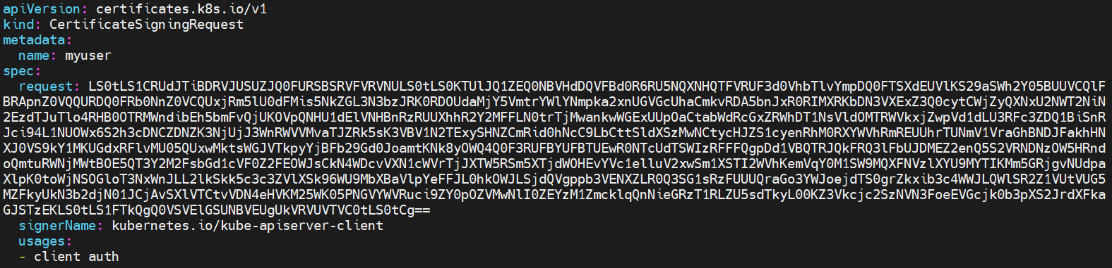

1. kubectl apply -f john-user.yaml (Read the documents to create CSR)
2. kubectl get csr
3. kubectl certificate approve
4. kubectl create role developer --verb=create,list,get,updates,delete --resource=pod -n development
5. kubectl get role -n development
6. kubectl describe role development -n development
7. kubectl auth can-i create pods -n development --as john
8. kubectl create rolebinding john-developer --role=developer --user=john -n development
9. kubectl get rolebinding -n development
10. kubectl describe rolebinding -n development
11. kubectl auth can-i get pods -n development --as john
12. kubectl auth can-i create pods -n development --as john
13. kubectl auth can-i updates pods -n development --as john
14. kubectl auth can-i watch pods -n development --as john

Create a nginx pod called **nginx-resolver** using image **nginx**, expose it internally with a service called **nginx-resolver-service**.

Test that you are able to look up the **service** and **pod** names from within the **cluster**. Use the image: **busybox:1.28** for dns lookup. Record results in **/root/CKA/nginx.svc** and **/root/CKA/nginx.pod**.

* Pod: **nginx-resolver** created
* Service **DNS Resolution** recorded correctly
* Pod **DNS resolutio**n recorded correctly

Solutions

1. kubectl run nginx-resolver --image=nginx
2. kubectl get pod
3. kubectl expose pod nginx-resolver --name=nginx-resolver-service --port=80
4. kubectl run busybox --image=busybox:1.28 --command sleep 4000
5. kubectl exec busybox -- nslookup nginx-resolver-service
6. kubectl exec busybox -- nslookup nginx-resolver-service > /root/CKA/nginx.svc
7. kubectl get pod -o wide
8. kubectl exec busybox ip.namespace.pod.cluster.local -- nslookup nginx-resolver-service
9. kubectl exec busybox ip.namespace.pod.cluster.local -- nslookup nginx-resolver-service > /root/CKA/nginx.pod

Create a static pod on **node01** called **nginx-critical** with image **nginx** and make sure that it is **recreated/restarted** automatically in case of a failure.

* Use **/etc/kubernetes/manifests** as the **Static Pod** path for example.
* static pod configured under **/etc/kubernetes/manifests** ?
* Pod **nginx-critical-node01** is up and running

Solutions

1. ssh node01
2. kubectl run nginx-critical --image=nginx --restart=Always --dry-run=client -o yaml
3. Copy file and create YAML on node01
4. cat > /etc/kubernetes/manifests/nginx-critical.yaml

# CKA-QUESTIONS-KODE KLOUD (MOCK EXAM -3)

1. Create a new service account with the name **pvviewer**, Grant this Service account access to **list** all **PersistentVolumes** in the cluster by creating an appropriate cluster role called **pvviewer-role** and ClusterRoleBinding called **pvviewer-role-binding**.

Next, create a **pod** called **pvviewer** with the image: **redis** and **serviceAccount**: **pvviewer** in the default namespace.

• ServiceAccount: **pvviewer**

• ClusterRole: **pvviewer-role**

• ClusterRoleBinding: **pvviewer-role-binding**

• Pod: **pvviewer**

• Pod configured to use **serviceaccount** **pvviewer**

Solutions

1. kubectl create service account pvviewer
2. kubectl create clusterrole pvviewer-role --verb=list --resource=persistentvolume
3. kubectl create get clusterrole pvviewer-role
4. kubectl create clusterrolebinding pvviewer-role-binding --clusterrole=pvviewer-role --serviceaccount=default:pvviewer
5. kubectl describe cluserrolebinding pvviewer-role-binding
6. kubectl run pvviewer --image=redis --dry-run=client -o yaml > pvviewer.yaml

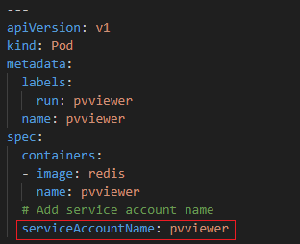

1. List the InternalIP of all nodes of the cluster. Save the result to a file /root/CKA/node_ips.

Answer should be in the format: InternalIP of controlplane<space>InternalIP of node01 (in a single line)

Solutions

1. kubectl get node -o wide
2. kubectl get node -o jsonpath=’{.items[0].status.addresses[?(@.type==”InternalIP”)].address}’ > /root/CKA/node.ips
3. Create a pod called **multi-pod** with two containers.

Container 1: name: **alpha**, image: **nginx**

Container 2: name: **beta**, image: **busybox**, command: **sleep 4800**

Environment Variables:

Container 1:

name: **alpha**

Container 2:

name: **beta**

• Pod Name: **multi-pod**

• Container 1: **alpha**

• Container 2: **beta**

• Container beta commands set correctly?

• **Container 1 Environment Value Set**

**• Container 2 Environment Value Set**

Solutions

1. kubectl run multi-pod --image=nginx --dry-run=client -o yaml > multi-pod.yaml

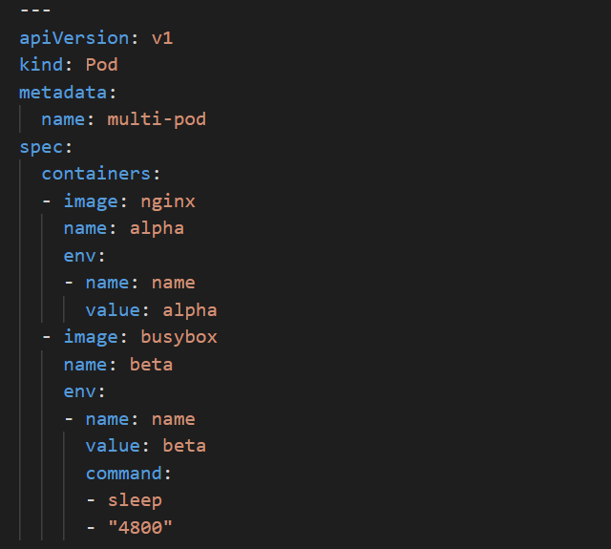

1. kubectl apply -f multi-pod.yaml
2. kubectl describe pod multi-pod
3. Create a Pod called **non-root-pod** , image: **redis:alpine**

**runAsUser: 1000**

**fsGroup: 2000**

* Pod **non-root-pod fsGroup** configured
* Pod **non-root-pod runAsUser** configured

Solutions

1. kubectl run non-root-pod --image=redis:alpine --dry-run=client -o yaml > non-root-pod.yaml (Read Documents).

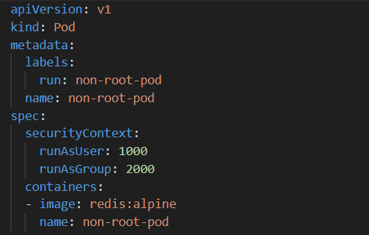

1. kubectl get pod
2. kubectl describe pod non-root-pod
3. kubectl exec -it non-root-pod -- sh
4. whoami
5. id -G
6. We have deployed a new pod called **np-test-1** and a service called **np-test-service**. Incoming connections to this service are not working. Troubleshoot and fix it.

Create NetworkPolicy, by the name **ingress-to-nptest** that allows incoming connections to the service over **port 80**.

Important: Don't delete any current objects deployed.

* Important: **Don't Alter Existing Objects**!
* NetworkPolicy: **Applied to All sources** (Incoming traffic from all pods)?
* NetWorkPolicy: **Correct Port**?
* NetWorkPolicy: **Applied to correct Pod**?

Solutions

1. kubectl get pod

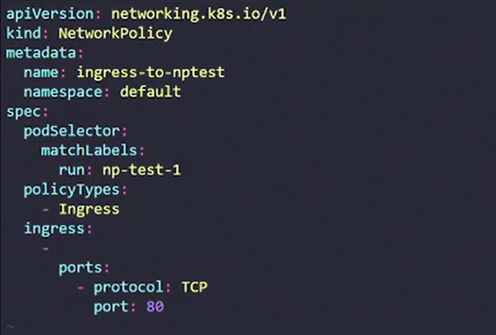

1. Taint the worker node **node01** to be Unschedulable. Once done, create a pod called **dev-redis**, image **redis:alpine**, to ensure workloads are not scheduled to this worker node.

Finally, create a new pod called **prod-redis** and image: **redis:alpine** with toleration to be scheduled on **node01**.

Key: **env_type**, value: **production**, operator: **Equal** and effect: **NoSchedule.**

* Key = **env_type**
* Value = **production**
* Effect = **NoSchedule**
* pod ‘**dev-redis**’ (no tolerations) is not scheduled on **node01**?
* Create a pod ‘**prod-redis**’ to run on **node01**

Solutions

1. kubectl get nodes
2. kubectl taint node node01 env_type=production:NoSchedule
3. kubectl describe node node01
4. kubectl run dev-redis --image=redis:alpine
5. kubectl get pods
6. kubectl run pod prod-redis --image=redis:alpine --dry-run=client -o yaml > pod-redis.yaml

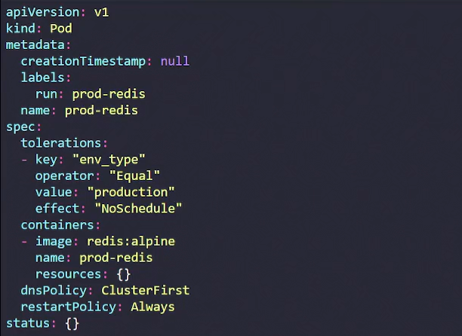

kubectl apply -f pod-redis.yaml

kubectl get pods

kubectl describe pods pod-redis

kubectl get pods -o wide

1. Create a pod called **hr-pod** in hr namespace belonging to the **production** **environment** and **frontend** **tier**. image: **redis:alpine**

Use appropriate labels and create all the required objects if it does not exist in the system already.

* **hr-pod** labeled with **environment production**?
* **hr-pod** labeled with **tier frontend**?

Solutions

1. kubectl run hr-pod --image=redis:alpine --labels=environment=productions,tier=frontend
2. kubectl get pods --show-labels
3. A kubeconfig file called **super.kubeconfig** has been created under **/root/CKA.** There is something wrong with the configuration. Troubleshoot and fix it

* Fix **/root/CKA/super.kubeconfig**

Solutions

1. kubectl get nodes
2. Cat .kube/config (To Check port)
3. Change the exact port 6443
4. We have created a new deployment called **nginx-deploy**. scale the deployment to **3 replicas**. Has the replica's increased? Troubleshoot the issue and fix it.

* deployment has **3 replicas**

Solutions

1. kubectl get deploy

kubectl scale deployment nginx-deploy --replicas=3

kubectl describe deploy nginx-deploy

kubectl get pods -n kube-system

vim /etc/kubernetes/manifests/kube-controller-manager.yaml

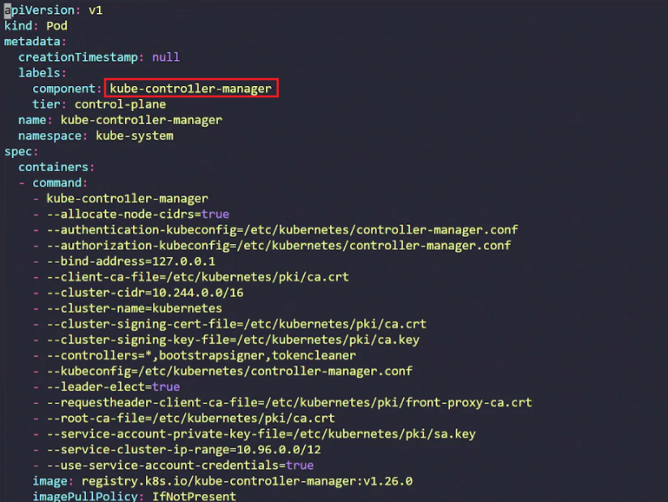

# CKA-QUESTIONS-HIGHSKY

1. Create new cluster role Named **deployment-clusterrole** which only allows to create the following resource type.

* Deployment
* StatefulSet
* DaemonSet

Create new service account named **cicd-token** in the existing namespace **app-team-1**

Bind the new ClusterRole **deployment-clusterrole** to the new ServiceAccount **cicd-token,** limited to the **namespace app-team1.**

Solutions

1. kubectl config use-context k8s
2. kubectl create clusterrole deployment-clusterrole --verb=create --resource=Deployment,StatefulSet,DaemonSet
3. kubectl create sa cicd-token -n app-team1
4. kubectl create clusterrolebinding deployment-clusterrole --clusterrole=deployment-clusterrole --serviceaccount=app-team1:cicd-token
5. kubectl auth can-i create pod -n app-team1 --as system:serviceaccount:app-team1:cicd-token

Set the node named **ek8s-node-0** as unavailable and reschedule all the pods running on it.

Solutions

1. kubectl config use-context ek8s@kubernetes
2. kubectl get nodes
3. kubectl drain --ignore-daemonsets ek8s-node-0
4. kubectl get nodes

Given an existing kubernetes cluster running **version 1.18.8**. upgrade all of the kubernetes control plane and node components on the master node only to **version 1.19.0.**

You are also expected to upgrade **kubelet**, and **kubectl**  on the **master node**.

Be sure to **drain** the **master node** before upgrading it and **uncordon** it after the upgrade. Do not upgrade the worker **noded**, **etcd**, the **container manager**, **the CNI plugin**, the **DNS service** or any **other addons**.

Solutions

1. kubectl config use-context mk8s
2. kubectl drain mk8s-master-o
3. ssh mk8s-master-0
4. sudo apt-get install kubeadm=1.19.0-00 kubelet=1.19.0-00 kubectl=1.19.0-00
5. sudo systemctl daemon-reload
6. sudo systemctl restart kubelet
7. exit

First create a snapshot of the existing **etcd** instance running at [**https://127.0.0.1:2379**](https://127.0.0.1:2379), saving the snapshot to **/srv/data/etcd-snapshot.db**

Creating a snapshot of the given instance is expected to complete in second. If the operations seems to hang, somethings likely, wrong with your command. Use **CTRL + C** to cancel the operation and try again

Next, restore an existing previous snapshot locat at /**data/backup/etcd-snapshot-previous.db**.

The following **TLS certificates/key** are supplied for connecting to the server with **etcdctl**:

* CA Certificate: **/opt/KUIN00601/ca.crt**
* Client Certificate: **/opt/KUIN00601/etcd-client.crt**
* Client Key: **/opt/KUIN00601/etcd-client.key**

Solutions

1. kubectl config use-context xn8s
2. ssh xn8s-node-0
3. cat /etc/kubernetes/manifests/etcd.yaml | grep file
4. ETCDCTL_API=3 etcdctl -h
5. ETCDCTL_API=3 etcdctl --endpoints=https://127.0.0.1:2379 --cacert=/opt/KUIN0061/ca.crt --cert=/opt/KUIN0061/etcd-client.crt --key=/opt/KUIN0061/etcd-client.key snapshot save /srv/data/etcd-snapshot.db
6. ETCDCTL_API=3 etcdctl --endpoints=https://127.0.0.1:2379 --cacert=/opt/KUIN0061/ca.crt --cert=/opt/KUIN0061/etcd-client.crt --key=/opt/KUIN0061/etcd-client.key --write-out=table snapshot status /srv/data/etcd-snapshot.db
7. ETCDCTL_API=3 etcdctl --endpoints=127.0.0.1:2379 snapshot restore --cacert/opt/KUIN00601/ca.crt --cert=/opt/KUIN00601/etcd-client.crt --key=/opt/KUIN00601/etcd-client.key --data-dir=/var/lib/etcd-backup /opt/etcd-backup.db
8. ETCDCTL_API=3 etcdctl snapshot restore --data-dir=/var/lib/etcd-backup2 /opt/etcd-backup.db

Create new **NetworkPolicy** named **allow-port-from-namespace** that allows **Pods** in the existing namespace **my-app** to connect to port **8080** of other **Pods** in the same **namespace**.

Ensure that the new **NetworkPolicy** :

* Does not allow access to **Pods not listening on port 8080**
* Does not allow access from **Pods not in namespace my-app**

Solutions

1. kubectl config use-context nk8s
2. vim netpolicy.yml

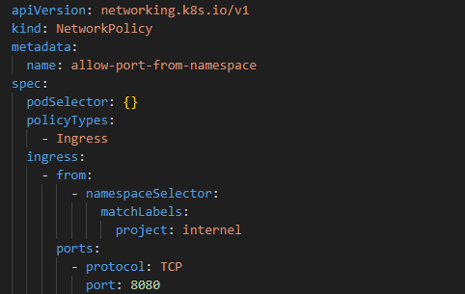

1. kubectl label ns internal project=internal
2. kubectl create -f netpolicy.yml -n my-app
3. kubectl get netpol -n my-app

Reconfigure the existing deployment **front-end** and add a port specification named **http** exposing **port 80/TCP** of the existing container **nginx.**

Create a **new service** named **front-end-svc** exposing the container port **http.**

Configure the new service to also **expose** the individual Pods via a **NodePort** on the nodes on which they are schedule.

Solutions

1. kubectl config use-context k8s
2. kubectl get deploy
3. kubectl get pod
4. kubectl edit deploy frontend

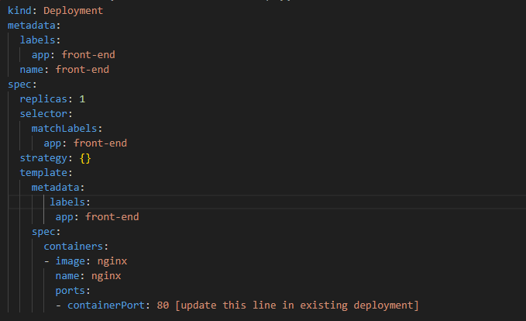

1. kubectl expose deploy front-end --type=NodePort --port=80 --name=front-end-svc
2. kubectl get service

Create new nginx Ingress resource as follows:

* Name: **ping**
* Namespace: **ing-internal**
* Exposing service **hello** on path **/hello** using service port **5678**
* The available service **hello** can be checked using the following command, which should return **hello**. Curl **internal IP**

Solutions

1. kubectl config use-context net8s
2. vim ingress.yml

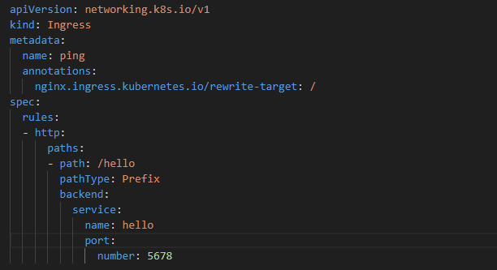

1. kubectl create -f ingress.yml -n ing-internal

Set Configuration context: **xt-k8s.**

* Scale the deployment webserver to **6 pods**.

Solutions

1. kubectl config use-context k8s
2. kubectl get deploy
3. kubectl scale deploy webserver --replicas=6
4. kubectl get pod

Set Configuration context: **xt-k8s.**

Schedule a pod as follows:

* Name: **nginx-kusc00401**
* Image: **nginx**
* Node Selector: **disk=spinning**

Solutions

1. kubectl config use-context k8s
2. vim pod.yml

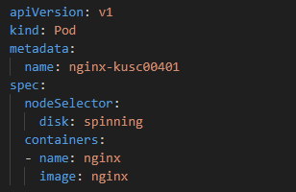

1. kubectl create -f nodeselect-pod.yml
2. kubectl get pods -o wide (Pod should be created on specific node as per labels)

Check see how many pods are ready (Not Including nodes tained NoSchedule) and write the number to **/opt/KUSC00401.txt**

Solutions

1. kubectl config use-context k8s
2. kubectl describe node | grep -i Taint or kubectl describe node | grep -A 5 Taint
3. echo 1 > /opt/KUSC00402/kusc00402.txt (Save file on the path)

Set Configuration context: **xt-k8s.**

* Create a pod name **kucc4** with a single app container for each of the following images running inside (there may be between **1** and **4** images specified): **nginx + redis**.

Solutions

1. kubectl run kucc4 --image=nginx --dry-run -o yaml > multi-container-pod.yml
2. vim multi-container-pod.yml

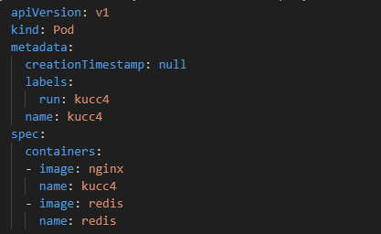

1. kubectl create -f multi-container-pod.yml

Set Configuration context: **xt-hk8s.**

* Create a persistant volume with name **app-config** of capacity **1Gi** and access mode **ReadWriteMany**. The type of **volume path** is **host path** is **/srv/app-config**.

Solutions

1. kubectl config use-context hk8s
2. vim pv.yml

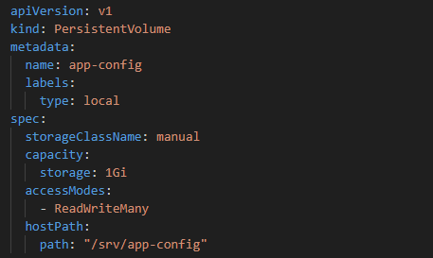

1. kubectl create -f pv.yml

Create new **PersistantVolumeClaim**:

* Name: **pv-volume**
* Class: **csi-hostpath-sc**
* Capacity: **10 Mi**

Create a new **Pod** which mount the **PersistantVolumeClaim** as volume.

* Name: **web-server**
* Image: **nginx**
* Mount Path: **/user/share/nginx/html**

Configure the new Pod to have **ReadWriteOnce** access on the volume.

Finally, using **kubectl** edit or **kubectl** patch expand the **PersistentVolumeClaim** to a capacity of **70Mi** and record that change.

Solutions

1. kubectl config use-context hk8s
2. vim pvc.yml

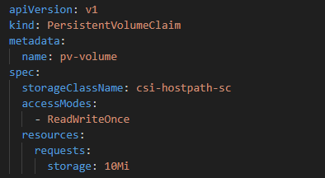

1. vim pod-pvc.yml

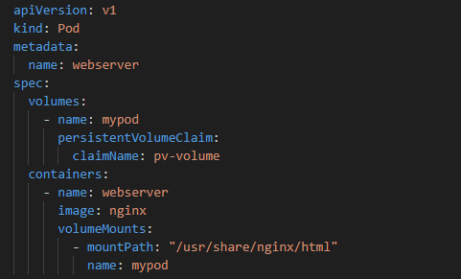

1. kubectl edit pvc pv-volume

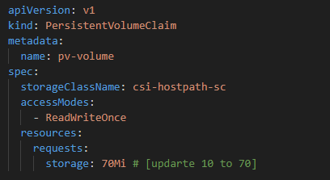

1. kubectl create -f pvc.yml
2. kubectl create -f pod-pvc.yml
3. kubectl get pv
4. kubectl get pod

Set Configuration context: **xt k8s.**

Monitor the logs of Pod **bar** and:

* Extract log lines corresponding to error

**Unable-to-access-website**

* Write them to **/opt/KUTR00101/bar**

Solutions

1. kubectl config use-context k8s
2. kubectl logs bar | grep unable-to-access-website > /opt/KUSSIN/bar

Without changing its existing containers, an existing Pod needs to be integrated into kubernetes built-in login architecture **(e.g kubelet logs)**. Adding a streaming **sidecar** container is a good and common way to accomplish this requirement.

* Add a **busybox sidecar** container to the existing Pod **legacy-app**. The new sidecar container has to run the following command:

/bin/sh -c tail -n+1 /var/log/legacy-app.log

* Use a volume mount named logs to make the file **/var/log/legacy-app.log** available to the sidecar container.
* Don’t modify the existing container, don’t modify the path of the log file, both container must access it at **/var/log/legacy-app.log**.

Solutions

1. kubectl config use-context wk8s
2. kubectl get pod
3. kubectl get pod big-corp-app -o yaml > sidecar.yml
4. kubectl delete pod big-corp-app
5. vim sidecar.yml

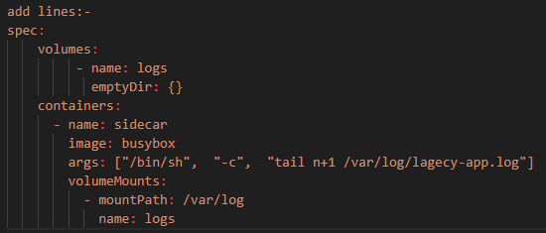

1. kubectl create -f sidecar.yml

Set Configuration context: **xt k8s.**

* From the pod label **name=cpu-loader**, find pods running high CPU workloads and write the name of the pod consuming most CPU to the file **/opt/KUTR00401.txt** (Which already exists).

Solutions

1. kubectl config use-context k8s
2. kubectl top pod -labels name=cpu-loader
3. echo "fdkfgjk-ofkg-node" > /opt/KUTR4001/KUTR401.xt

A kubernetes worker node, named **wk8s-node-0** is in state **NotReady.** Investigate why this is the case, and perform any appropriate steps to bring the node to a Ready state, ensuring that any changes are made permanent.

* You can SSH to the failed node using ssh wk8s-node-0

Solutions

1. kubectl config use-context wk8s
2. ssh wk8s-node-o
3. systemctl restart kubelet
4. systemctl enable kubelet

# CKA-QUESTIONS(YOUTUBE)

1. Join a node to the cluster

Solutions

1. kubeadm token create --print-join-command

Create **ReplicaSet** Name **appychip**, image:**nginx:1.18**, Replicaset:**4**

There is already a **pod** running in a **cluster**.

Make sure that the total count of pods running in the cli is not more than 4

Solutions

1. kubectl get replicasets
2. kubectl edit replicasets

Create **DaemonSet**

List all **persistent volumes** sorted by **capacity**, saving the full **kubectl output** to **/opt/pv/pv_list.txt**

Solutions

1. kubectl get pv --sort-by=.spec.capacity.storage -o wide > /opt/pv/pv_list.txt

Retrieve the logs from the pod name **‘webpod’,** search for any occurrences of the word **‘failed’** within those **logs** and then save those findings into a file located at **‘/opt/errorlogs.txt’**

Solutions

1. kubectl logs webpod | grep failed
2. kubectl logs webpod | grep failed > /opt/errorlogs.txt

Create a pod **“web-pod”** using image **“nginx”** with a **limit** of **0.5 CPU** and **200 Mi** **memory** and **resource request** of **0.1 CPU** and **100 Mi memory** in **“develop”** namespace.

1. Refer the documents and create the below yaml file.
2. vim pod-resource-limit.yaml

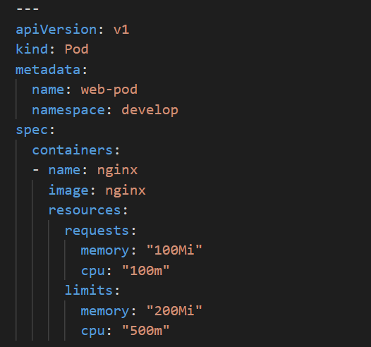

1. kubectl apply -f pod-resource-limit.yaml

You have access to **multiple clusters** from your main terminal through **kubectl contexts**. Write all those context those names into **/opt/course/1/contexts.**

Next write a command to display the current context into **/opt/course/1/context_default_kubectl.sh**, the command should use **kubectl**.

Finally write a second command doing the same thing into **/opt/course/1/context_default_no_kubectl.sh**, but **without the use of kubectl**.

Solutions

1. kubectl config get-contexts
2. kubectl config get-contexts > /opt/contexts
3. echo “kubectl config get-contexts” > /opt/context_default_kubectl.sh
4. sh /opt/context_default_kubectl.sh
5. cat ~/.kube/config | grep -i current-context | sed ‘s/current-context: //’
6. echo "cat ~/.kube/config | grep -i current-context | sed 's/current-context: //'" > /opt/context_default_no_kubectl.sh
7. sh /opt/ context_default_no_kubectl.sh

# CKA-QUESTIONS-KILLERSHELL

1. The metrics-server has been installed in the **cluster**. Your college would like to know the **kubectl** command to:

* Show **Nodes** resource usage
* Show **Pods** and their container resource usage

Please write the commands into **/opt/course/7/node.sh** and **/opt/course/7/pod.sh**

SSH into the master node with ssh **cluster-1master-1.** Check how the master components **kubelet**, **kube-apiserver, kube-scheduler, kube-controller-manager and etcd** are **started/installed** on the **master node.** Also find out the name of the **DNS** application and how it’s started/installed on the **master node.**

Write your finding into file **/opt/course/8/master-components.txt.** The file should be structure like:

kubelet: **[TYPE]**

kube-apiserver: **[TYPE]**

kube-scheduler: **[TYPE]**

kube-controller-manager: **[TYPE]**

etcd: **[TYPE]**

dns: **[TYPE] [NAME]**

Choices of **[TYPE]** are: **not-installed**, **process**, **static-pod, pod**

# COMMAND

kubectl get services --sort-by=.metadata.name

kubectl get pods --sort-by='.status.containerStatuses[0].restartCount'

kubectl get pv --sort-by=.spec.capacity.storage

kubectl get events --sort-by=.metadata.creationTimestamp

kubectl top pod POD_NAME --sort-by=cpu

kubectl api-resources | grep -i condigmap

kubectl api-resources | grep -i configmap

crictl ps

ps aux | grep -i kubelet

# CKA-QUESTIONS-KODE KLOUD (MOCK EXAM SERIES-1)

1. For this question, please set the context to cluster1 by running:

**kubectl config use-context cluster1**

Create a **pod** with name **tester-cka02-svcn** in **dev-cka02-svcn** namespace with image **registry.k8s.io/e2e-test-images/jessie-dnsutils:1.3**. Make sure to use command sleep 3600 with restart policy set to Always .  
  
Once the **tester-cka02-svcn** pod is running, store the output of the command nslookup **kubernetes.default** from tester pod into the file **/root/dns_output** on **student-node**.

* **'dev-cka02-svcn'** namespace exists?
* **'tester-cka02-svcn'** pod exists in **dev-cka02-svcn** namespace?
* correct image used?
* **Restart** policy set to "**Always**"?
* Command "**sleep 3600**" specified ?
* Correct dns output stored in **'/root/dns_output** ?

Solutions

1. kubectl config use-context cluster1
2. kubectl create ns dev-cka02-svcn
3. kubectl run tester-cka02-svcn --image registry.k8s.io/e2e-test-images/jessie-dnsutils:1.3 --command sleep 3600 --restart=Always -n dev-cka02-svcn
4. kubectl exec -it tester-cka02-svcn -n dev-cka02-svcn -- nslookup kubernetes.default
5. kubectl exec -it tester-cka02-svcn -n dev-cka02-svcn -- nslookup kubernetes.default > /root/dns_output
6. kubectl cat /root/dns_output
7. For this question, please set the context to cluster3 by running:

**kubectl config use-context cluster3**

Run a pod called **alpine-sleeper-cka15-arch** using the alpine image in the **default namespace** that will **sleep** for **7200 seconds**.

* alpine pod created?

Solutions

1. kubectl run alpine-sleeper-cka15-arch --image=nginx:alpine --command sleep 7200
2. For this question, please set the context to **cluster1** by running:

kubectl config use-context **cluster1**

We have created a **service account** called **green-sa-cka22-arch**, a cluster role called **green-role-cka22-arch** and a cluster role binding called **green-role-binding-cka22-arch**.  
  
Update the **permissions** of this **service account** so that it can only get all the **namespaces** in **cluster1**.

* service account permissions updated?

Solutions

1. kubectl describe clusterrole green-role-cka22-arch
2. kubectl describe clusterrolebinding green-role-binding-cka22-arch
3. kubectl edit clusterrole green-role-cka22-arch

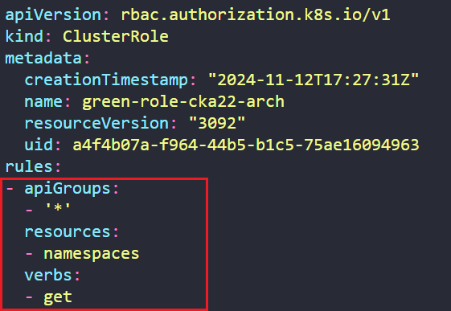

1. kubectl describe clusterrolebinding green-role-binding-cka22-arch

For this question, please set the context to cluster1 by running:

**kubectl config use-context cluster1**

There is a Cronjob called orange-cron-cka10-trb which is supposed to run every two minutes (i.e 13:02, 13:04, 13:06…14:02, 14:04…and so on). This cron targets the application running inside the orange-app-cka10-trb pod to make sure the app is accessible. The application has been exposed internally as a ClusterIP service.  
  
However, this cron is not running as per the expected schedule and is not running as intended.

Make the appropriate changes so that the cronjob runs as per the required schedule and it passes the accessibility checks every-time.

For this question, please set the context to cluster4 by running:

**kubectl config use-context cluster4**

The **pink-depl-cka14-trb** Deployment was **scaled** to **2 replicas** however, the current replicas is still **1**.

Troubleshoot and fix this issue. Make sure the **CURRENT** count is equal to the **DESIRED** count.  
  
You can **SSH** into the **cluster4** using ssh **cluster4-controlplane** command.

For this question, please set the context to cluster1 by running:

**kubectl config use-context cluster1**

A persistent volume called **papaya-pv-cka09-str** is already created with a **storage capacity** of **150Mi**. It's using the **papaya-stc-cka09-str** storage class with the path **/opt/papaya-stc-cka09-str**.  
  
Also, a **persistent volume claim** named **papaya-pvc-cka09-str** has also been created on this cluster. This **PVC** has requested **50Mi** of storage from **papaya-pv-cka09-str** volume.  
  
**Resize** the **PVC** to **80Mi** and make sure the **PVC** is in **Bound** state.

For this question, please set the context to **cluster3** by running:

**kubectl config use-context cluster3**

A pod called **logger-cka03-arch** has been created in the **default** namespace. Inspect this pod and save **ALL** **INFO** and **ERROR's** to the file **/root/logger-cka03-arch-all** on the **student-node**.

For this question, please set the context to cluster3 by running:

**kubectl config use-context cluster3**

Create a **ReplicaSet** with name **checker-cka10-svcn** in **ns-12345-svcn namespace** with image **registry.k8s.io/e2e-test-images/jessie-dnsutils:1.3**.  
  
Make sure to specify the below specs as well:

* command **sleep 3600**
* replicas set to **2**
* container name: **dns-image**

Once the checker pods are up and running, store the output of the command **nslookup** **kubernetes.default** from any one of the checker pod into the file **/root/dns-output-12345-cka10-svcn** on **student-node**.

* namespace **"ns-12345-svcn"** created ?
* replicaset **"checker"** created ?
* image **"registry.k8s.io/e2e-test-images/jessie-dnsutils:1.3"** used ?
* command: **"sleep 3600"** ?
* Replicas: **2**
* Container Name: **"dns-image"** ?
* Correct output stored in **"/root/dns-output-12345-cka10-svcn"** ?

For this question, please set the context to **cluster1** by running:

**kubectl config use-context cluster1**

Create a service account called **deploy-cka20-arch**. Further create a cluster role called **deploy-role-cka20-arch** with permissions to **get** the **deployments** in **cluster1**.  
  
Finally create a cluster role binding called **deploy-role-binding-cka20-arch** to bind **deploy-role-cka20-arch**cluster role with **deploy-cka20-arch** service account.

* Task completed?

For this question, please set the context to **cluster1** by running:

**kubectl config use-context cluster1**  
  
Create a nginx pod called **nginx-resolver-cka06-svcn** using image **nginx**, expose it internally with a service called **nginx-resolver-service-cka06-svcn**.  
  
Test that you are able to look up the service and pod names from within the cluster. Use the image: **busybox:1.28** for dns lookup. Record results in **/root/CKA/nginx.svc.cka06.svcn** and **/root/CKA/nginx.pod.cka06.svcn**

* Pod: **nginx-resolver-cka06-svcn** created
* Service **DNS Resolution** recorded correctly
* **"nginx-resolver-cka06-svcn"** pod exposed using **"nginx-resolver-service-cka06-svcn"** ?

For this question, please set the context to **cluster4** by running:

**kubectl config use-context cluster4**

We tried to schedule **grey-cka21-trb** pod on **cluster4** which was supposed to be deployed by the kubernetes scheduler so far but somehow its stuck in **Pending** state. Look into the issue and fix the same, make sure the pod is in **Running** state.

You can SSH into the cluster4 using ssh cluster4-controlplane command.

* Issues fixed?
* **grey-cka21-trb** POD is in running state?

For this question, please set the context to **cluster2** by running:

**kubectl config use-context cluster2**

The **yello-cka20-trb** pod is stuck in a **Pending** state. Fix this issue and get it to a **running** state. Recreate the pod if necessary.  
  
Do not **remove** any of the existing **taints** that are set on the cluster nodes.

* Node taints unchanged?
* pod is running?

For this question, please set the context to **cluster1** by running:

**kubectl config use-context cluster1**

In the **dev-wl07** namespace, one of the developers has performed a rolling update and upgraded the application to a newer version. But somehow, application pods are not being created.  
  
To get back the working state, **rollback** the application to the previous version .  
  
After rolling the deployment back, on the **controlplane** node, save the image currently in use to the **/root/rolling-back-record.tx**t file and increase the replica count to the **5**.

You can SSH into the **cluster1** using ssh **cluster1-controlplane** command.

* rolling back successful?
* image saved to the file?
* Replica set to **5**?

For this question, please set the context to **cluster1** by running:

**kubectl config use-context cluster1**

The **db-deployment-cka05-trb** deployment is having **0** out of **1** PODs ready.

Figure out the issues and fix the same but make sure that you do not remove any DB related environment variables from the **deployment/pod**.

* **DB deployment** is fixed?

For this question, please set the context to **cluster1** by running:

**kubectl config use-context cluster1**

Create a new deployment called **ocean-tv-wl09** in the default namespace using the image **kodekloud/webapp-color:v1**.  
Use the following specs for the deployment:

**1.**Replica count should be **3**.  
**2.**Set the **Max Unavailable to 40% and Max Surge to 55%.**  
**3.**Create the **deployment** and ensure all the **pods** are ready.  
**4.**After successful **deployment, upgrade the deployment** image to **kodekloud/webapp-**

**color:v2** and inspect the deployment rollout status.  
**5.**Check the rolling history of the deployment and on the **student-node**, save

the **current** revision count number to the **/opt/revision-count.txt** file.  
**6.**Finally, perform a rollback and revert back the deployment image to the older version.

* Deployment is running?
* **Replica set** to **3**?
* **maxSurge** set to **55%**?
* **maxUnavailable** set to **40%**?
* **Rolling back** successful?

For this question, please set the context to **cluster1** by running:

**kubectl config use-context cluster1**

There is a script located at **/root/pod-cka26-arch.sh** on the **student-node**. Update this script to add a command to **filter/display** the label with value **component** of the pod called **kube-apiserver-cluster1-controlplane** (on **cluster1**) using **jsonpath**.

* script updated?

For this question, please set the context to cluster3 by running:

kubectl config use-context cluster3

There is a deployment **nginx-deployment-cka04-svcn** in **cluster3** which is exposed using service **nginx-service-cka04-svcn**.  
  
Create an **ingress resource** **nginx-ingress-cka04-svcn** to load balance the incoming traffic with the following specifications:

* pathType: Prefix and path: /
* Backend Service Name: nginx-service-cka04-svcn
* Backend Service Port: **80**
* **ssl-redirect** is set to **false**

For this question, please set the context to **cluster1** by running:

**kubectl config use-context cluster1**

It appears that the **black-cka25-trb** deployment in **cluster1** isn't up to date. While listing the deployments, we are currently seeing **0** under the **UP-TO-DATE** section for this deployment. Troubleshoot, fix and make sure that this deployment is up to date.

For this question, please set the context to cluster1 by running:

**kubectl config use-context cluster1**

The **purple-app-cka27-trb** pod is an nginx based app on the container port **80**. This app is exposed within the cluster using a **ClusterIP** type service called **purple-svc-cka27-trb**.  
  
There is another pod called **purple-curl-cka27-trb** which continuously monitors the status of the app running within **purple-app-cka27-trb** pod by accessing the **purple-svc-cka27-trb** service using curl.  
  
Recently we started seeing some errors in the logs of the **purple-curl-cka27-trb** pod.

Dig into the logs to identify the issue and make sure it is resolved.  
  
**Note:** You will not be able to access this app directly from the **student-node** but you can **exec** into the **purple-app-cka27-trb** pod to check.

For this question, please set the context to cluster1 by running:

**kubectl config use-context cluster1**  
  
Create a storage class with the name **banana-sc-cka08-str** as per the properties given below:

* Provisioner should be **kubernetes.io/no-provisioner**.
* Volume binding mode should be **WaitForFirstConsumer**.
* Volume expansion should be **enabled**.