

Convert PowerPoint To Impress Presentation
Table of Contents
Introduction 1
Different Ways To Use This Tutorial 1
Convert PowerPoint to Impress Presentation 2

Introduction
This tutorial converts Microsoft PowerPoint Presentations to OpenOffice Impress Presentations.

When opening a PowerPoint presentation using OpenOffice, the slide transition settings do not always convert and are not applied. You will need to manually set the transition settings using Open Office Impress (Presentation).
Once you have set the transitions, you can save in MS PowerPoint format and the transitions will work for both PowerPoint and Open Office Presentations.

Different Ways To Use This Tutorial

- The quickest way to use this Step-By-Step tutorial is just to read it online.
- Print this tutorial.
- Read a step.
- Do a step.
- See what happens on the computer screen.

- If you already have a PowerPoint file, use that file with this tutorial. If you do not have a PowerPoint file, use the “Sample Presentation” file.

Convert PowerPoint to Impress Presentation
Activity | Explanation
- Open a PowerPoint file in Impress OR open the Sample Presentation file. Click File – Open and choose the file you want to open. | You should now be seeing the first slide of the presentation.
- Click Slide Show - Slide Show Settings | “Slide Show” window appears.
- Under Options, ensure that “Change slides manually” and “Change Slides by Clicking on background” are NOT checked. Click OK. | 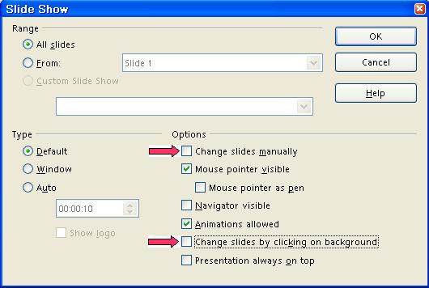
- Click Slide 1 tab | The first slide appears on the computer screen.  If using a projector, the first slide is seen
- Click Slide Show Under Tasks, click Slide Transition if it is not already available. | “Slide Transition” window opens.
- In the Advance slide box, click Automatically after. select how long this slide appears before the next slide will appear. | The Duration box is below the "Automatically after" button.  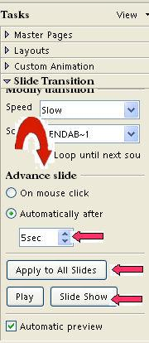  00:00:05 means 5 seconds.  02:00:00 means 2 hours.  Do this by clicking on the Duration box. Highlight the "sec" and type 00:00:05 OR  Click on the at the edge of the Duration box to enter a time.
- Click the Apply To All Slides button.
- Click File > Save As. In the Save in: " pull-down menu box, click My Documents (if it is not already selected). In the Save as type:" pull-down menu box, click OpenDocument Presentation (.odp) (if it is not already selected).
- In the File name: box, type Cats. .
- Click Save. | " Cats" is saved. The file, "Cats" is still on the screen.
- Click File > Close. | The file, " Cats", is no longer on the screen.

Notes

Tutorials are improved by input from users. We welcome your constructive criticism.
E-mail suggestions and comments to: contact@tutorialsforopenoffice.org
For other free tutorials go to: http://www.tutorialsforopenoffice.org

This work is licensed under a Creative Commons Attribution 3.0 License

