Python programming

***Author: Mehul Solanki Date: 03-Apr-2024 Version: 1.0***

Document History

|  |  |  |
| --- | --- | --- |
| *Author* | *Date* | *Comments* |
| Mehul Solanki | 03-Apr-2024 | This document will be used for learning purpose only. |

Table of Contents

1. OVERVIEW 4

2. INSTALLATION 4

2.1 Operating Systems 4

2.2 Create file and folder path 4

2.3 First Program 4

2.3.1 4

2.3.2 4

2.3.3 5

3. Python Characters Set 5

4. Variables 6

4.1.1 6

4.1.2 6

4.1.3 6

5. Data types 7

5.1.1 Data types. 7

5.1.2 Explain Data types. 7

5.1.3 Reserved Keywords 7

5.1.4 Comments 8

6. Operators 8

6.1 Types of operators 8

6.2 Arithmetic operators 9

6.3 Relational/ Comparison Operators 9

6.4 Logical operators 9

6.5 Type conversion 10

**Table of Figures**

Figure 1 - First Program Sample 4

Figure 2 - First Program sample with input and output. 4

Figure 3 - First program sample with different print statement. 5

Figure 4 - Python Character Set. 5

Figure 5 - Python Variables. 6

Figure 6 - Variable Example in programming. 6

Figure 7 - Rules for identifiers. 6

Figure 8 - Data types. 7

Figure 9 - Data types. 7

Figure 10 - Reserved Keyword. 7

Figure 11 - Comments in python. 8

Figure 12 - Types of Operators. 8

Figure 13 - Arithmetic Operators. 9

Figure 14 - Assignment operators. 9

Figure 15 - Logical operators. 9

# OVERVIEW

# INSTALLATION

## Operating Systems

## Create file and folder path

## First Program

### 

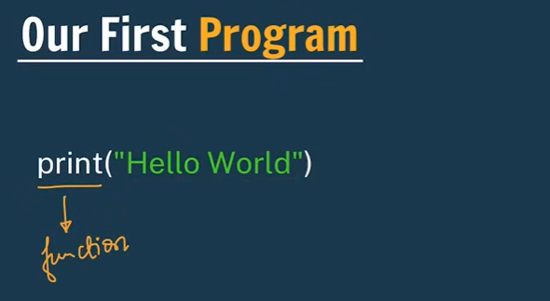

Figure 1 - First Program Sample

### 

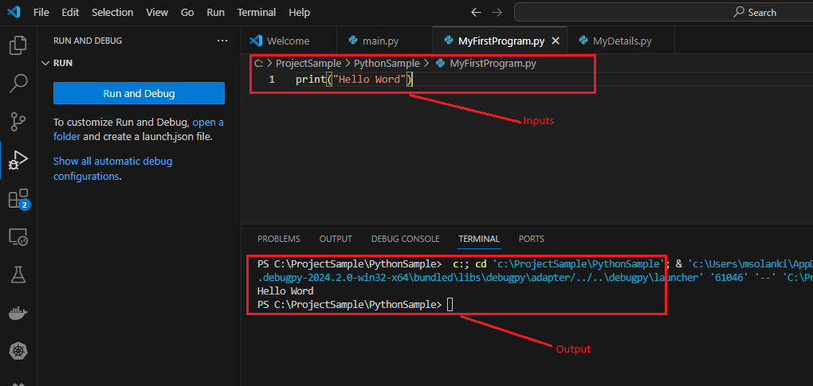

Figure 2 - First Program sample with input and output.

### 

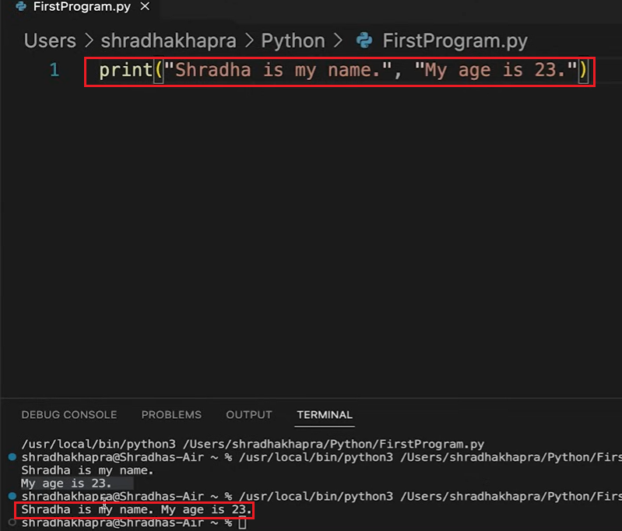

Figure 3 - First program sample with different print statement.

# Python Characters Set

Figure 4 - Python Character Set.

# Variables

### 

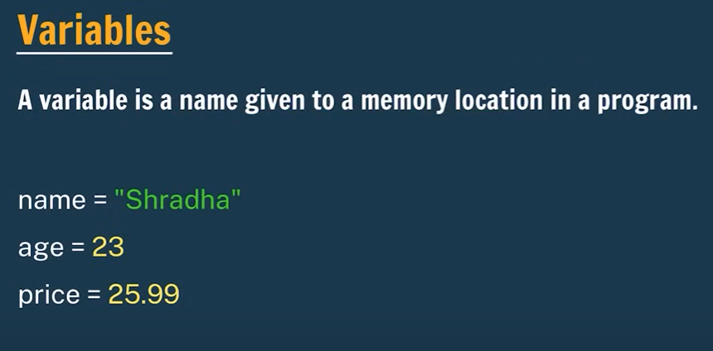

Figure 5 - Python Variables.

### 

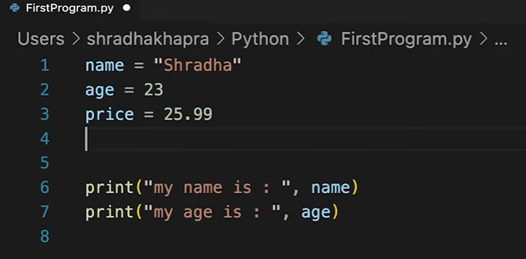

Figure 6 - Variable Example in programming.

### 

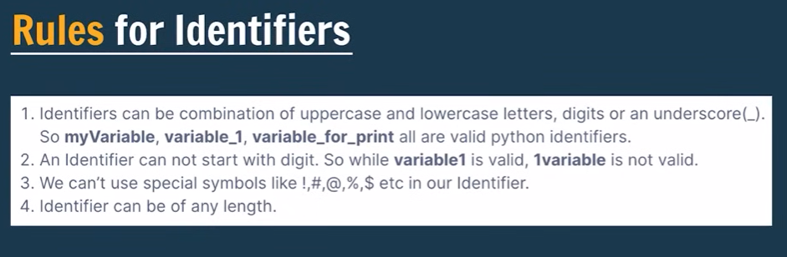

Figure 7 - Rules for identifiers.

# Data types

### Data types.

Figure 8 - Data types.

### Explain Data types.

Figure 9 - Data types.

### Reserved Keywords

Figure 10 - Reserved Keyword.

### Comments

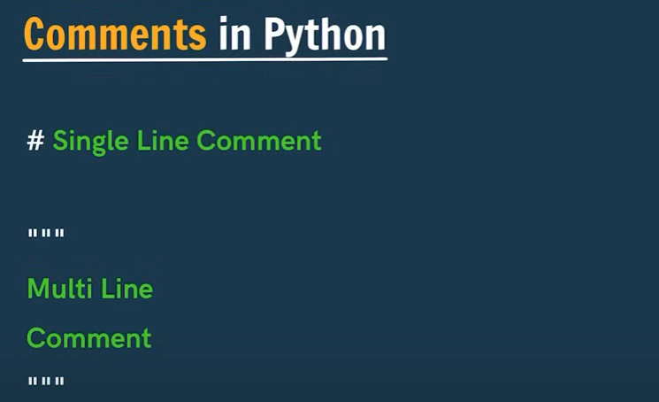

Figure 11 - Comments in python.

# Operators

## Types of operators

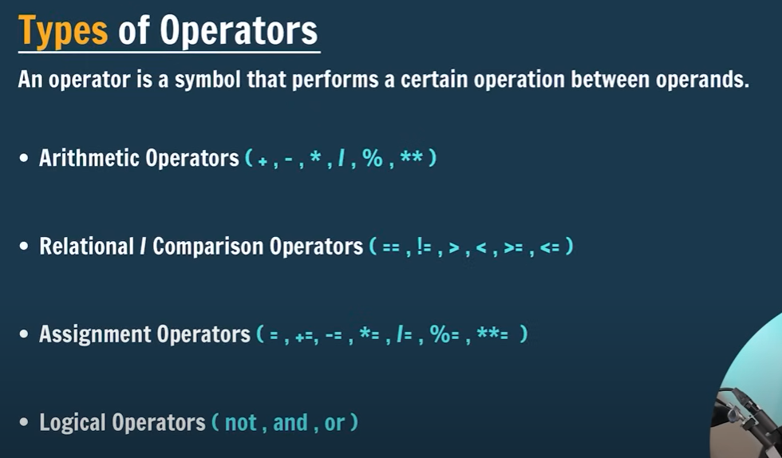

Figure 12 - Types of Operators.

## Arithmetic operators

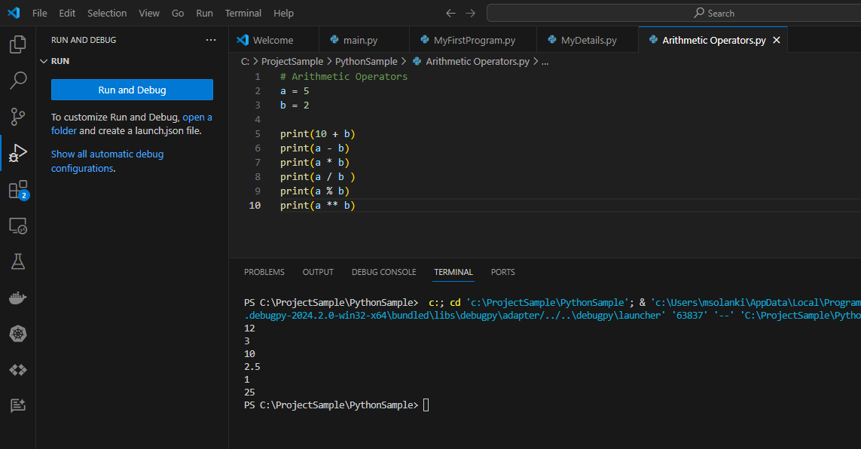

Figure 13 - Arithmetic Operators.

## Relational/ Comparison Operators

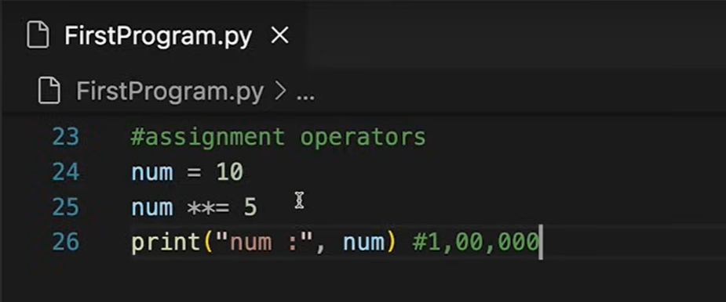

Figure 14 - Assignment operators.

## Logical operators

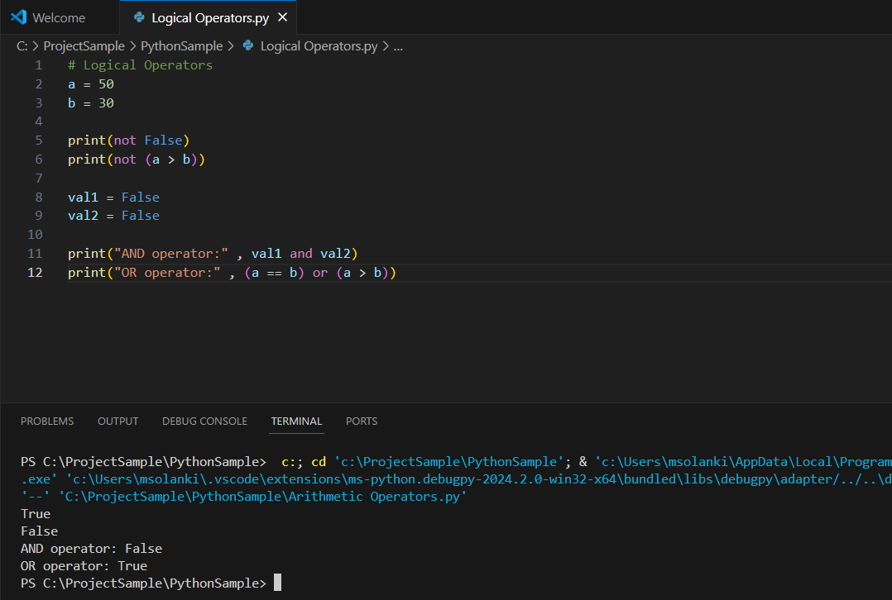

Figure 15 - Logical operators.

## Type conversion