R.B.INSTITUTE OF MANAGEMENT STUDIES (RBIMS)
Master of Computer Applications
Subject Code: MC03094021
Subject Name: Software Engineering

Unit -1 Introduction to Professional Software Development

What is professional software development?
Professional software development is the disciplined process of designing, developing, testing, deploying, and maintaining software systems by following engineering principles, industry standards, ethical practices, quality assurance processes, and collaborative development methods.
Unlike individual programming or academic coding, professional software development focuses on building reliable, secure, maintainable, scalable, and user-oriented software that meets business and customer requirements.
Professional software development is the application of software engineering principles, project management practices, quality standards, and ethical responsibilities to create software products that satisfy stakeholder needs and can be maintained throughout their lifecycle.

Simple understanding
Programming | Professional software development
Writing code | Developing complete software systems
Individual effort | Team collaboration
Limited testing | Systematic testing and quality assurance
Few standards | Industry standards and best practices
Short-term focus | Long-term maintenance and evolution
A professional software developer does not only write code; they also communicate with clients, understand requirements, design architecture, test software, document systems, ensure security, and maintain software after deployment.

Evolution of software development

Early era (1950s–1960s)
- Programs were small and simple.
- Developers worked individually.
- Documentation was minimal.
- Software failures became increasingly common.

Software crisis (1968)
As software systems became larger and more complex:
- Projects exceeded budgets.
- Delivery was delayed.
- Software contained many defects.
- Maintenance became difficult.
This led to the birth of software engineering as a professional discipline.

Modern era
Today software development includes:
- Agile development
- DevOps
- Cloud computing
- Artificial intelligence
- Cybersecurity
- Continuous integration and deployment
- Collaborative development platforms

Why professional software development is important
It helps organizations:
- Deliver high-quality software
- Reduce project failures
- Improve customer satisfaction
- Protect data and privacy
- Reduce maintenance costs
- Support business growth
- Ensure regulatory compliance

Characteristics of professional software development

Systematic process
Development follows a defined process rather than random coding.
Example: Requirements → Design → Coding → Testing → Deployment.

Team collaboration
Software is developed by teams including:

- Business analysts
- UI/UX designers
- Software developers
- Test engineers
- Security specialists
- Project managers

Documentation
Professional projects maintain documentation such as:
- Software Requirement Specification (SRS)
- Design documents
- API documentation
- User manuals
- Test reports
- Maintenance guides

Quality assurance
Software quality is verified through:

Code review
Code review is a systematic examination of source code by one or more developers to identify defects, improve code quality, ensure coding standards, and enhance maintainability before the code is integrated into the software system.

Unit testing
Unit testing is a software testing technique in which the smallest individual units or components of a program, such as functions, methods, or classes, are tested independently to verify that they perform as expected.

Integration testing
Integration testing is a testing process in which two or more software modules are combined and tested together to verify that they interact correctly and exchange data properly through their interfaces.

System testing
System testing is the process of testing the complete integrated software system as a whole to verify that it meets all specified functional and non-functional requirements in a production-like environment.

Acceptance testing
Acceptance testing is the final level of testing conducted by customers, end users, or business representatives to determine whether the software satisfies business requirements and is ready for deployment and use.

Security testing
Security testing is the process of evaluating a software system to identify vulnerabilities, threats, and risks, and to ensure the confidentiality, integrity, authentication, authorization, and availability of data and system resources.

Maintainability
Software should be easy to:
- Modify
- Upgrade
- Debug
- Extend
- Reuse

Ethical and legal responsibility
Professionals must:
- Protect user data
- Respect intellectual property
- Avoid plagiarism
- Ensure fairness and accessibility
- Follow laws and regulations

Goals of professional software development
- Correctness
- Security
- Reliability
- Maintainability
- Efficiency
- Scalability
- Usability
- Customer satisfaction
Software development lifecycle (SDLC)
Professional SDLC flow
Requirements Design Implementation
Maintenance Deployment Testing
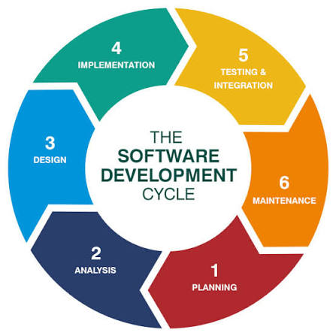

Requirement analysis
Activities:
- Understand customer needs.
- Identify functional requirements.
- Identify non-functional requirements.
- Prepare SRS document.
Example: An online banking system requires fund transfer, balance inquiry, and secure authentication.

System design
Design includes:
- Architecture
- Database
- User interface
- APIs
- Security mechanisms

Implementation (coding)
Developers write code using languages such as:
- Java
- Python
- C#
- JavaScript
- Go
- C++
Professional coding involves:
- Coding standards
- Version control
- Modular programming
- Error handling

Testing
Testing ensures the software works correctly.
Types:
- Unit testing
- Integration testing
- System testing
- Performance testing
- Security testing
- User acceptance testing

Deployment
Software is released to production.
Deployment may involve:
- Cloud servers
- Containers
- Mobile app stores
- Enterprise environments

Maintenance
Most software costs occur during maintenance.
Maintenance types:
- Corrective
- Adaptive
- Perfective
- Preventive

Professional software development workflow
- Client requirements
- Planning & estimation
- System design
- Coding with Git
- Code review
- Testing
- CI/CD deployment
- Monitoring & maintenance

Essential professional practices

Version control (Git)
Purpose:
- Track code changes.
- Collaborate with teams.
- Maintain history.
- Support branching and merging.
Platforms:
- GitHub
- GitLab
- Bitbucket

Code review
Senior developers review code for:
- Bugs
- Security issues
- Performance problems
- Readability
- Maintainability

Continuous integration (CI)
Code is automatically:
- Built
- Tested
- Validated
Tools:
- GitHub Actions
- Jenkins
- GitLab CI

Documentation
Documentation ensures:
- Knowledge sharing
- Easier maintenance
- Faster on boarding
- Regulatory compliance

Roles in a professional software team
Role | Responsibility
Business analyst | Gather requirements
Software architect | Design system architecture
Software developer | Implement features
QA engineer | Test software quality
DevOps engineer | Deployment and infrastructure
Project manager | Planning and coordination
UI/UX designer | User interface and experience
Security engineer | Security assessment

Professional standards
Common standards include:
- ISO/IEC 12207 – Software lifecycle processes
- ISO 9001 – Quality management
- IEEE software engineering standards
- CMMI (Capability Maturity Model Integration) – Process improvement
These standards improve:
- Quality
- Consistency
- Risk management
- Customer confidence

Challenges in professional software development
- Changing requirements
Customers often modify requirements during development.
- Tight deadlines
Market competition requires rapid delivery.
- Security threats
Software must resist cyber-attacks.
- Scalability
Applications must support growing users.
- Technical debt
Poor design decisions create future maintenance costs.
- Team coordination
Large projects require effective communication.
- Real-world example: online food delivery app
Professional development involves:

Requirements
- User registration
- Restaurant listing
- Order placement
- Online payment
- Delivery tracking

Design
- Mobile application
- Backend services
- Database
- Payment gateway
- GPS integration

Development
Multiple teams work simultaneously.

Testing
- Payment security
- Load testing
- GPS accuracy
- User interface testing

Deployment
Released through app stores and cloud servers.

Maintenance
- New features
- Bug fixes
- Security updates
- Performance optimization

Skills required for professional software developers

Technical skills
- Programming
- Data structures and algorithms
- Databases
- Web and mobile development
- Cloud computing
- Git
- Testing
- Security fundamentals

Professional skills
• Communication: The effective exchange of information and ideas.
• Teamwork: Working collaboratively with others to achieve shared objectives.
• Problem solving: Finding effective solutions to challenges or issues.
• Time management: Using time efficiently to accomplish tasks on schedule.
• Critical thinking: Evaluating information logically to make sound judgments.
• Adaptability: Adjusting successfully to change and new circumstances.
• Ethical decision making: Choosing actions that are morally and professionally appropriate.

Software engineering ethics
Software engineering ethics refers to the professional and moral obligations of software engineers to act honestly, responsibly, fairly, and in the public interest while developing and maintaining software systems.

Ethical responsibilities of a software engineer

Honesty
Engineers should not misrepresent software capabilities, project progress, or testing results.
Example: Reporting that software has passed security testing when it has not.

Confidentiality
Protect confidential information belonging to clients, employers, and users.
Example: Not sharing customer data with third parties.

Competence
Accept only work that matches one’s skills and experience.
Example: A developer unfamiliar with medical software regulations should seek training before working on a medical system.

Intellectual property
Respect copyrights, patents, licenses, and trade secrets.
Example: Using licensed software libraries legally.

Privacy protection
Collect only necessary data and protect personal information.
Example: Encrypting user passwords and financial data.

Security responsibility
Design software to resist cyber-attacks and vulnerabilities.
Example: Implementing secure authentication and regular security updates.

Case studies in software engineering ethics

Case study 1: Therac-25 radiation therapy machine

Background
Therac-25 was a computer-controlled radiation therapy machine used in hospitals during the 1980s.

Problem
Software defects caused patients to receive massive radiation overdoses.

Ethical issues
- Inadequate testing
- Poor software quality assurance
- Ignoring reported failures
- Lack of transparency

Consequences
- Several patients were seriously injured.
- Some deaths occurred.
- Public trust was damaged.

Ethical lesson
Software engineers must prioritize public safety over deadlines or cost.

Case study 2: Volkswagen emissions software

Background
Volkswagen installed software that detected emissions testing conditions.

Problem
The software reduced emissions only during tests, while actual road emissions were much higher.

Ethical issues
- Intentional deception
- Misrepresentation
- Environmental harm
- Violation of public trust

Consequences
- Billions of dollars in fines
- Criminal investigations
- Loss of reputation

Case study 3: Facebook and Cambridge Analytical

Background
Personal data of millions of Facebook users was accessed for political advertising.

Ethical issues
- Privacy violation
- Lack of informed consent
- Data misuse
- Insufficient data protection

Consequences
- Regulatory actions
- Public criticism
- Increased privacy regulations

Ethical lesson
User data must be collected transparently and used only with proper consent.

Case study 4: AI hiring algorithm bias

Background
An AI-based recruitment system favoured male candidates because it learned from biased historical hiring data.

Ethical issues
- Gender discrimination
- Unfair decision-making
- Lack of bias testing
- Insufficient oversight

Consequences
- Qualified candidates were rejected unfairly.
- The system had to be abandoned.

Ethical lesson
AI systems require fairness evaluation, bias detection, and human oversight.

Comparison of ethical and unethical behaviour
Ethical behaviour | Unethical behaviour
Protecting user data | Selling user data secretly
Reporting security vulnerabilities | Hiding security defects
Honest progress reporting | False project reports
Fair AI algorithms | Biased automated decisions
Proper software testing | Skipping testing to save time
Respecting licenses | Software piracy

Ethical challenges in modern software engineering

Artificial intelligence
- Bias
- Explain ability
- Accountability
- Human oversight

Big data
- Mass surveillance
- Data ownership
- Consent
- Profiling

Cybersecurity
- Responsible vulnerability disclosure
- Ethical hacking
- Ransom ware defense

Social media
- Misinformation
- Manipulation
- Addiction-oriented design

Software process models (software engineering)
A software process model is a structured framework that defines how software is developed, tested, deployed, and maintained. It specifies the sequence of activities, the flow of work, documentation requirements, and the responsibilities of team members throughout the Software Development Life Cycle (SDLC).

Definition
A software process model is a systematic approach used to plan, organize, execute, monitor, and control software development activities in order to produce high-quality software within the given time and budget constraints.

Major software process models

Waterfall model
The Waterfall model is a linear and sequential software development model. Each phase must be completed before the next phase begins.
- Requirements
- Design
- Implementation
- Testing
- Deployment
- Maintenance

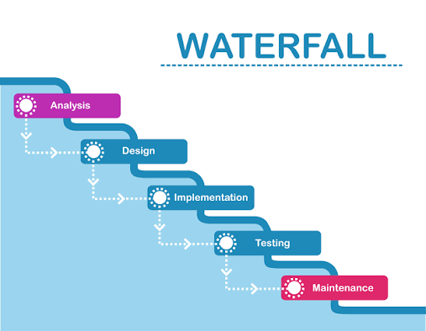

Characteristics
- Sequential phases.
- Extensive documentation.
- Minimal customer involvement after requirements.
- Difficult to accommodate changes.

Advantages
• Simple and easy to understand: A development process that follows a clear step-by-step sequence, making it easy for team members and stakeholders to understand and follow.
• Well-defined milestones: Clearly identified project stages or checkpoints that indicate the completion of a specific phase and help measure project progress.
• Good documentation: The practice of creating detailed and organized documents (such as requirements, design, and test reports) throughout the project for future reference, maintenance, and communication.
• Suitable for stable requirements: A process that is most effective when the project requirements are clearly defined at the beginning and are not expected to change significantly during development.

Disadvantages
• Inflexible to requirement changes: The Waterfall Model does not easily allow changes once a phase is completed, so modifying requirements during development is difficult and costly.
• Testing occurs late: Testing is performed only after the development phase is completed, which means defects are discovered at a later stage of the project.
• Higher risk if requirements are misunderstood: If the initial requirements are incorrect or misunderstood, the final software may not meet user needs, leading to significant rework and project failure risks.

Suitable for
- Government projects.
- Banking systems with fixed requirements.
- Small projects with clear specifications.

V-model (verification and validation model)
The V-model extends the Waterfall model by associating each development phase with a corresponding testing phase.
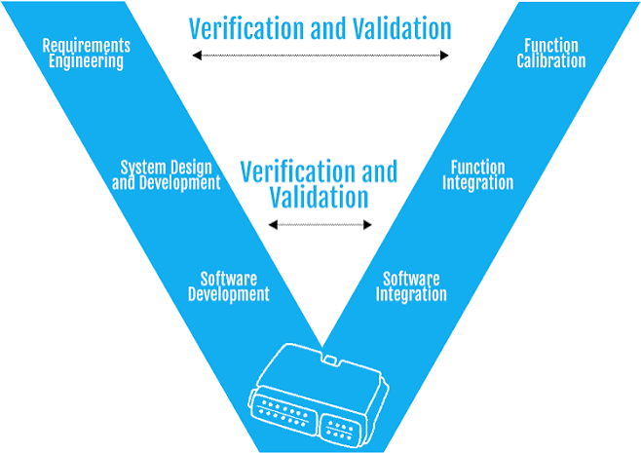
- Verification
- Requirements
- Acceptance testing
- System design
- System testing
- Architecture design
- Integration testing
- Module design
- Unit testing
- Coding

Key idea
Testing is planned from the beginning of development.

Advantages

Early test planning
Early test planning is the process of preparing testing activities, test cases, resources, and schedules at the beginning of software development so that defects can be identified as early as possible.

Better defect detection
Better defect detection means identifying and finding software errors and bugs more accurately and at an early stage, reducing the chances of defects remaining in the final product.

Improved software quality
Improved software quality refers to the development of software that is more reliable, efficient, secure, and meets user requirements by reducing defects and ensuring proper testing throughout the development process.

Disadvantages

Rigid structure
A rigid structure is a software development process with fixed phases and strict rules, where each phase must be completed before moving to the next phase, making changes difficult.

Difficult to handle changing requirements
Difficult to handle changing requirements means that the development process cannot easily accommodate new or modified customer requirements once development has started, resulting in delays, increased costs, and additional rework.

Suitable for
- Medical software.
- Aerospace systems.
- Safety-critical applications.

Incremental model
Software is developed and delivered in small increments (versions).
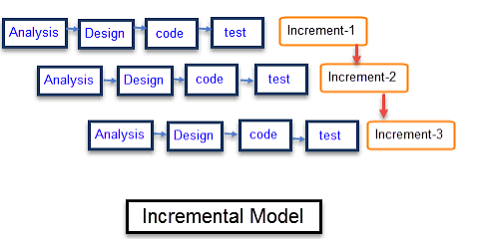
Increment 1
Requirements → Design → Code → Test
Increment 2
Additional features → Design → Code → Test
Increment 3
More features → Design → Code → Test
Each increment adds new functionality.

Example
An e-commerce website may be delivered as:
- Version 1: User registration.
- Version 2: Product catalog.
- Version 3: Shopping cart.
- Version 4: Payment system.

Advantages
- Early delivery.
- Customer feedback after each release.
- Reduced risk.
- Easier testing.

Disadvantages
- Requires good planning.
- Integration may become complex.

Suitable for
- Web applications.
- Business software.
- Products requiring early market release.

Iterative model
Software is developed through repeated cycles (iterations).
Each iteration improves the previous version.

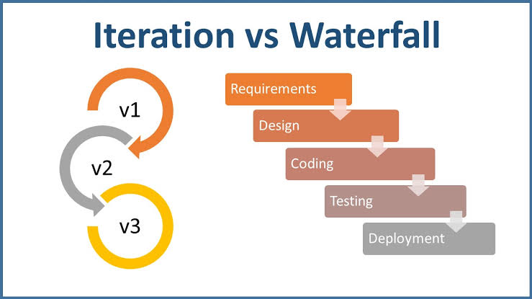

Iteration 1
Iteration 2
Iteration 3
Final system

Characteristics
- Continuous refinement.
- Regular customer feedback.
- Progressive enhancement.

Advantages
• Flexible: The ability of a software development process (especially Agile) to easily adapt to changing requirements, priorities, and customer feedback during development.
• Better understanding of requirements: Continuous interaction with customers and regular feedback help the development team understand user needs more accurately and clearly.
• Continuous improvement: The process of regularly evaluating work, identifying areas for improvement, and making changes to enhance product quality, team performance, and development practices.

Disadvantages
• More management effort: Agile projects require continuous planning, coordination, monitoring, communication, and decision-making, which increases the management workload.
• Scope may continuously expand: As new requirements and changes are added during development, the project scope can keep increasing, leading to longer timelines, higher costs, and additional work.

Suitable for
- Research projects.
- AI applications.
- User-interface-intensive systems.

Spiral model
The Spiral model combines iterative development with systematic risk analysis.
Each spiral represents one development cycle.
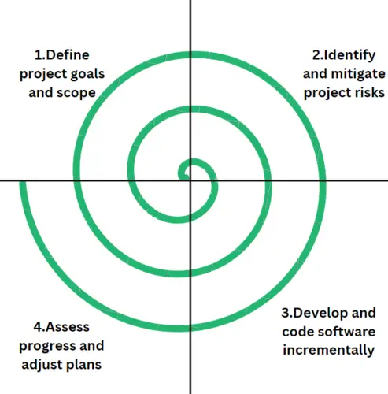

Planning
Planning is the first phase of the spiral cycle in which the project objectives, requirements, resources, schedule, and constraints are identified. The development team determines what needs to be developed and prepares a plan for the next iteration.

Risk analysis
Risk analysis is the phase where potential risks related to technology, cost, schedule, and requirements are identified and evaluated. Strategies are developed to reduce or eliminate these risks before development continues.

Engineering
Engineering is the phase in which the software is designed, coded, tested, and integrated. A working version or prototype of the software is developed during this stage.

Customer evaluation
Customer evaluation is the phase where the developed software or prototype is presented to the customer for review and feedback. The customer evaluates whether the software meets the requirements, and the feedback is used to plan improvements in the next spiral cycle.

Risk analysis is the main feature
Before implementation, risks are identified and evaluated.
Examples of risks:
- New technology.
- Budget constraints.
- Security issues.
- Performance limitations.

Advantages
• Excellent risk management: The model identifies, analyses, and reduces project risks at every stage of development, helping prevent major problems before they occur.
• Suitable for large projects: The model is appropriate for large and complex projects because it allows careful planning, risk assessment, and controlled development in multiple phases.
• supports changing requirements: The model can easily accommodate changes in customer requirements during development, making it flexible and adaptable to evolving project needs.

Disadvantages
• Expensive: The model requires a high budget because of repeated development cycles, risk analysis, testing, and management activities.
• Complex to manage: The model involves multiple phases, iterations, and continuous coordination, making project management more difficult than simpler models.
• Requires risk assessment expertise: The model needs experienced professionals who can identify, analyse, and manage risks effectively throughout the project lifecycle.

Suitable for
- Defense systems.
- Enterprise software.
- Large government projects.

Prototyping model
A prototype (working model) is developed before the final system.
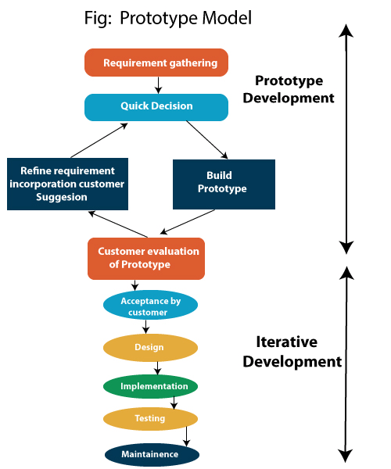
Requirements
Quick prototype
Customer feedback
Refinement
Final system

Types
- Throwaway prototype: discarded after understanding requirements.
- Evolutionary prototype: gradually evolves into the final product.

Advantages
• Clarifies requirements: The model helps in understanding and defining customer requirements more clearly before full development begins.
• Improves user satisfaction: Continuous user involvement and feedback ensure that the final software meets user needs and expectations, leading to higher satisfaction.
• Reduces misunderstanding: Regular communication and prototype evaluation minimize confusion between developers and users about system requirements and functionality.

Disadvantages
• Customers may think the prototype is the final product: Users may misunderstand the prototype as a complete and finished system, even though it is only a preliminary version created for feedback and requirement clarification.
• can increase development cost: Building, modifying, and improving prototypes may require additional time, effort, and resources, which can increase the overall cost of software development.

Suitable for
- User-interface design.
- Mobile applications.
- Customer-oriented software.

Agile process model
Agile is a flexible, iterative, and customer-focused software development approach.
Development occurs in short iterations called sprints (usually 1–4 weeks).
- Product backlog
- Sprint planning
- Development
- Testing
- Review
- Next sprint
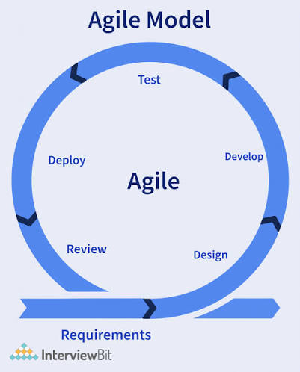

Agile principles
- Customer collaboration.
- Working software.
- Responding to change.
- Frequent delivery.
- Self-organizing teams.

Popular Agile methods
- Scrum.
- Extreme Programming (XP).
- Kanban.
- Lean.

Advantages
• Highly flexible: The model can easily adapt to changing requirements and customer needs during the development process.
• Fast delivery: Software is developed and delivered in small, frequent releases, allowing users to receive working features quickly.
• Continuous customer feedback: Customers regularly review the software and provide feedback, which is used to improve future iterations.
• Better product quality: Frequent testing, continuous improvement, and regular feedback help produce a more reliable and high-quality software product.

Disadvantages
• less documentation: Agile focuses more on working software than extensive documentation, so fewer documents are created compared to traditional models.
• requires experienced teams: Agile projects need skilled and experienced team members who can make quick decisions, collaborate effectively, and adapt to changes.
• Difficult for fixed-price contracts: Since requirements can change during development, it is difficult to estimate the exact cost and schedule in advance, making fixed-price contracts challenging.

Suitable for
- Startups.
- SaaS products.
- Web and mobile applications.

Comparison of software process models
Model | Flexibility | Risk handling | Customer involvement
Waterfall | Low | Low | Low
V-model | Low | Low | Medium
Incremental | Medium | Medium | High
Iterative | High | Medium | High
Spiral | High | Very high | High
Prototyping | High | Medium | Very high
Agile | Very high | High | Very high

How to choose the right process model
Selection depends on several factors:
- Requirement stability: stable → Waterfall or V-model; changing → Agile or Iterative.
- Project size: large and complex → Spiral; small and well-defined → Waterfall.
- Risk level: high risk → Spiral.
- Customer availability: continuous customer participation → Agile or Prototyping.
- Regulatory requirements: documentation-intensive industries → V-model or Waterfall.
- Time-to-market: rapid delivery → Agile or Incremental.

Software process activities
A software process is a structured set of activities required to develop, deliver, and maintain a software system.
Every software process, regardless of the model used (Waterfall, Agile, Spiral, etc.), includes four fundamental activities.

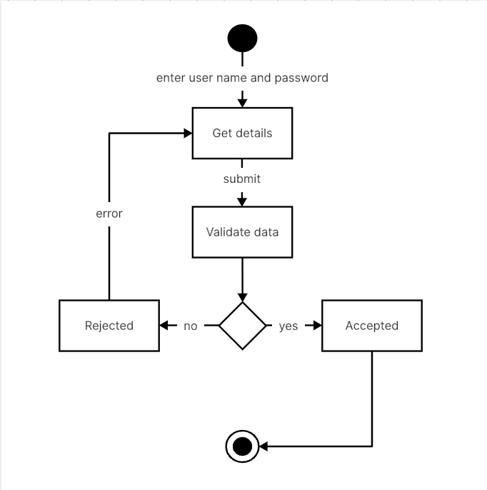
Specification
Development
Validation
Evolution

1. Software specification (requirements engineering)
This activity determines what the software should do.
The development team interacts with customers and stakeholders to understand requirements.
Main tasks
- Requirement elicitation
- Requirement analysis
- Requirement documentation
- Requirement validation
Example: An online shopping system must support user registration, product search, payment, and order tracking.
Output: Software Requirements Specification (SRS).

2. Software development (design and implementation)
This activity converts requirements into a working software system.
It includes:
- System architecture design
- Database design
- User interface design
- Coding
- Integration
Example:
- Frontend: React
- Backend: Java/Spring
- Database: MySQL
Output: Source code and executable software.

3. Software validation (testing)
Validation ensures that the software meets customer requirements.

Unit testing
Unit testing is the process of testing individual components or units of a software program, such as functions, methods, or classes, to verify that each unit works correctly in isolation.

Integration testing
Integration testing is the process of testing the interaction and data flow between two or more integrated software modules to ensure they work together correctly.

System testing
System testing is the process of testing the complete and integrated software system to verify that it meets the specified functional and non-functional requirements.

Acceptance testing
Acceptance testing is the process of testing the software by end users or customers to confirm that it satisfies business requirements and is ready for deployment or release.

Example: Verify that payment succeeds and inventory updates correctly.
Output: Test reports and defect logs.

4. Software evolution (maintenance)
After deployment, software must be modified because:
- Business requirements change
- Bugs are discovered
- Performance improvements are needed
- Security vulnerabilities appear
Maintenance types:
Type | Purpose
Corrective | Fix defects
Adaptive | Support new environments
Perfective | Improve features/performance
Preventive | Improve maintainability
Example: Adding UPI payment support to an e-commerce application.

Process activities diagram

Coping with change

Why change is unavoidable
Software projects operate in a dynamic environment.
Requirements may change because:
- Customer needs evolve
- Market competition changes
- Government regulations change
- Technology changes
- Users provide feedback
Example: A banking app initially supports only NEFT and RTGS. Customers later demand UPI and QR-code payments.

Problems caused by uncontrolled change
- Increased development cost
- Schedule delays
- Defects
- Customer dissatisfaction
- Reduced software quality
Therefore, software processes must be designed to cope with change.

Techniques for coping with change

1. Change anticipation
The process is designed expecting future changes.
Methods:
- Modular architecture
- Reusable components
- Configurable systems
- Scalable database design
Example: Designing a payment module that can easily add new payment gateways.

2. Change tolerance
The process allows changes during development with minimal disruption.
Agile methods are the best example.
Practices:
- Short iterations
- Frequent customer feedback
- Continuous integration
- Refactoring
Example: Scrum allows requirement changes between sprints.

Change management process
- Workflow
- Typical change management flow
- Change request submitted
- Impact analysis
- Approval / rejection
- Implementation
- Testing
- Release

Impact analysis
Before accepting a change, engineers analyze:
- Cost
- Time
- Risk
- Technical feasibility
- Effect on other modules
Example:
Adding biometric login may affect:
- Authentication module
- Mobile app
- Security testing
- Database

Refactoring
Refactoring improves internal code structure without changing external behaviour.
Example:
Before refactoring:
Java
if(type==1){...}
if(type==2){...}
if(type==3){...}
After refactoring:
Java
PaymentStrategy strategy = PaymentFactory.get(type);
strategy.pay();
Benefits:
- Easier maintenance
- Better readability
- Easier future changes

Process improvement

Definition
Process improvement is the systematic enhancement of software development processes to improve:
- Quality
- Productivity
- Cost efficiency
- Delivery speed
- Customer satisfaction
The objective is not only to improve software, but also to improve how software is developed.

Why process improvement is important
Poor processes lead to:
- Frequent defects
- Missed deadlines
- Cost overruns
- Communication problems
- Unpredictable project outcomes
Improved processes lead to:
- Better quality
- Faster delivery
- Lower maintenance cost
- Better teamwork

Process improvement cycle
PDCA (Plan–Do–Check–Act) cycle.
- Continuous process improvement
- Assess current process
- Identify weaknesses
- Plan improvements
- Implement changes
- Measure results
- Repeat continuously
This follows the PDCA (Plan–Do–Check–Act) cycle.

Steps in process improvement

1. Process measurement
Collect metrics such as:
- Defect density
- Development time
- Customer satisfaction
- Test coverage
- Productivity
Example:
- 20 defects per 1,000 lines of code

2. Process analysis
Identify root causes.
Techniques:
- Fishbone diagram
- Pareto analysis
- Root cause analysis
- Process mapping
Example:
Most defects originate during requirements analysis.

3. Process change
Possible improvements:
- Better requirement reviews
- Automated testing
- Coding standards
- CI/CD pipelines
- Developer training

4. Continuous monitoring
Measure whether the improvement actually worked.
Example:
Defects reduced from 20 to 8 per 1,000 LOC.

Process improvement frameworks

Capability maturity model integration (CMMI)
CMMI measures process maturity.
Level | Description
Initial | Chaotic process
Managed | Basic project management
Defined | Standard organizational process
Quantitatively managed | Metrics-driven process
Optimizing | Continuous improvement
Organizations aim to move toward Level 5.

ISO 9001
Focuses on quality management systems.
Emphasizes:
- Documentation
- Process control
- Continuous improvement
- Customer satisfaction

Lean process improvement
Lean software development eliminates waste.
Common wastes:
- Unnecessary documentation
- Waiting time
- Rework
- Excess features
- Manual repetitive tasks
Lean practices:
- Automation
- Small batch releases
- Fast feedback
- Continuous delivery

Example of process improvement

Before improvement
- Manual testing
- Monthly releases
- 100 defects per release

Improvement actions
- Automated unit tests
- CI/CD pipeline
- Code reviews
- Sprint-based development

After improvement
- Weekly releases
- 30 defects per release
- Faster deployment
- Higher customer satisfaction
Here is a comprehensive, accurate, and lecture-ready explanation of Agile methods, Agile development techniques, Agile project management, and scaling Agile methods based on widely accepted software engineering principles (aligned with the Agile Manifesto, Scrum Guide, Kanban principles, and modern Agile practices).

Agile software development

What is Agile?
Agile software development is an iterative and incremental approach to software engineering in which software is developed in small, usable increments, with continuous customer feedback, collaboration, and adaptation to changing requirements.
Traditional models (such as Waterfall) complete one phase before moving to the next. Agile allows frequent delivery, continuous improvement, and rapid response to change.

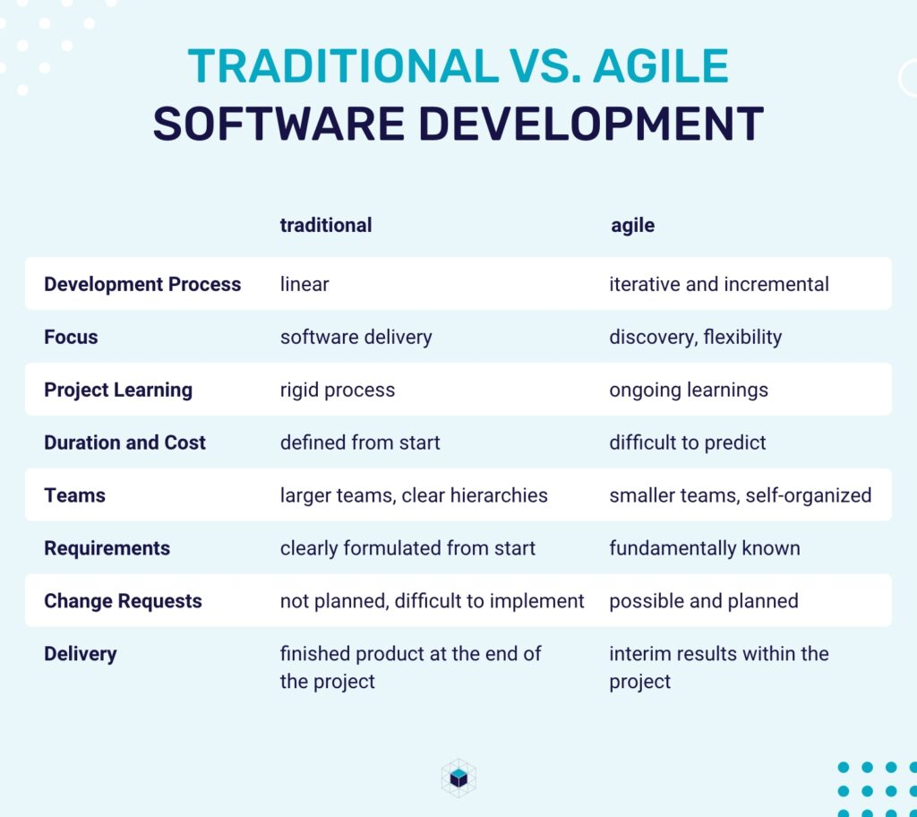

Agile manifesto (2001)
Agile is based on four core values:
- Individuals and interactions over processes and tools.
- Working software over comprehensive documentation.
- Customer collaboration over contract negotiation.
- Responding to change over following a plan.
These values do not eliminate planning or documentation; they emphasize that collaboration, working software, and adaptability create better outcomes.

Agile principles
The Agile Manifesto is supported by 12 principles, including:
- Early and continuous delivery of valuable software.
- Welcome changing requirements.
- Deliver working software frequently.
- Business people and developers work together daily.
- Build projects around motivated individuals.
- Face-to-face communication is most effective.
- Working software is the primary measure of progress.
- Maintain a sustainable development pace.
- Continuous attention to technical excellence.
- Simplicity.
- Self-organizing teams.
- Regular reflection and improvement.

Agile methods
Agile methods are specific frameworks or methodologies that implement Agile principles.

Major Agile methods

Scrum
The most widely used Agile framework.

Scrum roles
Role | Responsibility
Product owner | Manages product backlog and priorities
Scrum master | Facilitates Scrum process and removes obstacles
Developers | Build and deliver the product increment

Scrum events

- 1. Sprint
A Sprint is a short period of time in which the team works on a specific set of tasks.
  - Usually lasts 1–4 weeks.
  - The team tries to complete useful work by the end of the Sprint.
Example:
The team decides that during a 2-week Sprint, they will develop the login and registration features.

2. Sprint Planning
Sprint Planning happens at the beginning of the Sprint.
The team decides:
  - What work needs to be done?
  - Which tasks will be completed in this Sprint?
  - How will the team complete them?
Example:
The team selects:
  - Create login page
  - Create registration page
  - Connect login to database
  - Test login functionality

3. Daily Scrum
The Daily Scrum is a short meeting held every day, usually around 15 minutes.
Team members discuss:
  - What did I do yesterday?
  - What will I do today?
  - Is anything blocking my work?
Example:
“Yesterday I completed the login page. Today I'll connect it to the database. I have a problem with the database connection.”
The purpose is to keep everyone informed and identify problems quickly.

4. Sprint Review
The Sprint Review happens at the end of the Sprint.
The team shows stakeholders what they have completed and gets feedback.
Example:
The team demonstrates the new login and registration features to the customer.
The customer might say:
“The login works well, but we also need a ‘Forgot Password’ option.”
That feedback can be considered for future work.

5. Sprint Retrospective
The Sprint Retrospective happens after the Sprint Review.
Here, the team looks at how they worked, rather than just looking at the product.
They discuss:
  - What went well?
  - What went wrong?
  - What should we improve in the next Sprint?
Example:
Went well: Everyone completed their tasks on time.
Problem: Testing started too late.
Improvement: Start testing earlier in the next Sprint.

🔄 Simple flow
Sprint Planning
↓
Sprint starts
↓
Daily Scrum every day
↓
Sprint ends
↓
Sprint Review → Show the work
↓
Sprint Retrospective → Improve the way of working
↓
Next Sprint

Scrum artefacts

1. Product Backlog 📋
The Product Backlog is a big list of everything the product may need.
It contains:
- New features
- Improvements
- Bug fixes
- Technical work
Example:
For a shopping app, the Product Backlog might contain:
- User registration
- Login
- Search products
- Add to cart
- Online payment
- Order tracking
- Product reviews
👉 Think of it as the complete to-do list for the whole product.

2. Sprint Backlog 📝
The Sprint Backlog is the small list of work selected from the Product Backlog for one Sprint.
Suppose the team has a 2-week Sprint.
They choose:
- User registration
- Login
- Search products
These selected items become the Sprint Backlog.
👉 Think of it as: "What are we going to work on right now?"

3. Increment ✅
The Increment is the working product/features that are completed during the Sprint.
For example, at the end of the 2-week Sprint:
- Registration is completed ✅
- Login is completed ✅
- Search products is completed ✅
These completed and usable features together form the Increment.
👉 Think of it as: "What useful thing did we actually build?"

Kanban: A Kanban is a visual workflow management method used to organize work, improve efficiency, and limit tasks in progress. It originated in the manufacturing system developed by Toyota and is now widely used in software development, project management, and many other industries.
Kanban focuses on continuous flow of work.
Core practices:
- Visualize work
- Limit work in progress (WIP)
- Manage flow
- Make policies explicit
- Improve continuously
Example Kanban board:
- Kanban board
- To do
- Login page
- Search feature
- In progress (WIP: 2)
- Payment API
- Testing
- User profile
- Done

Extreme Programming (XP)
XP emphasizes engineering excellence.
Practices include:
- Pair programming
- Test-driven development (TDD)
- Continuous integration
- Refactoring
- Small releases
- Collective code ownership

Feature-driven development (FDD)
Development is organized around client-valued features.
Typical steps:
- Develop overall model.
- Build feature list.
- Plan by feature.
- Design by feature.
- Build by feature.

Lean software development
Based on lean manufacturing principles.
Principles:
- Eliminate waste.
- Build quality in.
- Deliver fast.
- Respect people.
- Optimize the whole system.

Agile development techniques
Agile development techniques are practical engineering practices used by Agile teams.

User stories
A user story captures a requirement from the user’s perspective.
Format:
As a customer, I want to track my order so that I know its delivery status.

Good user stories follow INVEST:
- Independent
- Negotiable
- Valuable
- Estimable
- Small
- Testable

Backlog refinement
The product backlog is continuously refined by:
- Splitting large stories
- Clarifying requirements
- Estimating effort
- Prioritizing features

Sprint planning
The team selects backlog items for the sprint.
Outputs:
- Sprint goal
- Sprint backlog
- Delivery plan

Daily stand-up
A 15-minute meeting where team members discuss:
- What did I complete yesterday?
- What will I do today?
- What obstacles am I facing?

Purpose:
- Improve coordination
- Detect blockers early
- Increase transparency

Pair programming
Two developers work together.
- Driver writes code.
- Navigator reviews continuously.

Benefits:
- Better code quality
- Knowledge sharing
- Reduced defects

Test-driven development (TDD)
Cycle:
- TDD cycle
- Write a failing test
- Write minimal code
- Run tests
- Refactor
Advantages:
- Higher reliability
- Better design
- Easier maintenance

Continuous integration (CI)
Developers frequently integrate code into a shared repository.
Automated pipeline:
- Build
- Unit tests
- Integration tests
- Code quality checks
Benefits:
- Early defect detection
- Reduced integration problems
- Faster feedback

Continuous delivery (CD)
Software is always in a deployable state.
CI + automated deployment enables:
- Faster releases
- Lower deployment risk
- Frequent customer delivery

Refactoring
Refactoring improves code structure without changing behavior.
Examples:
- Rename variables
- Extract methods
- Remove duplication
- Simplify complex logic

Benefits:
- Maintainability
- Readability
- Reduced technical debt

Agile project management
Agile project management applies Agile principles to planning, execution, monitoring, and delivery.

Agile project lifecycle
- Agile project lifecycle
- Vision and product roadmap
- Product backlog
- Sprint planning
- Sprint execution
- Review and retrospective
- Next sprint

Planning in Agile
Unlike Waterfall, Agile planning occurs at multiple levels.
Planning level | Description
Product vision | Long-term purpose
Roadmap | Major features over time
Release planning | Features for upcoming releases
Sprint planning | Work for current sprint
Daily planning | Team coordination

Estimation techniques

Story points
Measure relative effort, not time.
Common scale:
- 1
- 2
- 3
- 5
- 8
- 13
- 21

Planning poker
Team members estimate independently.
Process:
- Discuss story.
- Everyone selects a card.
- Reveal simultaneously.
- Discuss differences.
- Re-estimate.
This improves accuracy and shared understanding.

Velocity
Velocity = story points completed in a sprint.
Example:
Sprint | Completed story points
1 | 28
2 | 32
3 | 30
Average velocity = 30 points per sprint
Velocity helps forecast future delivery.

Burn down chart
Shows remaining work over time.
Sprint burndown concept
Remaining work
Start
End of sprint
The ideal line shows the planned burn; the actual line shows the team’s remaining work across the sprint.
If the actual line remains above the ideal line, the sprint may be delayed.

Agile risk management
Risks are managed through:
- Short iterations
- Frequent customer feedback
- Continuous testing
- Early integration
- Transparent progress tracking
This reduces uncertainty compared with long sequential projects.

Agile quality management
Quality is built into development through:
- Automated testing
- Code reviews
- TDD
- CI/CD
- Definition of Done
Definition of Done may include:
- Code completed
- Tests passed
- Documentation updated
- Product owner acceptance
- Deployment ready

Scaling Agile methods
When Agile is used across multiple teams and large organizations, coordination becomes difficult. Scaling Agile provides structures for large-scale development.

Why scale Agile?
Large organizations may have:
- Hundreds of developers
- Multiple products
- Shared components
- Regulatory requirements
- Distributed teams

Challenges:
- Team coordination
- Dependency management
- Architecture consistency
- Release synchronization

Scaling approaches

Scrum of Scrums (SoS)
Used when several Scrum teams work on the same product.
Each team sends a representative.
Discussion focuses on:
- Progress
- Dependencies
- Blockers
- Integration issues
Structure:
Scrum of Scrums
Team A
Team B
Team C
Scrum of Scrums meeting

SAFe (Scaled Agile Framework)
One of the most popular enterprise Agile frameworks.
Levels:
- Team
- Program
- Large Solution
- Portfolio
Key concept: Agile Release Train (ART)
An ART is a long-lived team of Agile teams delivering value together.
Features:
- PI (Program Increment) planning
- Shared objectives
- System demos
- Inspect and adapt workshops

LeSS (Large-Scale Scrum)
Extends Scrum with minimal additional roles and processes.
Characteristics:
- One product owner
- One product backlog
- Multiple Scrum teams
- Shared sprint
LeSS emphasizes simplicity and team autonomy.

Nexus
Created by Scrum.org.
Supports 3–9 Scrum teams.
Adds:
- Nexus integration team
- Cross-team refinement
- Integration-focused events

Main objective:
- Ensure a single integrated product increment each sprint.

Disciplined Agile (DA)
A flexible toolkit that combines:

Scrum
Definition: Scrum is an Agile framework used for developing, delivering, and maintaining complex products through short, time-boxed iterations called sprints, with continuous collaboration, feedback, and improvement.
Key idea: Work is completed in sprints (usually 1–4 weeks) by a cross-functional team.

Kanban
Definition: Kanban is an Agile workflow management method that visualizes work, limits work in progress (WIP), and improves the continuous flow of tasks through different stages of a process.
Key idea: Teams use a Kanban board with columns such as To Do, In Progress, and Done.

Lean
Definition: Lean is a management and software development approach that focuses on maximizing customer value while minimizing waste, improving efficiency, quality, and continuous improvement.
Key idea: Eliminate activities that do not add value to the customer.

DevOps
Definition: DevOps is a collaborative culture and set of practices that integrates software development (Dev) and IT operations (Ops) to automate and accelerate software development, testing, deployment, and maintenance.
Key idea: Faster and more reliable software delivery through automation and continuous integration/continuous deployment (CI/CD).

Agile Modelling
Definition: Agile Modelling (AM) is a practice-based methodology that emphasizes creating simple, effective, and lightweight models and documentation to support software development while adapting to changing requirements.
Useful for organizations with diverse project types.

Scaling challenges

Dependency management
Teams often depend on each other.
Solution:
- Shared planning
- Cross-functional teams
- Modular architecture

Architectural consistency
Independent teams may create incompatible designs.
Solution:
- Architecture guidelines
- Technical communities
- Shared engineering standards

Technical debt
Rapid development can accumulate poor-quality code.
Solutions:
- Refactoring
- Automated testing
- CI/CD
- Architecture reviews

Cultural resistance
Scaling Agile requires:
- Leadership support
- Team empowerment
- Continuous learning
- Organizational transparency

DevOps and agile scaling
Modern scaling increasingly integrates DevOps.
Agile focuses on developing software.
DevOps extends Agile into deployment and operations.

Pipeline:
- Agile + DevOps flow
- Plan
- Code
- Build
- Test
- Deploy
- Monitor

Benefits:
- Faster releases
- Better reliability
- Automated deployment
- Continuous feedback

Advantages of Agile
- Faster delivery
- Better customer satisfaction
- Higher software quality
- Improved team collaboration
- Early risk detection
- Flexibility to change
- Continuous improvement
- Greater transparency

Limitations of Agile
- Requires active customer involvement
- Difficult for fixed-scope contracts
- Scaling can be complex
- Documentation may become insufficient
- Team maturity is essential
- Estimation uncertainty
- Not ideal for some safety-critical systems

Agile Process Practical

Project Charter

Project name | Online Job Portal
Guide
Project’s expected start date | 21/12/2024
Project’s  expected end date | 28/4/2025
Project scope | - Provide users with a platform to search and apply for jobs online.  - Streamline the recruitment process for employers and job seekers.  - Improve communication between employers, candidates, and administrators.
Project mission | Our mission is to create an accessible online platform that connects job seekers with employers, simplifying the job application process, making hiring more efficient, and providing easy access to opportunities.
Project vision | Our vision is to empower both job seekers and employers by providing a dynamic, user-friendly online portal that enhances the recruitment experience, reduces time-to-hire, and fosters a transparent and engaging job search process.

