R.B.INSTITUTE OF MANAGEMENT STUDIES (RBIMS)
Master of Computer Applications
Subject Code: MC03094021
Subject Name: Software Engineering

Unit 4 - Software testing

Software Testing is the process of checking and evaluating a software application to ensure it works correctly, meets requirements, and is free from defects (bugs). Its goal is to improve software quality, reliability, security, and performance before the software is released to users.

Objectives of Software Testing
- Find defects and errors.
- Verify that the software meets the specified requirements.
- Ensure the software performs as expected.
- Improve the quality and reliability of the application.
- Reduce the risk of failures after deployment.

Types of Software Testing
- Manual Testing – Testers execute test cases manually without automation tools.
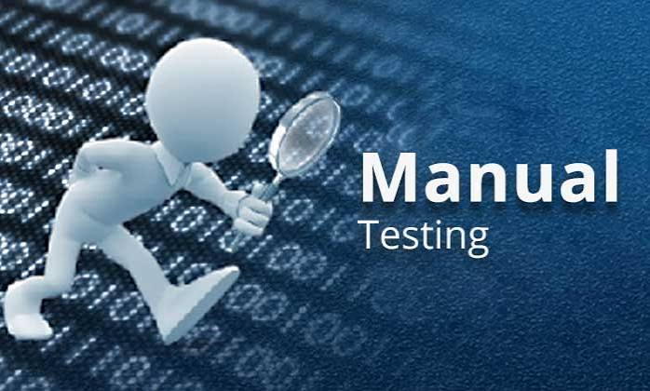
- Automation Testing – Test cases are executed using tools such as Selenium, Cypress, or Playwright.

Levels of Testing
- Unit Testing: Tests individual functions or components.
- Integration Testing: Verifies that different modules work together correctly.
- System Testing: Tests the complete application as a whole.
- Acceptance Testing (UAT): Confirms the software meets user and business requirements.

Common Testing Methods
- Black Box Testing: Tests functionality without knowing the internal code.
- White Box Testing: Tests the internal code, logic, and structure.
- Gray Box Testing: Combines aspects of both black-box and white-box testing.

Importance of Software Testing
- Improves software quality.
- Detects bugs early, reducing development costs.
- Increases customer satisfaction.
- Enhances security and performance.
- Ensures the software is reliable and stable.

Example
Suppose you are testing a login page:
- Check that valid username and password allow login.
- Verify that invalid credentials show an error message.
- Ensure empty fields display validation messages.
- Test whether the system remains secure against unauthorized access.

Development Testing

Development testing is the testing performed by developers while they are creating software. Its main purpose is to find and fix bugs early, before the software is given to testers or released to customers.

Main types
- Unit Testing
  - Tests individual functions, methods, or components.
  - Example: Checking whether a calculateTotal() function gives the correct result.
- Integration Testing
  - Tests whether different modules work correctly together.
  - Example: Checking whether the login module correctly communicates with the database.
- Component Testing
  - Tests a complete component or module independently.
  - Example: Testing the payment component separately from the rest of the application.

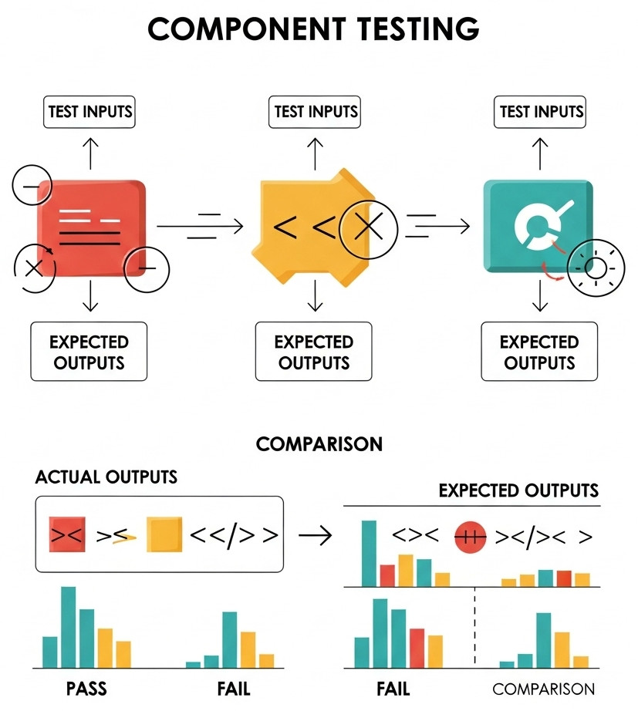
- Developer Debugging
  - When a test fails, the developer identifies the cause of the problem and fixes the code.

Simple example
Imagine a developer creates a login system:
- Developer writes the login code.
- Unit tests check username/password validation.
- Integration tests check the connection between login code and database.
- Bugs are found and corrected.
- The completed software is then passed to the testing/QA team.

Test-Driven Development (TDD)
Test-Driven Development (TDD) is a software development approach where tests are written before the actual code.
The developer first decides what the software should do, writes a test for that requirement, and then writes the minimum code needed to pass the test.

TDD Cycle
TDD follows three main steps:

1. Red 🔴 – Write a test
- Write a test for a new feature.
- The test initially fails because the feature has not been implemented.
2. Green 🟢 – Write the code
- Write the simplest code necessary to make the test pass.
3. Refactor 🔵 – Improve the code
- Clean up and improve the code without changing its behavior.
- Run the tests again to make sure everything still works.
So the cycle is:
Red → Green → Refactor → Repeat

Example
Suppose you want to create a function that adds two numbers.
First, write the test:

Function add (a, b){
Return a+b;

Test: add(2, 3) should return 5

The test fails because the add() function doesn't exist yet.

Then write the code:
add(2, 3) → 5
The test passes.
Finally, improve the code if necessary while keeping the test passing.

Advantages of TDD
- Finds bugs early
since the code is tested continuously, errors can be discovered while developing instead of after the whole project is finished.
Example: If a calculator function gives the wrong answer, the test immediately shows the problem.
- Improves code quality
Developers write small, focused pieces of code that are easier to test. This usually leads to simpler and better-organized programs.
- Makes requirements clearer
before coding, developers must think about what the software should do and create tests for those requirements.
Example: A requirement says, "A user should not be allowed to log in with an incorrect password." A test can clearly define this behavior.
- Makes code easier to maintain
TDD creates a collection of automated tests. When developers change the code later, these tests help them check that existing features still work.
- Helps developers safely modify existing code
Developers can make changes or add new features with more confidence because the existing tests can detect if something has been broken.
- Provides automated tests for future changes
The tests remain available after development. Whenever the software is updated, they can be run again automatically to check for problems.

Disadvantages of TDD
- Requires more time initially
Developers have to write tests before writing the actual code. This can make the beginning of development seem slower. However, it can save time later by reducing debugging.
- Can be difficult for beginners
New developers may find it challenging to understand what tests to write before they know how the code will be implemented.
- Poorly designed tests can make development harder
If tests are too complicated, too specific, or poorly written, developers may have difficulty changing the code without breaking the tests.
- Not every type of testing is suitable for TDD
TDD is mainly useful for testing individual pieces of code, such as functions and classes. Other testing—such as UI testing, performance testing, security testing, and usability testing—may require different approaches.

1. Release Testing
Release testing is testing the software before it is released to customers or the public.
Purpose:
To make sure the software is stable, works correctly, and is ready for release.
Example:
Suppose a company develops a banking app. Before releasing a new version, testers check:
- Login and logout
- Money transfer
- Balance display
- Notifications
- Security
- Performance
- Whether old features still work
If major problems are found, the release may be delayed.
In simple words:
👉 Release Testing = “Is the software ready to release?”

2. User Testing
User testing involves real or representative users using the software to see whether it meets their needs and is easy to use.
Purpose:
To find out whether users can actually use the system effectively and whether it satisfies their expectations.
Example:
Before launching an online shopping website, the company asks several users to:
- Search for a product.
- Add it to the cart.
- Apply a coupon.
- Complete a purchase.
The users may report things like:
- “The checkout button is difficult to find.”
- “The search is confusing.”
- “I don't understand this error message.”
The development team can then improve the product.
In simple words:
👉 User Testing = “Can users use the software successfully and comfortably?”

Key Difference

Release Testing | User Testing
Done before release | Done with real/representative users
Focuses on software quality | Focuses on user needs and experience
Usually performed by testers/QA | Performed by users or selected customers
Finds bugs and failures | Finds usability and requirement problems
Question: “Is it ready?” | Question: “Does it work well for users?”

Reliability Engineering:
Reliability Engineering is a branch of engineering concerned with ensuring that a system, product, or component performs its required function correctly and continuously for a specified period under specified conditions.

Example
Suppose a server is designed to operate continuously for 1 year.
If the server operates successfully for the entire year without an unexpected failure, it demonstrates high reliability.

There are four important elements in this definition:
- Probability – Reliability is expressed as a probability between 0 and 1.
- Intended function – The system must perform the function for which it was designed.
- Specified time – Reliability is measured over a particular period.
- Specified conditions – Temperature, load, environment, usage, etc., may affect reliability.

Example
If a machine has a reliability of 0.95 for 1000 hours, it means there is a 95% probability that the machine will operate successfully for 1000 hours under the specified conditions.

3. Objectives of Reliability Engineering
The major objectives are:

1. Prevent failures
Identify and eliminate potential causes of failure before they occur.

2. Improve product quality
Design systems that consistently meet their required performance.

3. Increase availability
Ensure that systems are operational when users need them.

4. Reduce maintenance cost
Minimize repair, replacement, and maintenance expenses.

5. Increase safety
Reduce failures that could cause accidents or damage.

6. Extend useful life
Design products and systems that remain functional for their expected lifetime.

7. Improve customer satisfaction
Reliable products require fewer repairs and provide consistent performance.

4. Reliability vs. Quality
Quality | Reliability
Mainly concerns conformance to requirements | Concerns continued successful operation
Often evaluated at or soon after production | Evaluated over time
Focuses on defects and specifications | Focuses on failures over time
Example: Product has no manufacturing defect | Example: Product continues working for 5 years

Failure
A failure occurs when a system or component is unable to perform its required function according to specified requirements.

Examples
- A hard disk stops reading data.
- A network router stops forwarding packets.
- A car engine stops operating.
- A power supply stops providing required voltage.
- A software application crashes.
- A sensor provides incorrect measurements.
Failure can be caused by:
- Component defects
- Design errors
- Manufacturing defects
- Environmental conditions
- Excessive stress
- Aging
- Poor maintenance
- Human errors
- Software defects
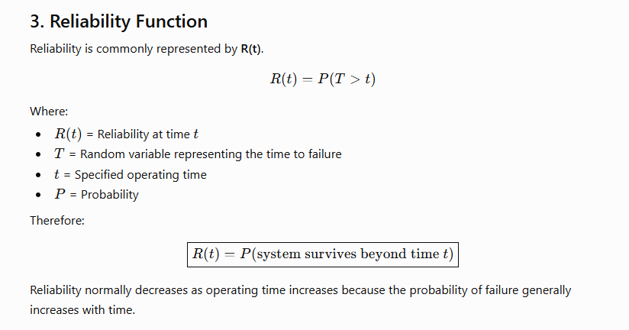

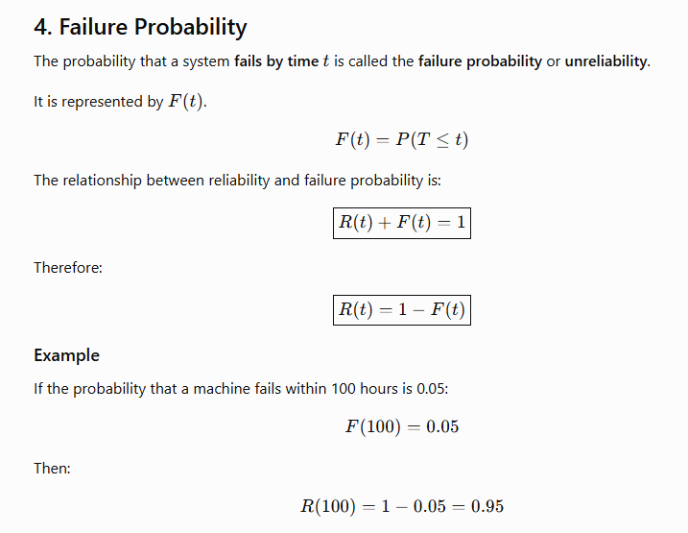

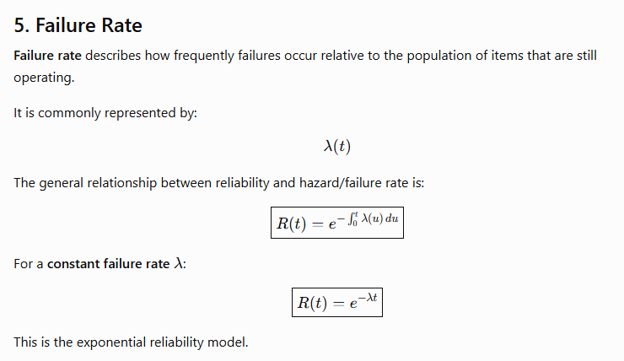

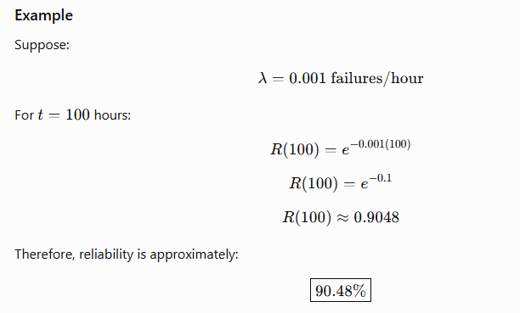.

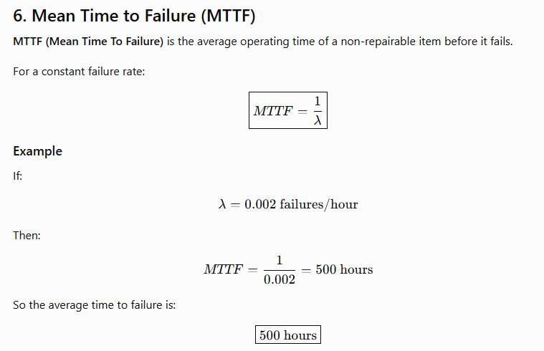

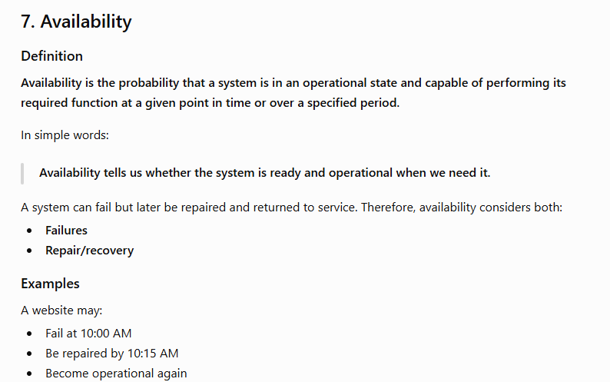

  - Reliability vs Availability
Reliability | Availability
Measures failure-free operation | Measures operational readiness
Focuses mainly on failures | Considers failures and restoration
Concerned with continuous operation without failure | Concerned with being operational when required
Repair does not restore the reliability of the completed mission | Repair can restore availability
Often expressed as R(t)R(t) | Often expressed as A(t)A(t)
Important for non-repairable and mission-critical systems | Especially important for repairable systems

Factors Affecting Reliability
Reliability can be affected by:

Hardware factors
- Component quality
- Manufacturing defects
- Component aging
- Temperature
- Vibration
- Electrical stress

Software factors
- Programming errors
- Design defects
- Configuration errors
- Unexpected inputs
- Integration problems

Environmental factors
- Temperature
- Humidity
- Dust
- Radiation
- Vibration
- Power fluctuations

Human factors
- Incorrect operation
- Improper maintenance
- Installation errors
- Configuration mistakes

Factors Affecting Availability
Availability is affected by:
- Failure frequency
- Failure severity
- Repair time
- Maintenance efficiency
- Availability of spare parts
- Availability of trained technicians
- Diagnostic capability
- Redundancy
- Preventive maintenance
- Logistics and support delays

Methods to Improve Reliability
Reliability can be improved through:
- High-quality components
- Good system architecture
- Proper testing
- Fault-tolerant design
- Preventive maintenance
- Environmental protection
- Quality control
- Failure analysis
- Redundancy
- Continuous monitoring

Methods to Improve Availability
Availability can be improved by:

1. Increasing reliability
Reduce the frequency of failures.

2. Reducing repair time
Improve maintenance procedures and diagnostics.

3. Using redundancy
Provide backup components or systems.

4. Predictive maintenance
Detect potential failures before they cause downtime.

5. Keeping spare parts
Ensure required replacement components are available.

6. Improving fault diagnosis
Quickly identify the cause of failure.

7. Automation
Automate recovery and failover processes where appropriate.

Key Difference in One Example
Imagine a car.

Car A
Runs for 10,000 km without failure but takes 3 days to repair when it fails.
→ High reliability, but repair downtime can reduce availability.

Car B
Fails more frequently but can be repaired in 30 minutes.
→ Lower reliability, but potentially high availability.

Fault-Tolerant Architectures
Fault-tolerant architecture is a system design approach in which a computer system, software application, or network is designed to continue operating correctly even when one or more components fail.
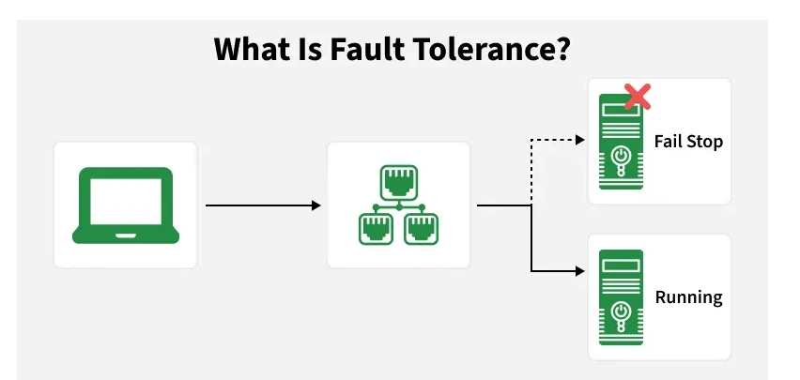

1. Basic Idea
In a normal system:
Component Failure → System Failure
In a fault-tolerant system:
Component Failure → Backup/Alternative Component Takes Over → System Continues
For example, if a server fails, another server can immediately take over its workload.

2. Main Characteristics

a. Redundancy
Extra components are provided so that another component can take over when the primary component fails.
Examples:
- Two or more servers
- Duplicate power supplies
- Multiple network connections
- Backup databases

b. Failure Detection
The system continuously monitors components to detect failures.
Examples:
- Heartbeat signals
- Health checks
- Monitoring systems

c. Failover
When a component fails, the system automatically switches to a backup component.
Example:
If Server A fails → traffic is automatically redirected to Server B.

d. Fault Isolation
The failure of one component is prevented from spreading to other components.

e. Recovery
The system restores normal operation after a failure, either automatically or with administrator intervention.

Types of Fault-Tolerant Architectures

1. Active-Passive Architecture
One component actively handles requests while another remains on standby.
Example:
Primary Server → Handles Requests
Backup Server → Standby
If the primary server fails:
Backup Server → Handles Requests
Advantages:
- Simple to implement
- Backup is ready when required
Disadvantage:
- Backup resources may remain unused.

2. Active-Active Architecture
Multiple components operate simultaneously and share the workload.
Example:
User Requests
↓
Server A + Server B + Server C
If Server A fails, Servers B and C continue serving users.
Advantages:
- Better resource utilization
- High availability
- Can handle more users
Disadvantage:
- More complex to design and manage.

3. N+1 Architecture
The system has N components required for normal operation plus one additional backup component.
For example, if 3 servers are required:
3 active servers + 1 backup server = N+1
If one server fails, the additional server takes over.

4. N+N Architecture
There are two complete sets of components.
For example:
Primary System: Server A + Server B
Backup System: Server C + Server D
If the primary system fails, the backup system can take over.
This provides a high level of fault tolerance but increases cost.

5. Replicated Architecture
Important data or services are maintained on multiple systems.
For example:
Database A ↔ Database B ↔ Database C
If one database becomes unavailable, another replica can provide the required data.

Load-Balanced Architecture
A load balancer distributes requests among multiple servers.
Users
↓
Load Balancer
↙ ↓ ↘
Server A Server B Server C

6. Advantages
- High availability: Services remain available even during failures.
- Improved reliability: The probability of complete system failure is reduced.
- Reduced downtime: Automatic failover can reduce service interruption.
- Better business continuity: Critical services can continue operating.
- Improved user experience: Users may not even notice individual component failures.
- Data protection: Replication and redundancy can protect against data loss.

7. Disadvantages
- Higher cost: Additional hardware, software, and infrastructure are required.
- Complexity: Designing and maintaining redundant systems is more difficult.
- Synchronization problems: Replicated systems need proper data synchronization.
- Maintenance overhead: More components require monitoring and management.
- Not all failures are prevented: Fault tolerance mainly reduces the impact of failures; it does not eliminate every possible failure.

Fault Tolerance | Fault Recovery
System continues operating when failure occurs | System restores operation after failure
Focuses on continuity | Focuses on restoration
Uses redundancy and failover | Uses backup, restore, and recovery procedures
Attempts to minimize interruption | May involve some downtime

