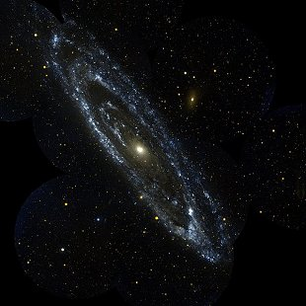
1. Andromeda Galaxy (Messier 31)
Spiral galaxy in Andromeda
magnitude 3.4

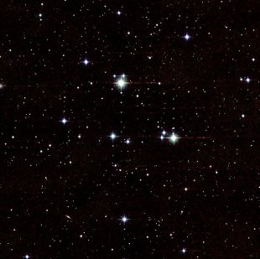
2. Beehive Cluster (Messier 44)
Open star cluster in Cancer
magnitude 4

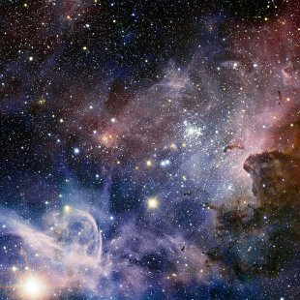
3. Eta Carinae Nebula (Caldwell 92)
Emission nebula in Carina
magnitude 3

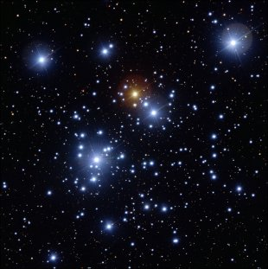
4. Jewel Box Cluster (Caldwell 94)
Globular star cluster in Crux
magnitude 4.2

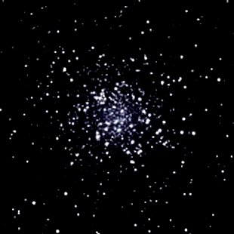
5. Large Magellanic Cloud (Messier 22)
Dwarf galaxy in Dorado
magnitude 0.9

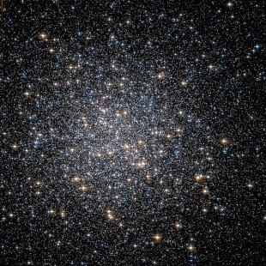
6. Hercules Cluster (Messier 13)
Globular star cluster in Hercules
magnitude 5.9

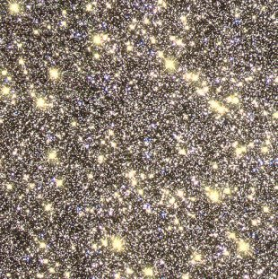
7. Omega Centauri (Caldwell 80)
Globular star cluster in Centaurus
magnitude 3.6

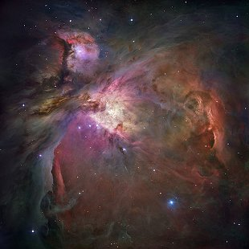
8. Orion Nebula (Messier 42)
Emission nebula in Orion
magnitude 4

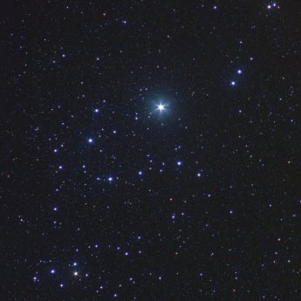
9. Alpha Persei Cluster
Open star cluster in Perseus
magnitude 1.2

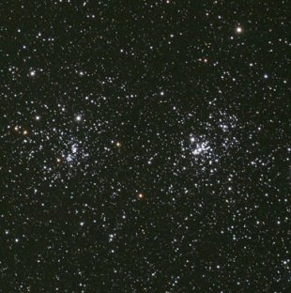
10. Double Cluster (Caldwell 14)
Double globular star cluster in Perseus
magnitude 4.3

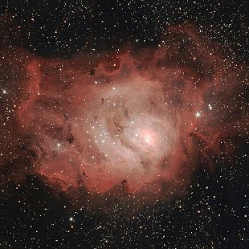
11. Lagoon Nebula (Messier 8)
Emission nebula in Sagittarius
magnitude 5

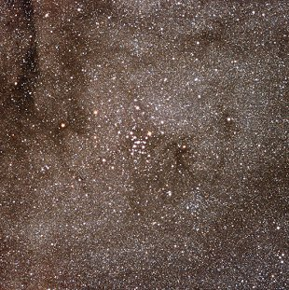
12. Ptolemy Cluster (Messier 7)
Open star cluster in Sagittarius
magnitude 3.3

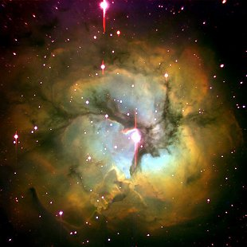
13. Trifid Nebula (Messier 20)
Emission nebula in Sagittarius
magnitude 6.3

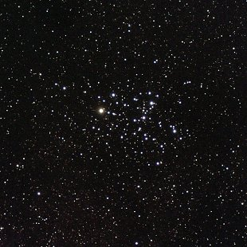
14. Butterfly Cluster
Open star cluster in Scorpius
magnitude 4.2

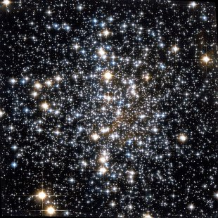
15. Messier 4
Globular star cluster in Scorpius
magnitude 5.9

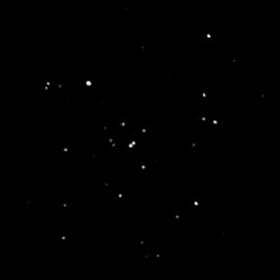
16. Hyades
Open star cluster in Taurus
magnitude 0.5

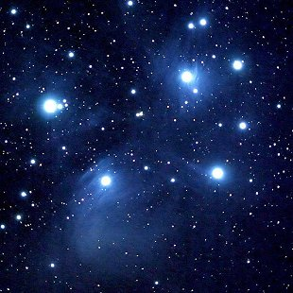
17. Pleiades (Messier 45)
Open star cluster in Taurus
magnitude 1.6

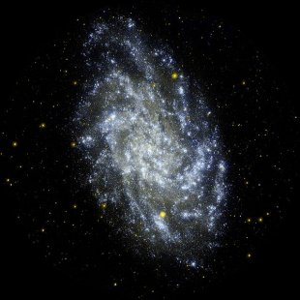
18. Triangulum Galaxy
Spiral galaxy in Triangulum
magnitude 5.7

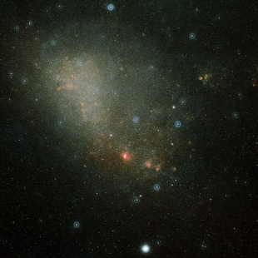
19. Small Magellanic Cloud
Dwarf galaxy in Tucana
magnitude 2.7

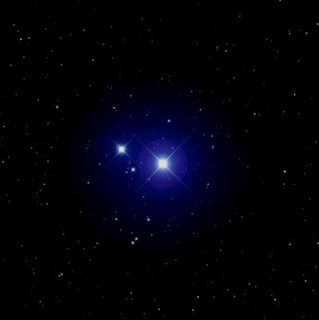
20. Mizar/Alcor
Binary stars in Ursa Major
magnitude 2/4

