**Report: User Interaction Analysis for** **Movie review Website Using Microsoft Clarity**

**1. Introduction:**

This report examines user engagement with our Movie Review Website on Render and Netlify. We used Microsoft Clarity to examine user interactions to identify the most popular features and buttons. Our goal is to provide straightforward insights to improve productivity and enhance the user experience.

**2. Research on Microsoft Clarity:**

**What is Microsoft clarity**

Clarity is an open-source behavioral analytics library written in typescript, with two key goals: privacy & performance.

It helps you understand how users view and use your website across all modern devices and browsers. Understanding how users navigate, interact and browse your website can provide new insights about your users. Empathizing with your users and seeing where features fail or succeed can help improve your product, grow revenue and improve user retention.

**Microsoft Clarity Versus Google Analytics**

Google Analytics and Microsoft Clarity are both analytics services, but they serve different purposes. Google Analytics focuses on traffic patterns, while Microsoft Clarity offers insights into user interactions with web pages. Rather than competing, Clarity complements Google Analytics, enhancing user behavior insights when connected.

**Microsoft Clarity Features**

The main features of Microsoft Clarity are:

1. **Clarity Heatmaps**.

Microsoft Clarity Heatmaps offer two types of data:

Click Heatmaps: These show engagement levels on different parts of a webpage and reveal where users are clicking, including non-clickable elements. This data can be refined with filters to understand how different users interact with page elements.

Scroll Heatmaps: These show how far users scroll on a page and can help identify if users aren’t reaching important information or calls to action. Filters can be applied to see how different users scroll through a page.

The Heatmaps can be segmented by filters like traffic sources, devices, and browsers to identify visitor patterns. This data is useful for debugging web page issues, understanding user experience, and improving conversions. The Heatmaps can help debug conversion issues and there are no traffic limits to this feature. The information can also be shared within your company or with clients.

1. **Session Recordings**.

Clarity’s Session Recordings feature records user journeys on a website, showing how users interact with various elements. It helps identify if site navigation and links are effective, and can detect issues like rage clicks, dead clicks, quick backs, and excessive scrolling.

Clarity Session Recordings track user behavior on a website, highlighting issues like:

* Rage Clicks: Repeated clicks on a non-interactive element, indicating user frustration.
* Dead Clicks: Clicks on an interactive element that doesn’t respond, signaling user frustration.
* Quick Backs: When a user navigates away from your site but quickly returns, indicating dissatisfaction.
* Excessive Scrolling: Unusual scrolling patterns that suggest the user isn’t finding what they expect.

These insights can help improve user experience and website performance. The data can be segmented by browser, campaign, and other filters for more detailed analysis. The session timeline visualizes user interaction, and filters allow for specific data isolation.

1. **Clarity Insights**.

Microsoft Clarity Insights uses Deep AI and Machine Learning to surface actionable insights from analytics data. It monitors session recordings for JavaScript errors, rage clicks, and dead clicks, and identifies user groups. Users can save groups for tracking. Clarity Insights uses ML-based filters and recommendations to highlight important content, helping users understand their website’s user interactions without needing to analyze extensive data. It identifies key trends and patterns in site activity, providing accurate and proactive analytics.

**Use cases for Microsoft Clarity**

Microsoft Clarity can be used for:

1. **Data-Driven Decision-Making**: Make informed decisions based on user behavior data.
2. **Content Optimization**: Test content placements and identify what users prefer.
3. **User Experience Enhancement**: Understand confusing webpage elements and improve user experience.
4. **Behavior Insights**: Analyze user behavior patterns using session recordings, heatmaps, and click tracking.
5. **Testing and Experimentation**: Test new ideas on your webpage and make changes based on user interactions.

**The Microsoft Clarity Pros**

1. **Free**: No cost to use.
2. **Easy Installation**: Simple setup process.
3. **Integration with Google Analytics**: Enhances data analysis capabilities.
4. **GDPR Compliant**: Adheres to data protection regulations.
5. **Superior Filtering Capabilities**: Allows detailed data segmentation.
6. **Useful UX Metrics**: Provides valuable user experience insights.
7. **Helpful Support Team**: Responsive and supportive customer service.
8. **Live Demo**: Offers real-time demonstration of its features.
9. **Clarity Live Extension Plugin**: Additional tool for enhanced functionality.
10. **Google Optimize Integration**: Allows for website optimization based on user behavior.

**Microsoft Clarity Cons**

1. **Limited GA Integration Documentation**: Detailed troubleshooting guides for Google Analytics integration are lacking.
2. **No Exclude Filter Option**: As of the time of publication, there’s no option to exclude certain data in filters.
3. **Login Confusion**: Issues may arise when using a shared login.

Overall, Microsoft Clarity offers a range of beneficial features for analyzing user behavior and optimizing web pages, though it has a few areas that could be improved.

**3. Identified Key Features:**

My movie review website, hosted on Render and Netlify, is being analyzed through Microsoft Clarity for research purposes: <https://moonflix1.netlify.app/>

Through interface analysis of the Movie review website, the following key features/buttons were identified:

* Home
* Movies
* Search
* Tv series

1. **Setup and Configuration:**

**Set up Microsoft Clarity:**

1. **Install Tracking Code**: Each website added to your Clarity account has a unique tracking code. This code can be added to multiple subdomains of your website.
2. **Choose Installation Method**: There are three ways to install Clarity:
   * **Manual Installation**: Select ‘Get tracking code’ and paste it into the <head> section of your website or web app.
   * **Third-Party Platform Installation**: Clarity can be installed on platforms like Shopify, SquareSpace, Wix, WordPress, etc. If your platform isn’t listed, you can submit a request for it.
   * **Share Code with Team Member**: If you prefer, you can share the code with a team member who can help set up Clarity. An email with the tracking code and setup instructions will be sent to them.

We've got Microsoft Clarity all set up and running smoothly to track how users are interacting with our movie review website. Each feature and button has its own custom tracking in place to make sure we capture every click and interaction accurately.

**Integrate Microsoft Clarity with Google Analytics**:

* + **Navigate to the Integration Page:** Visit the Google Analytics integration section on Clarity and select ‘Get Started’. You’ll be redirected to Google for authentication. Choose an existing account or use another account**.**
  + **Set Up the Connection:** A dialog box will appear. Select the specific web property you want to share data with Clarity. If your site is in the ‘Site to connect’ list, select it and click ‘Save’. If not, enter your site details manually**.**
  + **Access Enhanced Data:** After integration, a new Google Analytics tab will appear in your projects. Clarity will add a unique dimension to Google Analytics, providing a URL for each page session, allowing direct access to Session Recordings and Heatmaps.

1. **Data Analysis:**

****Data collected from Microsoft Clarity provided valuable insights into user interactions on the Movie review website:

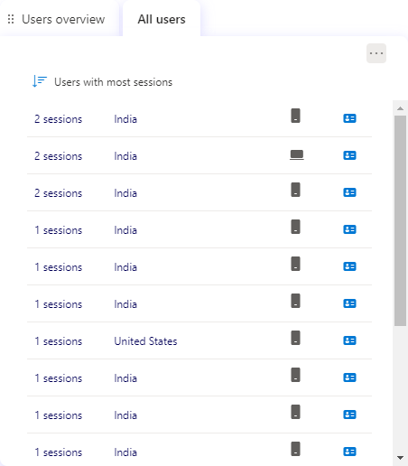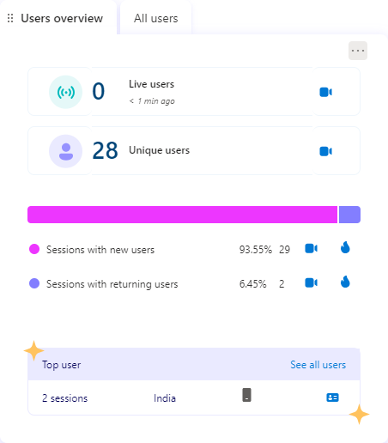

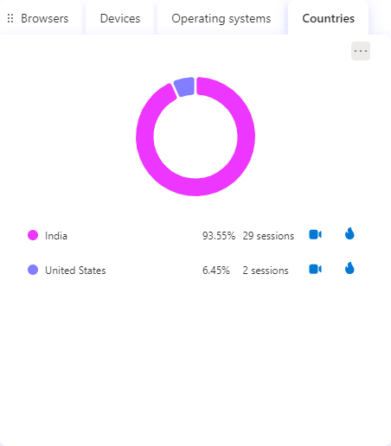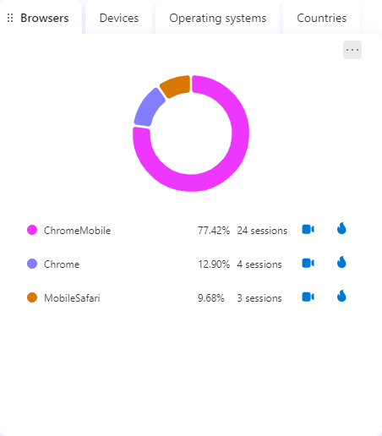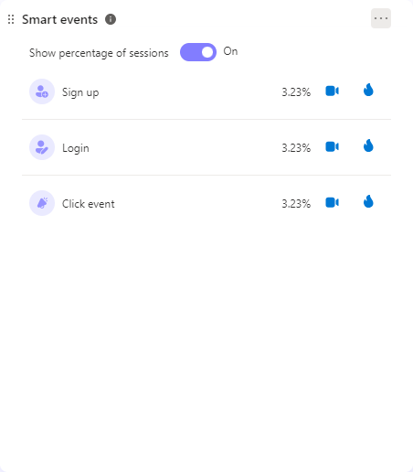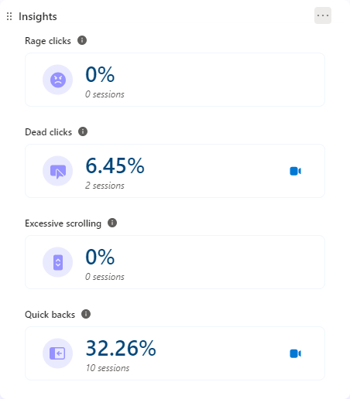

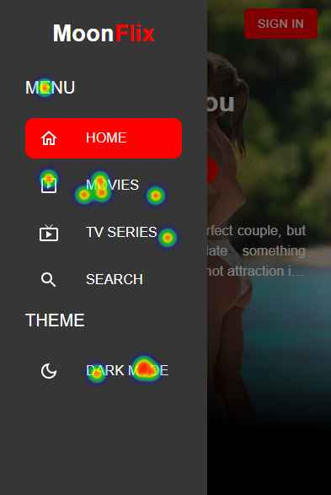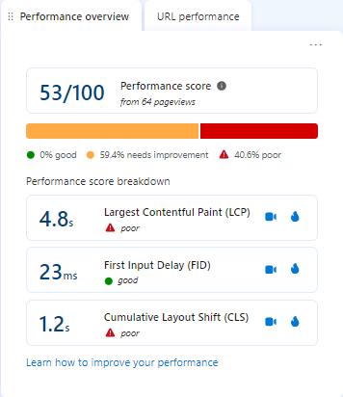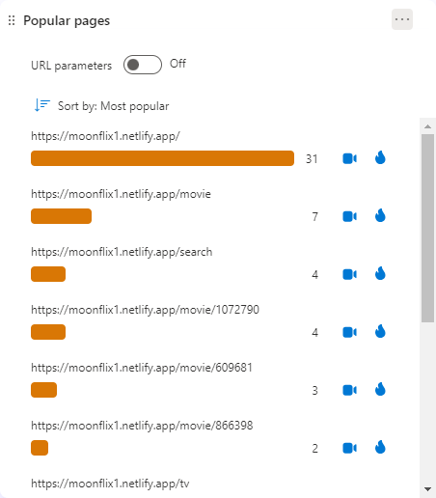

**User behaviors**

* **Desktop Users:** Scrolled through the entire page, mainly interacted with the play button and the main banner.
* **Tablet Users**: Did not visit the page, indicating a possible lack of interest or awareness.
* **Mobile Users**: Showed the most engagement by:
  + Scrolling to the middle and through the entire page.
  + Clicking on various elements such as the menu icon, the ‘watch now’ button of the main banner, and the second link of the sidebar menu.
  + Showing interest in the website’s navigation and branding by clicking on the Moon logo and the hamburger menu icon.
  + Interacting with movie posters and genre chips in the carousel, indicating a search for more information or filtering options for the movies.

**Key takeaways**

* **Content Variety:** Use more engaging and descriptive titles and images for slides and sections to encourage more clicks.
* **Tablet Optimization**: Conduct research and testing on user preferences and behavior on tablets, and adjust the design and layout accordingly.
* **Sidebar Menu**: Make menu items more visible and clickable, and provide feedback or confirmation when users select an option to reduce dead clicks.
* **Responsive Design**: Optimize the website for desktop and tablet users by ensuring that page elements are visible and functional on different screen sizes and devices.
* **Engaging Features**: Use more engaging and interactive elements, such as animations, hover effects, ratings, reviews, or trailers, to attract and retain users’ attention and curiosity.
* **Genre Chips**: Ensure that genre chips are clickable and lead to relevant results, or remove them if they are not intended to be filters, to reduce the possibility of dead clicks.

1. **Conclusion**:

Using user behavior and heatmap data, we get a full picture of how users interact with the Movie review website. If we use the suggested strategies, the Movie review website can make users more engaged, improve their experience, and get better conversion rates.

1. **References**

* <https://cypressnorth.com/conversion-optimization/microsoft-clarity-benefits-drawbacks-a-comprehensive-review/>
* <https://www.searchenginejournal.com/microsoft-clarity-analytics-overview/419311/>
* <https://learn.microsoft.com/en-us/clarity/setup-and-installation/clarity-setup>
* <https://learn.microsoft.com/en-us/clarity/>
* <https://clarity.microsoft.com/>