**Name –** Mehul Agarwal

**Project –** Nemocure

**Department –** Application Development

**23/08/2020**

**Objectives –** We’re trying to develop an app to show all the vitals to the user taken from our device and make communication with the doctor more efficient and easier.

**Introduction –** My task was to design the user interface for the application and make it look simple as well as attractive. I had to design the patient side of the application.

**Methodology –** I started off with looking for good looking and simple login/signup pages on the internet. After studying these ideas, I decided what the login page for the app would look like.

We were told to use red-white colour scheme for the applications as it closely represents health and well being.

**Designs –**

1. **Login Page**

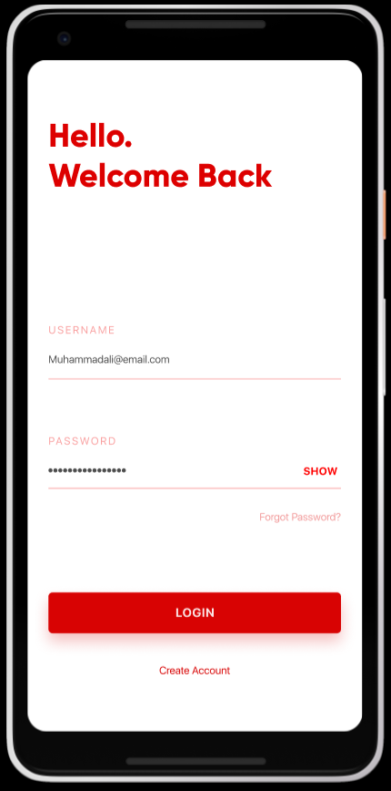

1. **Register**

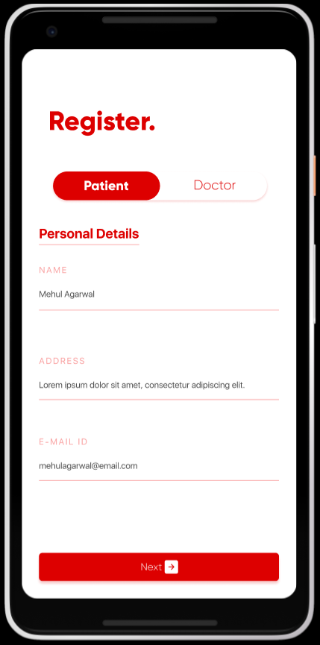 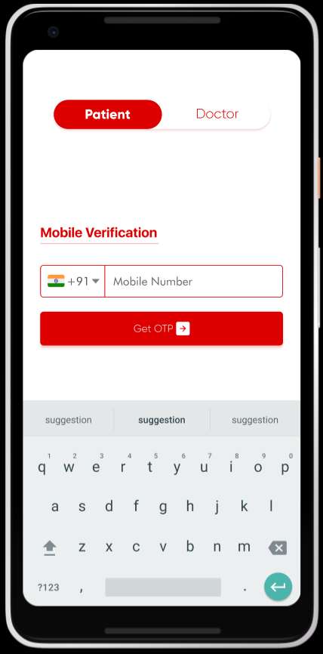  
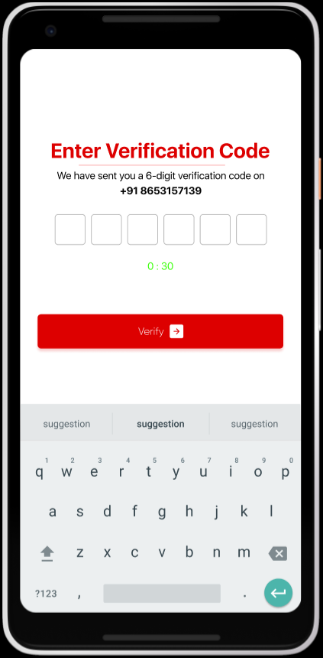 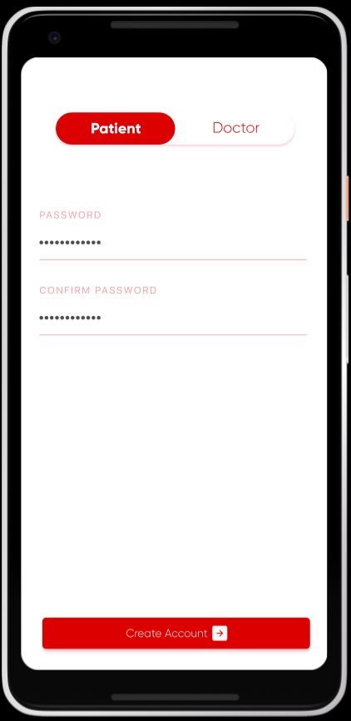

**24/08/2020**

**Objectives –** We’re trying to develop an app to show all the vitals to the user taken from our device and make communication with the doctor more efficient and easier.

**Introduction –** My task was to design the user interface for the application and make it look simple as well as attractive. I had to design the patient side of the application.

**Methodology –** After logging in I had to design the home and other pages for the Patients Application.

**Designs –**

1. **Home Page –** This page shows the vitals of a person. It will be showing live data if the device is connected else it will show the data throughout the day in forms of visual diagrams such as graphs and plots.

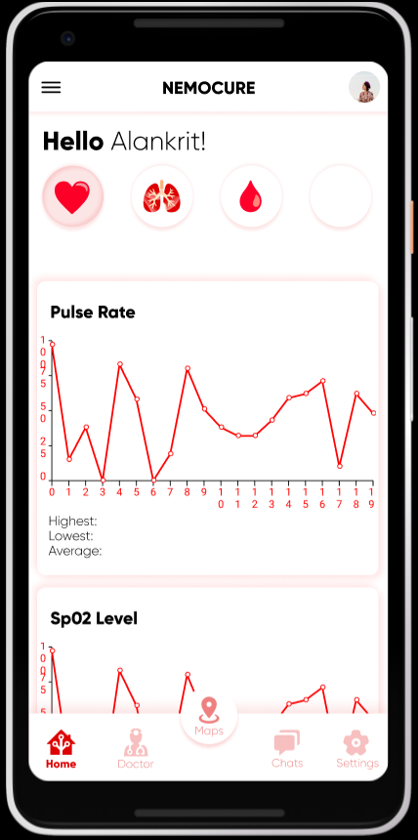

1. **Doctor Page –** It shows the list of doctors I am in contact with and details about the last appointment and remarks given by the doctor.

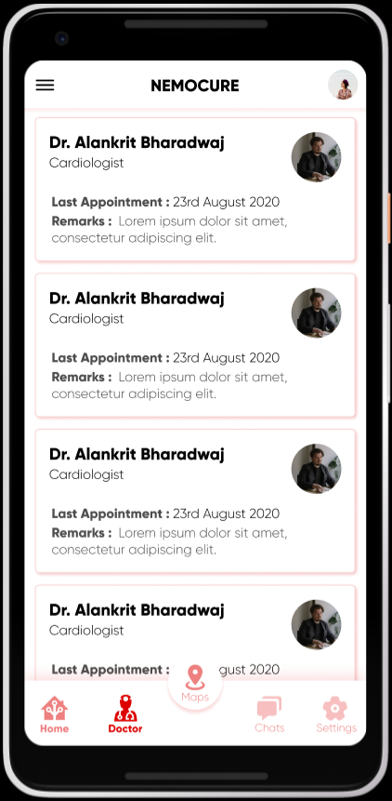

1. **Chat Page –** I had to design the chat cards and the User Interface for the chat page of the application.

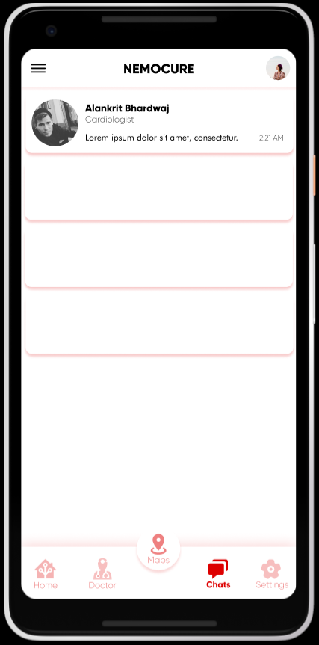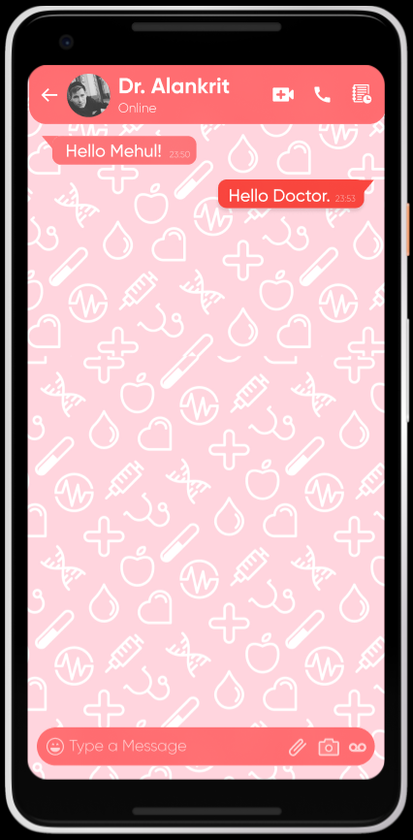

**25/08/2020**

**Objectives –** We’re trying to develop an app to show all the vitals to the user taken from our device and make communication with the doctor more efficient and easier.

**Introduction –** My task was to design the user interface for the application and make it look simple as well as attractive. I had to design the patient side of the application.

**Methodology –** I had to design the doctor’s login and registration page. Which is slightly different from the Patients page.

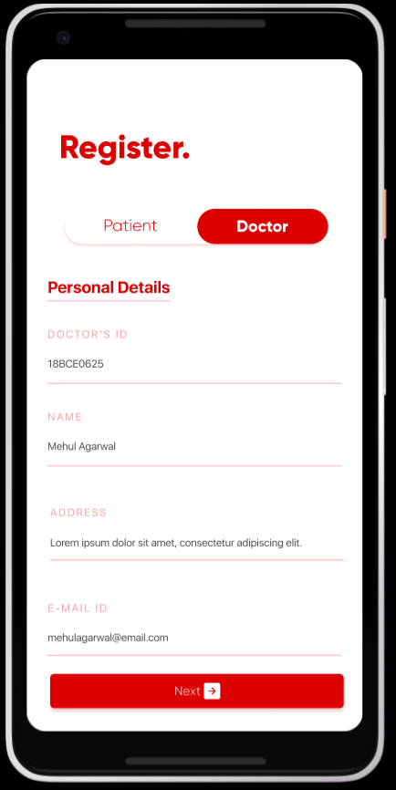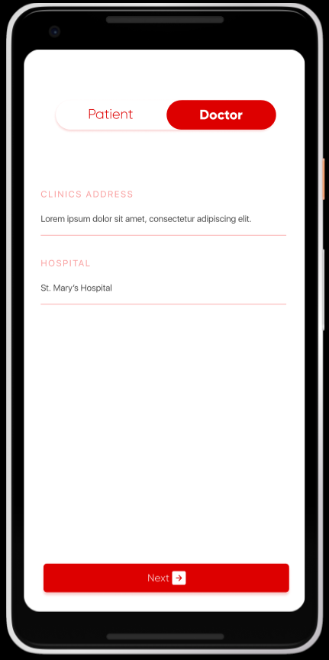

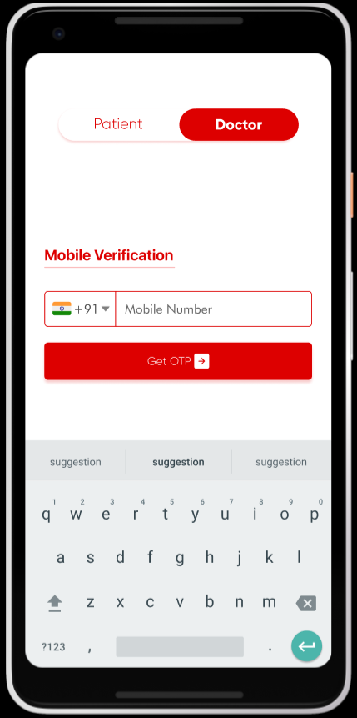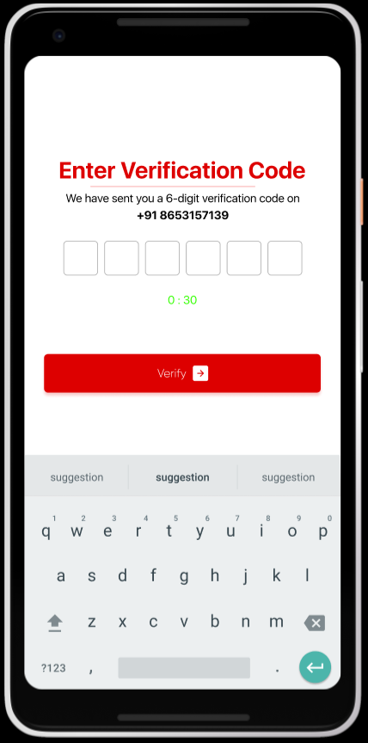

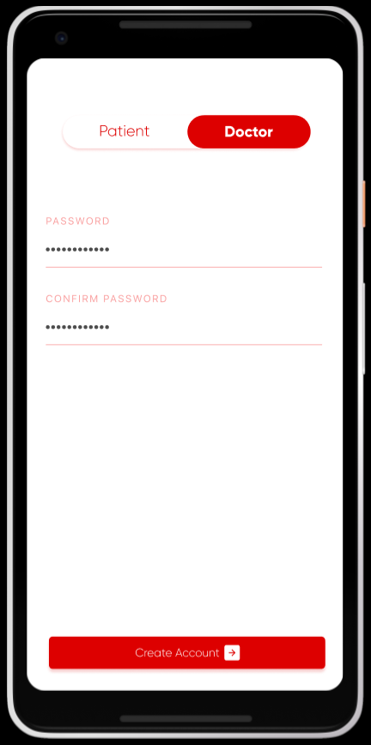

**26/08/2020**

**Objectives –** We’re trying to develop an app to show all the vitals to the user taken from our device and make communication with the doctor more efficient and easier.

**Introduction –** My task was to design the user interface for the application and make it look simple as well as attractive. I had to design the patient side of the application.

**Methodology –** After logging in I had to design the home and other pages for the Doctor’s Application.

1. **Home –** Home page show the appointments that the doctor has on that day. We can click on an appointment card to get the past appointment details as well as the present vitals detail of the patient.

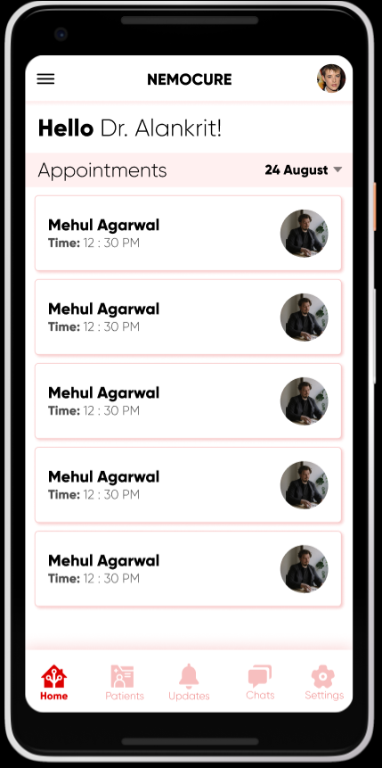 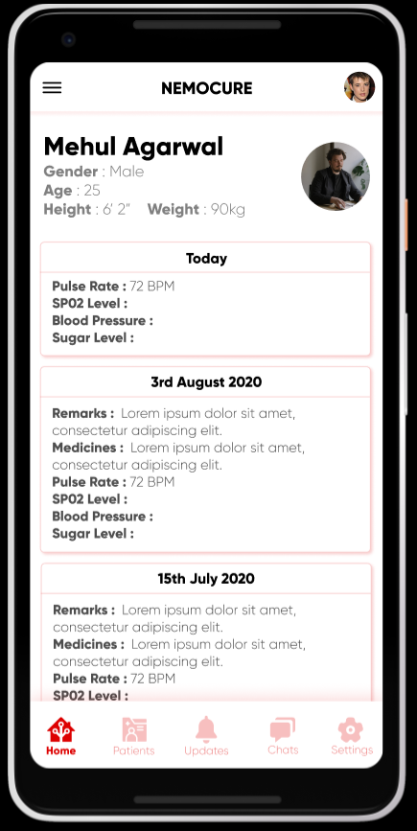

1. **Patients –** This page shows the list of patients the doctor has treated.

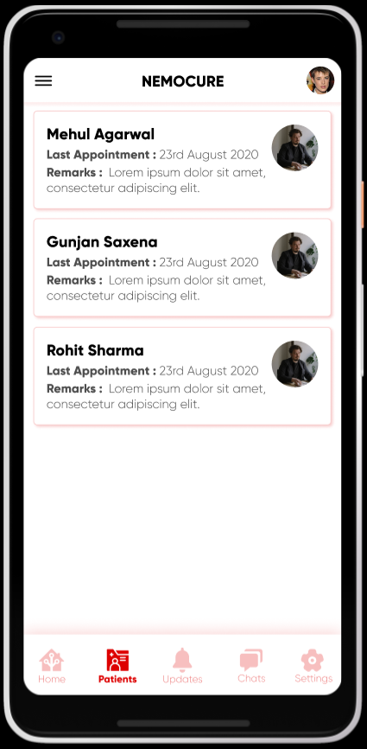

1. **Updates –** This page show the people who have requested for appointment and the doctor can see if he is available or not. He can also see if any emergency situation has taken place.

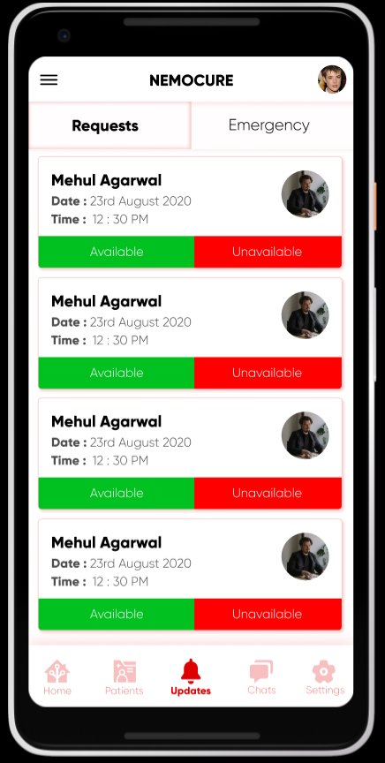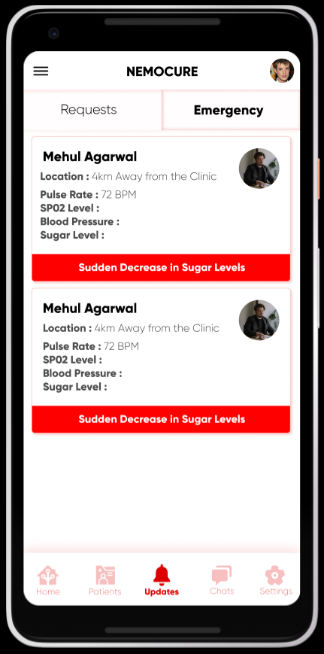

1. **Chat Page –**

