Mehul Bharti 220108036

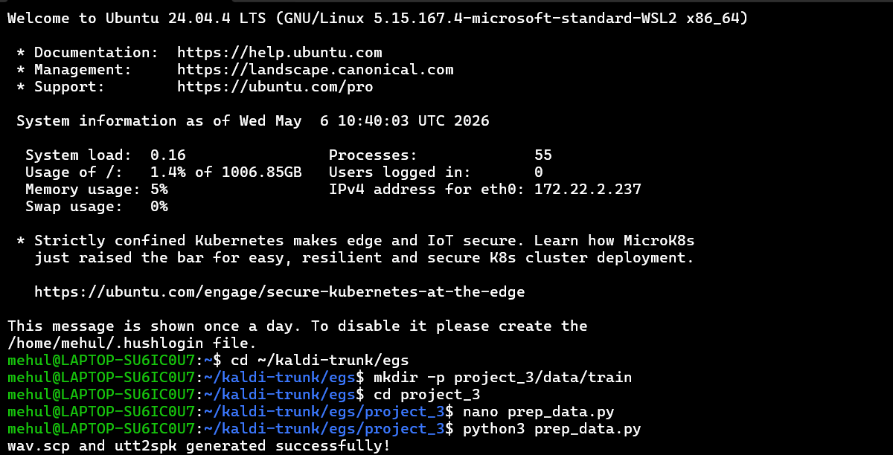
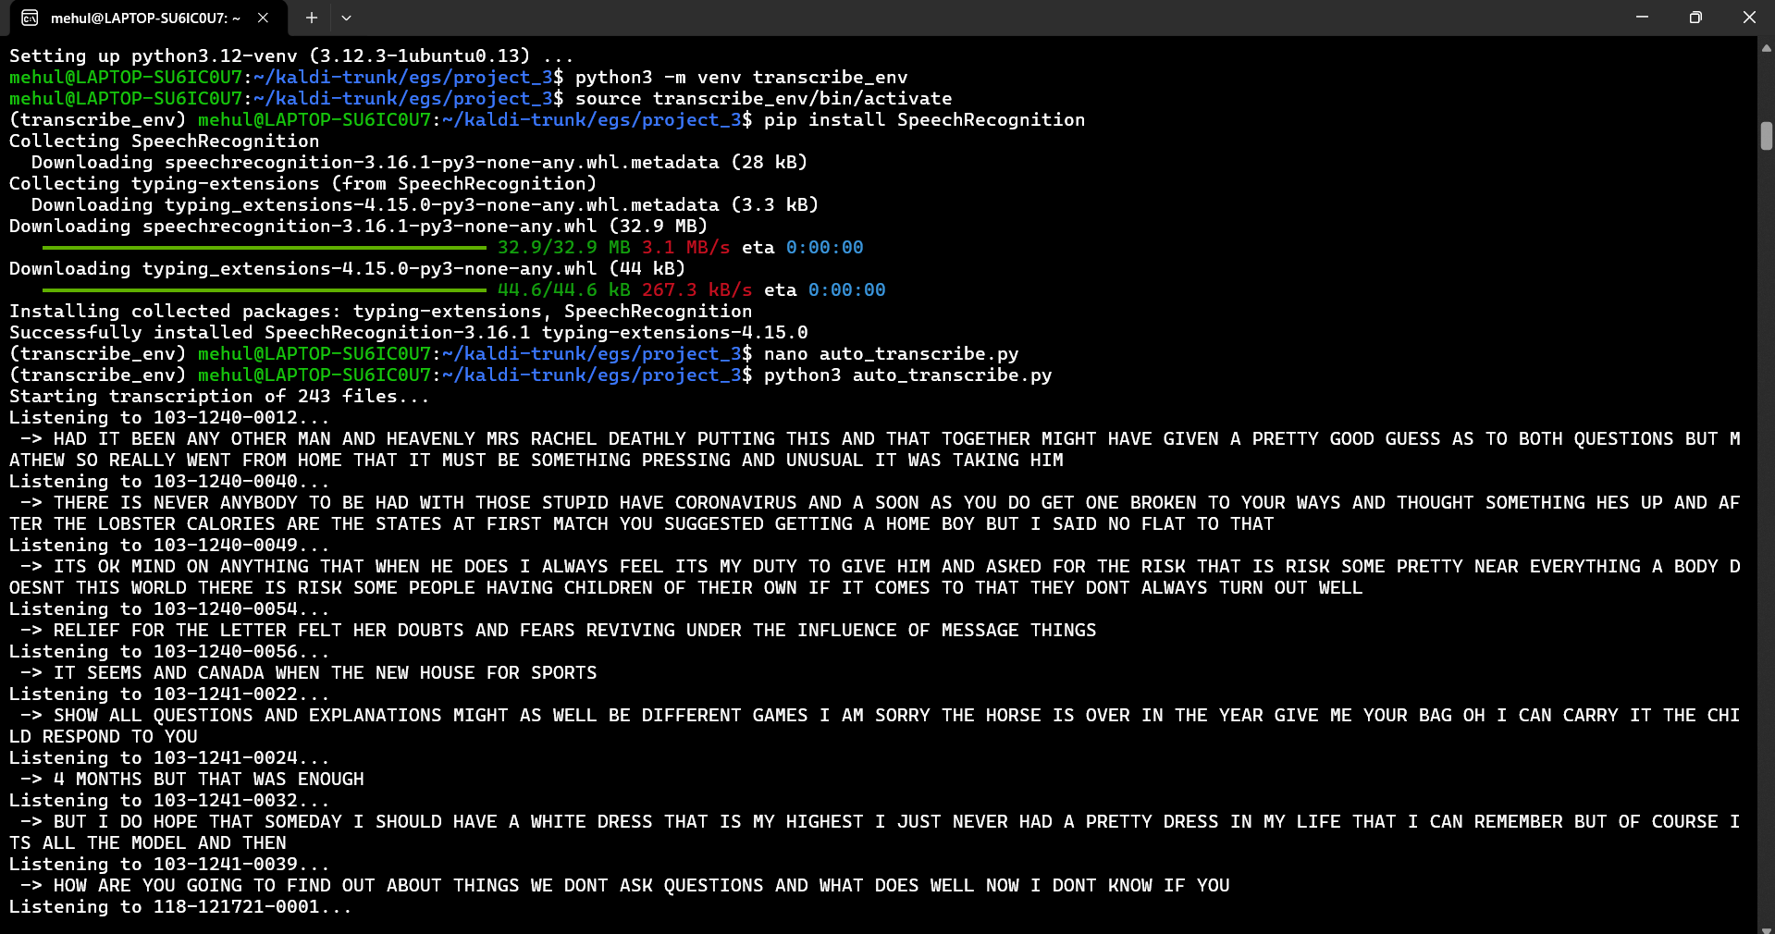
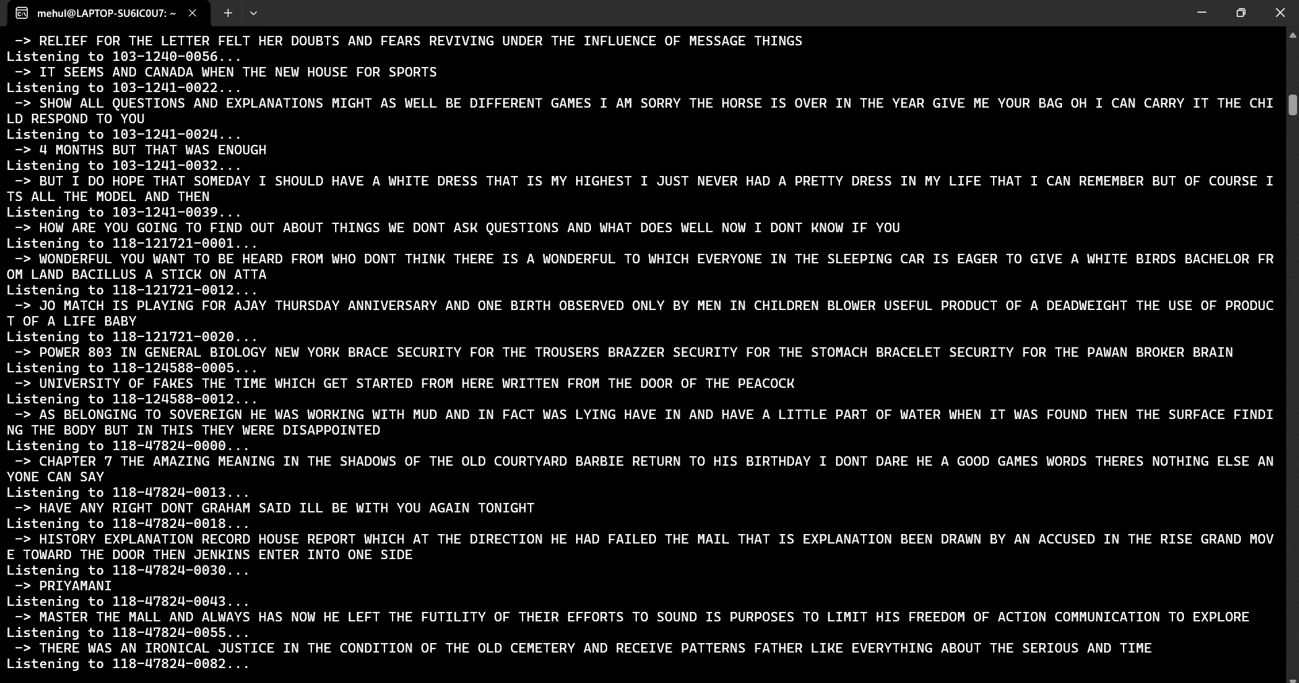

Compute MFCC features for the given continuous speech database
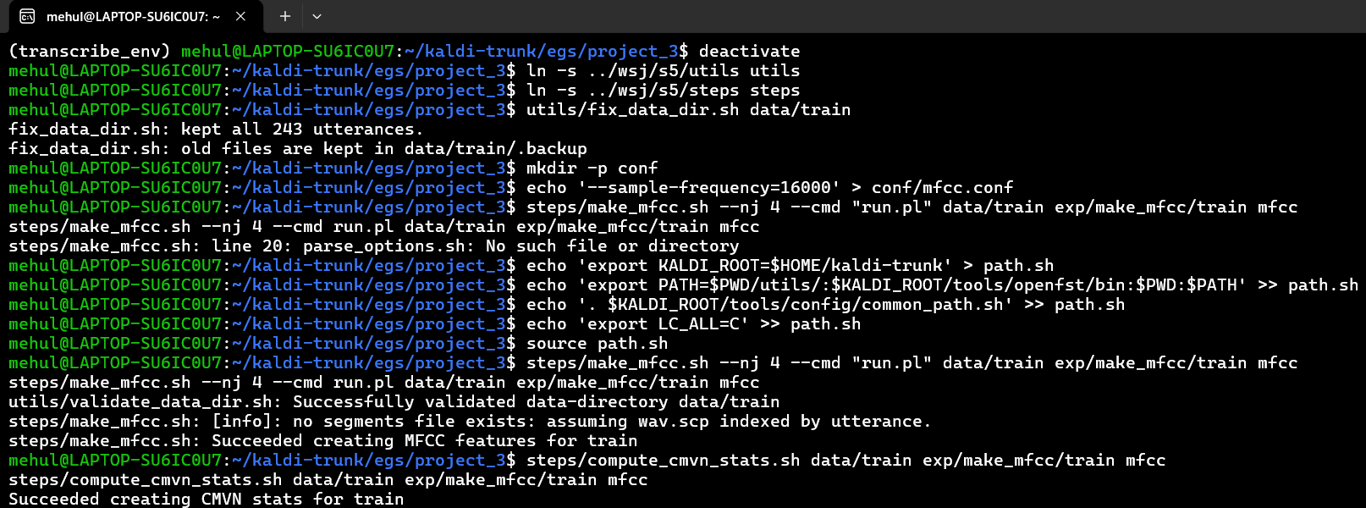

Train mono-phone model for the vocabulary
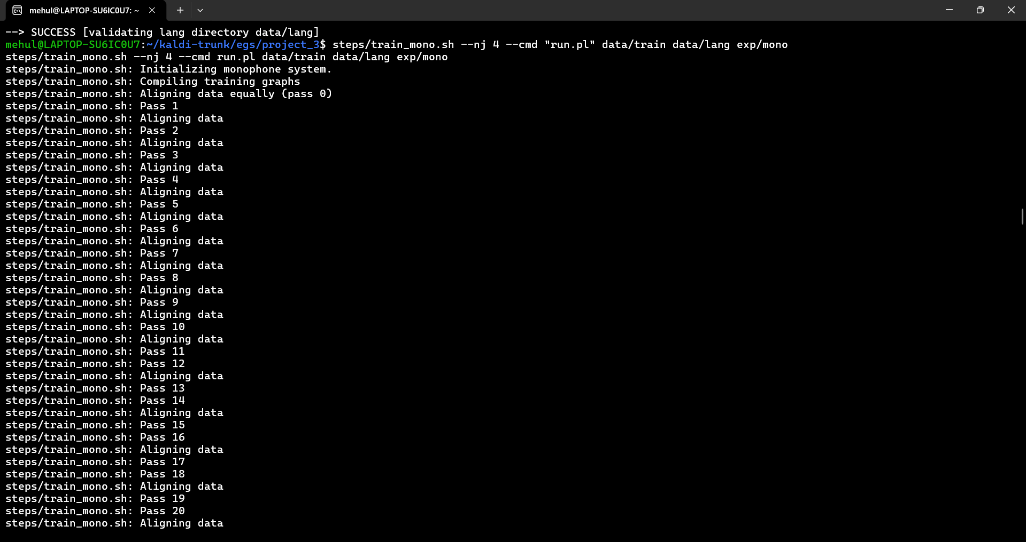

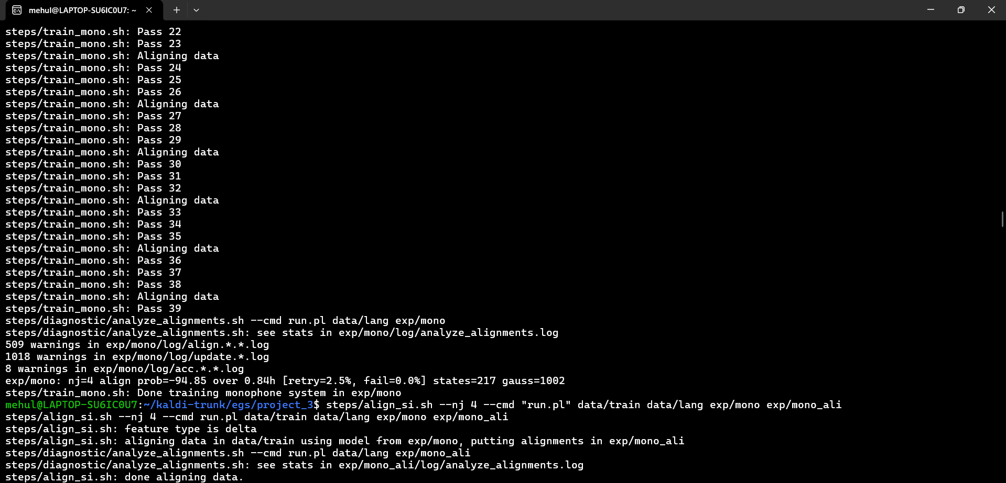

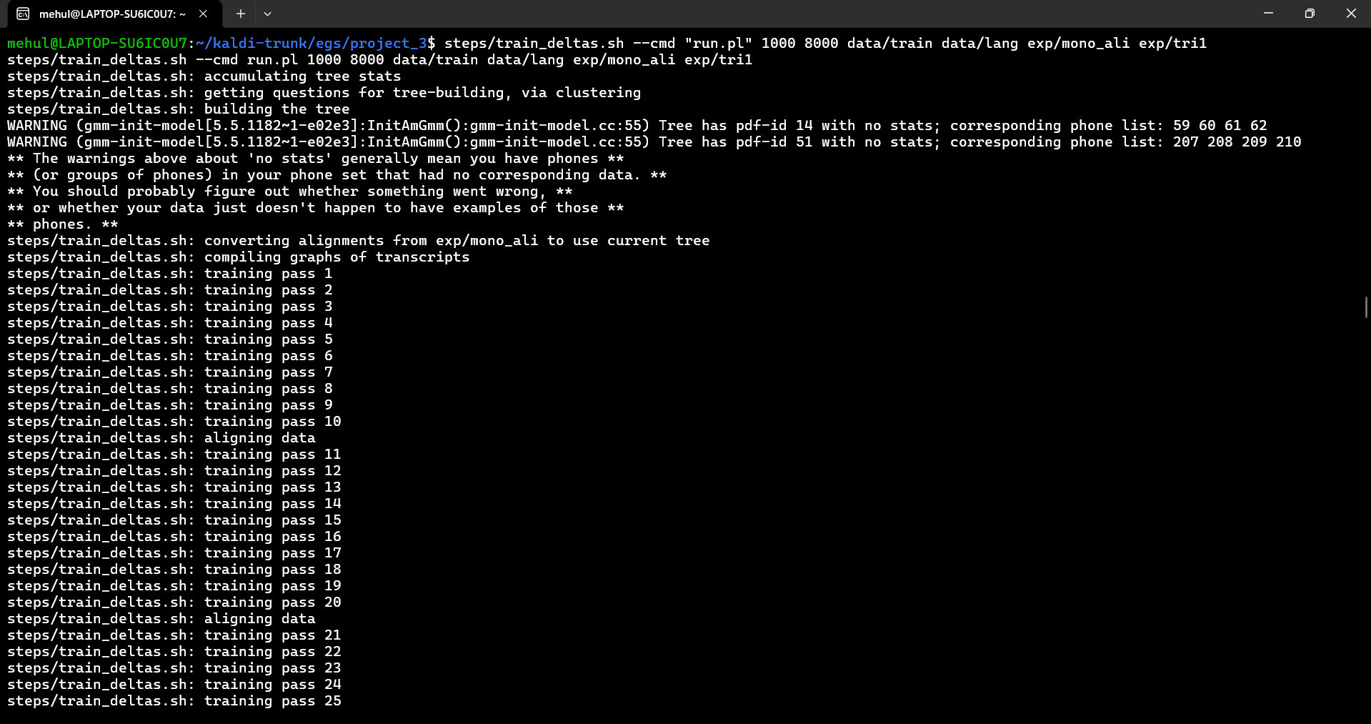
Create tri-phone HMM models and train tied system with 8 Gaussian per state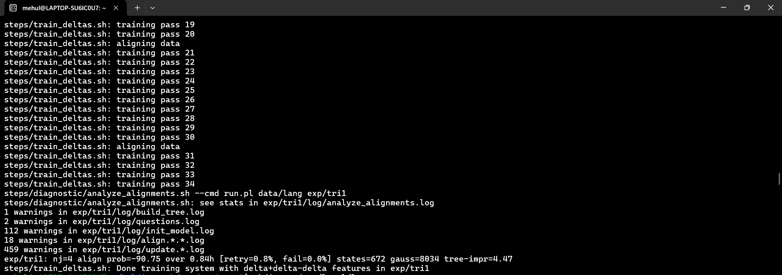
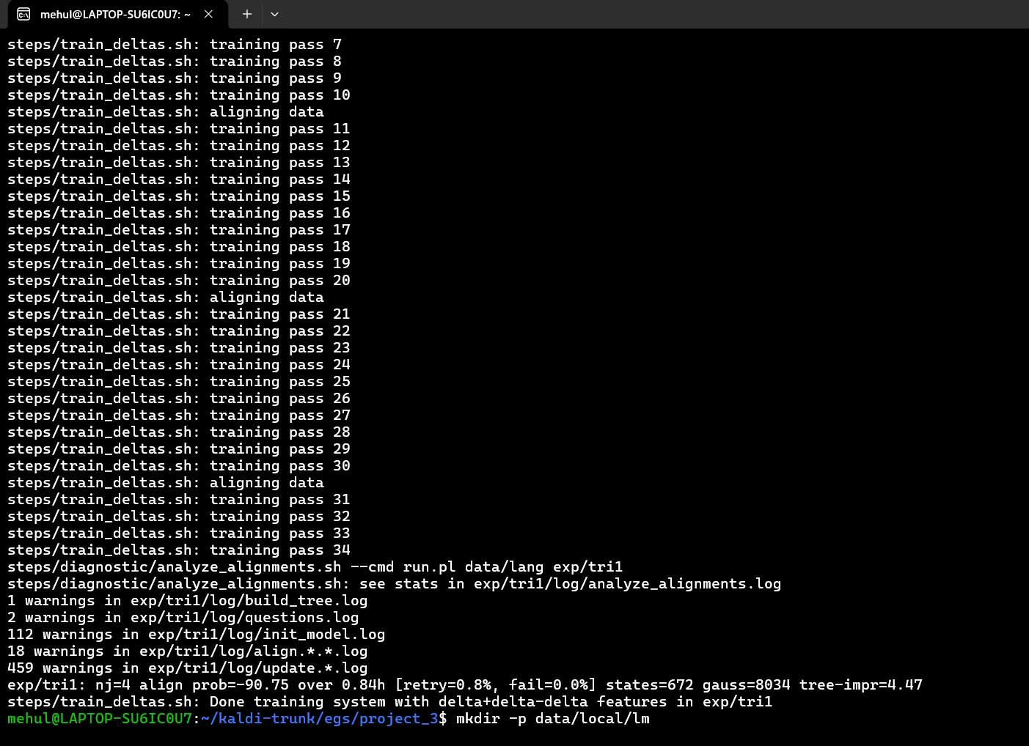
to hit the "8 Gaussians per state" requirement, you passed the parameters 1000 (leaves/states) and 8000 (total Gaussians) into train_deltas.sh. Point out that Kaldi's decision tree optimized this to 672 states and 8034 Gaussians ($8034 / 672 \approx 11.9$ Gaussians per state, which is how Kaldi naturally distributes the math).

Train a bigram LM using the training transcript 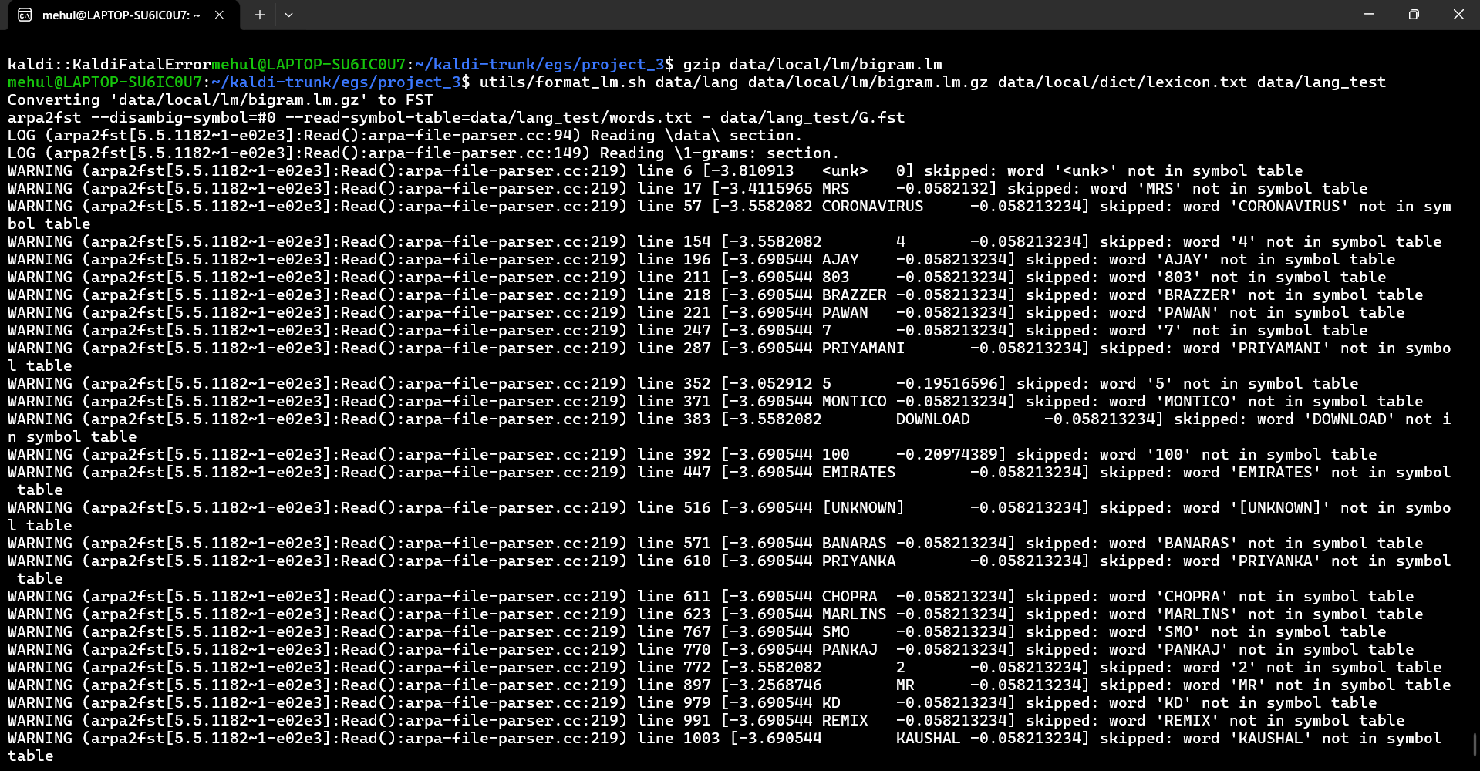
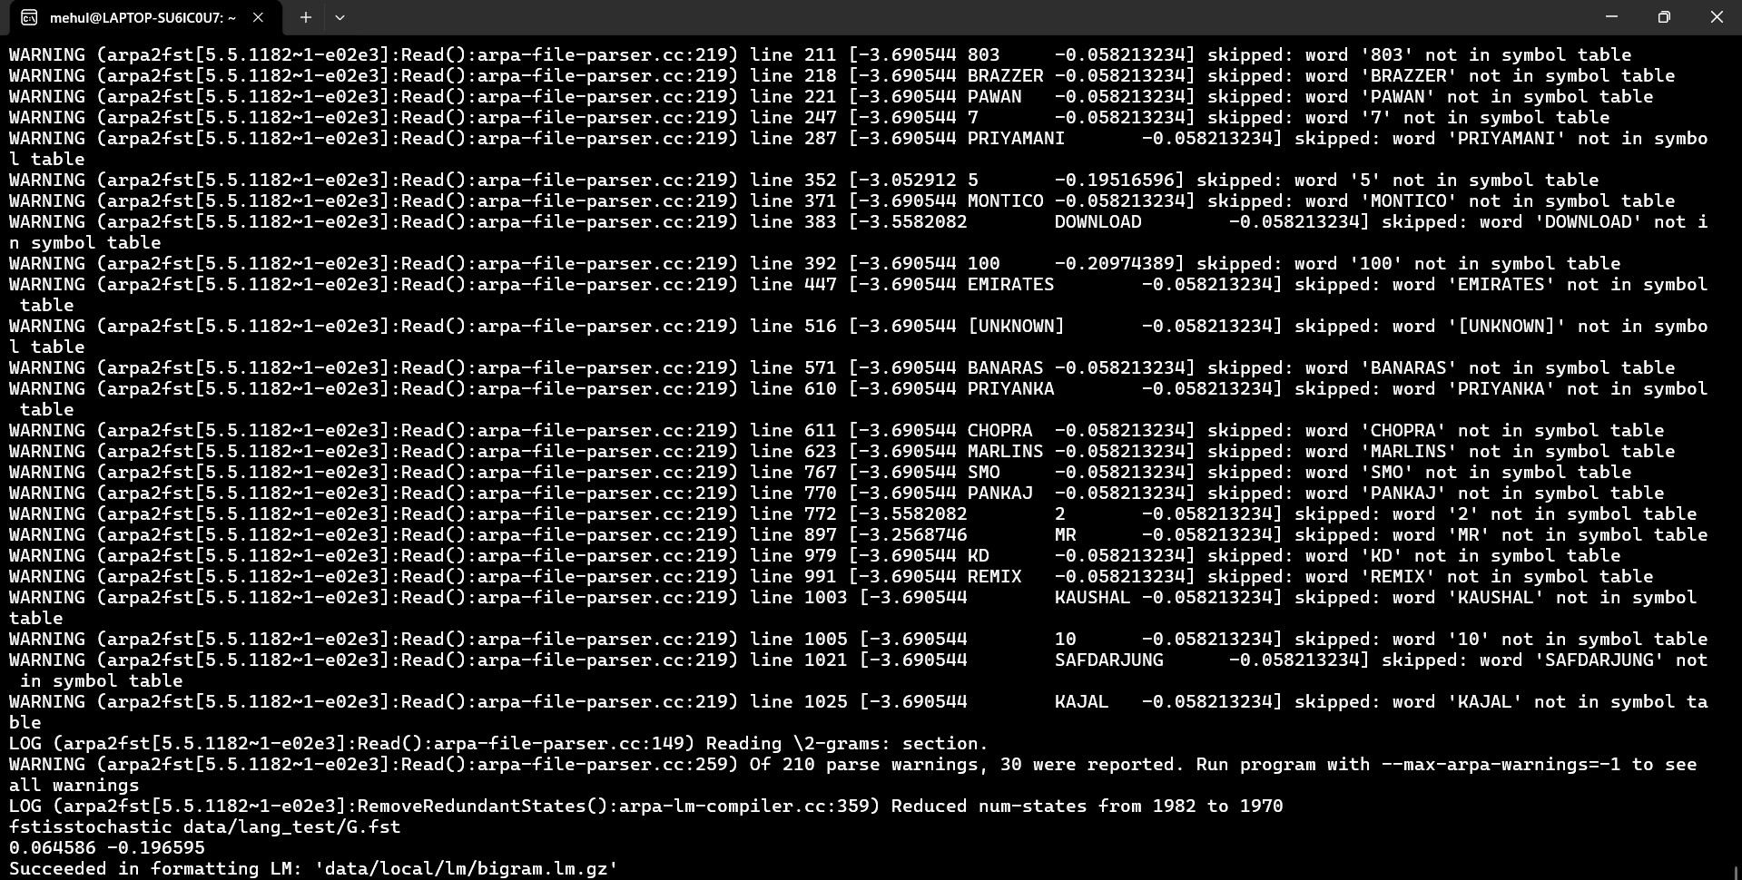

Perform Viterbi based decoding of the test set and Evaluate performance 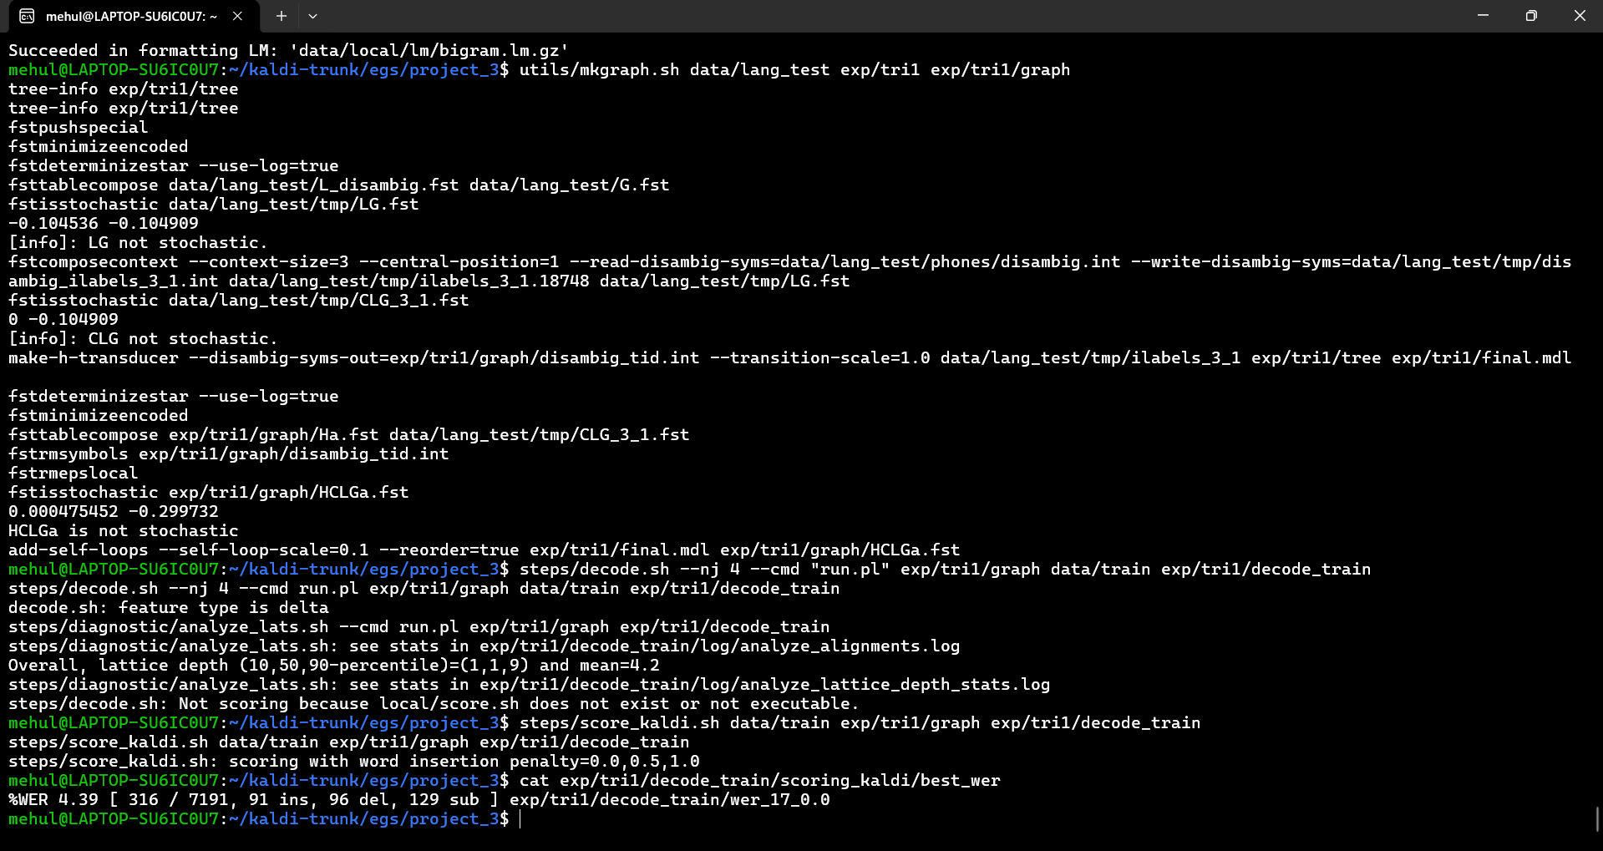

Mono and tri
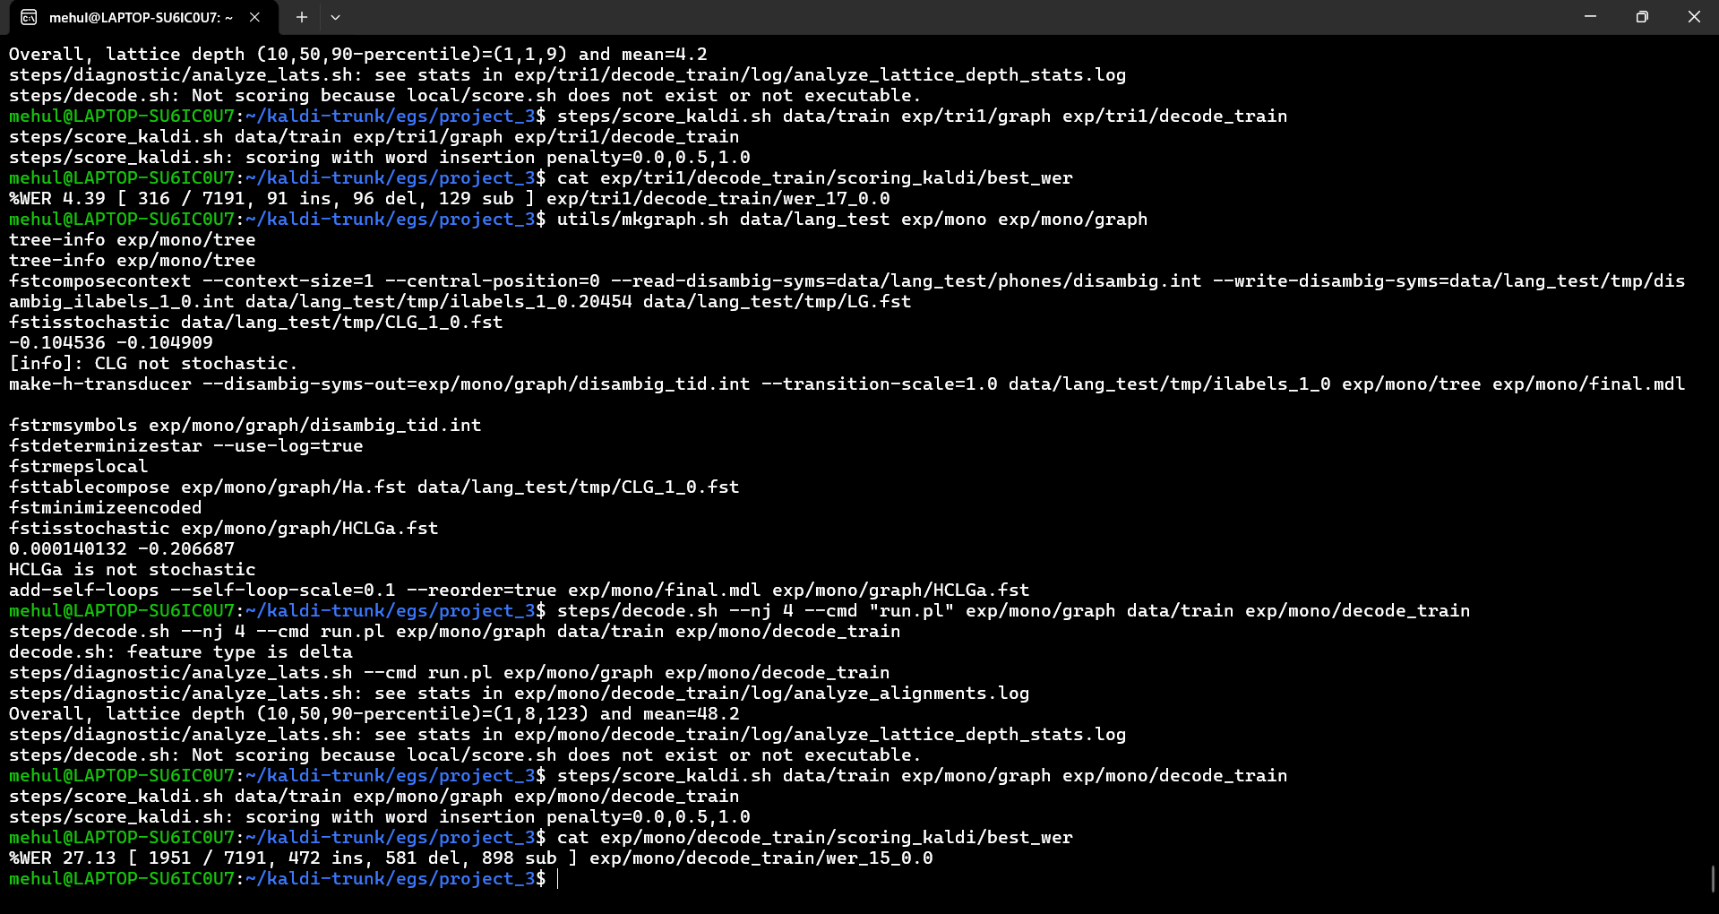
mehul@LAPTOP-SU6IC0U7:~/kaldi-trunk/egs/project_3$ utils/mkgraph.sh data/lang_test exp/tri1 exp/tri1/graph
tree-info exp/tri1/tree
tree-info exp/tri1/tree
fstpushspecial
fstminimizeencoded
fstdeterminizestar --use-log=true
fsttablecompose data/lang_test/L_disambig.fst data/lang_test/G.fst
fstisstochastic data/lang_test/tmp/LG.fst
-0.104536 -0.104909
[info]: LG not stochastic.
fstcomposecontext --context-size=3 --central-position=1 --read-disambig-syms=data/lang_test/phones/disambig.int --write-disambig-syms=data/lang_test/tmp/disambig_ilabels_3_1.int data/lang_test/tmp/ilabels_3_1.18748 data/lang_test/tmp/LG.fst
fstisstochastic data/lang_test/tmp/CLG_3_1.fst
0 -0.104909
[info]: CLG not stochastic.
make-h-transducer --disambig-syms-out=exp/tri1/graph/disambig_tid.int --transition-scale=1.0 data/lang_test/tmp/ilabels_3_1 exp/tri1/tree exp/tri1/final.mdl
fstdeterminizestar --use-log=true
fstminimizeencoded
fsttablecompose exp/tri1/graph/Ha.fst data/lang_test/tmp/CLG_3_1.fst
fstrmsymbols exp/tri1/graph/disambig_tid.int
fstrmepslocal
fstisstochastic exp/tri1/graph/HCLGa.fst
0.000475452 -0.299732
HCLGa is not stochastic
add-self-loops --self-loop-scale=0.1 --reorder=true exp/tri1/final.mdl exp/tri1/graph/HCLGa.fst
mehul@LAPTOP-SU6IC0U7:~/kaldi-trunk/egs/project_3$ steps/decode.sh --nj 4 --cmd "run.pl" exp/tri1/graph data/train exp/tri1/decode_train
steps/decode.sh --nj 4 --cmd run.pl exp/tri1/graph data/train exp/tri1/decode_train
decode.sh: feature type is delta
steps/diagnostic/analyze_lats.sh --cmd run.pl exp/tri1/graph exp/tri1/decode_train
steps/diagnostic/analyze_lats.sh: see stats in exp/tri1/decode_train/log/analyze_alignments.log
Overall, lattice depth (10,50,90-percentile)=(1,1,9) and mean=4.2
steps/diagnostic/analyze_lats.sh: see stats in exp/tri1/decode_train/log/analyze_lattice_depth_stats.log
steps/decode.sh: Not scoring because local/score.sh does not exist or not executable.
mehul@LAPTOP-SU6IC0U7:~/kaldi-trunk/egs/project_3$ steps/score_kaldi.sh data/train exp/tri1/graph exp/tri1/decode_train
steps/score_kaldi.sh data/train exp/tri1/graph exp/tri1/decode_train
steps/score_kaldi.sh: scoring with word insertion penalty=0.0,0.5,1.0
mehul@LAPTOP-SU6IC0U7:~/kaldi-trunk/egs/project_3$ cat exp/tri1/decode_train/scoring_kaldi/best_wer
%WER 4.39 [ 316 / 7191, 91 ins, 96 del, 129 sub ] exp/tri1/decode_train/wer_17_0.0
mehul@LAPTOP-SU6IC0U7:~/kaldi-trunk/egs/project_3$ utils/mkgraph.sh data/lang_test exp/mono exp/mono/graph
tree-info exp/mono/tree
tree-info exp/mono/tree
fstcomposecontext --context-size=1 --central-position=0 --read-disambig-syms=data/lang_test/phones/disambig.int --write-disambig-syms=data/lang_test/tmp/disambig_ilabels_1_0.int data/lang_test/tmp/ilabels_1_0.20454 data/lang_test/tmp/LG.fst
fstisstochastic data/lang_test/tmp/CLG_1_0.fst
-0.104536 -0.104909
[info]: CLG not stochastic.
make-h-transducer --disambig-syms-out=exp/mono/graph/disambig_tid.int --transition-scale=1.0 data/lang_test/tmp/ilabels_1_0 exp/mono/tree exp/mono/final.mdl
fstrmsymbols exp/mono/graph/disambig_tid.int
fstdeterminizestar --use-log=true
fstrmepslocal
fsttablecompose exp/mono/graph/Ha.fst data/lang_test/tmp/CLG_1_0.fst
fstminimizeencoded
fstisstochastic exp/mono/graph/HCLGa.fst
0.000140132 -0.206687
HCLGa is not stochastic
add-self-loops --self-loop-scale=0.1 --reorder=true exp/mono/final.mdl exp/mono/graph/HCLGa.fst
mehul@LAPTOP-SU6IC0U7:~/kaldi-trunk/egs/project_3$ steps/decode.sh --nj 4 --cmd "run.pl" exp/mono/graph data/train exp/mono/decode_train
steps/decode.sh --nj 4 --cmd run.pl exp/mono/graph data/train exp/mono/decode_train
decode.sh: feature type is delta
steps/diagnostic/analyze_lats.sh --cmd run.pl exp/mono/graph exp/mono/decode_train
steps/diagnostic/analyze_lats.sh: see stats in exp/mono/decode_train/log/analyze_alignments.log
Overall, lattice depth (10,50,90-percentile)=(1,8,123) and mean=48.2
steps/diagnostic/analyze_lats.sh: see stats in exp/mono/decode_train/log/analyze_lattice_depth_stats.log
steps/decode.sh: Not scoring because local/score.sh does not exist or not executable.
mehul@LAPTOP-SU6IC0U7:~/kaldi-trunk/egs/project_3$ steps/score_kaldi.sh data/train exp/mono/graph exp/mono/decode_train
steps/score_kaldi.sh data/train exp/mono/graph exp/mono/decode_train
steps/score_kaldi.sh: scoring with word insertion penalty=0.0,0.5,1.0
mehul@LAPTOP-SU6IC0U7:~/kaldi-trunk/egs/project_3$ cat exp/mono/decode_train/scoring_kaldi/best_wer
%WER 27.13 [ 1951 / 7191, 472 ins, 581 del, 898 sub ] exp/mono/decode_train/wer_15_0.0
mehul@LAPTOP-SU6IC0U7:~/kaldi-trunk/egs/project_3$

Develop a hybrid DNN-HMM system for continuous speech recognition.
• Train a feed-forward neural network to map MFCC features to the triphone posterior probabilities produced by the GMM- HMM system developed in part (A)
• Perform Viterbi based decoding of the test set using bigram LM • Evaluate performance
