### ACKNOWLEDGEMENTS

I would like to express my sincere gratitude to all those who supported me throughout the development of Byte Forge. Firstly, I extend my heartfelt thanks to my capstone project advisor Nilesh Parmar, for their invaluable guidance and encouragement. Your expertise and insights were instrumental in shaping this project and overcoming the challenges I encountered. I would also like to thank my fellow classmates and friends, [Names of classmates or friends], for their collaboration and support during the project. Your feedback and ideas contributed significantly to enhancing Byte Forge's functionality and user experience. Special appreciation goes to the developers of the libraries and frameworks I utilized, such as [list any specific libraries or frameworks], which provided the essential tools needed for building a robust Java learning environment. Finally, I would like to thank my family for their unwavering support and encouragement throughout my studies. Their belief in my abilities motivated me to push through challenges and stay focused on my goals. Thank you all for being a part of this journey.

### ABSTRACT

Byte Forge is a unique learning environment designed to help beginners effectively learn Java programming. Many new learners struggle with complex topics due to lengthy explanations and insufficient practical guidance. Traditional platforms often focus solely on theory, leading to confusion, especially with advanced concepts. To address this, Byte Forge provides an interactive platform that emphasizes hands-on learning. The user- friendly interface allows learners of all ages to access essential Java topics, including both basic and advanced concepts. Each module includes engaging tutorials, a built-in compiler, and a Java code editor, enabling users to practice coding and receive immediate feedback on their work. Additionally, Byte Forge features an AI-powered chatbot that offers instant assistance for any challenges users may encounter. The platform also provides note-taking facilities for each topic, helping learners keep track of important information. By integrating these resources, Byte Forge creates a supportive learning environment where beginners can confidently develop their Java programming skills.

### INDEX

1. Introduction 1
   1. Project Overview 1
   2. Project Background 1
   3. Problem Statement 1
   4. Purpose 1
2. Project Scope 2
   1. Objective 2
   2. Features And Functionality 2
   3. User Interface and User Experience (UI/UX) 2
   4. Security And Compliance 3
   5. Scalability And Performance 3
   6. Testing And Quality Assurance 3
3. Feasibility Analysis 4
   1. Technical Feasibility 4
   2. Operational Feasibility 5
   3. Legal and Regulatory Feasibility 5
   4. Economic Feasibility 5
   5. Scheduling Feasibility 5
4. Software And Hardware Requirement 7
   1. Minimum Hardware Requirements 7
   2. Minimum Software Requirements (Tools & Technology) 7
5. System Design 9
   1. Class Diagrams 9
   2. Activity Diagram 10
   3. Sequence Diagram 11
   4. Use case Diagram 12
   5. DFD (Data Flow Diagram) 13
6. Future Work 16
7. Literature Survey analyses table 18
8. Conclusion …………………………………………………………………………...…19
9. References 20

**CHAPTER-1: INTRODUCTION**

#### project overview

The Byte Forge project seeks to develop a beginner-friendly Java learning platform. The platform will offer a systematic learning route that breaks down complex concepts, taking users through theory, practical examples, and real-world challenges. This personalized approach enables people to not only understand but also implement the principles realistically. The features include an AI-powered chatbot, an integrated code editor and compiler, and a note-taking tool.

#### Project Background

The idea eliminates a frequent problem: existing Java learning tools overwhelm newcomers with extensive theoretical knowledge. This frequently results in a poor understanding of key concepts, especially when students graduate to more difficult areas. Byte Forge presents a solution by providing streamlined information and practical involvement to ease the learning process.

#### Problem Statement

When beginners approach learning new and complex Java topics, they often struggle to understand the material. Most learning platforms present users with lengthy theoretical content without guiding them through practical applications or potential challenges. This lack of a structured, learner-focused approach results in users failing to grasp core concepts effectively, especially as they progress to more advanced topics.

#### Purpose

Byte Forge's primary goal is to provide an easy-to-use Java learning platform that simplifies complex topics, allowing beginners to grasp and retain material effectively. The project also intends to deliver a more dynamic learning experience, allowing users to practice coding in real time and interact with the content via an AI chatbot. The platform aims to bridge the gap left by traditional educational tools by emphasizing practical learning.

### CHAPTER-2: PROJECT SCOPE

#### Objective

The primary goal of Byte Forge is to create an interactive learning platform that supports beginners in advancing their Java programming skills to an intermediate level. The platform aims to provide a user-friendly environment that includes easy access to learning materials, a built-in code compiler, and an AI chatbot designed to assist users throughout their learning journey.

#### Features and Functionality

Byte Forge will offer a variety of key features, including:

**Interactive Learning Modules:** Engaging tutorials and coding exercises tailored for users at the very beginner level.

**Code Editor and Compiler:** A built-in environment where users can write, run, and test Java code in real-time.

**AI Chatbot:** An intelligent assistant that provides immediate responses to user inquiries, enhancing the overall learning experience.

**Note-Taking Functionality:** Users can create, read, update, and delete notes related to their learning, promoting better retention and organization of information.

**User Accounts:** Registration and login features that allow for personalized experiences and access to note taking and chatbot functionalities.

#### User Interface and User Experience (UI/UX)

The design of Byte Forge will prioritize a clean and intuitive user interface to enhance engagement and facilitate effective learning. Key considerations include:

**Responsive Design:** Ensuring the platform is accessible on a range of devices, including desktops, tablets, and smartphones.

**User-Friendly Navigation**: Clear menus and content organization that allow users to easily find tutorials, access the code editor, and interact with the chatbot.

**Visual Aids:** Incorporating diagrams, code snippets, and interactive elements to help clarify complex concepts and make learning more enjoyable.

#### Security and Compliance

Byte Forge will implement strong security measures to protect user data and comply with relevant regulations:

**Data Encryption:** Sensitive user information will be encrypted both during transmission and when stored, safeguarding it from unauthorized access.

**User Authentication:** Secure login processes will be established, including password hashing.

#### Scalability and Performance

Byte Forge is designed to be scalable, accommodating growth as the user base expands:

**Cloud Infrastructure**: We will use Cloud service to maintain Vertical and Horizontal scalability.

**Microservices Architecture**: Employing a microservices approach to allow different components (such as the AI chatbot, database, and code execution engine) to scale independently.

#### Testing and Quality Assurance

#### A thorough testing and quality assurance strategy will be implemented throughout the development process:

#### Unit Testing: Automated tests will be used to ensure that individual components function correctly.

#### Integrated Testing: Verifying that various modules and services work together seamlessly.

### CHAPTER-3: FEASIBILITY ANALYSIS

#### Technical Feasibility

The technical feasibility of Byte Forge is assessed based on the available technology, tools, and infrastructure:

* + - **Technology Stack:** The project utilizes proven technologies, including Java with Spring Boot for the backend, React for the frontend, and MySQL/PostgreSQL for database management. This combination is widely supported and well- documented.
    - **Development Tools:** Developers will use established IDEs (IntelliJ IDEA & Spring Tool Suite for backend and Visual Studio Code for frontend development), as well as Docker for containerization, ensuring smooth development and deployment processes.
    - **Skill Availability:** The required technical skills (Java, React, database management) are widely available in the job market, facilitating the recruitment of qualified developers.

#### Operational Feasibility

Operational feasibility assesses whether Byte Forge can be integrated into existing operations:

* + - **User Engagement:** The platform is designed to cater to beginners, making it accessible and appealing to a broad audience, including students and self- learners.
    - **Support and Maintenance:** A dedicated team will be responsible for ongoing support and maintenance, ensuring that users receive assistance as needed and the platform remains up-to-date.
    - **Training and Documentation:** Comprehensive documentation and user training resources will be developed to help users maximize their experience with the platform.
    - **Management Commitment**: Strong support from management will ensure that adequate resources are allocated for the successful implementation and operation of Byte Forge.

#### Legal and Regulatory Feasibility

Legal and regulatory feasibility examines compliance with applicable laws and regulations:

* + - **Data Protection Regulations:** Byte Forge will adhere to data protection laws, to ensure that user data is handled securely and user rights are protected.
    - **Intellectual Property:** The platform will use open-source libraries and resources in compliance with licensing agreements, minimizing the risk of intellectual property infringement.
    - **Accessibility Standards:** The platform will aim to meet web accessibility standards to ensure it is usable on different browsers

#### Economic Feasibility

Economic feasibility evaluates the financial aspects of the Byte Forge project:

* + - **Cost Analysis:** Initial costs will include development, hosting, and marketing expenses. A detailed budget will be created to outline these costs and identify funding sources.
    - **Revenue Model**: Potential revenue streams may include features like courses, teaching from professionals which are not currently the priority
    - **Return on Investment (ROI):** When a solid userbase is achieved, we expect to have the Return on Investment based on the paid features mentioned above.

#### Scheduling Feasibility

Scheduling feasibility assesses the timeline for project completion and deployment:

* + - **Project Timeline:** A detailed project schedule will outline phases of development, testing, and deployment. Milestones will be established to track progress.
    - **Resource Allocation:** Adequate resources, including personnel and budget, will be allocated to ensure that the project stays on schedule.
    - **Contingency Planning:** Strategies will be developed to address potential delays or obstacles that may arise during the development process, ensuring the project remains on track.

### CHAPTER-4: SOFTWARE AND HARDWARE REQUIREMENTS

#### Minimum Hardware Requirements

#### For Users:

**Processor**: Intel Pentium/Celeron or equivalent

**RAM**:2GB or higher

**Storage:** 20GB of available space

**Internet Connection:** Stable connection with a minimum of 2 Mbps of download speed

#### For Developers:

**Processor**: Intel Core i3 or equivalent (2.0 GHz or higher) (for efficient development and testing)

**RAM:** 8GB or higher (to handle multiple development tools and environments simultaneously)

**Storage**: 128 GB of available space

**Internet Connection:** Stable connection with at least 5 Mbps of download speed Monitor: more than 720p monitors are recommended

#### Minimum Software Requirements (Tools & Technology) For Users:

**Operating System:** Windows xp or later, Linux(Lubuntu/Xubuntu) **Web Browser:** Latest version of Chrome, Firefox, Safari, or Edge

#### For Developers:

**Operating System:** Windows 7 (64 bits) or later, macOS, or Linux (Ubuntu 18.04)

#### Backend Technologies:

#### Spring Boot: Java framework for building the backend logic

**Database Management:** MySQL or PostgreSQL for managing user data and progress

#### Frontend Technologies:

**React:** For developing the user interface

**Node.js**: To support backend services and API functionalities

#### Development Tools:

**Docker:** For containerized deployment

**IntelliJ IDEA or Spring Tool Suite:** For Backend development **Visual Studio Code:** For frontend development

#### Version Control:

**Git and GitHub:** For version control and collaborative development

### CHAPTER 5: SYSTEM DESIGN

* 1. **Class Diagram**

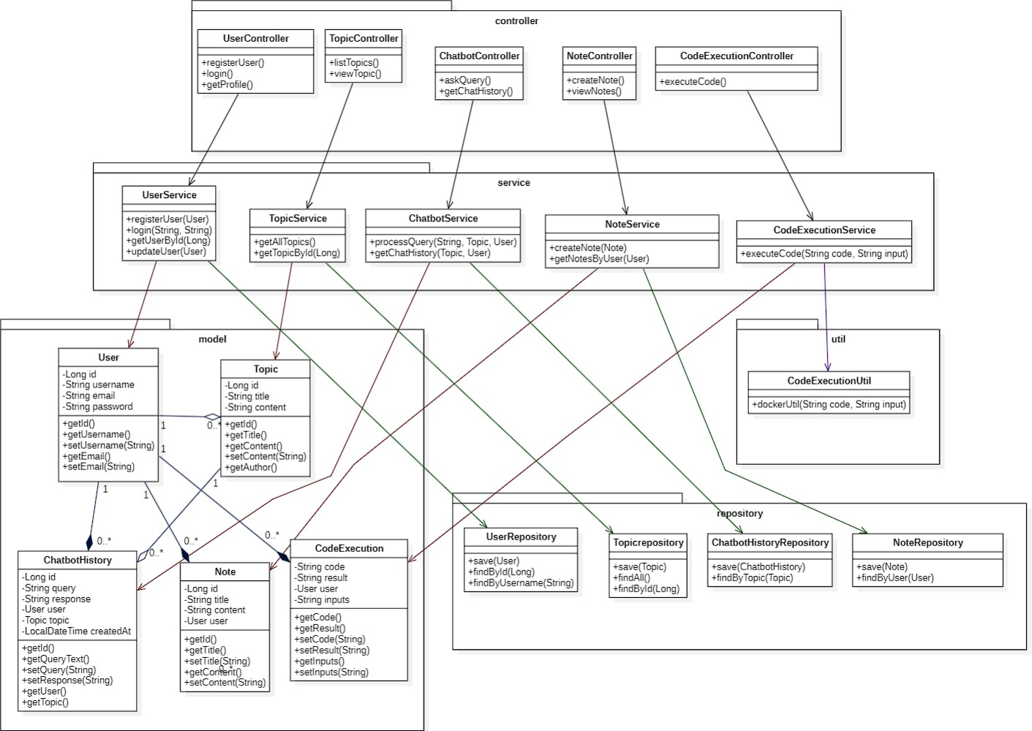

#### Activity Diagram

#### Sequence Diagram

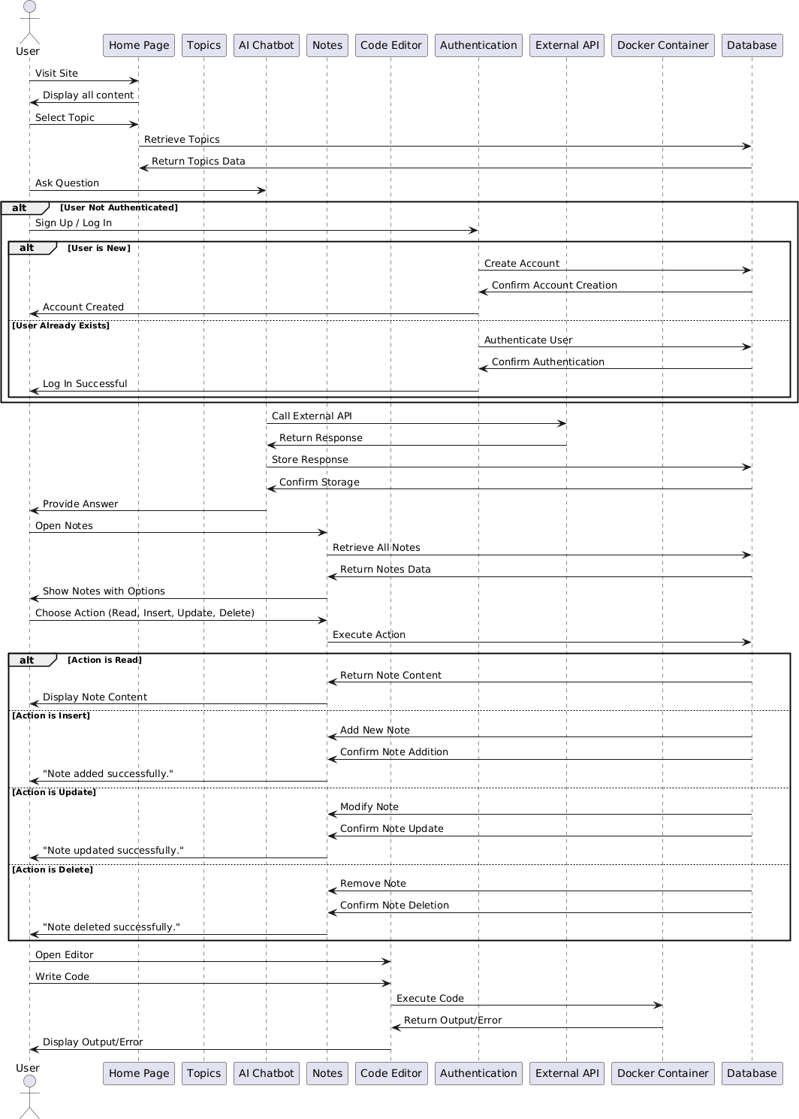

#### Use case Diagram

#### DFD (Data Flow Diagram)

* + 1. **DFD Level-0**

* + 1. **DFD Level-1:**

* + 1. **DFD-Level-2:**

### CHAPTER 6: FUTURE WORK

#### Enhanced Features:

Continuously adding new features and functionalities to the system based on user feedback and emerging trends in higher education. This could include features such as interactive course materials, virtual classrooms, and integration with learning management systems.

#### Mobile Accessibility:

Developing mobile applications to provide students, faculty, and administrators with convenient access to the College Management System from their smartphones and tablets. Mobile apps can offer features like push notifications, offline access, and optimized user interfaces for on-the-go usage.

#### Continuous Optimization:

Conducting performance tuning and optimization to ensure that the system remains responsive, scalable, and efficient, even as user loads and data volumes increase over time. This may involve optimizing database queries, improving code efficiency, and scaling infrastructure as needed.

#### Security Enhancements:

Proactively addressing security vulnerabilities and strengthening defences against cyber threats by implementing additional security measures such as encryption, multi-factor authentication, and regular security audits.

#### User Training and Support:

Providing comprehensive training resources and support materials to help users make the most of the Byte Forge. This includes developing user guides, tutorials, and help documentation, as well as offering responsive customer support channels.

#### Enhance AI Chatbot:

Training the AI chatbot with more and more data to enhance it’s quality of responses to make the responses more and more topic related and beginner friendly. Also enhancing the codebase to reduce the AI Chatbot response time.

#### Enhance Code Editor and Compiler:

Enhancing the codebase to reduce response time of compiler. Also making the docker containerization more robust to prevent it from malwares and data breaches.

### CHAPTER 7. Literature Survey

|  |  |  |  |
| --- | --- | --- | --- |
| **Website** | **Tech Stack** | **Features** | **Pros and Cons** |
| GeeksforGeeks | React, Node.js, MongoDB | - Comprehensive Java articles and tutorials  - Coding challenges  - Community Q&A section | Pros:  - Large user base  - Abundant resources  Cons:  - Less beginner-friendly approach for learning |
| Codecademy | React, Node.js, PostgreSQL | - Interactive coding lessons  - Instant code feedback  - Skill paths for beginners and experts | Pros:  - Gamified learning  - Self-paced  Cons:  - Paid access for full courses |
| Educative.io | React, Python | - Text-based interactive courses  - Focus on practical programming  - Detailed lessons with integrated coding environments | Pros:  - Hands-on coding experience  - Interactive lessons  Cons:  - Subscription model |
| JavaTPoint | HTML, PHP, MySQL | - In-depth tutorials for Java and related technologies  - Practical examples and source code  - Discussion forums | Pros:  - Extensive Java content  - Free access  Cons:  - Less interactive learning environment |
| LeetCode | JavaScript, Python | - Coding problems and solutions  - Discussion forums  - Competitions for learning through practice | Pros:  - Focus on problem-solving  - Active user community  Cons:  - Limited guided theory resources |

### CHAPTER 8: CONCLUSION

Byte Forge is dedicated to empowering aspiring Java programmers by providing an intuitive and interactive platform that simplifies the learning process. With its robust features—including a built-in compiler, code editor, and AI-driven chatbot—Byte Forge enables users to engage actively with the material, practice coding in real-time, and receive instant support for their queries.

The platform’s note-taking functionality enhances the learning experience, allowing users to track their progress and consolidate their knowledge. By addressing both hardware and software requirements, along with essential developer tools and technologies, Byte Forge ensures that learners can access the platform seamlessly, regardless of their starting point.

Ultimately, Byte Forge aspires to foster a community of confident Java developers, equipping them with the skills necessary to tackle more complex programming challenges. By remaining responsive to user feedback and continuously evolving its offerings, Byte Forge aims to be a vital resource for anyone looking to grow their Java programming abilities and embark on a successful coding journey.

### CHAPTER 9. REFERENCES

1. **Book: ‘**Sierra, K., & Bates, B. (2005)’. **“*Head First Java* (2nd ed.)”**. “O'Reilly Media, Inc”.
2. [https://www.geeksforgeeks.org/](https://www.geeksforgeeks.org/java/)java/
3. https://www.javatpoint.com/java-tutorial
4. https://stackoverflow.com/questions/tagged/java
5. [Oracle. (2023). documentation](https://docs.oracle.com/javase/tutorial/)
6. [Hugging face documentation](https://huggingface.co/docs)
7. [Docker Documentation](https://docs.docker.com/)