DELHI TECHNOLOGICAL UNIVERSITY
(Formerly Delhi College of Engineering)
Shahbad Daulatpur, Bawana Road, Delhi-110042
DEPARTMENT OF COMPUTER SCIENCE
AND ENGINEERING

Machine Learning Lab File
CO303
Submitted To:  Assistant Prof. Gull Kaur  Department of Computer Science and Engineering | Submitted By:  Mehul Gupta  24/CS/282

INDEX

SNo. | Aim | Date | Page No. | Signature
1 | To implement and evaluate the K-Nearest Neighbors (KNN) classification algorithm on the Iris dataset.
2 | To formulate a machine learning problem, inspect a dataset, split features and target, and establish a dummy baseline model.
3 | To implement preprocessing with Scikit-learn pipelines, identify data leakage, and compare leaky and leakage-free workflows.
4 | To implement simple linear regression, determine the best-fit line, analyze residuals, and study the effect of outliers.
5 | To study polynomial regression, identify overfitting, and apply Ridge (L2) and Lasso (L1) regularisation.
6 | To implement logistic regression, obtain predicted probabilities, analyze confusion matrices, and study threshold effects using ROC and Precision-Recall curves.

EXPERIMENT - 6

AIM:
To implement a Logistic Regression classifier, obtain predicted probabilities, study the effect of different classification thresholds on precision and recall, analyze confusion matrices, and use ROC and Precision-Recall curves to evaluate classification performance.

THEORY:

Logistic Regression
Logistic regression is a supervised learning algorithm used for binary classification. It first computes a linear score z = b0 + b1x1 + ... + bnxn and then transforms that score into a probability using the sigmoid function. The model is linear in the log-odds, which makes its fitted coefficients directly interpretable.
p(y = 1 | x) = 1 / (1 + exp(-z))

Predicted Probability and Classification Threshold
The sigmoid output lies between 0 and 1. A classification threshold converts this probability into a class label. At the default threshold of 0.50, probabilities at or above 0.50 are predicted as the positive class. Lower thresholds usually increase sensitivity but also increase false positives; higher thresholds usually increase specificity but may miss more positive cases.

Confusion Matrix and Classification Metrics
A confusion matrix records true negatives (TN), false positives (FP), false negatives (FN), and true positives (TP). Accuracy measures the overall fraction of correct predictions. Precision measures how many predicted positives are correct. Sensitivity, also called recall, measures how many actual positives are detected. Specificity measures how many actual negatives are correctly rejected, while the F1-score balances precision and sensitivity.

Metric | Formula | Meaning
Accuracy | (TP + TN) / Total | Overall correctness
Precision | TP / (TP + FP) | Reliability of positive predictions
Sensitivity | TP / (TP + FN) | Ability to find positive cases
Specificity | TN / (TN + FP) | Ability to reject negative cases
F1-score | 2PR / (P + R) | Balance of precision and recall

ROC and Precision-Recall Curves
The ROC curve plots the true-positive rate against the false-positive rate over all thresholds. ROC-AUC summarizes how well predicted scores rank positive cases above negative cases. The Precision-Recall curve plots precision against recall and is especially useful when attention is focused on the positive class. Average precision summarizes this curve and should be compared with the positive-class prevalence.

Leakage-Safe Pipeline and Dataset Setup
The heart-disease dataset initially contains 303 rows and 15 columns. After removing the exported index and one exact duplicate, 302 unique rows and 14 variables remain. Continuous measurements are median-imputed and standardized. Integer-coded clinical categories are most-frequent-imputed and one-hot encoded. All transformations are fitted inside a Scikit-learn pipeline so the test set and validation folds do not influence preprocessing.
The cleaned data is divided into 241 training rows and 61 testing rows using an 80:20 stratified split with random_state=42. The positive class represents heart disease. This experiment is educational and the fitted model is not clinically validated for diagnosis or patient-care decisions.

# EXPERIMENT 6: Logistic Regression, Thresholds and Classification Metrics

# 2. Import libraries
from pathlib import Path
import warnings

import matplotlib.pyplot as plt
import numpy as np
import pandas as pd
import seaborn as sns
from sklearn.compose import ColumnTransformer
from sklearn.dummy import DummyClassifier
from sklearn.impute import SimpleImputer
from sklearn.linear_model import LogisticRegression
from sklearn.metrics import (
ConfusionMatrixDisplay, accuracy_score, average_precision_score,
classification_report, confusion_matrix, f1_score,
precision_recall_curve, precision_score, recall_score,
roc_auc_score, roc_curve,
)
from sklearn.model_selection import StratifiedKFold, cross_validate, train_test_split
from sklearn.pipeline import Pipeline
from sklearn.preprocessing import OneHotEncoder, StandardScaler

RANDOM_STATE = 42
sns.set_theme(style="whitegrid", context="notebook")
pd.set_option("display.max_columns", 30)
pd.set_option("display.float_format", lambda value: f"{value:.4f}")

# 3. Load and audit the dataset
file_name = "heart disease classification dataset.csv"
candidate_paths = [Path(file_name), Path("Week 6") / file_name]
data_path = next((path for path in candidate_paths if path.exists()), None)
if data_path is None:
raise FileNotFoundError(f"Could not find {file_name!r} in the notebook directory or Week 6/.")

raw_data = pd.read_csv(data_path)
index_columns = [column for column in raw_data.columns if column.startswith("Unnamed:")]
data = raw_data.drop(columns=index_columns).copy()
duplicate_rows = int(data.duplicated().sum())
if duplicate_rows:
data = data.drop_duplicates().reset_index(drop=True)

target_map = {"no": 0, "yes": 1}
data["target"] = data["target"].str.strip().str.lower().map(target_map)

print(f"Loaded: {data_path.resolve()}")
print(f"Raw shape: {raw_data.shape}")
print(f"Removed saved-index columns: {index_columns or 'none'}")
print(f"Removed exact duplicate rows from the analysis copy: {duplicate_rows}")
print(f"Analysis shape: {data.shape}")
data.head()

quality_summary = pd.DataFrame({
"dtype": data.dtypes.astype(str),
"missing": data.isna().sum(),
"unique": data.nunique(dropna=False),
})
display(quality_summary)

target_summary = (
data["target"].value_counts().sort_index()
.rename(index={0: "No disease", 1: "Disease"})
.rename_axis("class").to_frame("rows")
)
target_summary["percent"] = 100 * target_summary["rows"] / len(data)
display(target_summary)
data.describe().T

fig, axes = plt.subplots(1, 3, figsize=(15, 4))

sns.countplot(data=data, x="target", hue="target", palette="Set2", legend=False, ax=axes[0])
axes[0].set(title="Target distribution", xlabel="Heart disease (0 = no, 1 = yes)", ylabel="Rows")

sns.histplot(data=data, x="age", hue="target", bins=15, element="step", stat="density", common_norm=False, ax=axes[1])
axes[1].set(title="Age distribution by class", xlabel="Age (years)")

sns.boxplot(data=data, x="target", y="thalach", hue="target", palette="Set2", legend=False, ax=axes[2])
axes[2].set(title="Maximum heart rate by class", xlabel="Heart disease", ylabel="Maximum heart rate (bpm)")

plt.tight_layout()
plt.show()

# 4. Define features and create a stratified split
continuous_features = ["age", "trestbps", "chol", "thalach", "oldpeak"]
categorical_features = ["sex", "cp", "fbs", "restecg", "exang", "slope", "ca", "thal"]
feature_columns = continuous_features + categorical_features

X = data[feature_columns].copy()
y = data["target"].astype(int).copy()

X_train, X_test, y_train, y_test = train_test_split(
X, y, test_size=0.20, random_state=RANDOM_STATE, stratify=y
)

split_summary = pd.DataFrame({
"rows": [len(X_train), len(X_test)],
"positive_rows": [int(y_train.sum()), int(y_test.sum())],
"positive_rate": [y_train.mean(), y_test.mean()],
}, index=["Training", "Testing"])
split_summary

# 5. Build leakage-safe preprocessing and models
numeric_pipeline = Pipeline([
("imputer", SimpleImputer(strategy="median")),
("scaler", StandardScaler()),
])
categorical_pipeline = Pipeline([
("imputer", SimpleImputer(strategy="most_frequent")),
("encoder", OneHotEncoder(handle_unknown="ignore", drop="first")),
])
preprocessor = ColumnTransformer([
("continuous", numeric_pipeline, continuous_features),
("categorical", categorical_pipeline, categorical_features),
])

logistic_model = Pipeline([
("preprocessor", preprocessor),
("classifier", LogisticRegression(max_iter=2000, random_state=RANDOM_STATE)),
])
dummy_model = DummyClassifier(strategy="most_frequent")

dummy_model.fit(X_train, y_train)
logistic_model.fit(X_train, y_train)
print("Both models fitted successfully.")

# 6. Evaluate held-out performance
def evaluate_classifier(name, model, features, labels):
predictions = model.predict(features)
probabilities = model.predict_proba(features)[:, 1]
tn, fp, fn, tp = confusion_matrix(labels, predictions, labels=[0, 1]).ravel()
return {
"Model": name,
"Accuracy": accuracy_score(labels, predictions),
"Precision": precision_score(labels, predictions, zero_division=0),
"Sensitivity (Recall)": recall_score(labels, predictions, zero_division=0),
"Specificity": tn / (tn + fp),
"F1-score": f1_score(labels, predictions, zero_division=0),
"ROC-AUC": roc_auc_score(labels, probabilities),
"Average Precision": average_precision_score(labels, probabilities),
}

models = {"Majority-class baseline": dummy_model, "Logistic regression": logistic_model}
test_results = pd.DataFrame([
evaluate_classifier(name, model, X_test, y_test)
for name, model in models.items()
]).set_index("Model")
test_results

fig, axes = plt.subplots(1, 2, figsize=(10, 4))
for ax, (name, model) in zip(axes, models.items()):
ConfusionMatrixDisplay.from_predictions(
y_test, model.predict(X_test), labels=[0, 1],
display_labels=["No disease", "Disease"], cmap="Blues", colorbar=False, ax=ax
)
ax.set_title(name)
plt.tight_layout()
plt.show()

logistic_predictions = logistic_model.predict(X_test)
print(classification_report(
y_test, logistic_predictions, labels=[0, 1],
target_names=["No disease", "Disease"], digits=4, zero_division=0
))

# 7. ROC and precision-recall curves
test_probabilities = logistic_model.predict_proba(X_test)[:, 1]
fpr, tpr, _ = roc_curve(y_test, test_probabilities)
precision_curve, recall_curve, _ = precision_recall_curve(y_test, test_probabilities)
roc_auc = roc_auc_score(y_test, test_probabilities)
average_precision = average_precision_score(y_test, test_probabilities)

fig, axes = plt.subplots(1, 2, figsize=(11, 4.5))
axes[0].plot(fpr, tpr, linewidth=2, label=f"Logistic regression (AUC = {roc_auc:.3f})")
axes[0].plot([0, 1], [0, 1], "--", color="gray", label="Random ranking")
axes[0].set(title="ROC curve", xlabel="False-positive rate", ylabel="True-positive rate")
axes[0].legend()

axes[1].plot(recall_curve, precision_curve, linewidth=2, label=f"AP = {average_precision:.3f}")
axes[1].axhline(y=y_test.mean(), linestyle="--", color="gray", label=f"Prevalence = {y_test.mean():.3f}")
axes[1].set(title="Precision-recall curve", xlabel="Recall", ylabel="Precision")
axes[1].legend()

plt.tight_layout()
plt.show()

# 8. Five-fold cross-validation on the training set
cv = StratifiedKFold(n_splits=5, shuffle=True, random_state=RANDOM_STATE)
scoring = {
"accuracy": "accuracy", "precision": "precision", "recall": "recall",
"f1": "f1", "roc_auc": "roc_auc", "average_precision": "average_precision",
}
with warnings.catch_warnings():
warnings.filterwarnings("ignore", message="Found unknown categories.*", category=UserWarning)
cv_scores = cross_validate(logistic_model, X_train, y_train, cv=cv, scoring=scoring)
cv_summary = pd.DataFrame({
metric.replace("test_", "").replace("_", " " ).title(): [values.mean(), values.std(ddof=1)]
for metric, values in cv_scores.items() if metric.startswith("test_")
}, index=["Mean", "Standard deviation"]).T
cv_summary

# 9. Interpret logistic-regression coefficients
feature_names = logistic_model.named_steps["preprocessor"].get_feature_names_out()
coefficients = logistic_model.named_steps["classifier"].coef_[0]
coefficient_table = pd.DataFrame({
"Feature": feature_names,
"Coefficient": coefficients,
"Odds ratio": np.exp(coefficients),
})
coefficient_table["Absolute coefficient"] = coefficient_table["Coefficient"].abs()
coefficient_table = coefficient_table.sort_values("Absolute coefficient", ascending=False).reset_index(drop=True)
display(coefficient_table.head(12))

top_coefficients = coefficient_table.head(12).sort_values("Coefficient")
colors = np.where(top_coefficients["Coefficient"] >= 0, "#d95f02", "#1b9e77")
plt.figure(figsize=(9, 6))
plt.barh(top_coefficients["Feature"], top_coefficients["Coefficient"], color=colors)
plt.axvline(0, color="black", linewidth=1)
plt.title("Largest logistic-regression coefficients")
plt.xlabel("Coefficient (change in log-odds)")
plt.ylabel("Transformed feature")
plt.tight_layout()
plt.show()

# 10. Probability-threshold trade-off
threshold_rows = []
for threshold in [0.30, 0.40, 0.50, 0.60, 0.70]:
threshold_predictions = (test_probabilities >= threshold).astype(int)
tn, fp, fn, tp = confusion_matrix(y_test, threshold_predictions, labels=[0, 1]).ravel()
threshold_rows.append({
"Threshold": threshold,
"Accuracy": accuracy_score(y_test, threshold_predictions),
"Precision": precision_score(y_test, threshold_predictions, zero_division=0),
"Sensitivity": recall_score(y_test, threshold_predictions, zero_division=0),
"Specificity": tn / (tn + fp),
"F1-score": f1_score(y_test, threshold_predictions, zero_division=0),
"Predicted positive rate": threshold_predictions.mean(),
})
threshold_results = pd.DataFrame(threshold_rows).set_index("Threshold")
display(threshold_results)

threshold_results[["Sensitivity", "Specificity"]].plot(marker="o", figsize=(8, 4))
plt.ylim(0, 1.05)
plt.title("Sensitivity-specificity trade-off")
plt.ylabel("Score")
plt.tight_layout()
plt.show()

# 11. Automated checks
assert data.shape[1] == 14, "Unexpected number of analysis columns"
assert set(feature_columns) == set(data.columns) - {"target"}
assert y.isna().sum() == 0 and set(y.unique()) == {0, 1}
assert X_train.index.intersection(X_test.index).empty, "Train/test row overlap detected"
assert len(X_train) + len(X_test) == len(data)
assert abs(y_train.mean() - y_test.mean()) < 0.03, "Stratification check failed"
assert np.isfinite(test_probabilities).all()
assert ((test_probabilities >= 0) & (test_probabilities <= 1)).all()
assert test_results.loc["Logistic regression", "ROC-AUC"] > 0.5
assert test_results.loc["Logistic regression", "Accuracy"] > test_results.loc["Majority-class baseline", "Accuracy"]
assert coefficient_table.shape[0] == len(feature_names)
print("All data, split, probability, performance, and coefficient checks passed.")

OUTPUT AND RESULTS:

1. Dataset Audit and Exploratory Analysis
The supplied CSV has 303 rows and 15 columns. The saved index column and one exact duplicate are removed only from the analysis copy, leaving 302 rows and 14 variables. Missing measurements occur in trestbps (4 rows), chol (1 row), and thalach (5 rows). The target contains 164 disease cases (54.30%) and 138 no-disease cases (45.70%).

Split | Rows | Positive rows | Positive rate
Training | 241 | 131 | 0.5436
Testing | 61 | 33 | 0.5410

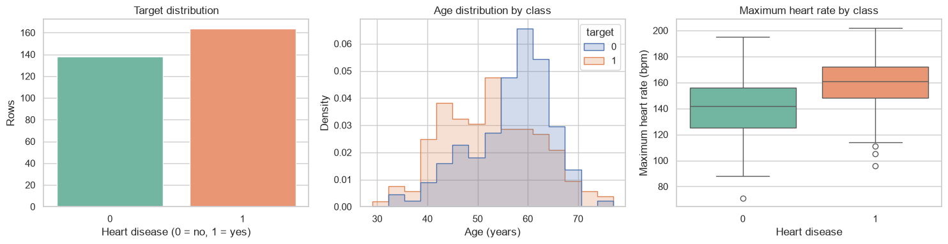
Target distribution, age distribution by class, and maximum heart rate by class.

2. Baseline Comparison and Held-Out Performance

Model | Acc. | Prec. | Sens. | Spec. | F1 | ROC-AUC | AP
Majority baseline | 0.5410 | 0.5410 | 1.0000 | 0.0000 | 0.7021 | 0.5000 | 0.5410
Logistic regression | 0.8361 | 0.8286 | 0.8788 | 0.7857 | 0.8529 | 0.8853 | 0.9023

The majority-class baseline labels every test row as positive, so its 54.10% accuracy merely matches positive-class prevalence and its specificity is zero. Logistic regression improves accuracy by 29.51 percentage points and performs better on every informative metric.

3. Confusion Matrix and Per-Class Results
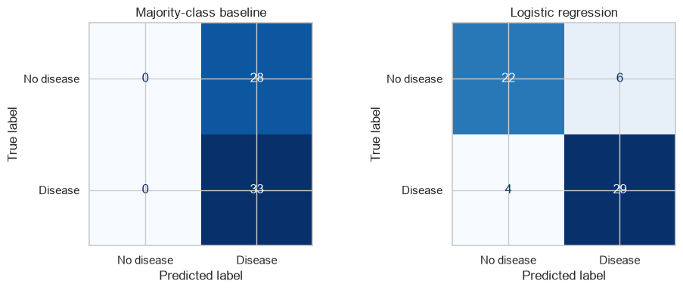
Confusion matrices for the majority-class baseline and logistic regression.

Actual class | Predicted no disease | Predicted disease
No disease | 22 | 6
Disease | 4 | 29

At the default threshold of 0.50, the model correctly classifies 51 of 61 test rows. It produces 6 false positives and 4 false negatives. The disease class has precision 0.8286, recall 0.8788, and F1-score 0.8529; the no-disease class has precision 0.8462, recall 0.7857, and F1-score 0.8148.

4. ROC and Precision-Recall Analysis
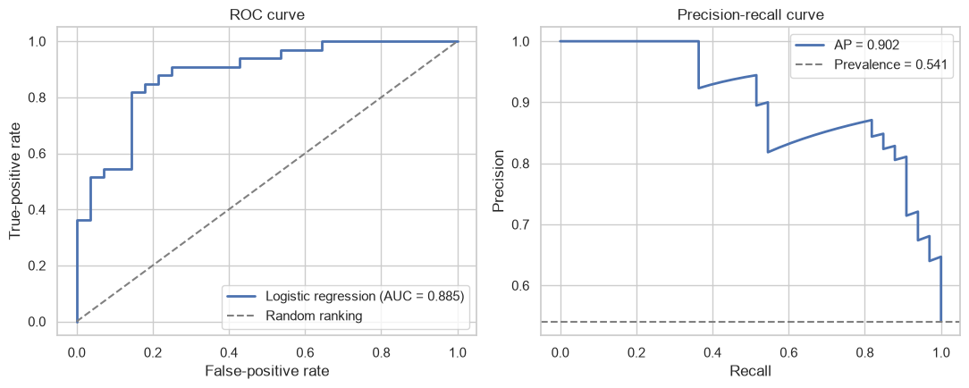
ROC curve and Precision-Recall curve for the logistic regression model.
The ROC-AUC of 0.8853 indicates useful ranking ability across thresholds. Average precision is 0.9023, substantially above the positive-class prevalence of 0.5410.

5. Five-Fold Cross-Validation
Cross-validation is performed only on the 241-row training portion. Every validation fold receives imputation, encoding, and scaling parameters learned from its corresponding training folds.

Metric | Mean | Standard deviation
Accuracy | 0.8509 | 0.0568
Precision | 0.8606 | 0.0623
Recall | 0.8701 | 0.0586
F1-score | 0.8641 | 0.0496
ROC-AUC | 0.9088 | 0.0425
Average precision | 0.9196 | 0.0295

The held-out results are consistent with these training-set estimates. The fold-to-fold variation is still meaningful because the dataset contains only 302 unique records.

6. Coefficient Interpretation

Transformed feature | Coefficient | Odds ratio
cp_2 | 1.4737 | 4.3653
cp_3 | 1.3751 | 3.9555
ca_2 | -1.3196 | 0.2673
ca_1 | -1.2280 | 0.2929
sex_male | -0.9670 | 0.3802
thal_2 | 0.9105 | 2.4856
thal_3 | -0.8069 | 0.4462
exang_1 | -0.7620 | 0.4667
cp_1 | 0.7374 | 2.0905
ca_3 | -0.6383 | 0.5282
Standardized chol | -0.4996 | 0.6068
Standardized oldpeak | -0.4939 | 0.6103

6. Coefficient Interpretation (Continued)
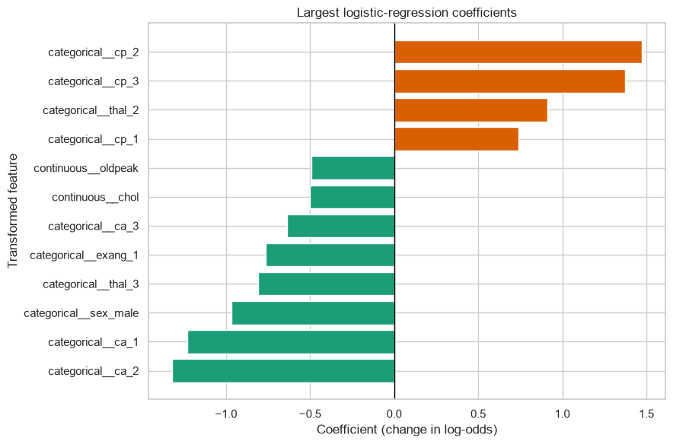
Largest fitted logistic-regression coefficients by absolute magnitude.
For a one-hot feature, the coefficient compares that category with the dropped reference category while other modeled variables stay fixed. For a standardized continuous feature, it corresponds to a one-standard-deviation increase. These values are fitted associations, not causal or clinical effects.

7. Probability-Threshold Analysis

Threshold | Accuracy | Precision | Sensitivity | Specificity | F1 | Positive rate
0.30 | 0.7541 | 0.7143 | 0.9091 | 0.5714 | 0.8000 | 0.6885
0.40 | 0.8197 | 0.7895 | 0.9091 | 0.7143 | 0.8451 | 0.6230
0.50 | 0.8361 | 0.8286 | 0.8788 | 0.7857 | 0.8529 | 0.5738
0.60 | 0.8361 | 0.8710 | 0.8182 | 0.8571 | 0.8438 | 0.5082
0.70 | 0.7377 | 0.8400 | 0.6364 | 0.8571 | 0.7241 | 0.4098

7. Probability-Threshold Analysis (Continued)
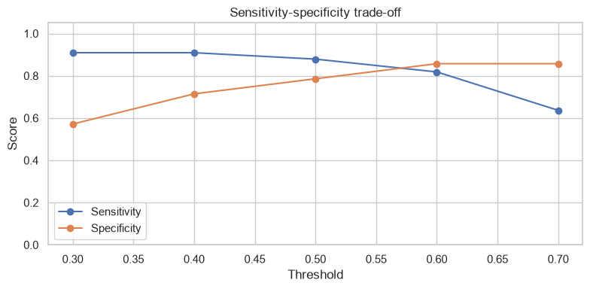
Sensitivity-specificity trade-off as the probability threshold changes.
Lowering the threshold from 0.50 to 0.40 increases sensitivity from 0.8788 to 0.9091 but lowers specificity from 0.7857 to 0.7143. Raising it to 0.60 increases specificity to 0.8571 while lowering sensitivity to 0.8182. The table demonstrates the trade-off and does not establish a clinical operating point.

8. Automated Checks and Final Result
All data-shape, feature/target, train-test separation, stratification, probability-range, performance, and coefficient-dimension checks passed successfully.
RESULT: The leakage-safe logistic regression model achieved 83.61% test accuracy, 87.88% sensitivity, 78.57% specificity, an F1-score of 0.8529, ROC-AUC of 0.8853, and average precision of 0.9023.

OBSERVATIONS:
- The dataset is only mildly imbalanced, but the dummy classifier shows that accuracy alone can still be misleading.
- Leakage-safe preprocessing is important even though only ten measurement values are missing.
- Logistic regression substantially outperforms the majority-class baseline on every informative test metric.
- At threshold 0.50, sensitivity is higher than specificity and the model produces 4 false negatives and 6 false positives.
- ROC-AUC and average precision show useful ranking performance on the held-out split.
- Cross-validation results are broadly consistent with the held-out results, although uncertainty remains because the dataset is small.
- One-hot encoding prevents integer category codes from being interpreted as equal-interval measurements.
- The fitted coefficients improve transparency but do not establish causal or clinical effects.
- Changing the threshold redistributes false positives and false negatives; no single threshold maximizes every metric.
- External validation, calibration, subgroup evaluation, and clinical review would be necessary before real-world use.

LEARNING OUTCOMES:
- Understand logistic regression, the sigmoid function, log-odds, and predicted probabilities.
- Build a leakage-safe preprocessing and classification pipeline using Scikit-learn.
- Use stratified train-test splitting and compare a learned model with a dummy baseline.
- Calculate and interpret accuracy, precision, sensitivity, specificity, F1-score, ROC-AUC, and average precision.
- Construct and interpret confusion matrices, ROC curves, and Precision-Recall curves.
- Use cross-validation to estimate model stability without including the held-out test set.
- Interpret logistic-regression coefficients and odds ratios with appropriate limitations.
- Analyze how classification thresholds change sensitivity, specificity, false positives, and false negatives.
- Recognize the difference between an educational predictive experiment and a clinically validated diagnostic model.

CONCLUSION:
The completed pipeline demonstrates a reliable logistic-regression workflow for binary classification. Correct feature typing, training-only preprocessing, baseline comparison, multiple evaluation metrics, cross-validation, and explicit threshold analysis make the experiment more trustworthy than reporting accuracy alone. On the fixed test split, the model achieved 83.61% accuracy and an ROC-AUC of 0.8853. The threshold analysis confirms that sensitivity and specificity cannot generally be maximized together. Because the dataset is small and lacks external validation, the result demonstrates machine-learning methodology rather than a deployable medical diagnostic system.

VIVA QUESTIONS AND ANSWERS:
1. Why is logistic regression used for classification? It models the probability of a class through a sigmoid transformation and converts the probability into a label using a threshold.
2. What does the sigmoid function do? It maps any real-valued linear score to a value between 0 and 1.
3. Why is it called regression? The method performs regression on the log-odds of the positive class, even though its final output is used for classification.
4. What is log-odds? Log-odds is log(p/(1-p)). Logistic regression models it as a linear combination of predictors.
5. What is a classification threshold? It is the probability cut-off used to convert a predicted probability into a class label.
6. Why is a pipeline used? It makes preprocessing reproducible and ensures imputation, encoding, and scaling are learned from training data only.
7. Why are coded variables one-hot encoded? Their numbers represent categories, not equal measurement intervals, so one-hot encoding avoids a false numeric order.
8. What is sensitivity? Sensitivity is the proportion of actual positive cases detected: TP/(TP+FN).
9. What is specificity? Specificity is the proportion of actual negative cases correctly rejected: TN/(TN+FP).
10. What is precision? Precision is the proportion of predicted positive cases that are actually positive: TP/(TP+FP).
11. What is the F1-score? It is the harmonic mean of precision and recall.
12. What does ROC-AUC measure? It measures how well prediction scores rank positive cases above negative cases across all thresholds.
13. Why is the Precision-Recall curve useful? It focuses on positive-class performance and is especially informative when positive cases are rare or errors on that class matter most.
14. Why use stratified splitting? It preserves approximately the same class proportion in the training and testing sets.
15. Why compare with a dummy classifier? It checks whether the model learns useful patterns beyond always predicting the majority class.
16. What happens when the threshold is lowered? More rows are labeled positive, so sensitivity usually rises while specificity and precision may fall.
17. Why should the threshold not always be 0.50? The appropriate cut-off depends on the relative cost of false positives and false negatives and must be validated for the application.
18. Can this model diagnose heart disease? No. It is an educational model trained on a small dataset without clinical or external validation.

