**iOS()**

**C Language & C++ Language**

**Core iOS(Swift)**

* ****Core Swift
* Basic Core
* Overview of objective C
* Basic Information of ios
* Introduction of ios
* Basic Concept with playground
* IB Outlets & IB Actions
* Storyboard & XIB
* Delegate & Protocol
* Text field & text view and Delegate methods of them
* 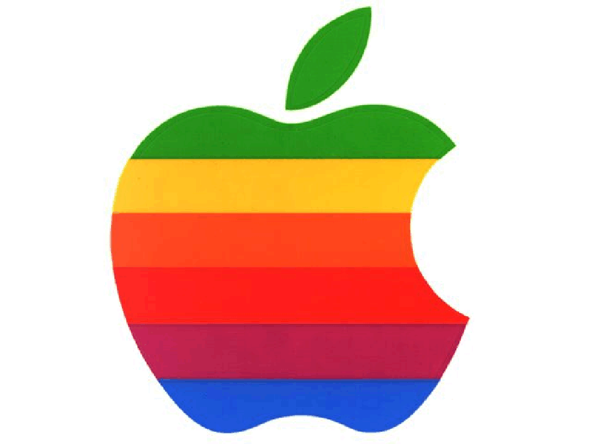Ui Controls
* Api Calling
* Constraints
* Dynamic UI Controls
* Cocoa Pods
* Local Database
* Core Database
* Tab Bar
* App Uploading

**Projects:-**

* Brain Games Card / Games | Expense Manager | App. Quiz App | EMI Calculator | Health AppR1O Exam app. | Contact Duplicate App | Tic-Tac-Toe Game | Teuth & Dare GameQR Code & Barcode Scanner & Generator app.

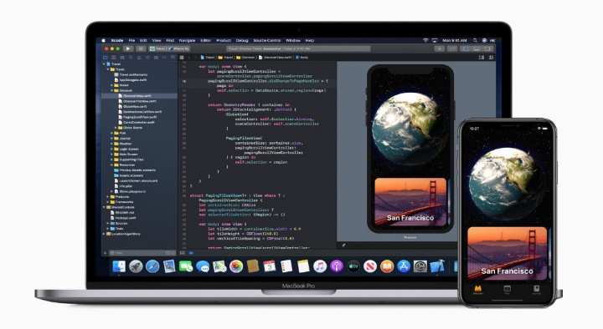**Advance ios (Swift)**

* Advance Swift
* Models
* Coding Intrusions as a Developer
* MVC Architecture
* MVVM Architecture
* Map, Filter, Reduce
* SideBar
* Advance API Calling
* Push Notifications
* Firebase Integrations
* Project Architecture
* Droppdown, pop-Ups
* Use Controls in Advance
* App Group
* Thread Controlling
* UI / UX Design
* Figma
* Introduction of Figma
* Select, Rectangle, Ellipse, Line, Polygon & Text tool.
* Pen Tool, Artboard Tool, Zoom Tool Appearance Option.
* Clipping Amsk, Repeat Grid, Scrolling Option Working with Assets and Layer, Grouping and Ungrouping
* Crautirg Cloud Acceurt & Introduction of Prototype Preview.
* Using Figma Kimts & Plugins.
* Sharing your Figma Designs.
* Viewing Design on Mobile.

**Projects:-**

* Multi-vendor app | Queue Management app | Video Streaming app | Weather App | Notes App | Mood Tracker app | Chart app 8.Cab Booking app | Survey apps 10.AR app

**Digital Marketing(ડિજીટલ માર્કેટીંગ)**

* Digital Marketing Overview
* Website Creation & Planning
* Search Engine Optimization (SEO)
* Search Engine Marketing (SEM)
* Social Media Optimization (SMO)
* Social Media Marketing (SMM)
* Email Marketing
* Online Reputation Management (ORM)
* Web Analytics
* Lead Generation
* Affiliate Marketing
* Content Marketing





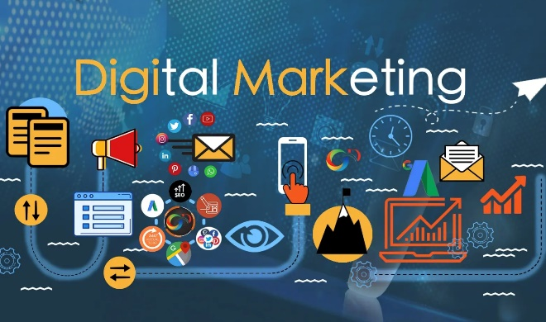

**Graphics Design(ગ્રાફિક્સ ડિઝાઈન)**

**Adobe Photoshop**

* History of the photoshop (Page Sizing Function)
* Selection, Cutting, Total Tool with Father
* Pen Tool
* Quick Selection Tool
* Marquee Tool
* Image Masking
* Navigation Bar
* Selection menu & Fill Color Layer, Mode Changer
* Select Menu: All Function
* Text Tool
* Align Tool
* Crop Tool
* Layer Masking
* UI/UX Design (Web Layout & Mobile App Layout)
* Gradient Tool
* Blur Tool
* Mockup
* Shape Tool: All Function
* Creating Cartoon
* Layer Style
* Creating Logo
* Creating Resume
* GIF Animation
* Image Men
* Banner Design
* Layer Menu
* Final Project

**Adobe Illustrator**

|  |  |
| --- | --- |
| * Creating a New Document * Drawing a Shape * Applying And Editing Color * Editing Shapes * Editing Strokes * Working With Layers * Working With Gradients * Warping Text * Logo Design * Banner Design * Creating And Editing A Gradient | * Cartoon Design * Creating Symbols * Getting To Know The Toolbar * All Tools * Practical Exam * Navigating Multiple Artboards * Creating A Clipping Mask * Creating Patterns * Flyer Design * Business Card * Final Practical Exam |

**Adobe XD**

* Creating a new file
* Setting up artboards
* Importing text
* Creating colored backgrounds for text
* Importing &Cropping Photos & Image masking
* Importing Vector Graphics, Fills, Shadows
* Background blur
* Making a recording of a prototype
* Using the included Ul Kits
* Adjusting the design
* Previewing the prototype
* Creating & editing symbols
* Exporting individual assets
* Sharing an XD file
* Final Project

**OR**

 **Figma**

* Figma
* Intro Of Figma
* Select
* Pen Tool
* Clipping Mask
* Rectangle
* Ellipse
* Line
* Polygon & Text Tool
* Artboard Tool
* 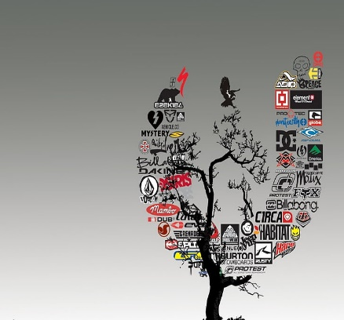Grouping And Ungrouping
* Creating Cloud Account & Intro Of Prototype Preview
* Using Adobe Figma Kits & Plugins
* Sharing Your Adobe Figma Designs
* Viewing Design On Mobile
* Appearance Option
* Repeat Grid
* Scrolling Option Working With Assets And Layer
* Zoom Tool

**Benefits Of Graphic Des.**

* Freedom to Express Your Imagination I Chance to meet new Designer | You Can Freelancing HigI Help to App and Web Developer I Learning New Techniques and Skills I Best Trainer

**Back End Developing (બેક એન્ડ ડેવલોપીંગ)**

**Front End Coding**

* Create a Website Structure Using HTML, HTML5
* Formatting Web Layouts Using CSS3
* Converting PSD to HTML
* Add Some Cool Effects Using JavaScript & jQuery
* Optimizing Website Using SEO Rules
* Launching Our Website
* Build Responsive Web Design Using Media Query Using Framework Like Bootstrap
* Adding Animation, Scrolling Effects, and Many More Effects Using JS & Jquery Learning About Domain, Hosting and Maintain Live Website Using Server Panel
* Working With WordPress, Installing, Customization, Using Dashboard

**Languages To Learn:**

* HTML5, CSS3, SASS, LESS, Media Query

**Framework:**

* JQUERY (ATCH.), BOOTSTRAP, WORDPRESS

**Other:**

* SEO, FTP, HOSTING

**Java Script:**

* JavaScript Importance
* ECMAScript & Versions & Install Environment Scratch JS
* Show different Types of Output Methods (alert, console, document, inner HTML)
* Syntax and Operations of JS
* Conditions & Looping
* Different types of Variable Like (var, const, let)
* Array and String With Different Methods
* Functions (Function Types, Return Types)
* Working with Objects (Prototype, Methods)
* Use Different Types of Objects LIKE (Date, Math, Boolean, Number)
* Understanding Class and Objects, constructor, Prototype, Inheritance
* Working with JavaScript DOM (document Object Module)
* Understanding ES6 Concept

- Arrows, Classes, Iterators + for..of, Modules & Module Loaders

- Proxies, Symbols, Promises, then, next

* Understanding Json (JavaScript Object Notation)
* Working with Json (json.parse, Json.stringify,Json object, Json array)
* Storing Local data in javascript with Json local storage

**Node JS**

* Understanding Developer Tools
* Setup Node Js Environment
* Installing NPM(Globally & Locally)
* Understanding Event Emitter & REPL and CMD
* Make server with node js and Handle http REQUEST and RESPONSE
* How to attach Server Static Resources
* Middleware & File Streaming
* Differe Types of web Application Frameworks

(Express, Koa, Hapi, Others)

* Understanding MVC Framework Express JS
* Setup MongoDB and Connect with Nodejs
* Callback Functionality (Promises and Bluebird Promises)
* Working with Different Type Module

(Node Mailer, PDFMAKE, Socket 10, Passport JS,

* Express-session, Cookie Parser, connect-flash)
* Installing Passport js and make Manual Authentication
* Working with API + JWT

(JSON WEB TOKEN) Management

* REST full Api (Social Media Integration Google, Facebook)
* Chat Application with SOCKET
* Debugging of Node Js application
* Deployment Project In Heroku



**Other Objectives:**

* MY SQL | AJAX | JQUERY | LIVE PORTFOLIO MAKING

**Included In Career & Master Course:**

* PD
* Entrepreneur & Freelancing