1. In the below elements which of them are values or an expression? eg:- values can be integer or string and expressions will be mathematical operators.

\*

Ans- expression

'hello'

Ans- values

-87.8

Ans- integer

/

Ans- expression

Ans- expression

6

Ans- integer

2. What is the difference between string and variable?

Ans- A string is a value representing text and a variable is a name that can refer to any value quotes, double or single

3. Describe three different data types.

Ans-String,Integer,Float are three different data types

4. What is an expression made up of? What do all expressions do?

Ans- An expression is any combination of symbols (like a variable, constants, and operators) representing a value. An expression must have at least one (variable or constant) and have one or more operators. After evaluating an expression, we get a value.

5. This assignment statements, like spam = 10. What is the difference between an expression and a statement?

Ans- A statement is a complete line of code that performs some action, while an expression is any section of the code that evaluates to a value.

6. After running the following code, what does the variable bacon contain?

bacon = 22

bacon + 1

Ans 23

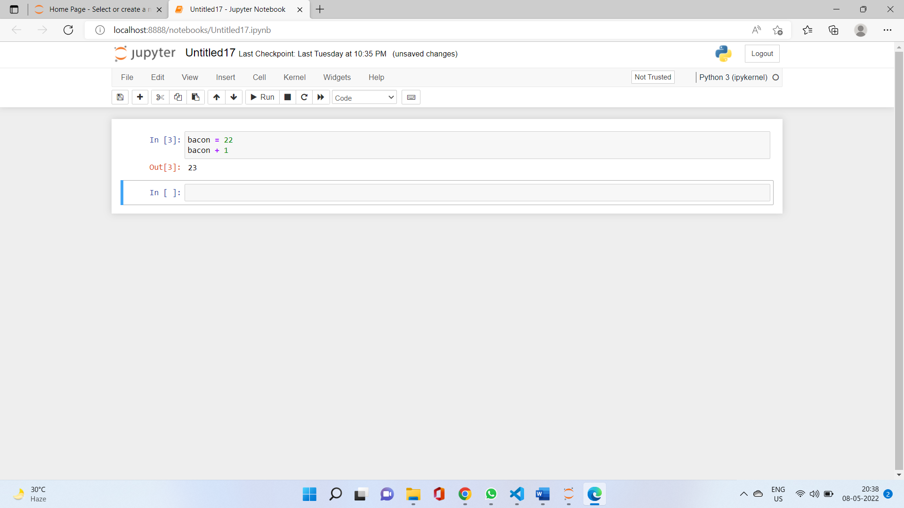

7. What should the values of the following two terms be?

'spam' + 'spamspam'

Ans:- spamspamspam

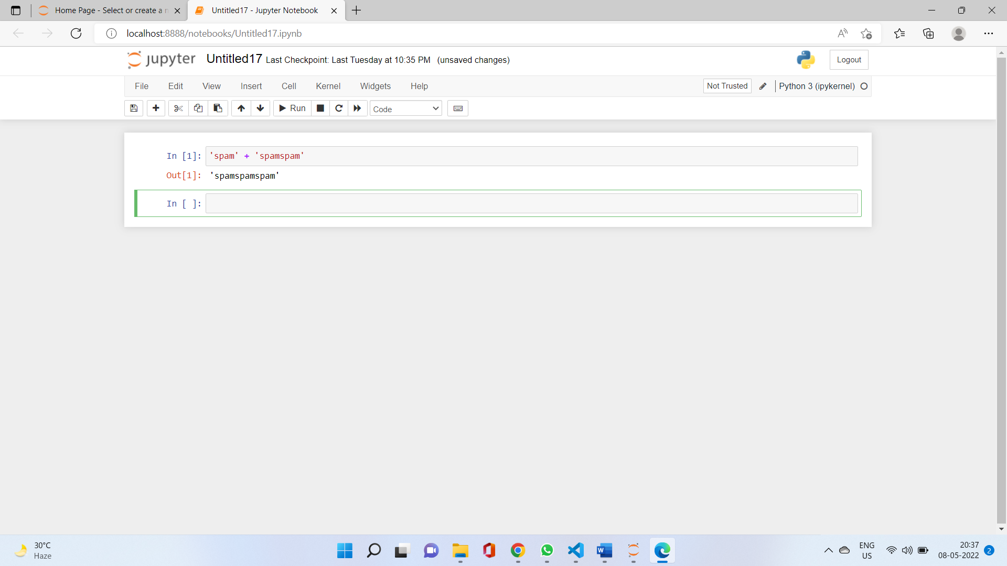

'spam' \* 3

Ans:- spamspamspam

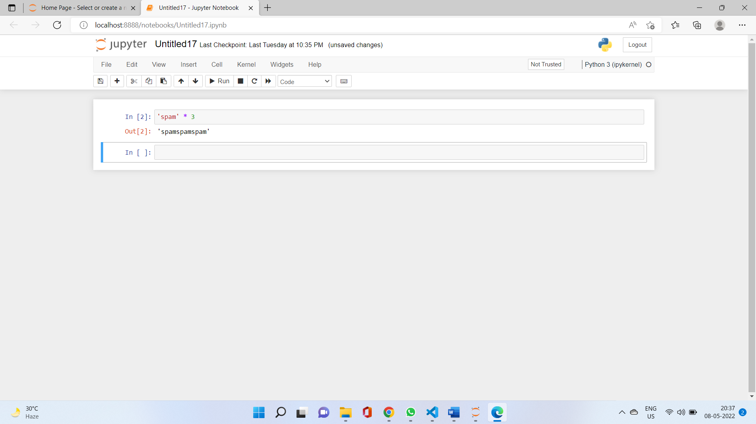

8. Why is eggs a valid variable name while 100 is invalid?

Ans:- Eggs a valid variable name while 100 is invalid because we can't start giving variable an integer name. if we, we should begin with, a string-like alphabet name then integer. e100 or eggs100 is valid.

9. What three functions can be used to get the integer, floating-point number, or string version of a value?

Ans- str(), int(), float()

10. Why does this expression cause an error? How can you fix it?

'I have eaten ' + 99 + ' burritos.'

Ans- because 99 is an integer it cannot be concatenated with strings, if we have to concatenate it we need to do typecasting.