Credit Card Default Prediction Model
Wireframe Document
Mehul Rampratap Nayak

Wireframes
Design Wireframes
Wireframe is a basic visual interface guide that suggests the structure of an interface and the relationships between its pages. They serve as a blue print that defines each Web page’s structure, content and functionality. Wireframes are created before any design work is started so that the focus is on layout without the distraction of colour and visual elements.

Gathering Requirements
Wireframes will often help to flush out new requirements and questions that may not have been considered by the project team. Wireframes often end up evolving into the requirements for a system. Wireframes can be created using a variety of software applications online or offline.

Functional Wireframes
This is another type of wireframe that is used in building web applications. It shows not only how each page is structured but information about each widget, button, field, each piece of content, and what page is rendered by an action. It provides a map of the entire page in the Web site, its function and features. Even the message that may be rendered by a behaviour can be included on this type of wireframe. I wanted to provide some background for this Web application process so that it would be clear what the wireframes represent. The purpose of the Web application is to provide a tool for users to create and maintain FAQs. Users can be either general users (who create and maintain their FAQs) or a system administrator who not only has the same authority to create and maintain FAQs but also maintains users (i.e., assigns new users or deletes existing users). The following screen captures are some of the general user wireframes.

Homepage
Front page has two sections – Top section has a header with logo and project name which acts as a hyperlink to home URL, bottom section has form to get input from the user. At the end we have submit button to execute the prediction, footer holds publish year and author information.
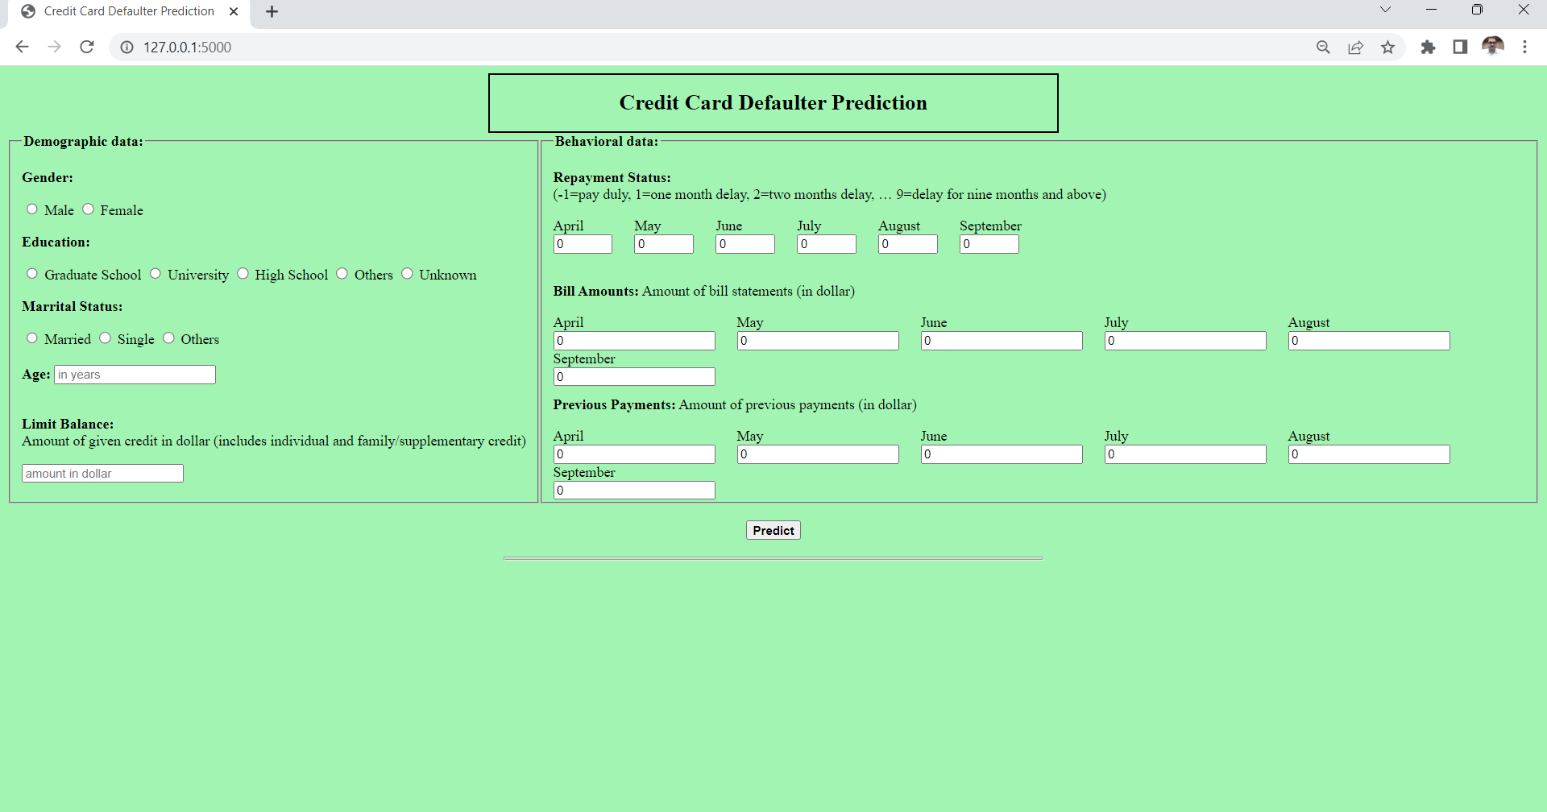
Input Fields
Limit Balance
Every Debit/Credit card has limit to purchase or withdraw amount from ATM depending on the type of card. Privileged customers will have more credit to perform transaction in a single day whereas basic customers will have limited usage power. User need to provide integer value matching their transaction limit.

Gender
Select appropriate gender from the drop down option

Age
Integer value is required

Education
User has to select generic education qualification from the options provided

Marriage
User need to specify customers marriage status for precise prediction

Payment History
This input field hold many options to select from to specify the customers previous payment practice whether the due has been paid on time or in delay

Pending Bill Amount
Specify current outstanding bill amount to be paid by the customer

Bill Amount of Apr, May,…September
Mention all Bill amount for past six months accordingly

Amount paid in Apr, May,…September
Mention all payments done by the customer for past six months accordingly
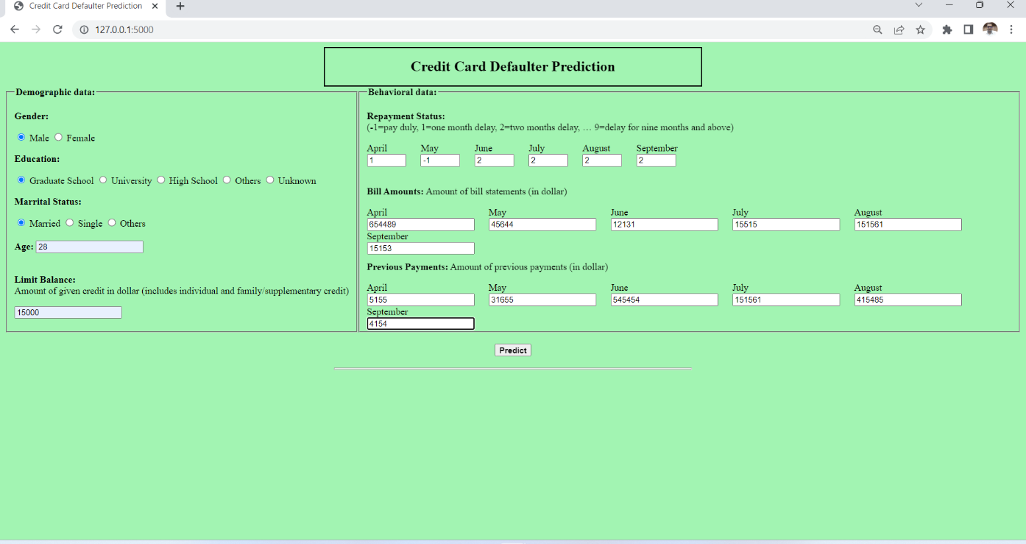

Predict Page
We will receive input from the user in homepage and execute the prediction process on clicking submit button. The output result will be displayed in between two section aligned centre for convenience.
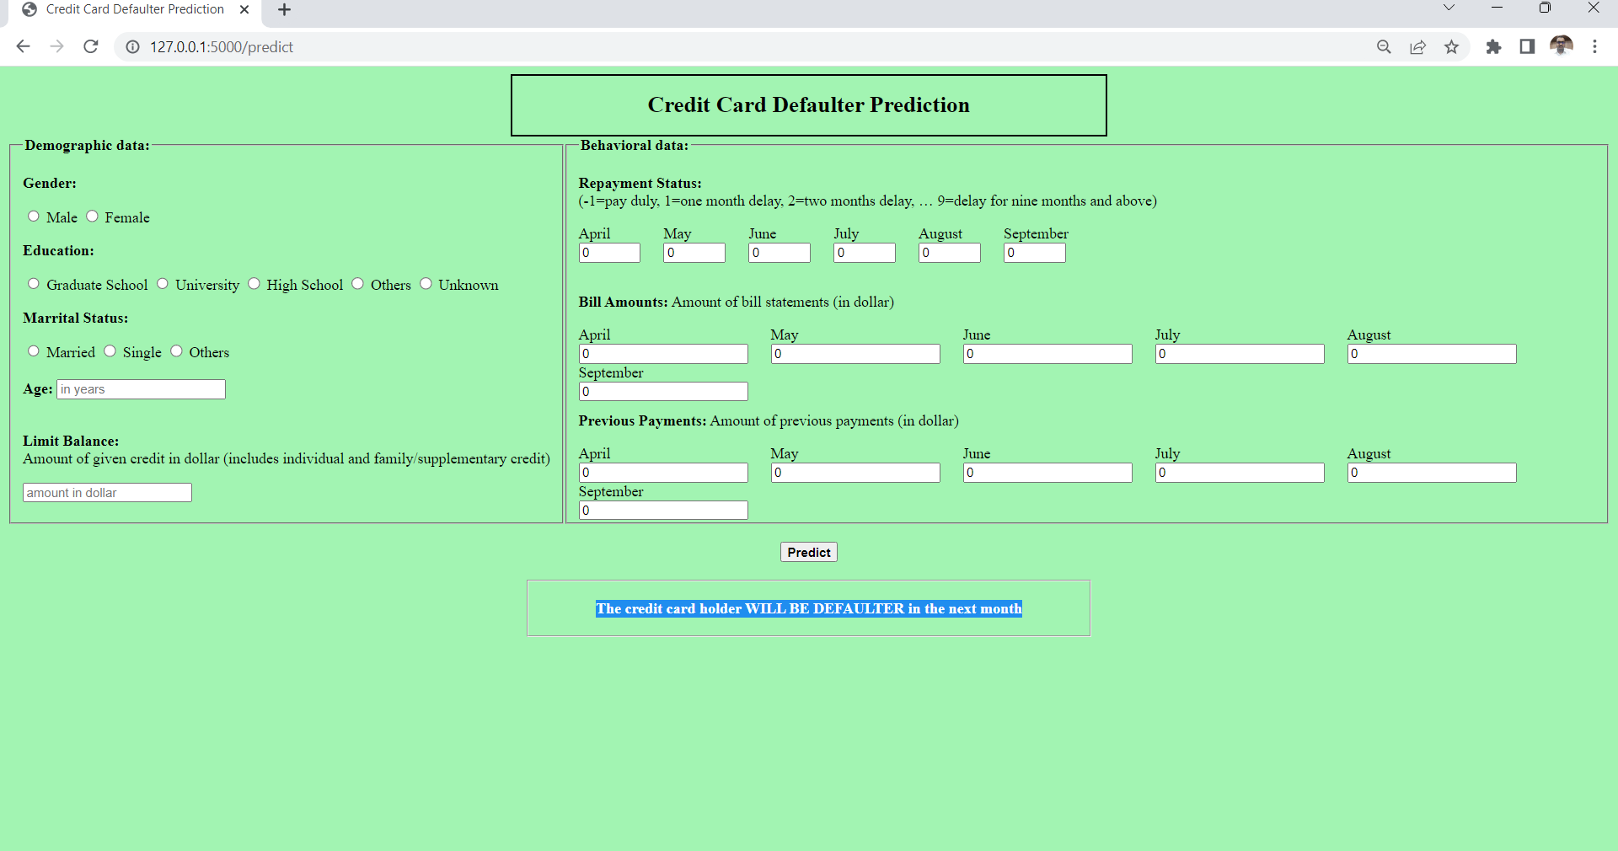

Predict Again
User can click on the project title in the header to load homepage again and make next prediction providing all the required information of the customer

