CSP554—Big Data Technologies

Assignment #4
Assignments can be uploaded via the Blackboard portal
It is ok to ask for hints from me to help solve the problems below. I will try to be helpful without giving away the answers.
Note: There may be short quiz questions about readings, assignments or articles (except extra credit) in the class period when they are due.
Read from (TW)
- Chapter 16
- Chapter 19
For this assignment you will be using your Hadoop environments
The general theme of this week’s assignment is to write several Hive command and queries programs to perform various tasks.
I have included the code I used to demo Hive as one of the files—hql.zip—associated with this assignment. There are useful bits to study and reuse, so have a look now.
You must test your exercises against randomly generated data files. You will generate these files using the TestDataGen program. To do so please follow the below steps:
- Download the file TestDataGen.class from the Blackboard. It is one of the attachments to the assignment.
- scp the file over to the home directory on your Hadoop VM (into the maria_dev account)
- Log on to your VM using ssh (maria_dev account) and execute the file using “java TestDataGen”
- This will output a magic number which you should copy down and provide with the results of your assignment.
Solution : Magic Number = 108070

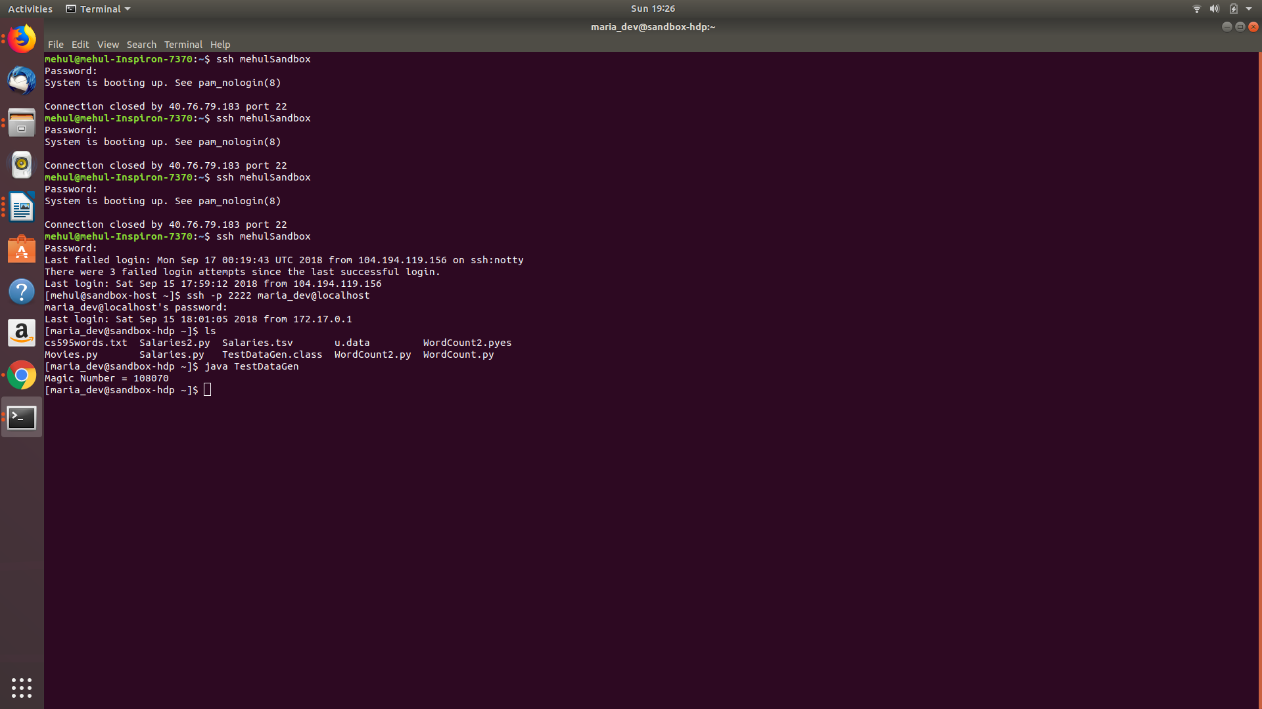

- It will also place the files foodratings<magic number>.txt and foodplaces<magic number>.txt in your VM home directory
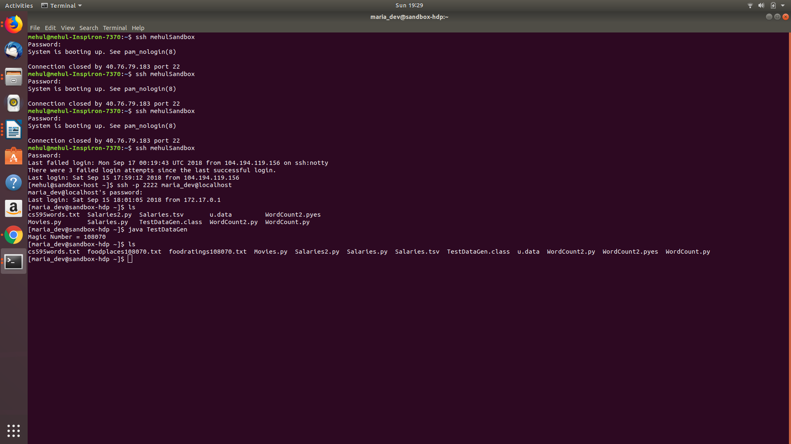

- Use them for your exercises
- Note, each time you execute the TestDataGen program it create new files of test data so you can exercise your program using different combinations of data. Make sure to send the magic number of your final test data set.
The foodratings<.magic number>.txt file has six comma separated fields. The first field is the name of a food critic. The second through fifth fields are the ratings each critic gives to four food types at each restaurant they review. The ratings are an integer from 1 through 50. The sixth field is the id of the restaurant.
The foodplaces<.magic number>.txt file has two comma separated fields. The first field is the id of a restaurant. The second field is the name of that restaurant.
Exercise 1) 2 points
Create a Hive database called MyDb.
Command : create database MyDB;
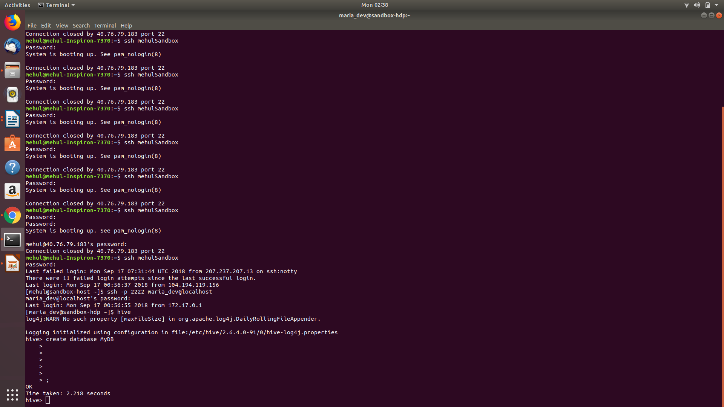
Command : show databases;

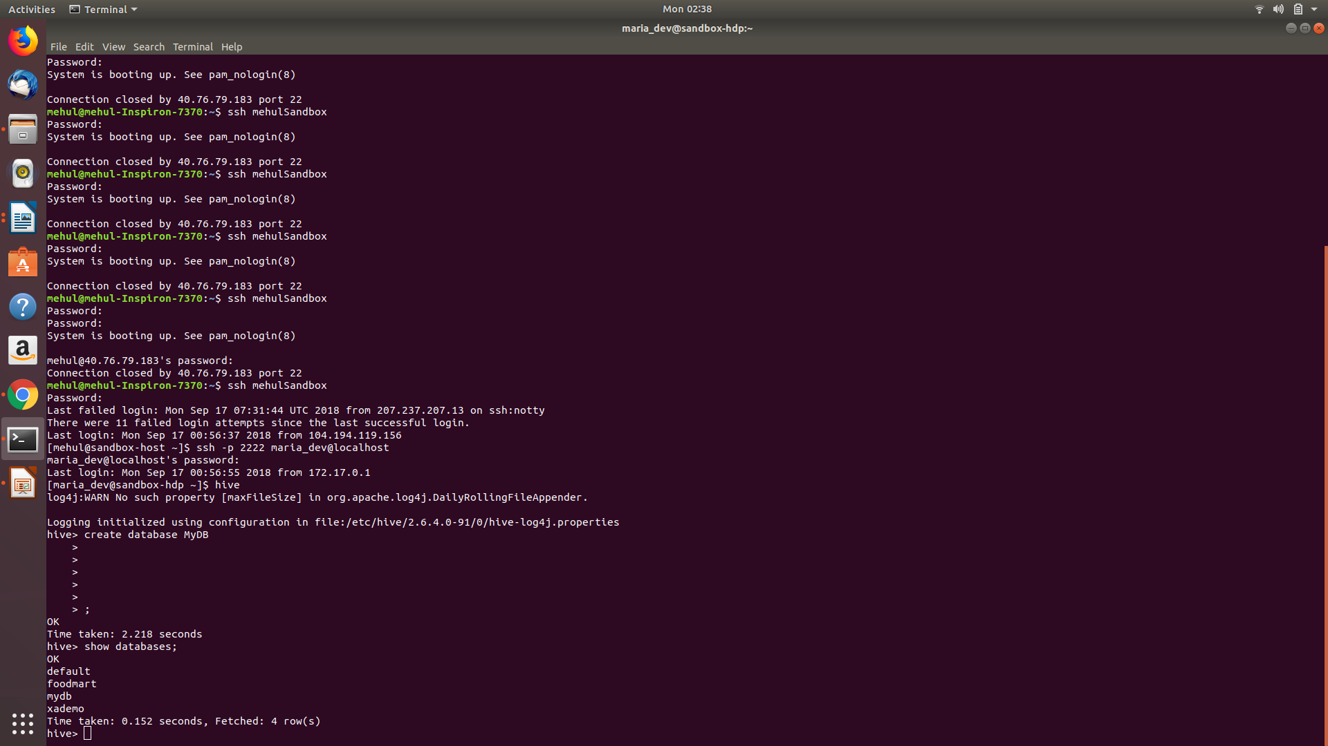
Then in MyDb create a table with name foodratings having six columns with the name of the first ‘name’ and the type of the first a string and the names of the remaining columns food1, food2, food3, food4 and id and indicate their types each ras an integer. The table should have storage format TEXTFILE and column separator a “,”. That is the underlying format should be a CSV file. The table itself and each column should include a comment (it does not matter what it says).
Execute a one shot Hive command of ‘DESCRIBE FORMATTED MyDb.foodratings’ and capture its output as one of the results of this exercise.
Command: Create table mydb.foodratings(name string comment 'name comment',food1 int comment'food1 comment',food2 int comment 'food2 comment',food3 int comment 'food3 comment',food4 int comment 'food4 comment',id int comment 'id comment') COMMENT 'Table for food ratings' ROW FORMAT DELIMITED FIELDS TERMINATED BY ',' STORED AS TEXTFILE;
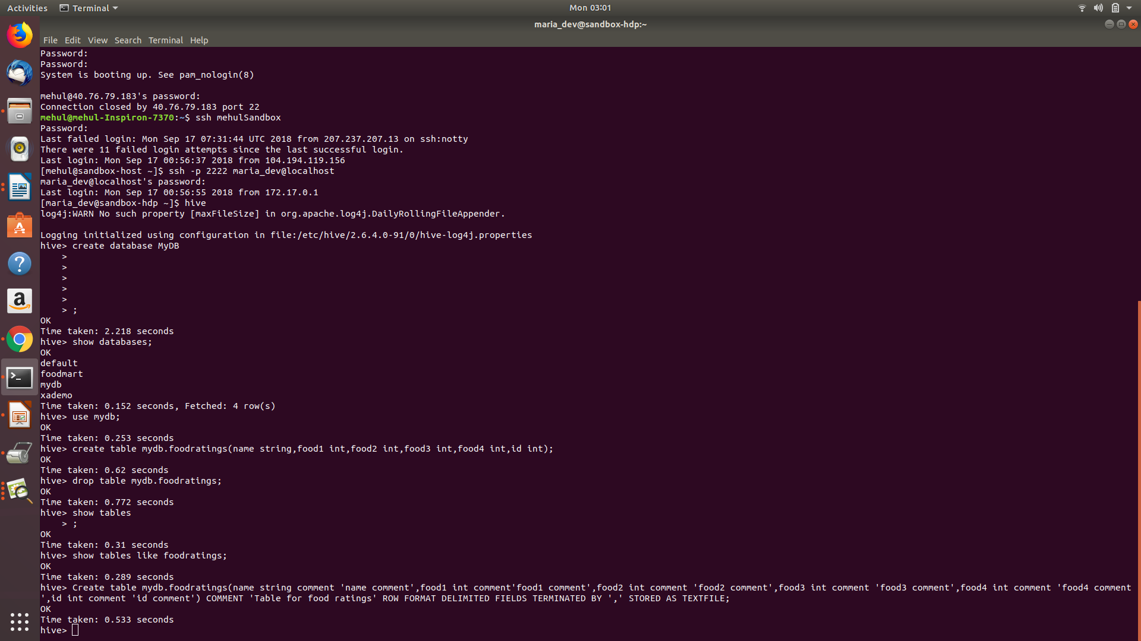
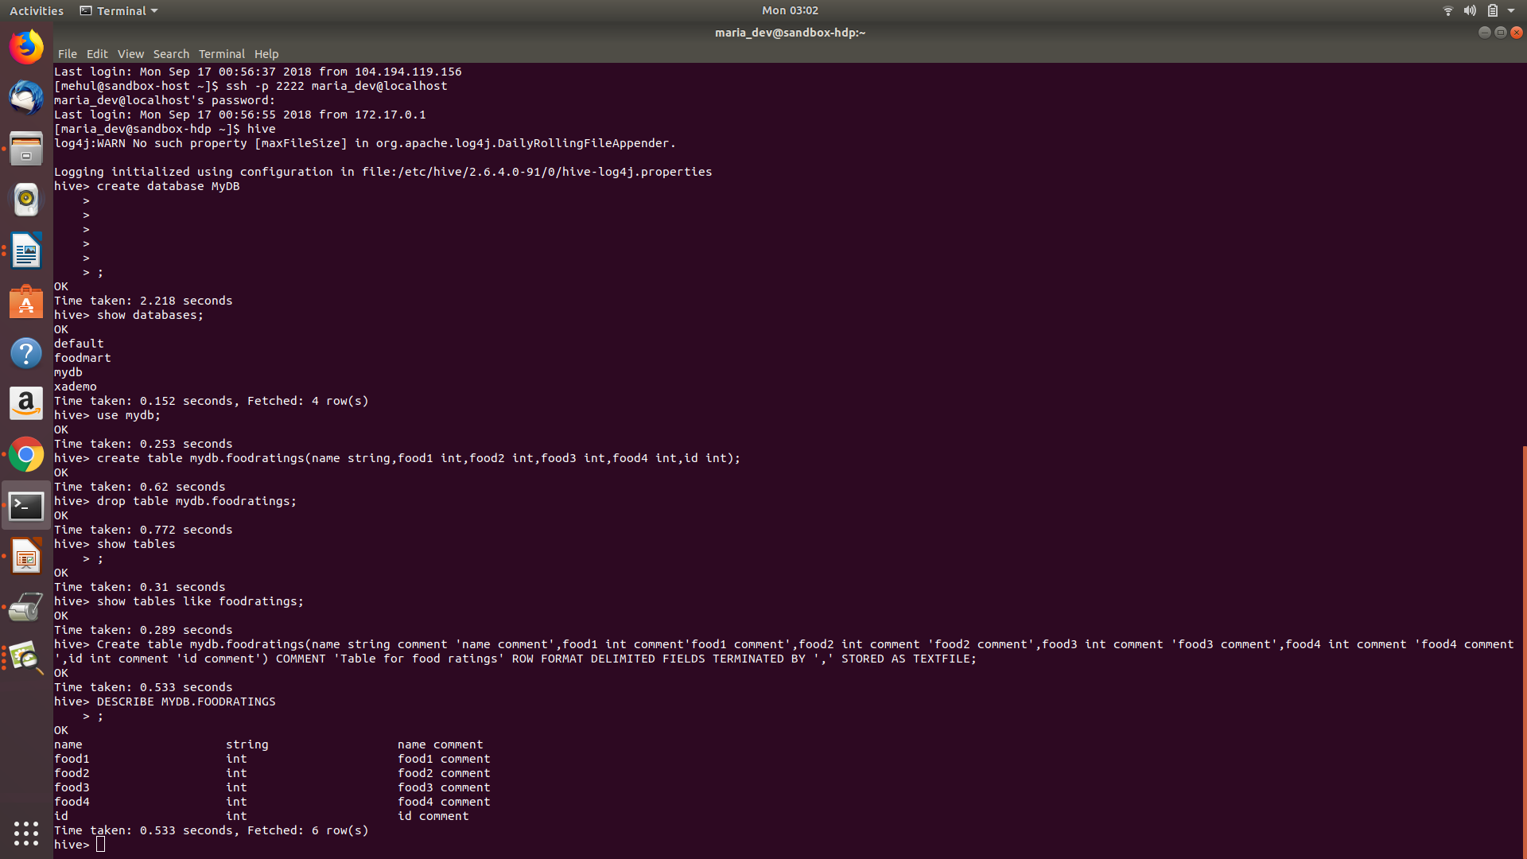
Command:DESCRIBE MYDB.FOODRATINGS;

Then in MyDb create a table with name foodplaces having two columns with first called ‘id’ and the type of the first an integer and the second called ‘place’ and the type of the second a string. This table should also have storage format TEXTFILE and column separator a “,”. That is the underlying format should be a CSV file. No comments are needed for this table
Execute a one shot Hive command of ‘DESCRIBE FORMATTED MyDb.foodplaces’ and capture its output as another of the results of this exercise.
Command:create table mydb.foodplaces(id int,place string)ROW FORMAT DELIMITED FIELDS TERMINATED BY ',' STORED AS TEXTFILE;
DESCRIBE FORMATTED MYDB.FOODPLACES;
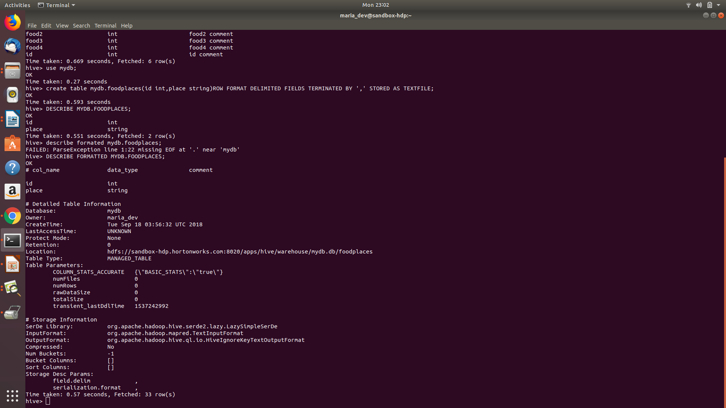

Exercise 2) 2 points
Load the foodratings<.magic number>.txt file created using TestDataGen from your local file system into the foodratings table.
Command: load data local inpath 'file:/home/maria_dev/foodratings108070.txt' into table mydb.foodratings;

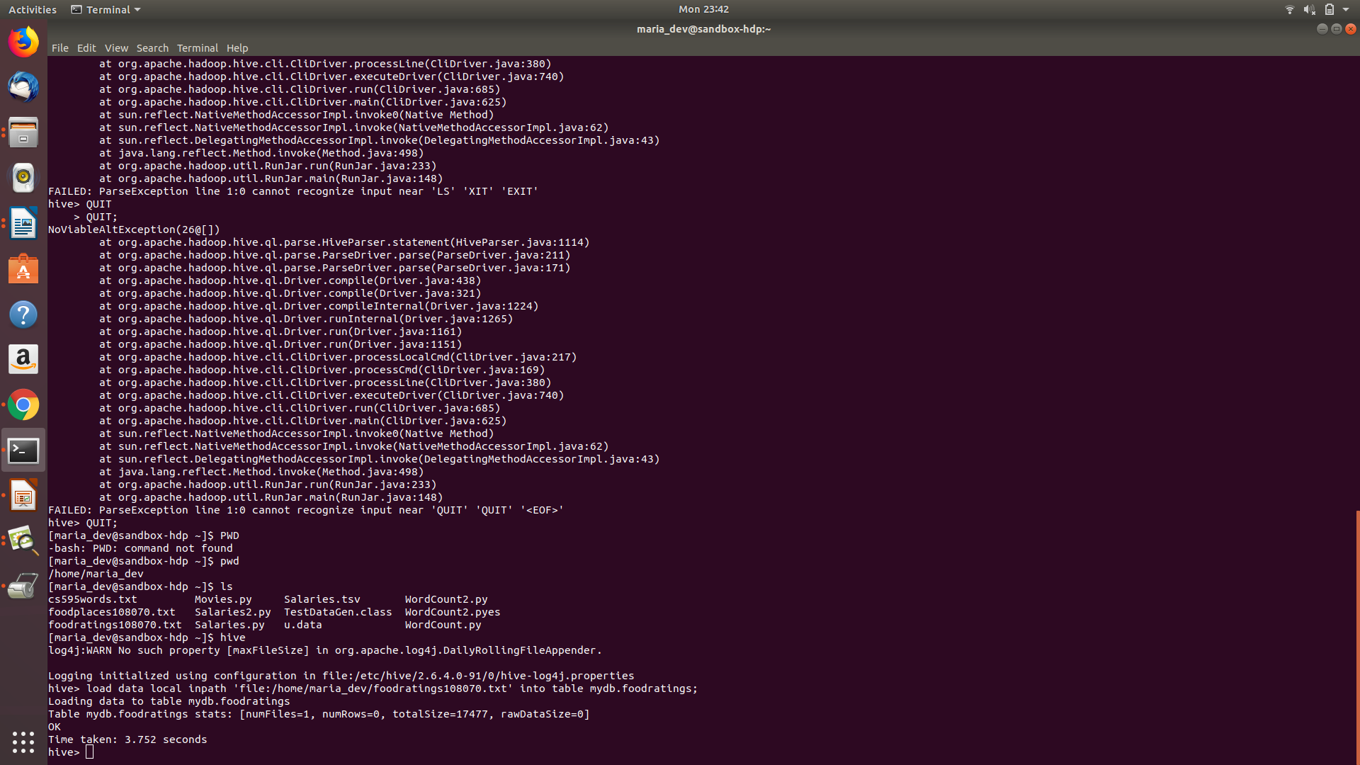
Execute a hive command to output the min, max and average of the values of the food3 column of the foodratings table.
A copy of the hive command you wrote, the output of this query and the magic number are the result of this exercise.
Command: select min(food3),max(food3),avg(food3) from mydb.foodratings;

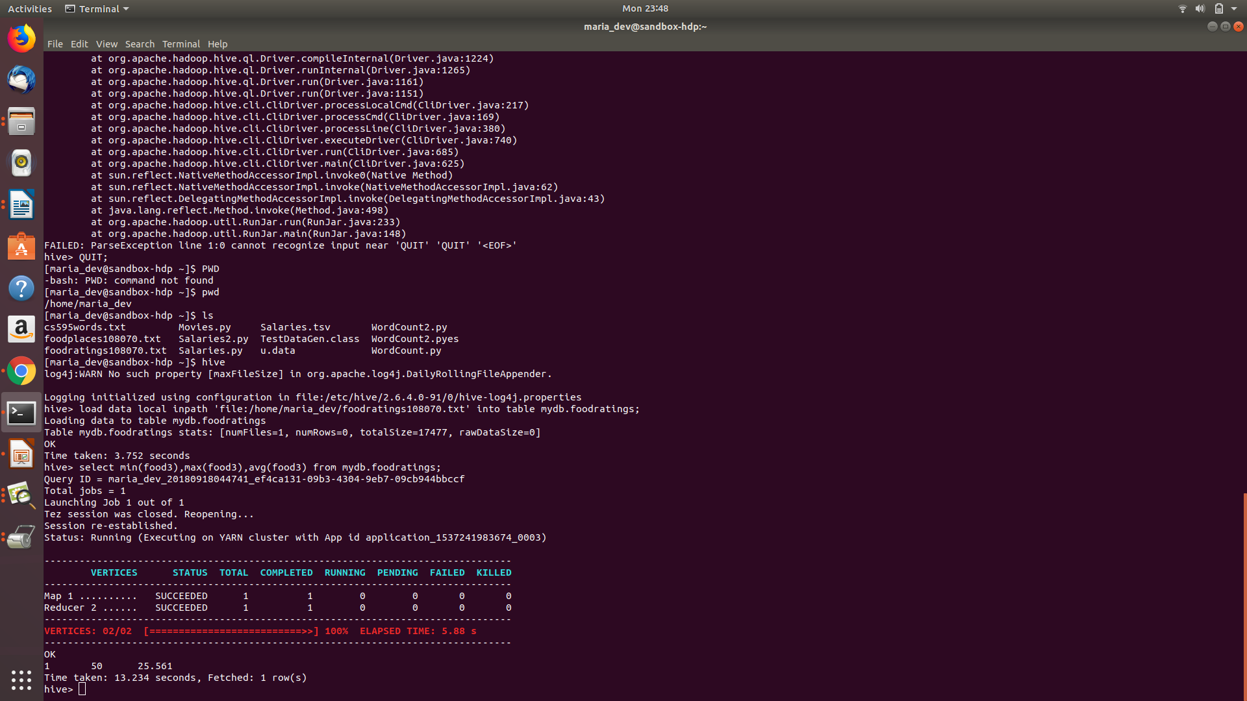
Exercise 3) Execute a hive command to output the min, max and average of the values of the food1 column grouped by the first column ‘name’.
The output should look something like:
Mel 10 20 15
Bill 20, 30, 24
…
A copy of the hive command you wrote, the output of this query and the magic number are the result of this exercise.
Command: select name ,min(food1),max(food1),avg(food1) from mydb.foodratings group by name;

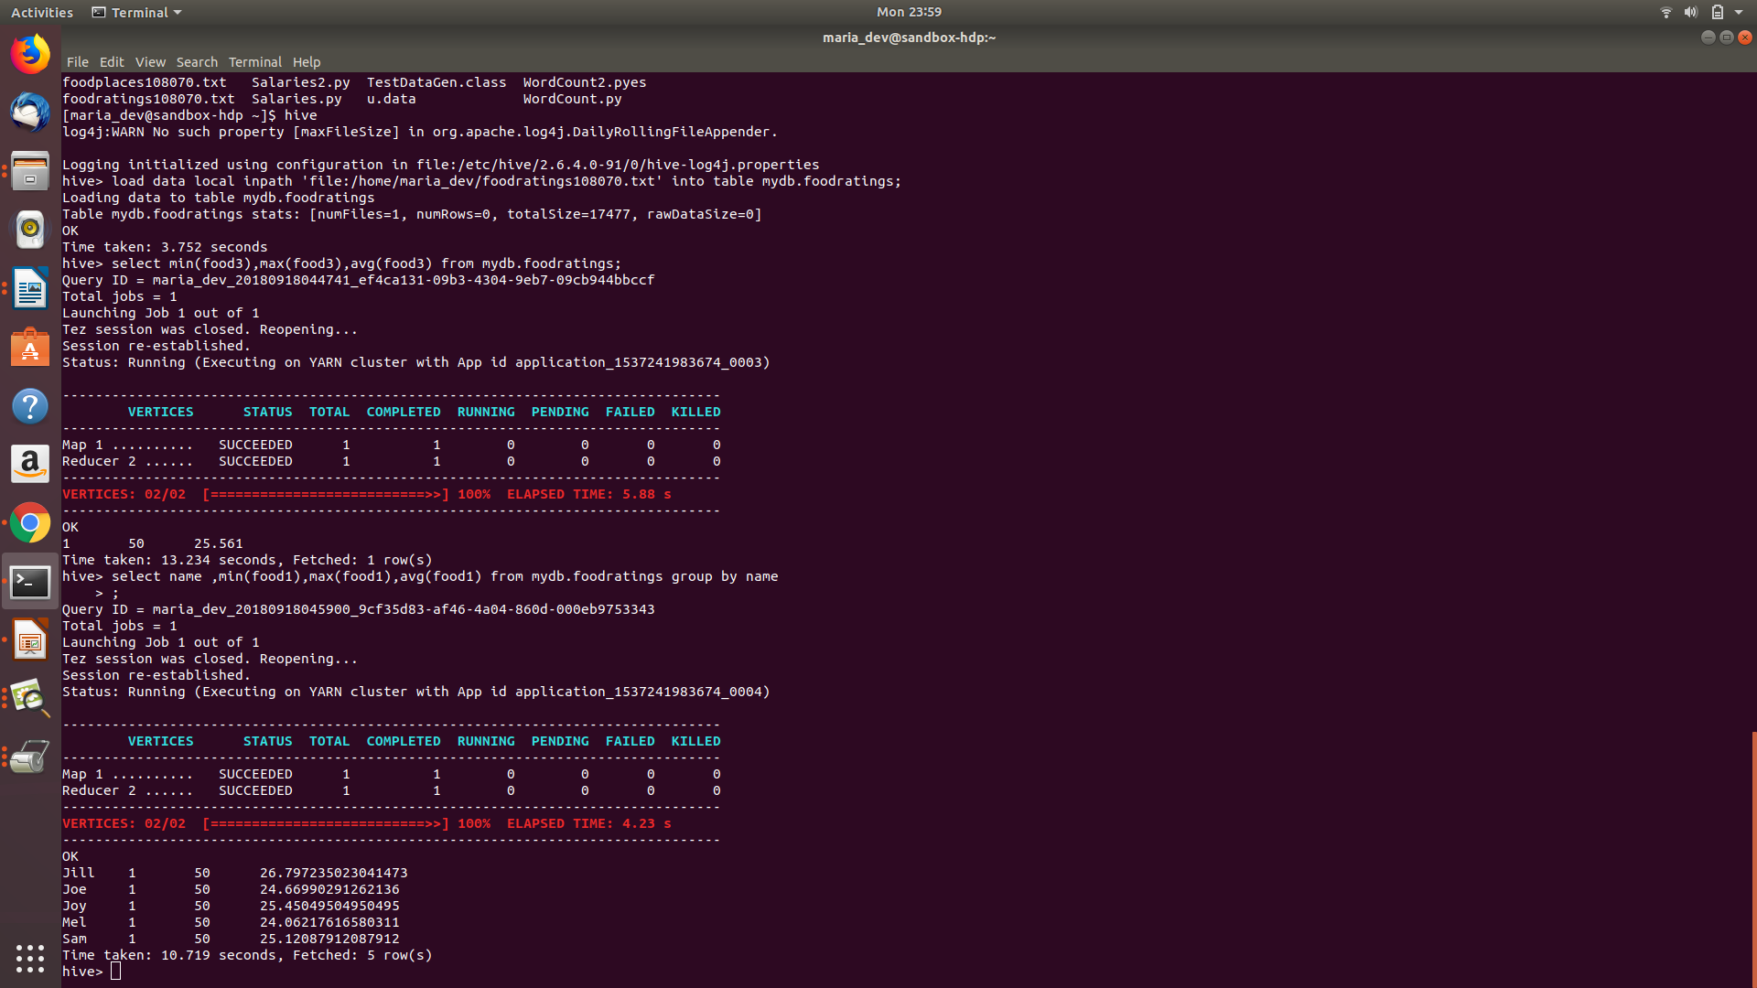
Exercise 4) In MyDb create a partitioned table called ‘foodratingspart’
The partition field should be called ‘name’ and its type should be a string. The names of the non-partition columns should be food1, food2, food3, food4 and id and their types each an integer. The table should have storage format TEXTFILE and column separator a “,”. That is the underlying format should be a CSV file. No comments are needed for this table.
Command: create table mydb.foodratingspart(food1 int,food2 int,food3 int,food4 int,id int) PARTITIONED BY(NAME STRING) ROW FORMAT DELIMITED FIELDS TERMINATED BY ',' STORED AS TEXTFILE;
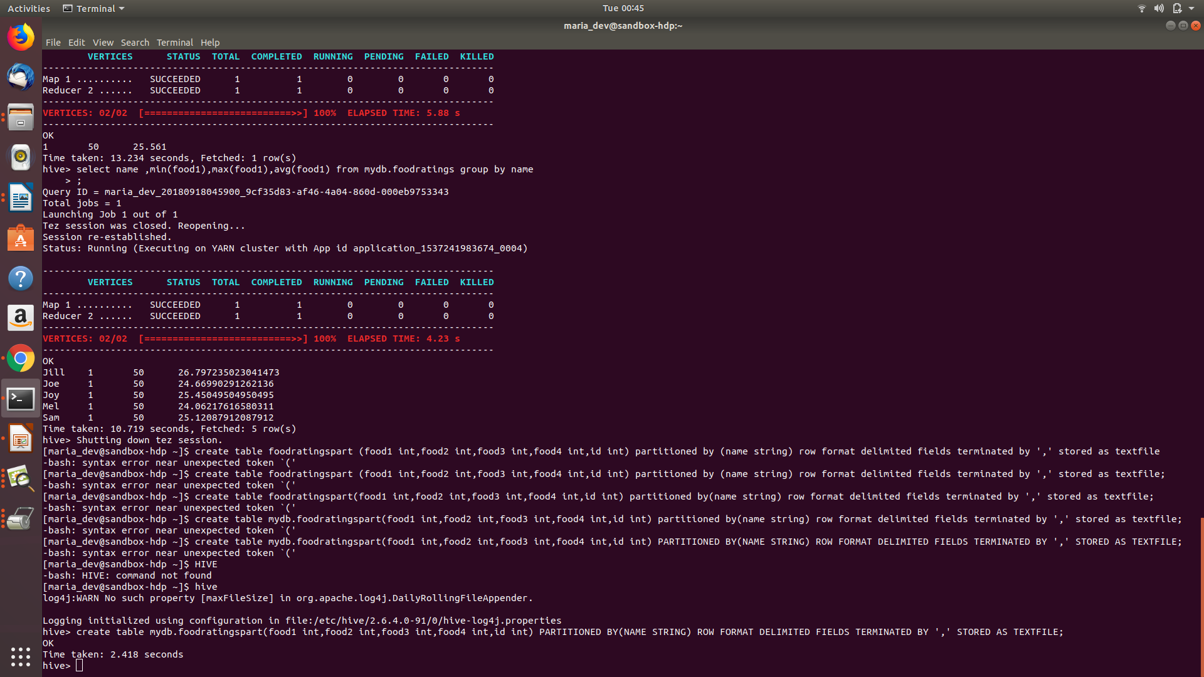
Execute a one shot Hive command of ‘DESCRIBE FORMATTED MyDb.foodratingspart’ and capture its output as the result of this exercise.
Command: DESCRIBE FORMATTED mydb.foodratingspart;
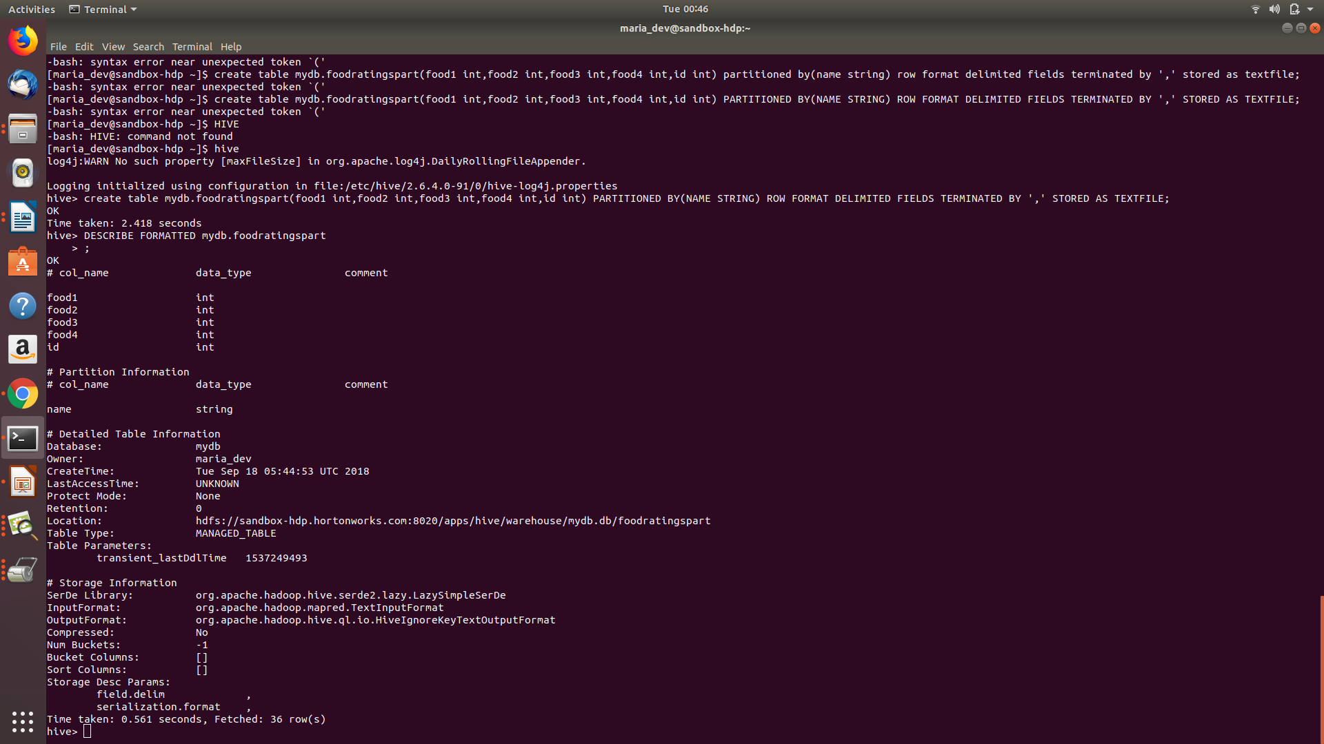
Exercise 5) 2 points
Configure Hive to allow dynamic partition creation as described in the lecture.
Use a hive command to copy from MyDB.foodratings into MyDB.foodratingspart to create a partitioned table from a non-partitioned one.
Hint: The ‘name’ column from MyDB.foodratings should be mentioned last in this command (whatever it is).
Provide a copy of the command you use to load the ‘foodratingspart’ table as a result of this exercise.
Command for dynamic partition:
SET hive.exec.dyanmic.partition=TRUE;
SET hive.exec.dynamic.partition.mode = non-strict;
Command:insert overwrite table mydb.foodratingspart PARTITION(name) select food1,food2,food3,food4,id,name from mydb.foodratings;
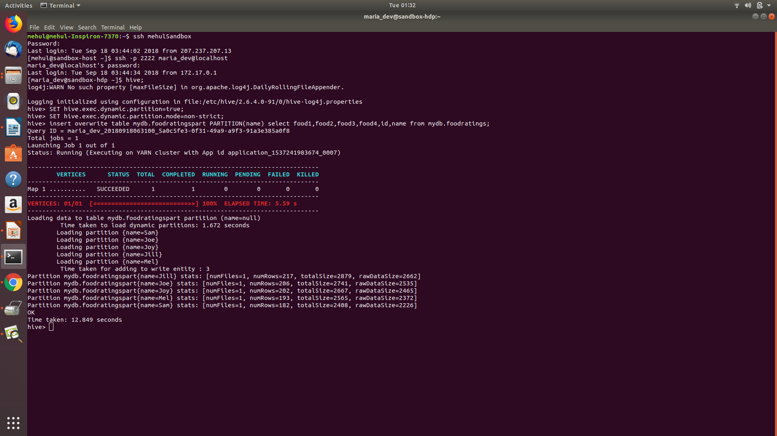
Execute a hive command to output the min, max and average of the values of the food2 column of MyDB.foodratingspart where the food critic ‘name’ is either Mel or Jill.
The query and the output of this query are other results of this exercise. It should look something like
10 20 15
Command:select min(food2),max(food2),avg(food2) from mydb.foodratingspart where name = 'Mel' or name = 'Jill';
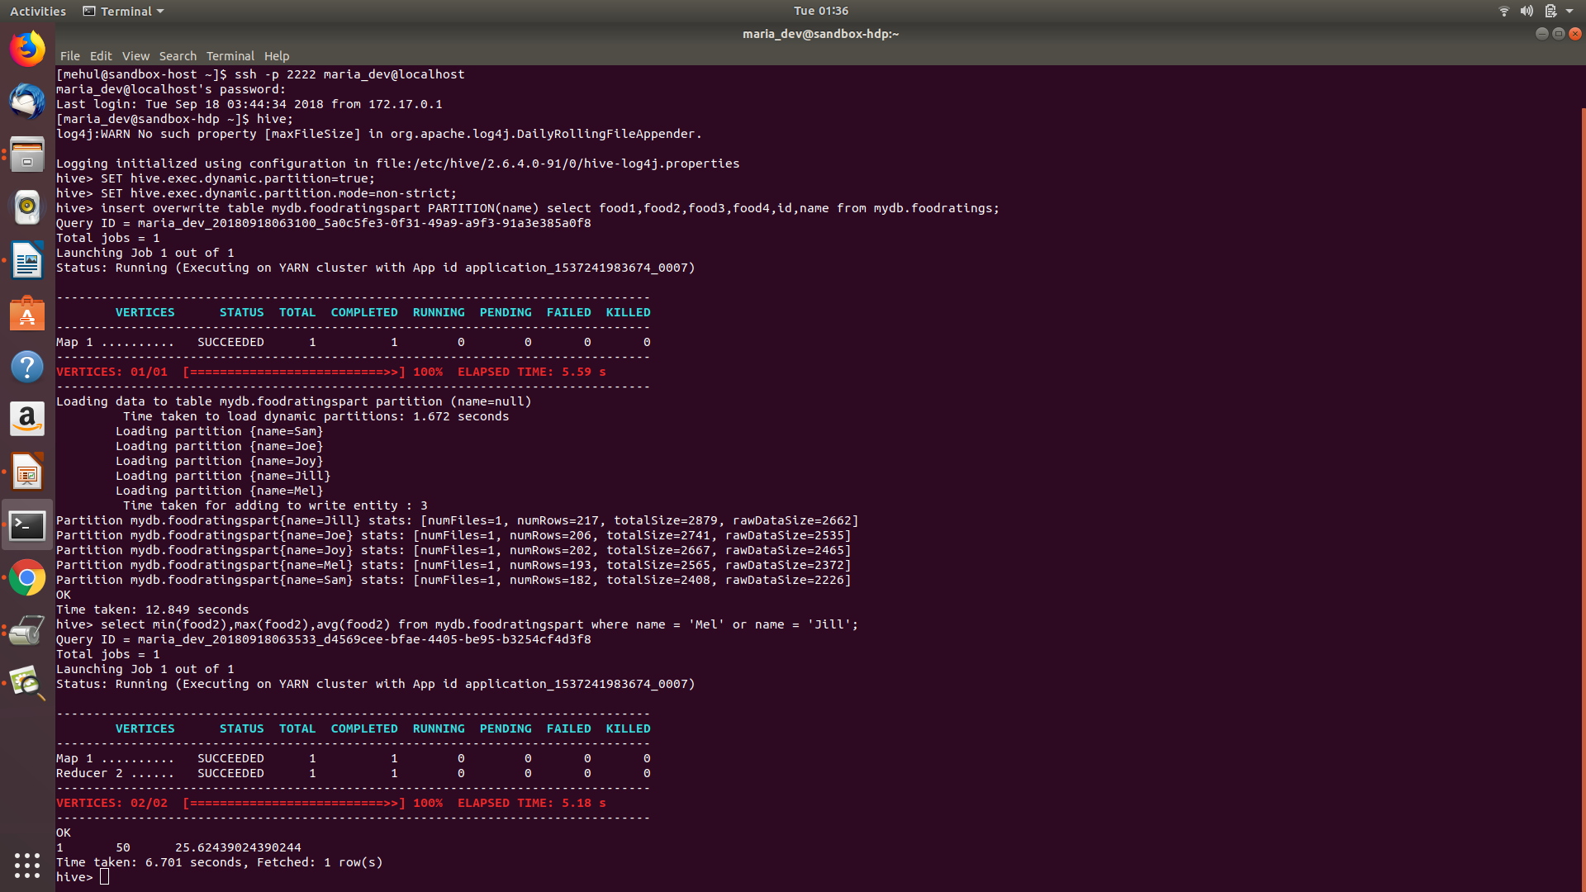

Exercise 6) 2 points
Load the foodplaces<.magic number>.txt file created using TestDataGen from your local file system into the foodplaces table.
Command: load data local inpath 'file:/home/maria_dev/foodplaces108070.txt' into table mydb.foodplaces;

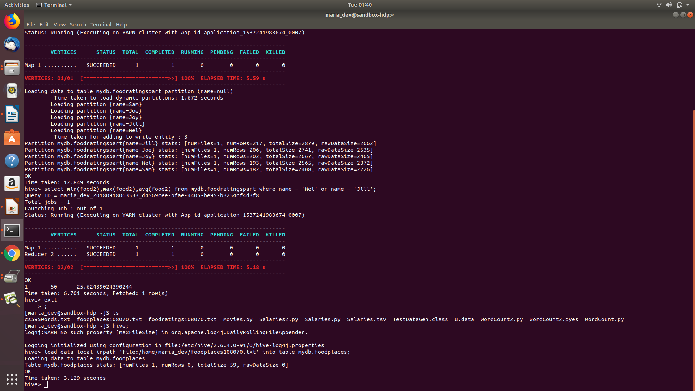
Use a join operation between the two tables (foodratings and foodplaces) to provide the average rating for field food4 for the restaurant ‘Soup Bowl’
The output of this query is the result of this exercise. It should look something like
Soup Bowl 20
Command: select fp.place, avg(fr.food4) from mydb.foodratings fr join mydb.foodplaces fp on fr.id=fp.id where place = 'Soup Bowl' group by place;
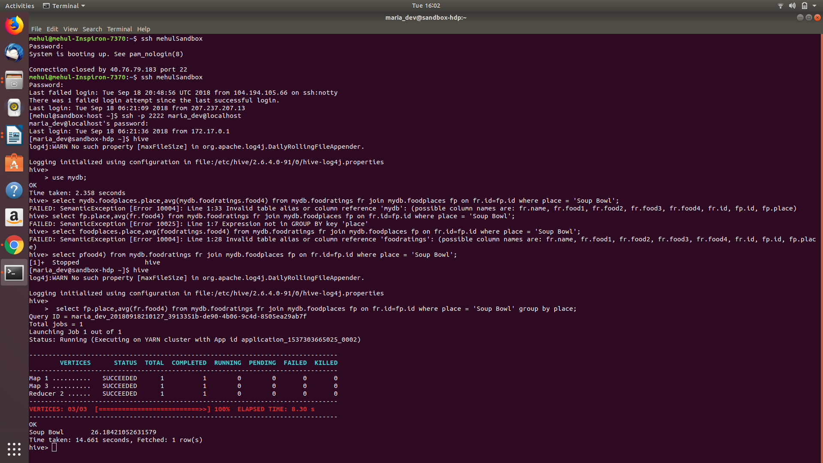
Exercise 7)
Write a half page summary of the following article on the blackboard in section “Articles:”
Pig Latin: A Not-So-Foreign Language for Data Processing
Answer : Pig Latin is a new language developed for improving speed of ad-hoc analysis of extreamly large dataset. Infact Yahoo! is using Pig for data analysis with dramatically reduced execution time.It is best of combination of SQL and map-reduce language.Pig Latin saves time of data importing while taking input and gives output according to user-provided function.It has a flexible,fully nested data model giving programmer flexibility of implementing user defined functions.Pig’s data model consist of Atom,Tuple,Bag and Map.Load command givin,along with optional USING and AS clause, is used for converting input file to Pig’s data model.Basic operation is performed using FOREACH and GENERATE command.Unwanted data is discarded using FILTER command,logical connectors and operators.We can group together two dataset into nested bags using COGROUP command.Incase we are having just one dataset for operations,GROUP command is used.We can also have equijoin using JOIN command. In Map-Reduce operation in Pig Latin ,Map step is perfomed followed by flattening of output data.Flatten data is then sent to reduce UDF to obtain final result.Some other useful command in Pig-latin are UNION,CROSS,ORDER,DISTINCT.User can materialize output in a file using STORE command.Pig Latin is fully implemented on Pig.Pig interpreter parses input files and just creates logical plan for it.It only process the plan when STORE command is invoked.This method od execution is beneficial as it permits various optimization like in-memory pipelining.Logical plan then gets compiled into map-reduce jobs,in which parallelism for various operations like FILTER and FOREACH is achieved.Pig comes with an interactive debugging environment which creates sandbox data set for testing purpose.Some of the places where Pig is used are Rollup aggregates of user activity log,web crawls ,temporal analysis of search logs and session analysis of web user sessions. Pig is still in active development phase and various work is being done for adding support for more non Java USD,providing better UI and developing it as an independent language like PERL and PYTHON.

