CSP554—Big Data Technologies

Assignment #9

Readings

Read Chapters 1, 2 and 3 from our next book: Pramod J. Sadalage and Martin Fowler. 2012. NoSQL Distilled: A Brief Guide to the Emerging World of Polyglot Persistence. Addison-Wesley.(PS)

Worth: 10 points (5 points for each exercise) + 5 points extra credit

Due by the start of the next class period
Assignments should be uploaded via the Blackboard portal
Exercise 1) Read and provide a half page summary and analysis of this article available on the blackboard in the ‘Articles’ section: Beyond Batch Processing: Towards Real-Time and Streaming Big Data
This article describes the alternative to the Hadoop for non batch processing job.It has described 2 non batch processing way mainly: Real time processing and stream processing of big data.In Real-time processing,the main aim is to provide solutions that can process big data very fast and interactively. An example for real-time processing is fast and interactive queries on big data warehouses.Stream processing of big data deals with problems that their input data must be processed without being totally stored. The use case for for stream processing include online machine learning, and continuous computations.There are two approach in which Real-Time Big data processing works.First appoach is In-Memory Computing.In this approach,it always try to reduce the overhead of MapReduce and make it faster to enable execution of jobs in less than seconds. It is based on using a distributed main memory storage system that can be used either as a standalone input source or as a caching layer for disk-based storages to store and process big data in real-time.Another approach is Real-Time Queries over Big Data.This solution focuses on providing a means for real-time queries over structured and unstructured big data using new optimized approaches. Streaming Big Data is another common scenario.Today’s applications need more stream-like demands in which the input data is not available completely at the beginning and arrives constantly. Also, sometimes an application should run continuously. Although MapReduce does not support stream processing, but it can partially handle streams using a technique known as micro-batching (implemented in Apache Spark Streaming). There are a few stream processing frameworks that are inherently designed for big data streams such as Storm from Twitter, and S4 from Yahoo.Considering high demands for interactive queries and big data streams, in-memory computing stands out as a notable solution that can handle both real-time and stream requirements. Apache Spark is a good example which supports in-memory computing using RDDs, real-time and interactive querying using Shark, and stream processing using fast micro-batching.
Exercise 2) Read and provide a half page summary and analysis of this article available on the blackboard in the ‘Articles’ section: Real-time stream processing for Big Data.
This article gives an overview of the state of the art of stream processors for low-latency Big Data analytics and conduct a qualitative comparison of the most popular contenders, namely Storm and its abstraction layer Trident, Samza and Spark Streaming.In Real-time analytics,which is in contrast to traditional data analytics systems that collect and periodically process huge – static – volumes of data, streaming analytics systems avoid putting data at rest and process it as it becomes available, thus minimizing the time a single data item spends in the processing pipeline.Various Real-time processors are Storm and Samza. An important distinction between the individual systems that directly translates to the achievable speed of processing, i.e. latency, is the processing model. Handling data items immediately as they arrive minimizes latency at the cost of high per-item overhead (e.g. through messaging), whereas buffering and processing them in batches yields increased efficiency, but obviously increases the time the individual item spends in the data pipeline. Systems like Storm Trident and Spark Streaming employ micro-batching strategies to trade latency against throughput: Trident groups tuples into batches to relax the one-at-a-time processing model in favor of increased throughput, whereas Spark Streaming restricts batch size in a native batch processor to reduce latency.Storm has a programming model provided an abstraction for stream-processing similar to the abstraction that the MapReduce paradigm provides for batch-processing.It is scalable, fault-tolerant and even elastic as work may be reassigned during runtime. Storm provides reliable state implementations that survive and recover from supervisor failure.Storm Trident was released as a high-level API with stronger ordering guarantees and a more abstract programming interface with built-in support for joins, aggregations, grouping, functions and filters.Samza is a stream processor with a one-at-a time processing model and at-least-once processing semantics.Spark streaming offers several benefits in comparison to Hadoop, most notably a more concise API resulting in less verbose application logic and significant performance improvements through in-memory caching.Batch-oriented systems have done the heavy lifting in data-intensive applications for decades, but they do not reflect the unbounded and continuous nature of data as it is produced in many real-world applications. Stream oriented systems process data as it arrives and thus are often times a more natural fit, though inferior with respect to efficiency.Whether at the core of novel system designs such as the Kappa Architecture or as a complement to existing architectures such as the Lambda Architecture, horizontally scalable stream processors are gaining momentum as the requirement for low latency has become a driving force in modern Big Data analytics pipelines.
Exercise 3) 5 points extra credit
- (1 point) Get the spark streaming demo code to work in your Hortonworks sandbox. Provide screen shots of output for various inputs
Input 1 :
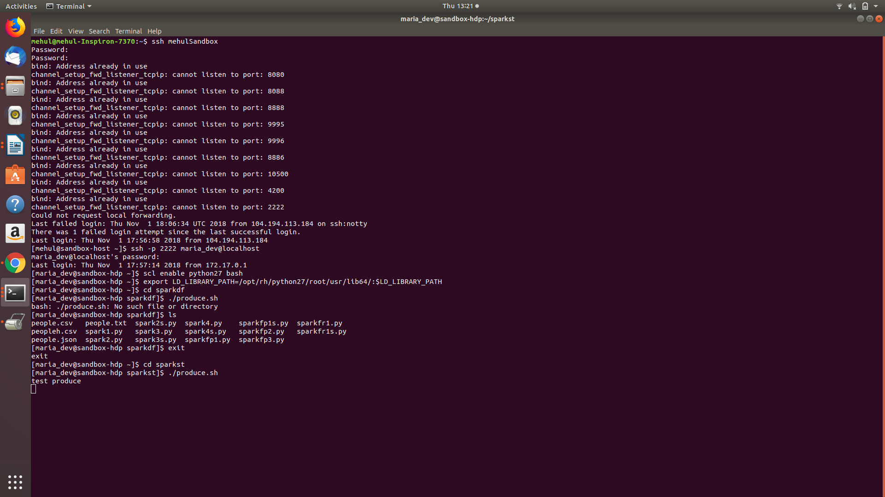
Output 1:
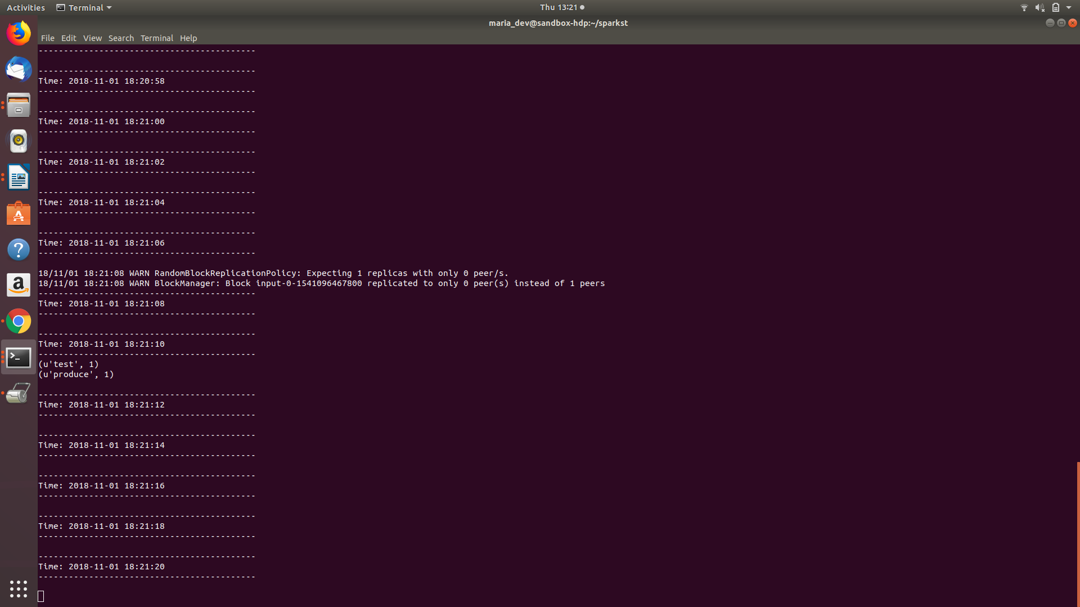

- (4 points) Modify consume.py to output a count of words beginning with only the letters a through h inclusive using just RDD transformations and actions. Provide screen shots of output for various inputs.

Screenshot :
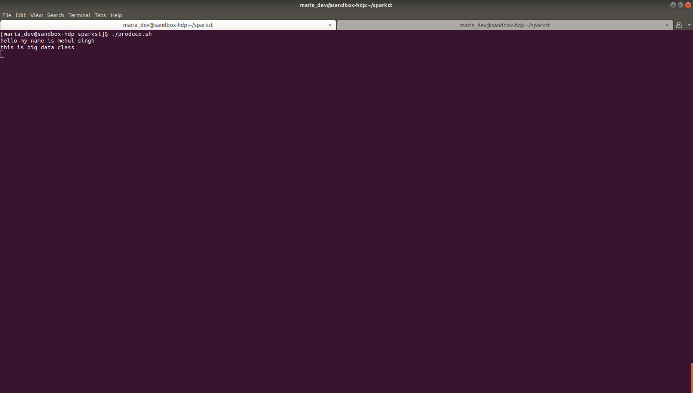
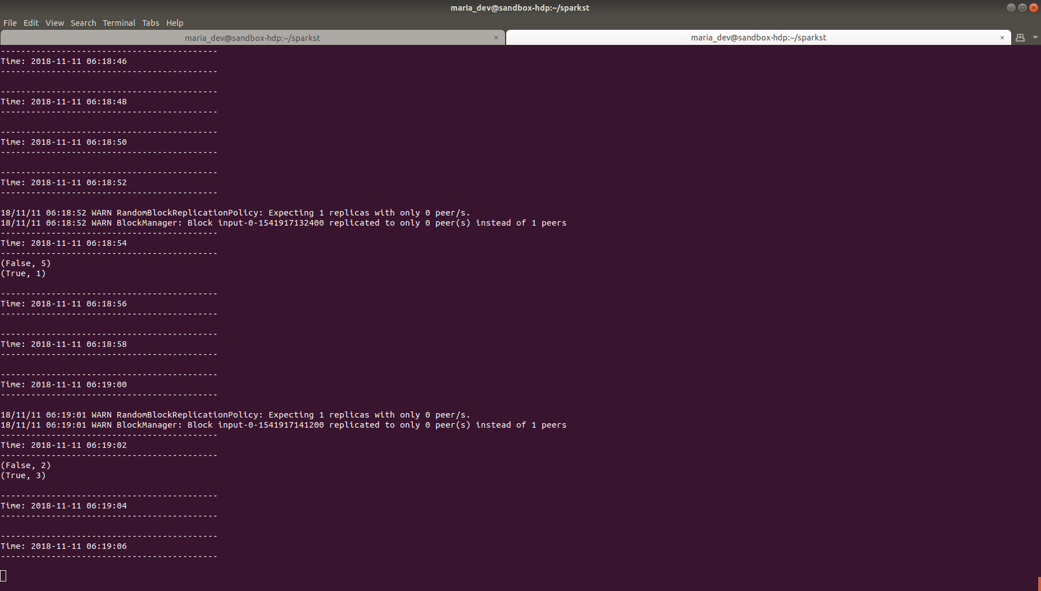

Code for consume.py :
rom pyspark import SparkContext
from pyspark.streaming import StreamingContext

# Create a local StreamingContext with two working threads and a batch interval of 2 seconds
sc = SparkContext("local[2]", "NetworkWordCount")
ssc = StreamingContext(sc, 2)

# Create a DStream
lines = ssc.socketTextStream("sandbox-", 3333)

# Split each line into words
words = lines.flatMap(lambda line: line.split(" "))

# Count each word in each batch
words = words.map(lambda x: x[0] in ("A","B","C","D","E","F","G","
pairs = words.map(lambda word: (word, 1))
wordCounts = pairs.reduceByKey(lambda x, y: x + y)

# Print each batch
wordCounts.pprint()
ssc.start() # Start the computation

