Assignment #3

4)
Step 5:
Now execute the following
python WordCount.py -r hadoop --hadoop-streaming-jar /usr/hdp/current/hadoop-mapreduce-client/hadoop-streaming.jar hdfs:///user/maria_dev/cs595words.txt
Note there must be three slashes in “hdfs:///” as “hdfs://” indicates that the file you are reading from is in the hadoop file system and the “/user” is the first part of the path to that file. Also note that sometimes copying and pasting this command from the assignment document does not work and it needs to be entered manually.
Check that it produces some reasonable output.
Note, the above command will erase all output files in hdfs. If you want to keep the output use the following command instead:
python WordCount.py -r hadoop --hadoop-streaming-jar /usr/hdp/current/hadoop-mapreduce-client/hadoop-streaming.jar hdfs:///user/maria_dev/cs595words.txt - -output-dir /user/maria_dev/some-non-existent-directory
Command : python WordCount.py -r hadoop --hadoop-streaming-jar /usr/hdp/current/hadoop-mapreduce-client/hadoop-streaming.jar hdfs:///user/maria_dev/cs595words.txt
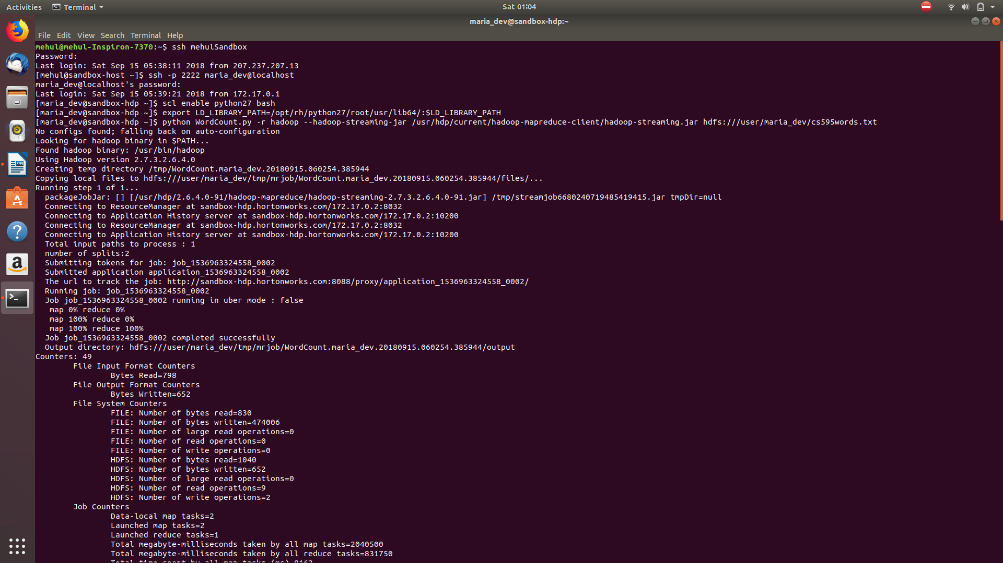
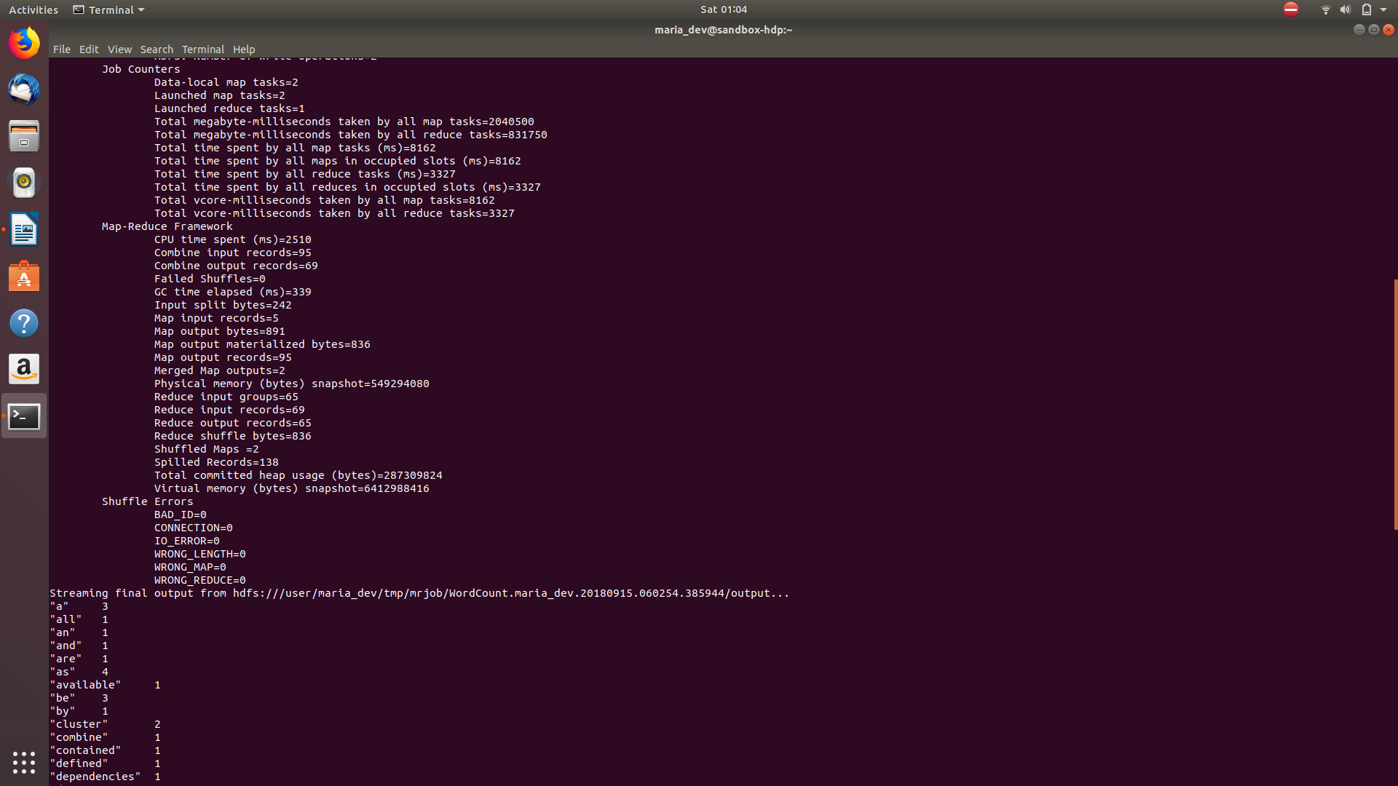

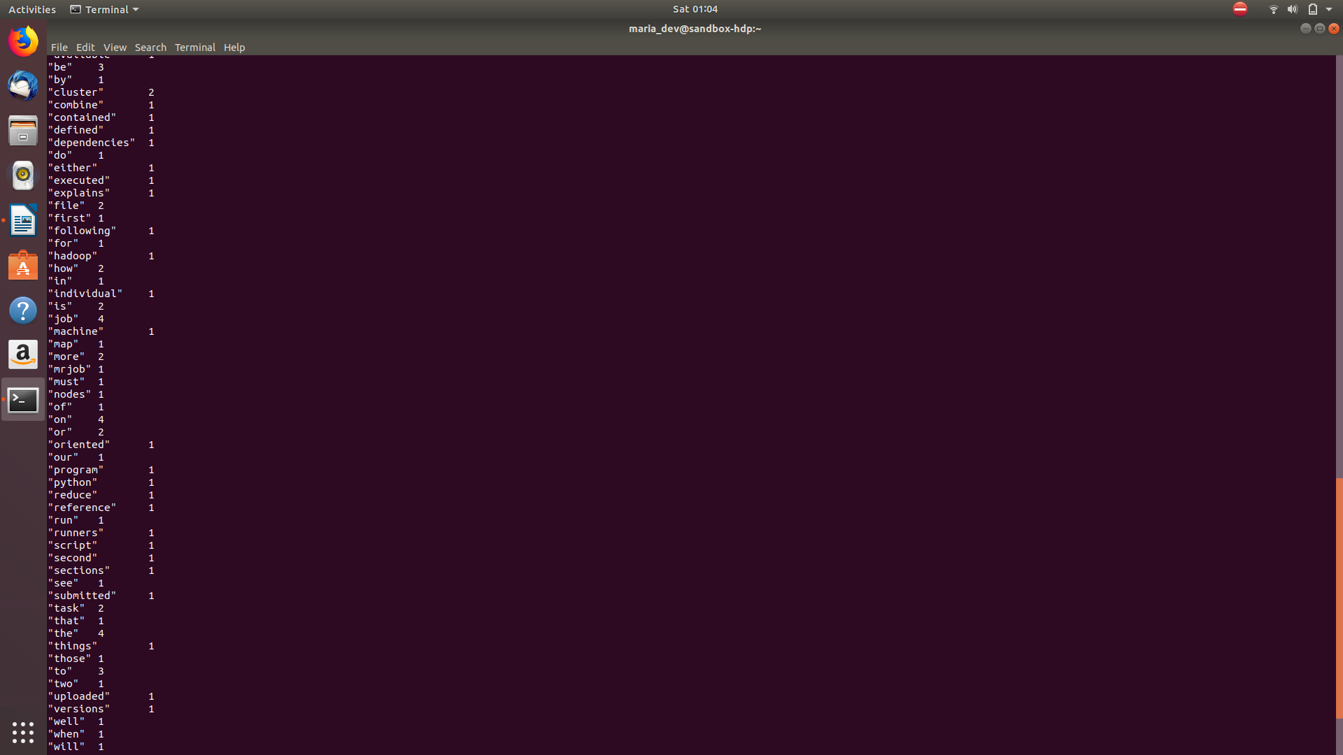

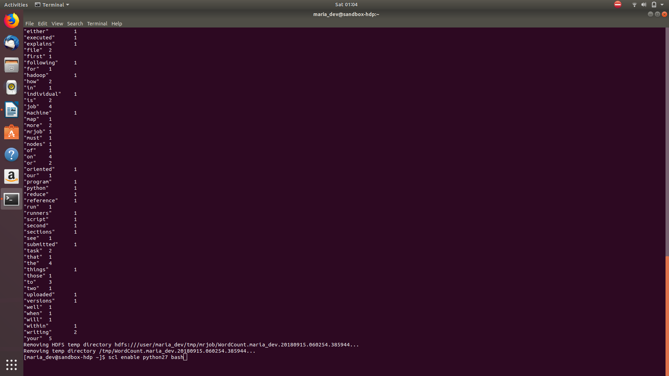

5) Now slightly modify the WordCount program. Call the new program WordCount2.py.
Instead of counting how many words there are in the input documents, modify the program to count how many words begin with the small letters a-n and how many begin with anything else.
The output file should look something like
a_to_n, 12
other, 21
Now execute the program and see what happens.
=====================Code=====================
from mrjob.job import MRJob
import re

WORD_RE = re.compile(r"[\w']+")
class MRWordCount(MRJob):
def mapper(self, _, line):
for word in WORD_RE.findall(line):
allowed = 'abcdefghijklmn'
if any(word.lower().startswith(x) for x in allowed):
yield 'a_to_n', 1
else:
yield 'other', 1
def combiner(self, word, counts):
yield word, sum(counts)
def reducer(self, word, counts):
yield word, sum(counts)
if __name__ == '__main__':
MRWordCount.run()
Command: python WordCount2.py -r hadoop --hadoop-streaming-jar /usr/hdp/current/hadoop-mapreduce-client/hadoop-streaming.jar hdfs:///user/maria_dev/cs595words.txt
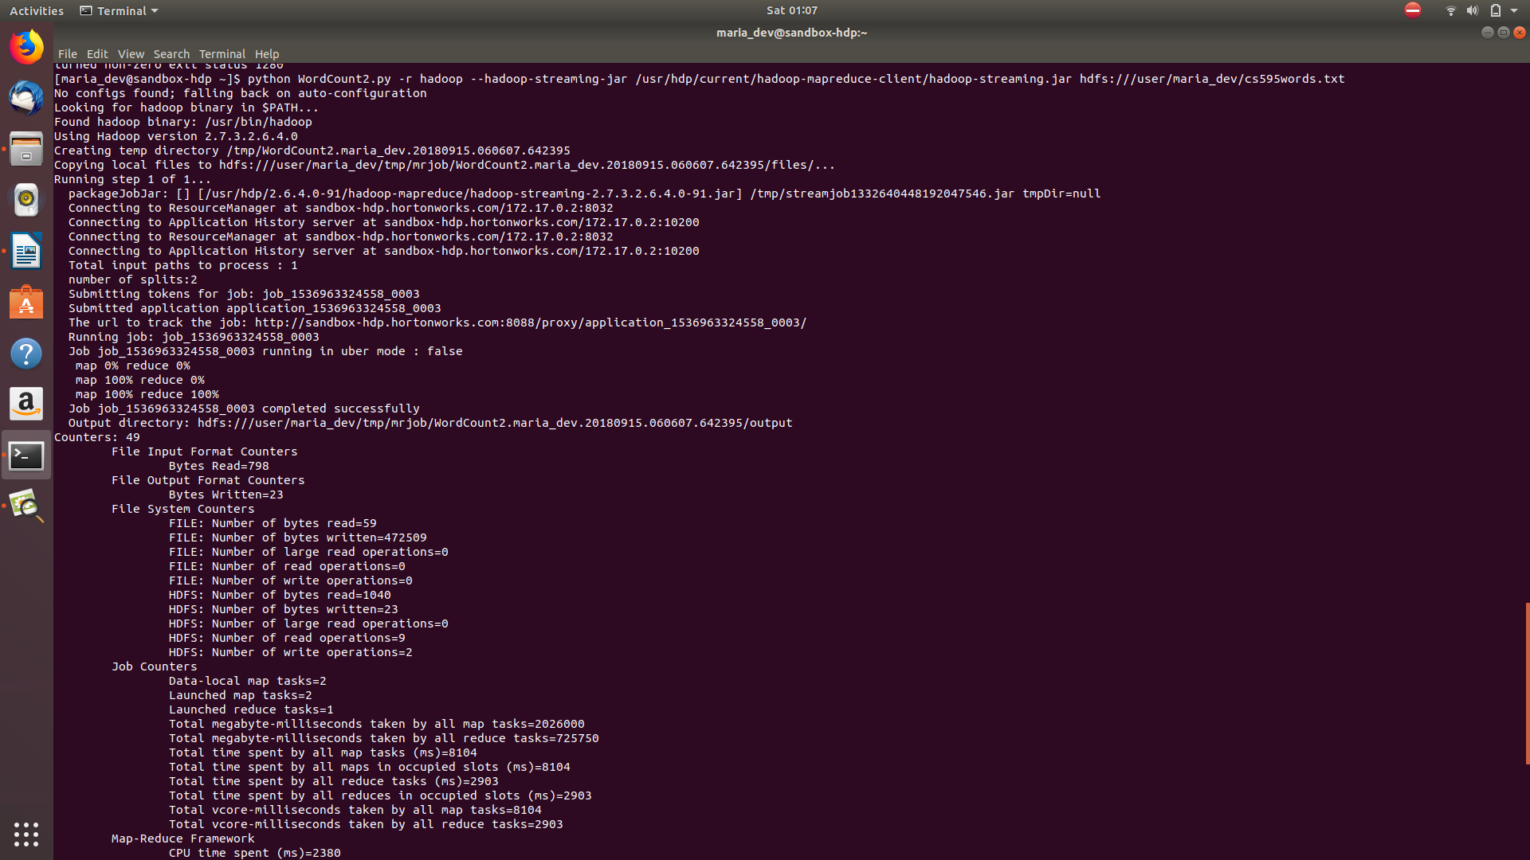
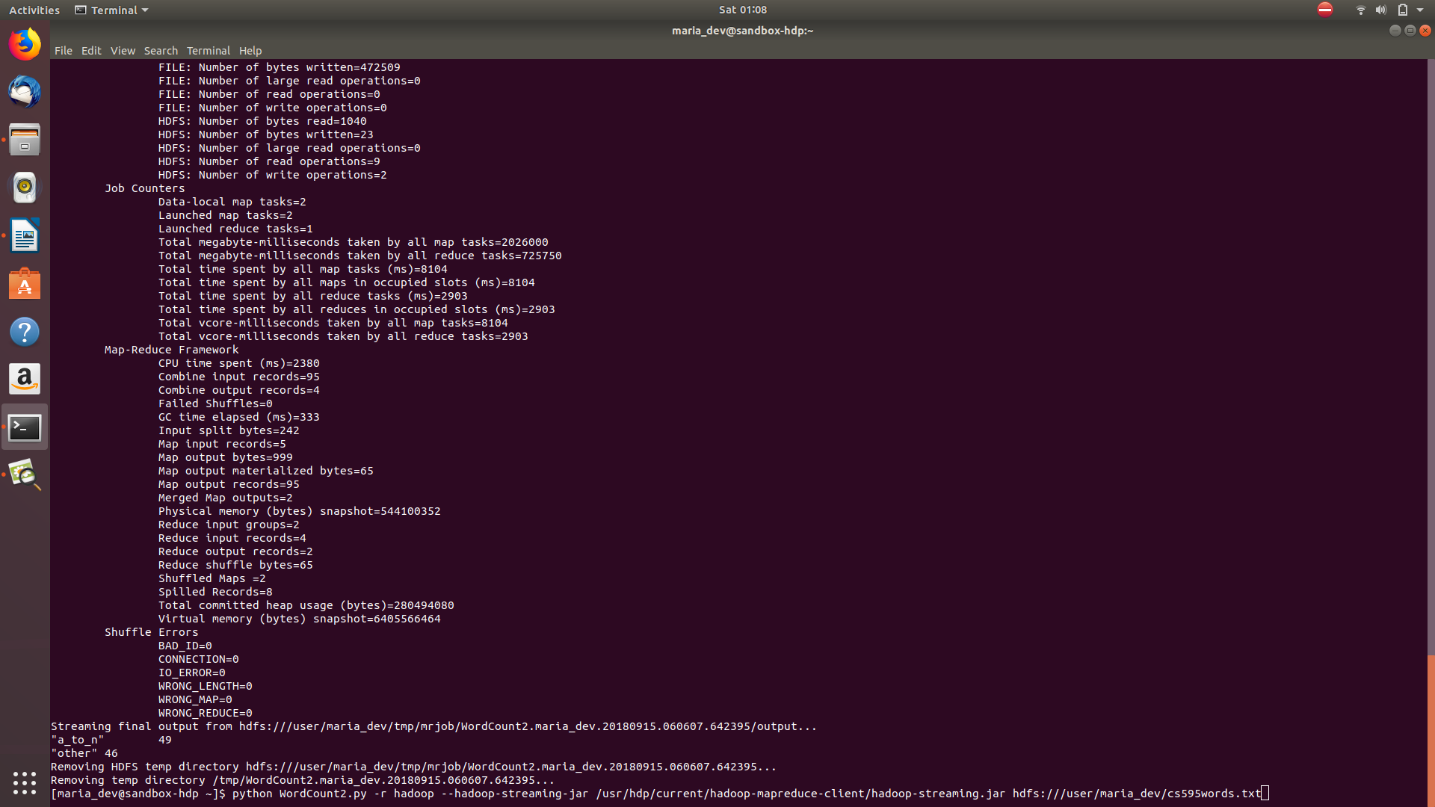
6) (5 points) Submit a copy of this modified program and a screen shot of the results of the program’s execution as the output of your assignment.
=====================Code=====================
from mrjob.job import MRJob
import re

WORD_RE = re.compile(r"[\w']+")
class MRWordCount(MRJob):
def mapper(self, _, line):
for word in WORD_RE.findall(line):
allowed = 'abcdefghijklmn'
if any(word.lower().startswith(x) for x in allowed):
yield 'a_to_n', 1
else:
yield 'other', 1
def combiner(self, word, counts):
yield word, sum(counts)
def reducer(self, word, counts):
yield word, sum(counts)
if __name__ == '__main__':
MRWordCount.run()
Command: python WordCount2.py -r hadoop --hadoop-streaming-jar /usr/hdp/current/hadoop-mapreduce-client/hadoop-streaming.jar hdfs:///user/maria_dev/cs595words.txt

7) Now do the same as the above for the files Salaries.py and Salaries.tsv. The “.tsv” file holds department and salary information for Baltimore municipal workers. Have a look at Salaries.py for the layout of the “.tsv” file and how to read it in to our map reduce program.
8) Execute the Salaries.py program to make sure it works. It should print out how many workers share each job title.
9) Now modify the Salaries.py program. Call it Salaries2.py
Instead of counting the number of workers per department, change the program to provide the number of workers having High, Medium or Low annual salaries. This is defined as follows:
High | 100,000.00 and above
Medium | 50,000.00 to 99,999.99
Low | 0.00 to 49,999.99

The output of the program should be something like the following (in any order):
High 20
Medium 30
Low 10
Some important hints:
- The annual salary is a string that will need to be converted to a float.
- The mapper should output tuples with one of three keys depending on the annual salary: High, Medium and Low
- The value part of the tuple is not a salary. (What should it be?)
Now execute the program and see what happens.
Command : python Salaries2.py -r hadoop --hadoop-streaming-jar /usr/hdp/current/hadoop-mapreduce-client/hadoop-streaming.jar hdfs:///user/maria_dev/Salaries.tsv --output-dir /user/maria_dev/salaries_output
======================Code======================
from mrjob.job import MRJob
class MRModifiedSalaries(MRJob):
def mapper(self, _, line):
(name,jobTitle,agencyID,agency,hireDate,totalAnnualSalary,grossPay) = line.split('\t')
if float(totalAnnualSalary) >= float(100000.00):
yield "High", 1
elif float(totalAnnualSalary) >= float(50000.00) and float(totalAnnualSalary) <= float(99999.00):
yield "Medium", 1
else:
yield "Low", 1
def combiner(self, jobTitle, counts):
yield jobTitle, sum(counts)
def reducer(self, jobTitle, counts):
yield jobTitle, sum(counts)

if __name__ == '__main__':
MRModifiedSalaries.run()
===================Screenshots===================
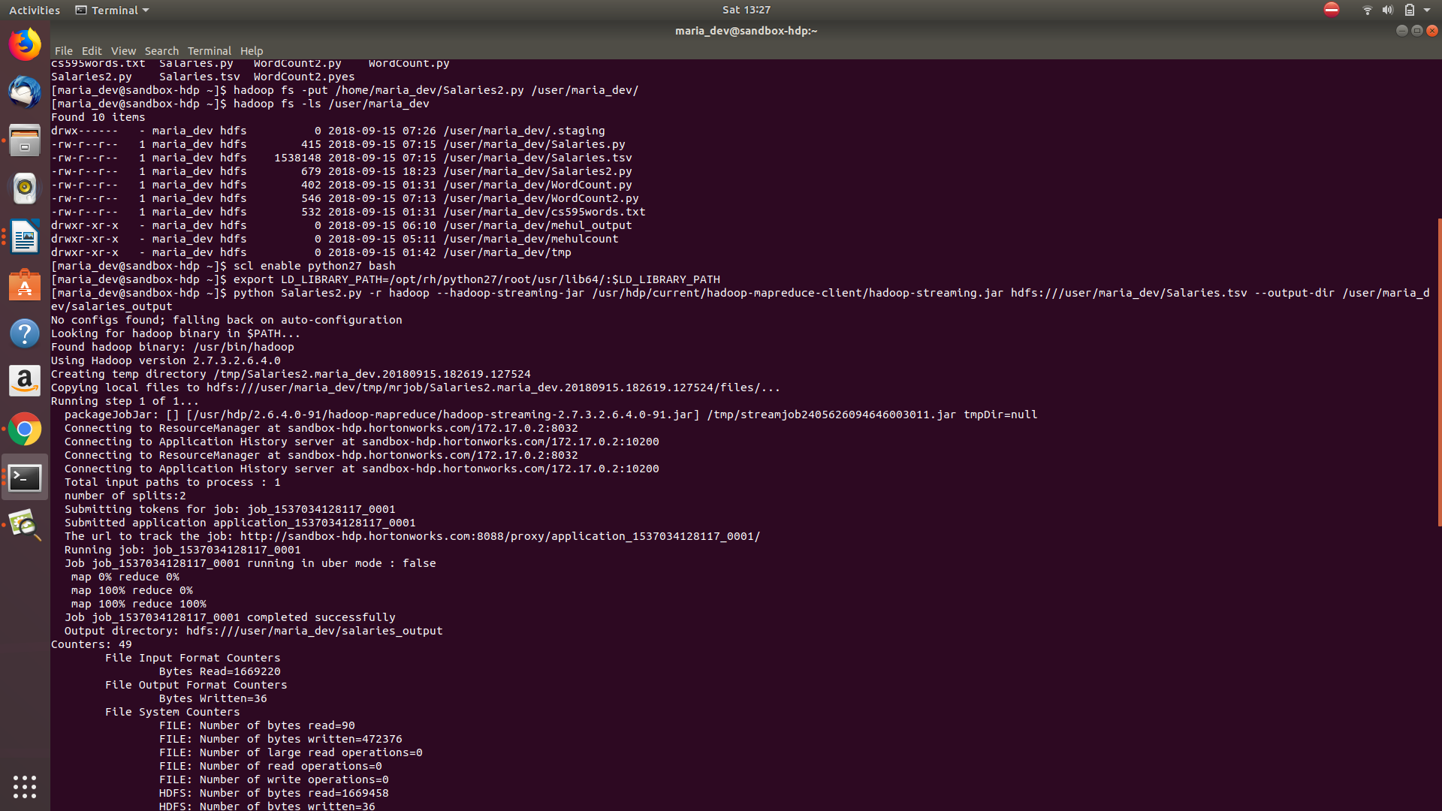
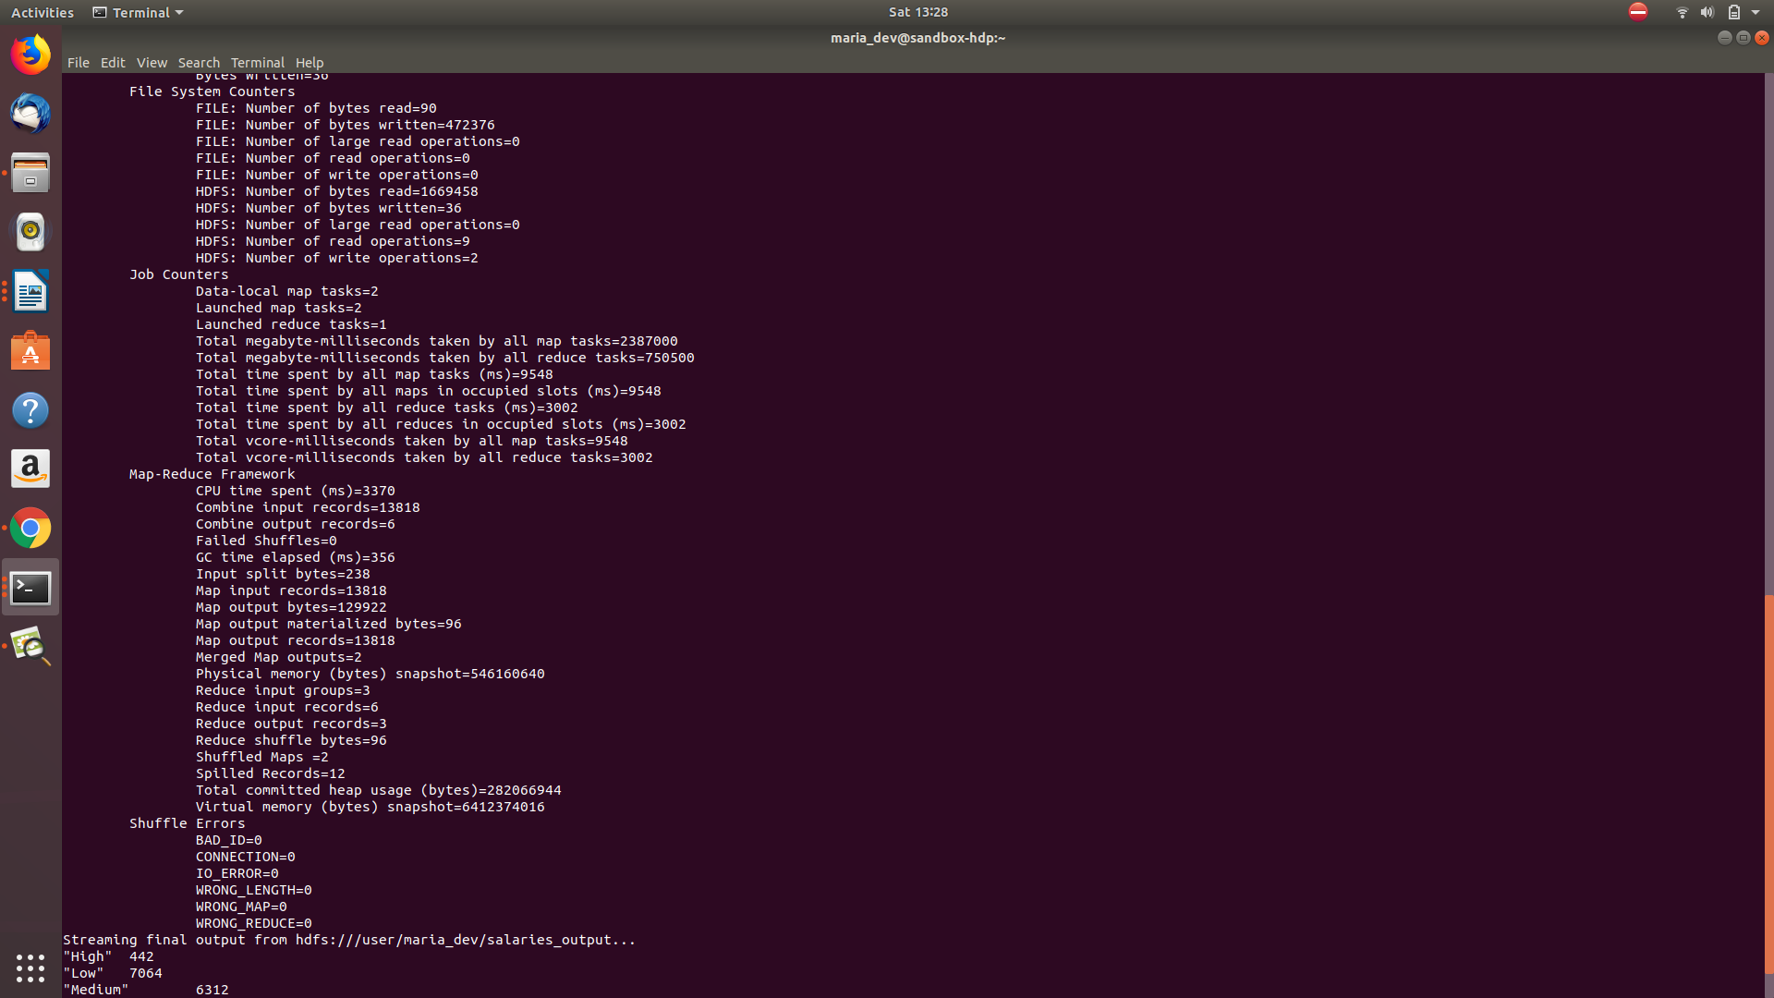

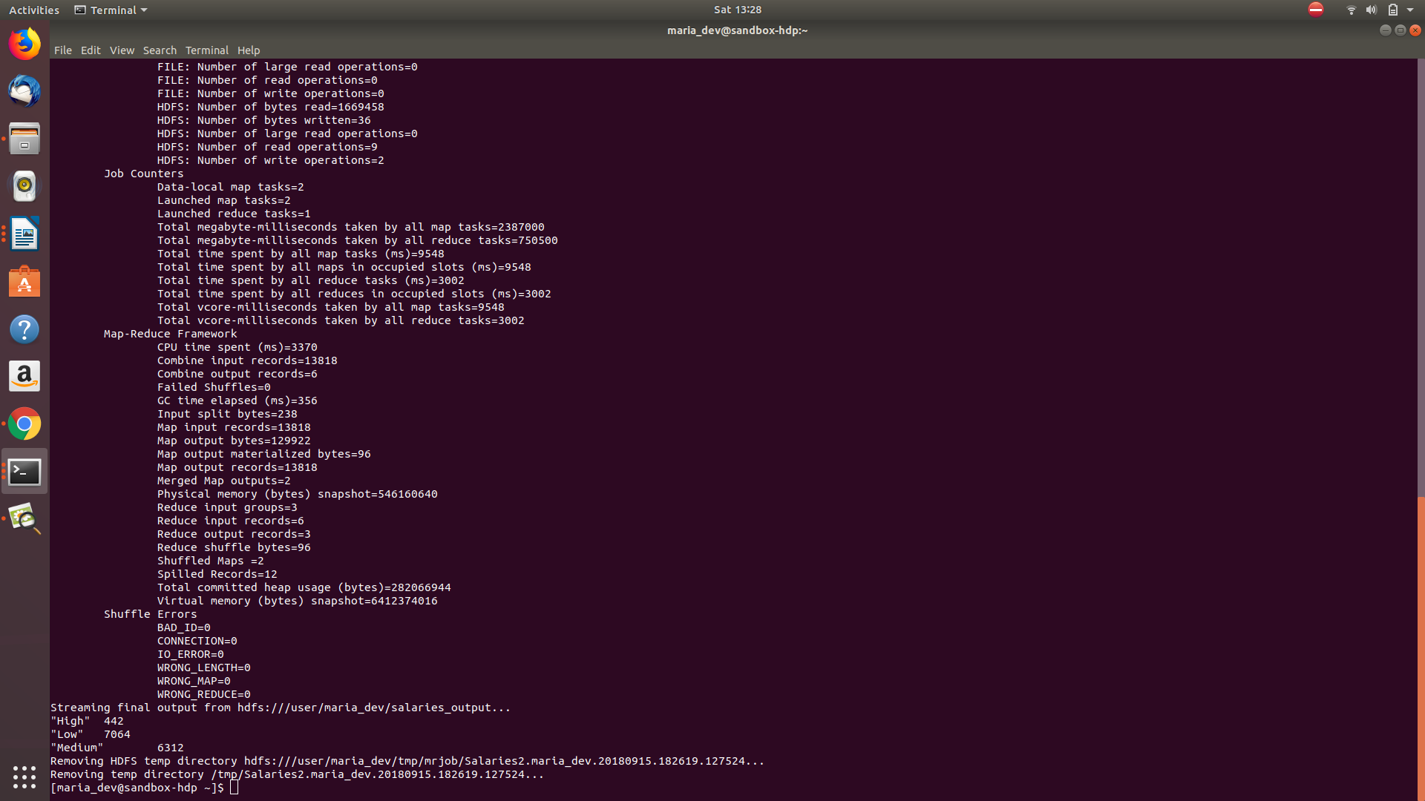
10) (5 points) Submit a copy of this modified program and a screen shot of the results of the program’s execution as the output of your assignment.
====================Modified Code=================
from mrjob.job import MRJob
class MRModifiedSalaries(MRJob):
def mapper(self, _, line):
(name,jobTitle,agencyID,agency,hireDate,totalAnnualSalary,grossPay) = line.split('\t')
if float(totalAnnualSalary) >= float(100000.00):
yield "High", 1
elif float(totalAnnualSalary) >= float(50000.00) and float(totalAnnualSalary) <= float(99999.00):
yield "Medium", 1
else:
yield "Low", 1
def combiner(self, jobTitle, counts):
yield jobTitle, sum(counts)
def reducer(self, jobTitle, counts):
yield jobTitle, sum(counts)

if __name__ == '__main__':
MRModifiedSalaries.run()

11) Now copy the file u.data to /user/maria_dev. This is similar to the file used for some examples in Module 03b. NOTE: unlike the slide deck examples, this version of u.data has fields separated by commas and not tabs.
12) (5 points) Review the slides 17-22 in lecture notes Module 3b. Now write a program to perform the task of outputting a count of the number of movies each user (identified via their user id) reviewed.

Output might look something like the following:
186: 2
192: 2
112: 1
etc.
Submit a copy of this program and a screen shot of the results of the program’s execution (only 10 lines or so of the result) as the output of your assignment.
Command:python Movies.py -r hadoop --hadoop-streaming-jar /usr/hdp/current/hadoop-mapreduce-client/hadoop-streaming.jar hdfs:///user/maria_dev/u.data --output-dir /user/maria_dev/movies_output

========================Code======================
from mrjob.job import MRJob
class MoviesReview(MRJob):
def mapper(self, _, line):
(usrID,movieID,rating,timestp) = line.split(',')
yield usrID, movieID
def combiner(self, usrID, movies):
yield usrID, len(list(movies))
def reducer(self, usrID, count):
yield usrID, sum(count)
if __name__ == '__main__':
MoviesReview.run()

=====================Screenshots=====================
