A report submitted to


Affiliated To: Veer Narmad South Gujarat University, Surat
For, Partial requirement for the fulfillment of the degree of
Bachelor of Computer Applications (BCA)

BCA Sem VI
A.Y. 2025-26

Project Report On <TYPE PROJECT TITLE HERE>

by
Roll No. | Seat No. | Name Of Student

Project Guide by:
<Project guide Name
Acknowledgement

The success and final outcome of this project required a lot of guidance and assistance from many people and we are extremely fortunate to have got this all along the completion of our project work. Whatever we have done is only due to such guidance and assistance.

We would not forget to thank Principal Dr. Aditi Bhatt, IQAC coordinator and trust representative Dr. Vaibhav Desai, In-charge of PG Courses Dr. Vimal Vaiwala , In-charge of UG-BCA and Head of the BCA Department Prof. Nainesh Gathiyawala and Project guide _________________ and all other Assistant professors of SDJ International College, Vesu, who took keen interest on our project work and guided us all along, till the completion of our project work by providing all the necessary information for developing a good system.

We are extremely grateful to her/him for providing such a nice support and guidance though she/he had busy schedule managing the college dealings.
We are thankful and fortunate enough to get support and guidance from all Teaching staffs of IT Department which helped us in successfully completing our project work. Also, we would like to extend our sincere regards to all the non-teaching staff of IT Department for their timely support.

Student Name (Exam Seat Number)
Student Name (Exam Seat Number)
Student Name (Exam Seat Number)
Student Name (Exam Seat Number)

I N D E X

Sr. No | Description | Page No.
1 | Introduction | 3
 | 1.1 Project description | 3
 | 1.2 Project Profile | 4
2 | Environment Description | 7
 | 2.1 Hardware and Software Requirements | 8
 | 2.2 Technology Used | 9
3 | System Analysis and Planning | 12
 | 3.1 Existing System and its Drawbacks | 12
 | 3.2 Feasibility Study | 13
 | 3.3 Requirement Gathering and Analysis | 14
4 | Proposed System | 16
 | 4.1 System Architecture Diagram & Description (3-Tier Model) | 16
 | 4.2 Project modules and scope | 17
 | 4.3 Module-wise objectives/functionalities Constraints | 18
5 | Detail Planning | 21
 | 5.1 DFD / UML – Use Case & Activity Flow Diagram | 21
 | 5.2 Activity Diagrams & Control Flow Definitions | 23
 | 5.3 Process Specification | 25
 | 5.4 Entity-Relationship Diagram | 26
6 | System Design | 27
 | 6.1 Database Design | 30
 | 6.2 User interface | 33
7 | Software Testing & Test Cases | 36
8 | Future Scope of Enhancements | 39
9 | References | 41

1. INTRODUCTION

The field of personal productivity and mental health monitoring has witnessed a remarkable transformation with the advent of digital technologies. Journaling, one of the oldest forms of personal reflection and documentation, has evolved significantly from traditional pen-and-paper methods to sophisticated digital platforms. The Daily Journal App represents this evolution, combining the intimacy of personal journaling with the power of modern web technologies to create a truly comprehensive digital journaling experience.

1.1 Project Overview
The "Daily Journal App" is a sophisticated, interactive, secure, and highly user-friendly web application expertly engineered using the modern MERN stack (MongoDB, Express.js, React.js, and Node.js). It fundamentally acts as a protected personal digital diary that not only allows users to chronologically write down their daily thoughts, narratives, and memories, but also enables them to mathematically track various contextual metadata parameters such as their daily overarching mood, geographical location, atmospheric weather conditions, and a self-assigned overall day score out of 10.

The project is a deliberate attempt to modernize and digitize the age-old habit of journaling by augmenting it with the power of modern database modeling and data analytics, thus giving users profound, actionable insights into their own lives and emotional well-being. The application serves as a sanctuary of privacy in an era dominated by social media exposure, providing individuals with a safe, secure, and entirely personal space for honest self-reflection without the pressures of social visibility.

Built as a Single Page Application (SPA) using React.js on the frontend and Node.js with Express.js on the backend, the Daily Journal App delivers a seamless, app-like experience within the browser environment. The database layer is handled by MongoDB, a powerful NoSQL document-oriented database that is particularly well-suited for storing the diverse and variable metadata associated with journal entries.

1.1.1 Motivation and Background
The practice of journaling has been scientifically proven over decades of extensive psychological research to significantly reduce stress, manage generalized anxiety, improve cognitive functioning, and assist individuals in processing complex emotional traumas. Psychologists and mental health professionals globally and frequently recommend keeping a consistent journal as a foundational baseline for mental health maintenance.

However, traditional physical pen-and-paper journals are fraught with inherent structural issues. They lack any form of privacy protection or encryption, meaning they can be accessed by anyone with physical proximity. They are entirely non-searchable, requiring exhaustive manual page-flipping to locate specific dates or content. They are susceptible to permanent physical destruction or loss through fire, water damage, or misplacement, with absolutely no backup capabilities available. Most critically, they cannot provide any form of analytical feedback or statistical insight over large datasets, making it impossible to identify emotional patterns or trends over extended time periods.

In today's fast-paced digital era, maintaining mental and emotional well-being using high-speed digital tools is infinitely more practical and accessible than traditional methods. The direct motivation behind the conceptualization of this project was to synthesize a sanctuary on the web—a strictly private, isolated space completely free from the pervasive influence of social media algorithms, public sharing mechanisms, and intrusive data mining practices. The application was designed to be a place where an individual can honestly and securely reflect on their daily experiences, while the software's intelligent backend autonomously assists them in recognizing meaningful mathematical patterns and frequencies in their emotional states over prolonged periods.

1.2 Project Profile
- Project Title: Daily Journal App
- Nature of Project: Full-Stack Web Application (Software as a Service Model)
- Structural Architecture: RESTful API Client-Server Architecture
- Frontend Framework: React.js (Bootstrapped with Vite Build Tooling)
- Backend Framework: Node.js utilizing Express.js for routing
- Database Management System: MongoDB (NoSQL Document-Oriented Database)
- Security & Authentication Protocol: JSON Web Tokens (JWT) with BCrypt Password Hashing
- Core Concept: Personal Digital Diary, Mental Health Tracking, and Algorithmic Data Analytics

1.2.1 Problem Statement
Currently, there is a distinct and verifiable lack of accessible, highly secure, and comprehensively analytical personal logging systems available for the general computing public that do not compromise on individual privacy. Existing applications currently occupying the market fall predominantly into two deeply flawed categories, each with significant limitations that fail to adequately serve the user's need for private, analytical journaling.

The first category comprises Pure Note-Taking Applications such as Apple Notes, Microsoft Notepad, Google Keep, and Microsoft Word. These platforms are far too generic in nature, designed primarily for shopping lists and meeting minutes rather than personal reflection. They utterly lack the proper specific metadata fields necessary to perform emotional or temporal analysis, such as natively tracking specific moods, weather context, or quantifiable day ratings. They offer no visualization capabilities and provide zero analytical insights into the user's emotional patterns or writing habits.

The second category encompasses Complicated Habit-Tracking Applications, which are often saturated with overly complex UI/UX designs that induce cognitive overload, gatekeep essential features behind expensive monthly premium subscription models, or worst of all, prioritize "social sharing" features that fundamentally violate the absolute privacy required for honest journaling. Furthermore, users are naturally and rightfully hesitant to type deeply personal thoughts on web applications that do not guarantee strict JWT authentication, server-side password encryption, and clear database data isolation. The Daily Journal App systematically solves these critical problems by combining a specific, targeted feature set with enterprise-grade security protocols.

1.2.2 Objectives of the System
The primary functional and structural objectives explicitly aimed to be fulfilled by the Daily Journal App are comprehensive and cover every aspect of the user's journaling experience:

- To engineer an unbreachable, highly secure authentication system utilizing JSON Web Tokens (JWT), where each registered user receives an entirely isolated data environment preventing any cross-user data access.
- To architect an intuitive, aesthetic, and fully responsive User Interface (UI) featuring customized CSS variable mapping that dynamically generates gender-based theme colorization, ensuring high user engagement and personalization.
- To allow users to effortlessly Create, Read, Update, and Delete (CRUD) journal entries in an asynchronous, non-blocking flow that completely eliminates disruptive page-reloads during data operations.
- To move past the severe limitations of plain text by capturing diverse contextual metadata alongside text narratives — specifically selecting multiple distinct moods, logging current weather conditions, tagging geographic location data, and recording a quantifiable Day Score metric ranging from 1 to 10.
- To automatically process historical data using a backend aggregation engine, visually representing insights on an intuitive Dashboard that calculates total words typed, total lifetime entries made, and a comprehensive visual breakdown of mood frequencies across all recorded time.
- To implement a robust algorithmically driven archival filtering system that dynamically navigates a user's past entries, filtered chronologically by automatically extracted unique years and categorized into interactive visual month grid blocks.

1.2.3 Scope of the Project
The scope of the Daily Journal App is intentionally and strictly localized to personal utility and individual reflection. The application decisively does not include any forms of social networking capabilities, public user profiles, comment sections, or peer-to-peer sharing mechanisms. This is a highly deliberate architectural and philosophical design choice made to preserve the absolute sanctity, security, and privacy of a personal diary application — the very foundation upon which honest journaling is built.

The scope encompasses the full development pipeline of a robust MERN Single Page Application (SPA) web client and a scalable Node.js server, bounded entirely by strict user-specific data compartmentalization and authorization middleware. The application is scoped to function as a web-based platform accessible through any modern browser, meaning no native mobile application development is included within the current project boundaries. All data processing, storage, and retrieval operations are conducted entirely within the MERN ecosystem without reliance on third-party data aggregators or commercial analytics platforms.

The project scope also explicitly covers the complete implementation of secure RESTful API endpoints, the design of MongoDB schema models with appropriate validation constraints, the development of responsive React UI components, and the implementation of JWT-based stateless authentication. Testing scope encompasses manual functional testing, boundary testing, and security testing covering all major user workflows. Future enhancements such as AI integration, mobile app development, or third-party API connections are considered outside the current project scope but documented for potential future development.

2. ENVIRONMENT DESCRIPTION & TECHNOLOGY STACK

A thorough understanding of the specific hardware and software environment configurations is critically essential for both the successful development, subsequent deployment, and continuous lifecycle maintenance of the Daily Journal App project. This application strictly utilizes a Client-Server distributed computing architecture, whereby the frontend client communicates asynchronously with a centralized backend server that manages all database operations and business logic processing.

2.1 Hardware Requirements
For Server / Development Machine Environment
The development of a modern MERN full-stack application requires running numerous computationally heavy processes concurrently in memory, including the React Vite Development Server, the Node.js Express Server daemon, the MongoDB database service, and resource-intensive Integrated Development Environments simultaneously.

- Central Processing Unit (CPU): Minimum requirement of an Intel Core i3 or AMD Ryzen 3 equivalent. Recommended specifications dictate an Intel Core i5 or Ryzen 5 or higher. Multi-threading capabilities significantly accelerate npm build operations and JSX transpilation processes.
- Random Access Memory (RAM): Minimum 8 GB allocation required. 16 GB is highly recommended by industry standards to prevent severe bottlenecking and memory-swapping when running Postman, Docker, or multiple heavy IDE instances alongside the database daemon concurrently.
- Persistent Storage: 256 GB Solid State Drive (SSD) minimum. Traditional Hard Disk Drives (HDDs) are heavily discouraged, as SSDs are absolutely crucial for the vast number of micro read/write operations required by the massively nested node_modules dependency tree structures.
- Network Interface: A standard broadband internet connection is necessary for downloading libraries from the remote NPM registry and accessing cloud-hosted MongoDB Atlas services during development.

For Client / End User Environment
The fundamental design philosophy of the application offloads computation and data processing to the cloud server and backend architecture whenever architecturally possible. Thus, the client environment requires very minimal hardware specifications, ensuring the widest possible accessibility across various user devices.

- Processor: Any standard 1GHz or faster mobile ARM or desktop x86 processor capable of running a modern HTML5 and ES6 compliant web browser engine without performance degradation.
- RAM: Minimum 2 GB of volatile working memory for smooth browser operation and JavaScript execution.
- Display Resolution: The system interface is engineered using robust CSS Flexbox and CSS Grid paradigms, rendering it completely fluid and responsive to mobile screens. A 720p minimum resolution (1280x720) is recommended for optimal desktop dashboard viewing.
- Connectivity: A stable and active internet connection is required to transmit JSON payloads to and from the REST API server.

2.1 Software Requirements
For Server / Development Machine Environment
- Host Operating System: Multi-platform support is inherent to Node.js. Developed primarily on Windows 11 64-bit architecture, fully capable of running on macOS 11 and above, or standard Linux distributions including Ubuntu 20.04 and Debian.
- Node.js Runtime Environment: Node.js v18.x.x LTS (Long Term Support) branch or above. Node.js is the foundational prerequisite to execute backend JavaScript and locally serve the frontend build tooling.
- Package Manager Toolkit: npm (Node Package Manager) v9.x.x, used exclusively to manage all third-party dependencies, scripts, and library versioning throughout the project lifecycle.
- Source Code Editor: Visual Studio Code (VS Code) utilizing extensions such as ES7+ React/Redux Snippets, Prettier code formatter, and ESLint for strict real-time syntax warning enforcement.
- Database Management System: MongoDB Community Server for local development or MongoDB Atlas cloud database hosted solution for production deployment environments.
- API Testing Tool: Postman Desktop Client or Thunder Client (VS Code Extension) for simulating and debugging complex HTTP requests during endpoint development without requiring frontend UI interactions.
- Version Control System: Git, utilized to track codebase history chronologically, manage development branching strategies, and revert catastrophic programming errors when necessary.

For Client / End User Environment
Up-to-date versions of Google Chrome (V8 Engine), Mozilla Firefox (SpiderMonkey Engine), Apple Safari (WebKit Engine), or Microsoft Edge (Blink Engine) are all fully supported. Browsers must explicitly have JavaScript execution enabled, as Single Page Applications fundamentally cannot render without JavaScript processing capabilities.

2.2 Technology Used (MERN Stack)
The project is built entirely from the ground up on JavaScript utilizing the industry-dominating MERN Stack architecture. The MERN stack is a popular, robustly tested collection of incredibly powerful technologies used collectively to develop highly scalable, maintainable, and performant full-stack web applications.

2.2.1 MongoDB (NoSQL Database System)
MongoDB is a cross-platform, document-oriented database classified structurally as a NoSQL database system. Instead of storing data in rigid, predefined tables comprising structured rows and columns as seen in traditional relational databases like MySQL or Oracle, MongoDB uses flexible, JSON-like BSON (Binary JSON) documents with optional, dynamic schemas. This fundamental architectural distinction provides extraordinary flexibility for storing complex, variable data structures.

In the highly specific context of this journaling project, journal entries inherently vary significantly in their structure. One entry might contain a specific Location string and a Weather array string, while the very next entry might only contain raw text with no additional metadata. A relational SQL database would rigidly require generating NULL values for all empty columns, leading to wasted storage space and forcing rigidly defined table structures that are challenging to modify after initial deployment. MongoDB natively handles these optional sub-fields with complete ease, storing data in a format that closely resembles native JavaScript Objects, dramatically streamlining the transition of data from the Node.js backend directly into the database.

2.2.2 Express.js (Backend Web Application Framework)
Express is characterized as a minimal, unopinionated, and highly flexible Node.js web application framework. It provides a robust, battle-tested set of features specifically geared toward developing scalable web APIs and mobile application backends with remarkable speed and efficiency.

If Node.js is the engine, Express.js is the steering wheel of the application. Express acts as the definitive middleware orchestrator in the architecture. It listens on a designated port for incoming HTTP requests (GET, POST, PUT, DELETE) transmitted from the React frontend. It processes these URL requests using a highly sophisticated, modular routing mechanism, applies necessary sequenced middleware such as intercepting the request to determine if it carries a valid encrypted authentication token, executes the specific JavaScript controller logic to interact directly with MongoDB, and then ultimately formats and sends the appropriate HTTP JSON responses back to the frontend client.

2.2.3 React.js (Frontend User Interface Library)
React is an open-source, component-based front-end JavaScript library meticulously maintained by Meta (formerly Facebook). It operates as the absolute gold standard in the modern web development industry for building highly dynamic user interfaces specifically tailored for Single Page Applications (SPAs), offering a vastly superior developer experience compared to traditional multi-page web applications.

In traditional web development, navigating to a new page on a website forces the entire browser window to refresh, requiring the server to transmit a completely new HTML file each time. This causes noticeable flickering and significant latency. React completely eliminates this paradigm. Upon the very first URL load, a single skeletal HTML file is downloaded. React then utilizes optimized JavaScript algorithms to dynamically re-render only the specific nested components of the DOM (Document Object Model) that require updating. This is accomplished through the Virtual DOM diffing algorithm, which compares the new state tree against the previous state tree and applies only the minimum necessary changes, massively boosting application speed, visual fluidity, and overall user experience.

The Daily Journal App heavily utilizes modern React Functional Components alongside React Hooks. The useState hook manages local, volatile data such as form input values. The useEffect hook triggers asynchronous API network calls precisely when components mount to the screen. The useContext hook securely manages and broadcasts global authentication state parameters across the entire application component tree without suffering from prop-drilling anti-patterns.

2.2.4 Node.js (JavaScript Runtime Environment)
Node.js is an open-source, cross-platform, asynchronous backend JavaScript runtime environment built directly on top of Google Chrome's highly optimized V8 JavaScript engine. Before Node.js was invented, JavaScript was entirely confined to running within web browsers. Node.js liberated JavaScript by allowing it to run directly on the machine's base operating system, enabling developers to write backend server code, manage file systems, and handle network protocols using the same language as the frontend.

Node.js utilizes an inherently asynchronous, event-driven, non-blocking I/O (Input/Output) model. This specific architectural choice makes it exceptionally lightweight, highly performant, and mathematically optimized for handling thousands of concurrent API requests simultaneously without blocking the main execution thread. This characteristic makes it particularly well-suited for real-time applications, RESTful API servers, and data streaming architectures where multiple users may be simultaneously interacting with the system.

2.2.5 Supplementary Essential Technologies
- Vite Tooling: A modern, lightning-fast build tool utilized instead of the outdated create-react-app standard. Vite provides dramatically faster Hot Module Replacement (HMR) cycle times and a significantly leaner local development server for modern web projects, drastically reducing development iteration times.
- Mongoose ODM: An Object Data Modeling (ODM) library built specifically for MongoDB and Node.js. While MongoDB is schema-less at the database level, Mongoose gracefully allows developers to define strict application-level schemas, validating data before authorizing its insertion into the database collections.
- Bcrypt.js Cryptography: A powerful cryptographic library utilized to securely hash user passwords. It applies random string salts to passwords prior to hashing, defending the database against rainbow table and brute-force computational attacks. No plain text passwords are ever stored in the database.
- JSON Web Tokens (JWT): An open industry standard (RFC 7519) presenting a compact, URL-safe means of securely representing claims transferred between two parties. Upon successful login, the server creates a mathematically signed token that the client includes in all subsequent API requests as cryptographic proof of identity.
- Lucide-React Iconography: A comprehensive, lightweight library of SVG (Scalable Vector Graphics) icons built specifically for React, providing consistent aesthetic visual cues and uniform iconography across the entire application user interface.
3. SYSTEM ANALYSIS AND PLANNING

System Analysis is a systematic, profound problem-solving technique geared fundamentally toward understanding what a proposed system should do, intricately investigating how it should optimally function, and scrutinizing existing market solutions to locate critical functional gaps. This phase represents one of the most critical stages of the Software Development Life Cycle, as it establishes the foundational requirements and design constraints that will guide all subsequent development activities.

3.1 Existing Systems and their Drawbacks
Presently, individuals attempting to maintain personal journals utilize several disparate, fragmented methods, all of which contain significant limiting functional flaws that prevent them from fully serving the user's journaling needs in the modern digital age.

Physical Diaries, Notebooks, and Paper Ledgers
- Zero Security Authorization: Physical books can be accessed, read, copied, or photographed by literally anyone with physical proximity to the object. There is absolutely no password protection, biometric verification, or any form of access control.
- High Physical Vulnerability: Physical journals can be permanently misplaced, stolen, or entirely destroyed by elemental damage such as fire or water submersion. There are absolutely zero backup or recovery capabilities available.
- Zero Analytical Capabilities: Users cannot easily identify or track psychological or mood patterns over expansive time frames without manually reading every single page and tallying occurrences by hand.
- Tedious Archiving and Search: Manually locating and categorizing specific dates is extraordinarily time-consuming, requiring physical page-flipping through potentially hundreds of pages.

Generic Note-Taking Applications
- Unstructured Context: These applications lack dedicated, standardized inputs for vital contextual metadata such as mood arrays, localized weather conditions, and quantifiable day scores, making them unsuitable for structured journaling.
- Poor Visualization and Feedback: They do not provide autonomous dashboards, mood breakdowns, or statistical analysis regarding the user's mental states or writing habits over time.
- Deeply Disorganized at Scale: Over extended time frames, large collections of notes become entirely cluttered, psychologically overwhelming, and practically unmanageable without dedicated organizational structures.

3.2 Feasibility Study
The feasibility study comprehensively assesses the technical validity and practical viability of the proposed project system before significant development hours and resources are irreversibly committed to the implementation phase.

1. Technical Feasibility
The MERN stack represents the absolute pinnacle of modern web technology architecture for full-stack JavaScript applications. The established requirements — secure tokenized authentication, RESTful APIs, dynamic frontend state management, and NoSQL persistent storage — are textbook standard use-cases for these specific technologies that have been proven at massive industrial scale by companies including Netflix, LinkedIn, and Uber. Mongoose provides all necessary database querying functionality, and React's Virtual DOM ensures the complex UI rendering remains performant even with large data sets. Therefore, the project is conclusively determined to be highly technically feasible with the available technology stack.

2. Economic Feasibility
The developmental logic, coding structures, and frameworks of this project rely entirely on free, open-source libraries including React, Node.js, and Express.js — all freely available through the NPM registry without licensing fees. The backend and frontend servers can be developed and served natively on any standard consumer operating system. For production deployment, MongoDB Atlas offers a generous free-tier cluster exceeding the storage requirements for thousands of text-based journal entries. Platforms like Vercel and Render offer free hosting tiers for the frontend and backend respectively. Therefore, the total project operational budget is virtually zero, rendering it extremely economically feasible.

3. Operational Feasibility
The system requires only a modern, standard web browser to fully operate, with no software installation required on the client machine. It is explicitly designed with an incredibly intuitive, minimalist, clutter-free graphical user interface that mirrors widely adopted UI paradigms including left-aligned sidebars, central modal forms, and clearly labeled action buttons. By providing hover tooltips and clear interface labels, the user learning curve is effectively minimized. Thus, the operational feasibility is graded as exceptional, with the application accessible to users of all technical skill levels.

4. Schedule Feasibility
The extensive project scope was methodically divided into clear phases including UI wireframing, backend infrastructure setup, frontend API integration, and rigorous testing. These phases were carefully mapped against the academic semester calendar deadlines. Given the rapid prototyping nature of React component development and Express routing logic, all project components were calculated to be comfortably completed within the 3 to 4 month timeframe allotted for the academic project cycle, demonstrating strong schedule feasibility.

3.3 Requirement Gathering and Systems Analysis
During the exhaustive system analysis phase, the following absolute system requirements were firmly established through careful consideration of user needs, technical constraints, and security imperatives.

Functional Requirements
Functional requirements define explicitly what specific actions and operations the system must be capable of performing to meet user expectations.

- FR-01 (Authentication Protocol): The system must explicitly allow new users to register an account by providing a valid username, unique email address, secure password, and gender preference selection.
- FR-02 (Authorization Protocol): The system must allow valid, credentialed users to log in and receive a secure encrypted session token that persists safely in browser storage for subsequent authorized requests.
- FR-03 (Journal Creation): The system must allow authenticated users to create new journal documents containing at minimum a valid title and content body, with optional metadata fields.
- FR-04 (Metadata Tagging): The system must allow users to select multiple moods from a strict predefined enumeration list, and optionally add weather conditions, location tags, and a day score to each entry.
- FR-05 (Journal Modification): The system must allow users to actively edit the content of existing journal entries and permanently delete entries they no longer wish to retain in the database.
- FR-06 (Statistics Generation): The system backend must calculate and return the total count of entries, the cumulative total word count, and a grouped frequency count of distinct mood occurrences across all user entries.
- FR-07 (Data Segregation): A user must absolutely never be able to query, view, intercept, or modify the private journal entries of any other registered user on the platform.

Non-Functional Requirements
Non-functional requirements define how the system should perform its operations in terms of security, speed, reliability, and usability standards.

- NFR-01 (Cryptographic Security): User passwords must never be stored as plain text. The system must encrypt all passwords using advanced BCrypt hashing with salt rounds prior to any database insertion operation.
- NFR-02 (Asynchronous Performance): The frontend UI thread must not freeze or lock while communicating with the remote database. All API calls must utilize asynchronous JavaScript promises and async/await syntax throughout.
- NFR-03 (Visual Responsiveness): The geometric layout of the Dashboard and Editor components must gracefully degrade and reflow correctly on varying mobile device viewports measuring less than 768 pixels in width.
- NFR-04 (Robust Error Handling): The backend architecture must gracefully catch all Mongoose validation schema errors and return standardized JSON error object structures to the client, preventing catastrophic server crashes.
- NFR-05 (CSS Theming): The application must fundamentally support localized CSS root variables to enable dynamic switching between overarching visual color profiles based on user gender preferences.

4. Proposed System

System design formally involves defining the high-level architecture, specialized components, logical modules, API interfaces, and data models for a system to cleanly satisfy the specified functional and non-functional requirements. This chapter details the architectural decisions made for the Daily Journal App and explains the rationale behind each major design choice.

4.1 System Architecture Diagram & Description (3-Tier Model)
The Daily Journal App implements a highly robust, modern 3-Tier Web Architecture model, ensuring a clean, pristine separation of concerns across presentation, business logic, and data storage layers. This architectural approach provides maximum maintainability, scalability, and testability across the entire system.

Tier 1: Presentation Tier (Frontend Client Web Interface)
This represents the uppermost, highly visible level of the software application. It directly translates complex background computational results into something the human user can visually understand and interact with. Built entirely in React.js utilizing the Vite build process, this tier manages the complex user interface rendering, React-Router-based client-side navigation routing, global state management through the Context API, and all modular CSS styling operations. Critically, it initiates HTTP AJAX asynchronous sequential calls to the Logic Tier whenever data operations are required.

Tier 2: Logic Tier (Backend Application Server Node)
This centralized layer coordinates the entire application, processes all incoming commands, makes complex logical decisions, and performs all data validation and transformation operations. Constructed with Node.js and the Express.js framework, it houses all RESTful API endpoints that the client can invoke. It features a chain of middleware components that intercept incoming requests from the Presentation Tier, decrypt JWT tokens for strict security clearance verification, and run constraint validation logic against predefined Mongoose models before any database operations are executed.

Tier 3: Data Tier (Database Persistence Storage)
The Data Tier handles the physical storage and retrieval of all persistent application data. MongoDB Atlas specifically handles the remote cloud storage of JSON-structured BSON documents. It operates independently, receiving structured query commands from the Logic Tier, executing those commands efficiently on indexed fields, and returning raw data objects back up the chain for further processing.

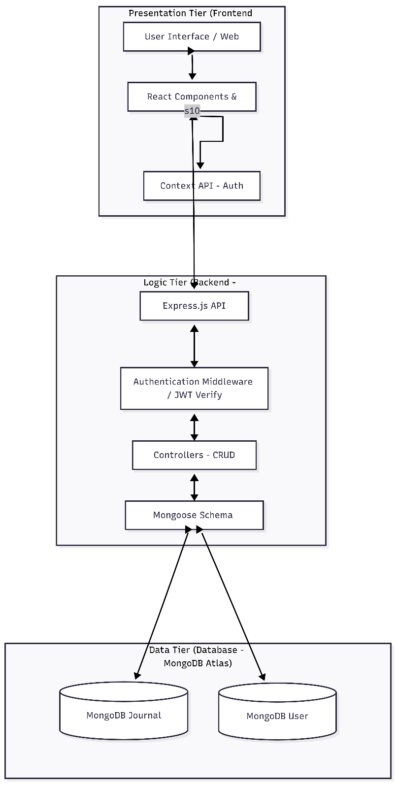
4.2 Project Modules Description and Scope
The project's codebase is structurally and functionally decomposed into three tightly cohesive, modular main modules, each handling a distinct domain of application functionality.

Module 1: Authentication & User Control Identity Module
This critical module handles all foundational identity operations. It contains the Frontend React AuthPage component and the Backend Express authController. It systematically handles new user registration, checks if submitted email addresses already exist in the database, cryptographically applies salts and irreversible hashes to raw passwords using BCrypt, securely signs and issues JSON Web Tokens upon successful authentication, and handles issuing HTTP 401 Unauthorized responses to invalid login attempts. It also manages personalized user preferences such as propagating the user's registered gender string to dynamically alter the CSS root globals for a customized color theme experience throughout the session.

Module 2: Journal Engine & CRUD Operations Module
The absolute powerhouse of the application. It comprises the UI components for the centralized JournalEditor modal, the responsive JournalList display cards, and the Backend journalController. It handles the primary data CRUD (Create, Read, Update, Delete) transactional operations. It manages the complex React functional states required to handle multi-select mood arrays, numeric range sliders for day score input, and large text area inputs simultaneously, compiling them all into a singular formatted JSON payload and transmitting it securely to the remote server. It also handles the real-time UI updates required after each database mutation operation.

Module 3: Analytics & Archival Discovery Presentation Module
A strictly data visualization and high-level computation module. It comprises the Frontend DashboardPage logic, the AllEntriesArchive navigation component, and the dedicated backend statistics API route. It autonomously operates algorithms on arrays of fetched BSON data: iteratively splitting strings by whitespace parameters to accurately generate cumulative word counts, aggressively aggregating identical mood tokens to calculate frequency distributions, and mechanically distilling complex ISO timestamps into unique year vectors to render the dynamic interactive archival calendar UI.
4.3 Module-wise Objectives, Functionalities & Constraints

Module 1: Authentication & User Control Identity Module
Objectives:
To provide a completely secure, stateless, token-based identity management system that ensures each user's data environment is fully isolated and inaccessible to any other entity on the platform.

Functionalities:
- Accepts new user registration input (username, email, password, gender) and creates a new user document in the users collection after validating all field constraints.
- Applies BCrypt salting and hashing to the raw password before any database write operation, ensuring plain-text passwords are never stored.
- Upon successful login, generates and returns a signed JSON Web Token (JWT) containing the user's MongoDB Object ID as the payload.
- Dynamically maps the user's registered gender preference to CSS root variable overrides, applying a personalized color theme across the entire UI for that session.
- Issues structured HTTP 400 or HTTP 401 error responses for duplicate emails, missing fields, or incorrect password attempts.

Input: Username, Email, Password, Gender selection.
Output: Signed JWT token, User object (excluding password), HTTP status code.

Constraints:
- Email must be unique across the entire users collection; duplicate registrations are strictly rejected.
- Password must meet minimum length requirements before hashing is applied.
- JWT has a fixed expiration time; expired tokens are rejected by middleware and require re-authentication.
- Gender field is constrained to a predefined enum array — no arbitrary values are accepted.

Module 2: Journal Engine & CRUD Operations Module
Objectives:
To serve as the core data management engine of the application, enabling authenticated users to seamlessly create, view, edit, and delete journal entries along with rich contextual metadata, in an asynchronous, non-blocking manner.

Functionalities:
- Creates new journal documents in the journals collection, associating them with the authenticated user's ID extracted from the verified JWT.
- Retrieves all journal entries belonging to the authenticated user, sorted in descending chronological order for display in the dashboard feed.
- Populates the JournalEditor modal with existing entry data when an edit operation is triggered, enabling pre-filled form modification.
- Executes findByIdAndUpdate() with ownership verification to update only journals belonging to the requesting user.
- Permanently removes a journal document from the database via DELETE request, with strict ownership verification before execution.
- Manages multi-select mood array state on the frontend using pill-button toggle logic and compiles all metadata fields into a single JSON payload for transmission.

Input: Journal title, content body, mood array, day score (1–10), weather string, location string, JWT Bearer Token.
Output: Created/updated journal document object, HTTP 201 Created or HTTP 200 OK, or structured error JSON.

Constraints:
- Title field is required and has a defined maximum character length; entries without a title are rejected by Mongoose schema validation.
- Content field requires a minimum character length to prevent empty or trivially short entries.
- Mood values are strictly validated against a predefined Mongoose enum array; any unrecognized mood string causes a validation error.
- Day Score is bounded between 1 and 10; values outside this range are rejected.
- A user can only edit or delete journal entries whose userId field matches their own authenticated ID — cross-user modification is architecturally impossible.

Module 3: Analytics & Archival Discovery Presentation Module
Objectives:
To autonomously process and aggregate a user's complete historical journal data, transforming raw database records into meaningful statistical insights and an interactive chronological navigation experience without any manual user intervention.

Functionalities:
- Fetches all journal documents for the authenticated user and iteratively splits content strings by whitespace to calculate a cumulative total word count across all entries.
- Aggregates all mood string tokens across all entries into a frequency hashmap, computing the occurrence count and percentage ratio of each distinct mood for visualization as dynamic CSS progress bars.
- Extracts and de-duplicates year values from all entry timestamps, rendering a selectable year list that drives the archival calendar view.
- Maps entries within a selected year to their corresponding month index, rendering a 12-block interactive grid where active months display entry count badges and empty months appear de-emphasized.
- Returns all statistics in a single API response from the dedicated /api/journal/stats endpoint to minimize network round-trips.

Input: Authenticated GET request to stats endpoint; year/month filter parameters for archival navigation.
Output: Stats JSON object (totalEntries, totalWords, moodBreakdown array), filtered entry arrays for archival grid rendering.

Constraints:
- Statistics are computed on-demand per request and are not cached; very large entry volumes may introduce minor computation latency.
- Word count calculation is based on whitespace tokenization and does not account for punctuation-attached words or special characters, meaning counts are approximate rather than linguistically precise.
- The archival grid is purely driven by existing data timestamps; no calendar entries are fabricated for months with zero journal records.
- All statistics are strictly user-scoped — no cross-user data aggregation occurs under any circumstances.

5. DETAILED PLANNING

Unified Modeling Language (UML) is a highly standardized, general-purpose developmental modeling language used in the field of software engineering to visually map the design architecture and behavioral characteristics of a complex software system. UML diagrams provide a common visual language that facilitates communication between developers, stakeholders, and project teams throughout the entire software development lifecycle.

5.1 DFD / UML – Use Case & Activity Flow Diagram
A Use Case diagram illustrates the expected interactions occurring between designated external actors and the specific capabilities represented as use cases within the system boundaries. Use cases describe what the system does from the user's perspective without specifying how it achieves the desired functionality.

System Actors
- Default User (Primary Human Actor): The end user who interacts with the system to perform journaling activities.
- Web System/API Architecture (Secondary Computer Actor): The backend system that processes requests and returns responses autonomously.

Primary Use Cases
- UC-01: Sign Up / Register Account — New user creates an account with username, email, password, and gender preference.
- UC-02: Sign In / Login Session — Registered user authenticates with credentials and receives a valid JWT session token.
- UC-03: Create New Journal Text Entry — Authenticated user creates a new journal entry with title, content, and optional metadata.
- UC-04: View Dashboard Feed of All Entries — User views their complete collection of journal entries in a visually organized feed layout.
- UC-05: Modify/Update Existing Journal Entry — User edits the content, moods, or score of a previously saved database journal entry.
- UC-06: Permanently Delete Journal Entry — User removes an existing journal entry completely and irreversibly from the database.
- UC-07: Display Visual Stats and Archival Grids — User views calculated statistics and navigates historical entries via interactive calendar.

Detailed Use Case Narrative — UC-05: Modify Existing Entry
Description: Allows a fully logged-in authenticated user to freely change the written content, select different mood tags, or alter the day score of an already saved, existing database journal entry.
Pre-Condition: The user must be authenticated with a valid temporal JWT token, and the targeted journal document ID must belong precisely to the authenticated user's account.
Main Flow: (1) User clicks the Edit button on a rendered Journal Card component. (2) Frontend triggers the onEdit() function, pushing the specific journal JSON object into the active editingJournal React state. (3) The Journal Editor CSS Modal animates into view. (4) Form input fields automatically pre-fill with loaded database data. (5) User alters text strings or selects new mood values. (6) User clicks the Save Changes button. (7) Client packages altered data and sends an HTTP PUT request to the API with the Bearer Token. (8) Backend verifies ownership and executes findByIdAndUpdate(). (9) Server responds with HTTP 200 OK. (10) Client re-fetches updated data and collapses the Editor Modal.
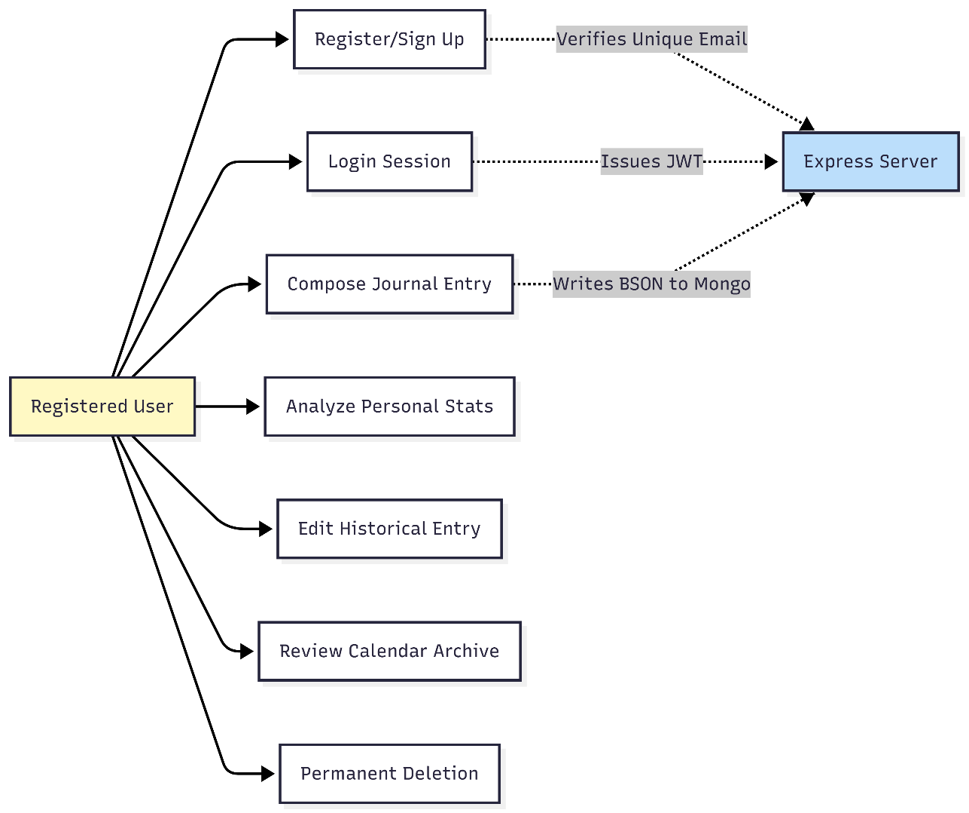

5.2 Activity Diagrams & Control Flow Definitions
An Activity diagram powerfully represents the step-by-step graphical workflow of operational components functioning within an active system, clearly depicting decision points, parallel flows, and sequence of activities from start to finish.

Activity Flow for Loading the Main Dashboard:
(1) Start Node.
(2) User navigates to dashboard URL.
(3) System checks AuthContext: Is a valid token string present in browser localStorage? Decision Node. (4) Path A — No Token: Router executes hard redirect to login page.
(5) Path B — Token Confirmed: System mounts Dashboard React component into DOM.
(6) System sets loading state to Boolean True, displaying loading spinner.
(7) System invokes parallel GET requests to both the journal feed API and the statistics API endpoints. (8) System waits for all asynchronous JavaScript Promises to resolve.
(9) Upon successful resolution: stores incoming JSON arrays into component state variables.
(10) System sets loading state to Boolean False.
(11) End Node — DOM re-renders displaying rich user data feed and calculated statistics.

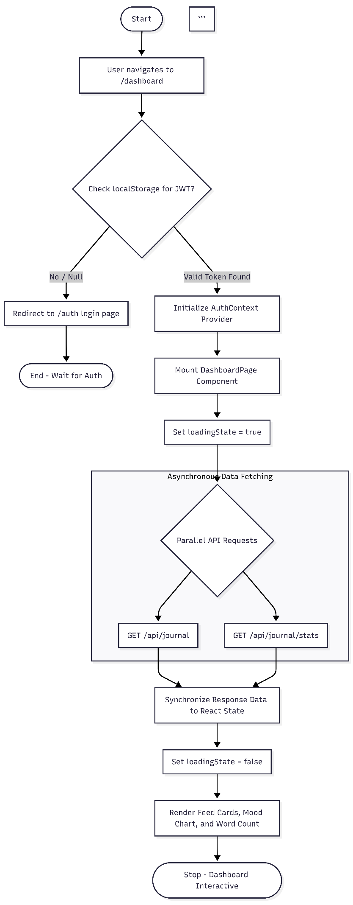

5.3 Process Specification
Sequence diagrams illustrate the chronological order of messages and interactions exchanged between multiple objects or components in a particular scenario. They show the lifetime of each participant and the sequence of method calls and responses across the system layers.

For the journal creation sequence, the interaction flows through multiple lifelines: the User initiates the action through the React UI, which calls the Axios service to format the HTTP POST request. The Express server receives the request and passes it through the JWT middleware for token verification. Upon successful verification, the Journal Controller processes the request and invokes the Mongoose model to save the new document to MongoDB. MongoDB returns the saved document object, which is then formatted into a success response by the controller, transmitted back through Express to the Axios service, which updates the React state, triggering a UI re-render displaying the newly created journal entry in the feed.
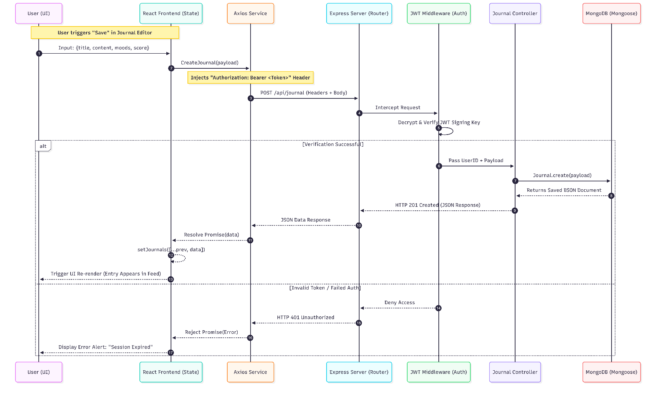

5.4 Entity-Relationship Diagram (ERD)
The Entity-Relationship Diagram is a structural diagram representing the exact conceptual layout and relational model of the abstract concepts permanently stored within the system database, showing entities, their attributes, and the relationships between them.

Identified Entities and Associated Schema Attributes
Core Entity — USER: Attributes include User_ID (Primary Key), Username String, Email String, Encrypted Password String, and Gender String Preference. This entity represents a registered application user with all associated identity and preference data.
Core Entity — JOURNAL: Attributes include Journal_ID (Primary Key), User_ID (Foreign Key linking to USER entity), Title Header String, Body Content Text, Mood_Array Object, Creation Date, Location Tag String, Weather Tag String, and Numerical DayScore value. This entity represents an individual journal entry document with all its associated metadata.

Relationship Designations and Cardinality Constraints
- Primary Relationship: A specific USER "Writes and Owns" distinct JOURNAL entries. The cardinality ratio is 1 to N — exactly one User can write many Journal entries.
- User to Journal Participation: Partial — a new user profile may exist with zero journal entries written.
- Journal to User Participation: Mandatory — every journal document must belong to exactly one registered user. Orphaned journal documents are architecturally impossible within the system.

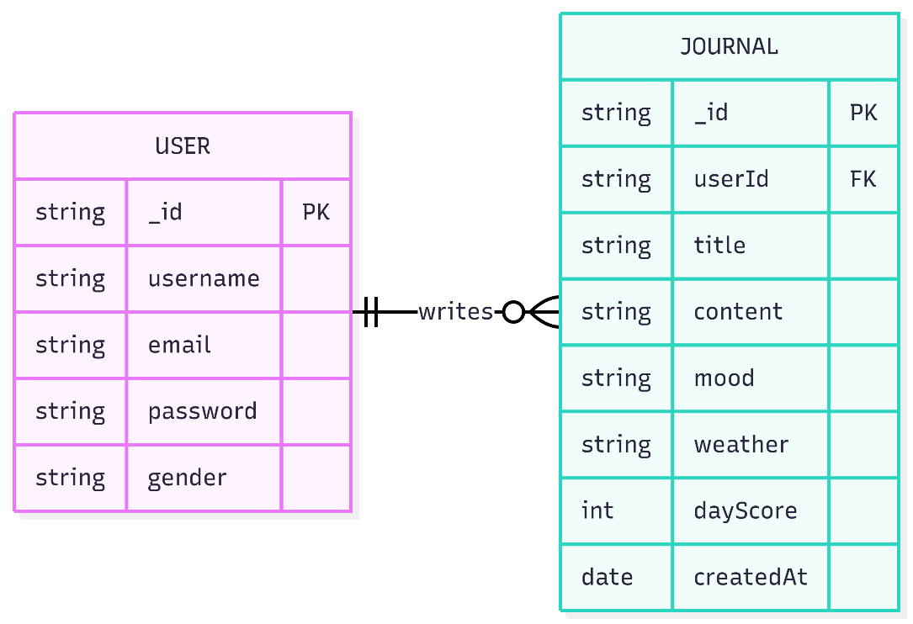
6. System Design
Data Flow Diagrams (DFD) Methodologies
Data Flow Diagrams graphically map out the actual physical flow of information payloads through a software system. DFDs use a standardized set of graphical symbols including rectangles for external entities, circles or rounded rectangles for processes, parallel lines for data stores, and directed arrows for data flows, to visually represent the movement of data through all components of the system.

Context Level (Level-0) DFD Diagram The Context Diagram represents the entire system as a single overarching high-level process, showing its relationship to external entities. At this level, the complete system is treated as a single black box that receives inputs from and produces outputs for the defined external entities.

- External Entity: The End User (Human Operator)
- Core Process 0: The Daily Journal Management Software System
- Inbound Data Flows: User credentials, registration data, journal text content, contextual metadata (mood arrays, weather tokens), and system commands (delete, edit requests).
- Outbound Data Flows: Authentication tokens, success/error alert messages, calculated statistics arrays, rendered journal entry arrays, and visual archival calendar grid data.

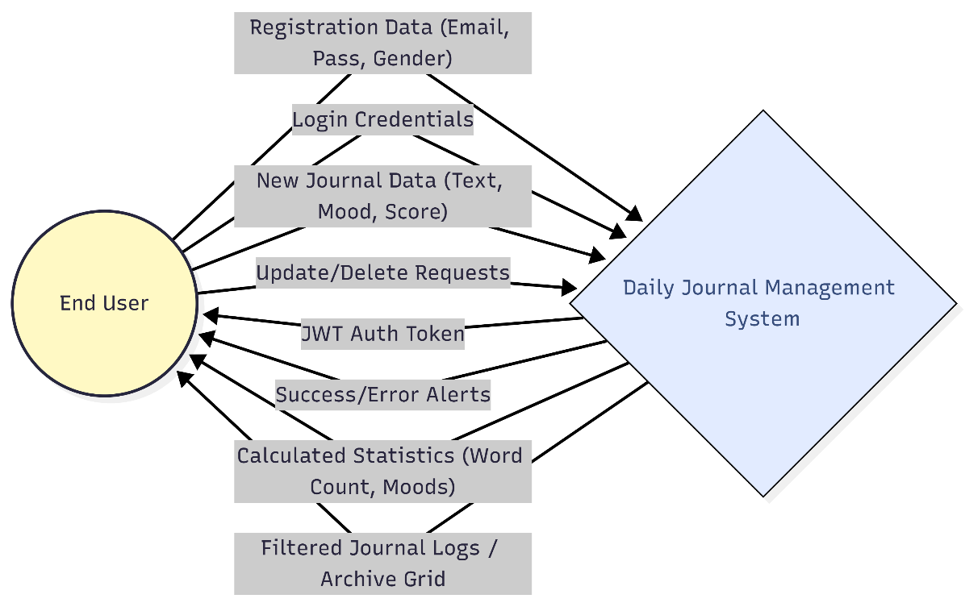

Level-1 DFD Diagram
The Level-1 DFD breaks down the monolithic Process 0 into primary distinct sub-processes, revealing the internal major components and their data interactions.

- Sub-Process 1.0 (User Authentication Management): Receives raw authentication data payloads, verifies credentials against the Users data store, and issues encrypted session tokens upon successful verification.
- Sub-Process 2.0 (Journal CRUD Transaction Engine): Receives verified tokens plus journal payload bodies, validates schema constraints, and executes write operations to the Journals data store.
- Sub-Process 3.0 (Statistics and Array Processor): Pulls data arrays from the Journals data store, calculates aggregated sums and frequency distributions, and dispatches formatted JSON statistics payloads to the frontend UI.

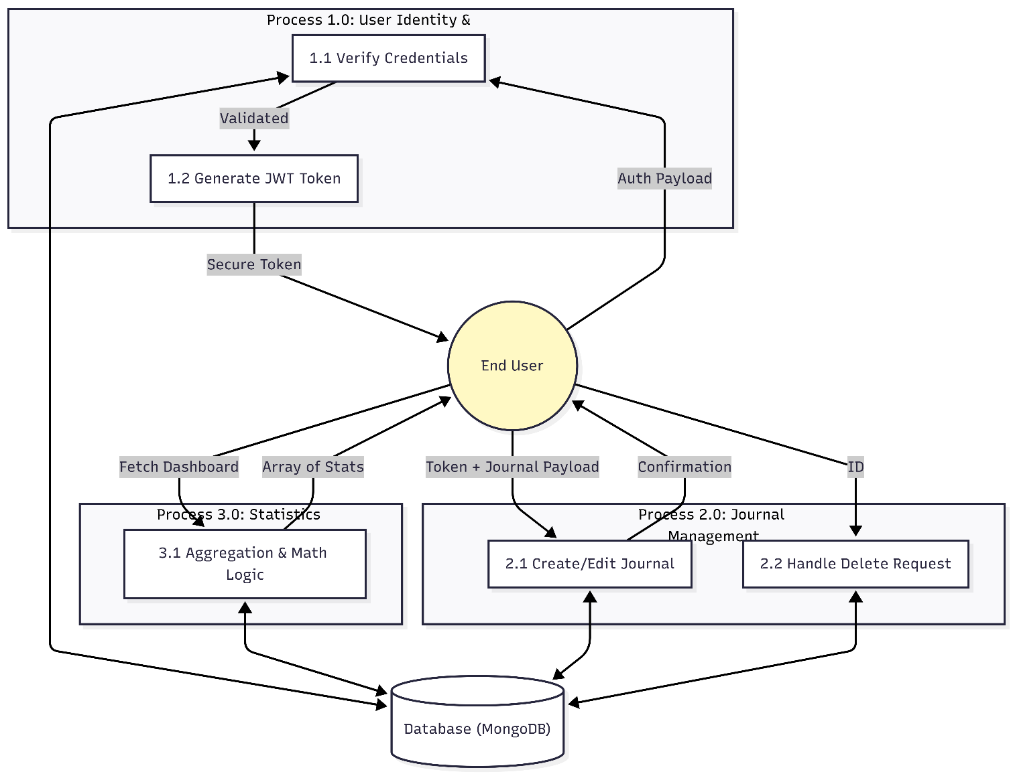
Level-2 DFD Diagram (Exploding Sub-Process 2.0: Journal CRUD Engine)
The Level-2 DFD hyper-focuses on the specific internal chronological processing sequence required for handling a new journal entry creation request, revealing the detailed steps within the CRUD engine.

- Sequence Node 2.1 (Receive POST Request): Captures User ID extracted securely from the JWT token and parses the incoming JSON request body payload.
- Sequence Node 2.2 (Schema Constraint Validator): Checks field length bounds for title and content, and verifies that all mood array string values match the predefined Mongoose enum array constants.
- Sequence Node 2.3 (Persistent Store Creation): Translates validated JavaScript JSON objects into BSON format documents and executes the MongoDB .save() operation.
- Sequence Node 2.4 (Response Emitter): Packages the newly generated Mongo unique document ID and timestamps, attaches HTTP Status Code 201 Created, and dispatches the success payload to the awaiting client thread.

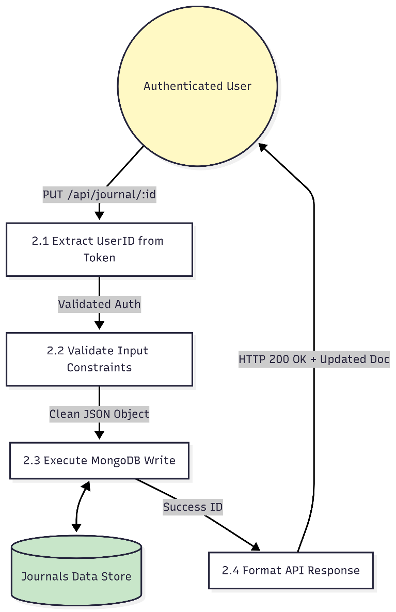
The database layer forms the foundational persistence backbone of the Daily Journal App. All user data, journal entries, and associated metadata must be stored reliably, retrieved efficiently, and protected with appropriate security measures. This chapter details the comprehensive database design decisions, the document structure of each collection, and the complete data dictionary specifications.
6.1 Database Design
6.1.1 Database Approach (NoSQL vs Relational SQL Paradigm)
The Daily Journal App strategically eschews traditional SQL relational database architectures, which rigidly enforce severely inflexible tabular data formats across interconnected grids, exclusively in favor of employing the NoSQL MongoDB platform. This architectural decision was driven by several fundamental characteristics of the journaling data model that align naturally with the document-oriented approach of MongoDB.

In the MongoDB paradigm, massive volumes of records are stored as highly flexible BSON (Binary JSON) documents. By storing these documents in a syntax format practically identical to native JavaScript JSON, the subsequent backend processing overhead is minimized, precisely because Node.js inherently manipulates JSON syntax natively without requiring any data transformation operations. The wildly dynamic schema functionality means that separate documents within the same collection can maintain vastly different attribute parameters — a capability absolutely crucial for handling the highly variable, optional data fields such as Weather strings, Location coordinates, and mood selections inherent in typical human journal entries.

A traditional relational database would require defining a fixed table schema upfront with columns for every possible field. When a user chooses not to add weather or location to a particular entry, the database would store empty NULL values in those columns for every such entry, leading to storage inefficiency and forcing unnatural NULL-checking throughout the application code. MongoDB's document model elegantly handles this by simply omitting fields that are not present in a given document, providing a far cleaner and more natural representation of the journaling data structure.

6.1.2 MongoDB Database Structure and Document Modeling
The hosted MongoDB cluster contains a distinct, isolated production database securely named mern-journal. This database encompasses exactly two fundamental collections, each serving a specific domain of the application's data requirements.

The users collection serves as the identity repository for the entire application. Each document within this collection represents a single registered user account and contains all information necessary for authentication, authorization, and personalization. The collection is indexed on both the email and username fields to enforce uniqueness constraints and optimize login query performance.

The journals collection serves as the primary data repository for all journal entries across all users of the platform. Each document within this collection represents a single journal entry, complete with all its text content and associated metadata. The collection is indexed on the userId field to enable efficient retrieval of all entries belonging to a specific user, which is the most common query pattern in the application. Secondary indexes on the date field enable chronological sorting and archival filtering operations.

6.1.3 Comprehensive Data Dictionary Definitions
A complete data dictionary comprehensively specifies the exact field names, data structure types, bounded length constraints, and detailed descriptions of every single field enforced by the database Mongoose schemas. The following tables present the complete specification for both primary collections.

Table: USERS Collection — Field Specifications and Constraints

Field Identifier | Data Type | Max Length | Constraints | Description
_id | ObjectId | 24 Hex Chars | Primary Key, Immutable | Auto-generated unique identifier for each user document.
username | String | Min:3, Max:50 | Required, Unique | User's chosen display alias for the application interface.
email | String | Valid Email | Required, Unique, Regex Match | Core email alias used for system login authorization.
password | String | 60 fixed chars | Required | Cryptographically hashed BCrypt password string stored.
gender | String (Enum) | Specific Enum | male/female/other | UI preference used to dynamically alter internal CSS theme.
createdAt | Timestamp | ISODate Format | Auto-generated | Exact temporal timestamp of account registration event.
updatedAt | Timestamp | ISODate Format | Auto-generated | Exact temporal timestamp of last profile modification.

Table: JOURNALS Collection — Field Specifications and Constraints

Field Identifier | Data Type | Max Length | Constraints | Description
_id | ObjectId | 24 Hex Chars | Primary Key, Immutable | Auto-generated unique identifier for each journal document.
userId | ObjectId | 24 Hex Chars | Foreign Key (users._id) | Reference linking the journal entry to its owner user.
title | String | Max: 200 chars | Required | The prominent header or subject line of the memory entry.
content | String | Min: 10 chars | Required | The main autobiographical text narrative body of the entry.
mood | Array[String] | Enum Checked | Required | Multi-select array storing selected emotion token strings.
date | Date | ISODate Format | Default: Date.now() | Locked chronological timestamp of the journal record.
location | String | Max: 100 chars | Optional | User-provided spatial geographic tag for the entry day.
weather | String (Enum) | Enum Checked | Optional | Constrained meteorological condition string scalar value.
dayScore | Number (Int) | Min:1 / Max:10 | Optional | Quantifying 10-point happiness metric for that specific day.

The mood field in the JOURNALS collection accepts values from a strict predefined enumeration set representing specific emotional states, including but not limited to: Happy, Sad, Anxious, Excited, Calm, Angry, Grateful, Lonely, Proud, Motivated, Tired, Confused, and Hopeful. This constrained enumeration ensures data consistency across all entries and enables accurate frequency analysis in the statistics calculation engine. Similarly, the weather field is constrained to recognized meteorological terminology constants such as Sunny, Cloudy, Rainy, Windy, Snowy, Humid, and Clear for consistent data categorization.
6.2. USER INTERFACE (UI) AND USER EXPERIENCE (UX) DESIGN

The User Interface and User Experience design of the Daily Journal App was guided by a fundamental philosophy of creating an overwhelmingly "Zen-like", highly minimalist, completely clutter-free graphical environment. The design explicitly prioritizes cognitive ease and emotional safety, recognizing that users who choose to journal are seeking a private, calming space for personal reflection. Complex functionalities were deliberately hidden behind smooth CSS transitions and modal overlays rather than crowding the main screen and inducing cognitive overload.

6.2.1 Input Design Principles & Validation Mechanics
The input design of the Daily Journal App incorporates several carefully considered principles that balance functionality with aesthetic simplicity, ensuring that data entry feels natural and effortless rather than clinical or bureaucratic.

- Fluid Hybrid Form Logic Mechanism: The traditional separate Sign Up and Sign In pages were merged into one single dual-purpose fluid container system. A React State boolean toggle instantly switches between registration and login form configurations without page reloads, reducing navigation friction to zero.
- Advanced Iconography Integration: Instead of plain text labels, the Lucide-React iconography toolkit was deployed inside input boundaries — a lock icon for passwords, an envelope icon for emails — dramatically accelerating user cognitive pattern recognition and reducing visual complexity.
- Multi-Select Emotion Pills System: Rather than an unwieldy default HTML multi-select box, moods are implemented as beautifully rendered pill-shaped dynamic buttons containing emoji icons. Custom JavaScript monitors click events, pushing or removing the selected string value from an underlying React state array while dynamically altering the pill's CSS background to visually indicate selection status.
- Secure Fixed Range Input Architecture: To prevent invalid data entry in the numerical Day Score field, the input exclusively utilizes a native HTML5 range slider strictly bounded from 1 to 10, visually displaying the selected value as the slider is dragged.
- Real-Time Client-Side Validation: Form fields perform validation checks as the user types, providing immediate visual feedback through color changes and inline error messages before the user attempts to submit, reducing failed submissions and improving the overall user experience.

6.2.2 Output Design Principles & Data Visualization Strategy
The output design strategy for the Daily Journal App places significant emphasis on transforming raw database data into visually engaging, easily interpretable information displays that motivate continued user engagement and provide genuine value through data-driven self-insight.

- Bold Data Visualization Hierarchies: Purely numerical statistical outputs are visually emphasized through complex typography — specifically deploying very large, dramatically bold, modern sans-serif fonts for crucial dashboard data parameters like Total Words Written and Total Entries Created, creating an immediate visual impact that communicates important information at a glance.
- Iterative Auto-Progression CSS Progress Bars: The Mood Breakdown interface does not merely output raw frequency numbers. Front-end logic dynamically computes the precise percentage ratio of each mood relative to the total mood count and physically renders proportional horizontal CSS linear progress bars mapped to those exact percentage values, providing instant visual comparison of emotional patterns.
- Iterative Dynamic Grid Mapping Systems: The Archive visualization portal algorithmically extracts unique years from stored timestamps and plots exactly 12 blocks representing January through December. Empty months are styled with reduced opacity to indicate absence of data, while active months bearing entries display count badges serving as clear navigation action points.
- Journal Entry Card Layout: Each journal entry is presented as a visually distinct card component displaying the title, excerpt of content, date, mood badges, day score indicator, and weather/location tags if present, providing a rich preview that enables users to quickly identify specific entries without opening them.

The Main Dashboard follows a two-column layout with a fixed left sidebar containing navigation options, user profile information, and statistics summary, while the right main content area displays the scrollable journal entry feed. This layout pattern is deeply familiar to users of applications like email clients and note-taking tools, reducing the learning curve to near zero.

The Journal Editor Modal appears as a centered overlay above the dashboard content, using a semi-transparent backdrop to maintain context while directing focus to the editing task. The modal design prevents navigation away from the editing context without explicit user action, reducing accidental data loss. All form fields within the editor are generously sized with comfortable padding to facilitate comfortable extended writing sessions
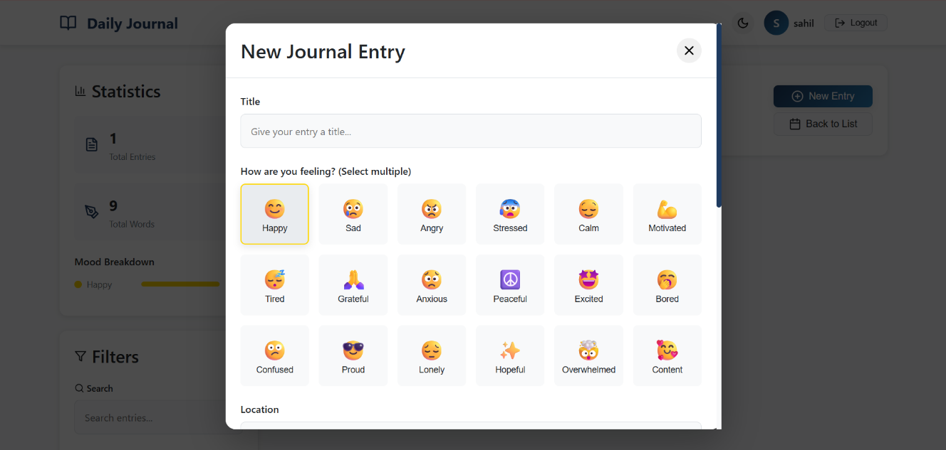
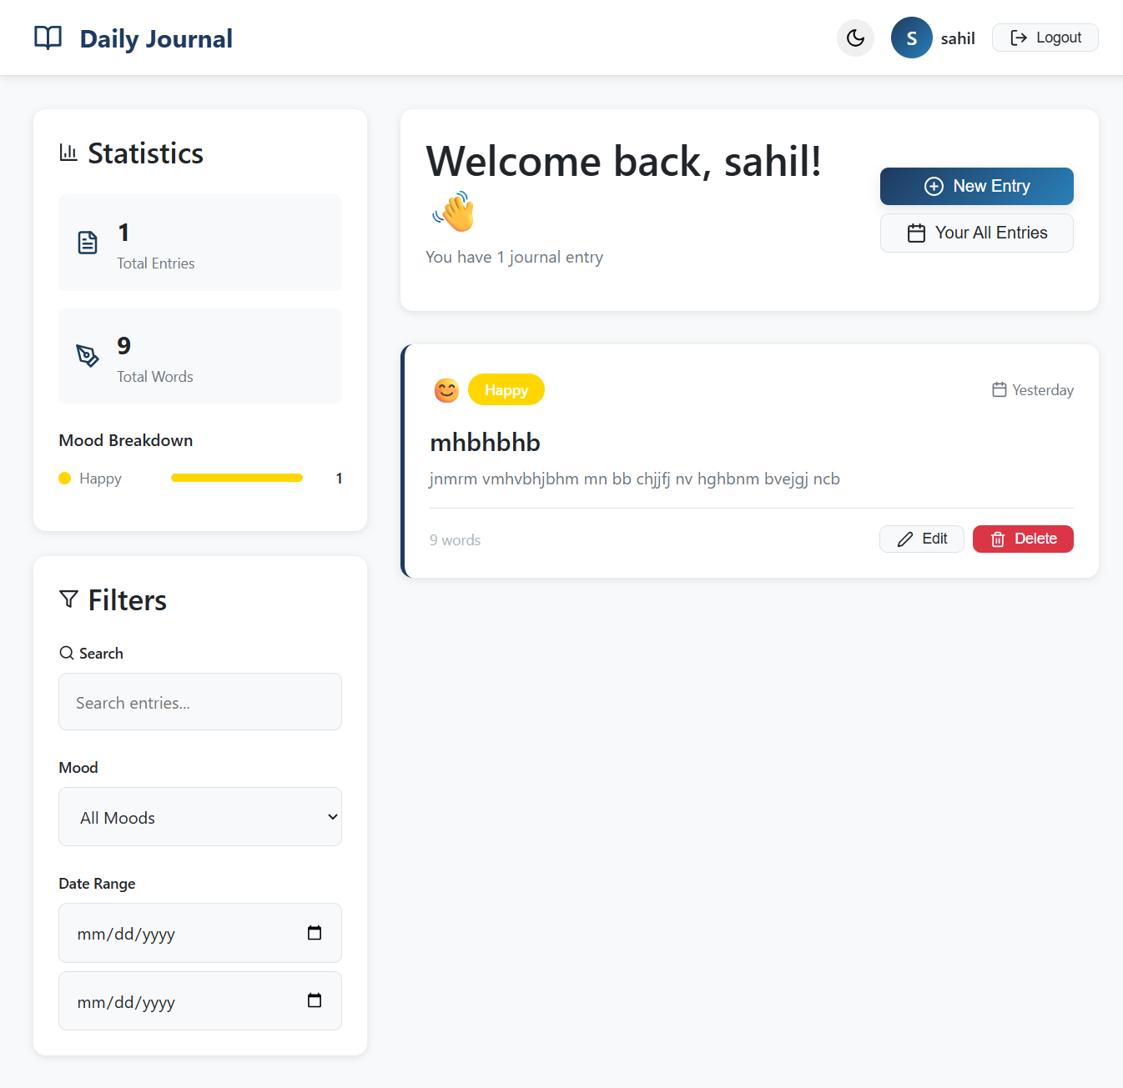

7. SOFTWARE TESTING & Test cases

Rigorous and comprehensive testing procedures are absolutely paramount and strictly non-negotiable to practically guarantee backend server route security, definitively prevent catastrophic API vulnerabilities, validate all functional requirements, and ensure overall structural reliability across multiple device types and browser environments. The overarching Quality Assurance methodology deployed integrated aspects across several distinct software testing vectors throughout the development lifecycle.

7.1 Overarching Testing Strategy and QA Methodologies
The testing strategy for the Daily Journal App adopted a multi-layered approach, combining several complementary testing methodologies to achieve comprehensive coverage of all application functionality. Testing was conducted iteratively throughout the development process rather than exclusively at the end, allowing bugs to be identified and resolved close to the point of introduction, dramatically reducing the cost and complexity of fixes.

The overall testing philosophy followed the testing pyramid model, allocating the greatest proportion of testing effort to unit tests covering individual functions and components, a moderate proportion to integration tests verifying component interactions, and a smaller proportion to end-to-end system tests covering complete user workflows. This distribution ensures maximum test coverage efficiency while maintaining reasonable test execution times.

7.2 Unit Testing and Integration Testing Paradigms
Unit Testing specifically focused on testing isolated, discrete individual logic functions in isolation from all dependencies. Key areas of unit testing included: verification of password hashing functions producing different hash outputs for identical inputs (confirming salt randomness), validation of JWT signing and verification functions, testing of individual Mongoose schema validation rules for both the User and Journal models, and verification of statistics calculation functions producing accurate results for known input datasets.

Integration Testing focused on ensuring that the highly volatile React state tree coordinates in perfect synchronization with the outbound Axios API calls, and that incoming server JSON responses are correctly processed and rendered into the active DOM without causing fatal component crashes or infinite re-render loops. Integration tests specifically covered the complete authentication flow from form submission through API call to state update and UI transition, the journal creation flow from editor form submission through API call to list refresh, and the statistics loading flow from component mount through API call to dashboard rendering.

7.3 System Testing and User Acceptance Testing (UAT)
System Testing was conducted at the application level to verify that all components work together correctly as an integrated system and that all functional and non-functional requirements are satisfied. System testing covered the complete end-to-end user workflows across all major features, including the full registration and login cycle, the complete journal lifecycle from creation through editing to deletion, and the statistics and archival navigation flows.

User Acceptance Testing (UAT) involved representative end-users interacting with the fully deployed application to verify that it meets their practical requirements and expectations. UAT identified several minor usability improvements including adjustments to mobile button sizing for touchscreen interaction and refinements to the modal close behavior on background click. These findings were incorporated into the final version of the application, improving the overall user experience based on real user feedback.

7.4 Comprehensive Test Cases Log (Positive, Negative, Boundary Scenarios)
The following matrix presents the comprehensive set of manual test cases the full-stack application systematically underwent during the quality assurance phase, covering positive scenarios (expected valid behavior), negative scenarios (invalid inputs and error handling), and boundary condition testing.

Test Case ID | Test Scenario / Focus | Input Condition | Expected Output | Result
TC-01-AUTH | Registration Validation Check | Invalid email (missing @), password too short | Browser/React blocks POST; visible alert displayed | Passed
TC-02-AUTH | Account Database Creation via API | Valid formats, correct length inputs submitted | HTTP 201 Created; DOM shifts to Login view successfully | Passed
TC-03-AUTH | Login Credentials Refusal | Correct registered email with incorrect password typed | BCrypt verify fails; API returns HTTP 401 Unauthorized | Passed
TC-04-ROUTER | Missing JWT Middleware Drop | Direct URL access to protected dashboard without token | Context detects missing token; Router redirects to login | Passed
TC-05-SCHEMA | Null Journal Blank Schema Handling | Forcefully submit form with blank title field removed | Mongoose schema validation error intercepted cleanly | Passed
TC-06-DB | Multi-Dimensional Array Document Upload | Fill form fully, toggle multiple mood pills, save entry | API parses nested arrays successfully; no CastErrors thrown | Passed
TC-07-SYNC | Update Data Synchronization Lifecycle | Click Edit button on rendered journal card in list | JSON object fully populates Editor inputs; DB updated correctly | Passed
TC-08-ALGO | Word Count Algorithm Verification | Input specific exact text string; save and dispatch | Dashboard stats aggregate and display precise word count | Passed
TC-09-UI | Archival Year Matrix Rendering | Create entry with forced historical timestamp date | UI dynamically spawns corresponding visible filter block year | Passed
TC-10-SEC | Cross-User Data Access Attempt | Attempt to query another user's journal ID via API | Server middleware blocks access; returns HTTP 403 Forbidden | Passed
TC-11-RESP | Mobile Responsive Layout Test | Load dashboard on 375px width mobile screen viewport | CSS Flexbox stack responds; layout adapts without overflow | Passed
TC-12-API | DELETE Journal Operation Test | Click delete button on specific journal entry card | HTTP DELETE fires; DB removes document; UI list refreshes | Passed

8. FUTURE SCOPE OF ENHANCEMENTS AND SCALABILITY PATHWAYS

The robust technological foundation established throughout the project lifecycle explicitly enables extensive future scalability and feature enhancement opportunities. Several promising enhancement pathways have been identified that would substantially increase the application's value proposition and user engagement without requiring fundamental architectural redesigns.

1 Artificial Intelligence Integration
The most profoundly impactful potential future enhancement involves incorporating advanced AI capabilities through integration with large language model APIs. By configuring an automated background Node.js cron job scheduling system, the server could periodically analyze a user's journal entries using AI sentiment analysis to provide deeper, more nuanced emotional insights beyond the simple mood tags the user manually selects. The AI could identify recurring themes, vocabulary patterns, and contextual connections across entries spanning months or years.

Additionally, an AI-powered journaling assistant could provide contextual writing prompts tailored to the user's historical emotional patterns, helping users who struggle with blank-page syndrome begin their entries more easily. The assistant could also generate periodic personalized summaries of the user's journaling activity, highlighting notable emotional trends and significant life events captured in the entry metadata over the preceding month or year.

2. Native Mobile Application Development
Developing dedicated native mobile applications for iOS (using React Native) and Android platforms would significantly expand the user base by providing a more convenient and immersive journaling experience on mobile devices. A native application could leverage device-specific capabilities unavailable in the browser environment, including push notification reminders to encourage daily journaling habits, biometric authentication through fingerprint or face recognition for enhanced security, offline writing capability with automatic synchronization when connectivity is restored, and direct integration with the device camera for attaching photos to journal entries.

3. Rich Media Attachment Support
Extending the journaling model to support rich media attachments would substantially increase the expressiveness and memorability of journal entries. Integration with cloud storage services such as Amazon S3 or Google Cloud Storage would enable users to attach photographs, voice recordings, and short video clips to their journal entries. This enhancement would require modifications to the MongoDB schema to store media reference URLs, additions to the backend API to handle multipart form data uploads and cloud storage operations, and UI updates to display media previews within the journal entry cards and editor.

4. Advanced Analytics and Data Export
The existing statistical analysis capabilities could be substantially expanded through more sophisticated data visualization techniques. Integration with charting libraries such as D3.js or Chart.js would enable the creation of interactive time-series charts showing day score trends over selectable time periods, heat maps visualizing journaling frequency across days of the week and months of the year, word cloud visualizations of the most frequently used vocabulary across all entries, and correlation analysis between different emotional states and other contextual variables like weather or location.

Providing users with the ability to export their complete journal archive in standard formats such as PDF or structured JSON would enhance the application's longevity value proposition, giving users confidence that their data is not permanently locked into the platform and can be preserved or migrated in the future.

5. Collaborative Features and Shared Journals
While the current application is exclusively designed for private individual use, a carefully implemented optional shared journaling feature could enable specific use cases such as couples journaling together in a mutually visible private space, family members sharing selected entries, or therapist-client journaling workflows where specific entries are selectively shared with a healthcare provider. All sharing would need to be explicitly consent-driven and granular, preserving the fundamental privacy philosophy of the application while adding valuable social use cases.

9. BIBLIOGRAPHY & REFERENCES

The following references were consulted during the research, design, and implementation phases of the Daily Journal App project. These resources provided foundational knowledge, best practices, and technical guidance for the various technologies and methodologies employed throughout the development process.

- Meta Open Source Organization. (n.d.). React Documentation — Main Concepts, Hooks API Reference, and Context API. Retrieved from the official React documentation portal at react.dev.
- The Node.js Foundation. (n.d.). Node.js API Documentation, Event Loop Guide, and Asynchronous I/O Overview. Retrieved from the official Node.js documentation portal at nodejs.org.
- Express.js Foundation. (n.d.). Express.js Guide — Routing, Middleware, Error Handling, and API Reference. Retrieved from the official Express.js documentation at expressjs.com.
- MongoDB, Inc. (n.d.). MongoDB Manual — CRUD Operations, Aggregation Pipeline, Schema Design Best Practices, and Atlas Configuration. Retrieved from docs.mongodb.com.
- Mongoose. (n.d.). Mongoose Documentation — Schema Definition, Validation, Middleware, and Query Building. Retrieved from mongoosejs.com/docs.
- Auth0 by Okta. (n.d.). Introduction to JSON Web Tokens — Structure, Signing Algorithms, and Implementation Best Practices. Retrieved from jwt.io and the Auth0 documentation portal.
- Mozilla Developer Network (MDN). (n.d.). Web APIs Reference — CSS Flexbox Layout, CSS Grid Layout, Fetch API, and localStorage. Retrieved from developer.mozilla.org.
- Vite. (n.d.). Vite Guide — Getting Started, Configuration Reference, and Build Optimization. Retrieved from the official Vite documentation at vitejs.dev.
- Pressman, R. S. (2014). Software Engineering: A Practitioner's Approach (8th ed.). McGraw-Hill Education. Used for SDLC methodology, feasibility study frameworks, and system design principles.
- Sommerville, I. (2016). Software Engineering (10th ed.). Pearson Education Limited. Referenced for requirements engineering, software testing methodologies, and UML diagram specifications.
- Axios. (n.d.). Axios Documentation — Request Configuration, Interceptors, and Error Handling. Retrieved from axios-http.com/docs.
- React Router. (n.d.). React Router Documentation — Route Definition, Navigation, and Protected Routes. Retrieved from reactrouter.com/docs.

— End of Report —

