A report submitted to


Affiliated To: Veer Narmad South Gujarat University, Surat
For, Partial requirement for the fulfillment of the degree of
Bachelor of Computer Applications (BCA)

BCA Sem VI
A.Y. 2025-26

Project Report On GlobeTrails

by
Roll No. | Seat No. | Name Of Student
 |  | Rana Mehul Chandrakantbhai
 |  | Agarwal Samarth
 |  | Tiwari Shani Pappubhai.

Project Guide by:
Disha Nalwala
Acknowledgement

The success and final outcome of this project required a lot of guidance and assistance from many people and we are extremely fortunate to have got this all along the completion of our project work. Whatever we have done is only due to such guidance and assistance.

we would not forget to thank Principal Dr. Aditi Bhatt, IQAC coordinator and trust representative Dr. Vaibhav Desai, In-charge of PG Courses Dr. Vimal Vaiwala , In-charge of UG and Head of the UG Department Prof. Nainesh Gathiyawala and Project guide Disha Nalwala and all other Assistant professors of SDJ International College, who took keen interest on our project work and guided us all along, till the completion of our project work by providing all the necessary information for developing a good system.

We are extremely grateful to her/him for providing such a nice support and guidance though she/he had busy schedule managing the college dealings.
We are thankful and fortunate enough to get support and guidance from all Teaching staffs of IT Department which helped us in successfully completing our project work. Also, we would like to extend our sincere regards to all the non-teaching staff of IT Department for their timely support.

Student Name (Exam Seat Number)
Student Name (Exam Seat Number)
Student Name (Exam Seat Number)
Student Name (Exam Seat Number)

I N D E X

Sr. No | Description | Page No.
1 | Introduction
 | 1.1 Project description
 | 1.2 Project Profile
2 | Environment Description
 | 2.1 Hardware and Software Requirements
 | 2.2 Technologies Used
3 | System Analysis and Planning
 | 3.1 Existing System and its Drawbacks
 | 3.2 Feasibility Study
 | 3.3 Requirement Gathering and Analysis
4 | Proposed System
 | 4.1 Scope
 | 4.2 Project Modules Functionalities
5 | Detail Planning
 | 5.1 Data Flow Diagram / UML
 | 5.2 Data Dictionary
 | 5.3 Process Specification / Activity Flow Diagram
 | 5.4 Entity-Relationship Diagram / Class Diagram
6 | System Design
 | 6.1 Database Design
 | 6.2 Input Design
 | 6.3 Output Design
7 | Software Testing
 | 7.1 Unit Testing
 | 7.2 Integration Testing
 | 7.3 System Testing
8 | Future Scope of Enhancements
9 | Bibliography & Reference

1. Introduction

1.1 Project Description
GlobeTrails is a comprehensive, web-based Tour and Travel Management System designed to bridge the gap between travel enthusiasts and curated travel experiences. In the modern tourism industry, travelers seek seamless platforms to discover, plan, and book their journeys with trust and transparency. GlobeTrails addresses this need by providing a user-centric interface for browsing high-quality tour packages while offering a robust administrative backend for managing content, bookings, and user interactions.

The system is built as a Single Page Application (SPA) using the MERN stack (MongoDB, Express.js, React.js, Node.js), ensuring a responsive and dynamic user experience. Core functionalities include secure user authentication (including Google OAuth), a detailed tour catalog with category-based filtering, an integrated booking inquiry system, and a comprehensive Admin Panel for data management.

Target audience:
- Travelers: Individuals looking for organized tour packages for adventure, heritage, wildlife, etc.
- Administrators: Travel agency managers needing a digital dashboard to track inventory and inquiries.

1.2 Project Profile

1.2.1 Application Overview

GlobeTrails is a comprehensive web-based tour and travel management system designed to modernize how travel bookings are conducted. The platform serves as a digital intermediary between travel service providers and customers, addressing common industry pain points like fragmented information and manual booking processes. Developed as a Single Page Application (SPA) using React.js, the system provides a seamless, app-like user experience where all necessary functions—from browsing tours to managing bookings—occur within a single, dynamic interface without full page reloads.

The application represents a practical solution for small to medium-sized tour operators looking to establish an online presence with full booking capabilities. For travelers, it offers a centralized platform to discover, compare, and reserve tours across various categories including adventure, heritage, and wildlife experiences. The project's architecture emphasizes both user-friendliness and administrative control, creating a balanced ecosystem that serves both ends of the travel transaction process.

1.2.2 Architectural Design

The system is built on the MERN stack (MongoDB, Express.js, React.js, Node.js), selected for its consistency across development layers and strong community support. This JavaScript-based stack allowed for efficient development with a unified language approach, reducing context switching and simplifying both frontend and backend implementation.

Frontend Layer: Constructed with React.js using functional components and hooks, the interface implements a component-based architecture that promotes reusability and maintainability. State management is handled through React's built-in hooks for local state and Redux Toolkit for global application state, particularly for user authentication and session persistence. The use of React Router enables smooth navigation between views while maintaining the SPA experience.

Backend Layer: Powered by Node.js with the Express.js framework, this layer provides a RESTful API that handles all business logic, authentication, and data processing. The backend follows a modular structure with separate routes, controllers, and middleware functions, ensuring clean separation of concerns. Key middleware includes authentication verification, error handling, and request validation.

Database Layer: MongoDB serves as the primary data store, chosen for its flexibility with JSON-like documents that align naturally with JavaScript objects. The Mongoose ODM library provides schema validation, relationship management, and query building capabilities. The database design utilizes both embedded documents for closely related data (like tour itineraries) and document references for transactional relationships (like bookings connecting users and tours).

1.2.3 Data Management Approach

User Data: User information is stored with security as a priority. Passwords are hashed using BCryptJS before storage, and authentication relies on JSON Web Tokens (JWT) for stateless session management. The user schema distinguishes between regular users and administrators through role-based permissions.

Tour Content: Tours are modeled as comprehensive documents containing all relevant details—descriptions, pricing, duration, categories, and detailed itineraries. The itinerary structure uses embedded sub-documents for each day's activities, allowing complete tour information to be retrieved in a single database query. This design choice significantly improves performance for the most common user action: browsing tour details.

Media Assets: Tour images are managed through Supabase's cloud storage service. When administrators upload photographs, files are transmitted to Supabase via secure API calls, and only the resulting URLs are stored in the database(mongoDB). This approach offloads media storage and delivery responsibilities to a dedicated service while ensuring fast, optimized image delivery through their global CDN.

Booking Transactions: Bookings create associations between users and tours, capturing essential details like travel dates, participant counts, and current status. The booking schema supports a straightforward status lifecycle (pending → confirmed/rejected) that both users and administrators can track through their respective interfaces.

1.2.4 Technical Implementation Standards

Security Measures: The application implements multiple security layers including JWT-based authentication, password hashing with salt rounds, role-based access controls, and input sanitization across all forms. MongoDB queries use parameterized inputs through Mongoose to prevent injection attacks, while React's built-in XSS protection safeguards against client-side vulnerabilities.

Responsive Design: The interface is built with mobile-first responsive principles using CSS Flexbox and Grid layouts. Breakpoints are set at standard device widths (mobile: 320px, tablet: 768px, desktop: 1024px) with particular attention to touch targets and readable typography on smaller screens. The design ensures consistent functionality across all modern browsers and devices.

Maintainability and Scalability: The codebase follows consistent naming conventions, modular component structure, and comprehensive documentation. While initially designed for smaller operations, the architecture supports scaling through horizontal deployment options, database indexing strategies, and the stateless nature of the JWT authentication system. Future expansion could include additional microservices without disrupting core functionality.

Development Practices: The project was developed using Git for version control, with feature-based branching and regular commits. Agile methodologies influenced the development process, with iterative improvements based on continuous testing and feedback. Post-deployment monitoring considerations include error tracking and performance analytics for ongoing optimization.

2. Environment Description

2.1 Hardware and Software Requirements

The development and deployment of GlobeTrails require specific environmental configurations to ensure optimal performance and compatibility.

Server-Side Requirements:

- Processor: Minimum 2 vCPU 2.4 GHz (Intel Xeon or AMD EPYC equivalent).
- RAM: 4GB Minimum (8GB Recommended for handling high concurrency during Booking transactions).
- Storage: SSD-based storage for database read/write efficiency; cloudbased storage-Supabase for hosting high-resolution tour imagery.
- Operating System: Windows 11,10
- Browser: The application leverages modern ES6+ JavaScript features. Used browsers with pervasive supported Google Chrome (v88+) and Microsoft Edge.
- Device Independence: The Responsive Web Design (RWD) implementation ensures compatibility across desktops, tablets (768px+), and mobile devices (320px+).

2.2 Technologies Used

The technology stack was selected based on a comprehensive feasibility study prioritizing scalability, non-blocking I/O, and component reusability.

Frontend:
- React.js (v19): Utilized for its Virtual DOM implementation, ensuring high-performance UI rendering. Functional components and Hooks (useState, useEffect, useContext) manage local state and side effects.
- Redux Toolkit: Implements the Flux architecture for global state management, specifically for handling User Session and Authentication states across the application wireframe.
- Vite: Adoption of Vite over Webpack significantly reduces build times and enhances Hot Module Replacement (HMR) during development.

Backend:
- Node.js & Express.js (v5): Provides the RESTful API layer. Express’s middleware architecture allows for modular handling of requests, including body parsing, CORS management, and error handling.
- Passport.js: Integrated for modular authentication strategies, specifically isolating the logic for Google OAuth 2.0.

Database:
- MongoDB: A NoSQL document store chosen for its flexible schema (BSON), allowing for the nesting of complex data structures like "Tour Itineraries" and "Daily Schedules" without complex joins.
- Mongoose: Acts as the Object Data Modeling (ODM) layer, providing schema validation, pre-save hooks (middleware), and query building abstraction.

Security:
- BCryptJS: Used for key derivation functions to salt and hash user passwords, defending against Rainbow Table attacks.
- JSON Web Tokens (JWT): Facilitates stateless session management, eliminating the server-side overhead of maintaining session stores (e.g., Redis) for this scale of application.

3
3. System Analysis

3.1 Existing System and its Drawbacks
Many traditional travel agencies still rely on:
- Manual Booking: Phone calls or physical visits, leading to inefficiency and time loss.
- Fragmented Information: Tour details scattered across brochures or static websites without real-time updates.
- Lack of Centralization: Admin data (users, tours, analytics) stored in spreadsheets or disparate systems.
Drawbacks:
- High operational costs.
- Slow response time to customer inquiries.
- Difficulty in updating tour inventory (pricing, availability).

3.2 Feasibility Study
Technical Feasibility: The project relies on JavaScript across the full stack (Isomorphic JavaScript). This uniformity minimizes context switching for developers and allows code sharing (e.g., validation logic) between client and server. The availability of robust libraries like mongoose for database interactions and lucide-react for iconography confirms high technical viability.
Operational Feasibility: The User Interface (UI) design focuses on HCI (Human-Computer Interaction) principles like "Visibility of System Status" and "Match between System and Real World." Consequently, travel agents or admins migrating from legacy paper-based systems to GlobeTrails will encounter a minimal learning curve.

3.3 Requirement Gathering
Functional Requirements:
R1 - Identity Management: The system must allow users to register via email or third-party providers (Google) and maintain persistent sessions.
R2 - Inventory Visualization: Users must be able to filter the tour catalog by specific meta-attributes (Price Range, Category, Duration).
R3 - Transactional Integrity: Booking requests must atomically update the database to prevent data inconsistency.
R4 - Administrative Control: Admin users must have elevated privileges to modify static content and view private user bookings.

4. Proposed System
4.1 Scope
The GlobeTrails system is designed to encompass the complete digital workflow of modern tour booking operations. The platform's scope extends across the entire user journey—from initial discovery and exploration to final booking confirmation and administrative management. This comprehensive approach ensures that both travelers and tour operators have access to all necessary tools within a unified ecosystem.

System Boundaries and Functional Coverage:
In-Scope Components:

Web Application Platform:

- A fully responsive, cross-browser compatible web interface accessible via standard web browsers
- Client-side application built with React.js providing dynamic, app-like user experience
- Mobile-optimized interface ensuring functionality across smartphones, tablets, and desktops

Core Database Infrastructure:

- MongoDB database for primary data storage including user profiles, tour information, and booking records
- Document-based schema design optimized for travel industry data structures
- Secure data access layers with proper authentication and authorization protocols
- API Server and Backend Services:
- RESTful API architecture built with Node.js and Express.js
- Comprehensive API endpoints covering user authentication, tour management, booking processing, and administrative functions
- Integration with third-party services for cloud storage (tour images) and authentication (Google OAuth)

Administrative Interface:

- Dedicated admin dashboard with role-based access control
- Content management system for tour creation, modification, and removal
- Booking management interface for status updates and customer communication
- Basic analytics and reporting functionalities for business insights
- Public tour catalog with advanced filtering and search capabilities
- Detailed tour presentation pages with comprehensive itineraries and multimedia content
- User registration and authentication system (email/password and social login)
- Booking request submission and status tracking

4.2 Project Module Functionalities

4.2.1 Authentication & Security Module
Overview: Authentication is the gatekeeper of the GlobeTrails system. Unlike monolithic applications that might rely on server-side sessions and cookies, GlobeTrails implements a stateless JWT (JSON Web Token) architecture. This ensures the backend remains scalable and decouples the frontend from specific server instances (crucial for eventual microservices architecture).

User Registration Workflow:
- Input Validation: When a user submits the signup form, the frontend performs initial regex validation on the email and password complexity checks.
- API Payload: A POST request is sent to /api/auth/register containing the sanitized payload.
- Uniqueness Check: The backend controller invokes User.findOne({ email }). Indexes on the email field in MongoDB allow this lookup to occur in O(log n) time.
- Cryptographic Hashing: Upon verification that the user does not exist, the password is passed through bcryptjs. We utilize a salt round of 10, balancing security against CPU processing time.
- Persistence: The new user document, containing the hashed password and default role: 'user', is written to the database.

Login Workflow & Session Management:

- Credential Verification: For email login, bcrypt.compare() compares the plaintext input against the stored hash. For Google login, passport-google-oauth20 exchanges the authorization code for an ID token and profile data.
- Token Generation: Upon successful verification, the server signs a JWT using the RS256 or HS256 algorithm and a private JWT_SECRET. The payload includes non-sensitive claims: userId and role.
- Storage Strategy: The token is sent to the client. The React application stores this token in localStorage or an HttpOnly Cookie. Within the React state (Redux), a boolean flag isAuthenticated is set to true.
- Role-Based Access Control (RBAC): RBAC is implemented via custom Express middleware.

Middleware Logic: A higher-order function verifyAdmin intercepts sensitive routes (e.g., POST /tours, DELETE /users/:id).
Token Decoding: The middleware decodes the JWT to extract the role claim.
Authorization: If req.user.role !== 'admin', the request is terminated immediately with a 403 Forbidden status code, preventing unauthorized logical access to administrative controllers
.
4.2.2 Tour Catalog & Content Management Module
Concept Explanation: The Tour Catalog is the core product engine of GlobeTrails. It transforms raw database entries into visually appealing, searchable travel packages. This module handles the complex data modeling required to represent multi-day itineraries, diverse amenities, and pricing structures.

Data Modeling & Design Decisions: The Tour schema in MongoDB is designed to be read-heavy. Since users browse tours far more often than admins update them, we utilize a denormalized schema structure.

Nested Itineraries: Instead of a separate SQL-style "Itinerary" table joined by ID, the itinerary is embedded directly within the Tour document as an array of objects [ { day: 1, activity: "..." }, { day: 2... } ]. This allows the application to fetch the complete tour details in a single database query, significantly reducing latency.

Categorization: The schema enforces strict Enum validation for categories (e.g., "Wildlife Tour", "Beach Tour"). This guarantees data integrity and ensures filters on the frontend always return consistent results.
Technical Workflow (Frontend):

Fetching: The Tours.jsx component initiates an asynchronous axios.get() call on mount via the useEffect hook.

State Management: Data is stored in local component state tours[].

Rendering: The map() function iterates over the array to render TourCard components.

Dynamic Routing: clicking a "View Details" button pushes the user to /tours/:id. React Router extracts the :id param, allowing the TourDetails component to fetch specific data for that unique ID.

4.2.3 Booking & Reservation Engine Module
Concept Explanation: The Booking Engine handles the transactional intent of the user. It captures user requirements (dates, guest count) and establishes a link between a User entity and a Tour entity.

Workflow:

- User Intent: On the TourDetails page, a logged-in user selects a preferredStartDate and enters the number of guests.
- Data Submission: The form submission triggers a POST /bookings request. This request header includes the Authorization: Bearer <token> to verify the user identity.
- Backend Processing:
- The controller extracts userId from the decoded token.
- It creates a new Booking document referencing both User (Who booked?) and
- Tour (What was booked?).
- The inquiryStatus is set to default 'pending'.
- Feedback: The user receives a success notification via sonner (toast notification library) and is redirected to their "My Bookings" page.

- Process Specification –
Status Lifecycle: A finite state machine governs the booking status:
- Pending: Initial state upon creation.
- Confirmed: Admin has reviewed capacity and accepted the booking.
- Rejected: Admin has declined the request (e.g., due to non-availability). This logic is enforced at the schema level using Mongoose Enums.

4.2.4 Administrative Dashboard (Admin Panel)
Concept Explanation: The Admin Panel is a specialized, secured Single Page Application accessible only to users with the admin role. It serves as the command center for the entire GlobeTrails platform.

Key Features & Implementation:

Dashboard Analytics:
Implementation:
Dashboard.jsx component aggregates data. It runs parallel Promises (Promise.all) to fetch counts from users, tours, and bookings collections simultaneously.
Visualization: Data is presented in "Stat Cards" providing immediate business intelligence (e.g., "Total Revenue: ₹125,000").

Tour Inventory Management (CRUD):
- Create: A sophisticated multi-step form allows admins to input tour metadata. The TourUploadForm handles complex state for dynamic itinerary arrays (adding/removing days).
- Update: An edit mode pre-fills the form with existing data, performing a PUT request on submission.
- Delete: A safeguarded delete action removes tours from the public catalog.

Booking Management:
Admins view a tabular list of all bookings.
Action buttons triggering PATCH requests allow the admin to toggle the status from 'Pending' to 'Confirmed'. This direct database update is immediately reflected in the user's view.
5. Detail Planning
5.1 Data Flow Diagram (DFD)
The Data Flow Diagrams (DFD) illustrate how data moves through the GlobeTrails system, transforming from user inputs to processed database records.

Level 0 Context Diagram: This high-level overview shows the interaction between external entities (User, Admin) and the GlobeTrails System as a complete black box.

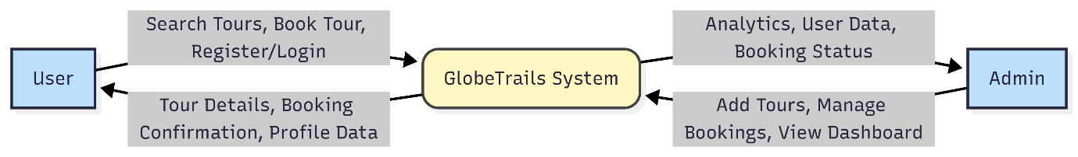

Level 1 Data Flow (booking process): This diagram breaks down the "Booking Process" into specific sub-processes to show the internal flow of logic.

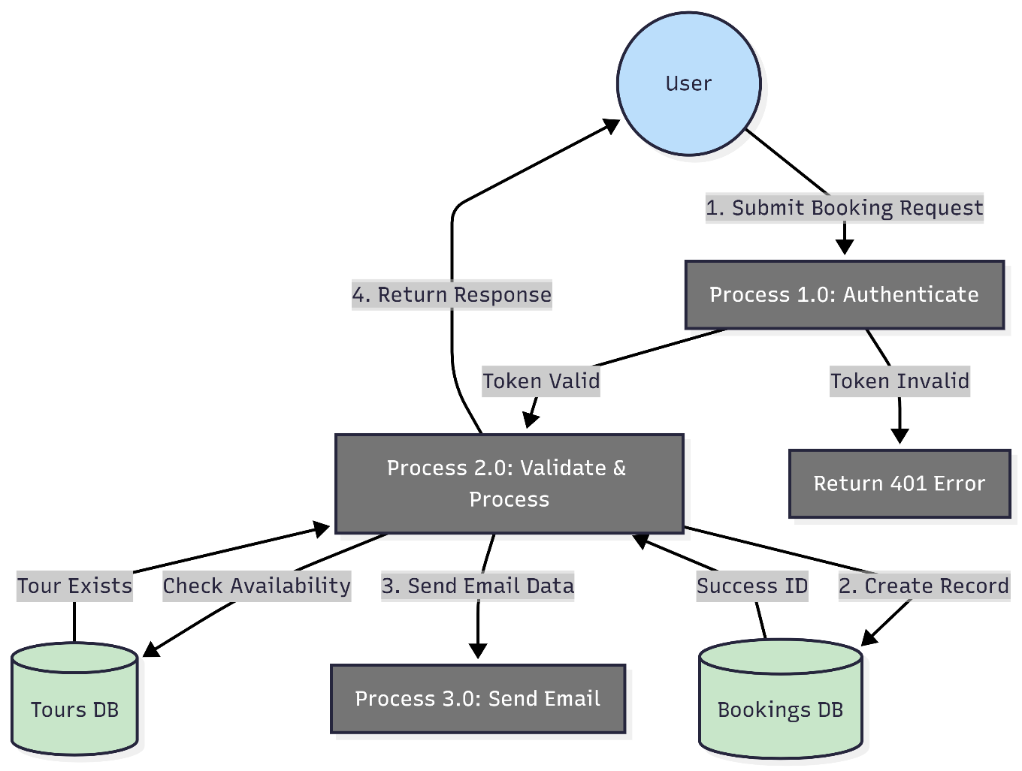
- Booking Request: The user initiates the flow by submitting a form on the Tour Details page.
- Auth Validation: The request is intercepted by the isAuthenticated middleware to verify the user's identity via JWT.
- Validation: The system checks business logic (e.g., date validity, duplicate bookings).
- Persistence: The validated data is saved to the Bookings collection in MongoDB.
- Notification: The system triggers an email service to notify the user.

5.2 Data Dictionary

The Data Dictionary provides a metadata definition for the fields used in the database schema, ensuring consistency across the development lifecycle.

Entity:User

Field Name | Data Type | Description
_id | ObjectId | Unique Primary Key (Auto-generated).
username | String | User's display name.
email | String | Unique email address used for login.
password | String | BCrypt hashed password string.
role | String | Access control tag ('user' or 'admin').
isVerified | Boolean | Flag for email verification status.

Entity:Tour
Field Name | Data Type | Description
title | String | Marketing name of the tour package.
category | String | Enum (Adventure, Wildlife, Heritage, etc.).
pricePerPerson | Number | Base cost per individual.
itinerary | Array[Obj] | Nested array of daily schedules.
images | Array[Str] | List of image URLs (Supabase).
Field Name | Data Type | Description

Entity: Booking
Field Name | Data Type | Description
user | ObjectId | Foreign Key referencing the User collection.
tour | ObjectId | Foreign Key referencing the Tour collection.
preferredStartDate | Date | The user's selected travel date.
guests | Number | Count of travelers in the group.
inquiryStatus | String | Enum: 'pending' (default), 'confirmed', 'rejected'.
finalPrice | Number | Calculated total (pricePerPerson * guests).

5.3 Process Specification / Activity Flow Diagram

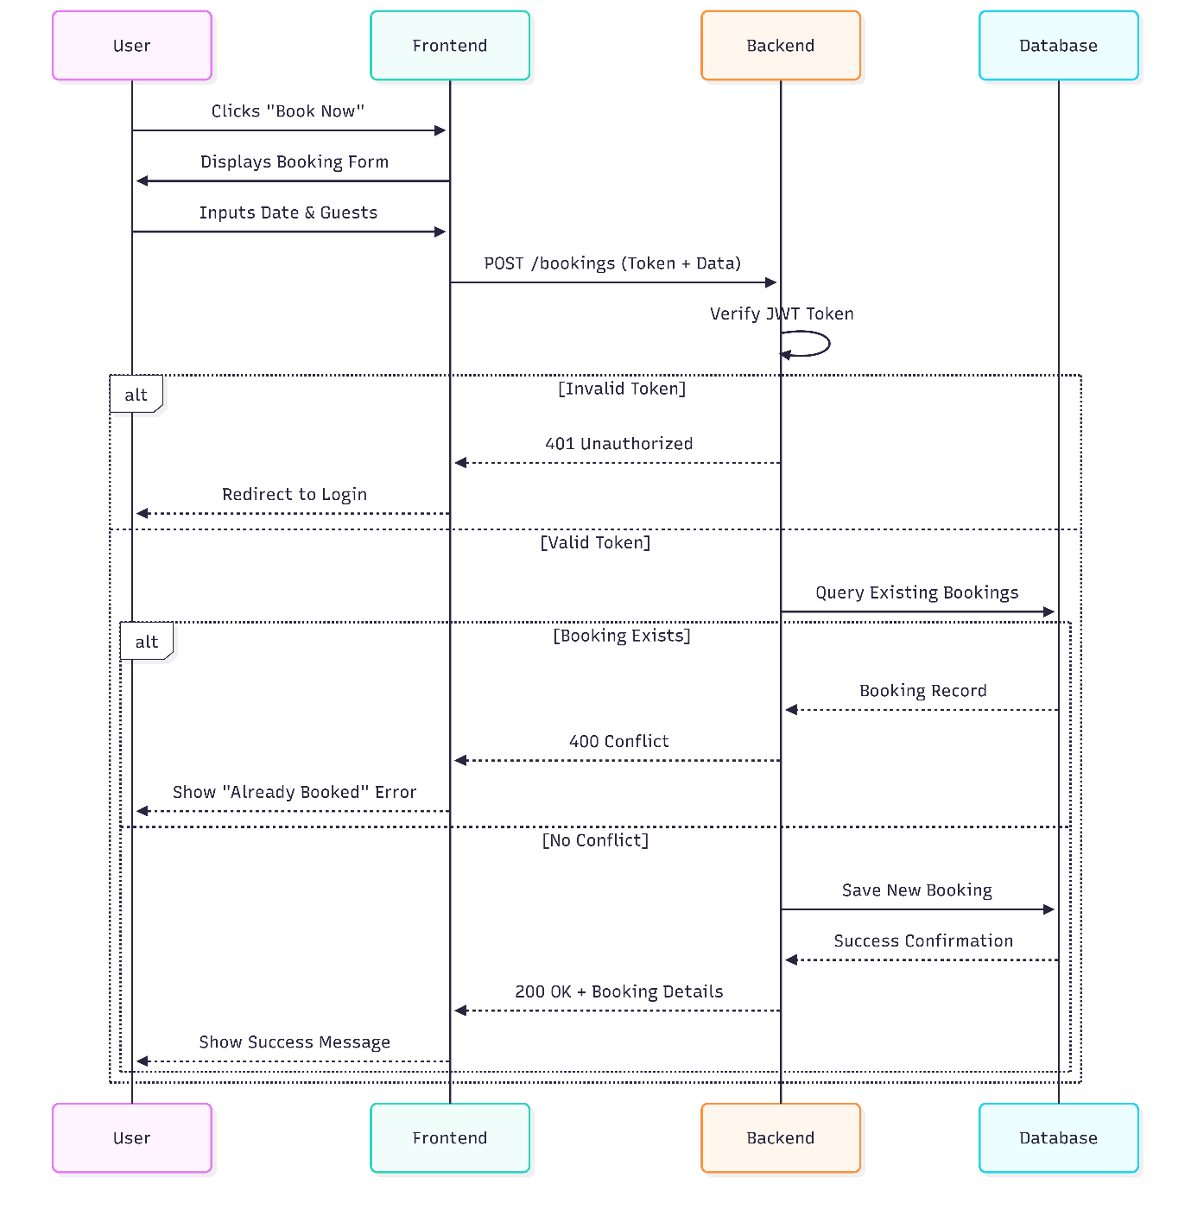
5.4 Entity-Relationship Diagram / Class Diagram

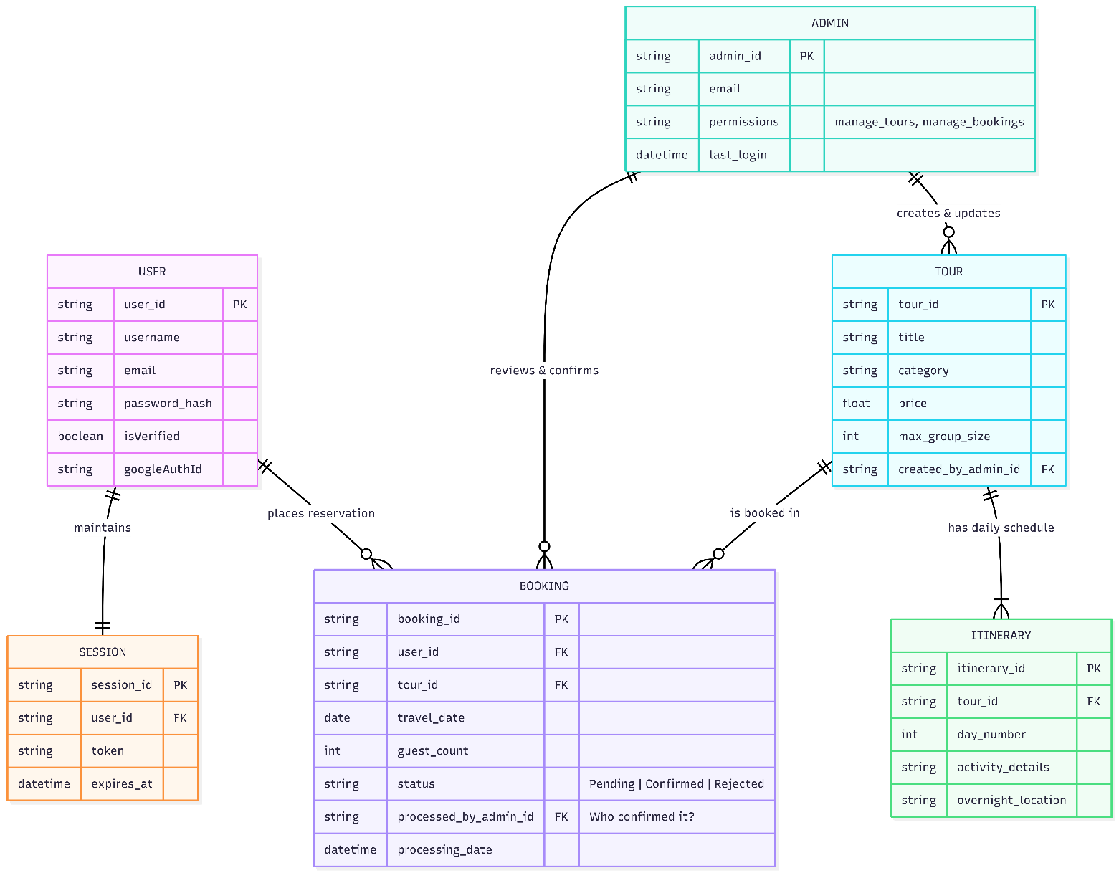

- Users have a One-to-Many relationship with Bookings (One user can have multiple bookings).
- Tours have a One-to-Many relationship with Bookings (One tour can be booked by many users).
- Users have a One-to-Many relationship with Reviews (Future scope: One user writes many reviews).

6. System Design

6.1 Database Design
The database is designed using MongoDB's document-oriented model. Normalization: Data is semi-normalized. While Users and Tours are separate collections, Bookings reference them via ObjectId. However, Tour documents allow nested arrays (itinerary, images) for faster read performance (denormalization for read efficiency).

Key Indexing:
- email in User collection (Unique Index).
- category in Tour collection (for faster filtering).
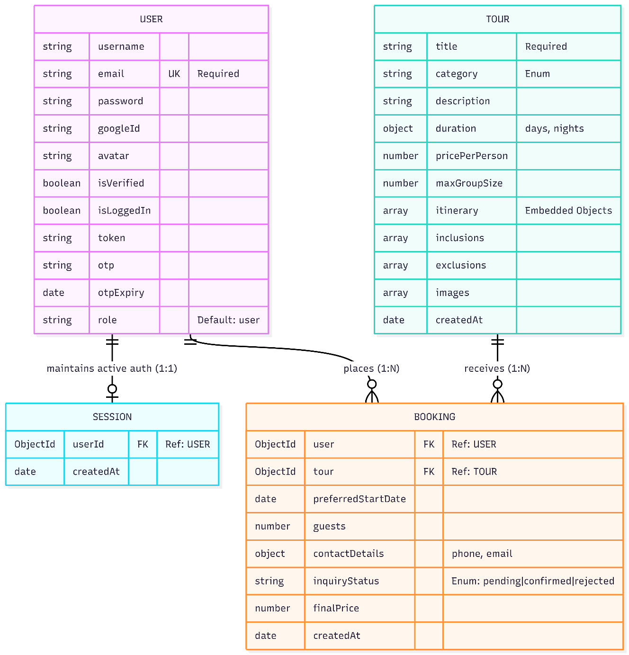

6.2 Input Design
- Forms:
Login Form: Email/Password fields with regex validation.
Booking Form: Date picker (min date = today), Guest counter (numeric only).
Tour Upload Form: Dynamic inputs for adding multiple itinerary days on the fly.

- Login Form:
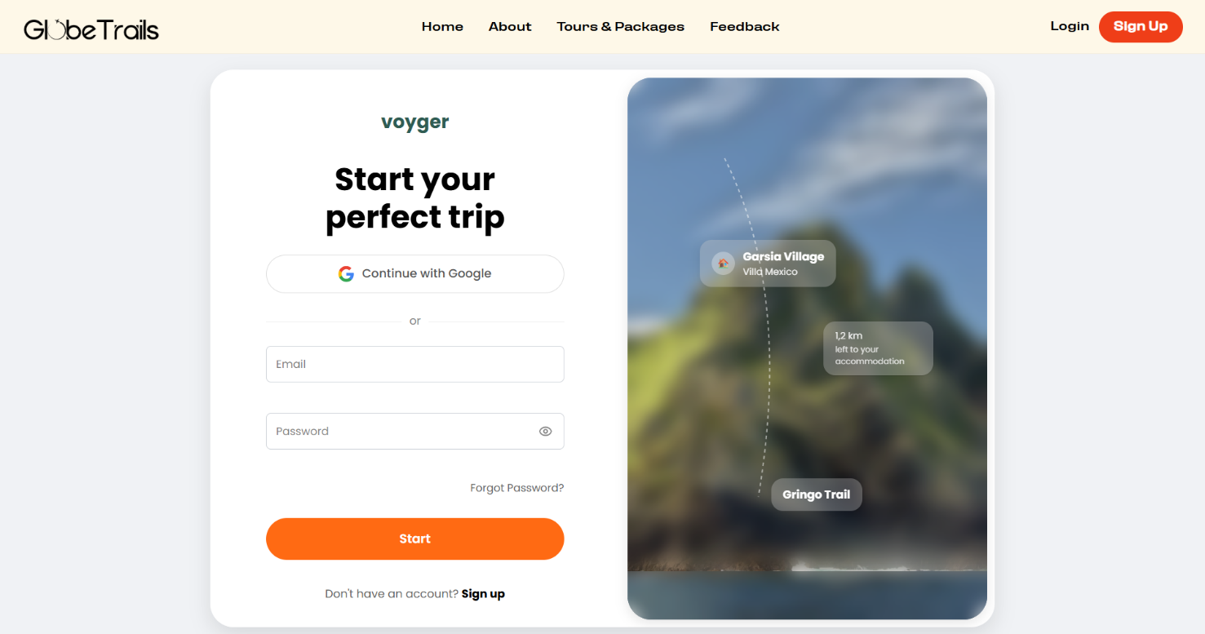
- Forget Password & Verify Email :
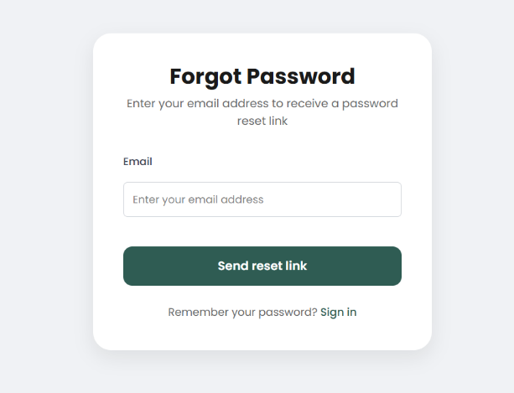
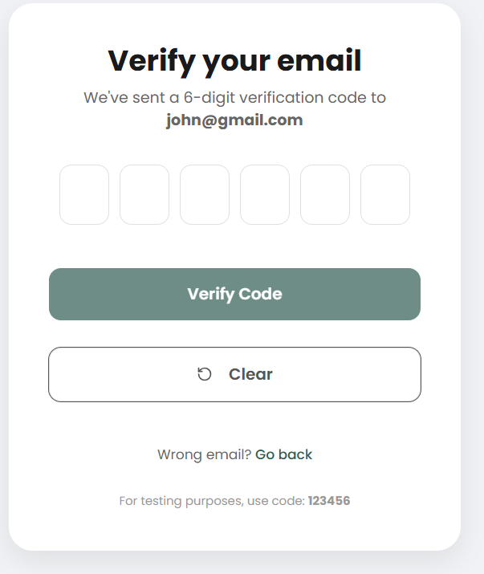
- Register Form:
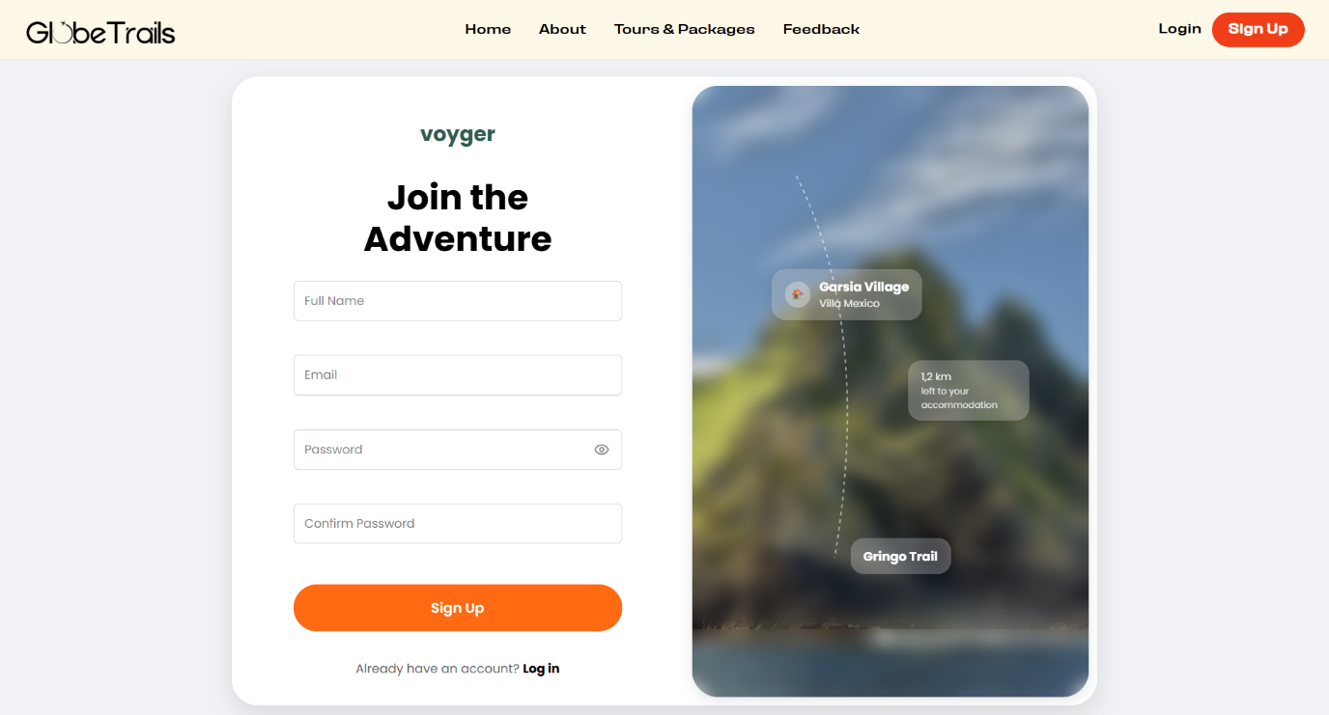
Booking Form:
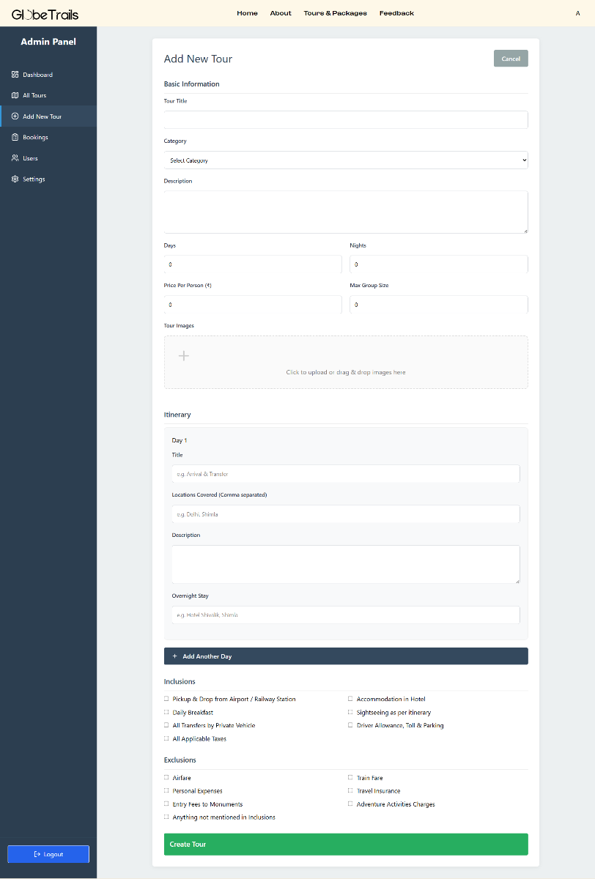

- Security Considerations:
Input Sanitization: All API inputs are validated using mongoose schema validation.
CSRF Protection: Handled via standard header checking and CORS policies.

6.3 Output Design
- Tour Cards: Visual cards displaying Image, Title, Price, and Rating.

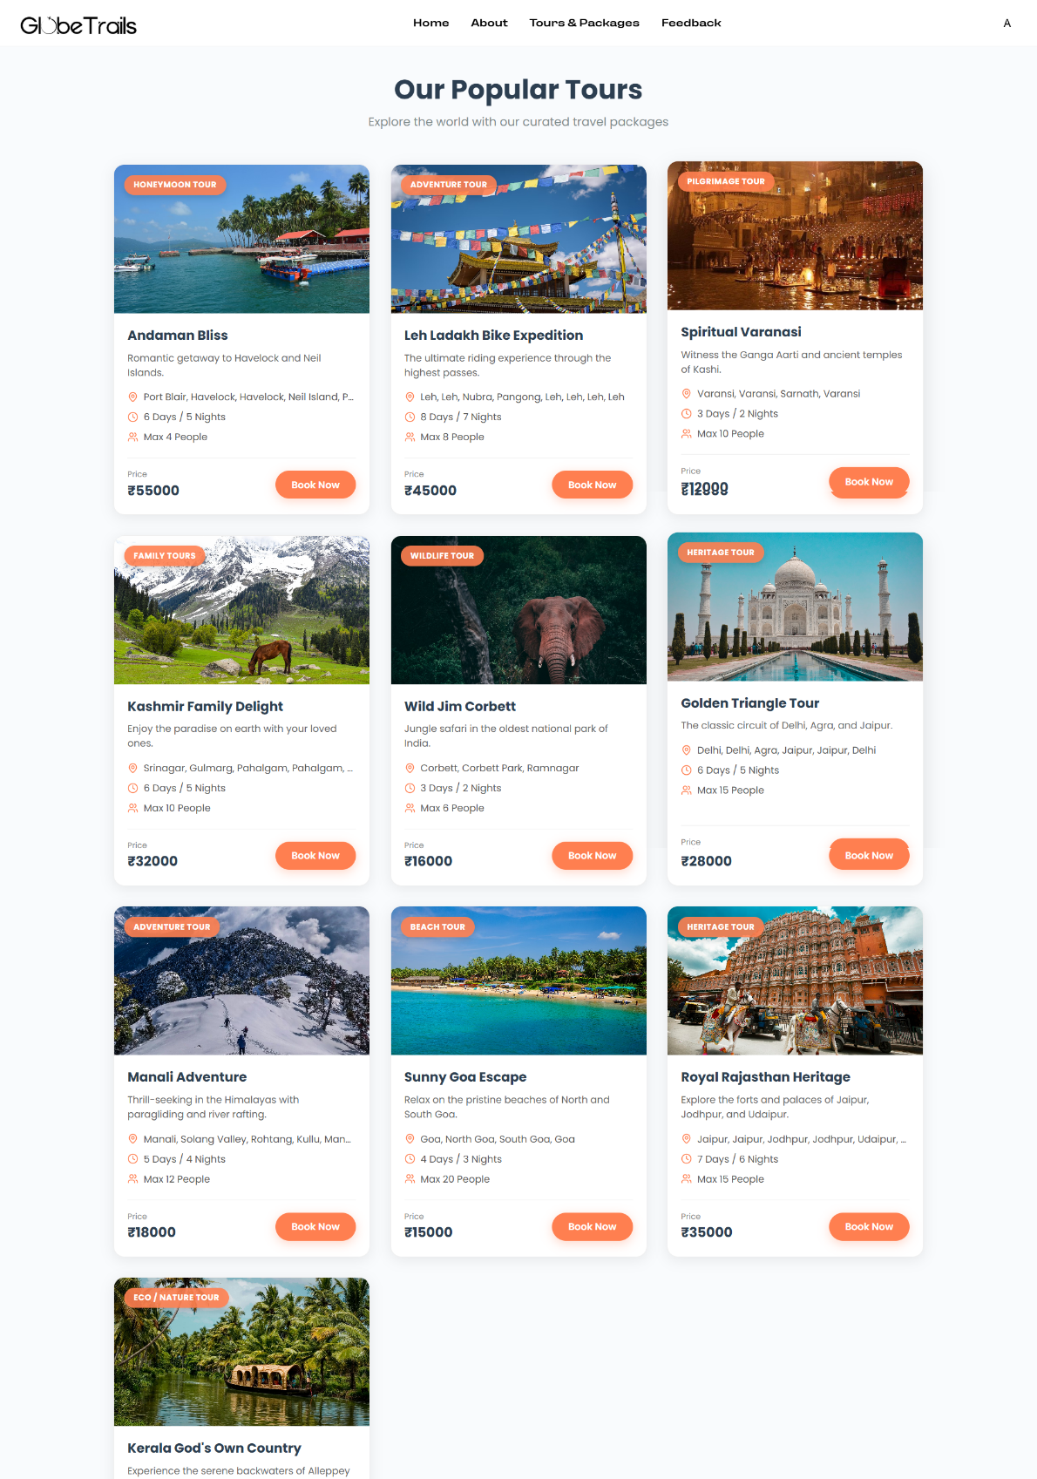
- Admin Dashboard: Cards showing aggregate statistics (Total Revenue, Active Users).
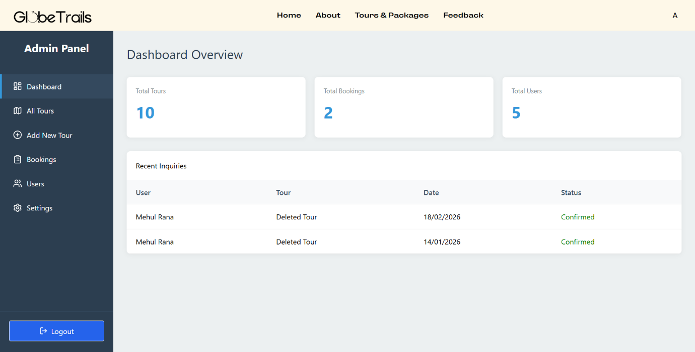

- Tables: Data grids for listing Users/Bookings with pagination and action buttons (Edit/Delete).
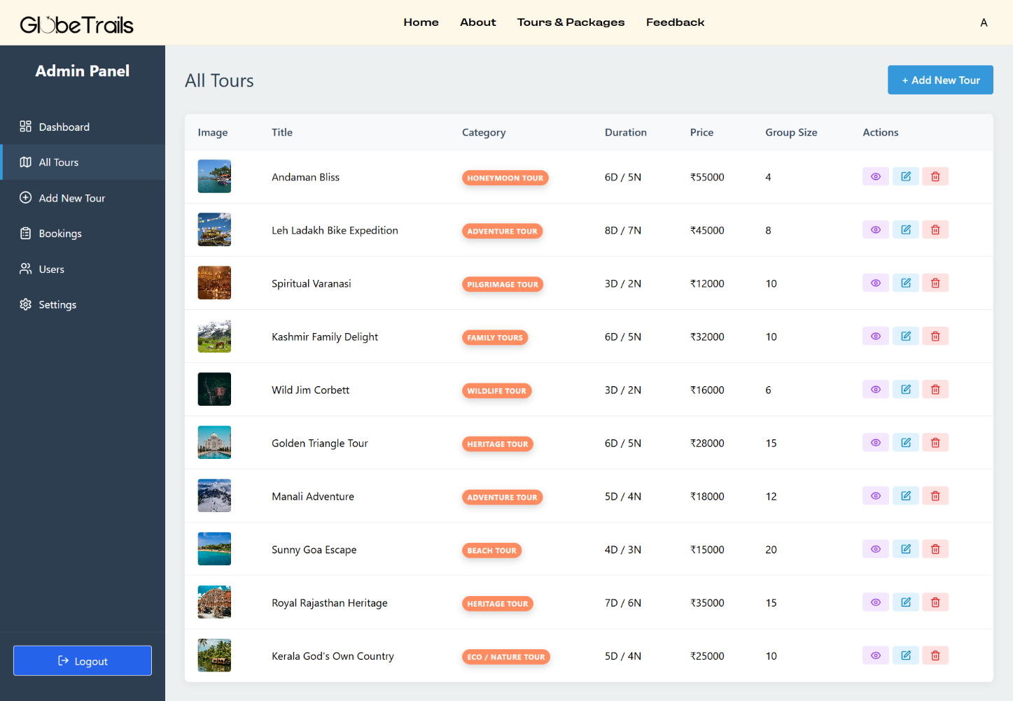

7. Software Testing
Software testing was performed to ensure that the GlobeTrails platform is reliable, secure, and functions as intended across different user roles.

7.1 Unit Testing
Unit testing focuses on individual components and backend controllers to verify they work in isolation.
Test_Case ID | Description | Input Data | Expected Output
TC_AUTH_01 | User Registration | Username, Email, Password | New User created in DB with isVerified: false
TC_AUTH_02 | OTP Verification | 6-digit valid OTP | isVerified set to true, Success message shown
TC_AUTH_03 | Valid User Login | Correct Email & Password | JWT Token generated and redirected to Home
TC_AUTH_04 | Invalid User Login | Incorrect Password | "Incorrect Password" error message displayed
TC_PW_01 | Forgot Password | Registered Email | System generates OTP and sends recovery email

7.2 Integration Testing
Integration testing verifies the data flow between the Frontend, Node.js Backend, MongoDB, and Supabase Storage.
Test_Case ID | Description | Input Data | Expected Output
TC_TOUR_01 | Admin Uploads Tour | Tour Details + Image Files | Images stored in Supabase; Tour URL saved in MongoDB
TC_BOOK_01 | Create Booking Inquiry | Tour ID, Date, Guests | Booking record created with inquiryStatus: "pending"
TC_DASH_01 | Dashboard Statistics | Fetch Data from API | Real-time counts of Users, Tours, and Bookings displayed
TC_EMAIL_01 | Inquiry Notification | Submit Booking Form | NodeMailer sends "Inquiry Received" email to User
TC_ADM_01 | Update Booking Status | Admin clicks "Confirm" | Status updates to "Confirmed" in DB; UI reflects change
7.3 System Testing

System testing covers end-to-end user journeys and security constraints of the entire application.

Test_Case ID | Description | Input Data | Expected Output
TC_SYS_01 | Full Booking Journey | Search -> Select -> Book | Inquiry successfully appears in Admin Recent Inquiries
TC_SYS_02 | Tour Filtering | Click "Adventure Tour" category | Search results display only Adventure-themed tours
TC_SEC_01 | Unauthorized Access | Visit /adminpanel as Guest | System redirects visitor to /signin page
TC_SEC_02 | Role-Based Control | User tries to access /tour-upload | Access denied; Admin-only route protected by middleware
TC_RESP_01 | Responsive UI Test | View site on Mobile (360px) | Navbar converts to hamburger menu; Grid stacks vertically
\

8. Conclusions & Future Enhancements

The GlobeTrails system successfully digitizes the tour booking workflow. It moves beyond a unified brochure to an interactive application.

Future Enhancements:
- Payment Gateway Integration: Integrating Stripe to allow for real-time payment capture to switch bookings to 'Confirmed' automatically.
- AI-Driven Recommendations: Implementing a collaborative filtering algorithm to suggest tours based on a user's previous booking history.
- PWA (Progressive Web App): Service Worker integration to allow basic catalog browsing while offline.

9. Bibliography & References

https://www.w3schools.com/php/php_sessions.asp https://www.w3schools.com/Php/php_mysql_connect.asp https://docs.npmjs.com/ https://www.mongodb.com/docs/ https://www.mongodb.com/docs/manual/crud/ https://react.dev/learn https://nodejs.org/docs/latest/api/ https://developer.mozilla.org/en-US/docs/Learn_web_development/Extensions/Serverside/Express_Nodejs/Introduction https://supabase.com/docs/guides/getting-started/quickstarts/reactjs

