**Given Dataset**

| **Feature 1** | **Feature 2** | **Target (Y)** |
| --- | --- | --- |
| 5 | A | 10 |
| 7 | A | 20 |
| 6 | B | 15 |
| 8 | B | 25 |
| 9 | C | 30 |
| 10 | C | 35 |

**Step-by-Step Calculation**

**1. Initial Variance Calculation**

**Overall Mean and Variance of Target Values:**

**Mean (Overall Target)**:

$$\overline{Y}=\frac{10+20+15+25+30+35}{6}=22.5$$

**Variance (Overall)**:

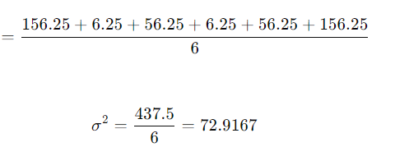

**2. Split by Feature 1**

We choose a threshold of 7 for **Feature 1**.

**Group 1 (Feature 1≤7)**:

* Instances: 5, 7, 6
* Target Values: 10, 20, 15

**Variance for Group 1**:

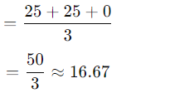

**Group 2 (Feature 1>7)**:

* Instances: 8, 9, 10
* Target Values: 25, 30, 35

**Variance for Group 2**:

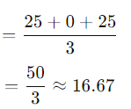

**Weighted Variance for Feature 1**:

$$Weighted Variance=\frac{3}{6}×16.67+\frac{3}{6}×16.67$$

$$Weighted Variance=16.67$$

**Variance Reduction for Feature 1**:

$$Variance Reduction(Feature 1)=72.92-16.67=56.25$$

**Evaluate Feature 2**

**Group A**:

* Instances: 5, 7
* Target Values: 10, 20

**Variance for Group A**:

Variance(Group A)= 25

**Group B**:

* Instances: 6, 8
* Target Values: 15, 25

**Variance for Group B**:

Variance(Group B)=25

**Group C**:

* Instances: 9, 10
* Target Values: 30, 35

**Variance for Group C**:

Variance(Group C)=26.25

**Weighted Variance for Feature 2**:

Weighted Variance(Split)=2/6×25+2/6×25+2/6×6.25 ​=18.75

**Variance Reduction for Feature 2**:

Variance Reduction(Feature 2)=72.92−18.75=54.17

**4. Decision Tree Construction**

Since the variance reduction for **Feature 1** is higher than that for **Feature 2**, Feature 1 will be used as the root. We will then use **Feature 2** to further split the groups.

**Final Decision Tree Structure**

**Root Node**: **Feature 1 ≤ 7**

* **Left Branch** (Feature 1 ≤ 7):
  + **Split by Feature 2**:
    - **Group A**: Target = 15
    - **Group B**: Target = 15
* **Right Branch** (Feature 1 > 7):
  + **Split by Feature 2**:
    - **Group B**: Target = 25
    - **Group C**: Target = 32.5

**Tree Diagram**:

Feature 1

/ \

≤ 7 > 7

/ \

Feature 2 Feature 2

/ \ / \

A B B C

/ \ / \

15 15 25 32.5

**Summary**

1. **Root Node**: **Feature 1** ≤ 7
   * **Left Subtree**:
     + **Feature 2** = A → Target = 15
     + **Feature 2** = B → Target = 15
   * **Right Subtree**:
     + **Feature 2** = B → Target = 25
     + **Feature 2** = C → Target = 32.5