- Do not edit/delete any heading or section with red text.
- Type /paste you answers in relevant sections (below Final Answer (in all questions , Approach (wherever required ) and Charts & tables (wherever required)) of the solution
- Link to submission guidelines
- Please note that submission not following the guidelines will not be accepted

OBJECTIVE QUESTIONS

Question 1: What is the total no. of attributes present in the data?

Solution:

Final Answer (if any):
The dataset contains 17 attributes in total across the two source tables:
- Tickets table: 11 attributes
- IT_Agents table: 6 attributes

Approach (if any):
Reviewed the column headers in both source tables and counted the total number of attributes present.

Charts & Tables (if any):

Question 2: Which columns have inconsistent or missing values, and what is the count of such values?

Solution:

Final Answer (if any):
No missing values were found in the original source attributes of the Tickets and IT Agents tables.
However, spelling inconsistencies were identified in categorical fields and standardized during cleaning:
- Severity: 0 - Unclasified — 356 records
- Severity: 3 - Mayor — 4,836 records
- Priority: 0 - Unassiged — 29,410 records
The Agent Name field was initially a derived/lookup field and was populated later using Agent ID, so its initial blanks were not treated as missing source data.

Approach (if any):
Performed:
- Missing-value audit using filters/blank checks
- Duplicate check
- Data-type validation
- Pivot-table consistency checks for categorical values
- Find and Replace for spelling standardization

Charts & Tables (if any):
Data Quality Audit
Description
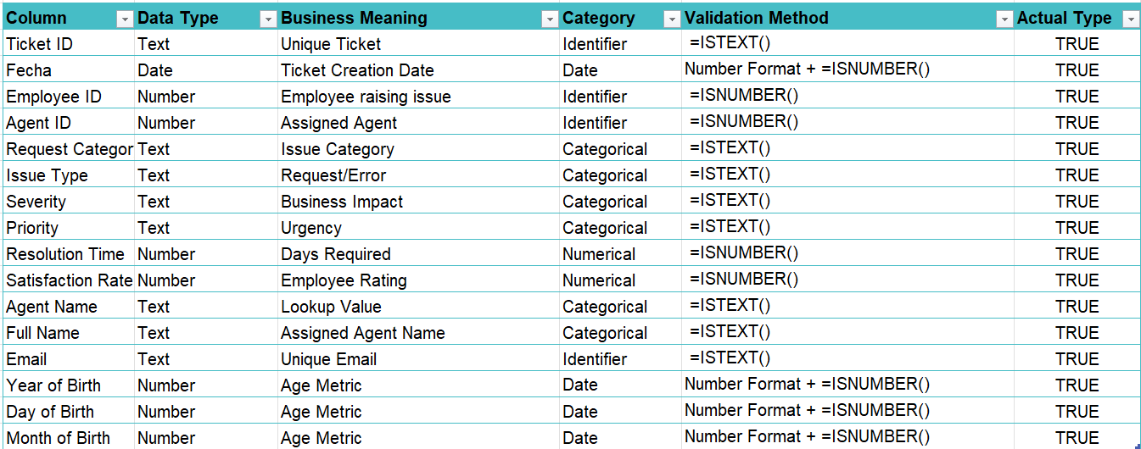
Documents missing-value checks, data-type validation, duplicate checks, categorical consistency checks, and corrections made during data cleaning.

Question 3: What is the average daily ticket volume over time?

Solution:

Final Answer (if any):
The average daily ticket volume over the available period is 53.37 tickets per day.

Approach (if any):
Created a Pivot Table using:
- Rows: Fecha
- Values: Count of Ticket ID
The daily ticket counts were then averaged using:
=ROUND(AVERAGE(daily_ticket_counts),2)

Charts & Tables (if any):
- Table / Chart Name:
DailyTicketVolumeTrend

Description:
Shows the number of tickets raised each day and provides the basis for calculating the overall average daily ticket volume.
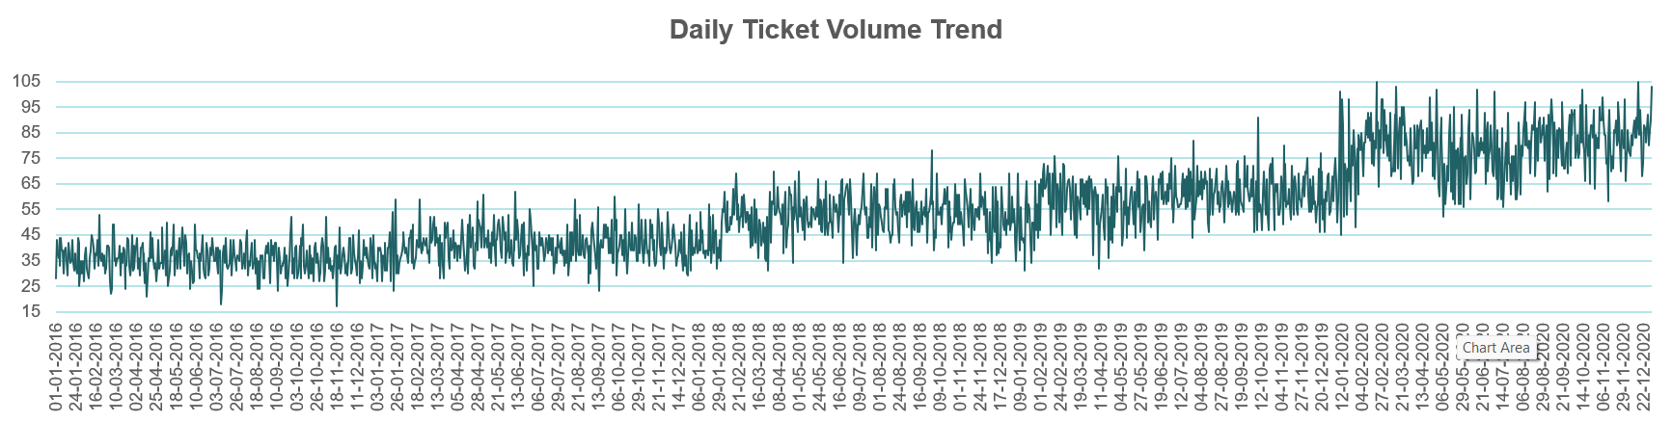

Question 4: What is the distribution of ticket categories (e.g., Login Access, System, Software)?

Solution:

Final Answer (if any):
The ticket distribution is:
- System: 39,002
- Login Access: 29,193
- Software: 19,570
- Hardware: 9,733
System requests represent the largest share of IT support workload, while Hardware requests occur least frequently.

Approach (if any):
Created a Pivot Table with:
- Rows: Request Category
- Values: Count of Ticket ID
A clustered bar chart was used to visualize the distribution.
Charts & Tables (if any):
- Table / Chart Name:

DistributionOfTicketCategories
Distribution of Ticket Categories

Description:
Displays the number of tickets across Hardware, Login Access, Software, and System request categories.
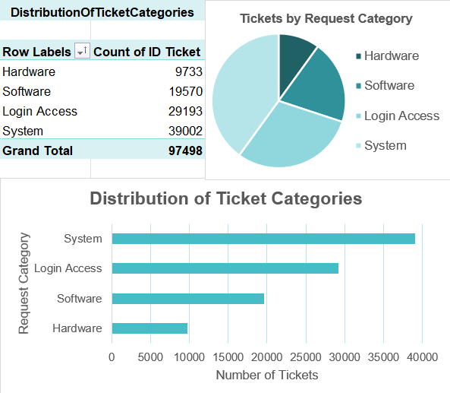

Business Insight
Management should focus process improvement and preventive measures particularly on System and Login Access, since they generate most of the workload.

Question 5: How many tickets has each agent handled?

Solution:

Final Answer (if any):
Ticket workload is relatively balanced across the 50 agents.
- Highest: Aurelio Tanori — 2,027 tickets
- Lowest: Griselda Galindo — 1,856 tickets
- Difference: 171 tickets
No agent appears significantly overloaded based on ticket count alone.

Approach (if any):
Created a Pivot Table with:
- Rows: Agent Name
- Values: Count of Ticket ID
Charts & Tables (if any):
- Table / Chart Name:

TicketHandling
Tickets Handled by Each IT Agent

Description:
Summarizes and compares the total number of tickets handled by every IT agent.
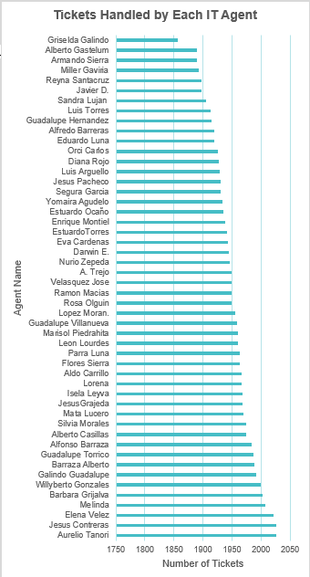

Question 6: How can you extract the domain from the email addresses in the IT Agents sheet?

Solution:

Final Answer (if any):
The email domain can be extracted using:
=MID([@Email], FIND("@", [@Email])+1, FIND(".", [@Email], FIND("@", [@Email]))-FIND("@",[@Email])-1)
This returns the text appearing after the @ symbol and before “.com”.

Approach (if any):
Used:
- FIND() to locate the @
- MID() to extract all characters after it
- A column named Email Domain was created in the IT_Agents Table.
- The domain was extracted from each email address using the MID() and FIND() functions.
- The FIND() function identified the position is the @ symbol and . symbol , while the MID() function extracted all the characters following it.
Charts & Tables (if any):
- Table / Chart Name:

ExtractedEmailDomain

Description:
Displays each IT agent's email address together with the extracted email domain.

Question 7: How can you find the full name of an agent given their Agent ID?

Solution:

Final Answer (if any):
The full agent name can be retrieved by matching the Agent ID with the IT Agents table.
Example using XLOOKUP:
=XLOOKUP(Agent_ID, Agent_ID_Range, Full_Name_Range, "Not Found")

Approach (if any):
Used Agent ID as the lookup key and retrieved the corresponding Full Name from the IT Agents table. The lookup results were cross-checked against the original agent table.

Charts & Tables (if any):
- Table / Chart Name:
IT_Agent_Table

Description:
Contains Info of IT Agents

Question 8: What is the count of each issue type (e.g., IT Error, IT Request)?

Solution:

Final Answer (if any):
  - IT Request: 73,220 tickets (75.10%)
  - IT Error: 24,278 tickets (24.90%)
Most support activity consists of IT service requests rather than technical errors.

Approach (if any):
Created a Pivot Table with:
- Rows: Issue Type
- Values: Count of Ticket ID

Charts & Tables (if any):
- Table / Chart Name:
Issue Type Distribution

Description:
Shows the number and relative frequency of IT Requests and IT Errors.
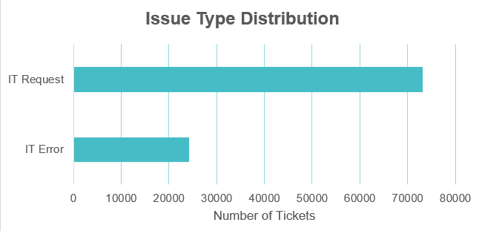

Question 9: What is the average resolution time for tickets?

Solution:

Final Answer (if any):
The average resolution time for IT support tickets is 4.55 days.

Approach (if any):
Applied the AVERAGE() function to the Resolution Time (Days) column.

Charts & Tables (if any):

Business Insight
The 4.55-day value provides a baseline for comparing performance across categories, severity levels, priorities, and agents.

Question 10: How has the volume of tickets changed over time?

Solution:

Final Answer (if any):
Ticket volume increased consistently over the five-year period:
- 2016: 13,051
- 2017: 14,915
- 2018: 18,954
- 2019: 21,490
- 2020: 29,088
This shows a substantial increase in IT support demand.

Approach (if any):
Extracted Month and Year from Fecha and created Pivot Tables using:
- Rows: Month/Year
- Values: Count of Ticket ID
Line charts were used for monthly and yearly trends.

Charts & Tables (if any):
- Table / Chart Name:
MonthlyTicketVolumeTrend
Description:
Shows monthly fluctuations and the overall increase in ticket volume from 2016 to 2020.
Business Insight
Growing ticket demand suggests increasing dependence on IT services and may eventually require more automation, process optimization, or staffing capacity.
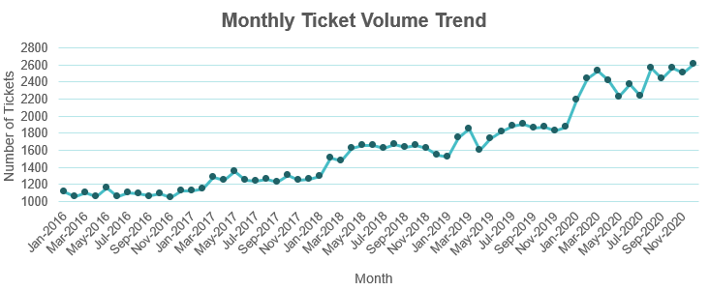

Question 11: What is the average age of the IT agents?

Solution:

Final Answer (if any):
The average age of the IT agents is 41.06 years.

Approach (if any):
Created an AgeAnalysis table by:
- Retrieving Year, Month, and Day of Birth
- Creating each agent's date of birth
- Calculating Age using DATEDIF()
- Applying AVERAGE() to the Age column

Charts & Tables (if any):
- Table / Chart Name:
AgeAnalysis

Description:
Contains each IT agent's birth information and calculated age and is used to determine the average workforce age.

Question 12: Is there a correlation between the severity of issues and the resolution time?

Solution:

Final Answer (if any):
- The Pearson correlation coefficient between Severity Score and Resolution Time is approximately −0.0405.
- This value is very close to zero, indicating a negligible negative linear correlation between ticket severity and resolution time. Therefore, higher-severity tickets do not necessarily take longer to resolve.
- The PivotTable further supports this result: Normal-severity tickets have the longest average resolution time (4.66 days), whereas Urgent tickets have the have the shortest (2.00 days).
Approach (if any):
- Severity is a categorical/ordinal field, so it was first converted into a numerical Severity Score: 0 = Unclassified, 1 = Minor, 2 = Normal, 3 = Major, 4 = Urgent.
- The Pearson correlation coefficient between Severity Score and Resolution Time (Days) was then calculated on the individual ticket-level data using:
- =CORREL(Tickets[Severity Score],Tickets[Resolution Time (Days)])
- The resulting correlation coefficient was approximately: r = −0.0405

A PivotTable was also created with:
Rows → Severity Values → Average of Resolution Time (Days)
A column chart was used to visually compare average resolution time across severity levels.
Charts & Tables (if any):
- Table / Chart Name:
SeverityResolutionDays
Severity vs Average of Resolution Days

Description:
Compares average resolution time across different severity levels.

Business Insight
- The near-zero correlation (r = −0.0405) indicates that increasing ticket severity does not lead to longer resolution times. In fact, Urgent tickets have the shortest average resolution time (2.00 days), suggesting that critical issues receive faster attention and prioritization.
- Normal-severity tickets have the longest average resolution time (4.66 days), indicating an opportunity to investigate and improve the handling of routine support requests.
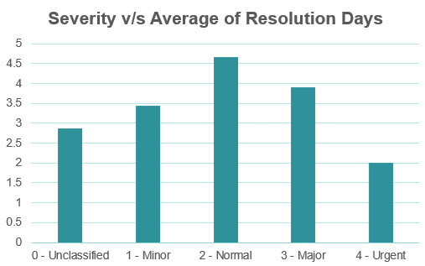

Question 13: How many categorical columns are there in the data? [Search about categorical and continuous data, and try to answer this question]

Solution:

Final Answer (if any):
The dataset contains 5 categorical columns:
1. Request Category
2. Issue Type
3. Severity
4. Priority
5. Agent Name
6. Satisfaction Rate
7. Full Name
8. Year of Birth
9. Month of Birth
10. Day of Birth
Therefore, the total number of categorical columns is 10.
Approach (if any):
All columns from both the Tickets/Cleaned Data and IT Agents tables were reviewed rather than considering only one table.
Each column was classified according to its analytical purpose as:
1. Identifier – used only to identify a record/person.
2. Date/Temporal – represents time or date.
3. Categorical – represents labels, groups, or discrete/ordered categories.
4. Numerical – represents measurable quantitative values on which arithmetic operations are meaningful.
After classifying all the attributes, the categorical columns were counted using the SUMPRODUCT() function.
If the Category column contains simply Categorical, use:
=SUMPRODUCT(--(array range="Categorical")) Result = 10
Note: The stored Excel data type and analytical category are different concepts. For example, Satisfaction Rate is stored as a number but is analytically classified as ordinal categorical because it consists of five ordered rating levels.
Charts & Tables (if any):
- Table / Chart Name:
ColumnDataTypeClassification

- Description:
The ColumnDataTypeClassification table classifies all attributes from the Tickets/Cleaned Data and IT Agents tables based on their analytical role. It distinguishes identifiers, temporal fields, numerical measures, and categorical variables and is used to determine the total number of categorical columns in the complete dataset.

SUBJECTIVE QUESTIONS

Question 1: If there is an investment, should it be used to hire more IT agents, improve training programs, or upgrade ticket management software?

Analysis: Perform a cost-benefit analysis using ticket resolution and satisfaction metrics.

Solution:

Approach:
Compared:
- Ticket workload by agent
- Average resolution time
- Ticket-volume growth
- Severity-based resolution performance
- Agent workload distribution
The goal was to determine whether the main constraint is lack of staff, lack of agent capability, or inefficient processes/tools.
Charts & Tables:
- Table / Chart Name:
Tickets Handled by Each IT Agent
Shows workload distribution across agents.
Severity vs Average Resolution Days
Shows how resolution efficiency varies across ticket complexity.
Monthly/Yearly Ticket Volume Trend
Shows increasing IT support demand.
Insights:
1. Ticket demand has increased substantially, rising from 13,051 tickets in 2016 to 29,088 in 2020, indicating increasing pressure on IT-support operations.
2. Despite this growth, ticket workload remains relatively balanced across the 50 agents, with most agents handling roughly 1,900–2,000 tickets. This does not indicate an immediate need for broad-based hiring.
3. The overall average resolution time is approximately 4.55 days, indicating scope for operational and process improvement.
4. Urgent tickets are resolved faster than lower-severity categories, suggesting that prioritization of critical issues is functioning effectively.
5. A major process-quality issue is the large Unassigned priority bucket: 29,410 tickets. This represents approximately 30.2% of all 97,498 tickets, indicating an opportunity to improve ticket classification, automated routing and priority assignment.
6. Agent performance is not uniform. Average satisfaction ranges from approximately 3.04 to 4.60, while average resolution times also vary substantially between agents. This suggests that targeted training for lower-performing agents would be more appropriate than treating the entire team as having the same training requirement.
7. Therefore, the evidence points more strongly toward process/software inefficiencies and targeted performance gaps than toward an immediate organization-wide staffing shortage.
Recommendations:
1. Prioritize ticket-management software and process improvement.
Introduce automated priority assignment, routing and escalation rules, particularly to reduce the 29,410 Unassigned-priority tickets. Set an initial target of reducing the Unassigned bucket by at least 50%.
2. Target a measurable reduction in resolution time.
Use workflow automation, improved routing and category-specific escalation to target approximately a 10–20% reduction in the current average resolution time of 4.55 days.
For example: 10% improvement → ~4.10 days 20% improvement → ~3.64 days
3. Implement targeted rather than general training.
Identify agents with relatively high-resolution times and lower satisfaction scores, then provide focused training in troubleshooting, ticket handling and escalation. Monitor
their KPIs after training to measure improvement.
4. Do not prioritize immediate large-scale hiring.
Since ticket workload is relatively balanced across agents, additional hiring should be considered only if ticket volume continues to increase and the existing team cannot maintain acceptable resolution time and satisfaction after technology/process improvements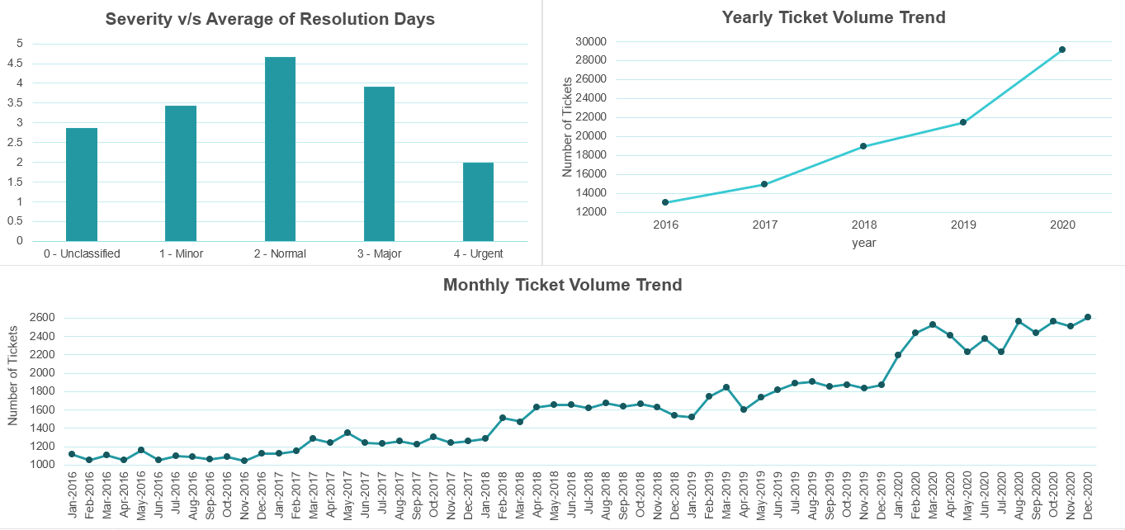

Question 2: Which agents need additional training based on their performance metrics?

Analysis: Identify agents with the lowest satisfaction ratings and longest resolution times.

Solution:

Approach:
Evaluated agents using:
- Average Satisfaction Rate
- Average Resolution Time
- Average Severity Score
Low satisfaction combined with long resolution time was treated as the strongest indication of potential training need.
Charts & Tables:
- Table / Chart Name:
AgentPerformanceAnalysis
Summarizes the average Satisfaction Rating, Resolution Time (Days), and Severity Score for each IT agent.
Comparison of Satisfaction Levels, Resolution Time and Severity Score of Each Agent
- Description:
A Clustered Column Chart comparing the average Satisfaction Rating, Resolution Time, and Severity Score for every IT agent. It helps identify agents whose performance may require improvement while considering the complexity of tickets handled.

Insights:
1. Agents with low Satisfaction Ratings and high Resolution Times are potential candidates for additional training.
2. The inclusion of Severity Score provides important context. Agents handling higher-severity tickets may naturally require more time to resolve issues, so longer resolution times do not always indicate poor performance.
3. Some agents exhibit lower satisfaction ratings despite handling only moderate-severity tickets, indicating opportunities for improving technical skills and customer interaction. (Alfonso Barraza, A. Trejo, Nurio Zepeda, Lorena, and Estuardo Ocaño.)
4. Agents handling high-severity tickets with acceptable satisfaction ratings demonstrate effective performance despite increased workload and ticket complexity.
Note: The Severity Score represents the average complexity of tickets assigned to an agent. A higher Severity Score indicates more challenging tickets and should not be interpreted as poor performance.
Recommendations:
1. Prioritize additional technical and customer-service training for agents who have low Satisfaction Ratings and high Resolution Times while handling low or moderate-severity tickets. (Alfonso Barraza, A. Trejo, Nurio Zepeda, Lorena, and Estuardo Ocaño.)
2. Review workload allocation before recommending training for agents handling predominantly high-severity tickets, as longer resolution times may be justified.
3. Monitor agent performance regularly using Satisfaction Rating, Resolution Time, and Severity Score together rather than relying on a single performance metric.
4. Encourage knowledge sharing by allowing high-performing agents to mentor those requiring improvement.
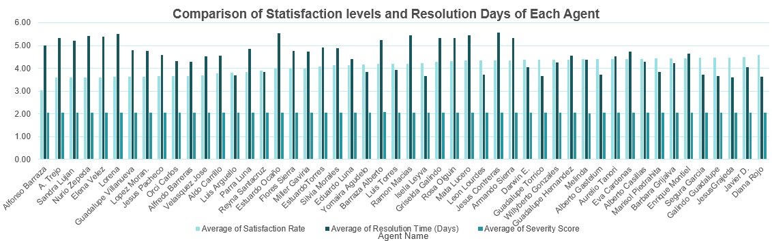

Question 3: Do certain categories of requests have longer resolution times?

Analysis: Analyze the resolution times by request category.

Solution:

Approach:
Calculated average resolution time for each Request Category using a Pivot Table and compared the results using a clustered column chart.
Charts & Tables:
- Table / Chart Name:
AverageResolutionTimebyRequestCategory
Average Resolution Time by Request Category

- Description:
The table and chart compare the average number of days required to resolve tickets belonging to each request category.

Insights:
1. Hardware requests have the longest average resolution time (7.63 days).
2. System requests are the second longest, requiring 6.62 days on average.
3. Software requests take an average of 5.24 days to resolve.
4. Login Access requests are resolved the fastest, with an average resolution time of only 0.31 days.
5. The overall average resolution time across all tickets is 4.55 days.
6. The large variation in resolution time indicates that different request categories require different levels of effort and technical expertise.

Recommendations:
1. Prioritize process improvements for Hardware and System requests, as they contribute most to longer resolution times.
2. Review Hardware and System support workflows to identify delays and bottlenecks.
3. Develop troubleshooting guides and provide additional technical training for agents handling these categories.
4. Continue the current efficient process for Login Access requests, as they are being resolved very quickly.
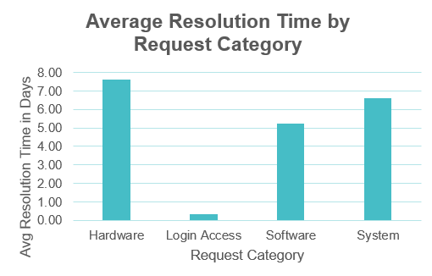

Question 4: How effective are the current software tools in managing IT tickets?

Analysis: Evaluate performance metrics before and after the implementation of new tools.

Solution:

Approach:
The dataset does not contain a software implementation date or explicit before/after indicator. Therefore, current effectiveness was evaluated through available KPIs rather than an unsupported pre/post comparison.
Metrics considered:
- Resolution time
- Satisfaction
- Ticket-volume trends
- Resolution time by category
Charts & Tables:
- Table / Chart Name:
Average Resolution Time by Request Category
Monthly Ticket Volume Trend
Yearly Ticket Volume Trend
Agent Satisfaction vs Resolution Time Analysis

Insights:
- The current process handles 97,498 tickets with average satisfaction of 4.10/5 and average resolution time of 4.55 days.
- Login Access is handled very efficiently, while Hardware and System categories remain bottlenecks.
- The system has continued to process increasing ticket volumes without a major deterioration in satisfaction.

Recommendations:
- Continue using the current system while improving Hardware and System workflows.
- Automate repetitive requests and begin maintaining explicit before/after performance data whenever future software upgrades are implemented.
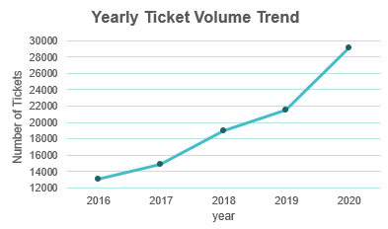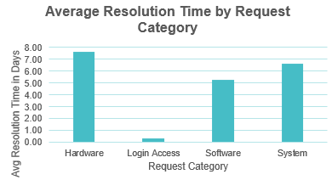
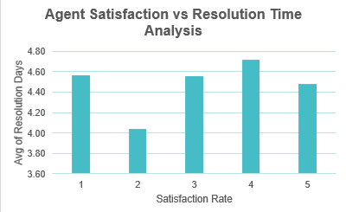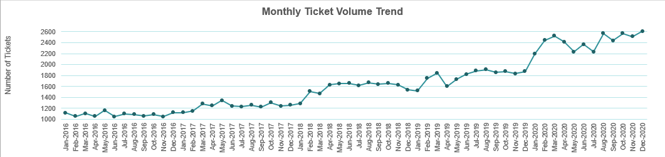

Question 5: How has the performance of the IT support team changed over time (e.g., monthly or quarterly)?

Analysis: Trend analysis using time series charts.

Solution:

Approach:
Performed monthly time-series analysis using:
- Average Resolution Time
- Average Satisfaction Rate
A line chart was used to observe changes from January 2016 to December 2020.

Charts & Tables:
- Table / Chart Name:
MonthlyITSupportPerformanceSummary
Monthly Performance Trend of IT Support Team

Insights:
- Customer satisfaction improved gradually from approximately 3.96 in early 2016 to 4.16 by December 2020.
- Average resolution time remained relatively stable, generally around 4.4-4.7 days, with no major sustained deterioration.
- The team therefore maintained operational stability while customer satisfaction improved modestly.

Recommendations:
Continue monthly KPI monitoring, investigate periods of unusually high-resolution time, and focus on lowering resolution time without sacrificing customer satisfaction.
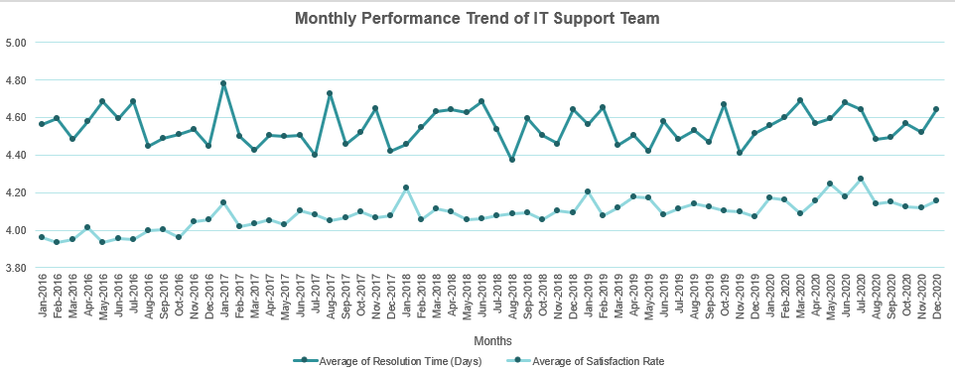

Question 6: If we invest more on tech (Hardware, software, etc), do you think it will improve the ticket resolution times and employee satisfaction?

Analysis: Use historical data to project potential improvements.

Solution:

Approach:
Step 1: Analyze Current Performance by Request Category
A PivotTable was created using:
Rows: Request Category
Values: Average of Resolution Time (Days), Average of Satisfaction Rate, Count of Ticket ID
This was used to determine which ticket categories currently have the greatest combination of high resolution time and high ticket volume.
The analysis shows that Hardware, System and Software have the greatest resolution-time improvement opportunities.

Step 2: Create a What-If Scenario
Since actual post-investment performance data is unavailable, a What-If analysis was used to estimate potential improvement.
Assumption 1: Technology investment reduces Average Resolution Time by 20%.
Current Average Resolution Time = 4.55 days
Formula: Projected Resolution Time = Current Resolution Time × (1 − 20%) Projected Resolution Time = 3.64 days
Assumption 2: Technology investment increases Average Satisfaction Rate by 5%.
Current Average Satisfaction Rate = 4.10
Formula: Projected Satisfaction Rate = Current Satisfaction Rate × (1 + 5%) Projected Satisfaction Rate = 4.305 ≈ 4.31/5
The projections were calculated using Excel formulas so that the analysis is traceable and reproducible rather than hard-coded.
Step 3: Compare Current and Projected Performance
A clustered column chart was used to compare current and projected KPIs.
Charts & Tables:
- Table / Chart Name:
RequestCategoryPerformanceMetrics
A PivotTable comparing Average Resolution Time, Average Satisfaction Rate, and Ticket Volume across Request Categories to identify the areas where technology investment could have the greatest operational impact.
CurrentvsProjectedITSupportPerformance
A What-If analysis table comparing current IT support KPIs with formula-driven projected values after assumed technology investment.

Request Category Performance Metrics
A combination chart comparing Average Resolution Time, Average Satisfaction Rate, and Ticket Volume across Hardware, Login Access, Software, and System requests. It identifies categories with both high workload and high-resolution time.
Chart1
A clustered column chart comparing current and projected Average Resolution Time and Average Satisfaction Rate under the assumed technology-investment scenario.
Insights:
1. System should be a major investment priority, as it has the highest ticket volume (39,002 tickets) while requiring an average of 6.62 days to resolve.
2. Hardware has the highest Average Resolution Time at 7.63 days, making it the largest resolution-time bottleneck, although its ticket volume is considerably lower at 9,733.
3. Software also presents an improvement opportunity, with 19,570 tickets and an Average Resolution Time of 5.24 days.
4. Login Access is already highly efficient, resolving 29,193 tickets in an average of only 0.31 days. This suggests that major additional investment in this category may provide less incremental benefit.
5. Satisfaction remains relatively stable at approximately 4.09–4.11 across all request categories, so the historical data does not by itself demonstrate that category-level resolution time is strongly associated with satisfaction.
6. Under the What-If scenario, a 20% improvement in resolution efficiency could reduce the overall Average Resolution Time from 4.55 to 3.64 days.
7. A 5% improvement scenario would increase Average Satisfaction Rate from 4.10 to approximately 4.31/5; however, this is an assumed potential improvement rather than an effect demonstrated by the historical data.

Recommendations:
1. Prioritize System-related technology investment.
System tickets account for 39,002 of 97,498 tickets and average 6.62 days to resolve. Improvements in system infrastructure, monitoring, diagnostics and automation could therefore affect a large portion of the total workload.
2. Address the Hardware resolution bottleneck.
Hardware has the highest Average Resolution Time at 7.63 days. Improve hardware availability, diagnostic tools, replacement processes and supporting infrastructure.
3. Improve Software support processes.
With an Average Resolution Time of 5.24 days, Software tickets could benefit from automated troubleshooting, improved ticket-management tools, knowledge-base solutions and standardized workflows.
4. Study and replicate the efficient Login Access process.
Login Access handles 29,193 tickets while maintaining an Average Resolution Time of only 0.31 days. Management should identify the processes or automation responsible for this efficiency and assess whether similar practices can be applied to System, Hardware and Software requests.
5. Track post-investment KPIs and ROI.
Use 3.64 days Average Resolution Time and 4.31/5 Average Satisfaction Rate as scenario benchmarks, then compare them with actual post-investment performance. Further investment decisions should be based on the observed improvement and cost-benefit/ROI.
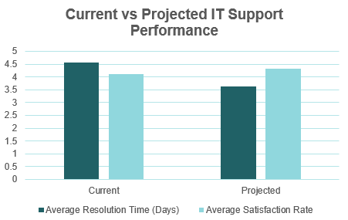
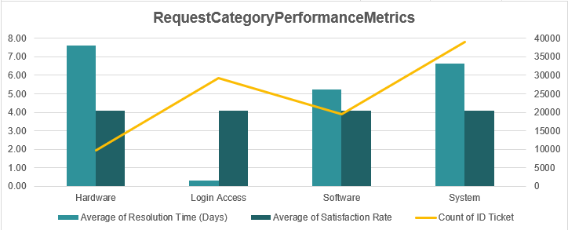

Question 7: What are the key performance metrics for IT agents, and how can they be improved, do we need to fire any agents?

Analysis: Define and analyze metrics such as average handling time, satisfaction scores, and number of tickets resolved.

Solution:

Approach:
Evaluated each agent using:
- Average Resolution Time
- Average Satisfaction Rate
- Tickets Handled
- Average Priority Score
- Average Severity Score

Charts & Tables:
- Table / Chart Name:
ITAgentPerformanceSummary
Comparison of IT Agent Performance Metrics
Tickets Handled by Each IT Agent

Insights:
Overall:
  - Avg Resolution Time: 4.55 days
  - Avg Satisfaction: 4.10/5
  - Avg Priority Score: 1.59
  - Avg Severity Score: 2.05
  - Tickets handled per agent: approximately 1,856-2,027
  - High-performing examples include Diana Rojo and Javier D., who combine good satisfaction with relatively efficient resolution.
  - Some agents such as A. Trejo, Nurio Zepeda and Lorena have longer resolution times, but complexity and workload differences are relatively small across agents.
  - No agent consistently performs poorly across all KPIs.

Recommendations:
Do not fire any agents based on the available dataset.
Instead:
- Provide targeted coaching
- Share high-performer best practices
- Monitor multiple KPIs together
- Add SLA compliance, First Contact Resolution, Reopen Rate and Escalation Rate in future performance reviews
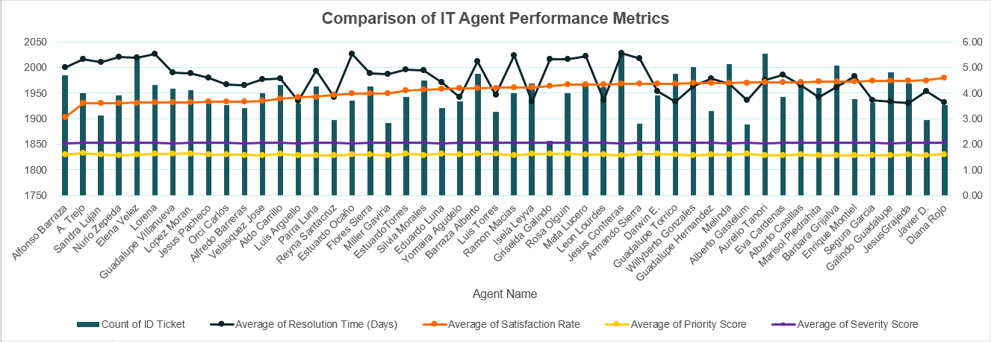

Question 8: How do employee demographics (e.g., department, seniority) impact satisfaction and ticket outcomes?

Analysis: Segment analysis using filters and pivot tables.

Solution:

Approach:
Department and seniority were not available, so Age Group was used as the available demographic characteristic.
The analysis compared:
- Satisfaction
- Resolution time
- Number of tickets
- Severity
- Priority

Charts & Tables:
- Table / Chart Name:
Age Group vs Number of Tickets
Impact of Age on IT Agent Performance
Severity Performance Metrics
Priority Performance Metrics

Insights:
Age-group results:
  - 20-29: Satisfaction 4.40, Resolution 3.71 days, Tickets 1,889
  - 30-39: Satisfaction 4.11, Resolution 4.64 days, Tickets 37,148
  - 40-49: Satisfaction 4.05, Resolution 4.68 days, Tickets 42,858
  - 50+: Satisfaction 4.20, Resolution 4.11 days, Tickets 15,603
  - Age does not appear to have a strong negative effect on service quality.
  - Ticket characteristics such as Severity and Priority have a stronger relationship with resolution outcomes than age.

Recommendations:
- Assign workload based on skills and capability rather than age.
- Monitor workload concentration in the 30-49 groups and continue using severity and priority to contextualize performance.
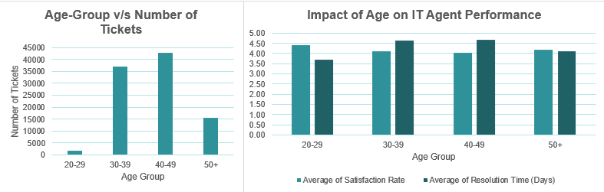
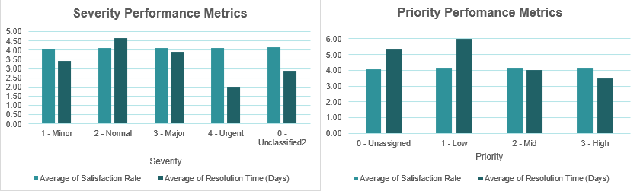

Question 9: Identify the trends for IT support operations based on ticket volumes and satisfaction, and mention the peak and stable times?

Analysis: Use pivot tables and charts to identify peak and off-peak hours.

Solution:

Approach:
Performed monthly and yearly time-series analysis of:
- Ticket volume
- Satisfaction
- Resolution time

Charts & Tables:
- Table / Chart Name:
Monthly Performance Trend
Monthly Ticket Volume Trend
Yearly Ticket Volume Trend

Insights:
- Ticket volume increased from 13,051 in 2016 to 29,088 in 2020.
- The peak workload period was 2020, when monthly volumes frequently reached approximately 2,400-2,600 tickets.
- The lowest workload occurred in 2016.
- Satisfaction remained strong and improved gradually, while resolution time remained comparatively stable.
- The 2018-2019 period was relatively stable operationally, with consistent satisfaction and resolution performance while ticket volume continued to increase.

Recommendations:
- Use historical trends for staffing and capacity planning.
- Prepare additional resources for future high-demand periods and continuously monitor whether rising volume begins to affect resolution time or satisfaction.
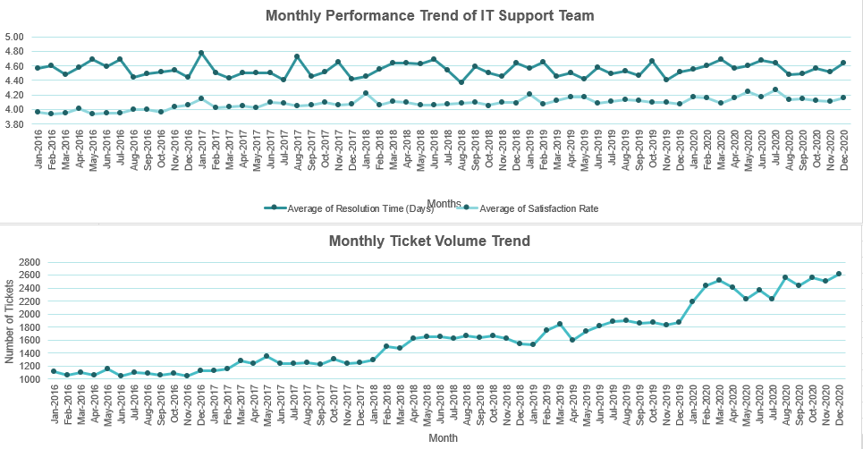

Question 10: What metrics should be included in the final dashboard to provide a comprehensive view of call center performance and guide investment decisions?

Solution:

Approach:
An interactive Excel dashboard was developed using PivotTables, PivotCharts, KPI cards, slicers, and trend/distribution charts. The dashboard is structured to answer four major management questions:
1. Demand: How much IT support is required and how is demand changing?
2. Efficiency: How quickly are tickets being resolved?
3. Service quality: Are employees satisfied with IT support?
4. Resources & investment: Where are the major bottlenecks, and where should management invest?
Charts & Tables:
- Table / Chart Name:
Dashboard Name: IT Support Performance Dashboard
The dashboard contains the following metrics and visualizations:
1. Total Tickets – 97,498: Measures overall IT support workload
2. Avg. Resolution Time – 4.55 days: Measures overall resolution efficiency
3. Avg. Satisfaction Rate – 4.1/5: Measures employee satisfaction with IT support
4. Total Agents – 50: Shows available IT support workforce
5. Avg. Severity Score – 2.05: Indicates average complexity/severity of tickets
6. Avg. Priority Score – 1.59: Indicates overall urgency of tickets
7. Avg. Agent Age – 41.06 Supports demographic/agent-performance analysis
8. Daily Ticket Volume – 53.68: Indicates average daily workload
9. Monthly Performance Trend: Compares resolution time and satisfaction over time
10. Resolution Time Distribution: Shows how tickets are distributed across resolution durations
11. Quarterly Avg. Resolution Time by Request Category: Identifies persistent category-level bottlenecks over time
12. Tickets by Request Categor: Shows workload across Hardware, Software, Login Access and System
13. Tickets by Issue Type: Compares IT Request and IT Error volumes
14. Tickets by Severity: Shows ticket distribution according to business impact
15. Tickets by Priority: Shows ticket distribution according to urgency
16. Yearly Ticket Volume Trend: Identifies long-term growth in IT support demand
17. Impact of Age on Agent Performance: Compares satisfaction and resolution performance across age groups
18. Ticket Distribution by Satisfaction Score: Shows overall distribution of employee satisfaction
19. IT Agent Performance Metrics: Compares individual agents using ticket count, resolution time, satisfaction, severity and priority
The dashboard also contains interactive Month, Year, Request Category, Issue Type, Priority and Severity slicers, enabling management to dynamically filter the analysis.
Insights:
1. Ticket demand increased significantly, from 13,051 tickets in 2016 to 29,088 in 2020.
2. Overall satisfaction is strong at 4.1/5, with 80.3% of tickets rated 4 or 5.
3. Hardware is the biggest resolution bottleneck, averaging 7.63 days.
4. System issues are the second-slowest category, averaging 6.62 days.
5. Hardware's longer resolution time persists across quarters, indicating a recurring operational issue.
6. High-priority tickets are resolved faster, suggesting effective prioritization of urgent requests.
7. Agent performance varies, indicating opportunities for targeted training and performance improvement.
8. Increasing ticket volumes may create future capacity pressure if the current trend continues.

Recommendations:
1. Prioritize Hardware and System support improvements to reduce the largest resolution delays.
2. Introduce automation and standardized troubleshooting workflows for repetitive issues.
3. Provide targeted training to lower-performing agents rather than immediately reducing workforce.
4. Investigate the causes of persistent Hardware delays, such as parts availability, escalation procedures or dependency on external support.
5. Maintain the current priority-based handling process, as urgent tickets are being resolved relatively quickly.
6. Expand self-service/knowledge-base solutions for common and repetitive requests.
7. Regularly monitor ticket volume versus agent capacity and consider additional staffing if demand continues to rise.
8. Focus technology investment on areas that can reduce resolution time while maintaining the strong satisfaction level.
