EHSS DIGITAL MANAGEMENT SYSTEM
Phase 3: System Design

Field | Detail
Project title | EHSS Digital Management System
Phase | Phase 3 — System Design
Tasks covered | Task 6: System Architecture  Task 7: Database Design  Task 8: UI/UX Design
Sections included | System Architecture Diagram, Technology Stack, Database Design, ER Diagram, Table Definitions, UI/UX Wireframes, Sample Screens
Prepared by | IT Department Intern
Department | Information Technology
Client department | Environment, Health, Safety & Sustainability (EHSS)
Version | 1.0 — For supervisor review
Date | May 2026

1. Introduction
This document presents the Phase 3 deliverables for the EHSS Digital Management System project. Phase 3 builds on the work completed in Phases 1 and 2, where the existing Excel workbooks were fully analyzed, a data dictionary and business rules were documented, and the functional and non-functional requirements of the new system were defined.

The purpose of Phase 3 is to design the full technical blueprint of the system before any code is written. This includes three deliverables: the system architecture (how the different parts of the system connect), the database design (how the data is structured and stored), and the UI/UX design (what each screen looks like and how users interact with it). These three blueprints together form the complete specification that will be handed to the development phase.

Every design decision in this document is directly traceable to a requirement from Phase 2 or a data finding from Phase 1.

2. System Architecture
System architecture describes how the different parts of the EHSS Digital Management System are structured, how they connect to each other, and what technology each part uses. Getting this right before coding begins prevents costly rework later.

2.1 Three-tier architecture overview
The system uses a standard three-tier web application architecture. This means the system is divided into three completely separate layers, each with its own job. The three tiers are:

Tier | Name | Technology | What it does
Tier 1 | Presentation layer (Frontend) | React.js | Everything the user sees and clicks on. Runs inside the user's web browser. Sends requests to the backend and displays the responses.
Tier 2 | Application layer (Backend / API) | Node.js with Express | The brain of the system. Receives requests from the frontend, applies the business rules (e.g. calculates TRIFR, validates PO uniqueness), and communicates with the database.
Tier 3 | Data layer (Database) | PostgreSQL | Where all data is permanently stored. Structured in tables with relationships. Never accessed directly by the user — only through the backend API.

The three tiers are deliberately kept separate. This means the frontend can be updated without touching the database, and the database structure can be changed without breaking the frontend — as long as the API in the middle stays consistent. This separation also improves security because users can never access the database directly.

2.2 How a user request flows through the system
To understand the architecture in practice, here is a step-by-step example of what happens when an EHSS Officer adds a new monthly safety record:

Step | What happens | Which tier
1 | The EHSS Officer fills in the safety form in their browser and clicks Save. | Tier 1 — Frontend (React)
2 | React validates the form fields on the screen — checks for empty required fields, checks that numeric fields like staff numbers are positive whole numbers, and checks that days away from work is zero when lost time incidents is zero. Calculated fields such as worked hours, TRIFR, LTIFR, and Severity rate are computed and displayed automatically as the user types. | Tier 1 — Frontend (React)
3 | React sends the form data as an HTTP POST request to the backend API, including the user's login token. | Tier 1 → Tier 2
4 | The backend API receives the request and first checks the login token to confirm the user is authenticated and has the EHSS Officer role. | Tier 2 — Backend (Node.js)
5 | The backend applies the business rules: calculates TRIFR, LTIFR, and Severity rate from the entered values; checks that no record already exists for that month. | Tier 2 — Backend (Node.js)
6 | If all validations pass, the backend saves the new record to the PostgreSQL database, including the calculated values and the user's ID. | Tier 2 → Tier 3
7 | The database stores the record permanently and confirms the save. | Tier 3 — Database (PostgreSQL)
8 | The backend sends a success response back to the React frontend. | Tier 2 → Tier 1
9 | React updates the safety table on screen to show the new record without requiring a full page reload. | Tier 1 — Frontend (React)

2.3 Authentication flow
Authentication means verifying that a user is who they say they are. The system uses JWT (JSON Web Tokens) for authentication. Here is how it works:

Step | What happens
1 | User enters email and password on the login page and clicks Login.
2 | React sends the credentials to the backend API login endpoint.
3 | The backend looks up the email in the database, retrieves the stored password hash, and uses bcrypt to verify the entered password matches.
4 | If the password matches, the backend generates a JWT token containing the user's ID, role, and an expiry time of 8 hours. This token is sent back to React.
5 | React stores the token in memory and includes it in the header of every subsequent API request.
6 | Every API endpoint checks the token before processing any request. If the token is missing, expired, or invalid, the request is rejected with a 401 Unauthorized response.
7 | The user's role inside the token determines what they can see and do in the system.

2.4 Technology stack
Component | Technology chosen | Version | Reason for choice
Frontend framework | React.js | 18+ | Required by supervisor. Industry standard for building interactive, component-based web UIs. Large community and extensive documentation.
Frontend routing | React Router | 6+ | Handles navigation between pages (e.g. /dashboard, /compliance) without full page reloads. Standard choice for React applications.
Frontend styling | Tailwind CSS | 3+ | Utility-first CSS framework. Produces consistent, responsive designs quickly without writing custom CSS files.
Frontend charts | Recharts | 2+ | React-native charting library. Supports line charts, bar charts, doughnut charts needed for safety and sustainability dashboards. Free and well documented.
Frontend state | React Context API | Built-in | Manages shared state (logged-in user, role, alerts) across all components without needing an external library for a project of this scale.
Backend runtime | Node.js | 20+ | JavaScript on the server side. Allows the same language to be used across frontend and backend, reducing context switching for the developer.
Backend framework | Express.js | 4+ | Minimal, flexible Node.js web framework. Fast to set up, well documented, and widely used for building REST APIs.
Authentication | JWT (JSON Web Tokens) | — | Secure, stateless token-based authentication. No server-side session storage required. Tokens carry the user role for access control.
Password hashing | bcrypt | — | Industry standard for hashing passwords before database storage. Prevents passwords being readable even if the database is compromised.
Database | PostgreSQL | 15+ | Open source relational database. Handles complex relationships between tables well. Supports constraints, foreign keys, and transactions — all needed for data integrity requirements.
ORM | PrismaS | 5+ | Translates JavaScript code into SQL database queries. Reduces the risk of raw SQL errors, provides type safety, and makes database schema changes manageable.
API style | REST API | — | Standard request-response API pattern. Simple to understand and test. Each EHSS module has its own set of API endpoints.
Hosting (TBC) | To be confirmed | — | Options: internal company server, or cloud platforms such as Render or Railway. To be confirmed with IT supervisor before Phase 4 begins.

2.5 Folder structure
The project will be organized into two main folders — one for the frontend and one for the backend — kept in a single project repository:

ehss-system/
frontend/ ← React application
src/
components/ ← Reusable UI components (buttons, tables, forms)
pages/ ← One folder per module (safety, costs, compliance...)
context/ ← User auth state shared across the app
hooks/ ← Custom React hooks for data fetching
utils/ ← Helper functions (date formatting, calculations)
App.jsx ← Main app with routing
backend/ ← Node.js + Express API
prisma/
schema. prisma ← Database schema definition
src/
routes/ ← API endpoints per module
controllers/ ← Business logic per module
middleware/ ← Auth token verification
utils/ ← Calculation helpers (TRIFR, GHG etc.)
server.js ← Entry point

2.6 EHSS Digital Management System — System Architecture
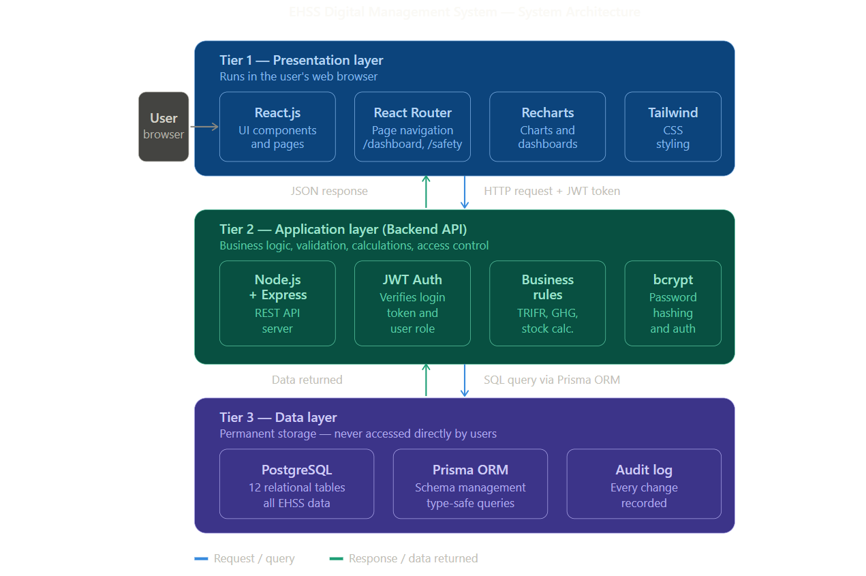

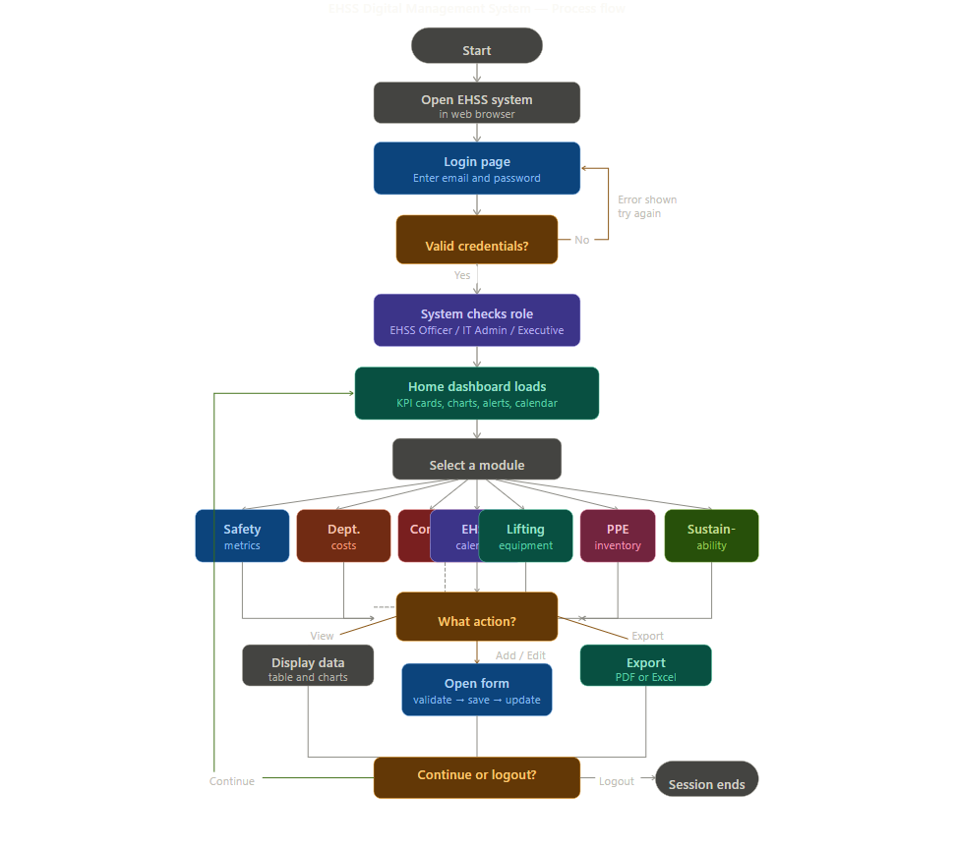
2.7 EHSS Digital Management System — Process flow

3. Database Design
The database is the permanent storage layer of the system. It converts the Excel workbook structure — sheets, rows, and columns — into formal database tables with defined relationships, constraints, and rules. A well-designed database is the foundation of a reliable system.

The database uses PostgreSQL, a relational database. In a relational database, data is organized into tables (like Excel sheets), each table has rows (like Excel rows) and columns (like Excel columns), and tables can be linked to each other through keys. This is more powerful and safer than Excel because the relationships are enforced automatically.

3.1 Key database concepts used in this design
Term | What it means | Example in this system
Primary Key (PK) | A unique identifier for every row in a table. No two rows can have the same value. | Every safety record has a unique id number. No two records share the same id.
Foreign Key (FK) | A field in one table that points to a primary key in another table. This creates the link between two tables. | Every cost record has a created_by field that points to the id of the user who created it in the users table.
Unique constraint | A rule that prevents two rows from having the same value in a specific column. | PO numbers in the costs table must be unique — the database rejects a duplicate before it is saved.
Not null constraint | A rule that prevents a field from being left empty. | The period field in the safety_metrics table cannot be empty — every record must have a date.
Enum | A field that only accepts a specific list of values. | The role field in users only accepts: ehss_officer, it_admin, executive.
Timestamp | A date and time value that is set automatically by the system. | The updated_at field records the exact date and time a record was last changed.
Calculated field | A value computed by the system from other fields. Never stored directly — always recalculated. | TRIFR is calculated from MTI, LTI, fatalities, and worked_hours every time a safety record is saved.

3.2 Table definitions
The following tables make up the complete database for the EHSS system. Each table corresponds to one or more sheets from the original Excel workbooks.

Table: users
Purpose: Stores all system user accounts and their roles. Created and managed by the IT Admin.
Field | Data type | Key / Constraint | Notes
id | INTEGER | PRIMARY KEY, AUTO INCREMENT | Unique identifier. Auto-generated by the database.
full_name | VARCHAR(100) | NOT NULL | User's full name.
email | VARCHAR(150) | UNIQUE, NOT NULL | Used as the login username. No two users can share an email.
password_hash | VARCHAR(255) | NOT NULL | bcrypt-hashed password. Never stored as plain text.
role | ENUM | NOT NULL | Values: ehss_officer, it_admin, executive.
is_active | BOOLEAN | DEFAULT true | False = account deactivated. Deactivated users cannot log in.
created_at | TIMESTAMP | DEFAULT NOW() | Auto-set when account is created.
last_login | TIMESTAMP | NULLABLE | Updated every time the user successfully logs in.

Table: safety_metrics
Purpose: Stores one row per calendar month of safety performance data. Replaces the EHS Monthly report sheet.
Field | Data type | Key / Constraint | Notes
id | INTEGER | PRIMARY KEY, AUTO INCREMENT
period | DATE | UNIQUE, NOT NULL | Stored as first day of the month (e.g. 2026-02-01). Only one record per month allowed.
staff_numbers | INTEGER | NOT NULL, >= 0 | Total headcount for the month.
worked_hours | INTEGER | CALCULATED | = 48 x 4 x staff_numbers. Computed by the system. Not user-editable.
fatalities | INTEGER | NOT NULL, DEFAULT 0, >= 0
medical_treatment_incidents | INTEGER | NOT NULL, DEFAULT 0, >= 0 | MTI — injuries needing more than first aid.
lost_time_incidents | INTEGER | NOT NULL, DEFAULT 0, >= 0 | LTI — injuries causing missed work days.
days_away_from_work | INTEGER | NOT NULL, DEFAULT 0, >= 0 | Must be 0 when lost_time_incidents = 0.
hse_training_hours | DECIMAL | NOT NULL, DEFAULT 0, >= 0 | Decimal allowed (e.g. 2.5 hours).
first_aid_cases | INTEGER | NOT NULL, DEFAULT 0, >= 0
near_misses | INTEGER | NOT NULL, DEFAULT 0, >= 0
accident_investigations | INTEGER | NOT NULL, DEFAULT 0, >= 0
hse_meetings | INTEGER | NOT NULL, DEFAULT 0, >= 0
hse_inspections | INTEGER | NOT NULL, DEFAULT 0, >= 0
trifr | DECIMAL | CALCULATED | = (MTI + LTI + fatalities) x 1,000,000 / worked_hours. System-computed.
ltifr | DECIMAL | CALCULATED | = LTI x 1,000,000 / worked_hours. System-computed.
severity_rate | DECIMAL | CALCULATED | = days_away x multiplier / worked_hours. Multiplier TBC with EHSS Officer (200,000 or 1,000,000).
created_by | INTEGER | FOREIGN KEY -> users.id | ID of the user who created this record.
updated_at | TIMESTAMP | DEFAULT NOW() | Auto-updated every time the record is saved.

Table: costs
Purpose: Stores all departmental cost records for 2025 and 2026. Replaces both cost sheets.
Field | Data type | Key / Constraint | Notes
id | INTEGER | PRIMARY KEY, AUTO INCREMENT
year | INTEGER | CALCULATED | Derived automatically from the date field.
item_description | VARCHAR(200) | NOT NULL | Description of the purchase or payment.
date | DATE | NOT NULL | Date of purchase. Cannot be a future date.
po_number | VARCHAR(50) | UNIQUE, NOT NULL | Purchase order number. No duplicates allowed across all records.
cost_excl_vat | DECIMAL(12,2) | NOT NULL, > 0 | Amount in Kenya Shillings excluding VAT. Must be positive.
cost_type | ENUM | NOT NULL | Values: statutory_requirement, staff_welfare, ppe_provision, waste_management, training, improvement_initiative.
refundable | ENUM | NOT NULL | Values: refundable, non_refundable.
budget_status | ENUM | NOT NULL | Values: in_budget, outside_budget.
created_by | INTEGER | FOREIGN KEY -> users.id
updated_at | TIMESTAMP | DEFAULT NOW()

Table: compliance_items
Purpose: Stores all legal compliance requirements and certificate details. Replaces the Compliance matrix sheet.
Field | Data type | Key / Constraint | Notes
id | INTEGER | PRIMARY KEY, AUTO INCREMENT
requirement | VARCHAR(150) | NOT NULL | Name of the legal requirement.
expert_organisation | VARCHAR(100) | NULLABLE | Issuing authority or organization.
reference_number | VARCHAR(100) | UNIQUE, NOT NULL | Certificate or license number. Must be unique.
requirement_reference | VARCHAR(100) | NOT NULL | Legal basis (e.g. County laws, OSHA).
date_of_issuance | DATE | NOT NULL | Cannot be a future date.
validity_period | ENUM | NOT NULL | Values: annual, two_years, five_years, permanent.
date_of_expiry | DATE | NOT NULL | Must be after date_of_issuance.
status | VARCHAR(20) | CALCULATED | Auto-set daily: valid, expiring_soon (<=30 days), expired, pending (no reference number).
remarks | VARCHAR(300) | NULLABLE | Optional notes.
updated_by | INTEGER | FOREIGN KEY -> users.id
updated_at | TIMESTAMP | DEFAULT NOW()

Table: calendar_activities
Purpose: Stores all EHSS training and statutory activities. Replaces the EHSS calendar sheet.
Field | Data type | Key / Constraint | Notes
id | INTEGER | PRIMARY KEY, AUTO INCREMENT
activity_name | VARCHAR(150) | NOT NULL | Name of the activity or training.
category | ENUM | NOT NULL | Values: statutory_requirement, industry_best_practice, behaviour_based_safety.
target_audience | VARCHAR(150) | NOT NULL | Who the activity is for.
internal_external | ENUM | NOT NULL | Values: internal, external.
scheduled_month | DATE | NOT NULL | Stored as first day of scheduled month.
status | ENUM | NOT NULL, DEFAULT scheduled | Values: scheduled, completed, rescheduled, not_conducted.
notes | VARCHAR(300) | NULLABLE | Optional.
updated_by | INTEGER | FOREIGN KEY -> users.id
updated_at | TIMESTAMP | DEFAULT NOW()

Table: lifting_equipment
Purpose: Stores the equipment register and inspection certificates. Replaces the Lifting equipment sheet.
Field | Data type | Key / Constraint | Notes
id | INTEGER | PRIMARY KEY, AUTO INCREMENT
item_name | VARCHAR(150) | NOT NULL | Name of the equipment.
quantity | INTEGER | NOT NULL, > 0 | Number of units. Must be positive.
location | VARCHAR(100) | NULLABLE | Where the equipment is kept.
equipment_number | VARCHAR(100) | NULLABLE | Serial or identification number.
description | VARCHAR(150) | NULLABLE | Equipment type or category.
safe_working_load | VARCHAR(50) | NOT NULL | e.g. SWL: 3 TON.
rope_length | VARCHAR(50) | NULLABLE | For slings and ropes only.
cert_expiry_date | DATE | NULLABLE | Required for items needing statutory inspection.
inspection_status | VARCHAR(20) | CALCULATED | Auto-set daily: certified, due_soon (<=30 days), overdue, not_recorded.
updated_by | INTEGER | FOREIGN KEY -> users.id
updated_at | TIMESTAMP | DEFAULT NOW()

Table: ppe_items
Purpose: Stores one row per PPE item per size. Current stock is calculated from transactions.
Field | Data type | Key / Constraint | Notes
id | INTEGER | PRIMARY KEY, AUTO INCREMENT
item_name | VARCHAR(150) | NOT NULL | Name of the PPE item.
size_spec | VARCHAR(20) | NOT NULL | Size or specification (e.g. XL, L, M). Each size is a separate row.
unit_of_measure | VARCHAR(20) | NOT NULL, DEFAULT pcs | Usually pcs (pieces).
reorder_level | INTEGER | NULLABLE, >= 0 | Alert is triggered when current_stock falls to or below this value.
current_stock | INTEGER | CALCULATED | = total received - total issued. Recalculated from ppe_transactions after every transaction. Not editable.
updated_by | INTEGER | FOREIGN KEY -> users.id

Table: ppe_transactions
Purpose: Records every stock movement (received or issued) for each PPE item. Used to calculate current_stock in ppe_items.
Field | Data type | Key / Constraint | Notes
id | INTEGER | PRIMARY KEY, AUTO INCREMENT
ppe_item_id | INTEGER | FOREIGN KEY -> ppe_items.id, NOT NULL | Links this transaction to the specific PPE item and size.
transaction_type | ENUM | NOT NULL | Values: received, issued.
quantity | INTEGER | NOT NULL, > 0 | Must be positive.
date | DATE | NOT NULL | Date of the stock movement.
notes | VARCHAR(200) | NULLABLE | Optional. e.g. Issued to Mill 2 staff.
created_by | INTEGER | FOREIGN KEY -> users.id
created_at | TIMESTAMP | DEFAULT NOW()

Table: sustainability_data
Purpose: Stores one row per calendar month of resource consumption data. Replaces all sustainability data sheets.
Field | Data type | Key / Constraint | Notes
id | INTEGER | PRIMARY KEY, AUTO INCREMENT
period | DATE | UNIQUE, NOT NULL | First day of the month. One record per month only.
water_consumption_m3 | DECIMAL | NULLABLE, >= 0 | Monthly total in cubic meters.
electricity_kwh | DECIMAL | NULLABLE, >= 0 | Monthly total in kilowatt-hours.
firewood_tonnes | DECIMAL | NULLABLE, >= 0 | Monthly total in metric tonnes.
diesel_litres | DECIMAL | NULLABLE, >= 0 | Monthly total in liters.
petrol_litres | DECIMAL | NULLABLE, >= 0 | Monthly total in liters.
lpg_kg | DECIMAL | NULLABLE, >= 0 | Monthly total in kilograms.
paper_waste_kg | DECIMAL | NULLABLE, >= 0 | Monthly total disposed in kg.
plastic_packaging_kg | DECIMAL | NULLABLE, >= 0 | Monthly plastic packaging waste in kg.
hazardous_waste_kg | DECIMAL | NULLABLE, >= 0 | E-waste, lab and medical waste in kg.
recyclable_plastic_kg | DECIMAL | NULLABLE, >= 0 | HDPE/LDPE bottles and broken pallets in kg.
paper_waste_annual_total_kg | DECIMAL | CALCULATED | = SUM of all monthly paper_waste_kg entries for the year. Auto-computed.
plastic_packaging_annual_total_kg | DECIMAL | CALCULATED | = SUM of all monthly plastic_packaging_kg entries for the year. Auto-computed.
hazardous_waste_annual_total_kg | DECIMAL | CALCULATED | = SUM of all monthly hazardous_waste_kg entries for the year. Auto-computed.
recyclable_plastic_annual_total_kg | DECIMAL | CALCULATED | = SUM of all monthly recyclable_plastic_kg entries for the year. Auto-computed.
scope1_tco2e | DECIMAL | CALCULATED | = (firewood x 61.81 + diesel x 2.7 + petrol x 2.3 + LPG x 1.51) / 1000. System-computed.
scope2_tco2e | DECIMAL | CALCULATED | = electricity_kwh x 0.5 / 1000. Uses 2023 EPRA Kenya grid factor. System-computed.
updated_by | INTEGER | FOREIGN KEY -> users.id
updated_at | TIMESTAMP | DEFAULT NOW()

Table: lpg_transactions
Purpose: Records individual LPG gas level readings. The difference (consumption) is calculated automatically per reading.
Field | Data type | Key / Constraint | Notes
id | INTEGER | PRIMARY KEY, AUTO INCREMENT
date | DATE | NOT NULL | Date of the reading.
initial_gas_level_kg | DECIMAL | NOT NULL, >= 0 | Gas level at the start of the consumption period in kg.
final_gas_level_kg | DECIMAL | NOT NULL, >= 0 | Gas level at the end of the period. Must be <= initial_gas_level_kg.
difference_kg | DECIMAL | CALCULATED | = initial_gas_level_kg - final_gas_level_kg. System-computed.
notes | VARCHAR(200) | NULLABLE | Optional.
created_by | INTEGER | FOREIGN KEY -> users.id
created_at | TIMESTAMP | DEFAULT NOW()

Table: materiality_topics
Purpose: Stores the ESG materiality assessment scores. Bubble size is calculated automatically.
Field | Data type | Key / Constraint | Notes
id | INTEGER | PRIMARY KEY, AUTO INCREMENT
topic_name | VARCHAR(150) | NOT NULL | Name of the ESG material topic.
category | ENUM | NOT NULL | Values: environmental, social.
importance | INTEGER | NOT NULL, BETWEEN 1 AND 5 | How important the topic is to stakeholders? Score 1-5.
influence | INTEGER | NOT NULL, BETWEEN 1 AND 5 | Company's level of influence over the topic. Score 1-5.
bubble_size | DECIMAL | CALCULATED | = importance x influence. Used for bubble chart plotting. System-computed.
year | INTEGER | NOT NULL | Assessment year (e.g. 2025, 2026).
updated_by | INTEGER | FOREIGN KEY -> users.id
updated_at | TIMESTAMP | DEFAULT NOW()

Table: audit_log
Purpose: Records every data change in the system for accountability and traceability.
Field | Data type | Key / Constraint | Notes
id | INTEGER | PRIMARY KEY, AUTO INCREMENT
user_id | INTEGER | FOREIGN KEY -> users.id | Who made the change.
module | VARCHAR(50) | NOT NULL | Which module was affected (e.g. safety_metrics, compliance).
record_id | INTEGER | NOT NULL | The id of the specific record that was changed.
action | ENUM | NOT NULL | Values: created, updated, deleted.
old_value | TEXT | NULLABLE | JSON snapshot of the record before the change. Null for new records.
new_value | TEXT | NULLABLE | JSON snapshot of the record after the change. Null for deleted records.
timestamp | TIMESTAMP | DEFAULT NOW() | Exact date and time of the change.

3.3 Table relationships (ER diagram summary)
The following table describes all relationships between the database tables. This represents the Entity Relationship (ER) diagram in text form. A visual ER diagram can be drawn in Draw.io or dbdiagram.io using these relationships as the blueprint.

Relationship | Type | Description
users → safety_metrics | One to many | One user can create many safety records. Each safety record is created by one user.
users → costs | One to many | One user can create many cost records.
users → compliance_items | One to many | One user can update many compliance items.
users → calendar_activities | One to many | One user can manage many calendar activities.
users → lifting_equipment | One to many | One user can update many equipment records.
users → ppe_items | One to many | One user can manage many PPE items.
users → ppe_transactions | One to many | One user can record many stock transactions.
ppe_items → ppe_transactions | One to many | One PPE item (per size) can have many stock transactions. The sum of these transactions calculates current stock.
users → sustainability_data | One to many | One user can enter many monthly sustainability records.
users → lpg_transactions | One to many | One user can record many LPG gas readings.
users → materiality_topics | One to many | One user can manage many materiality topics.
users → audit_log | One to many | One user can generate many audit log entries.
lpg_transactions → sustainability_data | Many to one | Multiple LPG transaction readings contribute to the monthly LPG total stored in the sustainability data record for that month.

4. UI/UX Design
UI (User Interface) design defines what each screen looks like — the layout, buttons, forms, and visual elements. UX (User Experience) design defines how the user moves through the system — the navigation flow, the sequence of actions, and how intuitive it feels to use.

The wireframes in this section are screen-by-screen blueprints for the React system. Each wireframe is described in enough detail to be built directly into code or drawn in a tool such as Figma or Draw.io. Every screen is traced back to a functional requirement from Phase 2.

4.1 Design principles
Principle | What it means for this system
Clarity over cleverness | Every label, button, and message should be immediately understood by an EHSS Officer with no IT background. No jargon, no cryptic icons without labels.
Status always visible | Compliance, lifting equipment, and PPE status must always be visible without the user having to open a record. Color badges with text labels achieve this.
Reduce manual work | Every calculation that was done manually in Excel must be done automatically. The user should never have to compute a value themselves.
Prevent errors before they happen | Forms validate input before saving. Required fields are clearly marked. Destructive actions (delete) require confirmation.
Consistent layout | Every module follows the same page structure: page title, summary cards, chart (where relevant), data table, action buttons. Users learn the pattern once and apply it everywhere.

4.2 Global layout
Every page in the system shares the same outer layout:

- Top navigation bar — system logo on the left, logged-in user name and role on the right, logout button on the far right.
- Left sidebar — persistent navigation menu with links to all modules the user's role can access. Active page is highlighted. Sidebar can be collapsed on smaller screens.
- Main content area — takes up the remaining screen space. Each module's content loads here.
- Alert banner — if any compliance items or lifting equipment are expiring within 30 days, a fixed amber banner appears at the top of every page with a count and a link to the affected module.

4.3 Page-by-page wireframes
Page 1 — Login
Requirement: FR-01
Element | Description
Layout | Centred card on a plain background. Company or EHSS logo above the card.
Fields | Email address (text input). Password (masked input).
Button | Login — full width, navy blue background.
Error state | If credentials are wrong, red error message appears below the button: 'Invalid email or password. Please try again.'
After 5 fails | Message changes to: 'Account temporarily locked. Please try again in 15 minutes.'
No registration | No sign-up link. Accounts are created by IT Admin only.

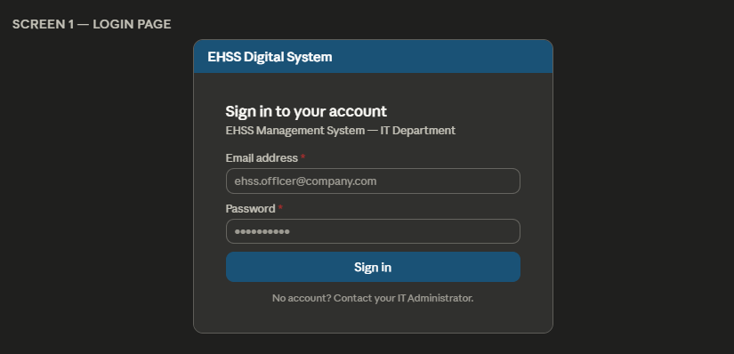

Page 2 — Dashboard (Home)
Requirement: FR-03
Element | Description
Page title | Good morning / afternoon [User name] | Role badge next to name.
Row 1 — KPI cards | 4 cards in a row: (1) Total YTD Cost — KES amount in large text, cost type breakdown below. (2) Compliance alerts — count of items expiring within 30 days in amber, expired in red. (3) Safety incidents YTD — total MTI + LTI count. (4) PPE low stock — count of items at or below reorder level.
Row 2 — Charts | Two charts side by side: (1) Line chart — monthly TRIFR and LTIFR for current year. (2) Doughnut chart — YTD costs by cost type with legend.
Row 3 — Alerts | Panel titled 'Action required'. Lists every compliance certificate and lifting equipment item expiring within 30 days, showing item name, expiry date, and days remaining. Items are sorted by days remaining (most urgent first).
Row 4 — Calendar | Panel titled 'Upcoming activities'. Lists the next 5 scheduled calendar activities showing activity name, category, and scheduled month.

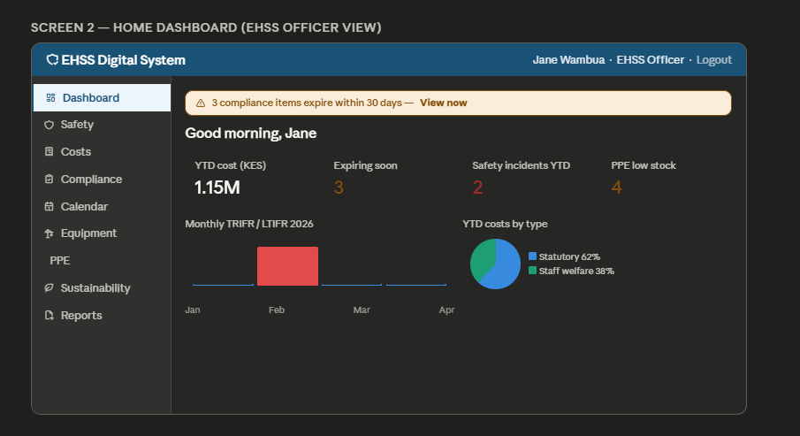

Page 3 — Safety Metrics
Requirement: FR-04
Element | Description
Page title | Safety Metrics — 2026
Summary cards | 4 cards: TRIFR YTD average, Total incidents (MTI + LTI), Total training hours, Total inspections.
Chart | Line chart of monthly TRIFR and LTIFR. Months with incidents are marked with a dot on the line.
Table | All monthly records. Columns: Period, Staff, Hours worked, Fatalities, MTI, LTI, Days lost, Training hrs., Near misses, Investigations, Meetings, Inspections, TRIFR, LTIFR, Severity rate. Rows with any incident > 0 are highlighted with a light amber background. Edit button at the end of each row (EHSS Officer only). Delete button visible to IT Admin only.
Add button | Add monthly record — opens a modal form (EHSS Officer only).
Modal form fields | Period (month picker), Staff numbers, Fatalities, MTI, LTI, Days away, Training hours, First aid, Near misses, Investigations, Meetings, Inspections. Worked hours, TRIFR, LTIFR, Severity rate shown as read-only calculated fields that update live as the user types.

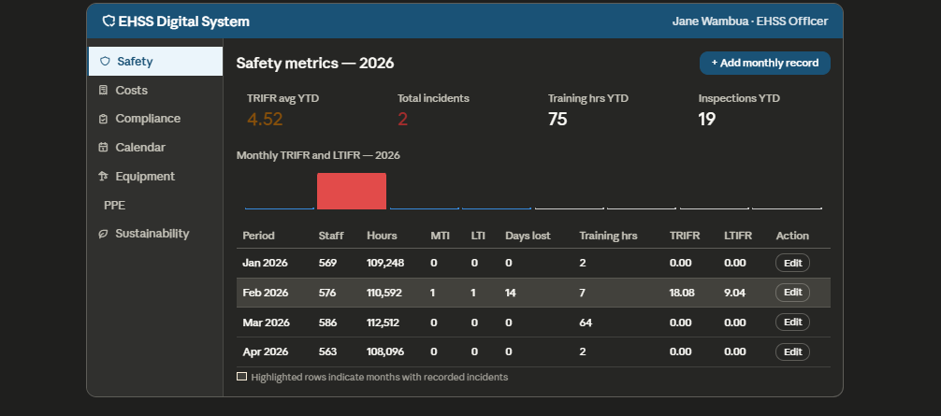

Page 4 — Departmental Costs
Requirement: FR-05
Element | Description
Page title | Departmental Costs
Filter bar | Year dropdown (2025 / 2026 / All). Cost type dropdown. Budget status dropdown. Search box for item description or PO number.
Summary cards | 4 cards: Total spend (filtered), Statutory requirement total, Staff welfare total, In-budget total.
Chart | Grouped bar chart comparing 2025 vs 2026 spend side by side, broken down by cost type.
Table | All cost records matching current filters. Columns: SN, Date, Item description, PO Number, Cost (KES), Cost type, Refundable, Budget status, Actions. Out-of-budget rows highlighted amber. Edit button per row (EHSS Officer only). Delete button per row (IT Admin only).
Add button | Add cost record — opens a form modal. PO number validated for uniqueness on submit.

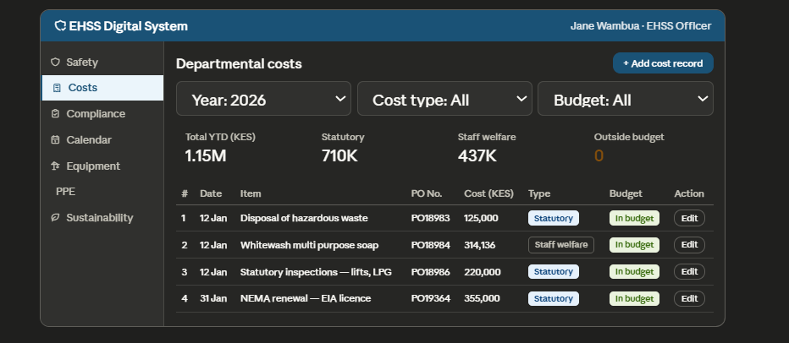
Page 5 — Compliance Matrix
Requirement: FR-06
Element | Description
Page title | Compliance Matrix
Status tabs | Filter tabs across the top: All | Valid | Expiring Soon | Expired | Pending. Count badge on each tab.
Summary cards | 4 cards with counts and colors: Valid (green), Expiring Soon (amber), Expired (red), Pending (grey).
Table | Columns: SN, Requirement, Organization, Reference No, Issued, Expires, Validity, Status badge, Remarks, Actions. Status badge shows both color and text label. Expired rows have a light red background. Expiring soon rows have a light amber background. Edit button per row (EHSS Officer only).
Add button | Add compliance item — opens a form modal. Status shown as read-only and auto-calculated.

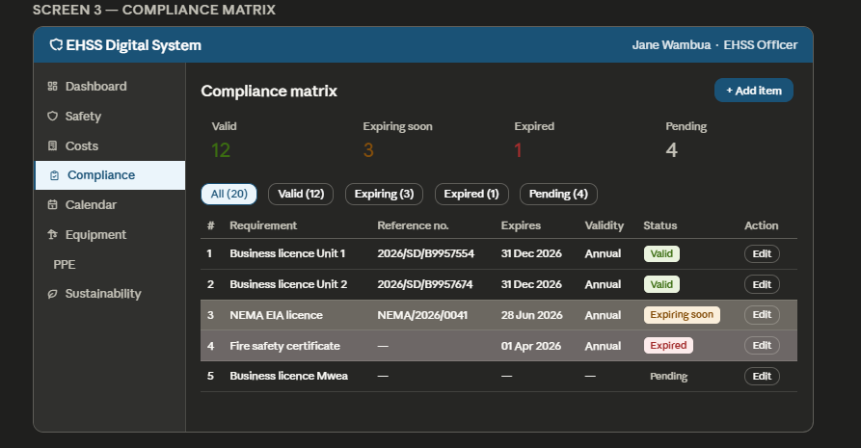

Page 6 — EHSS Calendar
Requirement: FR-07
Element | Description
Page title | EHSS Calendar 2026
View toggle | Table view / Monthly grid view toggle button in the top right.
Filter bar | Category dropdown. Status dropdown. Target audience search.
Table view | Columns: SN, Activity, Category, Audience, Internal/External, Scheduled month, Status, Actions. Overdue rows (past month but still Scheduled) highlighted amber. Status can be changed via an inline dropdown without opening the full edit form.
Monthly grid | 12-month grid. Each month shows the count of activities scheduled and their status summary.
Add button | Add activity — opens form modal (EHSS Officer only).

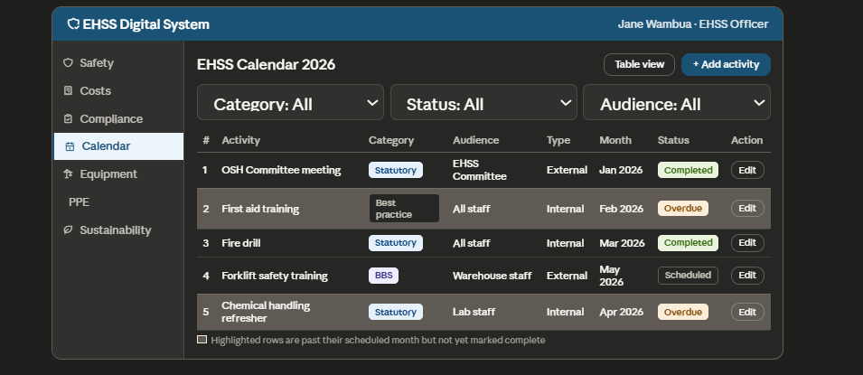
Page 7 — Lifting Equipment
Requirement: FR-08
Element | Description
Page title | Lifting Equipment Register
Summary cards | 4 cards: Total items, Certified (green), Due soon (amber), Overdue (red).
Table | Columns: SN, Item name, Qty, Location, Equipment No, SWL, Cert expiry date, Inspection status badge, Actions. Overdue rows highlighted red. Due soon rows highlighted amber.
Add button | Add equipment — opens form modal (EHSS Officer only).

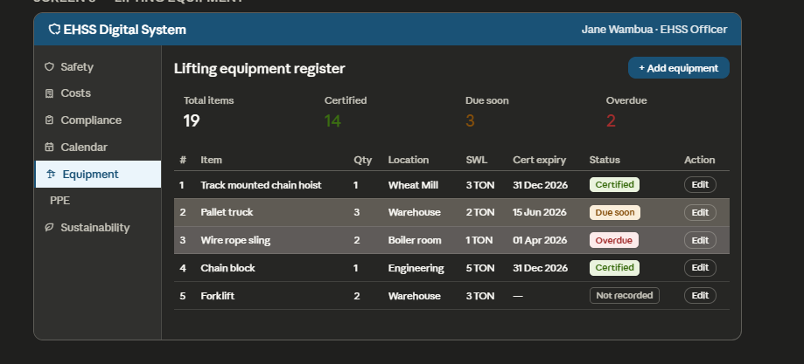
Page 8 — PPE Inventory
Requirement: FR-09
Element | Description
Page title | PPE Inventory
Summary cards | 3 cards: Total items tracked, Items at/below reorder level (amber), Items out of stock (red).
Table | Grouped by item name with each size as a sub-row. Columns: Item, Size, Unit, Current stock, Reorder level, Status. Rows at or below reorders level highlighted amber. Out of stock rows highlighted red.
Record transaction button | Opens a form: select item + size (dropdown), transaction type (Received / Issued), quantity, date, optional notes. Stock balance recalculates immediately on save.
Set reorder level | Each item row has an Edit reorder level action — opens a small inline input field to set the minimum stock value.

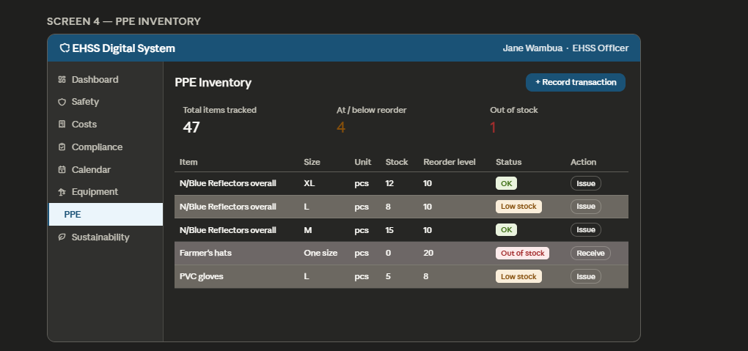

Page 9 — Sustainability
Requirement: FR-10
Element | Description
Page title | Sustainability Data
Year selector | Dropdown to select the reporting year.
Summary cards | 4 cards: Total Scope 1 emissions (tCO2e), Total Scope 2 emissions (tCO2e), Total water used (m3), Total electricity (kWh).
Tabs | Five tabs: Energy | Waste | Emissions | LPG Readings | Materiality.
Energy tab | Table of monthly water, electricity, firewood, diesel, petrol, LPG data. Year-on-year bar chart.
Annual waste totals | paper waste annual total, plastic packaging annual total, hazardous waste annual total, and recyclable plastic packaging annual total- all auto-calculated from monthly entries.
Waste tab | Table of monthly paper, plastic, hazardous, recyclable waste. Year-on-year comparison charts for each waste category.
Emissions tab | Table of monthly Scope 1 and Scope 2 values with total row. Bar chart of monthly emissions.
LPG tab | Transaction table showing each LPG gas reading with initial level, final level, and calculated difference.
Materiality tab | Scored ESG topics table with importance, influence, and bubble size. Bubble chart plotted from scores.
Enter data button | Opens a single form with all monthly fields for one month (EHSS Officer only).

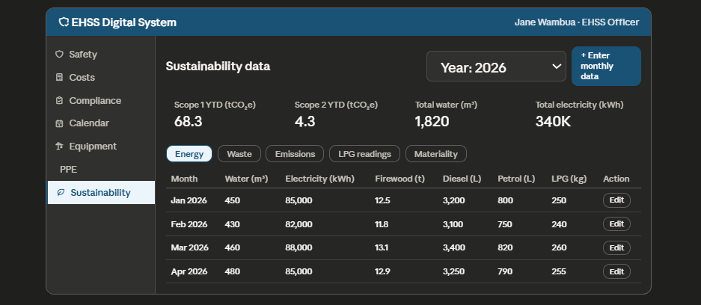
Page 10 — Reports
Requirement: FR-11
Element | Description
Page title | Reports
Report selector | Dropdown: Monthly EHSS Summary | Compliance Status Report | Cost Analysis Report.
Date range | Month and year picker for start and end of reporting period.
Preview pane | Shows a formatted preview of the selected report for the selected period before the user exports.
Export buttons | Download as PDF and Download as Excel (.xlsx) buttons side by side.
Table exports | Every data table in the system has its own Export button in the top right corner for quick independent exports.

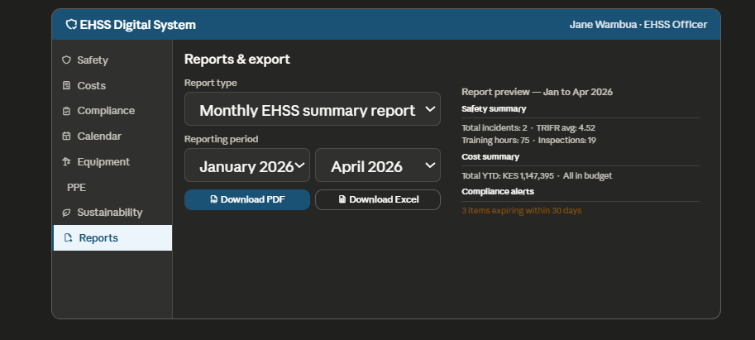
Page 11 — User Management (IT Admin only)
Requirement: FR-13
Element | Description
Page title | User Management
Table | All user accounts. Columns: Full name, Email, Role, Status (Active / Inactive), Last login, Actions.
Add user | Opens a form: full name, email, role dropdown, temporary password. New user receives a prompt to change password on first login.
Edit action | Opens the user record to update name, email, or role.
Deactivate | Confirmation dialog: 'Are you sure you want to deactivate [name]? They will no longer be able to log in.' Deactivated users show Inactive badge in the table.
Audit log link | Button to view the full system audit log — available to IT Admin only.

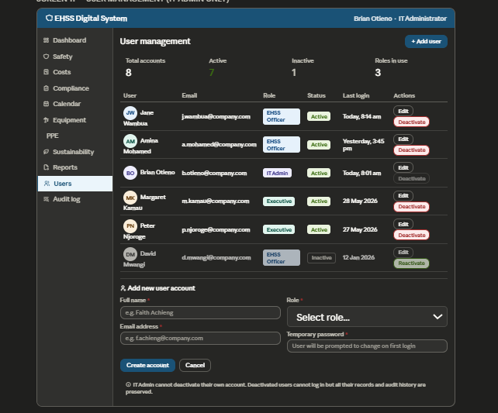

4.4 Form design standards
All forms across the system follow these consistent standards:

- Required fields are marked with a red asterisk (*) next to the label.
- Calculated fields (TRIFR, LTIFR, stock balance, GHG emissions) are shown in a grey read-only box with a small calculator icon and the label 'Auto-calculated'.
- Validation errors appear immediately below the relevant field in red text when the user tries to submit an incomplete or invalid form.
- Date fields use a date picker — users never type dates manually.
- Dropdown fields show all available options. No free text is allowed where a dropdown exists.
- Save and Cancel buttons always appear at the bottom of every form. Save is navy blue, Cancel is grey.
- After a successful save, the form closes and a green success notification appears at the top of the page for 3 seconds.
- After a failed save, the form stays open, the relevant field errors are shown, and a red notification appears at the top.

4.5 Color and status badge system
The same color logic is used consistently across compliance, lifting equipment, PPE, and calendar modules so users learn it once and recognize it everywhere:

Color | Meaning | Used for
Green | Valid / Certified / Completed / Sufficient stock | Compliance certificates, lifting equipment, PPE stock above reorder level, calendar activities marked complete.
Amber | Expiring soon / Due soon / Low stock / Overdue activity | Items within 30 days of expiry, PPE at or below reorder level, calendar activities past their scheduled month but not yet marked complete.
Red | Expired / Overdue inspection / Out of stock | Compliance certificates past expiry date, lifting equipment past inspection due date, PPE items with zero stock.
Grey | Pending / Not recorded / Scheduled (not yet due) | Compliance items with no reference number, equipment with no cert date, activities not yet due.
Navy | Primary action buttons, header row, selected navigation item | Consistent branding color throughout the system.

