WEB–BASED SALES AND INVENTORY MANAGEMENT SYSTEM FOR RJTECH COMPUTERS

A thesis Presented to
College of Computer Studies
Asian College of Technology
Cebu, Philippines

In Partial Fulfillment
of the Requirement for the degree of

Bachelor of Science in Information Technology

by

GLENN C. CUADERO
CHRISTIAN M. RIVERA
MARK STEVEN CORTES
IGGIE BOY B. CORDOVA

March 2026
EVALUATION OF THESIS PROPOSAL DEFENSE
(Thesis Advisory Committee)

Date: March 20, 2026

Thesis Title:
Web-Based Sales and Inventory Management System for RITech Computers__________
________________________________________________________________________
_________________________________________________________________________________
Evaluation:

PASSED RE-DEFENSE / CHANGE TOPIC

FAILED
✓

CONDITIONAL

Remarks:
________________________________________________________________________
________________________________________________________________________
________________________________________________________________________
_________

Evaluated by the Oral Examination Panel (Thesis Advisory Committee):
JAY MAR C. VILVESTRE, MIT
Chairman
CHIN CHIN N. FABROA  Member |  |  | ENRIQUE T. MANAL  Member
LEIF JAY B. DE SAGUN, PhD
Adviser

Approved by:

LEIF JAY B. DE SAGUN, PhD
College Dean
TABLE OF CONTENTS
 | Page
TITLE PAGE | i
EVALUATION OF THESIS PROPOSAL DEFENSE | ii
TABLE OF CONTENTS | iii
LIST OF FIGURES, CHARTS AND TABLES | v
CHAPTER
- INTRODUCTION
- Rationale of the Study | 1
- Objectives of the Study | 2
- Significance of the Study | 4
- Scope and Limitations of the System | 5
- Definition of Term | 7
- THEORETICAL BACKGROUND
- Review of Related Literature and Systems | 9
- Matrix of Comparison | 18
- METHODOLOGY
- Research Environment  - Methods and Techniques  - Models  - Tools  - Development Process | 21  22  24  25  26
- Requirements Analysis  - Functional Requirements  - Non-Functional Requirements  - Usability Requirements | 28  28  29  30
REFERENCES | 32
APPENDICES
APPENDIX A: Transmittal Letter | 33
APPENDIX B: Current Flow of the System | 34
APPENDIX C: Questionnaire | 36
APPENDIX D: Evidences | 39

LIST OF FIGURES, TABLES AND CHARTS
Figure
2.1 | ZOHO INVENTORY | 10
2.2 | ECount | 11
2.3 | Odoo | 12
2.4 | inFlow Inventory | 14
2.5  2.6  3.1  A.1  B.1  C.1  C.2  C.3  D.1  D.2 | Pipedrive QuickBooks Research Locale  Transmittal Letter  Current Flow of the System  Questionnaires for Product  Questionnaires for Inventory Flow  Questionnaires for Procedure  Evidences  Evidences | 15  16  22  33  34  36  37  38  39  40
Table
1 | Matrix of Comparison | 18
Diagram  3.1 | Development Process | 26

Chapter 1
INTRODUCTION

- Rationale of the Study
Managing sales and inventory is an essential responsibility for computer shops, particularly as the demand for computer components and accessories continues to grow. Businesses that sell computer parts must maintain accurate records of product availability, monitor sales transactions, and ensure that stock levels are properly controlled. Efficient inventory management enables shop owners to track product movement, prevent stock shortages or overstocking, and maintain reliable transaction records. In a competitive business environment, accurate information and organized operations are important factors that contribute to business efficiency, service quality, and long-term sustainability.
Despite the importance of proper inventory management, many small computer shops still rely on manual methods such as handwritten records or spreadsheets to track inventory and sales transactions. Manual record-keeping often requires more time and effort and is prone to human errors such as incorrect stock counts, misplaced records, duplicate entries, and delayed report preparation. In addition, the absence of a centralized and automated system makes it difficult for shop owners to monitor inventory levels in real time and evaluate daily sales performance. These limitations may lead to inefficient decision- making and operational delays that can affect the overall performance of the business.
To address these issues, this study proposes the development of a Web–Based Inventory and Sales Management System for RJTech Computers. The proposed system aims to automate the recording of product information and sales transactions while providing real- time monitoring of inventory levels. The system will also generate sales and inventory reports that can assist the shop owner in analyzing business performance. Additional features such as user access control, stock–level notifications, and organized product categorization will support accurate data management and improve operational efficiency.
The implementation of the proposed system is expected to benefit the owner and staff of RJTech Computers by simplifying the processes involved in inventory control and sales monitoring. By reducing manual work and minimizing errors, the system will help improve data accuracy and streamline daily business operations. Customers may also benefit from faster and more reliable transactions. Furthermore, the proposed system may serve as a practical reference for other small businesses that experience similar challenges in managing sales and inventory records.

- Objectives of the System
The general objective of this study is to develop a web-based Inventory and Sales Management System for RJTech Computers that automates product tracking and sales recording to improve the accuracy, organization, and efficiency of business operations. Specifically, it aims to:
- develop a product management module that allows authorized users to add, update, categorize, and manage computer parts and accessories;
- implement real–time inventory monitoring that automatically updates stock levels whenever products are sold or restocked;
- automate the recording of sales transactions and payment information to reduce manual workload and minimize recording errors;
- Generate organized sales and inventory reports, including daily, weekly, and monthly reports for business monitoring;
- provide automated stock notifications when inventory levels reach a predefined minimum quantity;
- implement user authentication and access control to ensure data security and controlled system access; and
- design a simple and user–friendly interface that allows employees and managers to efficiently perform daily shop operations.

- Significance of the Study
The development of the Inventory and Sales Management System is expected to provide several benefits to different stakeholders.
RJTech Computers – The proposed system will help improve the management of inventory and sales transactions by automating record–keeping and monitoring processes. It will allow the business to maintain accurate product records, monitor stock levels in real time, and generate reports that support better decision–making.
Employees and Staff – The system will simplify daily operational tasks such as recording sales transactions, updating product information, and monitoring stock availability. By reducing manual processes, employees can complete their work more efficiently and with fewer errors.
Customers – Customers may benefit from faster and more accurate transaction processing. With organized product records and real–time inventory monitoring, the shop can provide more reliable service and improved customer experience.
Researchers – this study may serve as a useful reference for researchers who plan to conduct studies related to inventory management systems, retail automation, or business information systems.
Future Researchers – Future researchers may use this study as a guide in developing similar systems or improving existing inventory and sales management solutions for other business environments.

- Scope and Limitations of the System
The proposed Web–Based Inventory and Sales Management System for RJTech Computers is designed to support the daily sales and inventory operations of the business. The system will include the following functionalities:
Product Management – the system will allow authorized users to add, edit, delete, and categorize products such as computer components and accessories. Each product record will contain information including product name, category, supplier, price, and stock quantity.
Inventory Management – the system will automatically update inventory levels whenever products are sold or restocked. Users will be able to monitor inventory levels in real time to ensure accurate stock records.
Sales and Transaction Management – the system will record sales transactions and automatically compute the total amount of purchased items. This feature helps reduce manual calculations and improves transaction accuracy.
Payment Recording – the system will record payment transactions associated with each sale to maintain organized financial documentation.
Inventory Notifications – the system will generate automated alerts when product stock levels reach a predefined minimum quantity, allowing users to restock items in a timely manner.
Sales and Inventory Reports – the system will generate reports summarizing daily, weekly, and monthly sales and inventory data to support monitoring and decision–making.
Security and Access Control – user authentication and access control will be implemented to ensure that only authorized users can access and manage system records.
User Interface – the system will be developed as a web-based application with a simple and user-friendly interface that can be accessed through standard web browsers.

Despite the capabilities of the proposed system, several limitations are identified:
- The system is designed for single–business use only and does not support multi -branch inventory management.
- The system requires a stable internet connection to access and update system records in real time.
- The system does not include advanced accounting functions such as tax computation, payroll processing, or financial statement generation.
- The system will only be accessible through web browsers on desktop or laptop devices and will not include a dedicated mobile application.
- The system focuses primarily on inventory and sales management and does not support advanced enterprise resource planning features.
DEFINITION OF TERMS

This section defines key terms as they are specifically used within the context of this system and study. Each term is explained in direct relation to the project's objectives, scope, and practical application to ensure readers understand its unique relevance and meaning within the research. The following definitions are presented briefly and clearly, focusing exclusively on how each concept applies to the functional requirements and operational framework of the RJTech Computers Inventory and Sales Management System.
Automation – refers to the capability of the proposed system to automatically perform tasks such as recording sales transactions, updating inventory levels, and generating reports without relying on manual record–keeping.
Centralized Database – a digital storage system where all product information, inventory records, and sales transactions of RJTech Computers are stored and managed in a single organized location.
Inventory Management – the process of monitoring, controlling, and updating product stock levels within the system to maintain accurate inventory records and prevent shortages or overstocking.
Inventory Notification – an automated alert generated by the system when the quantity of a product reaches a minimum stock level, prompting users to restock items.
Payment Management – the system feature responsible for recording and organizing payment transactions for products purchased by customers.
Product Management – the system process that allows users to add, edit, delete, and categorize computer parts and accessories while maintaining accurate product information such as name, category, price, supplier, and stock quantity.
Real–Time Monitoring – the ability of the system to instantly update and display current inventory levels and sales transactions immediately after data is recorded.
Sales Analytics – the system capability that analyzes sales data and presents summarized information to help the shop owner evaluate product performance and business trends.
Sales Transaction – a recorded process within the system where a product purchase is completed, including the calculation of total cost and the update of inventory records.
Stock Level – the available quantity of a particular product recorded in the inventory database.
User–Friendly Interface – a system interface that is designed to be simple, organized, and easy to navigate, allowing users to perform tasks efficiently with minimal training.

Chapter 2
THEORETICAL BACKGROUND

- Review of Related Literature and Systems
A Review of Related Systems involves the systematic examination of existing software applications or platforms that perform functions similar to the proposed system. This process enables a comparative analysis of system design, user interaction, and data management practices. By evaluating the strengths and limitations of these existing systems, developers can identify best practices as well as areas that require improvement. Consequently, the Review of Related Systems serves as a foundational basis for the development of a more efficient and effective solution, allowing the proponents to avoid previously encountered shortcomings while incorporating proven and successful features.

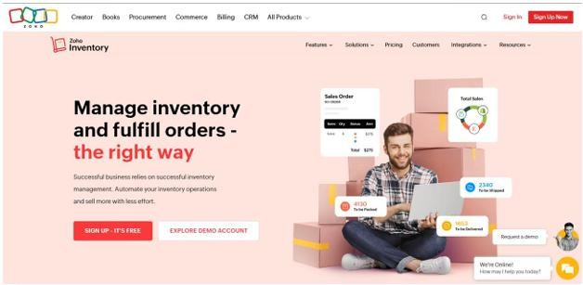
1. Zoho Inventory
Figure 2.1: Zoho Inventory Homepage
Zoho Inventory is a cloud-based inventory management system developed by Zoho Corporation that helps businesses track stock levels, manage orders, and monitor warehouse operations. It is commonly used by small to medium-sized businesses engaged in retail, wholesale, and e-commerce activities. The system allows organizations to maintain accurate product records and manage inventory operations through a centralized online platform.
The system provides features such as real-time inventory tracking, order fulfillment, shipping integration, and automated reporting. It also integrates with e-commerce platforms and accounting tools, enabling businesses to coordinate inventory management across different sales channels. These capabilities help companies maintain organized inventory records and improve operational efficiency.
Despite its advanced features, Zoho Inventory includes several functions that are designed for larger organizations or online businesses with multiple sales channels. The system also requires subscription payments, which may not be practical for smaller single- location shops. In comparison, the proposed Web-Based Inventory and Sales Management System for RJTech Computers focuses only on the essential functions required for daily computer shop operations, including product management, real–time inventory monitoring, automated sales recording, and stock notifications. This simplified design provides a more practical and affordable solution for managing the business operations of RJTech Computers.
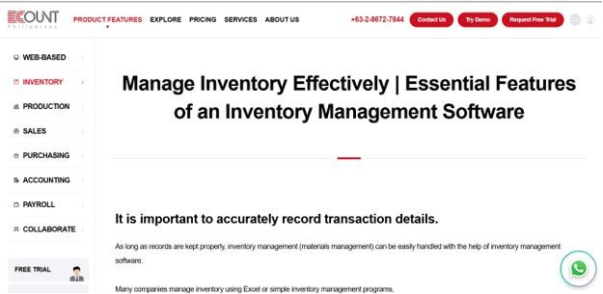
2. ECount
Figure 2.2: Ecount Homepage
ECount is a cloud–based Enterprise Resource Planning (ERP) system developed by ECount Inc. that integrates various business functions such as inventory management, accounting, purchasing, and production monitoring into a single platform. The system is commonly used by manufacturing and trading companies that require comprehensive management of multiple business processes.
The platform provides features including real-time inventory tracking, financial reporting, production management, and multi-user collaboration. By integrating different operational modules, ECount allows businesses to monitor inventory, track financial transactions, and coordinate operations across multiple departments. This integration helps organizations improve overall business management and operational control.
Although ECount offers comprehensive enterprise management features, its interface and workflow structure can be complex for smaller businesses. Many of its modules, such as production management and accounting integration, are designed for larger organizations with multiple operational departments. In contrast, the proposed Inventory and Sales Management System for RJTech Computers focuses specifically on the needs of a single computer shop by providing essential functions such as product organization, real-time inventory monitoring, sales transaction recording, and automated stock notifications. This focused approach simplifies system usage while maintaining effective inventory and sales management.

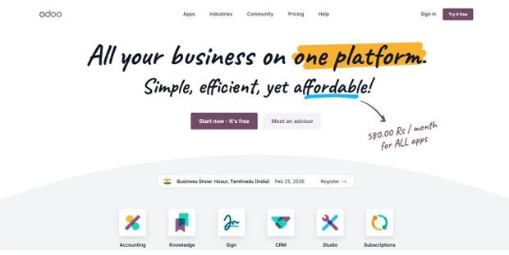
3. Odoo
Figure 2.3: Odoo Homepage
Odoo is an open-source enterprise management platform developed by Odoo S.A. that provides modular applications for inventory management, sales operations, accounting, manufacturing, and customer relationship management. The system is designed to support organizations that require customizable and integrated business software.
The inventory module of Odoo allows businesses to monitor stock levels, manage warehouses, and automate procurement processes. Additional modules support sales management, financial reporting, and customer relationship management. Because of its modular architecture, organizations can select and configure different features according to their operational requirements.
While Odoo provides flexible and customizable business management tools, implementing and configuring the system often requires technical expertise and additional customization. The setup process may also require more time and resources for system deployment. In comparison, the proposed system for RJTech Computers emphasizes simplicity and ease of use by providing only the essential functions required for computer shop operations. The system focuses on real–time inventory monitoring, sales recording, report generation, and stock alerts through a straightforward web–based interface that supports efficient daily operations.

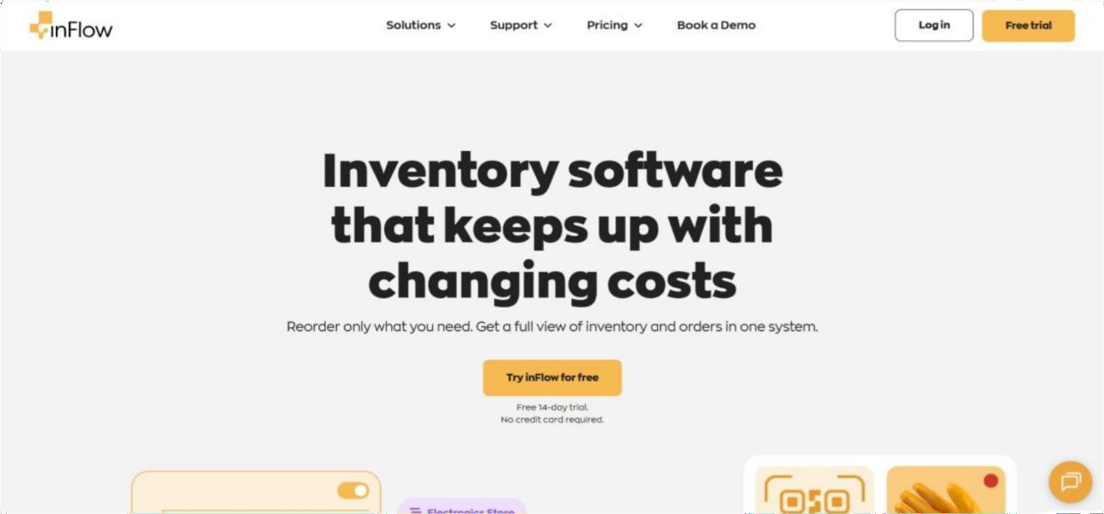
4. inFlow Inventory
Figure 2.4: inFlow Inventory Homepage
inFlow Inventory is an inventory and order management software developed by Archon Systems Inc. that is available on desktop, web, and mobile platforms. The system is designed primarily for small and medium–sized businesses that require reliable stock monitoring and product management.
The software includes features such as barcode support, purchase and sales tracking, warehouse monitoring, and inventory reporting tools. These features allow businesses to maintain accurate inventory records and monitor product movement across different storage locations. The system also provides offline functionality, allowing users to continue managing inventory even without constant internet connectivity.
Although inFlow Inventory provides strong inventory control capabilities, its primary focus is on stock monitoring and order management. Some operational functions required in a retail computer shop environment, such as integrated sales monitoring and shop-specific reporting, may be limited. In contrast, the proposed system for RJTech Computers integrates inventory management with sales transaction recording, payment monitoring, and real–time reporting. This integration allows the shop owner to monitor both product stock and sales performance within a single system.

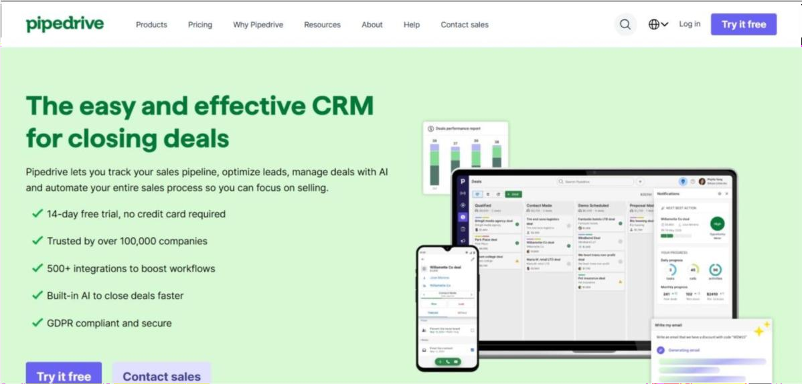
5. Pipedrive
Figure 2.5: Pipedrive Homepage
Pipedrive is a Customer Relationship Management (CRM) system developed by Pipedrive Inc. that is designed to help businesses manage customer relationships and monitor sales activities. The platform is widely used by sales teams and service–oriented organizations that need to track leads, manage client interactions, and monitor deal progress.
The system provides features such as visual sales pipelines, contact management, workflow automation, and performance reporting. These features help businesses organize sales activities and improve communication with customers. By monitoring sales stages and customer interactions, the system supports decision–making and sales performance analysis.
However, Pipedrive primarily focuses on customer relationship management and sales pipeline monitoring rather than inventory control. The system does not include product stock monitoring, inventory updates, or automated stock notifications. In comparison, the proposed Inventory and Sales Management System for RJTech Computers integrates inventory monitoring with sales transaction recording. This integration ensures that product stock levels are automatically updated whenever a sale is recorded, allowing the business to maintain accurate inventory records and efficient operational management.

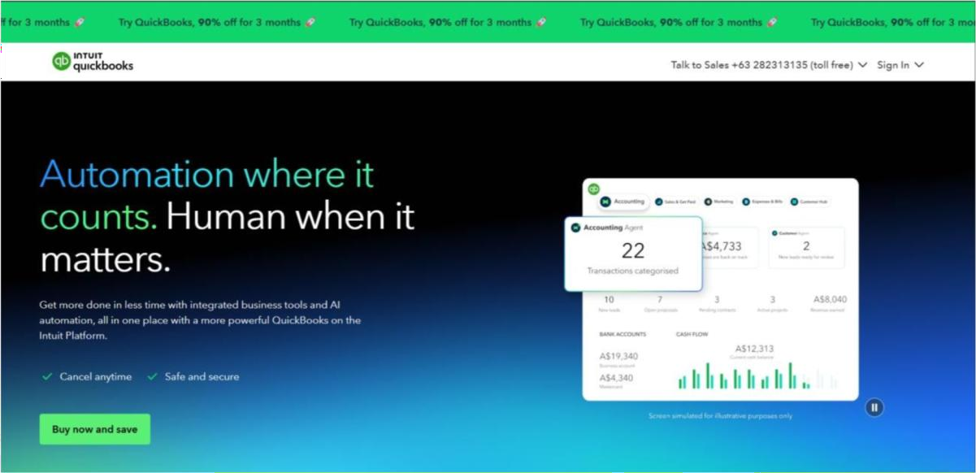
6. QuickBooks
Figure 2.6: QuickBooks Homepage
QuickBooks is an accounting and financial management software developed by Intuit Inc. that is widely used by small and medium-sized businesses to manage financial transactions and generate accounting reports. The system helps businesses monitor financial activities such as invoicing, expense tracking, payroll processing, and financial statement preparation.
The platform provides financial reporting tools that help organizations evaluate profitability, manage expenses, and maintain accurate financial records. These capabilities support businesses in managing financial operations and monitoring overall financial performance.
Although QuickBooks provides strong financial management features, its primary focus is accounting rather than inventory control. Standard versions of the software offer only limited inventory monitoring capabilities and do not include real–time stock alerts or product categorization specifically designed for retail inventory management. In contrast, the proposed Web-Based Inventory and Sales Management System for RJTech Computers focuses on managing product records, monitoring inventory levels, recording sales transactions, and generating operational reports. By concentrating on these operational functions, the proposed system provides a more suitable solution for the inventory and sales management needs of RJTech Computers.

- Matrix of Comparison
This table compares six existing systems with the proposed Inventory and Sales Management System for RJTech Computer, focusing on inventory management, real–time stock monitoring, sales recording, reporting, user access, and usability. While most existing systems cover basic inventory and sales functions, few are tailored for small, single-branch retail settings with simple interfaces, user–friendly operation, and cost efficiency. The proposed system addresses these gaps, integrating all essential features to meet RJTech Computer’s operational needs and support efficient, accurate inventory and sales management.

Table 2.1 Matrix of Comparison
System/  Function | Zoho Inventory |  | ECount ERP |  | Odoo |  | Inflow | Pipedrive | Quickbooks |  | Proposed System
Product Management (Add, Edit, Delete, Categorize  Products) | ✓ |  | ✓ |  | ✓ |  | ✓ |  | ✓ |  | ✓
Inventory management | ✓ | ✓ |  | ✓ |  | ✓ |  |  | ✓ | ✓
Real–time stock monitoring | ✓ | ✓ |  | ✓ |  | ✓ |  |  | ✓ | ✓
Sales transaction recording | ✓ | ✓ |  | ✓ |  | ✓ |  | ✓ | ✓ | ✓
Real–Time Transaction Processing | ✓ | ✓ |  | ✓ |  | ✓ |  |  | ✓ | ✓
Payment Management | ✓ | ✓ |  | ✓ |  | ✓ |  | ✓ | ✓ | ✓
Inventory Notifications (Low–Stock  Alerts) | ✓ | ✓ |  | ✓ |  | ✓ |  |  |  | ✓
Sales and Inventory Reports | ✓ | ✓ |  | ✓ |  | ✓ |  | ✓ | ✓ | ✓
User Authentication  / Access Control | ✓ | ✓ |  | ✓ |  | ✓ |  | ✓ | ✓ | ✓
Centralized Database | ✓ | ✓ |  | ✓ |  | ✓ |  | ✓ | ✓ | ✓
User–Friendly Interface for Shop Staff | ✓ |  |  |  |  | ✓ |  | ✓ | ✓ | ✓
Designed for small computer shop |  |  |  |  |  | ✓ |  |  |  | ✓
Order fulfillment | ✓
Shipping integration | ✓
Integration with e-commerce platforms | ✓
Integration with accounting tools | ✓
Production management |  | ✓
Multi-user collaboration |  | ✓
Manage warehouses |  |  |  | ✓
Automate procurement processes |  |  |  | ✓
Customer relationship management (CRM) |  |  |  | ✓ |  |  |  | ✓
Modular architecture (select and configure different features) |  |  |  | ✓
Barcode support |  |  |  |  |  | ✓
Warehouse monitoring (detailed product movement across storage locations) |  |  |  |  |  | ✓
Offline functionality (work without internet) |  |  |  |  |  | ✓
Visual sales pipeline |  |  |  |  |  |  |  | ✓
Contact management |  |  |  |  |  |  |  | ✓
Workflow automation |  |  |  |  |  |  |  | ✓
Performance reporting (sales stages) |  |  |  |  |  |  |  | ✓
Financial reporting tools |  |  |  |  |  |  |  |  | ✓

Chapter 3
METHODOLOGY

- Research Environment
The study will be conducted at RjTech Computers, located at Shintomo Bldg., San Isidro Road, Sangi, Tabunoc, Talisay City, Cebu. This establishment offers a variety of services, including computer repair, maintenance, and other IT-related solutions, this creates an appropriate context for the research. The researchers will observe and analyze the current operational processes within the establishment, focusing on managing products, customer requests, and transactions. Data collection methods will encompass direct interviews with the owner and a review of records utilized in the daily operations. The insights obtained from this will facilitate the identification of existing challenges and will form the foundation for the development of a proposed system aimed at enhancing operational efficiency and service management.

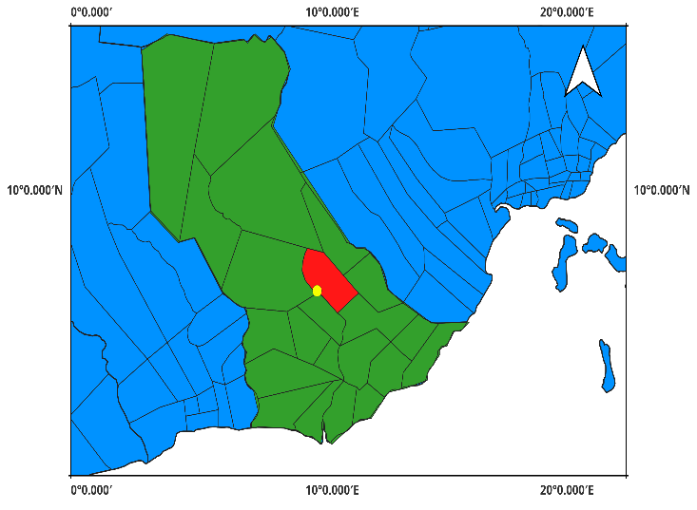
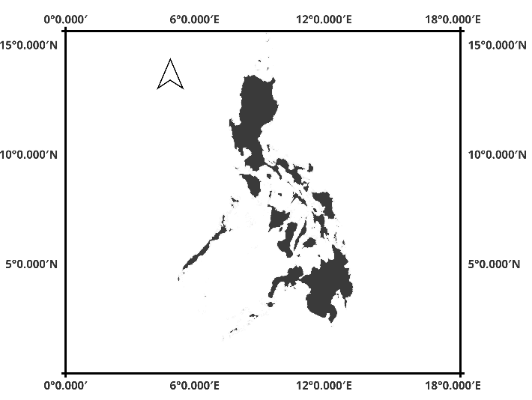
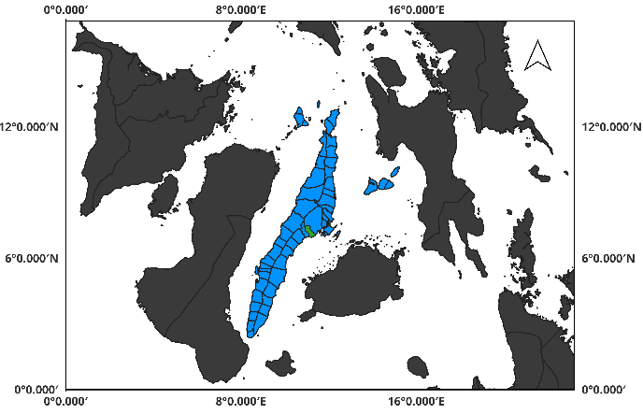
Philippines
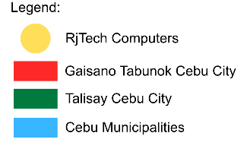

Visayas

Figure 3.1: Research Locale

- Methods and Techniques
The researchers will employ several methods and techniques to gather the necessary information and support the development of the proposed system.
Developmental Method – The study will use the Developmental Research Method because the primary objective of the research is to design and develop a computerized Inventory and Sales Management System for RJTech Computers. The developmental approach focuses on creating and improving a system that addresses a specific operational problem within an organization. Through this method, the researchers analyze the current processes used by the business and develop a system that enhances efficiency, accuracy, and data organization.
Qualitative Method – The Qualitative Method will be used to collect descriptive
information about the current sales and inventory management processes of the establishment. This method allows the researchers to gather detailed insights regarding the workflow, challenges, and operational practices of the business. The information obtained from this method will help identify the problems encountered in the existing system and determine the necessary features for the proposed system.
Interview Technique – The researchers will conduct interviews with the owner and staff of RJTech Computers to gather information regarding their current procedures for managing products, recording sales transactions, and monitoring inventory levels. This technique will help the researchers understand the operational challenges faced by the business and identify the system requirements needed for the development of the proposed system.
User Acceptance Testing – User Acceptance Testing (UAT) will be conducted to evaluate whether the developed system meets the operational requirements of the users. Selected users will test the system by performing tasks such as recording sales transactions, managing product information, and monitoring inventory levels. Feedback gathered during this testing phase will be used to identify possible errors or improvements before the final implementation of the system.
- Models
This section presents the system models used in analyzing and designing the proposed Inventory and Sales Management System. These models illustrate the structure of the system, the interactions between users and the system, and the organization of system data.
SDLC Model – The SDLC Model is included to provide a structured process for developing the proposed system. It outlines the key phases such as planning, design, implementation, and testing, ensuring that the system is developed in an organized manner and meets the required user needs.
Use Case Model – The Use Case Model illustrates how users interact with the system and identifies the functions that the system provides. It describes the different roles involved in the system, such as the shop owner and authorized staff, and the actions they can perform. The use case model helps define the functional requirements of the system and clarifies the interaction between the users and the system.
Entity Relationship Model (ER Model) – The Entity Relationship Model (ER Model) describes the structure of the system database by identifying the main data entities and the relationships between them. In the proposed system, the database includes entities such as products, sales transactions, inventory records, users, and payment records. The ER model helps organize the data in a logical structure to ensure that information can be stored, retrieved, and managed efficiently.

- Tools
This section presents the software and technologies used in developing the proposed system. Each tool was selected based on its ability to support different aspects of system development such as programming, database management, interface design, testing, and version control.
Microsoft SQL Server – Microsoft SQL Server will be used as the database management system for storing and managing the system's data. It will handle product records, sales transactions, inventory information, and user data. The database system provides a secure and organized environment for storing and retrieving system information.
Visual Studio 2022 – Visual Studio 2022 will serve as the primary integrated development environment (IDE) for building the system. It provides tools for coding, debugging, testing, and managing the overall development process.
ASP.NET MVC – ASP.NET MVC will be used as the framework for developing the web-based system. The framework organizes the application into three components: Model, View, and Controller. This architecture helps maintain a structured application design and simplifies system maintenance.
C# Programming Language – The C# programming language will be used for developing the backend logic of the system. It handles the system processes such as data processing, transaction management, and communication between the application and the database.
HTML, CSS, and JavaScript – HTML, CSS, and JavaScript will be used for developing the front-end interface of the system. HTML structures the web pages, CSS manages the visual layout and styling, and JavaScript provides interactive functions that improve the user experience.
Git and GitHub – Git and GitHub will be used for version control and project management. These tools allow the researchers to track code changes, manage different versions of the system, and maintain backup copies of the development progress.
Google Chrome – Google Chrome will be used as the primary web browser for testing and running the system during development. It helps verify that the system functions properly when accessed through a web browser.
Figma – Figma will be used to design the prototype and layout of the system interface before the actual development begins. The prototype helps visualize the structure and navigation of the system.

- Development Process
The development of the proposed system will follow the Rapid Application Development (RAD) Model, which focuses on faster development through continuous user feedback and iterative improvements. The RAD model allows the researchers to quickly develop system components while incorporating user feedback throughout the development process.
- Requirements Planning Phase – During this phase, the researchers identify and analyze the system requirements needed for the proposed system (January Week 1 – Week 3). Information will be gathered through interviews with the owner and staff of RJTech Computers and through observation of the current operational processes. The researchers will determine the necessary system features required for managing inventory and sales transactions.
- User Design Phase – In this phase, the overall design of the system will be developed (April Week 2 – June Week 1). The researchers will design the database structure, system architecture, and user interface layout. The system design will focus on providing a simple and efficient interface that allows users to manage products, record sales transactions, and monitor inventory levels easily.
- Construction Phase – The construction phase involves the actual development of the system (June Week 2 – August Week 3). Using the selected tools and technologies, the researchers will implement the system functionalities based on the system design and gathered requirements. During this phase, the system modules will be programmed, tested, and integrated.
- Cutover Phase – The final phase involves system testing, evaluation, and deployment (September Week 1 – Week 2). The researchers will verify whether all system functions are operating correctly, including sales recording, inventory updates, and report generation. User Acceptance Testing will also be conducted to ensure that the system meets the operational needs of RJTech Computers before final implementation.
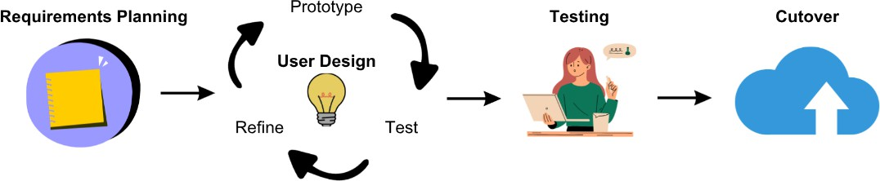
Diagram 3.1: Development Process of Sales and Inventory System

- Requirements Analysis
- Functional Requirements
Functional requirements define the specific operations and core features that the system must perform to meet user needs and support business processes.
- The system shall allow authorized users to log in and log out securely using their assigned credentials.
- The system shall allow authorized users to manage product records, including adding, editing, updating, and deleting product information such as product name, category, supplier, price, and stock quantity.
- The system shall automatically update inventory levels whenever products are sold or new stock is added.
- The system shall allow users to record sales transactions, including the products purchased, quantity, and total transaction amount.
- The system shall allow users to record payment information for each transaction to maintain organized financial records.
- The system shall allow users to monitor inventory levels in real time.
- The system shall provide automated alerts when product stock levels reach a predefined minimum quantity.
- The system shall generate sales and inventory reports, including daily, weekly, and monthly reports.
- The system shall store all system records in a centralized database for efficient data management and retrieval.

- Non-Functional Requirements
Non-functional requirements describe the quality attributes and performance standards that the system must achieve to ensure reliability, security, and efficiency.
- The system shall provide fast response time when processing sales transactions, updating inventory records, and retrieving system information.
- The system shall ensure data security by implementing user authentication and restricting access to authorized users only.
- The system shall maintain data accuracy and consistency by validating user inputs and automatically updating inventory records after each transaction.
- The system shall operate reliably during normal business hours without frequent interruptions or system failures.
- The system shall provide data backup and recovery mechanisms to protect system records from accidental loss or system failure.
- The system shall be accessible through modern web browsers without requiring additional software installation.
- The system shall be capable of handling an increasing number of product records and transaction data as the business grows.

- Usability Requirements
Usability requirements specify the ease of use and user experience considerations that enable users to effectively and efficiently interact with the system.
- The system shall provide a simple and organized user interface that allows users to easily navigate system functions.
- The system shall display clear menus and labels to help users understand the available features of the system.
- The system shall allow users to complete common tasks such as recording sales transactions and updating product information with minimal steps.
- The system shall provide clear system messages or notifications to inform users of successful transactions or input errors.
- The system shall maintain consistent layout and design across all system pages to improve user familiarity and ease of use.
- The system shall provide data backup and recovery mechanisms to protect system records from accidental loss or system failure.
- The system shall be accessible through modern web browsers without requiring additional software installation.
- The system shall be capable of handling an increasing number of product records and transaction data as the business grows.

REFERENCES

- Zoho Corporation, “Zoho Inventory,” 2024. [Online]. Available: https://www.zoho.com/inventory. [Accessed: Feb. 22, 2026].
- ECount Inc., “ECount ERP System,” 2024. [Online]. Available: https://www.ecount.com. [Accessed: Feb. 22, 2026].
- Odoo S.A., “Odoo ERP,” 2024. [Online]. Available: https://www.odoo.com. [Accessed: Feb. 22, 2026].
- Archon Systems Inc., “inFlow Inventory,” 2024. [Online]. Available: https://www.inflowinventory.com. [Accessed: Feb. 22, 2026].
- Pipedrive Inc., “Pipedrive CRM,” 2024. [Online]. Available: https://www.pipedrive.com. [Accessed: Feb. 22, 2026].
- Intuit Inc., “QuickBooks,” 2024. [Online]. Available: https://quickbooks.intuit.com. [Accessed: Feb. 22, 2026].

APPENDICES


Appendix A. Transmittal Letter
Figure A.1: Transmittal Letter

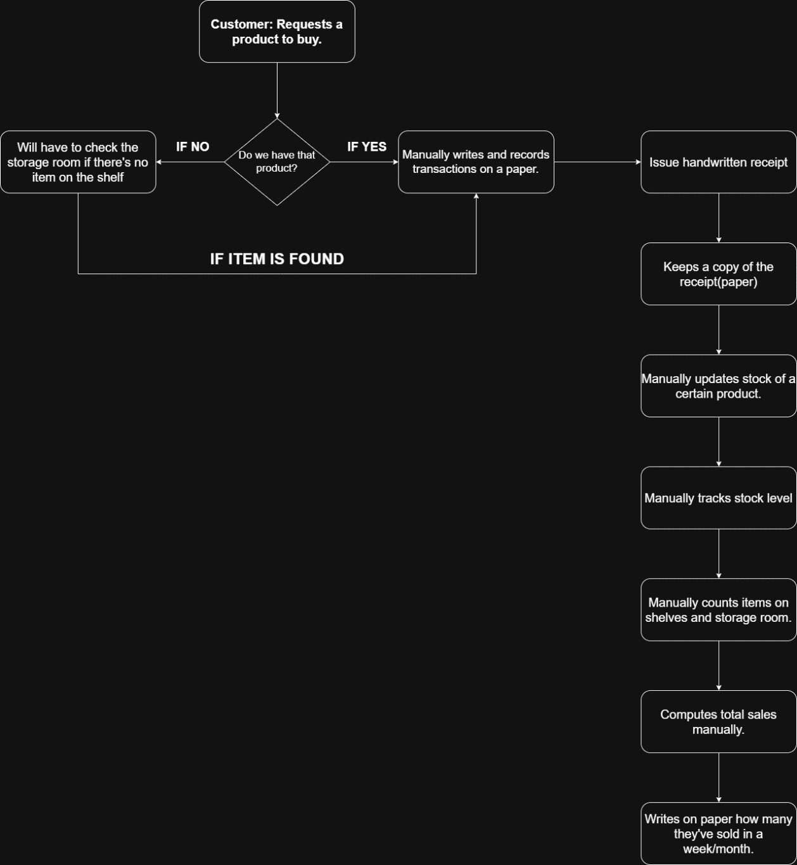
Appendix B. Current Flow of the System
Figure B.1: Current Flow of the System

RJTech Computers currently follows a fully manual process in handling sales and inventory transactions. When a customer asks a product, store personnel must first verify whether the item is available in stock before proceeding with the transaction. If the product is on the shelf, the staff brings the item to the counter and manually writes down the transaction details on paper. Inventory levels are monitored through manual stock checks, which are prone to inaccurate counts, misplaced records, and slow retrieval of information. Since everything is done by hand, mistakes are bound to happen records get lost, stock counts become unreliable, and keeping up with daily transactions quickly becomes a challenge.


Appendix C. Questionnaires
Figure C.1: Questionnaire for Products
Figure C.2: Questionnaire for Inventory Flow


Figure C.3: Questionnaire for Procedure

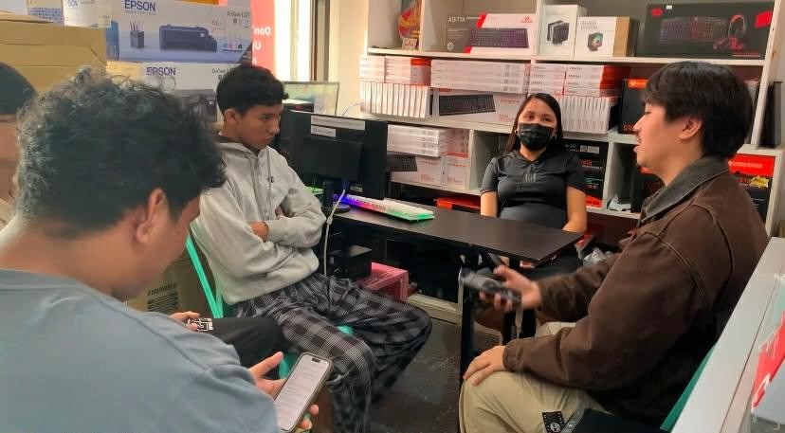
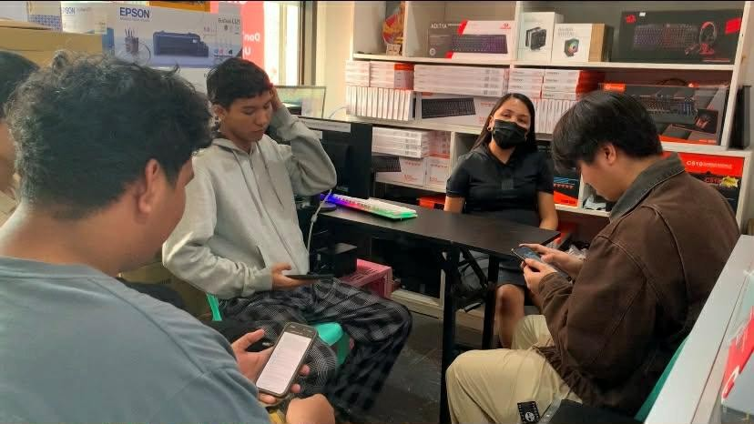
Appendix D. Evidences
Figure D.1: Evidences

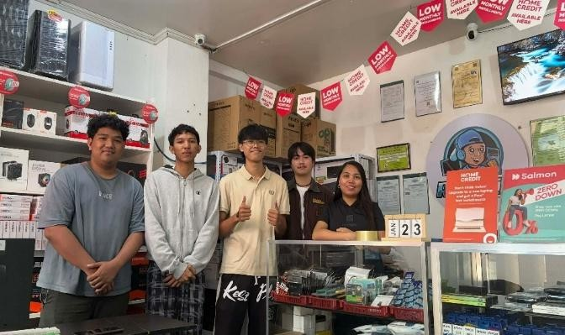
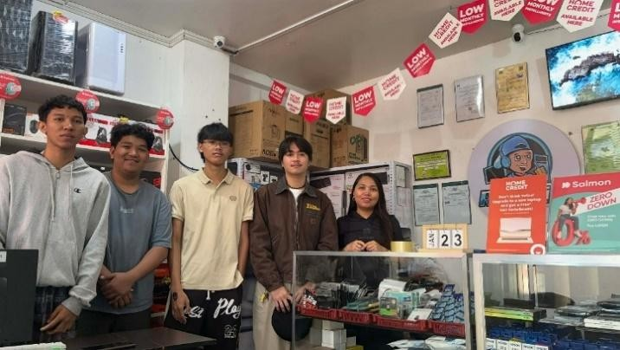
Figure D.2: Evidences

