WEB-BASED SALES AND INVENTORY MANAGEMENT
SYSTEM FOR RJTECH COMPUTERS

A thesis Presented to
College of Computer Studies
Asian College of Technology
Cebu, Philippines

In Partial Fulfillment
of the Requirement for the degree of

Bachelor of Science in Information Technology

by

GLENN C. CUADERO
CHRISTIAN M. RIVERA
MARK STEVEN CORTES
IGGIE BOY B. CORDOVA

October 2026

EVALUATION OF THESIS PROPOSAL DEFENSE
(Thesis Advisory Committee)

Date:

Thesis Title:
A Web-Based Sales & Inventory Management System for RJTech computers
______________________________________________________________________
________________________________________________________________________
_________________________________________________________________________________
Evaluation:

PASSED RE-DEFENSE / CHANGE TOPIC

FAILED

CONDITIONAL

Remarks:
________________________________________________________________________
________________________________________________________________________
________________________________________________________________________
_________

Evaluated by the Oral Examination Panel (Thesis Advisory Committee):
JAY MAR C. VILVESTRE, MIT
Chairman
JUSHUA A. CHO  Member |  |  | JONEL FRANZ L. VERO  Member
LEIF JAY B. DE SAGUN, PhD
Adviser

Approved by:

LEIF JAY B. DE SAGUN, PhD
College Dean
APPROVAL SHEET

This research entitled: WEB-BASED SALES AND INVENTORY MANAGEMENT SYSTEM FOR RJTECH COMPUTERS, prepared and submitted by Glenn C. Cuadero, Christian M. Rivera, Mark Steven Cortes, Iggie Boy B. Cordova in partial fulfillment of the subject CAPSTONE 2, have been examined and recommended for Oral Hearing.

THESIS ADVISORY COMMITTEE
JAY MAR C. VILVESTRE, MIT
Chairman
JOSHUA A. CHO  Member |  |  | JONEL FRANZ L. VERO  Member
LEIF JAY B. DE SAGUN, PhD
Adviser

Approved by the Committee on Oral Examination with a grade of ________________.

PANEL OF EXAMINERS
JAY MAR C. VILVESTRE, MIT
Chairman
JOSHUA A. CHO  Member |  |  | JONEL FRANZ L. VERO  Member
LEIF JAY B. DE SAGUN, PhD
Adviser

April 6, 2026
Pre-Oral Defense :
September 28, 2026
Final Oral Defense :

Approved by:

LEIF JAY B. DE SAGUN, PhD
College Dean
ABSTRACT

This study aimed to develop and evaluate a web-based Sales and InventoryManagement System that can help make the management of products, customers, sales transactions, deliveries, payments, and reports easier and more organized. The study focused on the need for a centralized system where administrators can access important business information in one place, monitor inventory, process sales, and manage daily activities more efficiently. It also looked at how a web-based system can make inventory and sales processes more convenient and organized.
The study used the Developmental Research Method and Agile Development Model, which allowed the researchers to develop the system step by step and improve its features based on the needs and feedback of the users. Data were gathered through surveys, interviews, observation, and document analysis. These were used to identify the users' needs and determine the features needed in the system. The developed system included user authentication, dashboard monitoring, product and category management, customer information, sales transactions, delivery and product receiving, installment monitoring, and report generation.
The findings showed that the system can provide a more organized way of handling important business activities. It brings sales, inventory, customer, delivery, and transaction information together in one platform, making the information easier to access and monitor. Overall, the study provides a practical web-based solution that can support daily business operations and help reduce the difficulty of managing information manually. It can also serve as a useful reference for similar businesses planning to use a digital management system.

Keywords: Inventory Management, sales management system, web-based system, product management, sales transactions.

ACKNOWLEDGEMENT

First and foremost, we would like to thank our adviser, Dr. Leif Jay B. De Sagun, for his patience, guidance, and constant encouragement throughout this study. His feedback and advice helped us shape and improve our research every step of the way

We are also grateful to our Thesis Advisory Committee Chin Chin N. Fabroa, Enrique T. Manal III, and Jay Mar C. Vilvestre, MIT, for their thoughtful feedback during the early stages of our study. Their suggestions helped us build a stronger foundation for our research.

Our sincere thanks goes to Reymar Dablo, owner of RJTech Computers, for allowing us to conduct our study at his establishment and for accommodating our interview. We're also thankful to the wife of the owner, Judy Ann Dablo, who took the time to answer our questions and share their honest insights about their daily operations.

We would like to thank the College of Computer Studies of Asian College of Technology for giving us the resources and support we needed to complete this study.

Lastly, we want to thank our families and friends for their unwavering support, patience, and encouragement. They kept us going even during the most difficult parts of this journey. To all individuals who helped us in ways big or small, thank you this study wouldn't have been possible without you.

TABLE OF CONTENTS
 | Page
TITLE PAGE | i
APPROVAL SHEET | iii
ABSTRACT | iv
ACKNOWLEDGEMENT | v
TABLE OF CONTENTS | vi
LIST OF FIGURES, CHARTS AND TABLES | viii
CHAPTER
- INTRODUCTION
- Rationale of the Study | 1
- Objectives of the Study | 2
- Significance of the Study | 3
- Scope and Limitations of the System | 4
- Definition of Term | 6
- THEORETICAL BACKGROUND
- Review of Related Literature and Systems | 8
- Matrix of Comparison | 15
- METHODOLOGY
- Research Environment  - Methods and Techniques  - Models  - Tools  - Development Process | 19  20  21  22  24
- Requirements Analysis  - Functional Requirements  - Non-Functional Requirements  - Usability Requirements  - Use Case Model  - Class Model  - Entity-Relationship Model  - Database Schema  - Implementation Strategies  - System User Interface | 25  25  26  27  28  67  71  73  74  77
- Ethical Considerations | 85
- RESULTS AND ANALYSIS | 86
- DISCUSSION OF RESULTS | 93
- SUMMARY, CONCLUSIONS AND RECOMMENDATIONS | 95
REFERENCES | 98
APPENDICES
APPENDIX A: System Specifications | 99
APPENDIX B: Flow of the System | 102
APPENDIX C: Application Prototype | 104
APPENDIX D: Sample Program Code | 112
APPENDIX E: System Usability Scale | 126
APPENDIX F: Plagiarism Result | 128
CURRICULUM VITAE | 129

LIST OF FIGURES, TABLES AND CHARTS
Figure
2.1 | Zoho Inventory Homepage | 8
2.2 | Ecount Homepage | 10
2.3 | Odoo Homepage | 11
2.4 | inflow Inventory Homepage | 12
2.5 | Pipedrive Homepage | 13
2.6 | QuickBooks Homepage | 14
3.1 | Research Locale | 19
3.2 | Development Process of Sales and Inventory System | 25
3.3 | System Use Case for Process Login | 29
3.4 | System Use Case for Manage Dashboard | 34
3.5 | System Use Case for Manage Menu | 45
3.6 | System Use Case for Manage Category | 48
3.7 | System Use Case for Manage Product | 52
3.8 | System Use Case for Generate Report | 59
3.9 | System Use Case for Process Transaction | 64
3.10 | Model Class Model | 68
3.11 | ViewModel Class Model | 69
3.12 | Controller Class Model | 70
3.13 | Entity Relationship Diagram | 72
3.14 | Database Schema | 73
3.15 | User Interface for Login | 77
3.16 | User Interface for Dashboard | 78
3.17 | User Interface for Deliveries | 78
3.18 | User Interface for Receive Products | 79
3.19 | User Interface for Products | 79
3.20 | User Interface for New product | 80
3.21 | User Interface for Category | 80
3.22 | User Interface for Reports | 81
3.23 | User Interface for Sales | 81
3.24 | User Interface for New Checkout | 82
3.25 | User Interface for Customers | 82
3.26 | User Interface for Purchase History | 83
3.27 | User Interface for Instalment | 83
3.28 | User Interface for Notifications | 84
3.29 | User Interface for Account Settings | 84
Table
2.1 | Matrix of Comparison | 16
4.1 | Likert Agreement Scale | 86
5.1 | SUS Score Guidelines | 93
5.2 | Respondent’s Individual SUS Score with Grade and Adjective Rating | 94
5.3 | Overall SUS Score with Grade and Adjective Rating | 94
Chart
4.1 | System Usability Scale for Gender | 87
4.2 | System Usability Scale for Likelihood of Using the Product | 87
4.3 | System Usability Scale for Complexity of the Product | 88
4.4 | System Usability Scale for Ease of Use | 88
4.5 | System Usability Scale for Need for Technical Support | 89
4.6 | System Usability Scale for Integration of Functions | 89
4.7 | System Usability Scale for Consistency of the Product | 90
4.8 | System Usability Scale for Quick Learning Curve | 90
4.9 | System Usability Scale for Awkwardness of Use | 91
4.10 | System Usability Scale for Confidence in Using the Product | 91
4.11 | System Usability Scale for Learning Curve | 92

Chapter I
INTRODUCTION

- Rationale of the Study
Managing sales and inventory is an essential responsibility for computer shops, particularly as the demand for computer components and accessories continues to grow. Businesses that sell computer parts must maintain accurate records of product availability, monitor sales transactions, and ensure that stock levels are properly controlled. Efficient inventory management enables shop owners to track product movement, prevent stock shortages or overstocking, and maintain reliable transaction records. In a competitive business environment, accurate information and organized operations are important factors that contribute to business efficiency, service quality, and long-term sustainability.
Despite the importance of proper inventory management, many small computer shops still rely on manual methods such as handwritten records or spreadsheets to track inventory and sales transactions. Manual record-keeping often requires more time and effort and is prone to human errors such as incorrect stock counts, misplaced records, duplicate entries, and delayed report preparation. In addition, the absence of a centralized and automated system makes it difficult for shop owners to monitor inventory levels in real time and evaluate daily sales performance. These limitations may lead to inefficient decision- making and operational delays that can affect the overall performance of the business.
To address these issues, this study proposes the development of a Web–Based Inventory and Sales Management System for RJTech Computers. The proposed system 2 aims to automate the recording of product information and sales transactions while providing real- time monitoring of inventory levels. The system will also generate sales and inventory reports that can assist the shop owner in analyzing business performance. Additional features such as user access control, stock–level notifications, and organized product categorization will support accurate data management and improve operational efficiency.
The implementation of the proposed system is expected to benefit the owner and staff of RJTech Computers by simplifying the processes involved in inventory control and sales monitoring. By reducing manual work and minimizing errors, the system will help improve data accuracy and streamline daily business operations. Customers may also benefit from faster and more reliable transactions. Furthermore, the proposed system may serve as a practical reference for other small businesses that experience similar challenges in managing sales and inventory records.

- Objectives of the Study
The general objective of this study is to develop a web-based Inventory and Sales Management System for RJTech Computers that automates product tracking and sales recording to improve the accuracy, organization, and efficiency of business operations. Specifically, it aims to:
- develop a product management module that allows authorized users to add, update, categorize, and manage computer parts and accessories;
- implement real–time inventory monitoring that automatically updates stock levels whenever products are sold or restocked;
- automate the recording of sales transactions and payment information to reduce manual workload and minimize recording errors;
- Generate organized sales and inventory reports, including daily, weekly, and monthly reports for business monitoring;
- provide automated stock notifications when inventory levels reach a predefined minimum quantity;
- implement user authentication and access control to ensure data security and controlled system access; and
- design a simple and user–friendly interface that allows employees and managers to efficiently perform daily shop operations.

- Significance of the Study
The development of the Inventory and Sales Management System is expected to provide several benefits to different stakeholders.
RJTech Computers – The proposed system will help improve the management of inventory
and sales transactions by automating record–keeping and monitoring processes. It will allow the business to maintain accurate product records, monitor stock levels in real time, and generate reports that support better decision–making.
Employees and Staff – The system will simplify daily operational tasks such as recording
sales transactions, updating product information, and monitoring stock availability. By reducing manual processes, employees can complete their work more efficiently and with fewer errors.
Customer – Customers may benefit from faster and more accurate transaction processing.
With organized product records and real–time inventory monitoring, the shop can provide more reliable service and improved customer experience.
Researchers – this study may serve as a useful reference for researchers who plan to
conduct studies related to inventory management systems, retail automation, or business information systems.
Future Researchers – Future researchers may use this study as a guide in developing similar
systems or improving existing inventory and sales management solutions for other business environments.

- Scope and Limitations of the System
The proposed Web–Based Sales and Inventory Management System for RJTech
Computers is designed to support the daily sales and inventory operations of the business. The system will include the following functionalities:
Product Management – the system will allow authorized users to add, edit, delete, and
categorize products such as computer components and accessories. Each product record will contain information including product name, category, supplier, price, and stock quantity.
Inventory Management – the system will automatically update inventory levels whenever
products are sold or restocked. Users will be able to monitor inventory levels in real time to ensure accurate stock records.
Sales and Transaction Management – the system will record sales transactions and
automatically compute the total amount of purchased items. This feature helps reduce manual calculations and improves transaction accuracy.
Payment Recording – the system will record payment transactions associated with each
sale to maintain organized financial documentation.
Inventory Notifications – the system will generate automated alerts when product stock
levels reach a predefined minimum quantity, allowing users to restock items in a timely manner.
Sales and Inventory Reports – the system will generate reports summarizing daily, weekly,
and monthly sales and inventory data to support monitoring and decision–making.
Security and Access Control – user authentication and access control will be implemented
to ensure that only authorized users can access and manage system records.
User Interface – the system will be developed as a web-based application with a simple
and user-friendly interface that can be accessed through standard web browsers.

Despite the capabilities of the proposed system, several limitations are identified:
- The system is designed for single–business use only and does not support multi branch inventory management.
- The system requires a stable internet connection to access and update system records in real time.
- The system does not include advanced accounting functions such as tax
computation, payroll processing, or financial statement generation.
- The system will only be accessible through web browsers on desktop or laptop devices and will not include a dedicated mobile application.
- The system focuses primarily on inventory and sales management and does
not support advanced enterprise resource planning features.

DEFINITION OF TERMS

This section defines key terms as they are specifically used within the context of this system and study. Each term is explained in direct relation to the project's objectives, scope, and practical application to ensure readers understand its unique relevance and meaning within the research. The following definitions are presented briefly and clearly, focusing exclusively on how each concept applies to the functional requirements and operational framework of the RJTech Computers Inventory and Sales Management System.
Automation – refers to the capability of the proposed system to automatically
perform tasks such as recording sales transactions, updating inventory levels, and generating reports without relying on manual record–keeping.
Centralized Database – a digital storage system where all product information, inventory
records, and sales transactions of RJTech Computers are stored and managed in a single organized location.
Inventory Management – the process of monitoring, controlling, and updating product
stock levels within the system to maintain accurate inventory records and prevent shortages or overstocking.
Inventory Notification – an automated alert generated by the system when the quantity of
a product reaches a minimum stock level, prompting users to restock items.
Payment Management – the system features responsible for recording and organizing
payment transactions for products purchased by customers.
Product Management – the system process that allows users to add, edit, delete, and
categorize computer parts and accessories while maintaining accurate product information such as name, category, price, supplier, and stock quantity.
Real–Time Monitoring – the ability of the system to instantly update and display current
inventory levels and sales transactions immediately after data is recorded.
Sales Analytics – the system capability that analyzes sales data and presents summarized
information to help the shop owner evaluate product performance and business trends.
Sales Transaction – a recorded process within the system where a product purchase is
completed, including the calculation of total cost and the update of inventory records.
Stock Level – the available quantity of a particular product recorded in the inventory
database.
User–Friendly Interface – a system interface that is designed to be simple, organized, and
easy to navigate, allowing users to perform tasks efficiently with minimal training.

Chapter II
THEORETICAL BACKGROUND

- Review of Related Literature and Systems
A Review of Related Systems involves the systematic examination of existing software applications or platforms that perform functions similar to the proposed system. This process enables a comparative analysis of system design, user interaction, and data management practices. By evaluating the strengths and limitations of these existing systems, developers can identify best practices as well as areas that require improvement. Consequently, the Review of Related Systems serves as a foundational basis for the development of a more efficient and effective solution, allowing the proponents to avoid previously encountered shortcomings while incorporating proven and successful features.

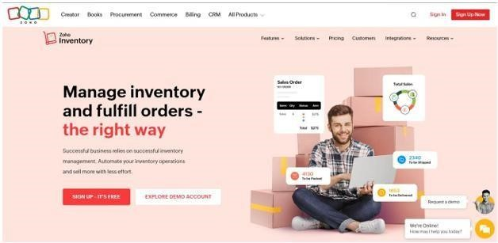
- Zoho Inventory
Figure 2.1: Zoho Inventory Homepage
Zoho Inventory is a cloud-based inventory management system developed by Zoho Corporation that helps businesses track stock levels, manage orders, and monitor warehouse operations. It is commonly used by small to medium-sized businesses engaged in retail, wholesale, and e-commerce activities. The system allows organizations to maintain accurate product records and manage inventory operations through a centralized online platform.
The system provides features such as real-time inventory tracking, order fulfillment, shipping integration, and automated reporting. It also integrates with ecommerce platforms and accounting tools, enabling businesses to coordinate inventory management across different sales channels. These capabilities help companies maintain organized inventory records and improve operational efficiency.
Despite its advanced features, Zoho Inventory includes several functions that are designed for larger organizations or online businesses with multiple sales channels. The system also requires subscription payments, which may not be practical for smaller single- location shops. In comparison, the proposed Web-Based Inventory and Sales Management System for RJTech Computers focuses only on the essential functions required for daily computer shop operations, including product management, real–time inventory monitoring, automated sales recording, and stock notifications. This simplified design provides a more practical and affordable solution for managing the business operations of RJTech Computers.

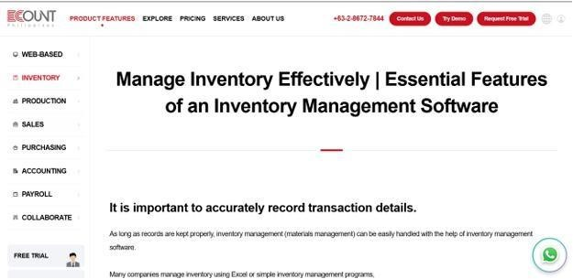
- ECount
Figure 2.2: Ecount Homepage
ECount is a cloud–based Enterprise Resource Planning (ERP) system developed by ECount Inc. that integrates various business functions such as inventory management, accounting, purchasing, and production monitoring into a single platform. The system is commonly used by manufacturing and trading companies that require comprehensive management of multiple business processes.
The platform provides features including real-time inventory tracking, financial reporting, production management, and multi-user collaboration. By integrating different operational modules, ECount allows businesses to monitor inventory, track financial transactions, and coordinate operations across multiple departments. This integration helps organizations improve overall business management and operational control.
Although ECount offers comprehensive enterprise management features, its interface and workflow structure can be complex for smaller businesses. Many of its modules, such as production management and accounting integration, are designed for larger organizations with multiple operational departments. In contrast, the proposed Inventory and Sales Management System for RJTech Computers focuses specifically on the needs of a single computer shop by providing essential functions such as product organization, real-time inventory monitoring, sales transaction recording, and automated stock notifications. This focused approach simplifies system usage while maintaining effective inventory and sales management.
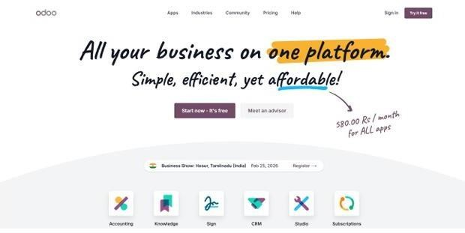
- Odoo

Figure 2.3: Odoo Homepage
Odoo is an open-source enterprise management platform developed by Odoo S.A. that provides modular applications for inventory management, sales operations, accounting, manufacturing, and customer relationship management. The system is designed to support organizations that require customizable and integrated business software.
The inventory module of Odoo allows businesses to monitor stock levels, manage warehouses, and automate procurement processes. Additional modules support sales management, financial reporting, and customer relationship management. Because of its modular architecture, organizations can select and configure different features according to their operational requirements.
While Odoo provides flexible and customizable business management tools, implementing and configuring the system often requires technical expertise and additional customization. The setup process may also require more time and resources for system deployment. In comparison, the proposed system for RJTech Computers emphasizes simplicity and ease of use by providing only the essential functions required for computer shop operations. The system focuses on real–time inventory monitoring, sales recording, report generation, and stock alerts through a straightforward web–based interface that supports efficient daily operations.
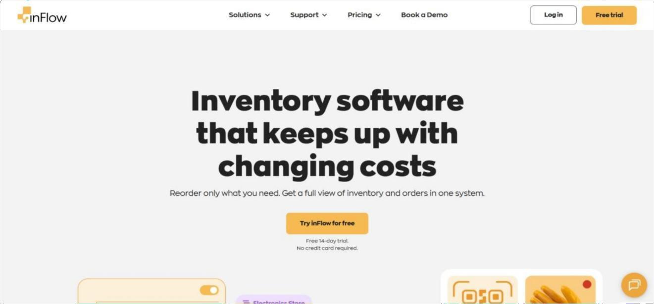
- inFlow Inventory

Figure 2.4: inFlow Inventory Homepage
inFlow Inventory is an inventory and order management software developed by
Archon Systems Inc. that is available on desktop, web, and mobile platforms. The system is designed primarily for small and medium–sized businesses that require reliable stock monitoring and product management.
The software includes features such as barcode support, purchase and sales tracking, warehouse monitoring, and inventory reporting tools. These features allow businesses to maintain accurate inventory records and monitor product movement across different storage locations. The system also provides offline functionality, allowing users to continue managing inventory even without constant internet connectivity.
Although inFlow Inventory provides strong inventory control capabilities, its primary focus is on stock monitoring and order management. Some operational functions required in a retail computer shop environment, such as integrated sales monitoring and shop-specific reporting, may be limited. In contrast, the proposed system for RJTech Computers integrates inventory management with sales transaction recording, payment monitoring, and real–time reporting. This integration allows the shop owner to monitor both product stock and sales performance within a single system.
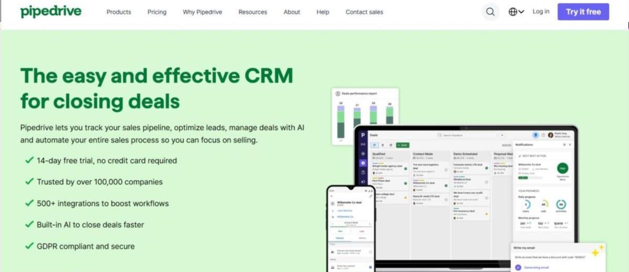
- Pipedrive

Figure 2.5: Pipedrive Homepage
Pipedrive is a Customer Relationship Management (CRM) system developed by Pipedrive Inc. that is designed to help businesses manage customer relationships and monitor sales activities. The platform is widely used by sales teams and service–oriented organizations that need to track leads, manage client interactions, and monitor deal progress.
The system provides features such as visual sales pipelines, contact management, workflow automation, and performance reporting. These features help businesses organize sales activities and improve communication with customers. By monitoring sales stages and customer interactions, the system supports decision–making and sales performance analysis.
However, Pipedrive primarily focuses on customer relationship management and sales pipeline monitoring rather than inventory control. The system does not include product stock monitoring, inventory updates, or automated stock notifications. In comparison, the proposed Inventory and Sales Management System for RJTech Computers integrates inventory monitoring with sales transaction recording. This integration ensures that product stock levels are automatically updated whenever a sale is recorded, allowing the business to maintain accurate inventory records and efficient operational management.
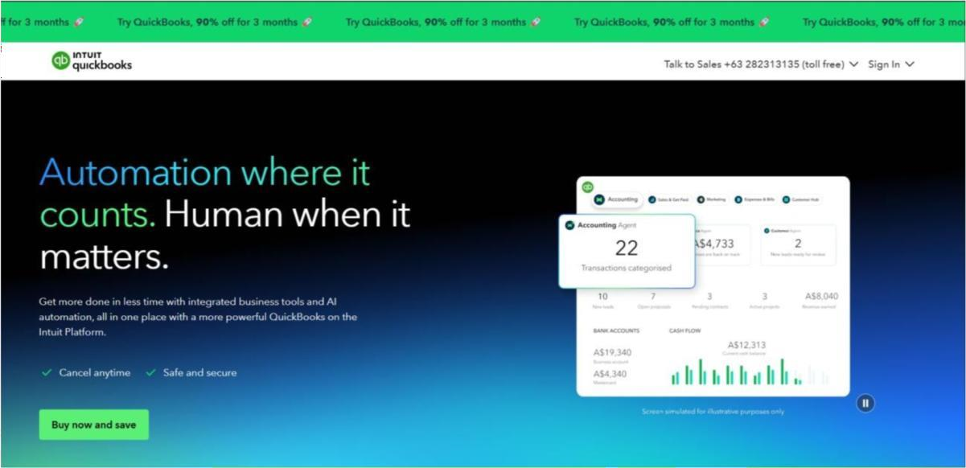
- QuickBooks

Figure 2.6: QuickBooks Homepage

QuickBooks is an accounting and financial management software developed by Intuit Inc. that is widely used by small and medium-sized businesses to manage financial transactions and generate accounting reports. The system helps businesses monitor financial activities such as invoicing, expense tracking, payroll processing, and financial statement preparation.
The platform provides financial reporting tools that help organizations evaluate profitability, manage expenses, and maintain accurate financial records. These capabilities support businesses in managing financial operations and monitoring overall financial performance.
Although QuickBooks provides strong financial management features, its primary focus is accounting rather than inventory control. Standard versions of the software offer only limited inventory monitoring capabilities and do not include real–time stock alerts or product categorization specifically designed for retail inventory management. In contrast, the proposed Web-Based Inventory and Sales Management System for RJTech Computers focuses on managing product records, monitoring inventory levels, recording sales transactions, and generating operational reports. By concentrating on these operational functions, the proposed system provides a more suitable solution for the inventory and sales management needs of RJTech Computers.

- Matrix of Comparison
This table compares six existing systems with the proposed Inventory and Sales Management System for RJTech Computer, focusing on inventory management, real–time stock monitoring, sales recording, reporting, user access, and usability. While most existing systems cover basic inventory and sales functions, few are tailored for small, single-branch retail settings with simple interfaces, user–friendly operation, and cost efficiency. The proposed system addresses these gaps, integrating all essential features to meet RJTech Computer’s operational needs and support efficient, accurate inventory and sales management.

Table 2.1 Matrix of Comparison
System/  Function | Zoho Inventory |  | ECount ERP |  | Odoo |  | Inflow | Pipedrive | Quickbooks |  | Proposed System
Product Management (Add, Edit, Delete, Categorize  Products) | ✓ |  | ✓ |  | ✓ |  | ✓ |  | ✓ |  | ✓
Inventory management | ✓ | ✓ |  | ✓ |  | ✓ |  |  | ✓ | ✓
Real–time stock monitoring | ✓ | ✓ |  | ✓ |  | ✓ |  |  | ✓ | ✓
Sales transaction recording | ✓ | ✓ |  | ✓ |  | ✓ |  | ✓ | ✓ | ✓
Real–Time Transaction Processing | ✓ | ✓ |  | ✓ |  | ✓ |  |  | ✓ | ✓
Payment Management | ✓ | ✓ |  | ✓ |  | ✓ |  | ✓ | ✓ | ✓
Inventory Notifications (Low–Stock  Alerts) | ✓ | ✓ |  | ✓ |  | ✓ |  |  |  | ✓
Sales and Inventory Reports | ✓ | ✓ |  | ✓ |  | ✓ |  | ✓ | ✓ | ✓
User Authentication  / Access Control | ✓ | ✓ |  | ✓ |  | ✓ |  | ✓ | ✓ | ✓
Centralized Database | ✓ | ✓ |  | ✓ |  | ✓ |  | ✓ | ✓ | ✓
User–Friendly Interface for Shop Staff | ✓ |  |  |  |  | ✓ |  | ✓ | ✓ | ✓
Designed for small computer shop |  |  |  |  |  | ✓ |  |  |  | ✓
Order fulfillment | ✓
Shipping integration | ✓
Integration with e-commerce platforms | ✓
Integration with accounting tools | ✓
Production management |  | ✓
Multi-user collaboration |  | ✓
Manage warehouses |  |  |  | ✓
Automate procurement processes |  |  |  | ✓
Customer relationship management (CRM) |  |  |  | ✓ |  |  |  | ✓
Modular architecture (select and configure different features) |  |  |  | ✓
Barcode support |  |  |  |  |  | ✓
Warehouse monitoring (detailed product movement across storage locations) |  |  |  |  |  | ✓
Offline functionality (work without internet) |  |  |  |  |  | ✓
Visual sales pipeline |  |  |  |  |  |  |  | ✓
Contact management |  |  |  |  |  |  |  | ✓
Workflow automation |  |  |  |  |  |  |  | ✓
Performance reporting (sales stages) |  |  |  |  |  |  |  | ✓
Financial reporting tools |  |  |  |  |  |  |  |  | ✓

Chapter III
METHODOLOGY

- Research Environment
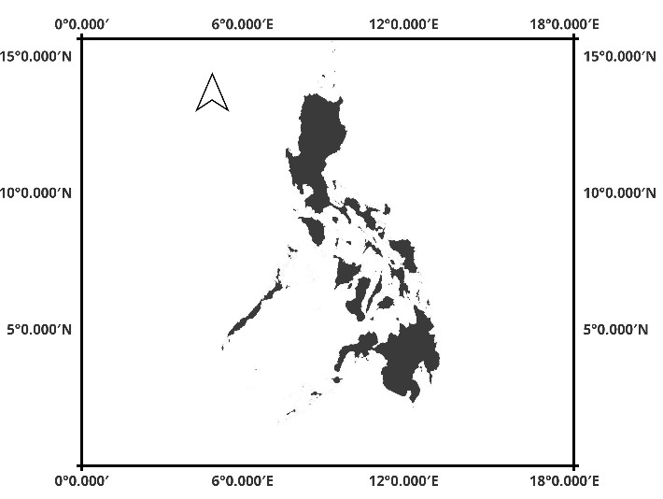
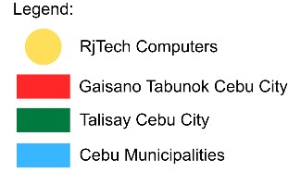
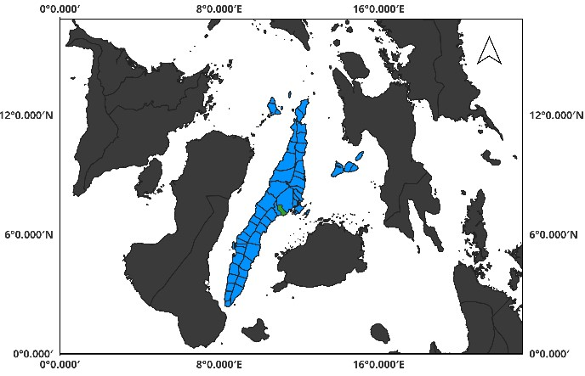
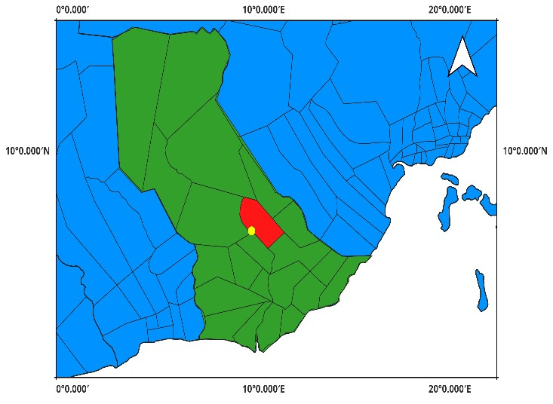
The study will be conducted at RjTech Computers, located at Shintomo Bldg., San Isidro Road, Sangi, Tabunoc, Talisay City, Cebu. This establishment offers a variety of services, including computer repair, maintenance, and other IT-related solutions, this creates an appropriate context for the research. The researchers will observe and analyze the current operational processes within the establishment, focusing on managing products, customer requests, and transactions. Data collection methods will encompass direct interviews with the owner and a review of records utilized in the daily operations. The insights obtained from this will facilitate the identification of existing challenges and will form the foundation for the development of a proposed system aimed at enhancing operational efficiency and service management.

Philippines

Visayas

Figure 3.1: Research Locale
- Methods and Techniques
The researchers will employ several methods and techniques to gather the necessary information and support the development of the proposed system.
Development Method – The study will use the Development Research Method
because the primary objective of the research is to design and develop a computerized Sales and Inventory Management System for RJTech Computers. The Development approach focuses on creating and improving a system that addresses a specific operational problem within an organization. Through this method, the researchers analyze the current processes used by the business and develop a system that enhance efficiency, accuracy, and data organization.
Qualitative Method – The Qualitative Method will be used to collect descriptive
information about the current sales and inventory management processes of the establishment. This method allows the researchers to gather detailed insights regarding the workflow, challenges, and operational practices of the business. The information obtained from this method will help identify the problems encountered in the existing system and determine the necessary features for the proposed system.
Interview Technique – The researchers will conduct interviews with the owner and
staff of RJTech Computers to gather information regarding their current procedures for managing products, recording sales transactions, and monitoring inventory levels. This technique will help the researchers understand the operational challenges faced by the business and identify the system requirements needed for the development of the proposed system.
User Acceptance Testing – User Acceptance Testing (UAT) will be conducted to
evaluate whether the developed system meets the operational requirements of the users. Selected users will test the system by performing tasks such as recording sales transactions, managing product information, and monitoring inventory levels. Feedback gathered during this testing phase will be used to identify possible errors or improvements before the final implementation of the system.
- Models
This section presents the system models used in analyzing and designing the proposed Inventory and Sales Management System. These models illustrate the structure of the system, the interactions between users and the system, and the organization of system data.
SDLC Model – The SDLC Model is included to provide a structured process for
developing the proposed system. It outlines the key phases such as planning, design, implementation, and testing, ensuring that the system is developed in an organized manner and meets the required user needs.
Use Case Model – The Use Case Model illustrates how users interact with the
system and identifies the functions that the system provides. It describes the different roles involved in the system, such as the shop owner and authorized staff, and the actions they can perform. The use case model helps define the functional requirements of the system and clarifies the interaction between the users and the system.
Entity Relationship Model (ER Model) – The Entity Relationship Model (ER
Model) describes the structure of the system database by identifying the main data entities and the relationships between them. In the proposed system, the database includes entities such as products, sales transactions, inventory records, users, and payment records. The ER model helps organize the data in a logical structure to ensure that information can be stored, retrieved, and managed efficiently.
- Tools
This section presents the software and technologies used in developing the proposed system. Each tool was selected based on its ability to support different aspects of system development such as programming, database management, interface design, testing, and version control.
Microsoft SQL Server – Microsoft SQL Server will be used as the database
management system for storing and managing the system's data. It will handle product records, sales transactions, inventory information, and user data. The database system provides a secure and organized environment for storing and retrieving system information.
Visual Studio 2022 – Visual Studio 2022 will serve as the primary integrated
development environment (IDE) for building the system. It provides tools for coding, debugging, testing, and managing the overall development process.
ASP.NET MVC – ASP.NET MVC will be used as the framework for developing
the web-based system. The framework organizes the application into three components: Model, View, and Controller. This architecture helps maintain a structured application design and simplifies system maintenance.
C# Programming Language – The C# programming language will be used for
developing the backend logic of the system. It handles the system processes such as data processing, transaction management, and communication between the application and the database.
HTML, CSS, and JavaScript – HTML, CSS, and JavaScript will be used for
developing the front-end interface of the system. HTML structures the web pages, CSS manages the visual layout and styling, and JavaScript provides interactive functions that improve the user experience.
Git and GitHub – Git and GitHub will be used for version control and project
management. These tools allow the researchers to track code changes, manage different versions of the system, and maintain backup copies of the development progress.
Google Chrome – Google Chrome will be used as the primary web browser for
testing and running the system during development. It helps verify that the system functions properly when accessed through a web browser.
Figma – Figma will be used to design the prototype and layout of the system
interface before the actual development begins. The prototype helps visualize the structure and navigation of the system.

- Development Process
The development of the proposed system will follow the Rapid Application Development (RAD) Model, which focuses on faster development through continuous user feedback and iterative improvements. The RAD model allows the researchers to quickly develop system components while incorporating user feedback throughout the development process.
- Requirements Planning Phase – During this phase, the researchers identify and analyze the system requirements needed for the proposed system (January Week 1 – Week 3). Information will be gathered through interviews with the owner and staff of RJTech Computers and through observation of the current operational processes. The researchers will determine the necessary system features required for managing inventory and sales transactions.
- User Design Phase – In this phase, the overall design of the system will be developed (April Week 2 – June Week 1). The researchers will design the database structure, system architecture, and user interface layout. The system design will focus on providing a simple and efficient interface that allows users to manage products, record sales transactions, and monitor inventory levels easily.
- Construction Phase – The construction phase involves the actual development of the system (June Week 2 – August Week 3). Using the selected tools and technologies, the researchers will implement the system functionalities based on the system design and gathered requirements. During this phase, the system modules will be programmed, tested, and integrated.
- Cutover Phase – The final phase involves system testing, evaluation, and deployment (September Week 1 – Week 2). The researchers will verify whether all system functions are operating correctly, including sales recording, inventory updates, and report generation. User Acceptance Testing will also be conducted to ensure that the system meets the operational needs of RJTech
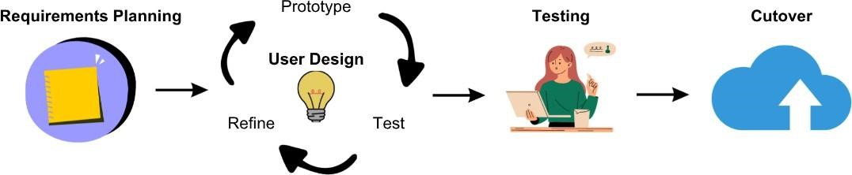
Computers before final implementation.

Figure 3.2: Development Process of Sales and Inventory System

- Requirements Analysis
- Functional Requirements
Functional requirements define the specific operations and core features that the system must perform to meet user needs and support business processes.
    - The system shall allow authorized users to log in and log out securely using their assigned credentials.
    - The system shall allow authorized users to manage product records, including adding, editing, updating, and deleting product information such as product name, category, supplier, price, and stock quantity.
    - The system shall automatically update inventory levels whenever products are sold or new stock is added.
    - The system shall allow users to record sales transactions, including the products purchased, quantity, and total transaction amount.
    - The system shall allow users to record payment information for each transaction to maintain organized financial records.
    - The system shall allow users to monitor inventory levels in real time.
    - The system shall provide automated alerts when product stock levels reach a predefined minimum quantity.
    - The system shall generate sales and inventory reports, including daily, weekly, and monthly reports.
    - The system shall store all system records in a centralized database for efficient data management and retrieval.

- Non-Functional Requirements
Non-functional requirements describe the quality attributes and performance standards that the system must achieve to ensure reliability, security, and efficiency.
    - The system shall provide fast response time when processing sales transactions, updating inventory records, and retrieving system information.
    - The system shall ensure data security by implementing user authentication and restricting access to authorized users only.
    - The system shall maintain data accuracy and consistency by validating user inputs and automatically updating inventory records after each transaction.
    - The system shall operate reliably during normal business hours without frequent interruptions or system failures.
    - The system shall provide data backup and recovery mechanisms to protect system records from accidental loss or system failure.
    - The system shall be accessible through modern web browsers without requiring additional software installation.
    - The system shall be capable of handling an increasing number of product records and transaction data as the business grows.

- Usability Requirements
Usability requirements specify the ease of use and user experience considerations that enable users to effectively and efficiently interact with the system.
  - The system shall provide a simple and organized user interface that allows users to easily navigate system functions.
  - The system shall display clear menus and labels to help users understand the available features of the system.
  - The system shall allow users to complete common tasks such as recording sales transactions and updating product information with minimal steps.
  - The system shall provide clear system messages or notifications to inform users of successful transactions or input errors.
  - The system shall maintain consistent layout and design across all system pages to improve user familiarity and ease of use.
  - The system shall provide data backup and recovery mechanisms to protect system records from accidental loss or system failure.
  - The system shall be accessible through modern web browsers without requiring additional software installation.
  - The system shall be capable of handling an increasing number of product records and transaction data as the business grows.

- Use Case Model
This section presents the use case model of the proposed system, which illustrates the interactions between the system users and its different functionalities. It identifies the main actors involved and describes how they perform specific processes such as managing reservations, guest information, check-in and checkout, payments, and room availability. The use case model provides a clear representation of the system’s expected behavior and the processes that support the hotel’s daily operations.
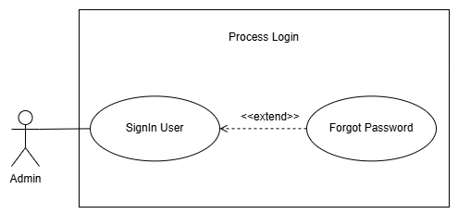

Use Case Name: Signin User
Purpose: Allow the admin to access the system using their username/email and password.
Actors:
- Admin
Input Parameters:
- Username / Email
- Password
- New Password
- Confirm New Password
Output Parameters:
- Status – Login succeeded or failed
- Display the Dashboard
- Password successfully changed
Pre-Condition:
- Admin has an existing account in the system.
- Admin is on the Login page.
Post-Condition:
- Admin successfully logs in to the system.
- The Dashboard is displayed.
Successful Scenario:
- Admin opens the Login page
- Admin inputs their username/email and password
- Admin clicks the Sign In button
- The system validates the admin's username/email and password
- If valid, proceed to step 5.
- If invalid, display an error message
- The system displays the Dashboard
- If the admin forgets their password, the admin clicks the Forgot Password function
- The system displays the Forgot Password page
- Admin inputs their username/email
- Admin clicks the Send Verification Code button
- The system validates the entered username/email
- If valid, the system sends a verification code to the admin's registered email.
- If invalid, the system displays an error message.
- Admin enters the verification code
- The system validates the verification code
- If valid, proceed to step 13.
- If invalid, display an error message.
- Admin enters a new password and confirms the new password
- Admin clicks the Change Password button
- The system validates the new password
- If valid, the system changes the admin's password.
- If invalid, display an error message.
- The system redirects the admin to the Login page
- Admin enters the new password and clicks the Sign In button
- The system validates the new password
- The system displays the Dashboard
Exception Scenario:
- If the admin inputs an incorrect username/email or password:
- The system displays the message “Invalid username/password. Please try again.”
- If the admin inputs a username/email that is not recognized by the system when using Forgot Password:
- The system displays an error message indicating that the account was not found.
- If the admin enters an incorrect or expired verification code:
- The system displays an error message and allows the admin to request a new verification code.
- If the admin enters a new password and confirmation password that do not match:
- The system displays the message “New password and confirmation do not match.”
Additional Remarks:
- The verification code will expire after a specific amount of time, such as 15 minutes.
- The admin must have an existing account to access the system.

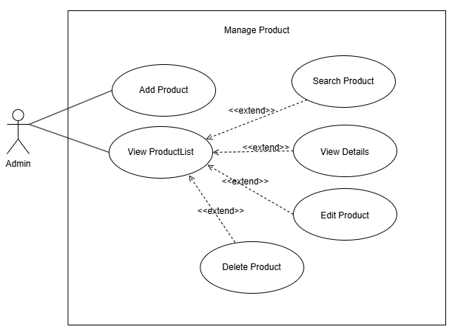
Use Case Name: Add Product
Purpose: Allows the admin to add a new product to the system by entering its product details, inventory information, pricing, and category.
Actors:
- Admin
Input Parameters:
- Product Name
- Brand
- Description
- Quantity
- Selling Price
- Reorder Level
- Category
Output Parameters:
- Product successfully added
- Product information saved in the system
- Initial product status
Pre-Condition:
- Admin is successfully logged in to the system.
- Admin has access to the Product Management function.
- A product category is available in the system.
Post-Condition:
- The new product is saved in the system.
- The product is assigned to the selected category.
- The product information is stored in the database.
- The product is initially set to Unavailable.
Successful Scenario:
- Admin opens the Product page.
- Admin clicks the Add Product button.
- The system displays the New Product page.
- Admin enters the Product Name.
- Admin enters the Brand.
- Admin enters the Description of the product.
- Admin selects the Inventory Tracking Type:
- Non-Serialized
- Serialized
- Admin enters the Quantity.
- Admin enters the Selling Price.
- Admin enters the Reorder Level.
- Admin selects the Category of the product.
- The system displays the initial status as Unavailable.
- Admin reviews the entered product information.
- Admin clicks the Add Product button.
- The system validates the entered product information.
- If valid, proceed to step 16.
- If invalid, the system displays an error message.
- The system saves the product information.
- The system adds the product to the product list.
- The system displays a confirmation that the product was successfully added.
Exception Scenario:
- If the admin leaves a required field empty:
- The system displays an error message requiring the admin to complete the field.
- If the admin does not select a category:
- The system displays an error message requiring the admin to select a category.
Additional Remarks:
- The initial status of a newly added product is Unavailable.
- Stock is updated when products are received through the Delivery process.
- The admin can choose between Serialized and Non-Serialized inventory tracking.

Use Case Name: View ProductList
Purpose: Allow the admin to view the complete information of an existing product, search for a specific product and perform actions such as editing, deleting, or view the details of the selected product.
Actors:
- Admin
Input Parameters:
- Product Name
- Product Keyword
- Brand
- Description
- Selling Price
- Reorder Level
- Category
Output Parameters:
- Updated product information
- Confirmation that the product was successfully updated
- Confirmation that the product was successfully deleted
- List of matching products
- Product information
Pre-Condition:
- Admin is successfully logged in to the system.
- The product already exists in the system.
- Admin has access to the Product Management function.
Post-Condition:
- The selected product information is displayed to the admin.
- If the admin edits the product, the updated information is saved in the system.
- If the admin deletes the product, the product is removed from the active product records.
Successful Scenario:
- Admin opens the Product page.
- Admin view the product list.
- Admin may also search the product to be viewed.
- The system displays the matching product.
- Admin selects the product.
- Admin may select Edit Product or Delete Product.
- If Admin selects Edit Product proceed to step 7.
- If Admin selects Edit Product proceed to step 14.
- The system displays the existing product information in editable fields.
- Admin modifies the necessary product information.
- Admin reviews the updated information.
- Admin clicks the Save Changes button.
- The system validates the updated product information.
- If valid, proceed to step 14.
- If invalid, the system displays an error message.
- The system saves the updated product information.
- The system displays a confirmation that the product was successfully updated.
- The system displays a confirmation message asking the admin to confirm the deletion.
- Admin confirms the deletion.
- The system validates the deletion request.
- The system removes the product from the active product records.
- The system displays a confirmation that the product was successfully deleted.
Exception Scenario:
- If the admin leaves a required field empty:
- The system displays an error message requiring the admin to complete the field.
- If the entered information is invalid:
- The system displays an error message and does not save the changes.
- If the product cannot be found:
- The system displays a message indicating that the product does not exist.
- If the admin cancels the deletion:
- The system cancels the deletion process and keeps the product unchanged.
- If the product cannot be deleted because it is associated with existing transactions:
- The system displays a message indicating that the product cannot be deleted.
Additional Remarks:
- Only authorized admins can edit product information.
- Changes made by the admin should be saved in the product record.

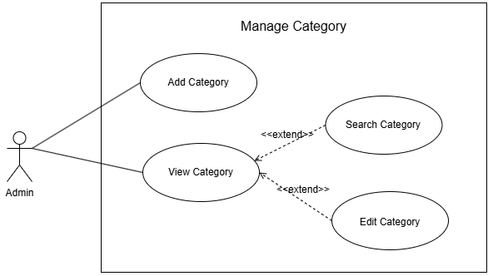
Use Case Name: Add Category
Purpose: Allows the admin to add a new product category to the system.
Actors:
- Admin
Input Parameters:
- Category Name
- Category Description
Output Parameters:
- Category successfully added
- Confirmation message
Pre-Condition:
- Admin is logged in to the system.
- Admin has access to the Manage Category function.
Post-Condition:
- The new category is saved in the system.
- The added category is displayed in the category list.
Successful Scenario:
- Admin opens the Category page
- Admin clicks the Add Category button
- The system displays the Add Category form
- Admin inputs the category name and description
- Admin clicks the Save/Add Category button
- The system saves the new category
- The system displays a confirmation message that the category was successfully added
- The system displays the newly added category in the category list
Exception Scenario:
- If the category already exists in the system:
- The system displays an error message indicating that the category already exists.
Additional Remarks:
- The category name must be unique.
- Only authorized admins can add a new category.

Use Case Name: View Category
Purpose: Allow the admin to view the complete list of an existing category, search for a specific product category and perform action such as editing the selected category.
- Admin
Input Parameters:
- Category Name
Output Parameters:
- Updated category information
- Confirmation message
- List of matching categories
Pre-Condition:
- Admin is logged in to the system.
- The category already exists in the system.
- Admin has accessed the View Category function.
Post-Condition:
- The category information is successfully updated.
- The updated category information is displayed in the system.
Successful Scenario:
- Admin opens the Category page
- Admin views the list of available categories
- Admin may also search the list of available categories
- Admin selects the category to be edited
- Admin clicks the Edit Category button
- The system displays the existing category information
- Admin modifies the category information
- Admin clicks the Save Changes button
- The system validates the updated category information
- If valid, proceed to step 9.
- If invalid, the system displays an error message
- The system updates the category information
- The system displays a confirmation message that the category was successfully updated
- The system displays the updated category information
Exception Scenario:
- If the updated category name already exists:
- The system displays an error message indicating that the category name is already existed.
- If the selected category cannot be found:
- The system displays an error message indicating that no category match your search.
Additional Remarks:
- Edit Category and Search Category is an extension of the View Category.
- Only authorized admins can edit category information.
- The system should save the updated information immediately after a successful update.
- The search results should only display categories that match the entered keyword.

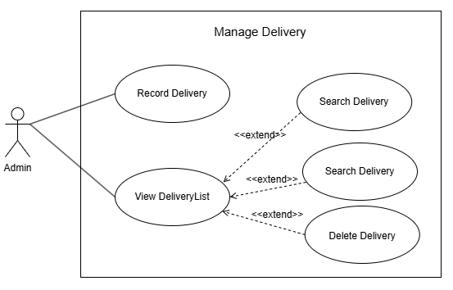
Use Case Name: Record Delivery
Purpose: Allows the admin to record incoming products and update the inventory by selecting the products received and entering their received quantities.
Actors:
- Admin
Input Parameters:
- Batch ID
- Delivery Date
- Received By
- Product
- Received Quantity
Output Parameters:
- Delivery record successfully saved
- Selected products recorded in the delivery
- Inventory quantity updated
Pre-Condition:
- Admin is successfully logged in to the system.
- Admin has access to the Manage Delivery function.
- Products to be received already exist in the system.
Post-Condition:
- The delivery record is successfully saved.
- The selected products are recorded under the delivery.
- The received quantity is added to the product's inventory.
- The delivery can be viewed through the Search Delivery function.
Successful Scenario:
- Admin opens the Delivery page.
- Admin clicks the Receive Products button.
- The system displays the Receive Products page.
- The system displays the Batch ID.
- The system displays the Delivery Date.
- The system displays the Received By information.
- Admin searches for the product to be received.
- The system displays the available products.
- Admin selects the product to include in the delivery.
- The system adds the selected product to the Products to Receive section.
- Admin enters the received quantity for the selected product.
- Admin repeats steps 7–11 if there are additional products to receive.
- The system displays the selected products and total quantity.
- Admin reviews the delivery information and selected products.
- Admin clicks the Receive Products button.
- The system validates the delivery information and received quantities.
- If valid, proceed to step 17.
- If invalid, the system displays an error message.
- The system saves the delivery record.
- The system updates the inventory based on the received quantities.
- The system displays a confirmation that the products were successfully received.
Exception Scenario:
- If the admin does not select or emptied the important details:
- The Receive Products button will not be clickable.
- If the product is no longer available in the system:
- The system displays an error message and does not add the product to the delivery.
Additional Remarks:
- The Batch ID identifies the delivery record.
- The Delivery Date records when the products were received.
- The Received By field identifies the admin who recorded the delivery.
- Receiving products updates the inventory quantity.
- Only products selected in the Products to Receive section are included in the delivery.

Use Case Name: View Delivery
Purpose: Allow the admin to view the complete list of an existing delivery, search the specific delivery and perform action such as deleting the selected delivery.
Actors:
- Admin
Input Parameters:
- Batch ID
- Delivery Keyword
- Selected Delivery Record
Output Parameters:
- Delivery record deleted
- Confirmation of successful deletion
Pre-Condition:
- Admin is successfully logged in to the system.
- Admin has access to the Manage Delivery function.
- The delivery record already exists in the system.

Post-Condition:
- The system displays the delivery records matching the admin's search criteria.
- The selected delivery record is deleted from the system.
- The delivery record is no longer displayed in the active delivery records.
Successful Scenario:
- Admin opens the Delivery page.
- Admin searches for the delivery record to be viewed.
- The system displays the matching delivery record.
- Admin selects the delivery record.
- Admin clicks the Delete Delivery option.
- The system displays a confirmation message asking the admin to confirm the deletion.
- Admin confirms the deletion.
- The system validates the deletion request.
- The system deletes the selected delivery record.
- The system displays a confirmation that the delivery record was successfully deleted.
Exception Scenario:
- If the delivery record cannot be found:
- The system displays a message indicating that the delivery record does not exist.
- If the admin cancels the deletion:
- The system cancels the deletion process and keeps the delivery record unchanged.
- If the delivery record cannot be deleted because it is associated with inventory transactions:
- The system displays a message indicating that the delivery record cannot be deleted.
Additional Remarks:
- The system should require confirmation before deleting a delivery record.
- Only authorized admins can delete delivery records.
- Delivery records associated with inventory transactions should be protected from accidental deletion.
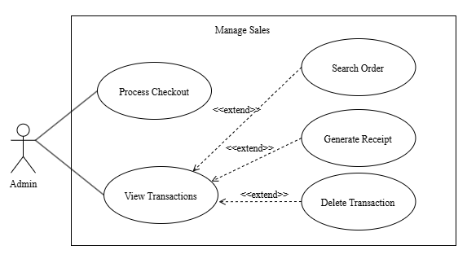

Use Case Name: Process Checkout
Purpose: Allow the administrator to process a customer's purchase by entering customer information, selecting products, and completing the payment transaction.
Actors:
- Admin
Input Parameters:
- Customer Full Name
- Customer Phone Number
- Customer Email Address
- Customer Address
- Product
- Quantity
- Payment Type
- Payment Method
- Date Purchased
Output Parameters:
- Customer order
- Order summary
- Total purchase amount
- Payment status
- Updated product inventory
- Checkout confirmation
Pre-Condition:
- Administrator has an existing account in the system.
- Administrator is logged in to the system.
- Products are available in the system.
Post-Condition:
- Customer order is successfully recorded in the system.
- Payment information is recorded.
- Product inventory is updated.
- The completed transaction is saved in the system.
Successful Scenario:
- Administrator opens the Sales page.
- Administrator selects New Checkout.
- The system displays the New Checkout page.
- Administrator searches for an existing customer using their name, phone number, or email address.
- The system displays the matching customer information.
- If the customer exists, proceed to step 6.
- If the customer does not exist, proceed to step 7.
- Administrator confirms the customer's information.
- Administrator enters the customer's Full Name, Phone Number, Email Address, and Address.
- Administrator searches for a product using the product name, code, brand, or category.
- The system displays the available products.
- Administrator selects a product to add to the order.
- The system adds the selected product to the Selected Items section.
- Administrator enters the quantity of the selected product.
- The system calculates the product subtotal.
- Administrator repeats steps 8–13 if additional products need to be added.
- Administrator selects the Payment Type, such as Full Payment or Installment.
- If payment type is Full Payment proceed to step 16.
- If payment type is Installment proceed to step 17.
- Administrator selects the Payment Method, such as Cash.
- Administrator selects Installment Term, such as 6 months.
- Administrator enters customer’s Down Payment.
- Administrator reviews the selected items and Order Summary.
- The system displays the number of items and the total amount.
- Administrator clicks the Complete Checkout button.
- The system validates the customer, product, quantity, and payment information.
- If valid, proceed to step 21.
- If invalid, the system displays an error message.
- The system records the customer's order and payment information.
- The system updates the product inventory.
- The system displays a confirmation that the checkout was successfully completed.
- The system displays a checkout details.
- The administrator selects Generate Receipt, the system will generates a receipt containing the order and customer information.
- The system displays the generated receipt to the administrator.
Exception Scenario:
- If the administrator does not provide the required customer information:
- The complete checkout button is not clickable and requires the administrator to complete the required fields.
- If the administrator attempts to complete the checkout without selecting a product:
- The system prevents the checkout from being completed.
- If the administrator does not select a payment type or payment method:
- The system requires the administrator to provide the required payment information.
- If the administrator clicks the Cancel button:
- The system cancels the current checkout process.

Additional Remarks:
- The system automatically calculates the subtotal and total purchase amount.
- The system displays the available quantity of each product.
- For serialized products, the required serial number must be entered before completing the checkout.
- The system must update the inventory after a successful checkout.

Use Case Name: View OrderList
Purpose: Allow the administrator to view the complete list of all the recorded transaction, search the specific transaction and perform action such as generate a receipt or deleting the selected order transaction.
Actors:
- Admin
Input Parameters:
- Sales Order Name or Keyword
Output Parameters:
- Order details
- Generated receipt
- Updated order records after deletion
Pre-Condition:
- Administrator has an existing account in the system.
- Administrator is logged in to the system.
- Existing orders are recorded in the system.
Post-Condition:
- Administrator can view the selected order's details.
- Administrator can generate a receipt for the selected order.
- Administrator can delete the selected order when necessary.
Successful Scenario:
- Administrator opens the Sales page.
- Administrator accesses the order records.
- The system displays the available order transaction list.
- The system displays the order's information, including the customer information, purchased products, quantities, prices, payment information, total amount, and order status.
- Administrator can search for the specific order transaction.
- Administrator may select Generate Receipt.
- If the administrator selects Generate Receipt, the system generates a receipt containing the order and customer information.
- The system displays the generated receipt to the administrator.
- Administrator may return to the order details or search results.
- Administrator may select Delete Order if the order needs to be removed.
- If the administrator selects Delete Order, the system displays a confirmation message.
- Administrator confirms the deletion of the order.
- The system deletes the selected order from the records.
- The system updates the order records and displays a confirmation that the order was successfully deleted.
Exception Scenario:
- If the administrator selects Delete Order but cancels the confirmation:
- The system does not delete the order and returns to the order details.
- If an error occurs while deleting the order:
- The system displays an error message and keeps the order in the system.
- If the Administrator search a specific order and no match was displayed:
- The system displays an error message inciting no match can be found.
Additional Remarks:
- Generate Receipt, and Delete Order are functions performed within the View Order process.
- The administrator can optionally first select an order before performing actions on it.
- The system should require confirmation before deleting an order.
- The generated receipt should contain the relevant customer, product, payment, and order information.

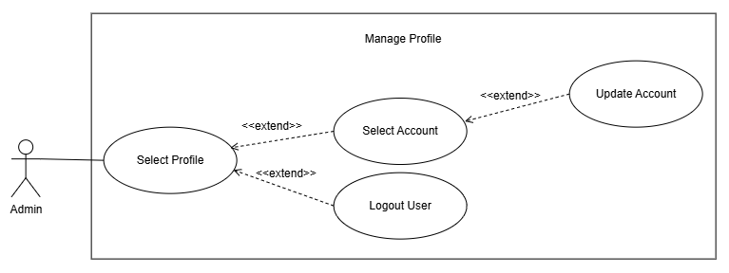

Use Case Name: Select Profile

Purpose: Allow the administrator to access their profile and account settings, where they can view and update their account information. The administrator may also log out of the system.
Actors:
- Admin
Input Parameters:
- Full Name
- Email Address
- Username
- Current Password
- New Password
- Confirm Password
Output Parameters:
- Display the Account Settings page
- Updated account information
- Updated password
- Confirmation that changes were successfully saved
- Administrator successfully logged out of the system
Pre-Condition:
- Administrator has an existing account in the system.
- Administrator is logged in to the system.
Post-Condition:
- Administrator can view and manage their account information.
- Administrator can update their profile information or password.
- If the administrator chooses to log out, the system terminates the administrator's session and redirects them to the Login page.
Successful Scenario:
- Administrator selects the Profile option from the system.
- The system displays the Account Settings page.
- The system displays the administrator's profile information, including their full name, email address, and username.
- Administrator reviews their account information.
- Administrator may update their Full Name, Email Address, or Username.
- Administrator clicks the Save Changes button.
- The system validates the administrator's updated account information.
- If valid, proceed to step 8.
- If invalid, the system displays an error message.
- The system saves the updated account information.
- The system displays a confirmation that the account information has been successfully updated.
Exception Scenario:
- If the administrator inputs invalid or incomplete account information:
- The system displays an error message and requires the administrator to provide valid information.
- If the administrator enters an email address or username that is already associated with another account:
- The system displays an error message indicating that the email address or username is already in use.
Additional Remarks:
- The Select Profile use case includes the Logout User use case as an extension.
- The administrator may choose to log out after accessing their profile.
- When the administrator selects Logout User, the system terminates the current session and redirects the administrator to the Login page.

- Class Model
This section shows the class model, for the RJTech Sales and Inventory Management System. The class model lays out the system by naming the classes, attributes and methods that represent products, inventory, deliveries, sales, customers, payments and system users. It also shows how these classes relate to each other and how many of each can exist together. The model mirrors the domain classes that are written in the system’s ASP.NET Core MVC code and it helps us see how the data parts of the RJTech Sales and Inventory Management System work together.

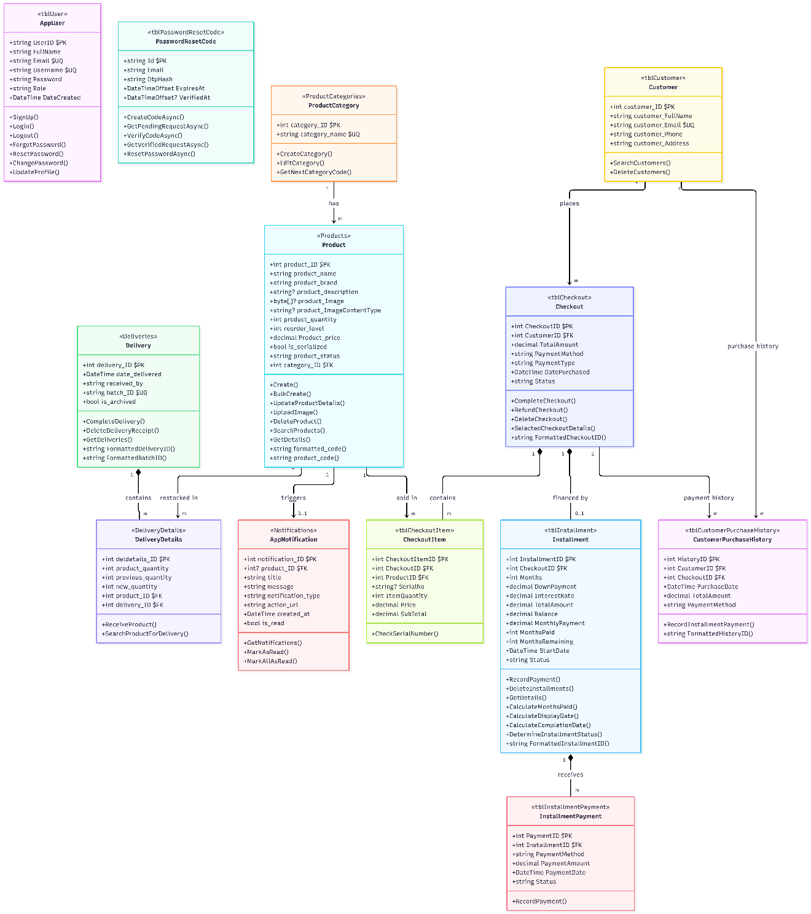
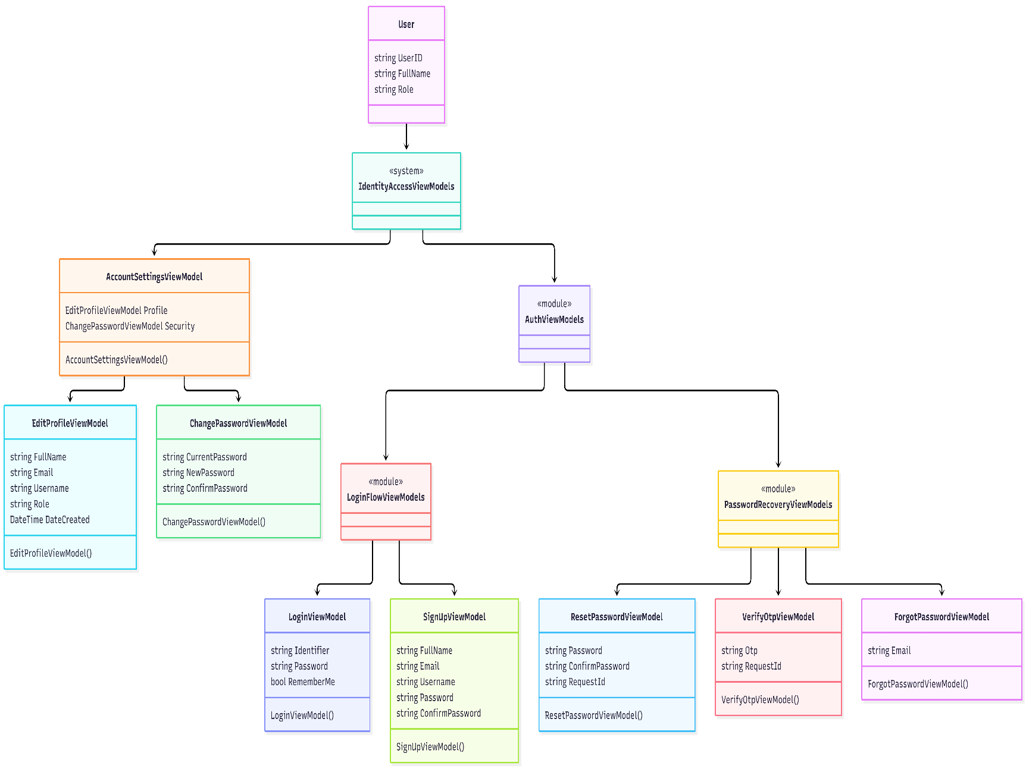
Figure 3.10: Model Class Diagram

Figure 3.11: ViewModel Class Diagram

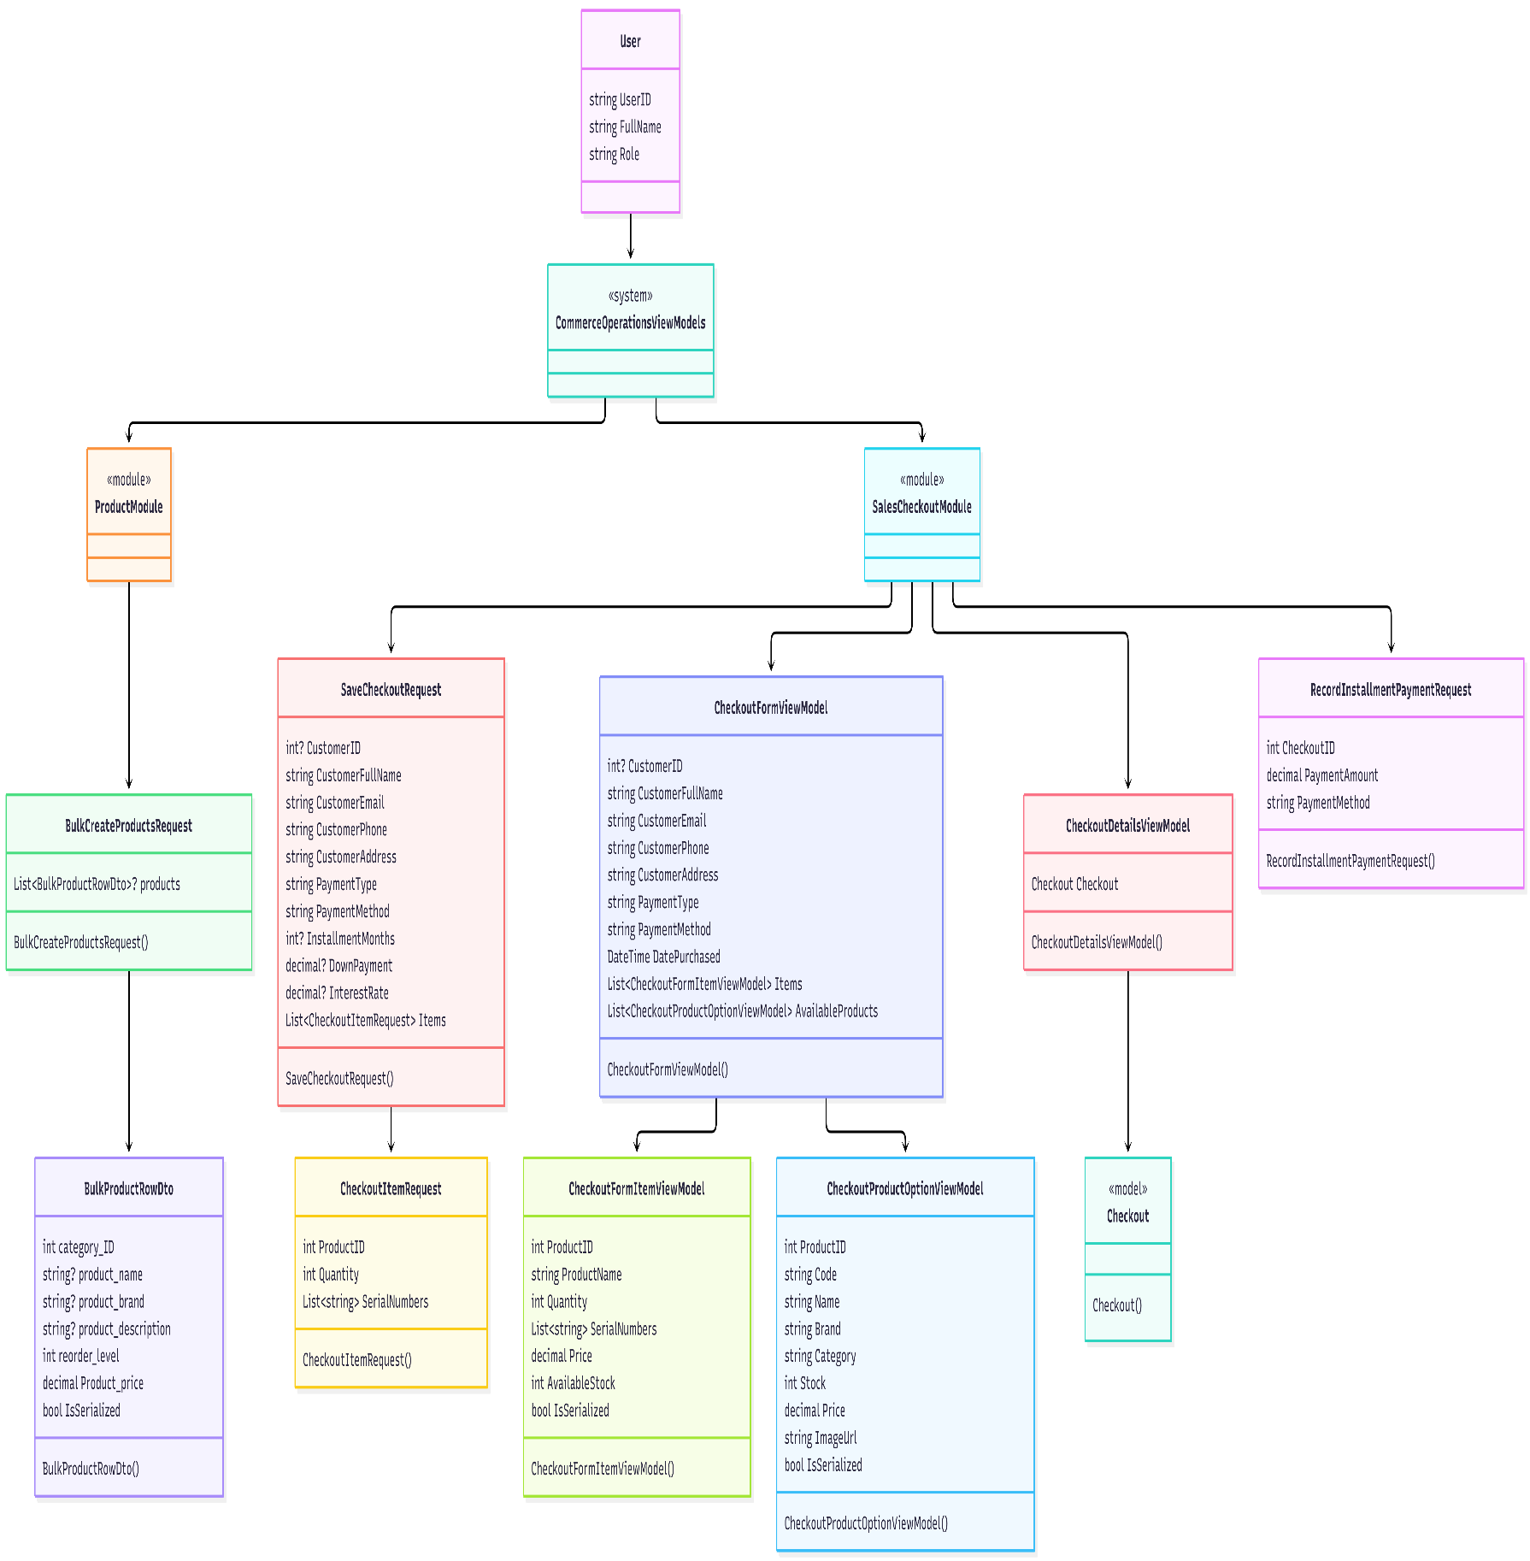

Figure 3.12: ViewModel Class Diagram
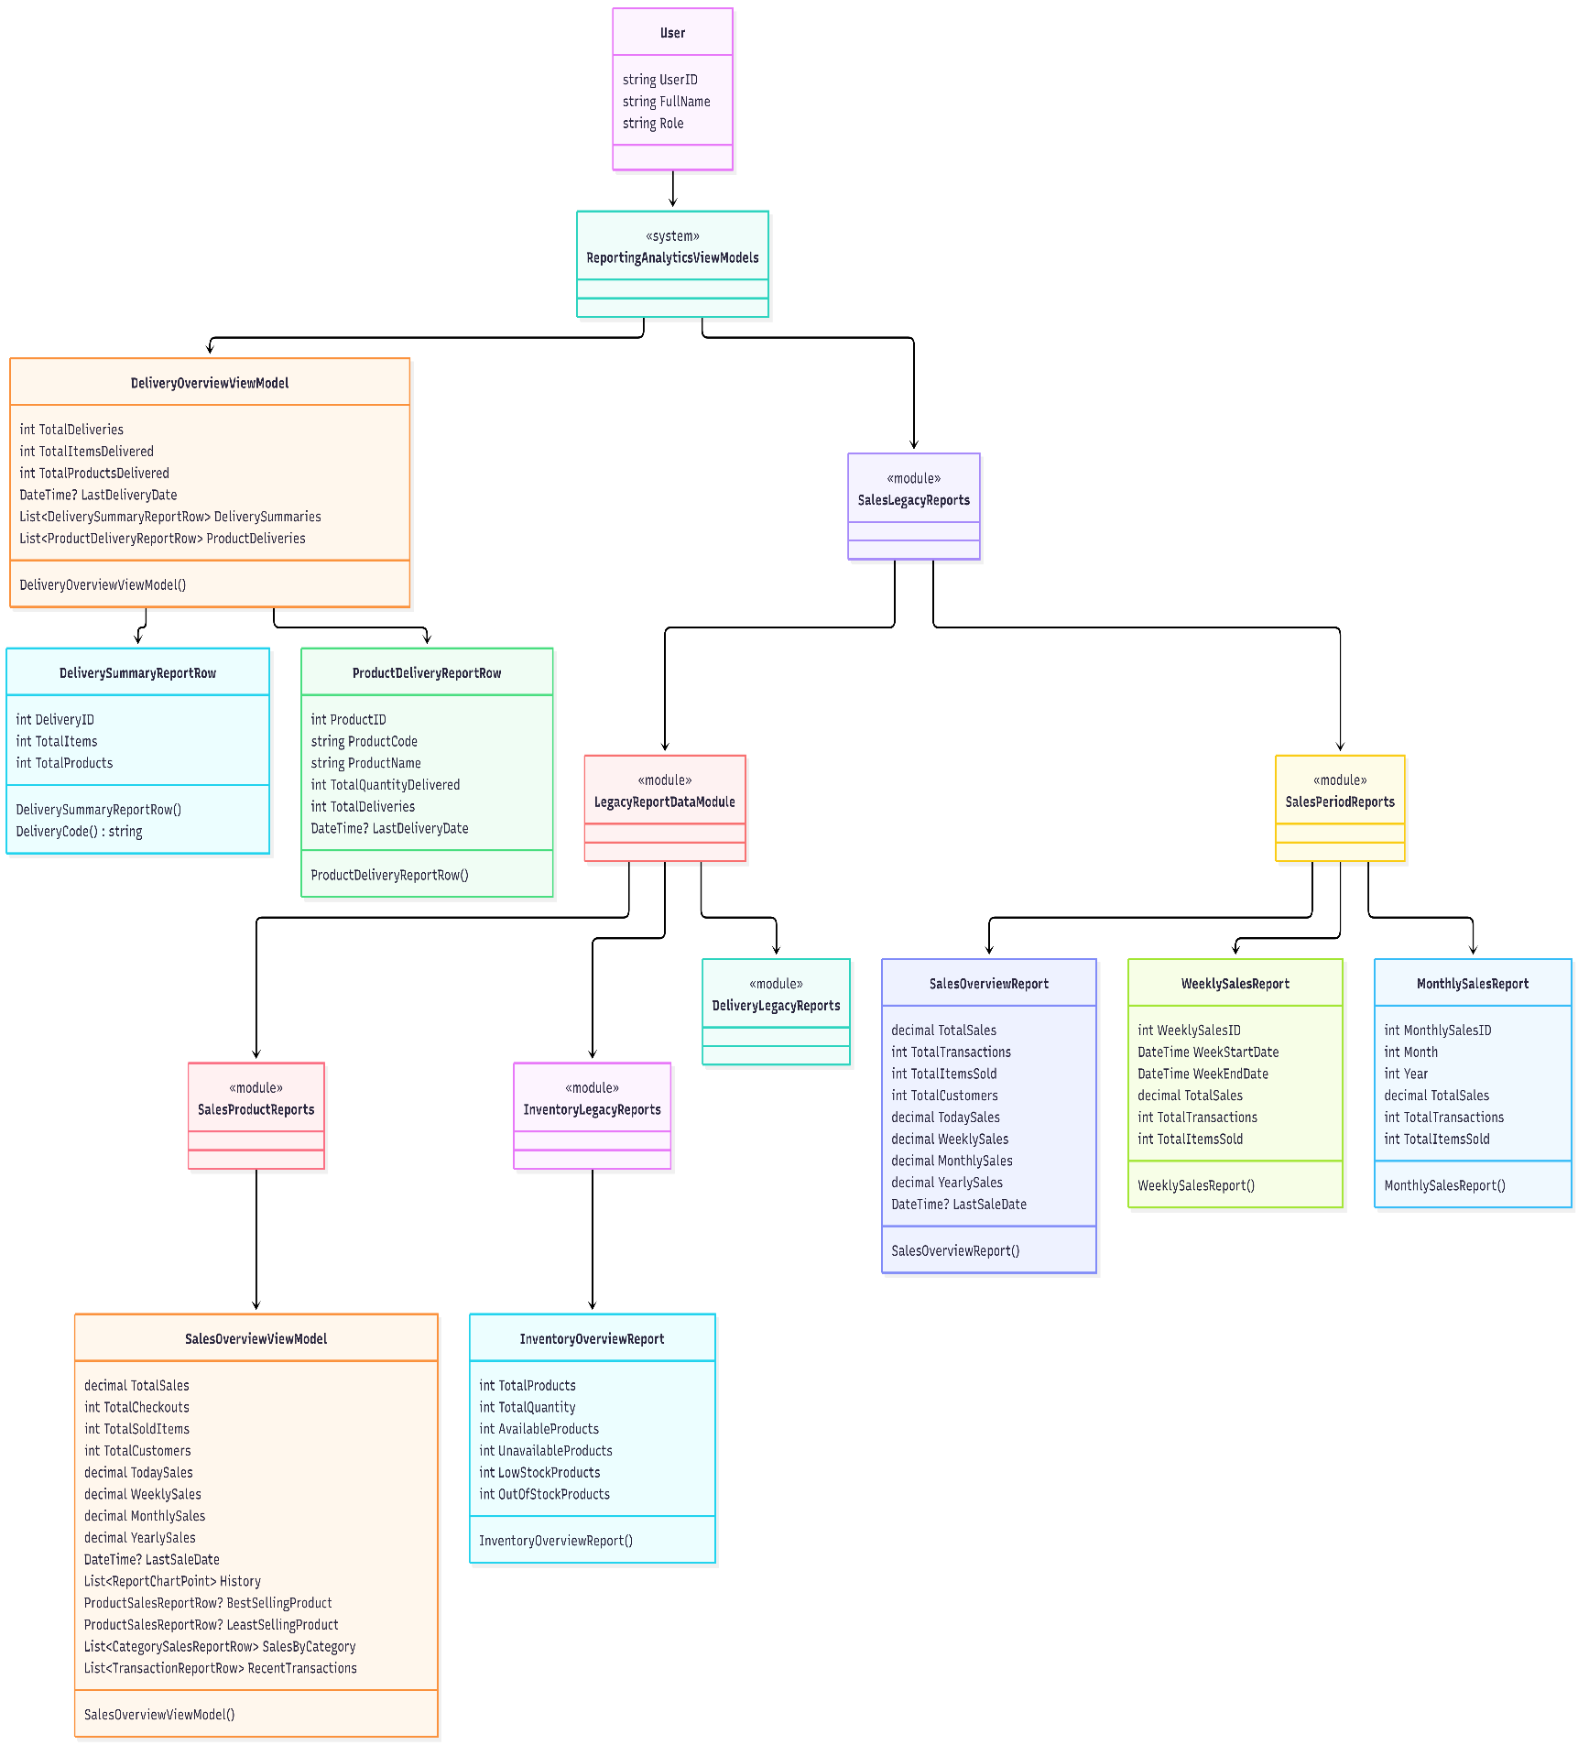
Figure 3.12: ViewModel Class Diagram
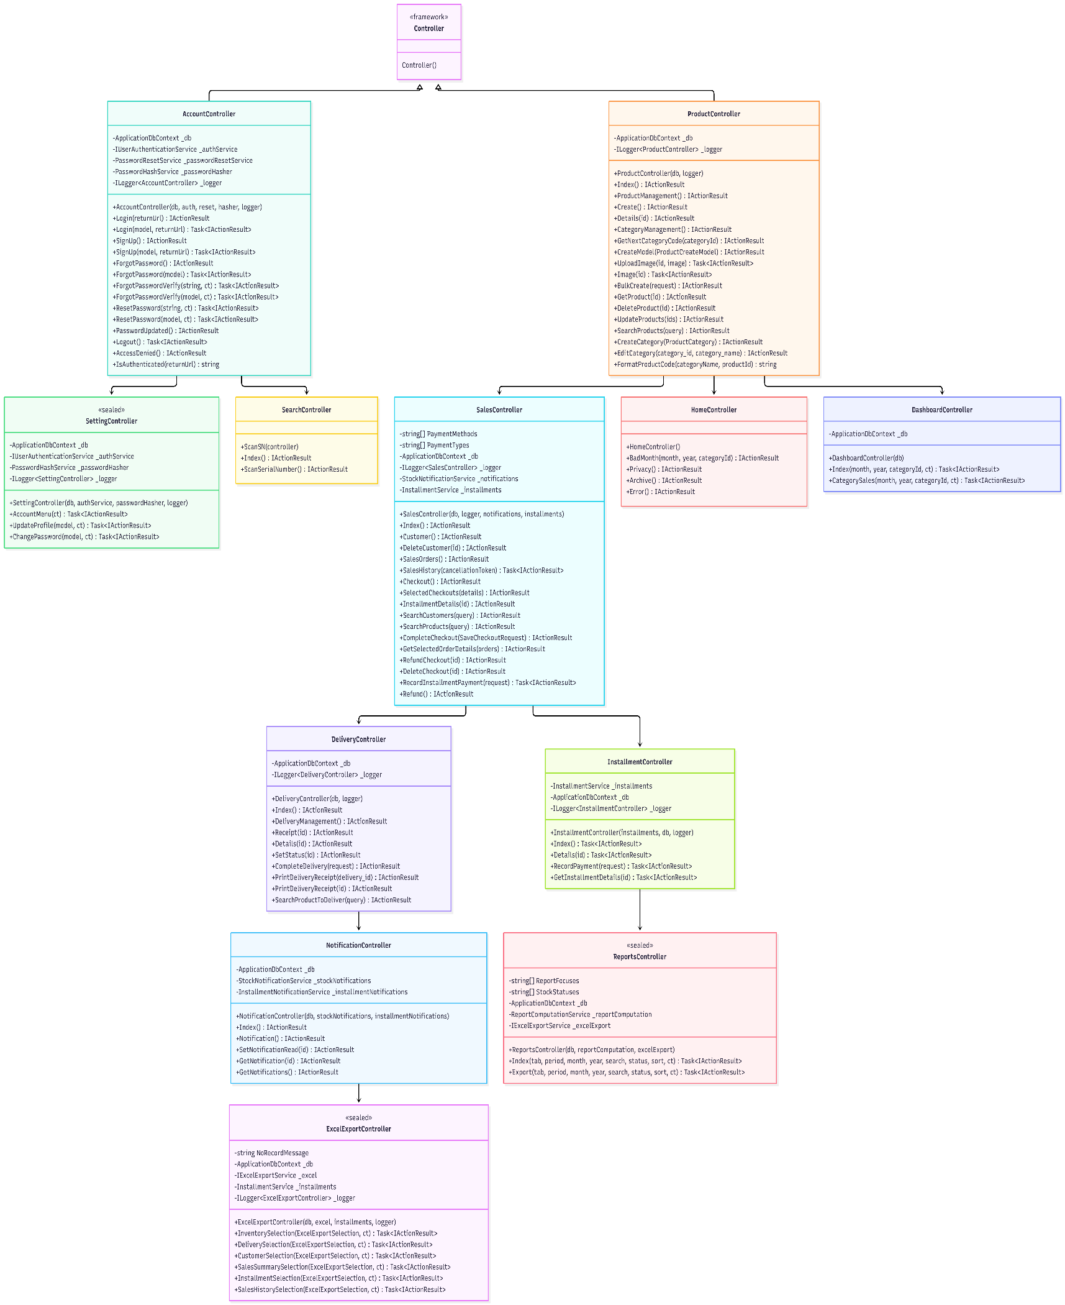
Figure 3.12: Controller Class Diagram

The Model, ViewModel and Controller class diagrams together give a picture of the RJTech Sales and Inventory Management System. The Model classes show the database tables that were created in the ER Model and Database Schema. The ViewModels take care of checking the input and putting the data in a way that the user can understand. The Controllers are responsible for the parts of the system, like managing products and inventory handling deliveries, processing sales and checkouts managing customers handling installment payments generating reports sending notifications and controlling who can access the system.

- Entity-Relationship Model
This section presents the Entity-Relationship (ER) Model RJTech Sales and Inventory Management System. The ER Model illustrates the system's underlying database structure by showing the entities (database tables), their attributes, and the relationships that exist among them. It serves as the conceptual foundation for the physical database schema implemented through Entity Framework Core and Microsoft SQL Server.ApplicationDbContext.cs.
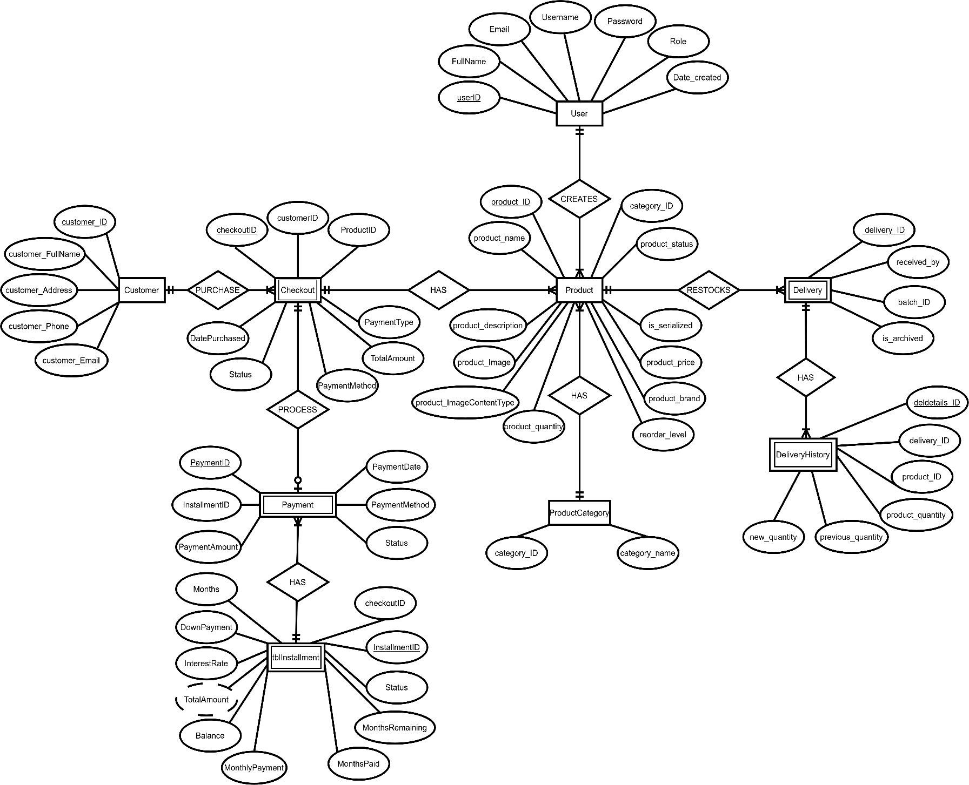
Figure 3.13: Entity Relationship Diagram
- Database Schema
This section outlines the database schema of the RJTech Sales and Inventory Management System, defining each table's fields, data types, keys, and constraints as configured in the system's Entity Framework Core model and Microsoft SQL Server database (HotelEaseDb2). The schema is the physical realization of the ER Model presented above and directly maps to the C# model classes under the Models/ folder.

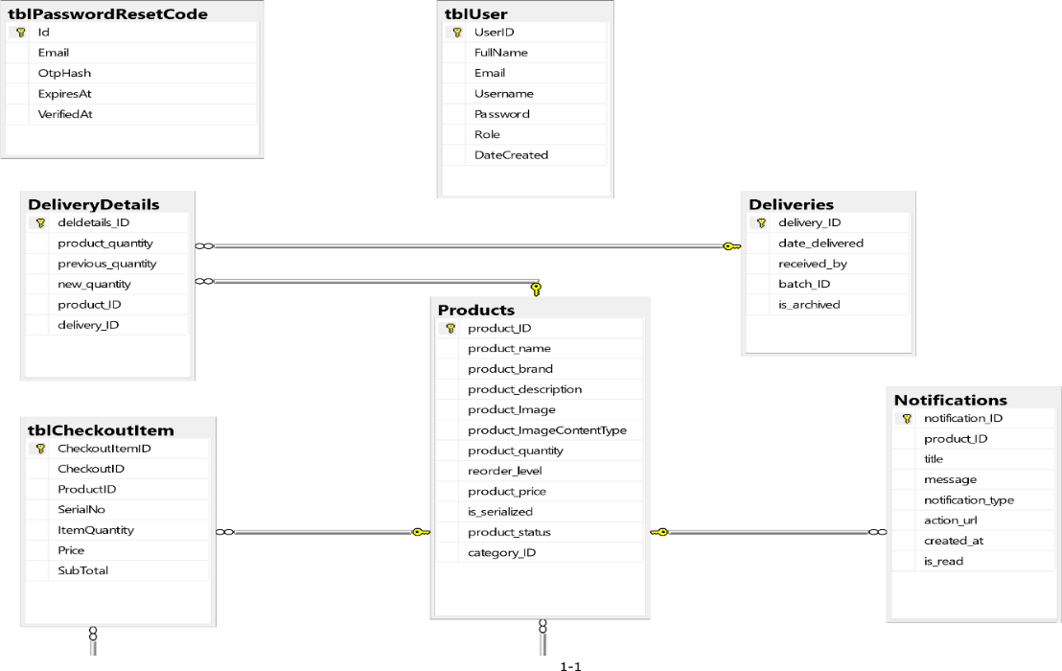
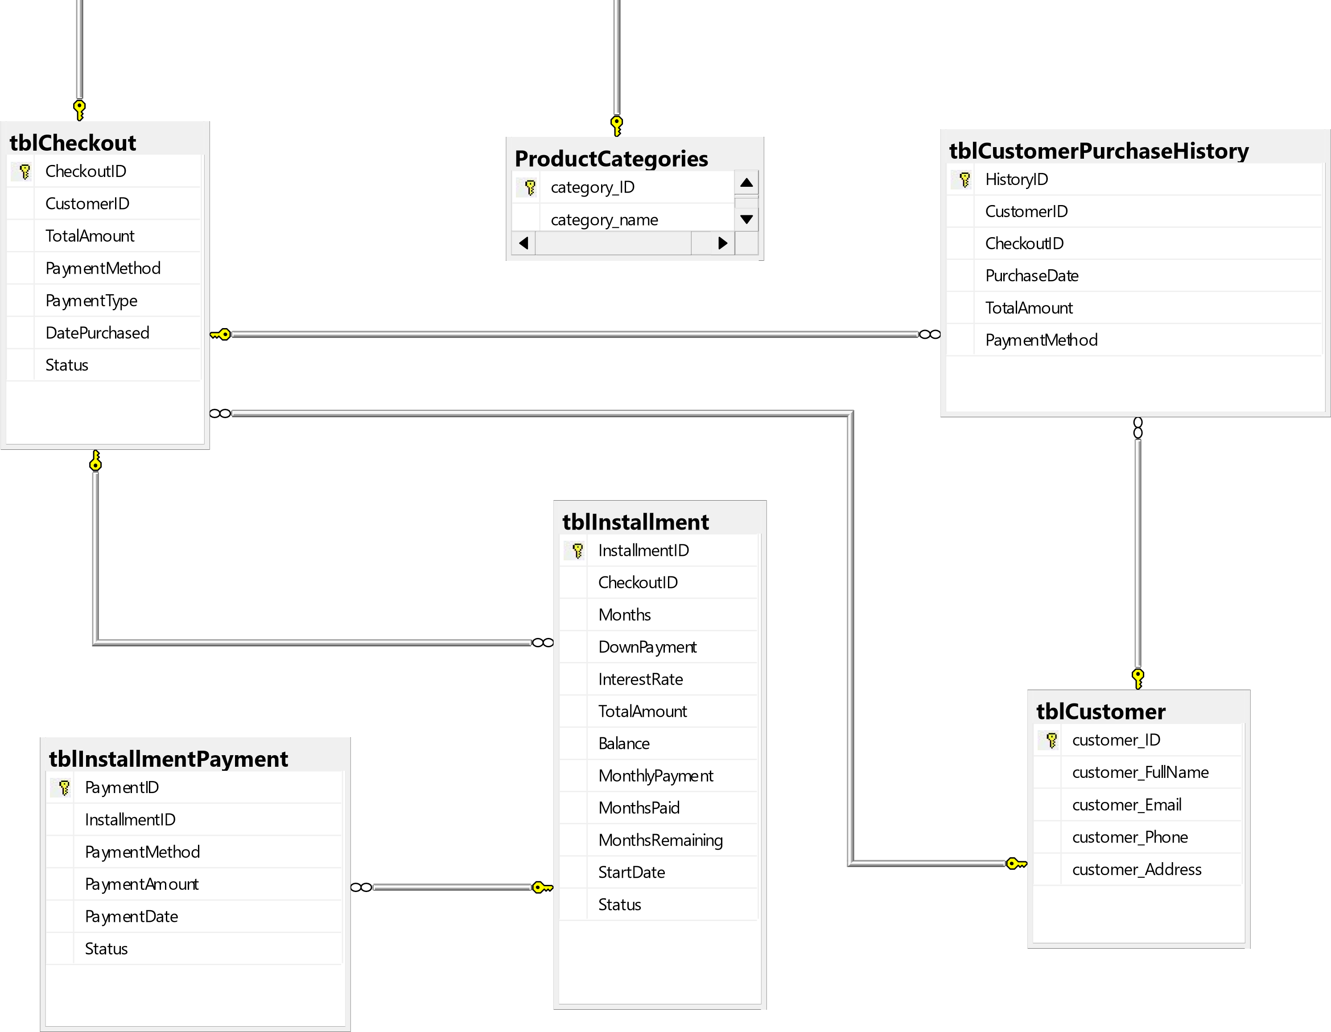
Figure 3.14: Database Schema

- Implementation Strategies
The implementation strategy for the Web-Based Inventory and Sales Management System describes the steps that will be followed in developing, testing, deploying, and maintaining the proposed system. The researchers will use an Agile approach, where the system will be developed in stages through planning, development, testing, and improvements. This approach will allow the researchers to make changes based on the requirements and feedback gathered during the development of the system. The implementation will be divided into five main phases: planning and analysis, design and coding, testing and quality assurance, deployment and training, and maintenance and continuous improvement.

The planning and analysis phase will focus on understanding the current processes and determining the requirements of the business. The researchers will gather information through surveys, interviews, observations, and document analysis with the intended users. The information gathered will be used to identify the functions and features needed in the system. Data Flow Diagrams and Use Case Diagrams will also be prepared to help the researchers understand and represent the processes that the system needs to support. The main areas considered during this phase will include product management, customer management, sales transactions, deliveries and receiving, payments and installments, reports, and dashboard monitoring.

The design and coding phase will focus on turning the identified requirements into the actual system. The researchers will first plan the layout and navigation of the system to make the different functions easy to access and understand. The system will then be developed gradually using the Agile approach. The major features to be developed will include user login and authentication, dashboard monitoring, product and category management, customer management, sales transactions, delivery and product receiving, payment and installment monitoring, and report generation. As each feature is developed, it will be reviewed and improved when necessary to make sure that it meets the identified requirements.

After the system features have been developed, the testing and quality assurance phase will be conducted. The researchers will test the different functions of the system to determine whether they work properly and produce the expected results. Testing will cover important processes such as adding and updating products, managing customers, processing sales transactions, recording deliveries and received products, monitoring payments and installments, and generating reports. Any errors or problems found during testing will be recorded and corrected before the system is tested again. Feedback from the intended users will also be considered to identify areas that may need improvement. The System Usability Scale (SUS) will be used to help evaluate the users' perception of the system's usability after they have used the developed system.
Once the system has passed the necessary testing, it will proceed to the deployment and training phase. The web-based system will be set up in the intended working environment and made accessible using a standard web browser. The intended users will be given training and orientation on how to use the system properly. The training will cover common tasks such as managing products and categories, recording customer information, processing sales, handling deliveries and received products, monitoring payments and installments, and generating reports. A user guide or manual will also be provided to help users understand the system and perform their regular tasks.

After deployment, the maintenance and continuous improvement phase will begin. The system will be regularly monitored to identify errors, technical issues, or functions that may need improvement. Feedback from the users will be collected and considered when making necessary adjustments to the system. The researchers will also perform maintenance activities when needed to keep the system functioning properly and to ensure that it continues to support the business processes.

The implementation of the system will follow a planned development timeline based on the schedule of the research project. Tasks will be divided among the researchers according to their assigned responsibilities, such as requirements gathering, system analysis, interface design, programming, testing, documentation, and deployment. By following these phases in an organized manner, the researchers aim to develop a reliable and functional Web-Based Inventory and Sales Management System that can help organize the management of products, customers, sales transactions, deliveries, payments, and reports.

- System User Interface
This section presents the design and layout of the RJTech Sales and Inventory Management System. The interface is designed to be simple, user-friendly, and efficient for system administrators and store owners, allowing easy management of products, inventory, deliveries, sales, customers, payments, and reports. It provides a clear and organized interface to support daily operations and improve the overall management of RJTech Computers.

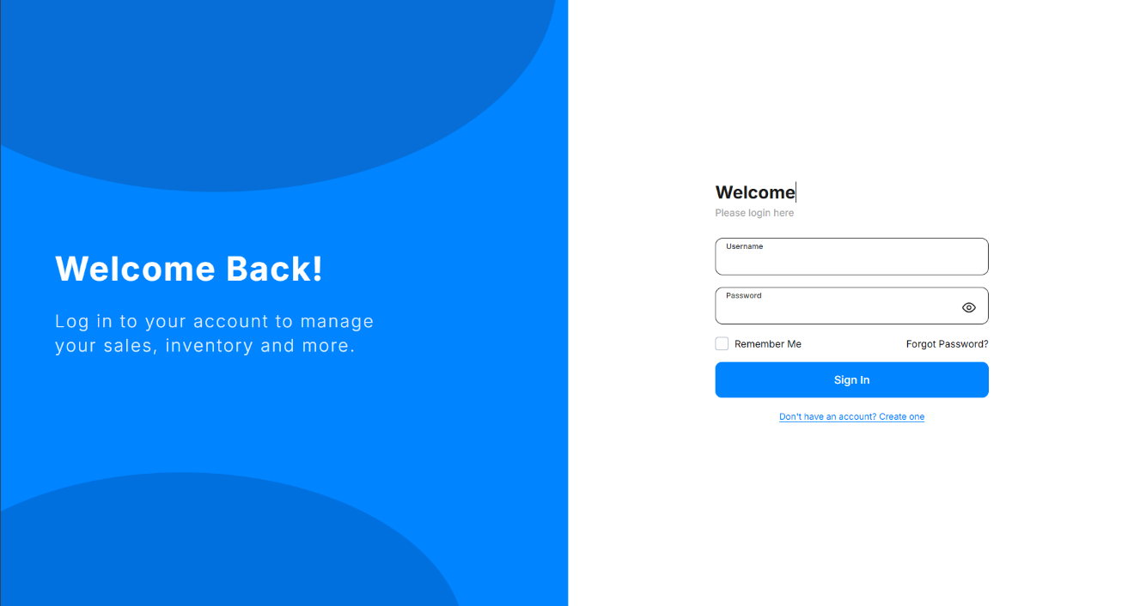
Figure 3.15: User Interface for Login
Description: The Login Page lets authorized RJTech staff securely sign in to the system using their email and password.
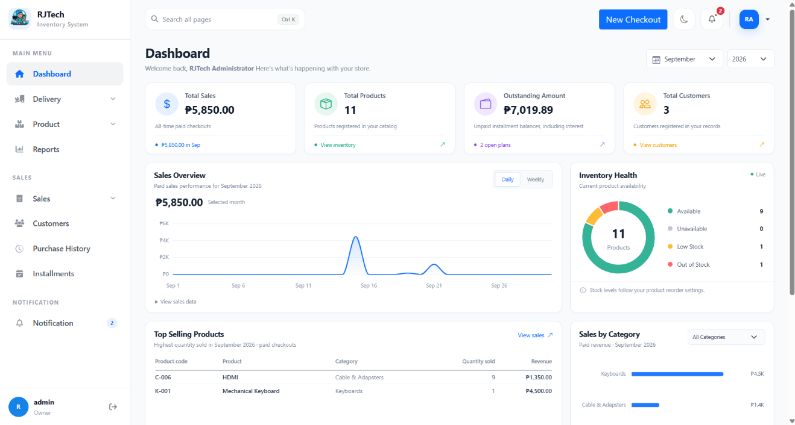

Figure 3.16: User Interface for Dashboard
Description: The Dashboard is intended to give the owner an overview of the business as soon as they log in (the image here currently shows the Account Settings page, so it needs to be replaced).

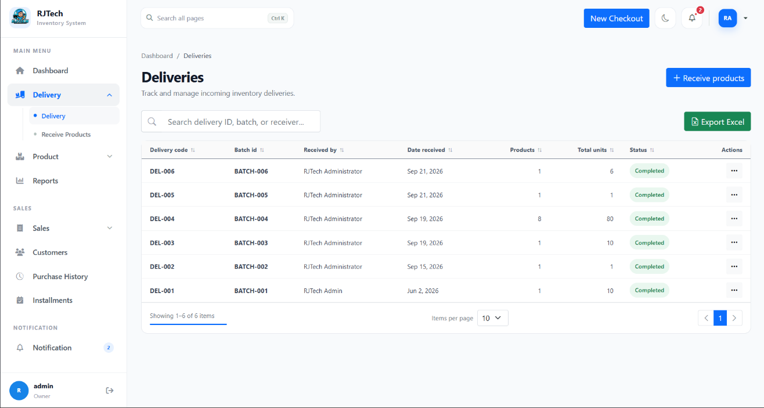
Figure 3.17: User Interface for Deliveries
Description: The Delivery page allows the owner to monitor incoming supplier deliveries and record newly received stock.

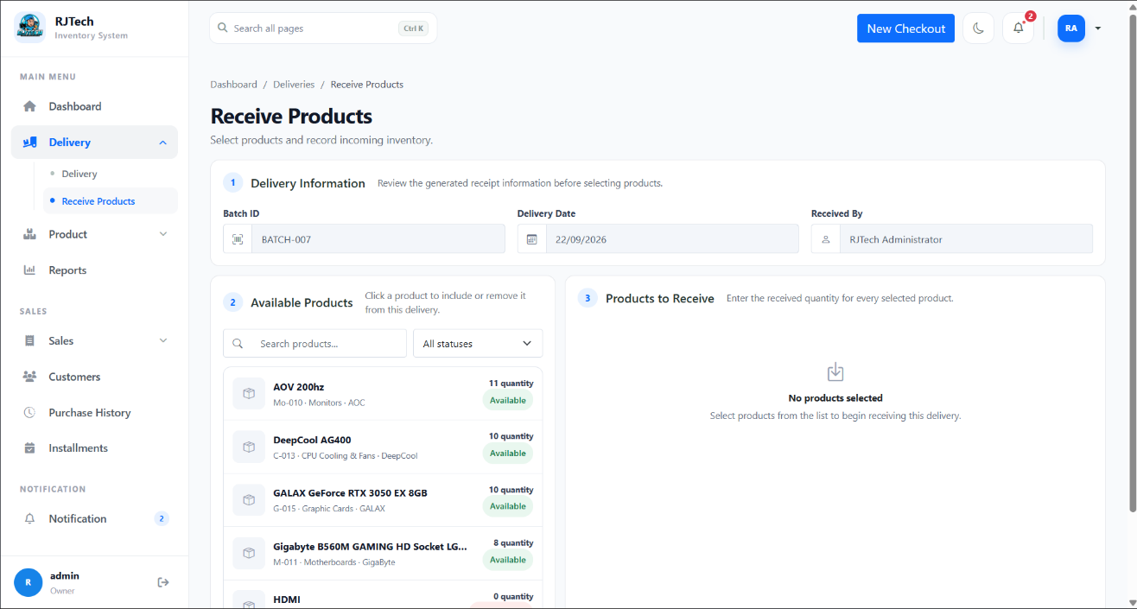
Figure 3.18: User Interface for Receive Products
Description: The Receive Products page guides the user in recording a delivery by confirming the batch details, selecting the items received, and entering their quantities so inventory stays accurate.

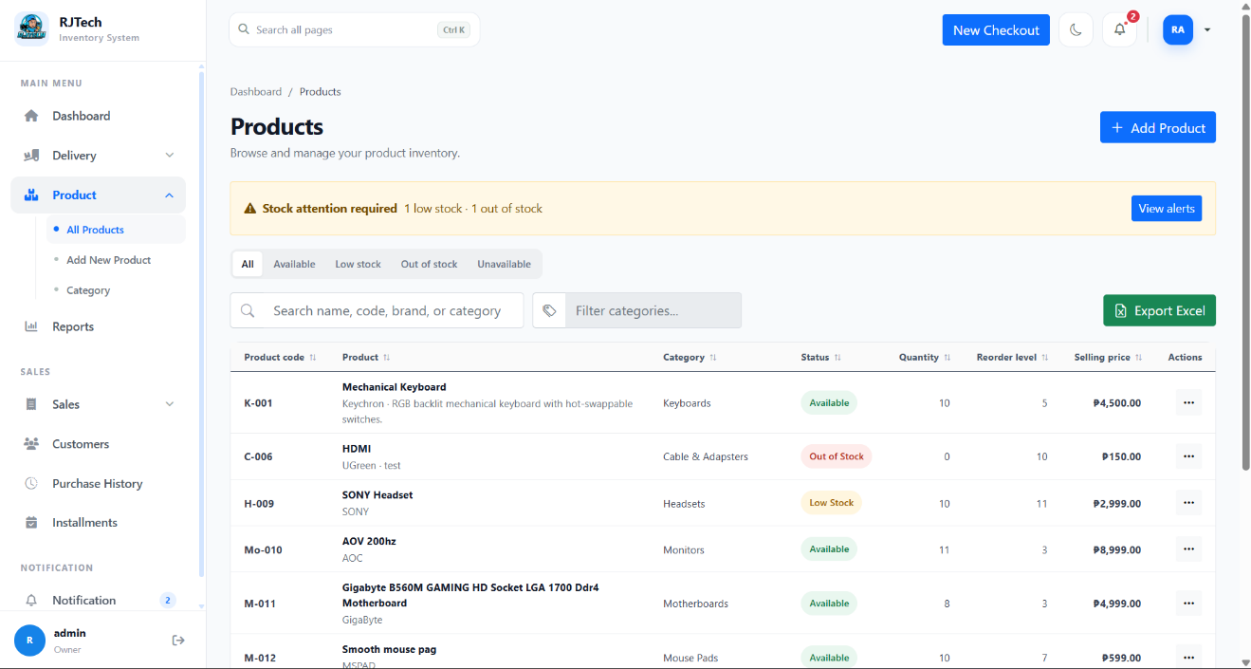
Figure 3.19: User Interface for Products
Description: The Products page displays the complete inventory in one table, helping the owner search items and track their stock status and prices.

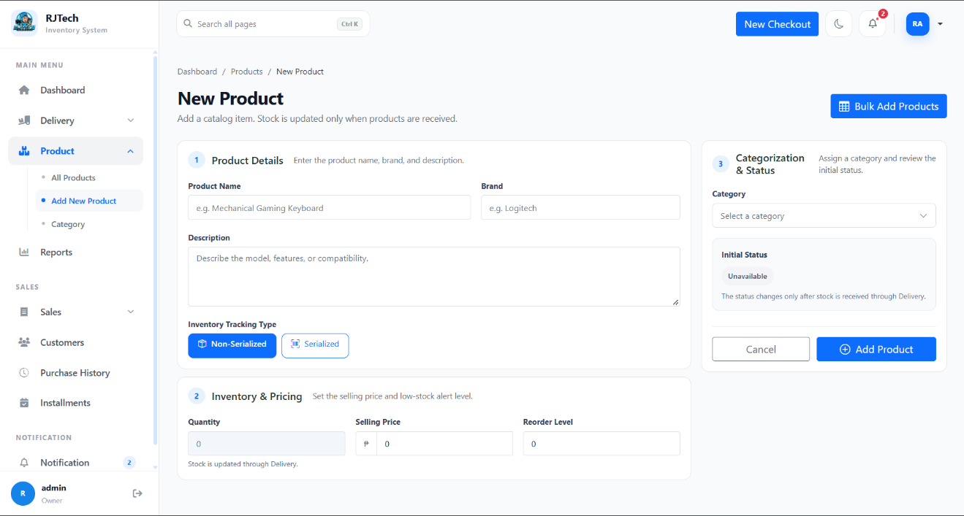
Figure 3.20: User Interface for New product
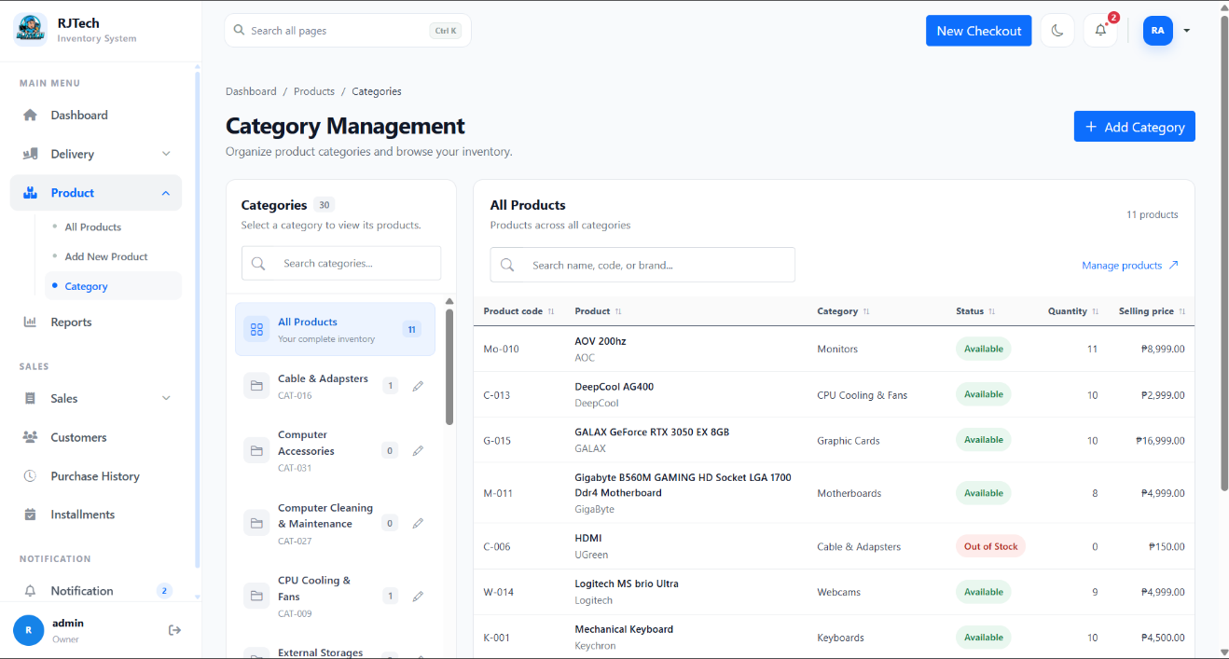
Description: The New Product page lets the owner add a new item to the catalog with its details, price, and reorder level, while stock is only updated once the item is received through Delivery.
Figure 3.21: User Interface for Category
Description: The Category page helps the owner organize products into groups and quickly view which items belong to each category

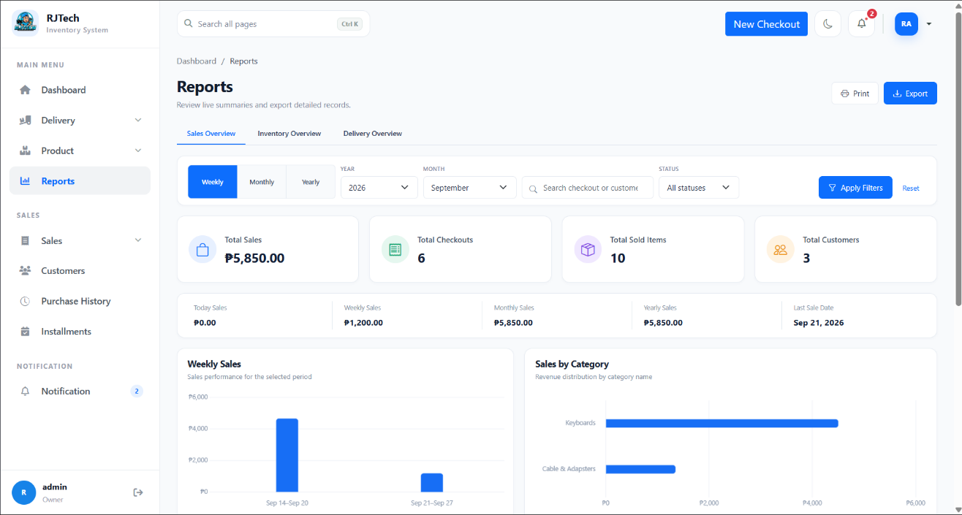
Figure 3.22: User Interface for Reports
Description: The Reports page presents sales, inventory, and delivery summaries through cards and charts to support the owner's business decisions, with an option to export them.

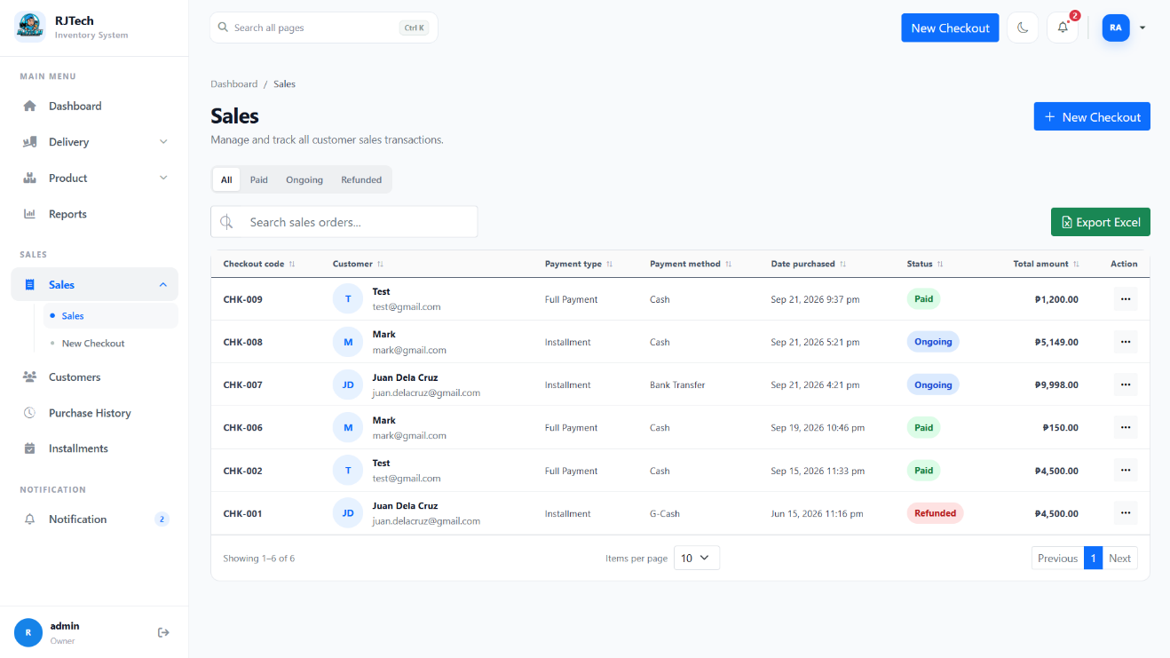
Figure 3.23 User Interface for Sales
Description: The Sales page shows the history of customer payments, including installments, so the owner can review past transactions.

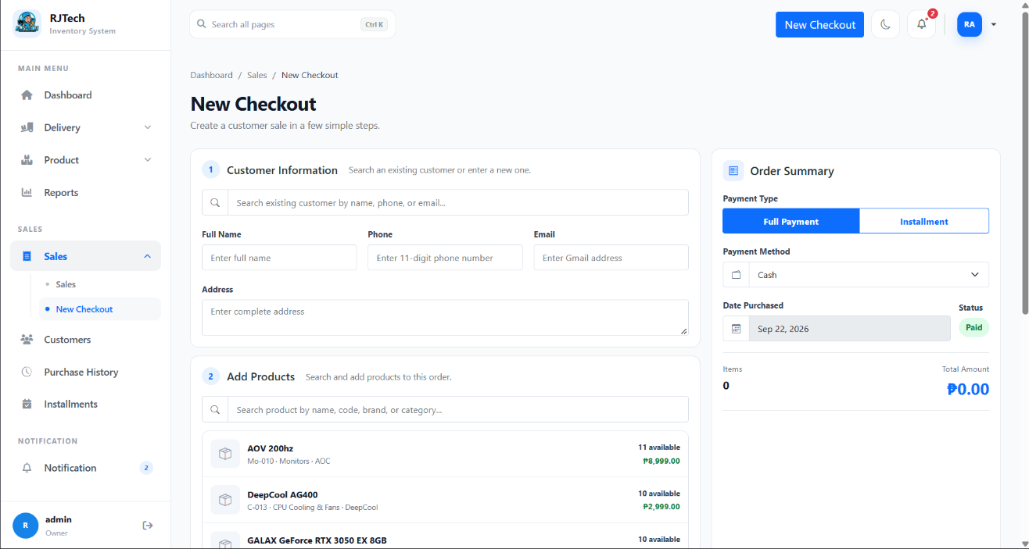
Figure 3.24: User Interface for New Checkout
Description: The New Checkout page is where a sale is processed, from recording customer information and adding products to choosing a full payment or installment plan.

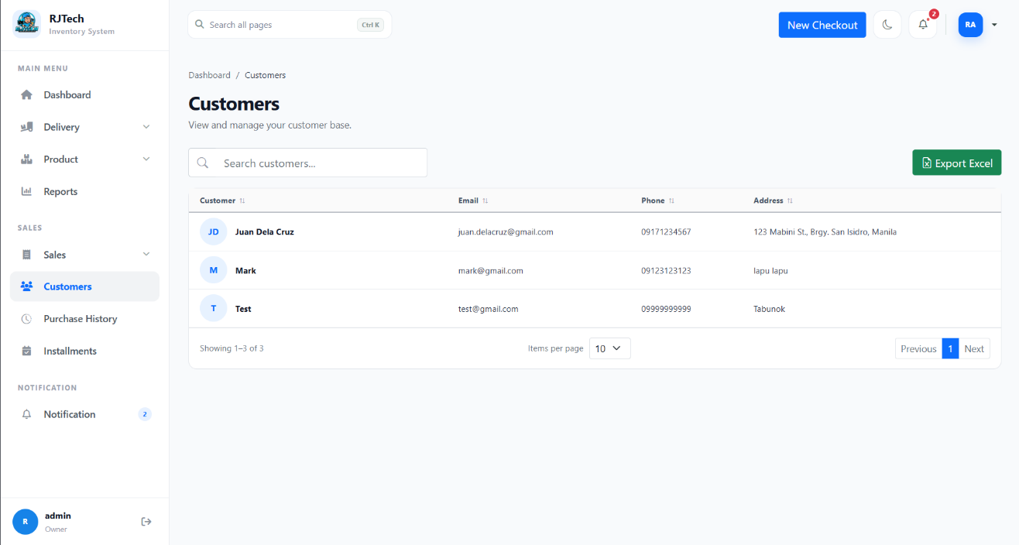
Figure 3.25: User Interface for Customers
Description: The Customers page stores and displays customer contact details so the owner can easily look up and manage their customer base.

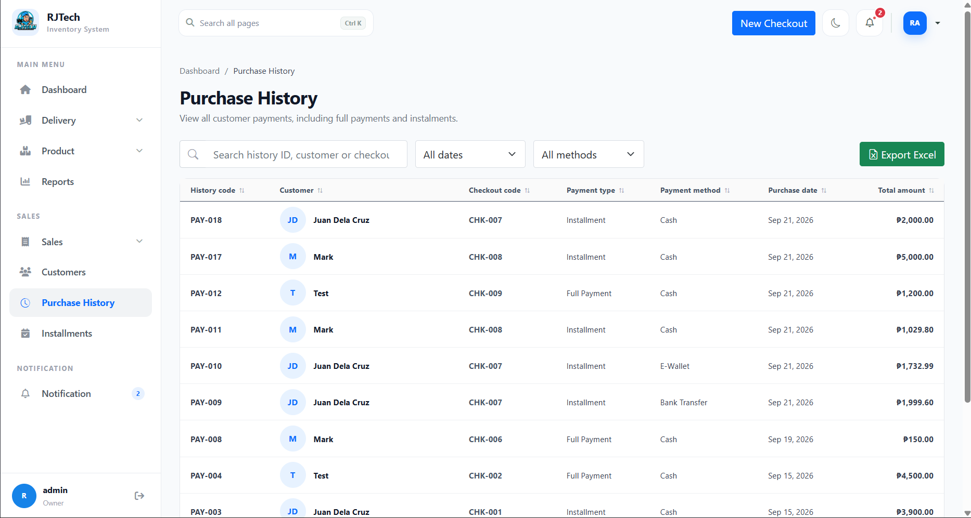
Figure 3.26: User Interface for Purchase History
Description: The Purchase History page keeps a complete record of every payment made, including the customer, payment type, method, date, and amount.

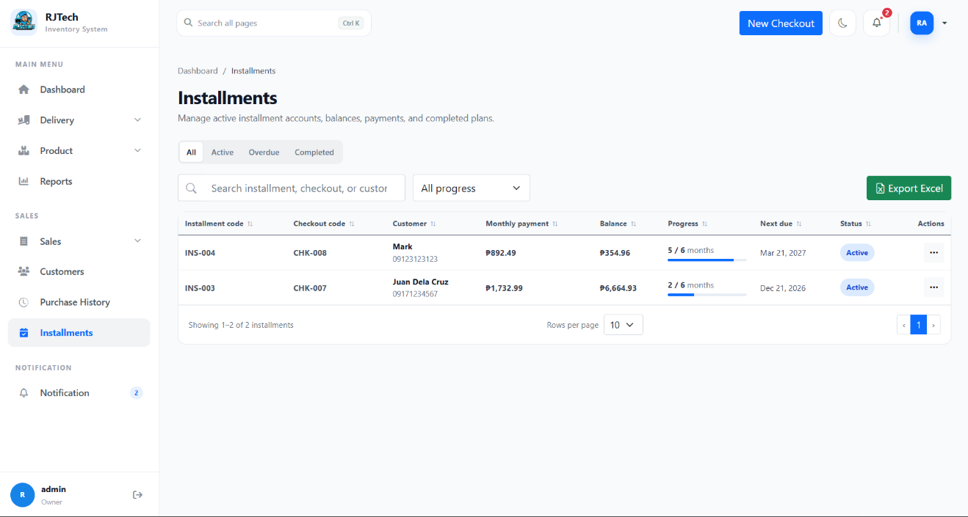
Figure 3.27: User Interface for Instalment
Description: The Installment page helps the owner monitor customers' payment plans by showing balances, progress, due dates, and whether an account is active, overdue, or completed.

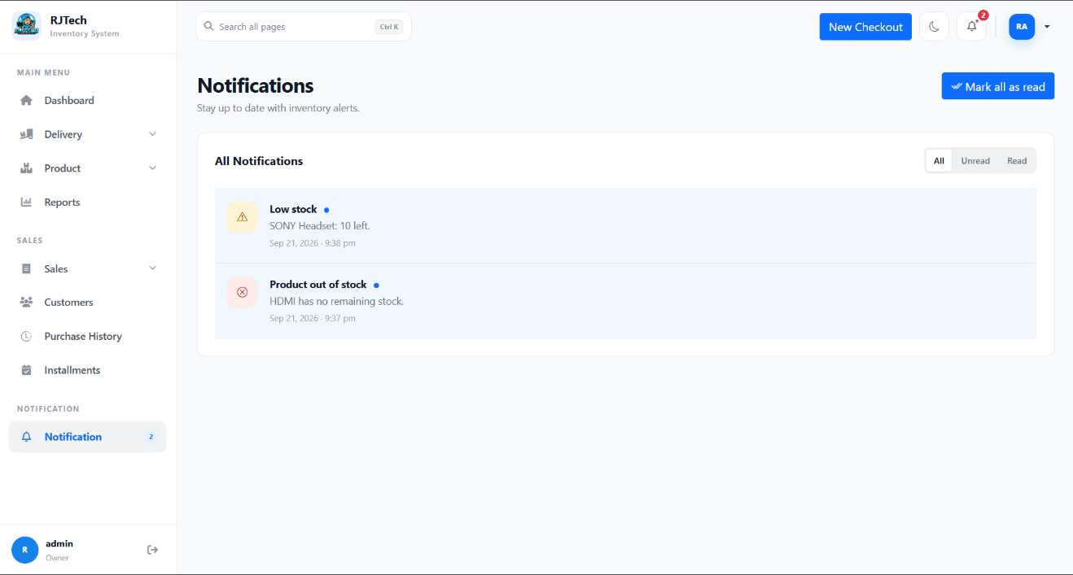
Figure 3.28: User Interface for Notifications
Description: The Notifications page is designed to alert the owner about important inventory updates, such as low or out-of-stock items.

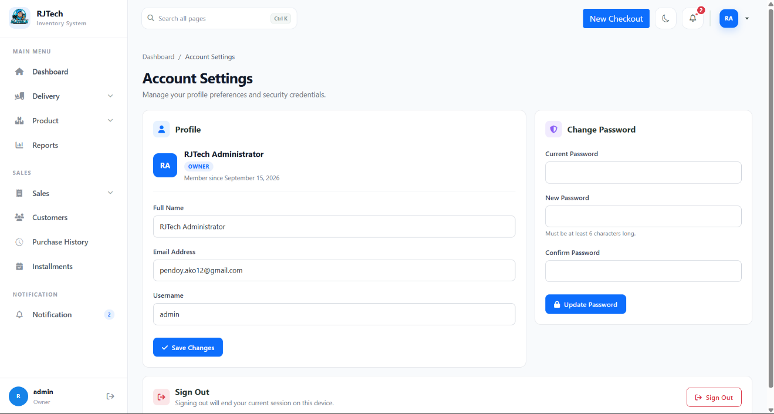
Figure 3.29: User Interface for Account Settings
Description: The Account Settings page allows the user to update their profile information, change their password, and sign out of the system

- Ethical Considerations
In conducting the study on Web-Based Sales and Inventory Management System for RJTech Cmputers, the researchers strictly adhere to ethical standards to ensure the integrity, privacy, and safety of all participants and data. The research process emphasized transparency, confidentiality, and responsible handling of information.

Informed Consent – Staff and Owner were fully informed about the purpose and scope of the study and voluntarily participated. They understood that their responses and operational data would be used solely for system development and research purposes.

Privacy and Confidentiality - All personal data, including Customer Information, User’s Information and payment records, were treated with strict confidentiality. Only authorized researchers and Admin had access to sensitive information.

Responsible Use of AI - AI tools were employed exclusively to improve sentence structure, grammar, and clarity in written documentation. The use of AI did not influence the ideas, findings, or decisions in the research. The original contributions, data collection, and system design remained entirely the work of the researchers.

Data Protection and Security - Collected data were securely stored and protected to prevent unauthorized access or misuse. They system ensures that customer information is encrypted and only accessible to authorized personnel.

Chapter IV

RESULT AND ANALYSIS

The System Usability Scale (SUS) is a widely used tool to check how easy and user-friendly software, websites, and other technological systems are. It helps collect feedback from users and measure their thoughts about how easy it is to use a system. In our study, we used the SUS to see what participants thought about the usability of a specific system [7]. This report shares the results, analysis, and discussion of the SUS survey. It gives us a better understanding of what participants experienced and what they think about how easy the system is to use.
In this study, the researcher utilized the System Usability Scale (SUS) survey to assess how easy and practical the application was to use. The SUS survey consists of 10 questions, which were designed to gather feedback from users by presenting statements in both positive and negative ways. A total of 10 individuals participated in the survey, providing their valuable insights based on their experience with the application. Each question in the survey was rated on a scale of 1 to 5, allowing participants to indicate their level of agreement or disagreement.
5 | Strongly Agree
4 | Agree
3 | Neutral
2 | Disagree
1 | Strongly Disagree
Table 4.1: Likert Agreement Scale
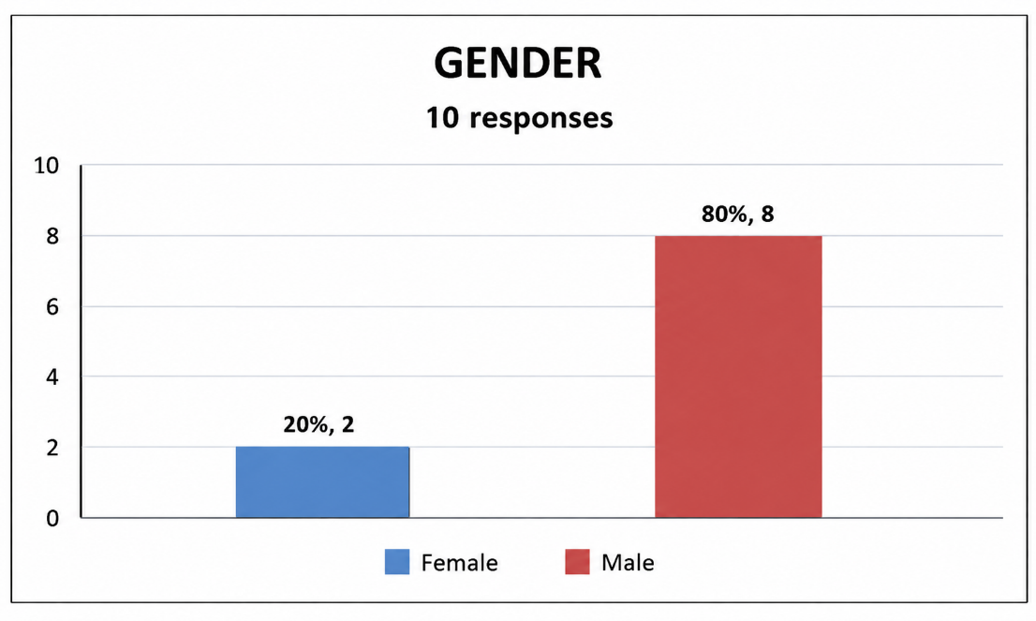
Chart 4.1: System Usability Scale for Gender
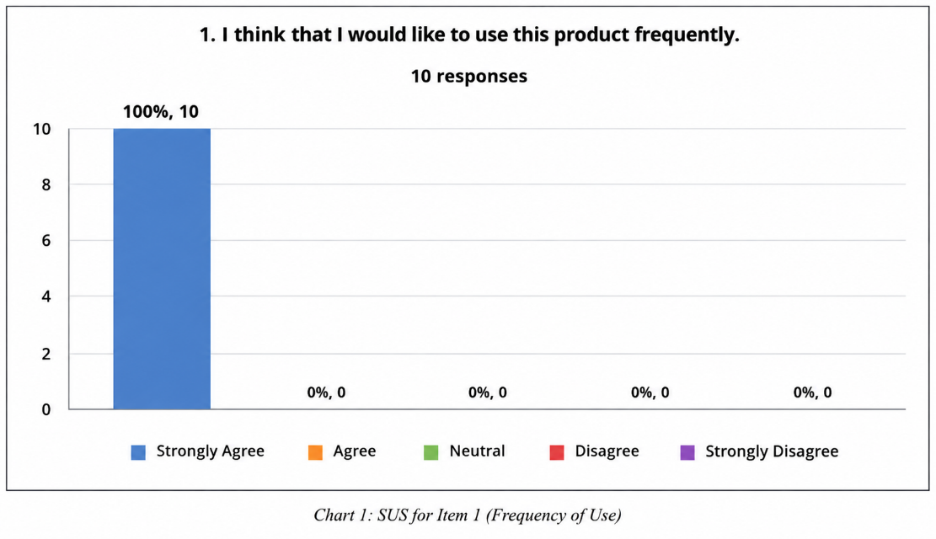
A majority of the respondents were male (80%), while 20% were female. This indicates that male respondents comprised the larger portion of the 10 participants included in the study.
Chart 4.2: System Usability Scale for Likelihood of Using the Product
All respondents (100%) strongly agreed that they would like to use the product frequently. No respondents disagree or strongly disagreed, and no neutral opinions were expressed.
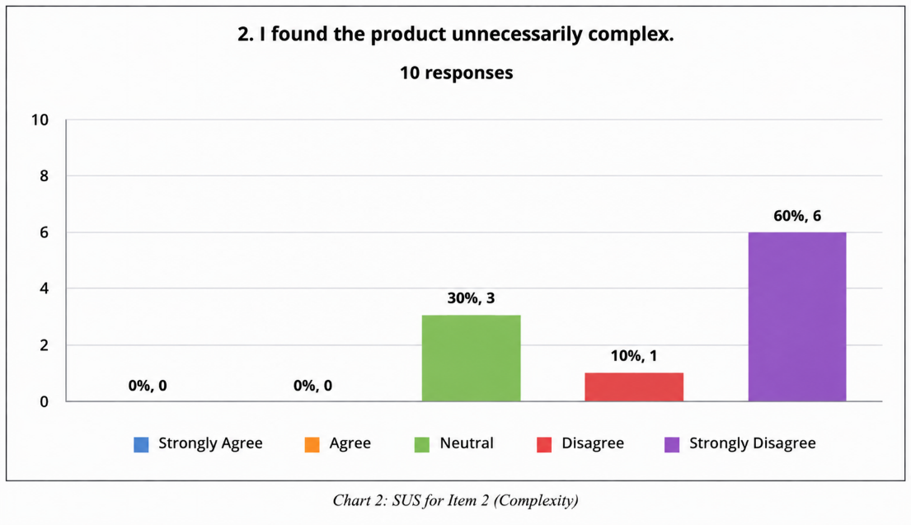
Chart 4.3: System Usability Scale for Complexity of the Product
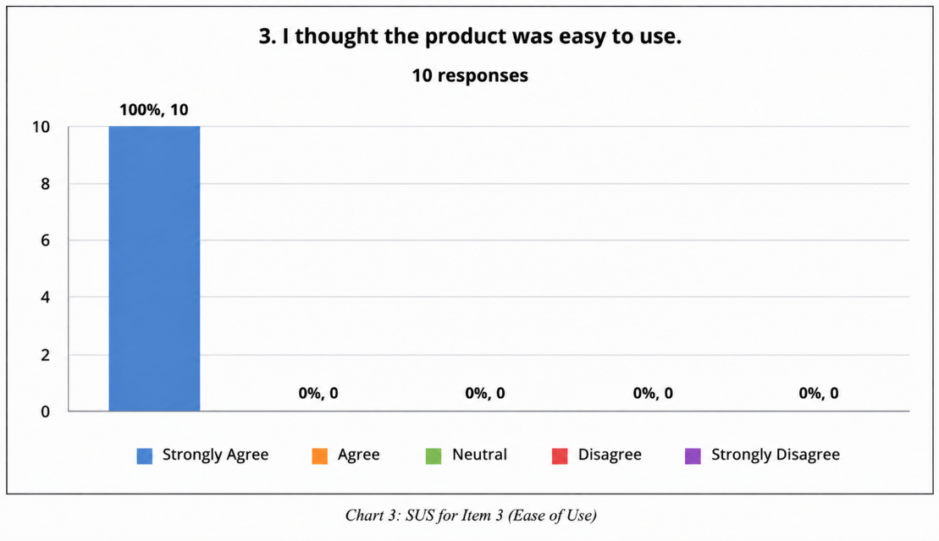
A significant proportion of respondents (60%) strongly disagreed about whether they found the product unnecessarily complex. Meanwhile, 30% remained neutral, 10% disagreed. No respondents agree or strongly agreed were expressed.
Chart 4.4: System Usability Scale for Ease of Use
All respondents (100%) strongly agreed that the product was easy to use. No respondents disagree or strongly disagreed, and no neutral opinions were expressed.
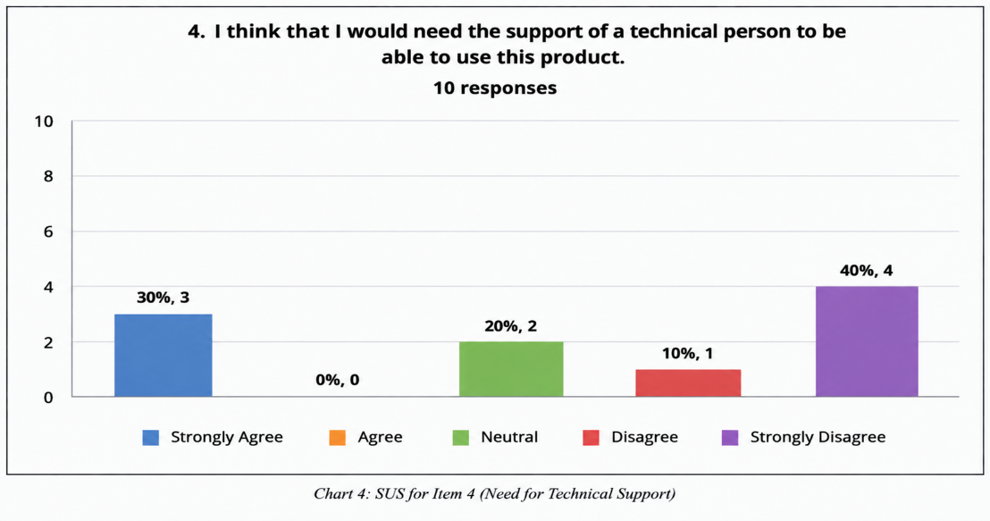
Chart 4.5: System Usability Scale for Need for Technical Support
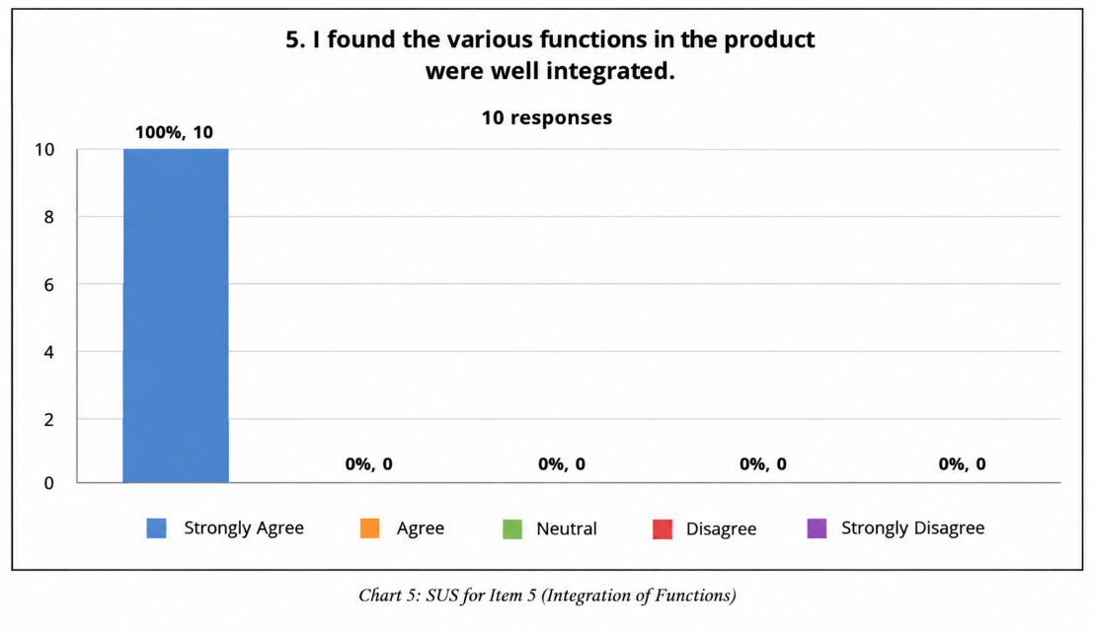
A significant proportion of respondents (40%) strongly disagreed about needing the support of a technical person to use the product. Meanwhile, 30% strongly agreed, 20% remained neutral, and 10% disagreed, with the system.
Chart 4.6: System Usability Scale for Integration of Functions
All respondents (100%) strongly agreed that the various functions in the product were well integrated. No respondents disagree or strongly disagreed, and no neutral opinions were expressed.

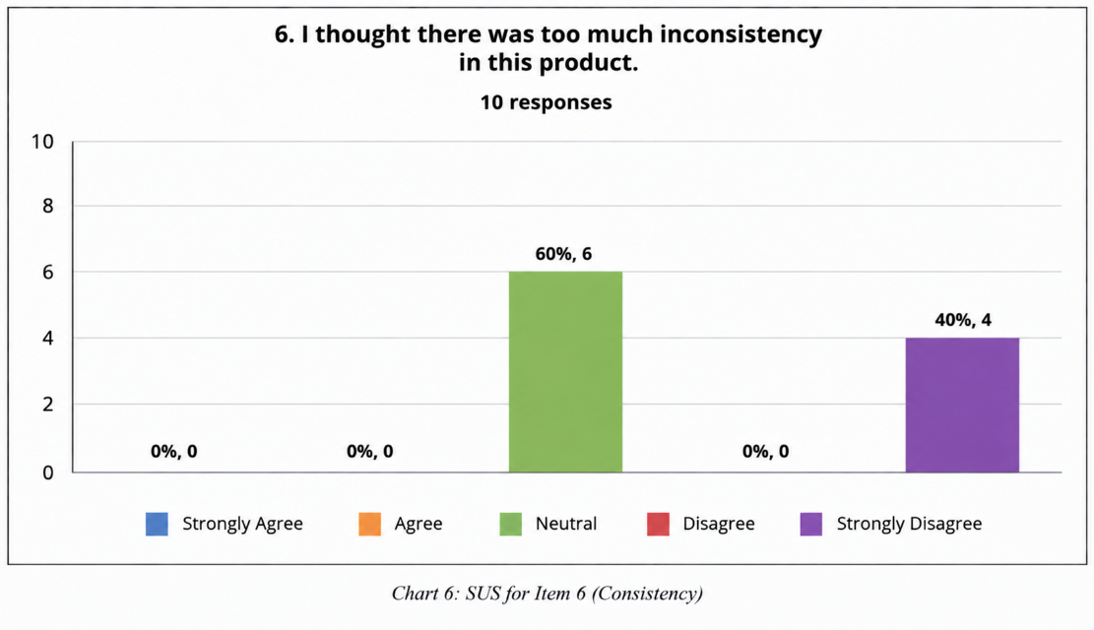
Chart 4.7: System Usability Scale for Consistency of the Product
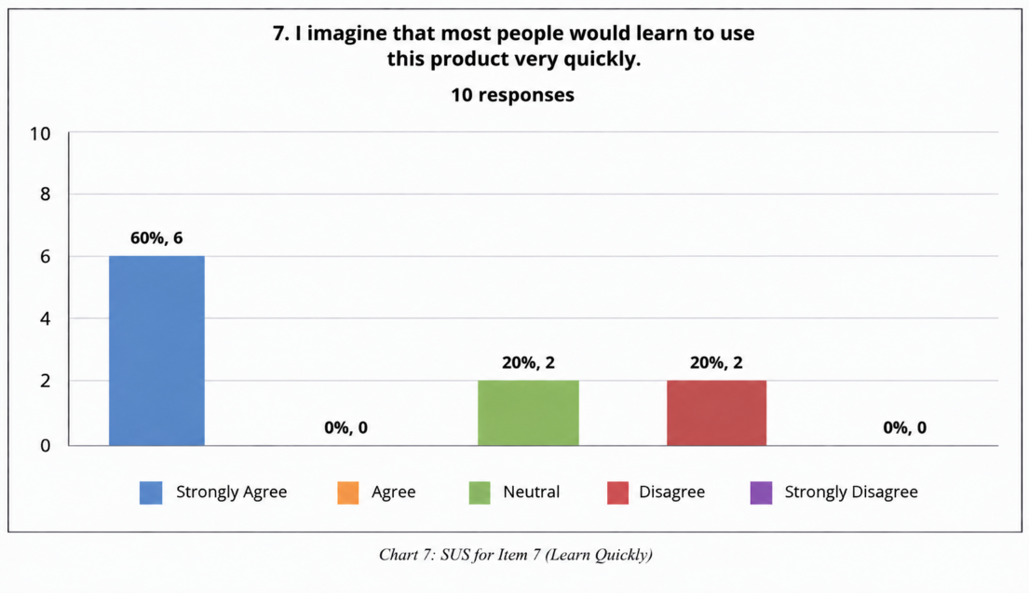
A significant proportion of respondents (60%) remained neutral about whether there was too much inconsistency in the product, while 40% strongly disagreed. No respondents agree or strongly agreed opinions were expressed.
Chart 4.8: System Usability Scale for Quick Learning Curve
A significant proportion of respondents (60%) strongly agreed about whether most people would learn to use the product very quickly, while 20% remained neutral and 20% disagreed with the statement.
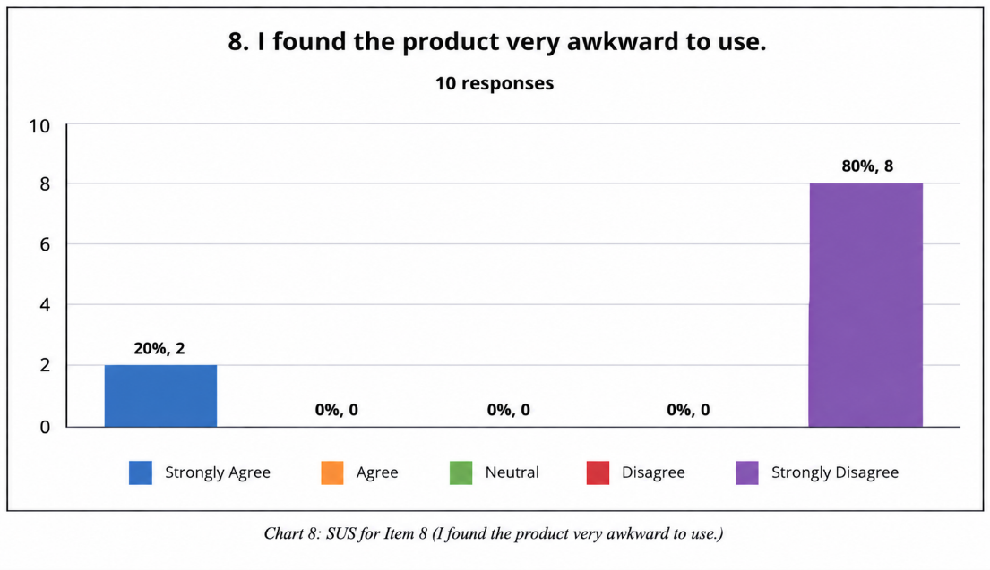
Chart 4.9: System Usability Scale for Awkwardness of Use
A significant proportion of respondents (80%) strongly disagreed that they found the product very awkward to use, while 20% strongly agreed with the statement.
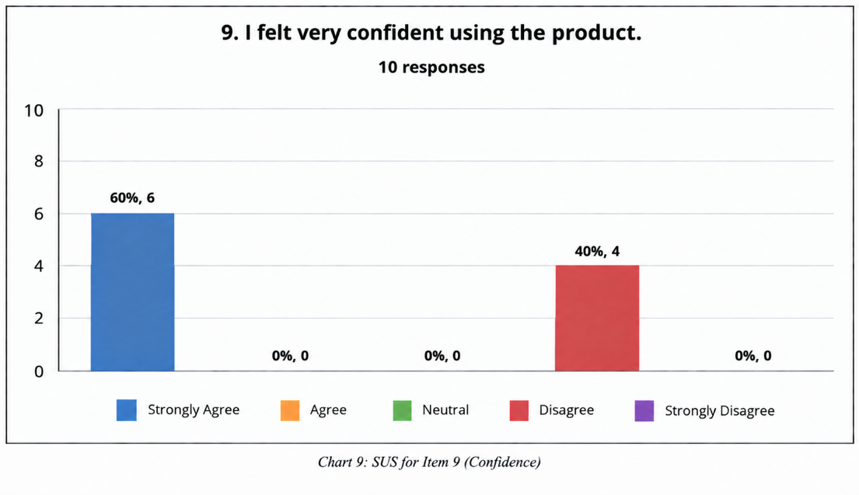
Chart 4.10: System Usability Scale for Confidence in Using the Product
A significant proportion of respondents (60%) strongly agreed that they felt very confident using the product, while 40% disagreed with the statement.

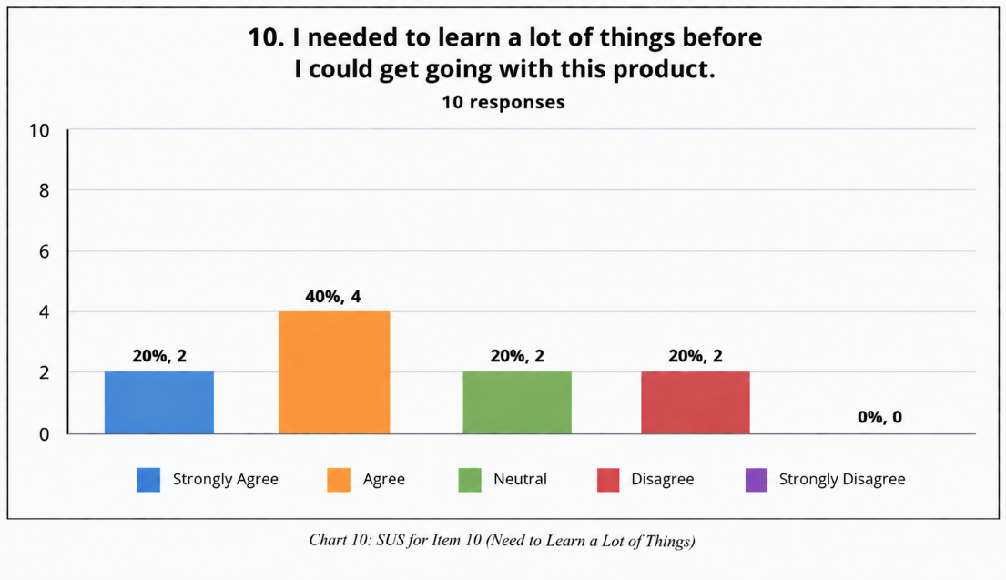
Chart 4.11: System Usability Scale for Learning Curve
A significant portion of respondents (40%) agreed about needing to learn many things before using the product, while 20% strongly agreed, 20% remained neutral and 20% disagreed with the statement.

Chapter V
Discussion of Results

The system's usability score was assessed by calculating each respondent's SUS score using a specific formula: SUS Score = (X + Y) x 2.5. Here, X represents the sum of points for all odd-numbered questions minus 5, and Y is calculated as 25 minus the sum of points for all even-numbered questions [7].
The SUS score serves as an indicator of the application's performance in terms of usability, encompassing factors like effectiveness, efficiency, and overall ease of use [7].
Below is a general guideline to help interpret the SUS score:

SUS Score | Grade | Adjective Rating
> 80.3 | A | Excellent
68 – 80.3 | B | Good
68 | C | Okay
51 – 68 | D | Poor
< 51 | E | Awful
Table 5.1: SUS Score Guidelines

Respondent No. | SUS Score | Grade | Adjective Rating
1 | 82.5 | A | Excellent
2 | 82.5 | A | Excellent
3 | 90.0 | A | Excellent
4 | 90.0 | A | Excellent
5 | 75.0 | B | Excellent
6 | 70.0 | B | Good
7 | 70.0 | B | Good
8 | 70.0 | B | Good
9 | 90.0 | A | Excellent
10 | 85.0 | A | Excellent
Table 5.2: Respondent’s Individual SUS Score with Grade and Adjective Rating
The table shows the individual SUS scores of the respondents, along with their corresponding grade and adjective rating. Among the 10 respondents, the highest SUS score was 90.0, while the lowest was 70.0. A score of 90.0 indicates that the respondent found the application highly usable, reflecting a very positive user experience.

SUS Score | Grade | Adjective Rating
80.5 | A | Excellent
Table 5.3 Overall SUS Score with Grade and Adjective Rating
Using the SUS formula, the system's overall usability score was calculated to be 80.5, which falls into the "Excellent" category (Grade A). This indicates that the application is well-received by users and provides a favorable user experience overall.
Chapter VI
Summary, Conclusions and Recommendations

- Summary
This study focused on the development of a Web-Based Sales and Inventory Management System for RJTech Computers. The system was created to help address the difficulties of managing products, inventory, sales, payments, and records using manual processes. Its main purpose was to provide one system where these activities could be managed in a more organized way. The system includes product management, inventory monitoring, sales and payment recording, stock notifications, report generation, and user access control. The researchers used interviews, observation, and User Acceptance Testing to understand the needs of RJTech Computers and evaluate the developed system.
The system was developed using ASP.NET MVC, C#, HTML, CSS, JavaScript, and Microsoft SQL Server. It provides a centralized database where important sales and inventory information can be stored and managed. Through these features, the system helps reduce manual work and makes business records easier to organize and access.

- Conclusion
The development of the Web-Based Sales and Inventory Management System for RJTech Computers provides the business with a more organized way to manage its daily sales and inventory activities. Instead of relying mainly on manual records, users can manage product information, monitor stocks, record sales and payments, and view reports through one system.
The system also helps keep inventory information updated when sales are recorded. Stock notifications can help users notice products that need attention, while the report feature allows them to view their sales and inventory information for different periods. These functions make it easier for the business to keep track of its records and daily activities.
Overall, the system meets the main needs identified by the study and provides RJTech Computers with a practical tool for managing its sales and inventory processes. It also provides a foundation for possible improvements and additional features in the future.

- Recommendations
Based on the study, it is recommended that RJTech Computers continue using and maintaining the developed system for its daily sales and inventory activities. Users should regularly update product, stock, sales, and payment records to keep the information accurate and up to date. Regular maintenance should also be done to make sure that the system continues to work properly.
The system may also be improved in the future by adding features that are not included in its current scope. These may include mobile access, support for additional branches, and advanced accounting functions.
Future researchers may also improve the system by adding other features that can help businesses manage their sales and inventory more effectively. They may conduct further studies with more users to identify additional needs and possible improvements for future versions of the system.

REFERENCES

- Zoho Corporation, “Zoho Inventory,” 2024. [Online]. Available:
https://www.zoho.com/inventory. [Accessed: Feb. 22, 2026].
- ECount Inc., “ECount ERP System,” 2024. [Online]. Available:
https://www.ecount.com. [Accessed: Feb. 22, 2026].
- Odoo S.A., “Odoo ERP,” 2024. [Online]. Available: https://www.odoo.com.
[Accessed: Feb. 22, 2026].
- Archon Systems Inc., “inFlow Inventory,” 2024. [Online].
Available: https://www.inflowinventory.com. [Accessed: Feb. 22, 2026].
- Pipedrive Inc., “Pipedrive CRM,” 2024. [Online]. Available: https://www.pipedrive.com. [Accessed: Feb. 22, 2026].
- Intuit Inc., “QuickBooks,” 2024. [Online]. Available:
https://quickbooks.intuit.com. [Accessed: Feb. 22, 2026].

APPENDICES
Appendix A. System Specifications
Hardware Specification
The table below presents the minimum and recommended hardware specifications needed to develop, deploy, and run the Web-Based Sales and Inventory Management System.

Component | Minimum Requirement | Recommended Requirement
Processor | Intel Core i3 (8th Gen) or AMD Ryzen 3 or equivalent | Intel Core i5 (10th Gen) or AMD Ryzen 5 or higher
Memory (RAM) | 4 GB | 8 GB or higher
Storage | 128 GB HDD/SSD with at least 10 GB free space | 256 GB SSD or higher
Display | 1366 × 768 resolution | 1920 × 1080 (Full HD) resolution
Network | Stable internet connection for database access and system services | Broadband connection with at least 10 Mbps
Peripherals | Keyboard, mouse, and printer for receipts/reports | Keyboard, mouse, thermal receipt printer, and backup storage device

Software Specification
The table below presents the software requirements used to build and run the system, based on the actual technology stack implemented in the Web-Based Sales and Inventory Management System.
Category | Current Technology | Description & Notes
Operating System | Windows (Development) | Uses SQL Server LocalDB during development on Windows. Production OS is to be determined.
Web Framework | ASP.NET Core MVC (.NET 8) | Built with .NET 8 using MVC controllers, Razor views, and standard routing.
Database Management System | Microsoft SQL Server | Uses RJTechInventory on SQL Server LocalDB (MSSQLLocalDB) for local development.
ORM / Data Access | Entity Framework Core 8 | Handles database queries, migrations, and schema updates using SQL Server providers.
Authentication & Security | Cookie Authentication & Hashing | Uses application cookie login, hashed passwords, HTTPS, and email-based password resets.
View Rendering | Razor Views (.cshtml) | Server-renders dynamic HTML pages using ASP.NET Core Razor views and Tag Helpers.
Front-End Libraries | Bootstrap, jQuery, Font Awesome | Uses Bootstrap for layout, jQuery for client-side scripting/validation, and Font Awesome for icons.
IDE / Development Tools | Visual Studio 2026 & .NET 8 SDK | Developed in Visual Studio with standard .NET 8 SDK tooling and User Secrets for local API keys.
Database Tools | EF Core Migrations & SQL Scripts | Manages database updates via EF Core migrations and custom SQL scripts for test data.
Version Control | Git | Tracks project code changes on the master branch in a Git repository.

Appendix B. Flow of the System
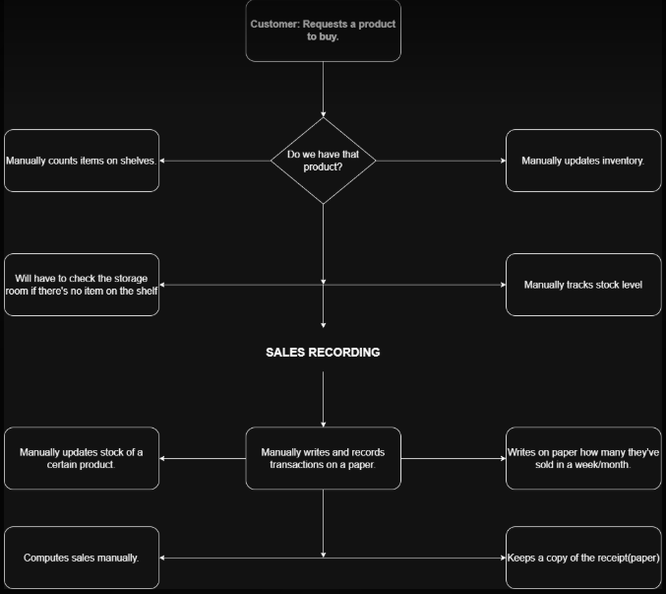
Current Flow of the System

Figure B.1: Current Flow of the System

Proposed Flow of the System

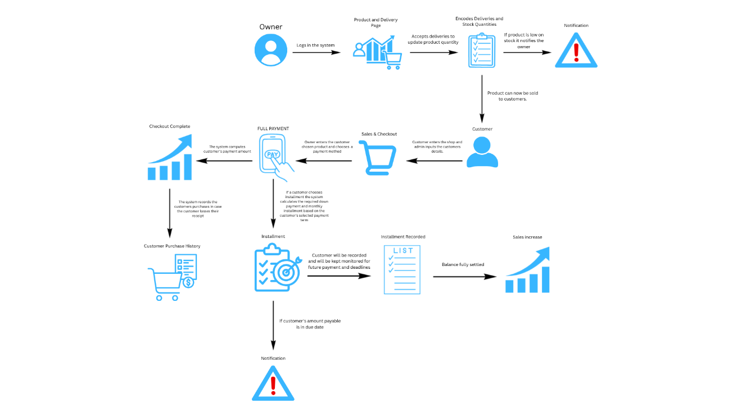

Figure B.2: Proposed Flow of the System

Appendix C. Application Prototype
The application prototype serves as the initial functional model of the proposed RJTech Sales and Inventory Management System, showcasing its main features and user interface. The prototype includes essential modules such as product and inventory management, delivery and stock monitoring, sales and checkout, customer management, installment payment tracking, notifications, reports, and user access. It also allows the development team to evaluate the system’s functionality, gather feedback, refine system requirements, and make necessary improvements before full-scale implementation.

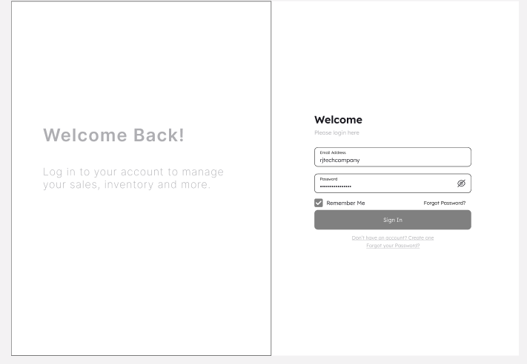

Figure C.1: Login Page Prototype
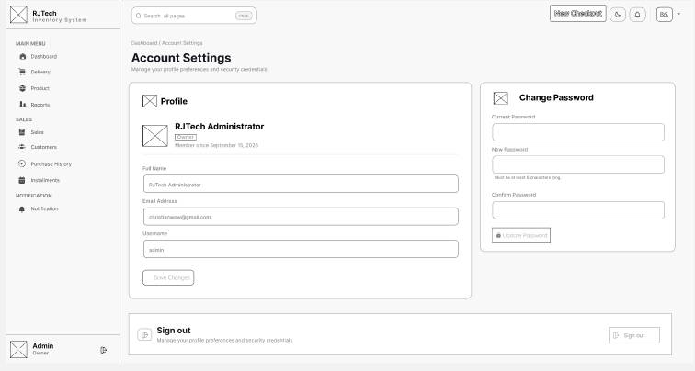
Figure C.2: Dashboard Prototype

Figure C.3: Delivery Prototype

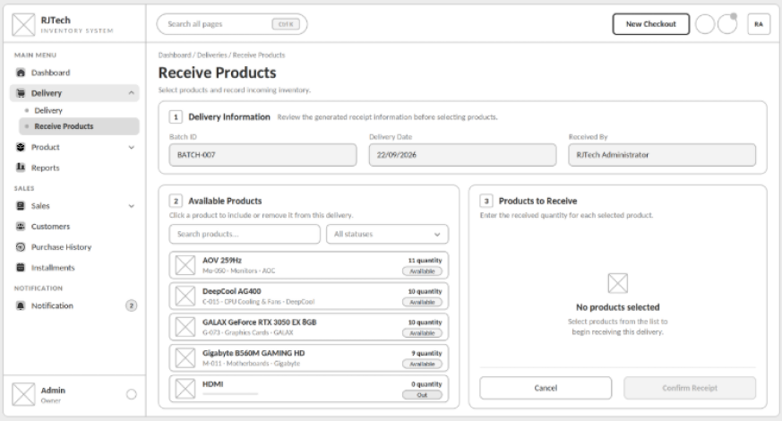
Figure C.4: Receive Products Prototype
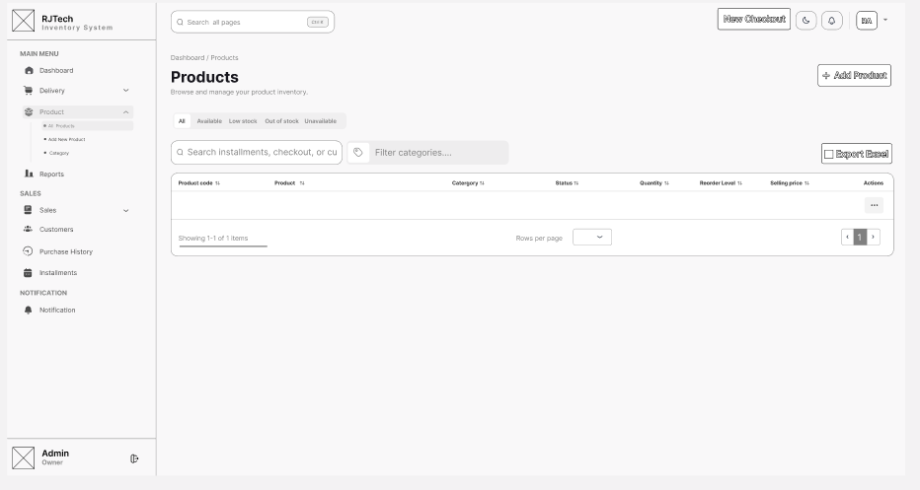

Figure C.5: Products Prototype

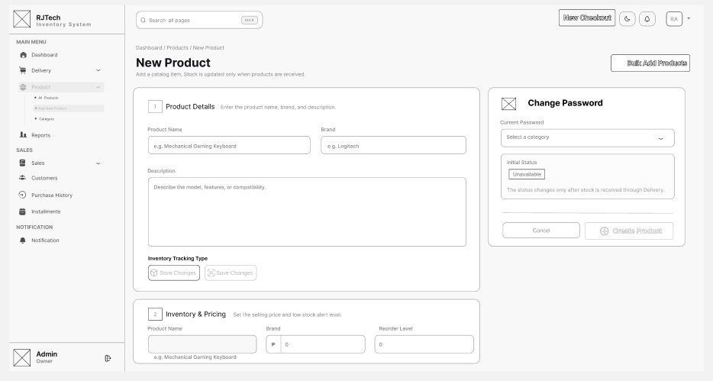
Figure C.6: New Products Prototype
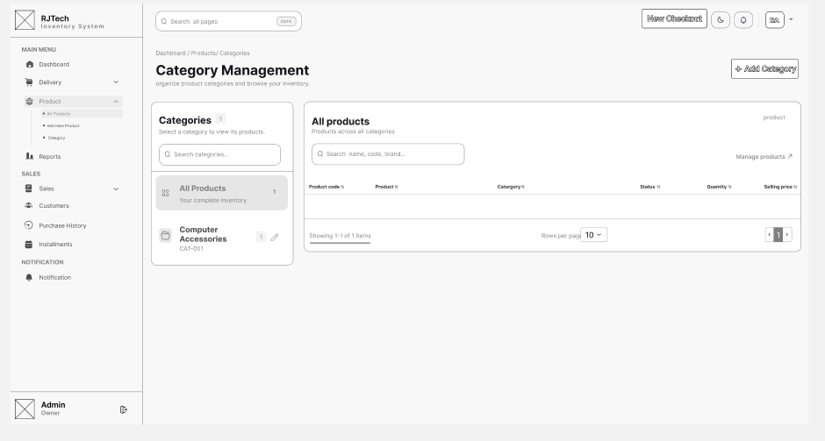

Figure C.7: Category Prototype

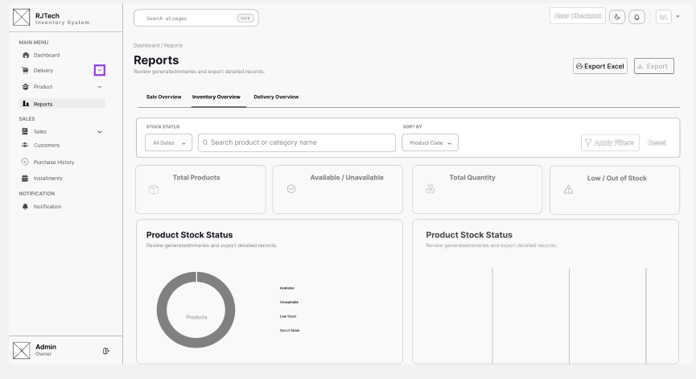
Figure C.8: Reports Prototype
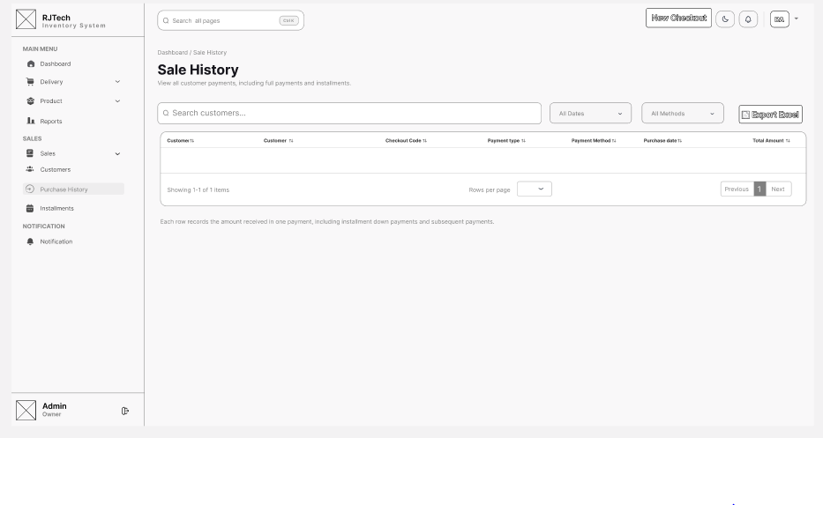

Figure C.9: Sales Prototype

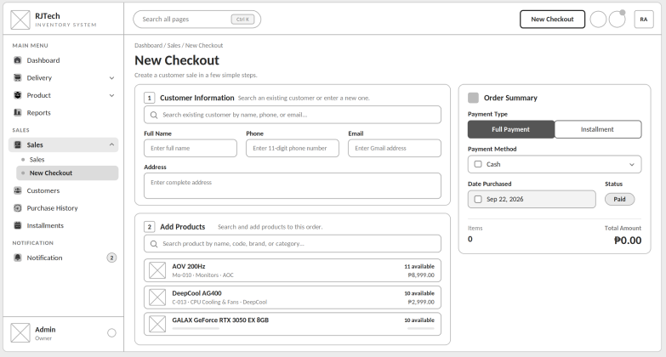
Figure C.10: New Checkout Prototype
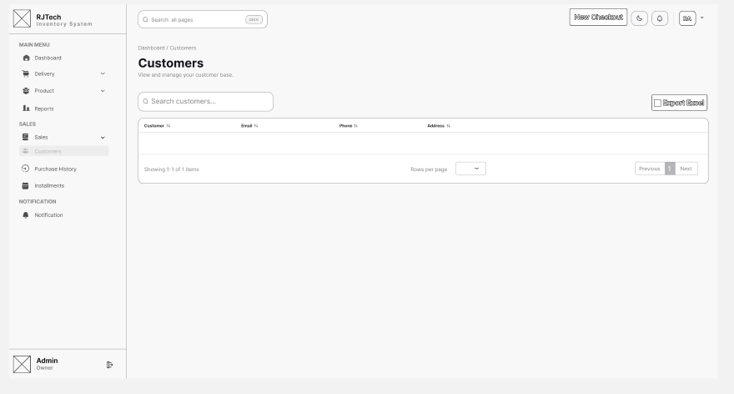

Figure C.11: Customers Prototype

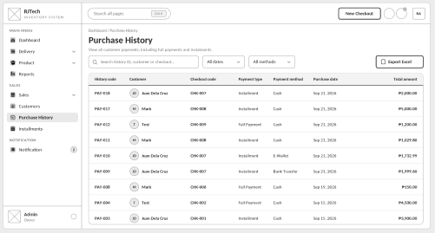
Figure C.12: Purchase History Prototype

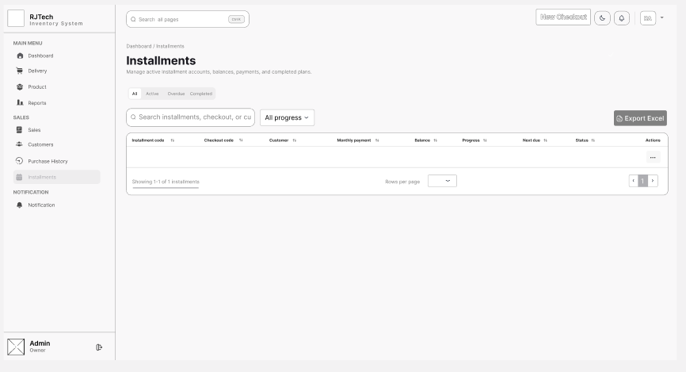

Figure C.13: Instalment Prototype

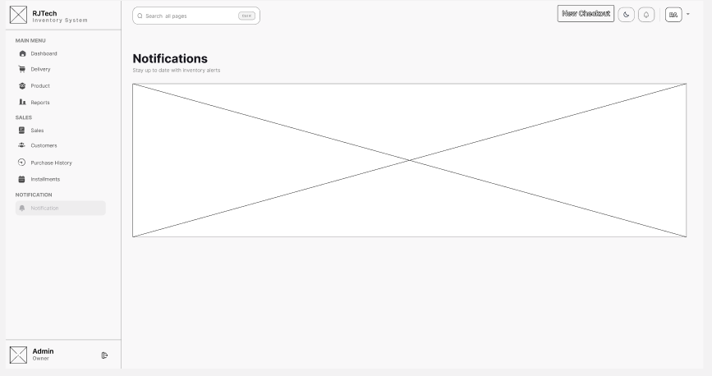

Figure C.14: Notifications Prototype
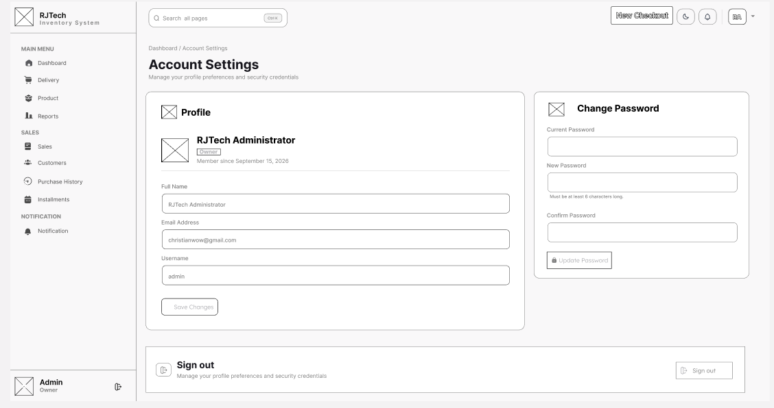

Figure C.15: Account Settings Prototype

Appendix D. Sample Program Code

[HttpPost]
public IActionResult CompleteDelivery([FromBody] DeliveryCompleteRequest request)
{
if (request == null || string.IsNullOrWhiteSpace(request.received_by) ||
request.items == null || request.items.Count == 0)
return Json(new { success = false, message = "Complete the delivery information and select at least one product." });

if (request.items.Any(item => item.quantity <= 0))
return Json(new { success = false, message = "Every delivery item must have a whole-number quantity of at least one." });
if (request.items.GroupBy(item => item.product_ID).Any(group => group.Count() > 1))
return Json(new { success = false, message = "A product can only appear once in a delivery." });

int[] productIds = request.items.Select(item => item.product_ID).ToArray();
var products = _db.Products
.Where(product => productIds.Contains(product.product_ID))
.ToDictionary(product => product.product_ID);
if (products.Count != productIds.Length)
return Json(new { success = false, message = "One or more selected products no longer exist." });

using var transaction = _db.Database.BeginTransaction(IsolationLevel.Serializable);
try
{
DateTime receivedAt = DateTime.Now;

var delivery = new Delivery
{
date_delivered = receivedAt,
received_by = request.received_by.Trim(),
// SQL Server assigns delivery_ID during the first save.
batch_ID = $"PENDING-{Guid.NewGuid():N}"
};
_db.Deliveries.Add(delivery);
_db.SaveChanges();

// Both displayed identifiers use the same database identity.
delivery.batch_ID = delivery.FormattedBatchID;

foreach (var requestedItem in request.items)
{
var product = products[requestedItem.product_ID];
bool isInitialReceipt = product.product_status == "Unavailable";
int previousQuantity = isInitialReceipt ? 0 : product.product_quantity;
int newQuantity = checked(previousQuantity + requestedItem.quantity);

delivery.DeliveryDetails.Add(new DeliveryDetails
{
product_quantity = requestedItem.quantity,
previous_quantity = previousQuantity,
new_quantity = newQuantity,
product_ID = product.product_ID,
Product = product
});

product.product_quantity = newQuantity;
product.product_status = "Available";
product.product_status = ProductController.EvaluateProductStatus(product);
}

_db.SaveChanges();
transaction.Commit();

return Json(new
{
success = true,
message = "Delivery completed and recorded.",
redirectUrl = Url.Action(nameof(Details), new { id = delivery.delivery_ID }),
delivery = new
{
delivery_ID = delivery.delivery_ID,
delivery_code = delivery.FormattedDeliveryID,
batch_ID = delivery.FormattedBatchID,
date_delivered = delivery.date_delivered,
received_by = delivery.received_by,
items = delivery.DeliveryDetails.Select(detail => new
{
detail.product_ID,
quantity = detail.product_quantity,
detail.previous_quantity,
detail.new_quantity
}).ToList()
}
});
}
catch (Exception exception)
{
transaction.Rollback();
_logger.LogError(exception, "Error completing delivery.");
return Json(new { success = false, message = "An error occurred while completing the delivery." });
}
}

//Export to Excel file for Sales Summary
[HttpPost]
[ValidateAntiForgeryToken]
[ResponseCache(NoStore = true, Location = ResponseCacheLocation.None)]
public Task<IActionResult> SalesSummary(
[FromBody] ExcelExportSelection? selection,
CancellationToken cancellationToken = default)
=> ExportAsync(selection, "SALES SUMMARY", "SalesSummary",
[
new("Checkout ID", MinWidth: 12, MaxWidth: 15),
new("Customer", MinWidth: 25, MaxWidth: 30),
new("Payment Type", MinWidth: 18, MaxWidth: 22),
new("Payment Method", MinWidth: 18, MaxWidth: 22),
new("Date Purchased", ExcelColumnType.Date, 18, 20),
new("Status", ExcelColumnType.Status, 15, 20),
new("Total Amount", ExcelColumnType.Currency, 15, 18)
], async (ids, token) =>
{
// Match Sales Summary's applicable records, including refunded sales.
var query = _db.Checkouts.AsNoTracking().Where(checkout => checkout.Status != "Cancelled");
if (ids != null)
query = query.Where(checkout => ids.Contains(checkout.CheckoutID));

var checkouts = await query
.OrderByDescending(checkout => checkout.DatePurchased)
.ThenByDescending(checkout => checkout.CheckoutID)
.Select(checkout => new
{
checkout.CheckoutID,
CustomerName = checkout.Customer == null ? "Unknown customer" : checkout.Customer.customer_FullName,
checkout.PaymentType,
checkout.PaymentMethod,
checkout.DatePurchased,
checkout.Status,
checkout.TotalAmount
})
.ToListAsync(token);

return ToRows(checkouts, checkout =>
[
$"CHK-{checkout.CheckoutID:D3}",
checkout.CustomerName,
checkout.PaymentType,
checkout.PaymentMethod,
checkout.DatePurchased,
checkout.Status,
checkout.TotalAmount
]);
}, cancellationToken);

//Record instalment Payment
[HttpPost]
[ValidateAntiForgeryToken]
public async Task<IActionResult> RecordPayment(RecordInstallmentPaymentViewModel request)
{
if (!ModelState.IsValid)
{
string message = ModelState.Values
.SelectMany(value => value.Errors)
.Select(error => error.ErrorMessage)
.FirstOrDefault() ?? "Enter valid payment information.";
return Json(new { success = false, message });
}

var result = await _installments.RecordPaymentAsync(
request.InstallmentID,
request.PaymentAmount,
request.PaymentMethod);

if (!result.Success)
return Json(new { success = false, message = result.Message });

return Json(new
{
success = true,
message = result.Message,
paymentID = result.PaymentID,
installmentID = result.InstallmentID,
installmentCode = result.InstallmentCode,
amount = result.PaymentAmount,
balance = result.Balance,
completed = result.Completed,
monthsPaid = result.MonthsPaid,
monthsRemaining = result.MonthsRemaining,
status = result.Status,
nextDue = result.NextDue?.ToString("yyyy-MM-dd"),
progressPercentage = result.ProgressPercentage
});
}

//get Product Notifications Alerts
[HttpGet]
public IActionResult GetNotifications(int limit = 6)
{
_stockNotifications.Synchronize();
_installmentNotifications.Synchronize();
var notifications = _db.Notifications
.AsNoTracking()
.OrderByDescending(item => item.created_at)
.Take(Math.Clamp(limit, 1, 20))
.ToList()
.Select(ToNotificationResponse)
.ToList();

return Json(new
{
success = true,
unreadCount = _db.Notifications.Count(item => !item.is_read),
notifications
});
}

[HttpPost]
public IActionResult MarkAsRead(int id)
{
var notification = _db.Notifications.Find(id);
if (notification == null)
return Json(new { success = false, message = "Notification not found." });

notification.is_read = true;
_db.SaveChanges();
return Json(new { success = true, message = "Notification marked as read." });
}

[HttpPost]
public IActionResult MarkAllAsRead()
{
var unreadNotifications = _db.Notifications.Where(item => !item.is_read).ToList();
unreadNotifications.ForEach(item => item.is_read = true);
_db.SaveChanges();
return Json(new { success = true, message = "All notifications marked as read." });
}

//Add Product with validation and error handling
[HttpPost]
public IActionResult Create([FromForm] ProductCreateViewModel model)
{
ModelState.Remove("Category");

if (!ModelState.IsValid)
{
var errors = ModelState.Values.SelectMany(value => value.Errors).Select(error => error.ErrorMessage);
return Json(new { success = false, message = "Validation failed.", errors });
}

string normalizedName = NormalizeProductIdentity(model.product_name);
string normalizedBrand = NormalizeProductIdentity(model.product_brand);
if (string.IsNullOrWhiteSpace(normalizedName) || string.IsNullOrWhiteSpace(normalizedBrand))
return Json(new { success = false, message = "Validation failed.", errors = new[] { "Product name and brand are required." } });

bool categoryExists = _db.ProductCategories.Any(category => category.category_ID == model.category_ID);
if (!categoryExists) return Json(new { success = false, message = "Select a valid category." });

bool alreadyExists = _db.Products.Any(existing =>
existing.category_ID == model.category_ID &&
existing.product_name == normalizedName &&
existing.product_brand == normalizedBrand);
if (alreadyExists) return Json(new { success = false, message = "Item Already Exists" });

var product = new Product
{
category_ID = model.category_ID,
product_name = normalizedName,
product_brand = normalizedBrand,
product_description = model.product_description?.Trim(),
product_quantity = 0,
reorder_level = model.reorder_level,
Product_price = model.Product_price,
product_status = "Unavailable",
is_serialized = model.IsSerialized
};
_db.Products.Add(product);
_db.SaveChanges();

var category = _db.ProductCategories.AsNoTracking().First(item => item.category_ID == model.category_ID);
return Json(new
{
success = true,
message = "Product created successfully!",
redirectUrl = Url.Action(nameof(Details), new { id = product.product_ID }),
data = ToProductResponse(product, category)
});
}

//Bulk create products with validation and error handling
[HttpPost]
public IActionResult BulkCreate([FromBody] BulkCreateProductsRequest request)
{
var rows = request?.products;
if (rows == null || rows.Count == 0)
return Json(new { success = false, message = "Add at least one product." });
if (rows.Count > 100)
return Json(new { success = false, message = "A bulk upload is limited to 100 products." });

var categories = _db.ProductCategories.AsNoTracking().ToDictionary(category => category.category_ID);
var existingProducts = _db.Products.AsNoTracking().ToList();
var errors = new List<string>();
var normalizedRows = new List<(BulkProductRowDto Row, string Name, string Brand)>();
var batchKeys = new HashSet<string>(StringComparer.OrdinalIgnoreCase);

for (int index = 0; index < rows.Count; index++)
{
var row = rows[index];
string name = NormalizeProductIdentity(row.product_name);
string brand = NormalizeProductIdentity(row.product_brand);
string label = $"Row {index + 1}";

if (!categories.ContainsKey(row.category_ID)) errors.Add($"{label}: select a valid category.");
if (string.IsNullOrWhiteSpace(name)) errors.Add($"{label}: product name is required.");
if (string.IsNullOrWhiteSpace(brand)) errors.Add($"{label}: brand is required.");
if (row.Product_price <= 0) errors.Add($"{label}: price must be greater than zero.");
if (row.reorder_level < 0) errors.Add($"{label}: reorder level cannot be negative.");

string key = $"{row.category_ID}|{name}|{brand}";
if (!batchKeys.Add(key)) errors.Add($"{label}: this product is duplicated in the bulk list.");
if (existingProducts.Any(existing => existing.category_ID == row.category_ID &&
string.Equals(NormalizeProductIdentity(existing.product_name), name, StringComparison.OrdinalIgnoreCase) &&
string.Equals(NormalizeProductIdentity(existing.product_brand), brand, StringComparison.OrdinalIgnoreCase)))
errors.Add($"{label}: item already exists.");

normalizedRows.Add((row, name, brand));
}

if (errors.Count > 0)
return Json(new { success = false, message = "Please correct the bulk product list.", errors });

var products = normalizedRows.Select(entry => new Product
{
category_ID = entry.Row.category_ID,
product_name = entry.Name,
product_brand = entry.Brand,
product_description = entry.Row.product_description?.Trim(),
product_quantity = 0,
reorder_level = entry.Row.reorder_level,
Product_price = entry.Row.Product_price,
product_status = "Unavailable",
is_serialized = entry.Row.IsSerialized
}).ToList();

_db.Products.AddRange(products);
_db.SaveChanges();

var createdProducts = products
.Select(product => ToProductResponse(product, categories[product.category_ID]))
.ToList();
return Json(new { success = true, message = $"{createdProducts.Count} products created successfully.", data = createdProducts });
}

//Create Sales Transaction
[HttpPost]
public IActionResult CompleteCheckout([FromBody] SaveCheckoutRequest? request)
=> request == null
? Json(new { success = false, message = "Checkout information is required." })
: SaveCheckout(request);

[HttpGet]
public IActionResult CheckSerialNumber(string? serialNumber)
{
string? normalizedSerial = NormalizeSerial(serialNumber);
if (string.IsNullOrWhiteSpace(normalizedSerial))
return Json(new { success = true, duplicate = false });

bool duplicate = _db.CheckoutItems
.AsNoTracking()
.Any(item => item.SerialNo == normalizedSerial &&
item.Checkout != null &&
(item.Checkout.Status == "Paid" || item.Checkout.Status == "Ongoing"));

return Json(new { success = true, duplicate });
}

[HttpPost]
public IActionResult RefundCheckout(int id)
=> TransitionCheckout(id, "Refunded");

[HttpPost]
public IActionResult DeleteCheckout(int id)
{
using var transaction = _db.Database.BeginTransaction(IsolationLevel.Serializable);
try
{
var checkout = _db.Checkouts.Find(id);
if (checkout == null)
return Json(new { success = false, message = "Sales details not found." });

if (_db.CustomerPurchaseHistories.Any(payment => payment.CheckoutID == id))
return Json(new { success = false, message = "This checkout has payment history and cannot be deleted." });

_db.Checkouts.Remove(checkout);
_db.SaveChanges();
transaction.Commit();
return Json(new { success = true, message = "Sales details deleted. Product inventory was not changed." });
}
catch (Exception exception)
{
transaction.Rollback();
_logger.LogError(exception, "Unable to delete sales details for checkout {CheckoutId}.", id);
return Json(new { success = false, message = "Unable to delete the sales details." });
}
}

// ── POST /Setting/AccountMenu/UpdateProfile ─────────────────────────
[HttpPost("AccountMenu/UpdateProfile")]
[ValidateAntiForgeryToken]
public async Task<IActionResult> UpdateProfile(
[Bind(Prefix = "Profile")] EditProfileViewModel model,
CancellationToken ct)
{
var user = await GetCurrentUserAsync(ct);
if (user is null) return Forbid();

// Preserve display-only fields across validation failures
model.Role = user.Role;
model.DateCreated = user.DateCreated;

if (!ModelState.IsValid)
{
return View("AccountMenu", new AccountSettingsViewModel { Profile = model });
}

var normalizedUsername = model.Username.Trim();
var normalizedEmail = model.Email.Trim();

if (await _db.Users.AnyAsync(u => u.Username == normalizedUsername && u.UserID != user.UserID, ct))
{
ModelState.AddModelError($"Profile.{nameof(EditProfileViewModel.Username)}", "That username is already in use.");
}

if (await _db.Users.AnyAsync(u => u.Email == normalizedEmail && u.UserID != user.UserID, ct))
{
ModelState.AddModelError($"Profile.{nameof(EditProfileViewModel.Email)}", "An account with that email already exists.");
}

if (!ModelState.IsValid)
{
return View("AccountMenu", new AccountSettingsViewModel { Profile = model });
}

user.FullName = model.FullName.Trim();
user.Email = normalizedEmail;
user.Username = normalizedUsername;

await _db.SaveChangesAsync(ct);

// Re-issue auth cookie so claims reflect updated values
await RefreshSignInAsync(user);

_logger.LogInformation("User {UserId} updated profile.", user.UserID);
TempData["ToastSuccess"] = "Profile updated successfully.";
return RedirectToAction(nameof(AccountMenu));
}

// ── POST /Setting/AccountMenu/ChangePassword ────────────────────────
[HttpPost("AccountMenu/ChangePassword")]
[ValidateAntiForgeryToken]
public async Task<IActionResult> ChangePassword(
[Bind(Prefix = "Security")] ChangePasswordViewModel model,
CancellationToken ct)
{
var user = await GetCurrentUserAsync(ct);
if (user is null) return Forbid();

var profileVm = new EditProfileViewModel
{
FullName = user.FullName,
Email = user.Email,
Username = user.Username,
Role = user.Role,
DateCreated = user.DateCreated
};

if (!ModelState.IsValid)
{
return View("AccountMenu", new AccountSettingsViewModel { Profile = profileVm, Security = model });
}

if (!_passwordHasher.Verify(model.CurrentPassword, user.Password))
{
ModelState.AddModelError($"Security.{nameof(ChangePasswordViewModel.CurrentPassword)}", "Incorrect password.");
return View("AccountMenu", new AccountSettingsViewModel { Profile = profileVm, Security = model });
}

user.Password = _passwordHasher.Hash(model.NewPassword);
await _db.SaveChangesAsync(ct);

_logger.LogInformation("User {UserId} changed password.", user.UserID);
TempData["ToastSuccess"] = "Password changed successfully.";
return RedirectToAction(nameof(AccountMenu));
}

Appendix E. System Usability Scale
USER ACCEPTANCE FORM
SYSTEM USABILITY SCALE
TITLE OF THE CAPSTONE PROJECT | DATE
NAME OF THE CLIENT/USER | SIGNATURE
Instruction: Please check the box that reflects your response to each statement.
Strongly Strongly Agree Agree Neutral Disagree Disagree
1 | 2 | 3 | 4 | 5

1. I think that I would like to use this product frequently.

2. I found the product unnecessarily complex.

3. I thought the product was easy to use.

4. I think that I would need the support of a technical person to be able to use this product.

5. I found the various functions in the product were well integrated.

6. I thought there was too much inconsistency in this product.

7. I imagine that most people would learn to use this product very quickly.

8. I found the product very awkward to use.

9. I felt very confident using the product.

10. I needed to learn a lot of things before I could get going with this product.

Comments/Suggestions

Appendix F. Plagiarism Result


Curriculum Vitae

PERSONAL DATA
NAME | : Glenn C. Cuadero
ADDRESS | : Sudtungan, Basak Lapu Lapu  City, Cebu
DATE OF BIRTH | : March 30, 2005
RELIGION | : Roman Catholic
MOTHER’S NAME | : Nora C. Cuadero
FATHER’S NAME | : Romeo C. Cuadero
CONTACT NUMBER | : 09052142859

EDUCATION BACKGROUND
TERTIARY LEVEL | Bachelor of Science in Information Technology Asian College of Technology – IEF P. del Rosario Streets, Cebu City, Cebu 2023 – Present
SECONDARY LEVEL | Zamboanga Del Sur National High School  Pagadian City, ZDS  2021-2023  Zamboanga Del Sur National High School  Pagadian City, ZDS  2017 – 2021
PRIMARY LEVEL | Tiguma Elementary School  Tiguma, Pagadian City, ZDS  2011 – 2017

PERSONAL DATA
NAME | : Iggie Boy G. Cordova
ADDRESS | : Brgy Mohon, Talisay City, Cebu
DATE OF BIRTH | : June 12, 2005
RELIGION | : Roman Catholic
MOTHER’S NAME | : Imelda G. Cordova
FATHER’S NAME | : Julito F. Cordova
CONTACT NUMBER | : 09275324895

EDUCATION BACKGROUND
TERTIARY LEVEL | Bachelor of Science in Information Technology Asian College of Technology – IEF P. del Rosario Streets, Cebu City, Cebu 2023 – Present
SECONDARY LEVEL | Madridejos National High School  Poblacion, Madridejos, Cebu  2021 – 2023  Madridejos National High School  Poblacion, Madridejos, Cebu  2017 – 2021
PRIMARY LEVEL | Kabangbang Central Elementary School  Kabangbang, Bantayan, Cebu  2011 – 2017
PERSONAL DATA
NAME | : Mark Steven Cortes
ADDRESS | : 407-A Kalikasa Basak Pardo  Cebu City
DATE OF BIRTH | : June 1, 2004
RELIGION | : Roman Catholic
MOTHER’S NAME | : Baby Jane Cortes
FATHER’S NAME | : Segried A. Mendoza
CONTACT NUMBER | : 09618501828

EDUCATION BACKGROUND
TERTIARY LEVEL | Bachelor of Science in Information Technology Asian College of Technology – IEF P. del Rosario Streets, Cebu City, Cebu 2023 – Present
SECONDARY LEVEL | Don Vicente Rama Memorial National High School Macopa Street, Basak Pardo Cebu City 2021-2023  Don Vicente Rama Memorial National High School Macopa Street, Basak Pardo Cebu City 2017-2021
PRIMARY LEVEL | Don Vicente Rama Memorial National High School Macopa Street, Basak Pardo Cebu City 2011-2017
PERSONAL DATA
NAME | : Christian Maglasang Revira
ADDRESS |   : 6045 Lawaan III, Talisay City  Cebu, Philippines
DATE OF BIRTH | : July 6, 2004
RELIGION | : Roman Catholic
MOTHER’S NAME | : Arceli M. Rivera
FATHER’S NAME | : German S Rivera
CONTACT NUMBER | : 09999677225

EDUCATION BACKGROUND
TERTIARY LEVEL | Bachelor of Science in Information Technology Asian College of Technology – IEF P. del Rosario Streets, Cebu City, Cebu 2023 – Present
SECONDARY LEVEL | Asian College of Technology  P. del Rosario Street, Cebu City  2021– 2023  Pardo National High School  Gabuya Street, Poblacion, Pardo, Cebu City 6000, Philippines  2017 – 2021
PRIMARY LEVEL | Lawaan III Elementary School  230 Narra St., Lawaan III, Talisay City, Cebu 6045, Philippines 2010 – 2017

