AWS CLI East Region Verification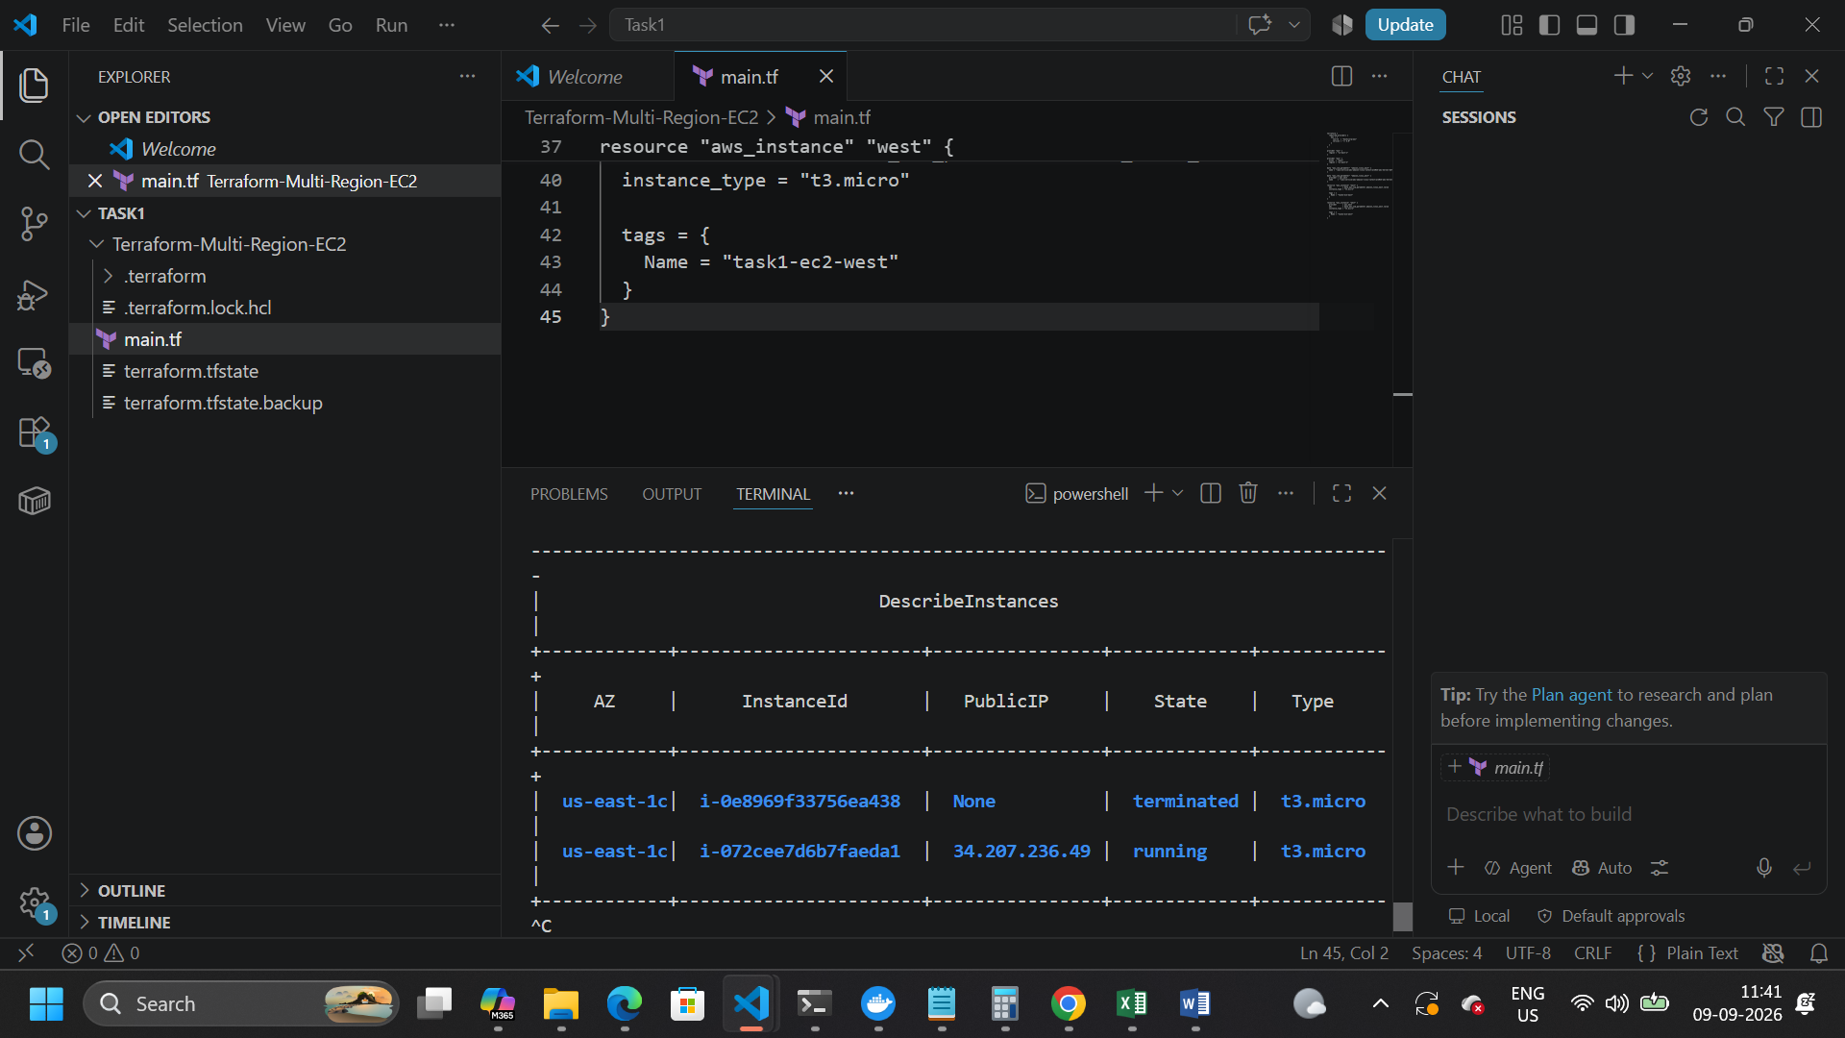

AWS CLI West Region Verification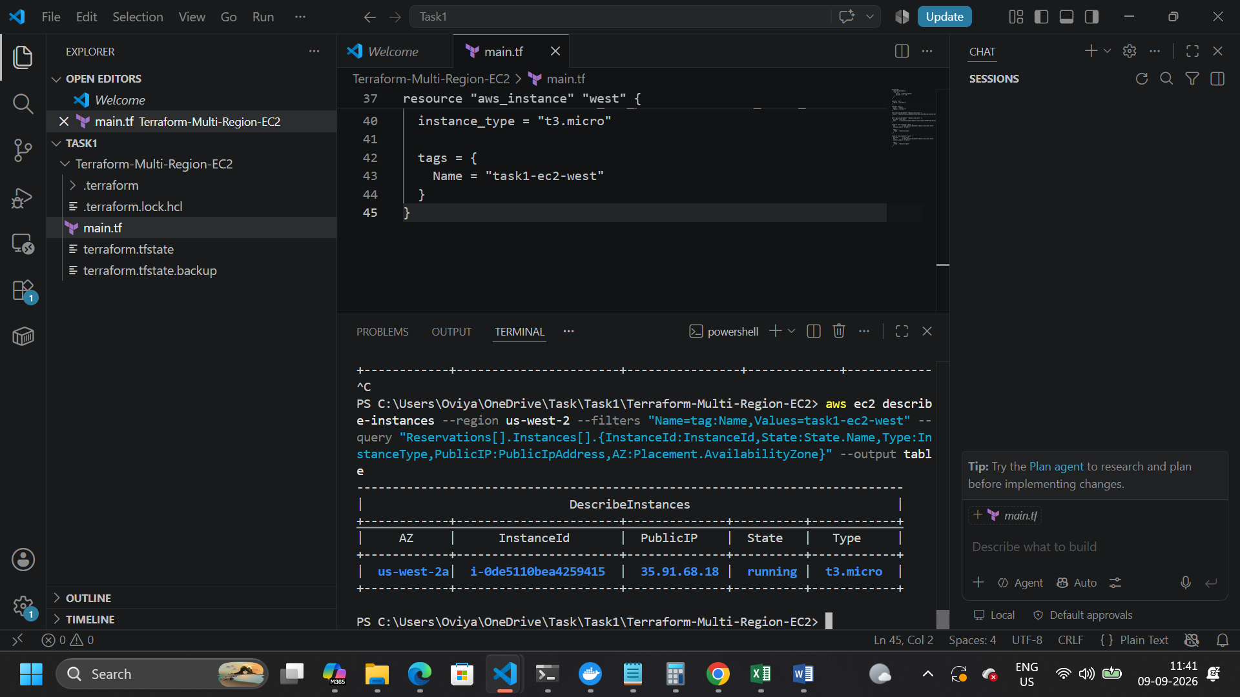

Main.tf
terraform {
required_providers {
aws = {
source = "hashicorp/aws"
version = "~> 6.0"
}
}
}

provider "aws" {
region = "us-east-1"
}

provider "aws" {
alias = "west"
region = "us-west-2"
}

data "aws_ssm_parameter" "amazon_linux_east" {
name = "/aws/service/ami-amazon-linux-latest/al2023-ami-kernel-default-x86_64"
}

data "aws_ssm_parameter" "amazon_linux_west" {
provider = aws.west
name = "/aws/service/ami-amazon-linux-latest/al2023-ami-kernel-default-x86_64"
}

resource "aws_security_group" "east" {
name = "task2-nginx-east-sg"
description = "Allow HTTP and SSH"

ingress {
description = "HTTP"
from_port = 80
to_port = 80
protocol = "tcp"
cidr_blocks = ["0.0.0.0/0"]
}

ingress {
description = "SSH"
from_port = 22
to_port = 22
protocol = "tcp"
cidr_blocks = ["0.0.0.0/0"]
}

egress {
from_port = 0
to_port = 0
protocol = "-1"
cidr_blocks = ["0.0.0.0/0"]
}

tags = {
Name = "task2-nginx-east-sg"
}
}

resource "aws_security_group" "west" {
provider = aws.west
name = "task2-nginx-west-sg"
description = "Allow HTTP and SSH"

ingress {
description = "HTTP"
from_port = 80
to_port = 80
protocol = "tcp"
cidr_blocks = ["0.0.0.0/0"]
}

ingress {
description = "SSH"
from_port = 22
to_port = 22
protocol = "tcp"
cidr_blocks = ["0.0.0.0/0"]
}

egress {
from_port = 0
to_port = 0
protocol = "-1"
cidr_blocks = ["0.0.0.0/0"]
}

tags = {
Name = "task2-nginx-west-sg"
}
}

resource "aws_instance" "east" {
ami = data.aws_ssm_parameter.amazon_linux_east.value
instance_type = "t3.micro"
vpc_security_group_ids = [aws_security_group.east.id]

user_data = <<-EOF
#!/bin/bash
dnf update -y
dnf install -y nginx
systemctl enable nginx
systemctl start nginx
echo "<h1>NGINX - us-east-1</h1>" > /usr/share/nginx/html/index.html
EOF

tags = {
Name = "task2-nginx-east"
}
}

resource "aws_instance" "west" {
provider = aws.west
ami = data.aws_ssm_parameter.amazon_linux_west.value
instance_type = "t3.micro"
vpc_security_group_ids = [aws_security_group.west.id]

user_data = <<-EOF
#!/bin/bash
dnf update -y
dnf install -y nginx
systemctl enable nginx
systemctl start nginx
echo "<h1>NGINX - us-west-2</h1>" > /usr/share/nginx/html/index.html
EOF

tags = {
Name = "task2-nginx-west"
}
}

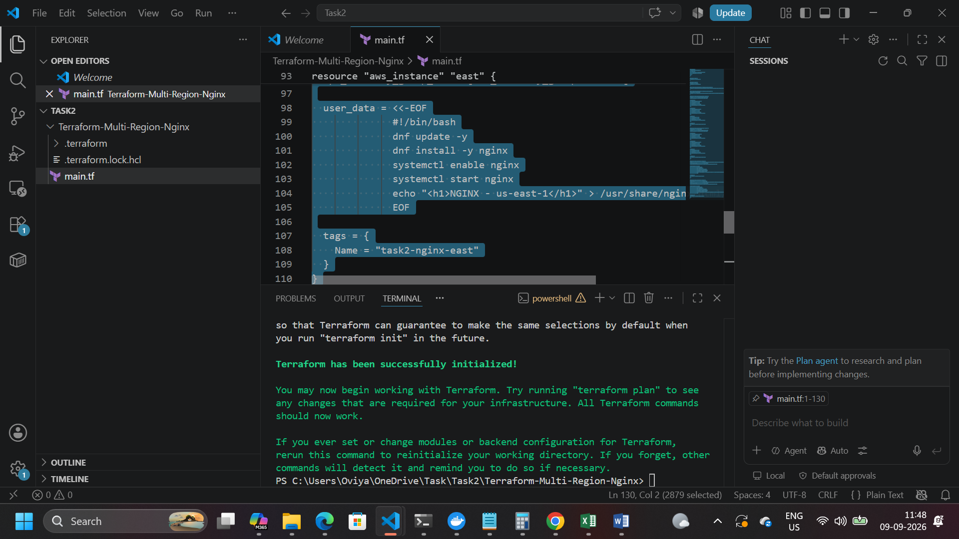

Terraform configuration successfully formatted and validated for deploying NGINX-enabled EC2 instances across two AWS regions.

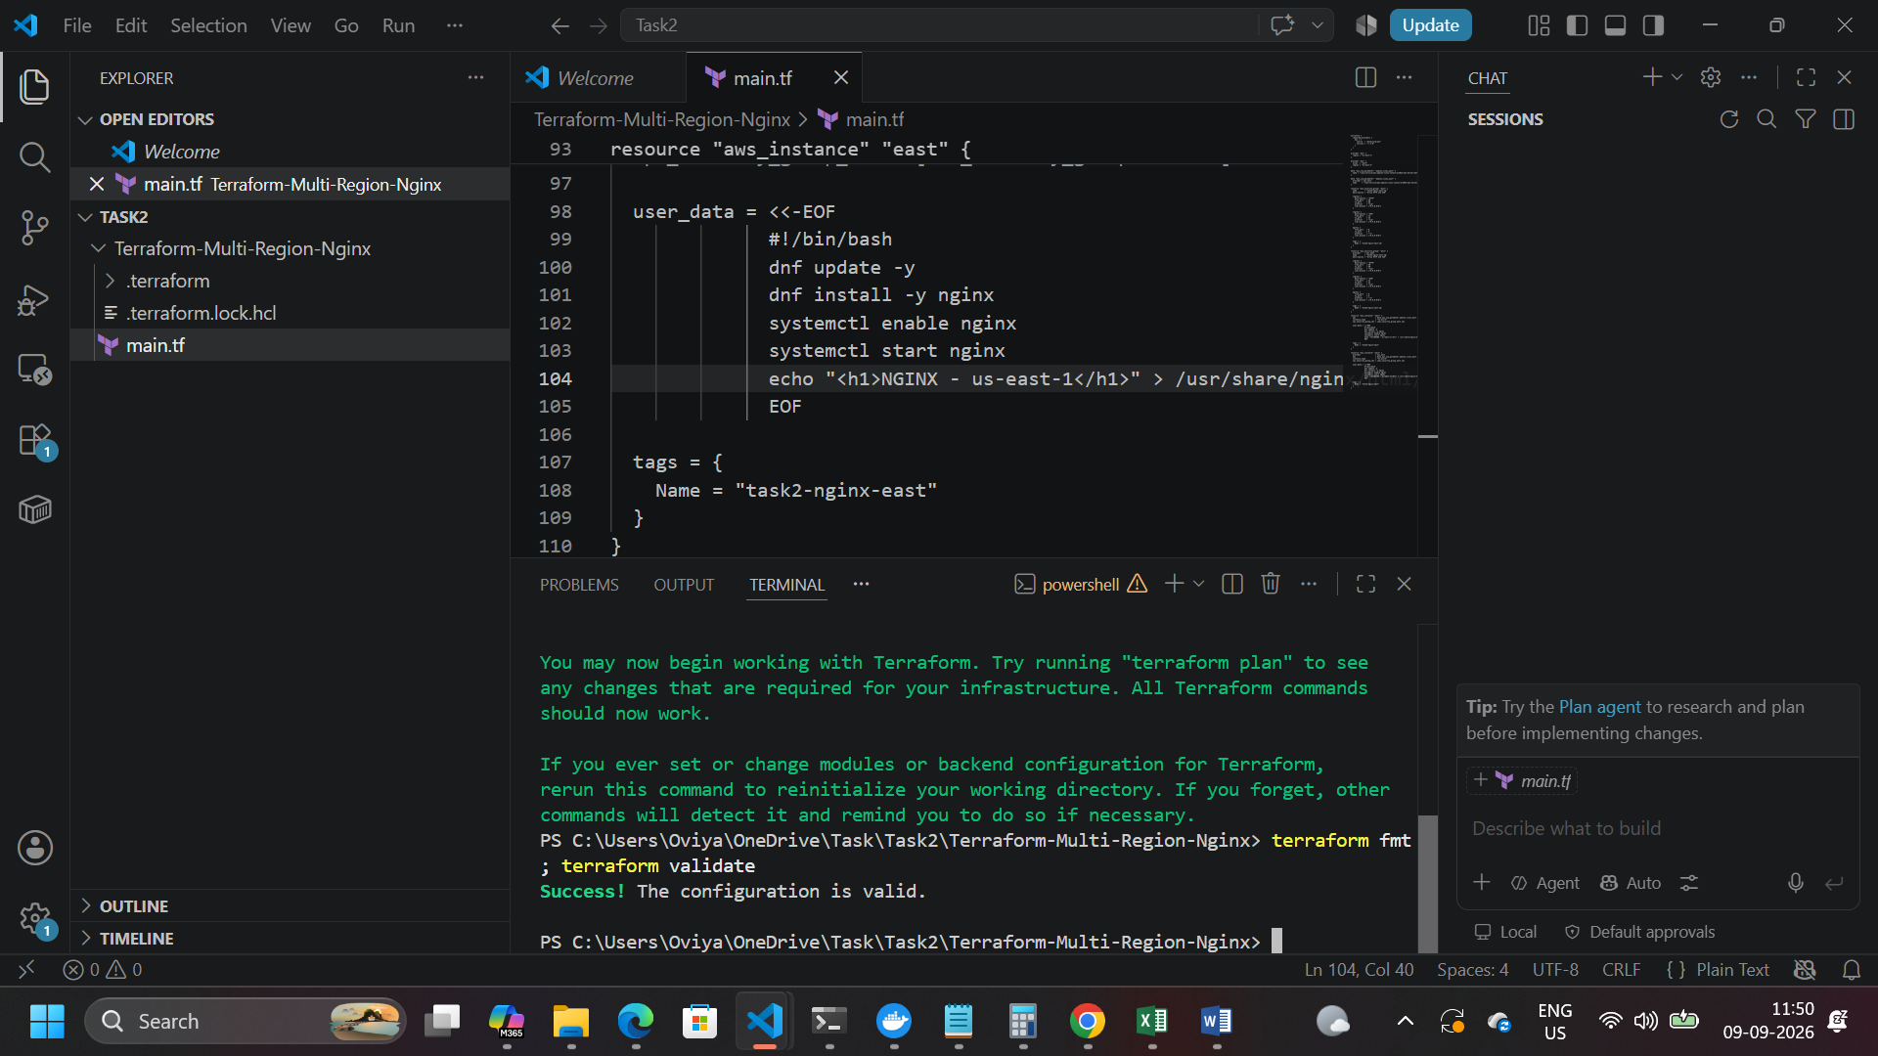

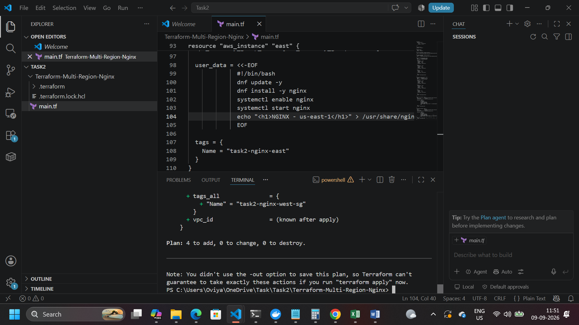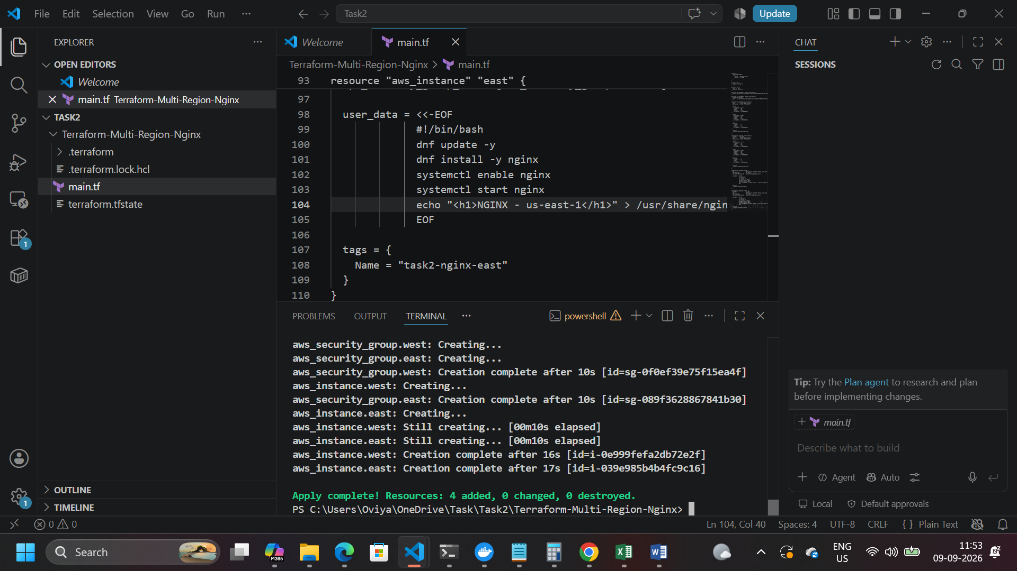
AWS CLI verification confirming the NGINX-enabled Linux EC2 instance is running successfully in the us-east-1 region.
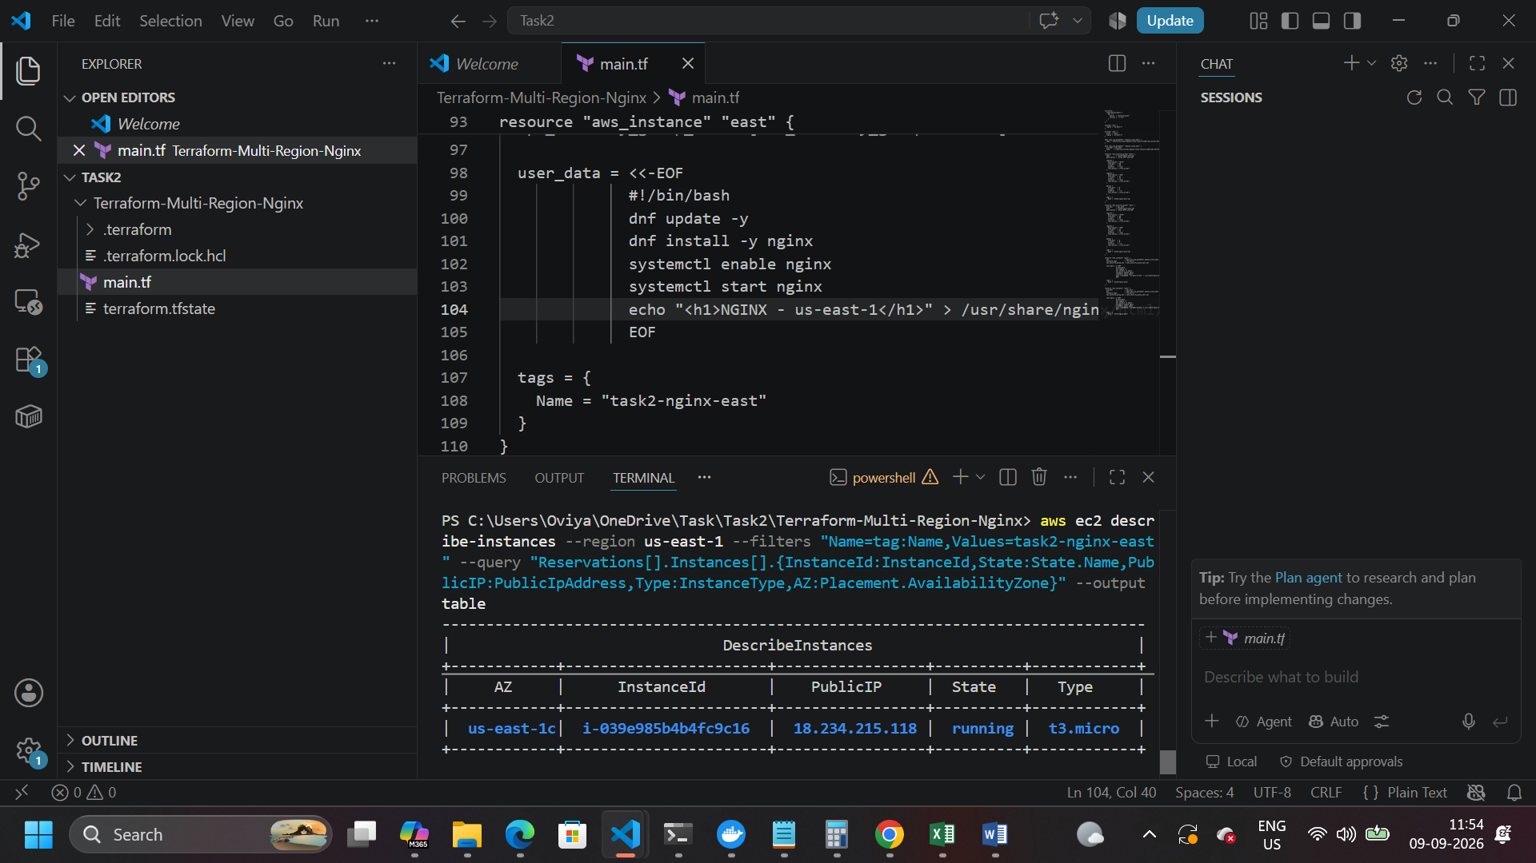
WS CLI verification confirming the NGINX-enabled Linux EC2 instance is running successfully in the us-west-2 region.

