MindTrack – DevOps Project Evidence
End-to-end flow: Docker → Amazon ECR → Amazon EKS → Kubernetes → CodeBuild → CodePipeline → Automated EKS Deployment
✓ Dockerized application and local container validation
✓ Amazon ECR image storage and tagging
✓ Amazon EKS cluster, node, Deployment and LoadBalancer
✓ GitHub source repository
✓ AWS CodeBuild configuration
✓ AWS CodePipeline successful execution
✓ Automated EKS rollout and final application validation

1. Docker & Amazon ECR
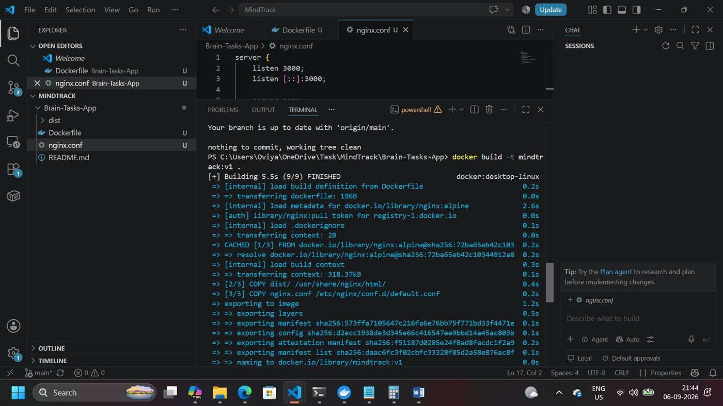
Docker image built successfully for the MindTrack application.
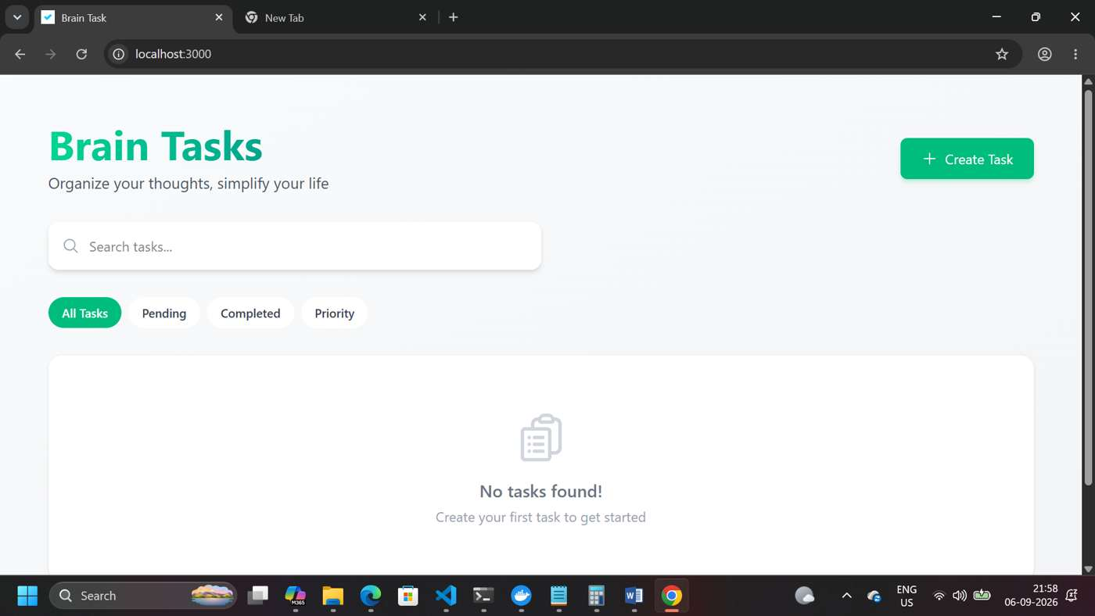
MindTrack / Brain Tasks application running locally in Docker on port 3000.
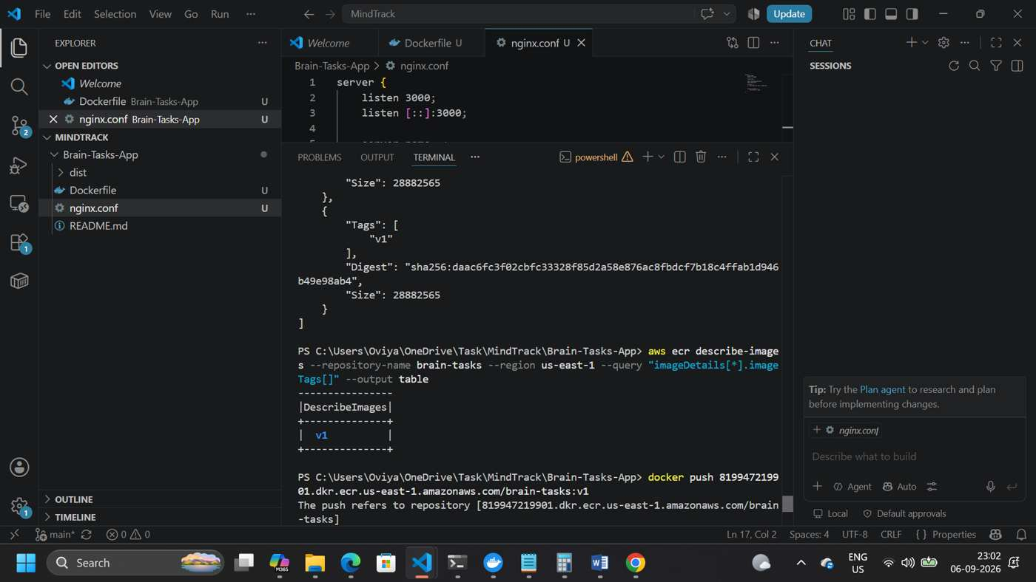
Amazon ECR repository contains the Brain Tasks image tagged v1.

2. Amazon EKS & Kubernetes
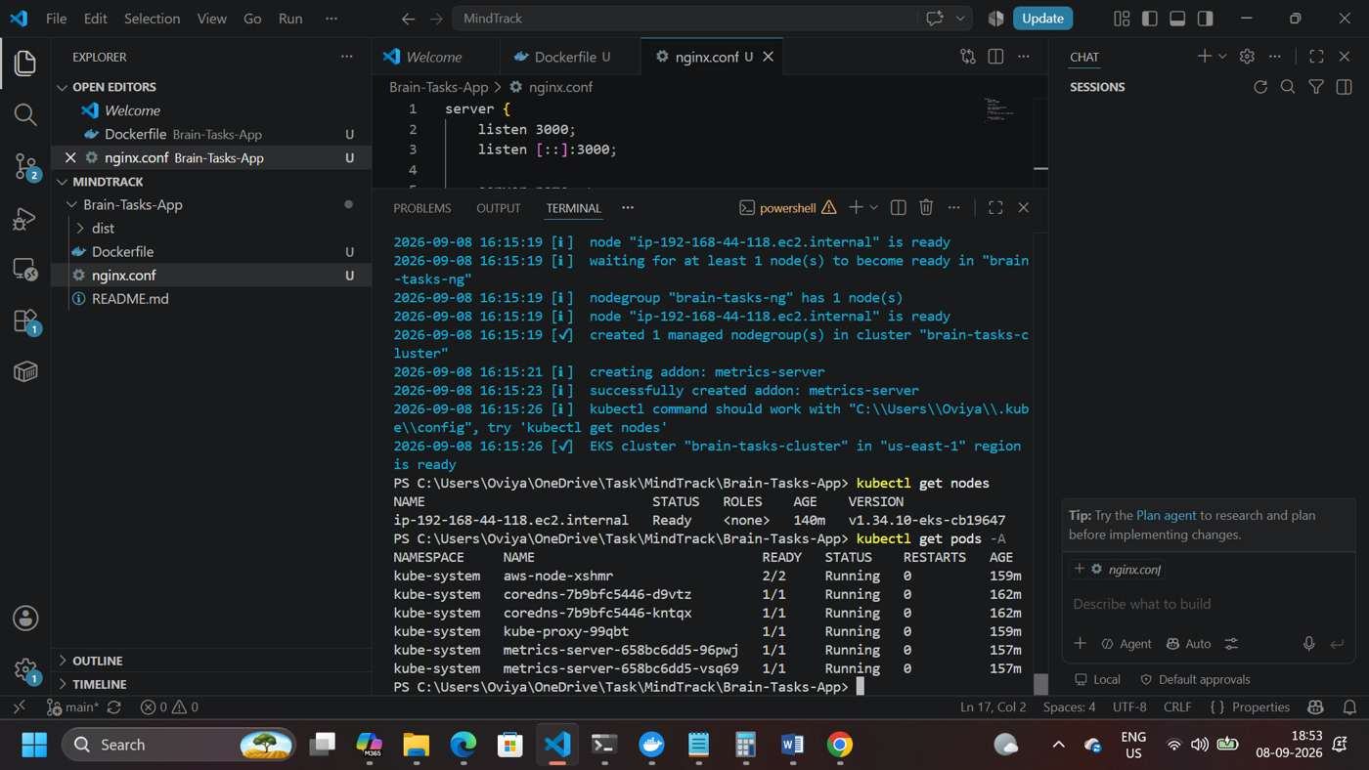
Amazon EKS cluster and managed worker node verified in Ready state.
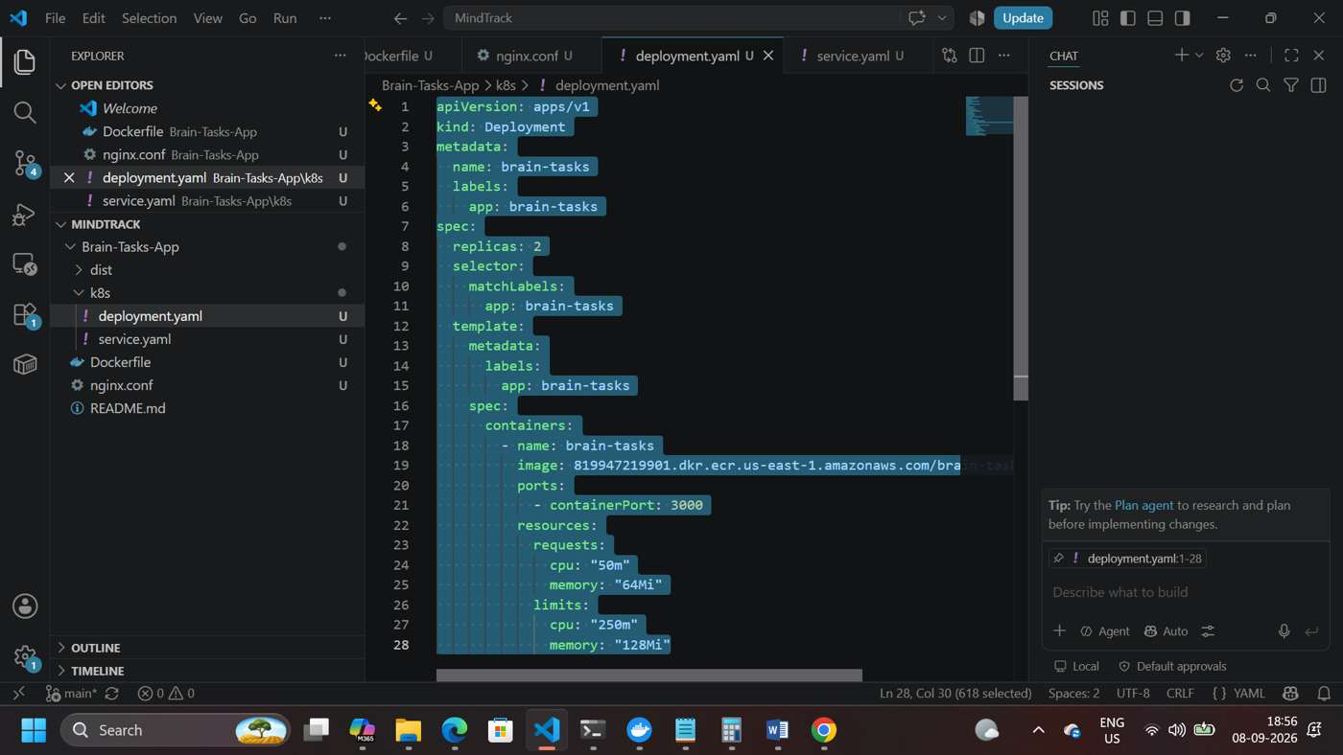
Kubernetes Deployment configured with two application replicas using the ECR image.
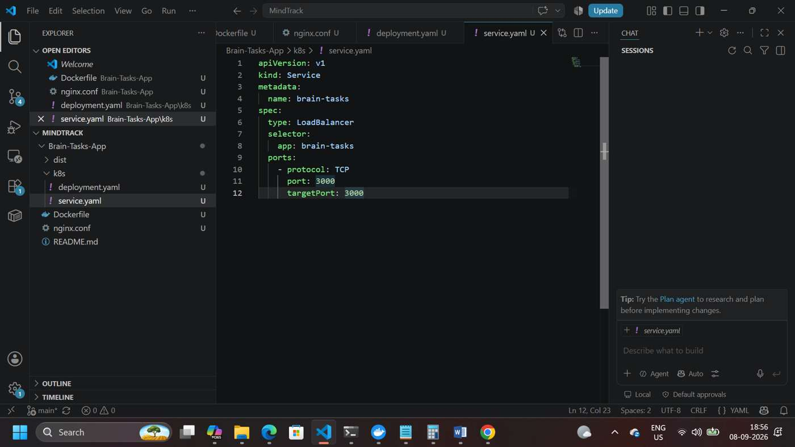
Kubernetes LoadBalancer Service configured to expose the application on port 3000.

3. External Application Access
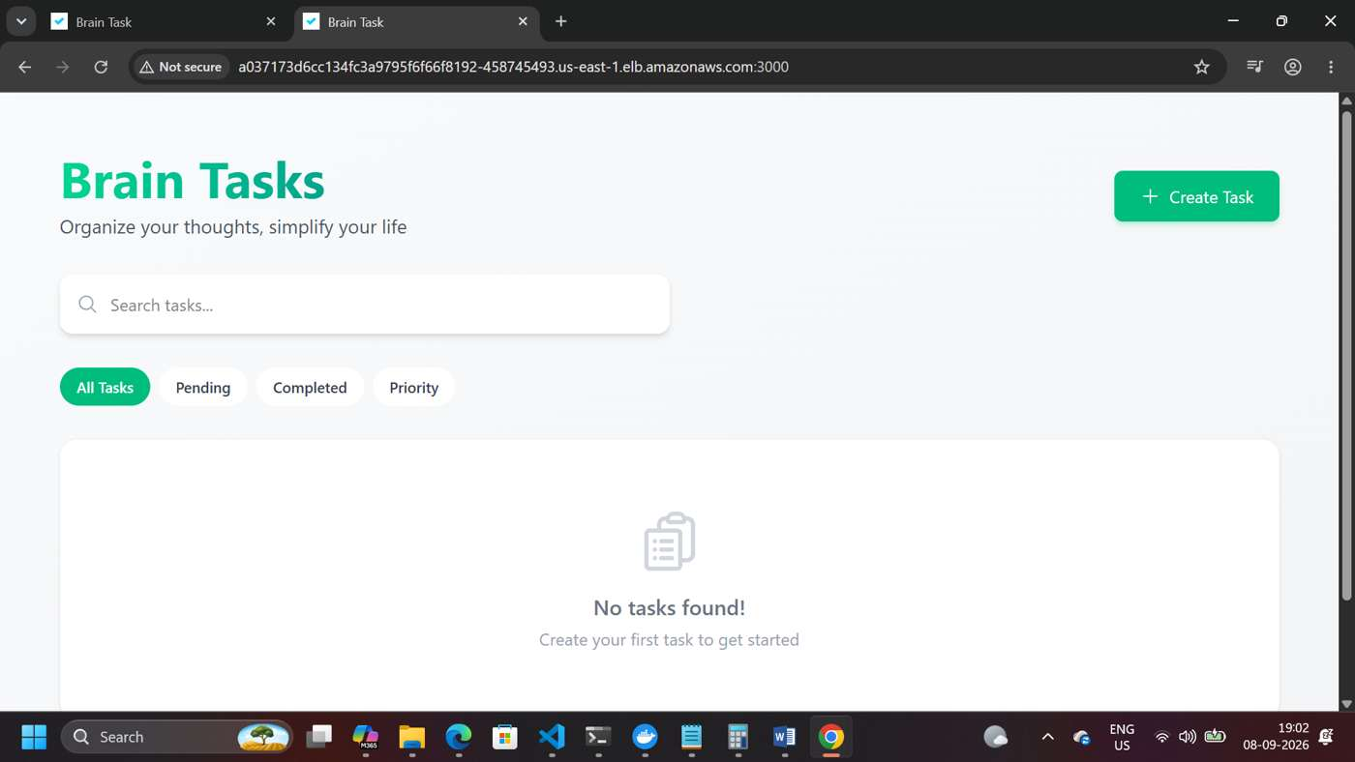
Brain Tasks application accessed successfully through the AWS LoadBalancer.

4. GitHub & AWS CodeBuild
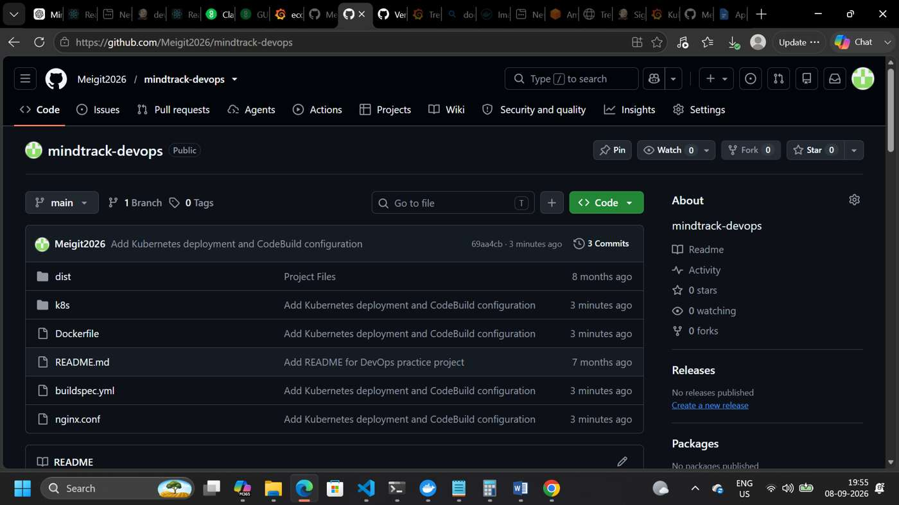
MindTrack DevOps source code and deployment configuration pushed to GitHub.
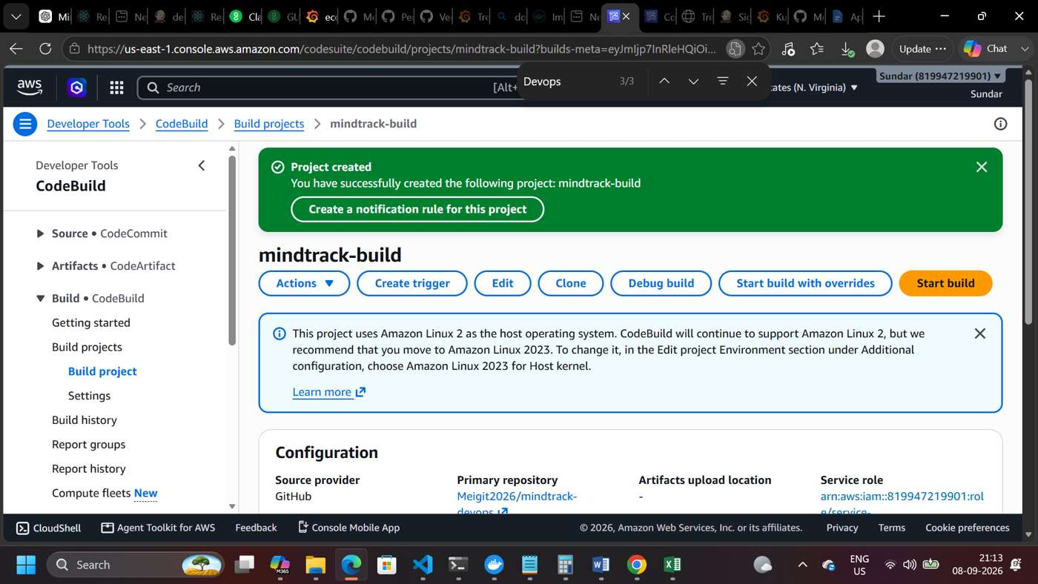
AWS CodeBuild project created and configured for the MindTrack repository.

5. AWS CodePipeline
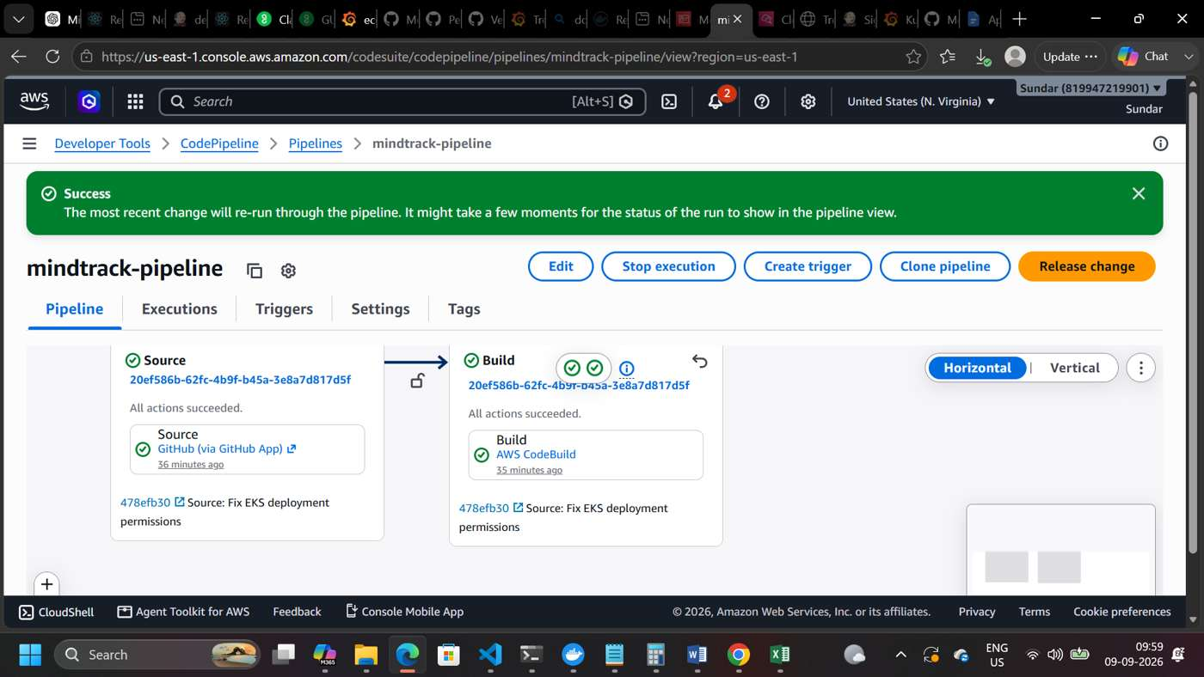
AWS CodePipeline execution succeeded for the MindTrack application.

6. Automated EKS Deployment
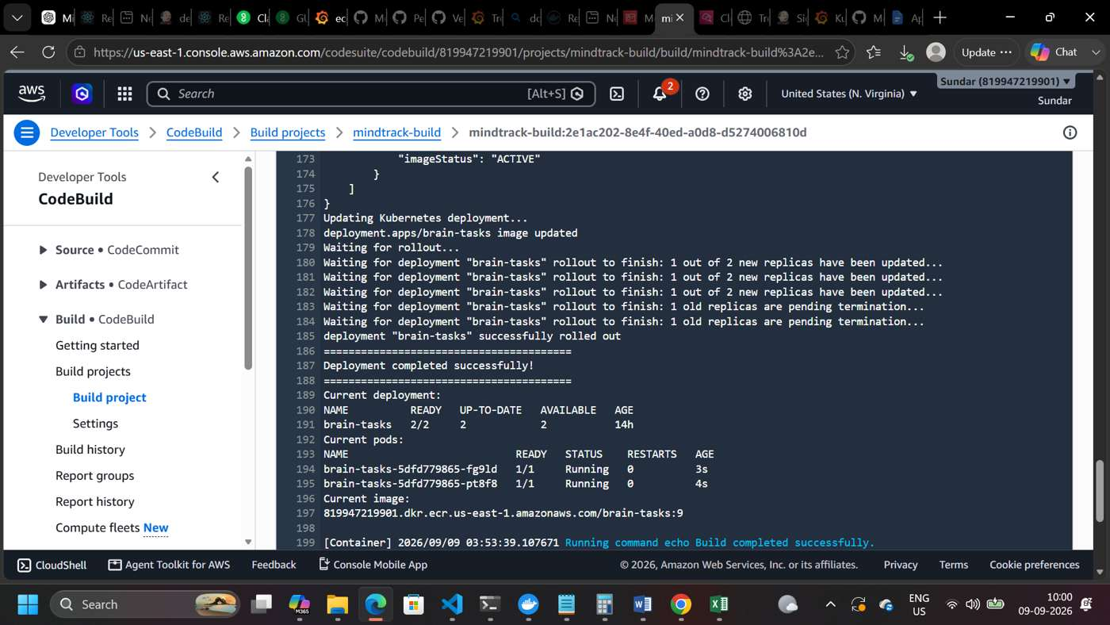
CodeBuild successfully deployed the new ECR image to Amazon EKS and completed rollout.
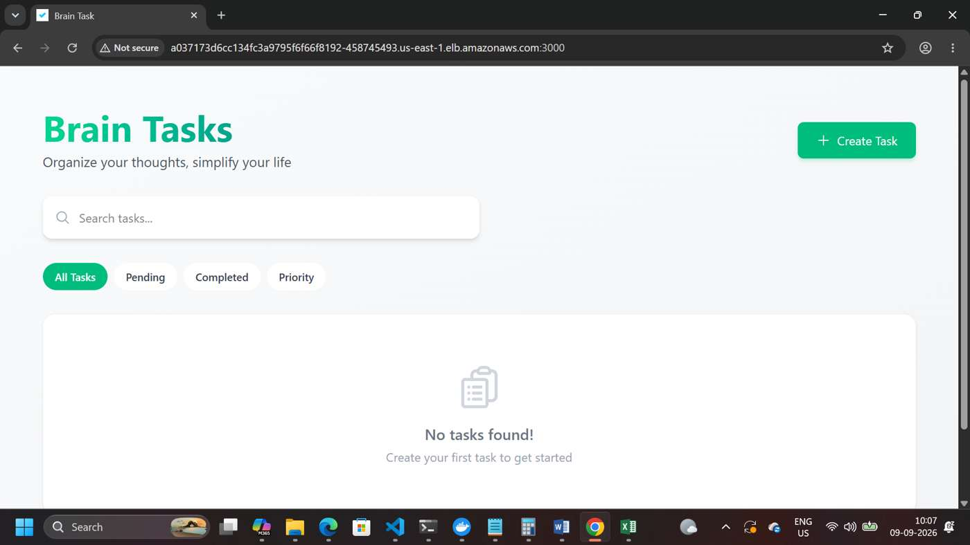
Final validation: Brain Tasks application accessible through the AWS LoadBalancer after automated deployment
Summary
The evidence demonstrates a complete DevOps workflow for MindTrack: the application was containerized, stored in Amazon ECR, deployed to Amazon EKS with Kubernetes, exposed through a LoadBalancer, and then automated through GitHub, AWS CodeBuild, and AWS CodePipeline. The final screenshots confirm successful automated rollout and external application access.

