ESE Management System Usage Guide

（ESE:Ericsson Special Equipment）

1. Dashboard

This dashboard contains all and the amount not processed during the quarter, the amount of processing completed, all costs and the cost during the quarter.As shown in picture 1, figure 1 follows: The number of cases completed in each quarter in the past two years, as well as the completion ratio;Figure 2: Expenditure and proportion of each quarter in the past two years;Figure 3: Distribution of expenditure types;Figure 4: Distribution of spending departments.

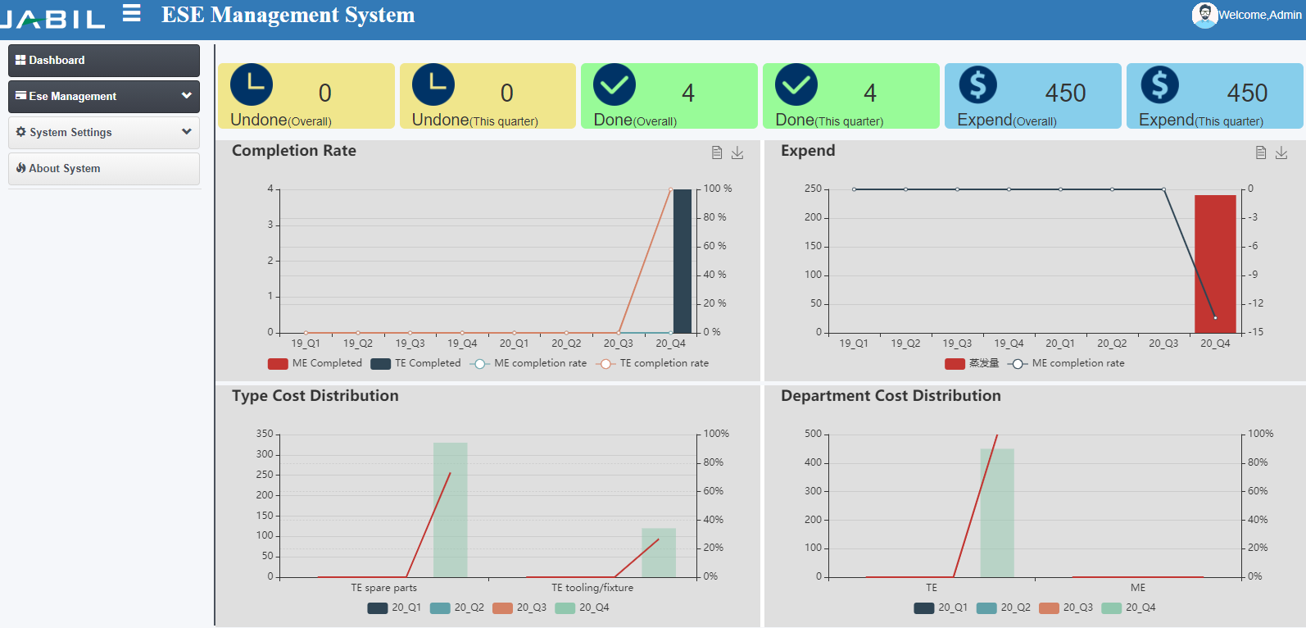

图1

1. Function
   1. Add New PO

As shown in figure 2.1.1, fill in the blanks according to the requirement, when fill in the PO Number will pop up figure after 2.1.2 (existing PO Number can't repeat fill in), figure 2.1.2 will fill in after the completion of the click the Add button will be added to the data in the table below, and enter the next data repeat operations until the PO Number under all the records are input is completed, the final check list at the top of the USD data with the Actual figure 2.1.1 Actual PO Value (USD) (that is, the red box data) are consistent, if the same can be submitted,Otherwise, it cannot be submitted.

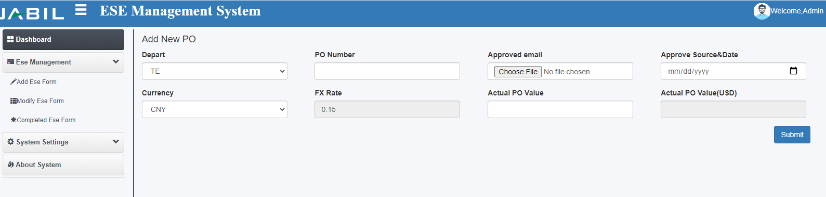

图2.1.1

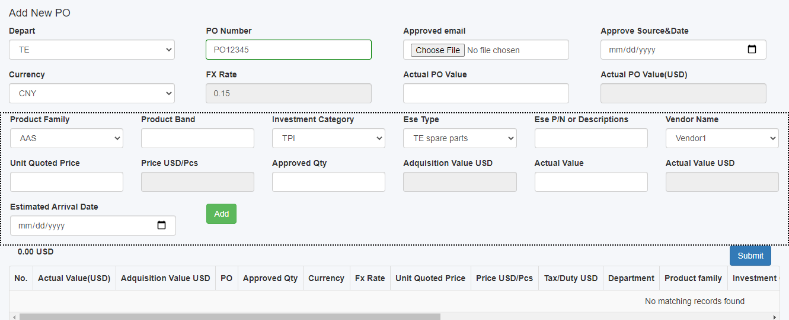

图2.1.2

* 1. Manage PO

After new PO record, the record is shown in figure 2.2.1 table (all outstanding PO will be shown here), click on the plus sign before each PO, you can see the PO under specific records, double-click the record pop-up fill in the form of the goods as shown in figure 2.2.2, fill in the receiving quantity (receiving) amount shall not exceed the number of applications, the awb, tariffs (if the awb already exists, it automatically pop-up need not fill in), note: mandatory.

Right-click the record, and a form to modify the record pops up, as shown in Figure 2.2.3. The modification can be made.

When the quantity of goods received for all records under the PO is the same as the quantity requested, it is completed. If it is not completed, this record will always be displayed on this page.

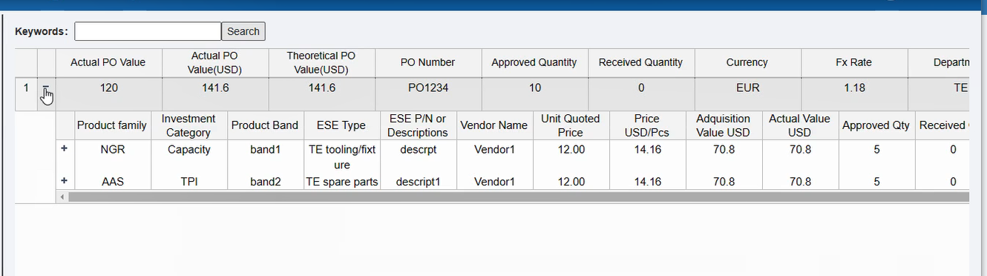

图2.2.1

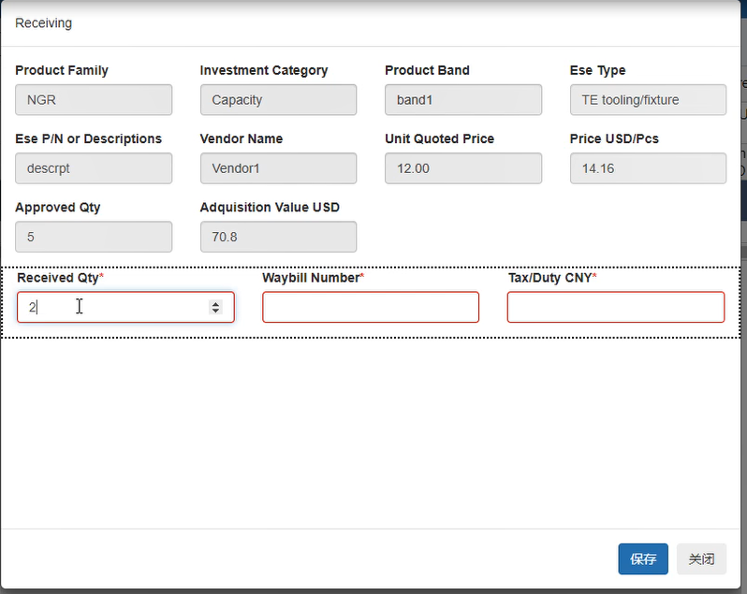

图2.2.2

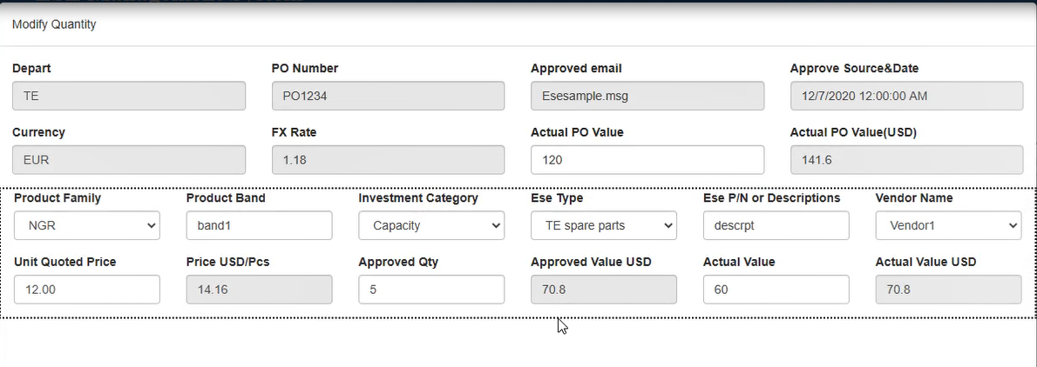

图2.2.3

* 1. Completed PO

The completed PO will be displayed in the interface as shown in Figure 2.3.1. The PO records completed within this period can be searched by selecting the start time and end time. If the Actual PO Value is greater than the Approved Value, the yellow background will be displayed in the table.

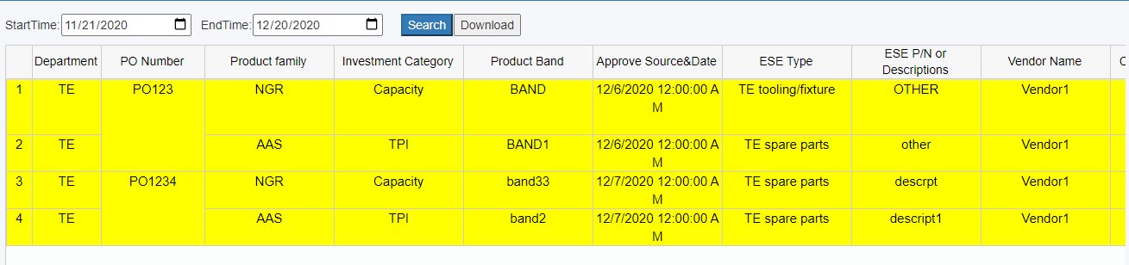

图2.3.1

Click the Download button to Download the contents of the table and the attachment (PO request mail), as shown in Figure 2.3.2.



图2.3.2

1. Settings
   1. Manage Vendor

Vendor management: The table in the figure (Figure 3.1.1) shows all added suppliers, which can be added through the Add button. Check the supplier and click the Clear button to delete the supplier. If the supplier already exists, it cannot be added repeatedly

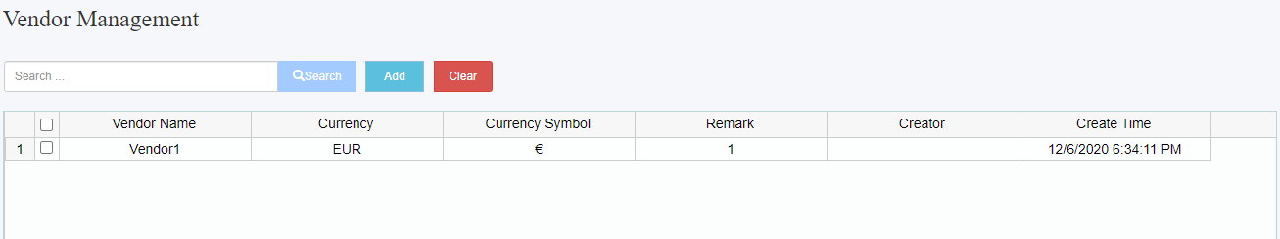

图3.1.1

* 1. Manage ExchangeRate

Managed exchange rate: All used exchange rates will exist in the following table. When a new PO is added, the default exchange rate will be the latest in the table.

Click Upgrade to pop up the form to fill in the latest exchange rate, as shown in Figure 3.2.2. Click Save after completing the filling, and the record will be displayed in the first row of the table.

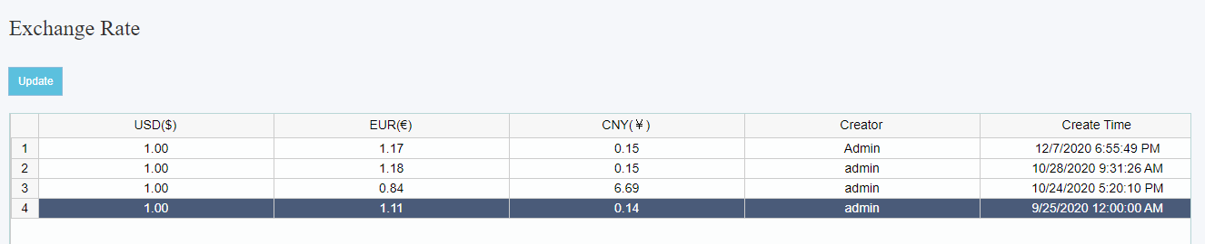

图3.2.1

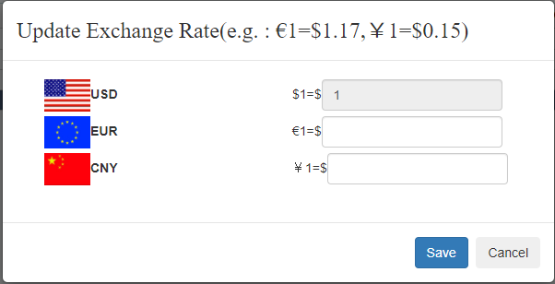

图3.2.2

ESE Management System 使用指导

（ESE:Ericsson Special Equipment）

1. Dashboard

该看板包含了所有的以及本季度未处理的数量，处理完成的数量，所有的花费及本季度的花费。如图1，下列图一:近两年每个季度完成的Case数量，以及完成比率；图二: 近两年每个季度的花费以及占比；图三:花费种类的分布；图四:花费部门的分布。

图1

1. Function
   1. Add New PO

如图2.1.1,按要求填写空格，当填入PO Number后则会弹出图2.1.2（已存在的PO Number不能重复填写），将图2.1.2填写完成后点击Add按钮将这条数据新增到下面的表格中，再输入下一条数据重复操作直至该PO Number下的所有记录都输入完成，最后核对表格上方的USD数据与图2.1.1上的Actual PO Value(USD) （即红框内的数据）是否一致，如果一致则可以提交，反之则不能提交。



图2.1.1



图2.1.2

* 1. PO 管理

在新增PO记录后，该记录会显示在图2.2.1的表格中（所有未完成的PO都会在这里显示），点击每个PO前的加号，可以看到该PO下具体的记录，双击这条记录弹出填写收货的表单如图2.2.2，填写收货数量（收货数量不得超过申请数量）、运单号、关税（若运单号已经存在，则自动弹出无需填写），注：必填。右击这条记录，则弹出修改该条记录的表单，如图2.2.3，可以进行修改。当PO 下所有的记录的收货数量与申请数量一致时则完成，若没有完成，则这条记录将一直在这个页面显示。



图2.2.1



图2.2.2



图2.2.3

* 1. 完成后的PO

完成的PO会在如图2.3.1的界面显示，通过选择开始时间和结束时间可以搜索到这个时间段内完成的PO记录，若是Actual PO Value大于Approved Value 就会在表格中显示黄色背景。



图2.3.1

点击Download按钮，就可以下载表中的内容及附件（PO的申请邮件），如图2.3.2。



图2.3.2

1. 系统设置
   1. 供应商管理

管理供应商：图中的表格（如图3.1.1）会显示所有已经添加的供应商，通过Add按钮可以进行添加，勾选上供应商并点击Clear按钮则可以删除该供应商，若供应商已经存在，则不能重复添加。



图3.1.1

* 1. 汇率管理

管理汇率：所有使用过的汇率会存在在下表中，在添加新的PO时，默认汇率是表格中最新的。点击Upgrade则会弹出填写最新汇率的表单，如图3.2.2，填写完成后点击保存，则这条记录会显示在表中的第一行。



图3.2.1



图3.2.2