**Exercise 1: Setting Up JUnit**

**Calculator.java**

package com.example;

public class Calculator {

public int add(int a, int b) {

return a + b;

}

}

**CalculatorTest.java**

package com.example;

import org.junit.Test;

import static org.junit.Assert.*;

public class CalculatorTest {

@Test

public void testAdd() {

Calculator calc = new Calculator();

System.out.println("Test passed: 2 + 3 = " + calc.add(2, 3));

assertEquals(5, calc.add(2, 3));

}

}

**pom.xml**

<project xmlns="http://maven.apache.org/POM/4.0.0"

xmlns:xsi="http://www.w3.org/2001/XMLSchema-instance"

xsi:schemaLocation="http://maven.apache.org/POM/4.0.0

http://maven.apache.org/xsd/maven-4.0.0.xsd">

<modelVersion>4.0.0</modelVersion>

<groupId>com.example</groupId>

<artifactId>calculator</artifactId>

<version>1.0-SNAPSHOT</version>

<dependencies>

<dependency>

<groupId>junit</groupId>

<artifactId>junit</artifactId>

<version>4.13.2</version>

<scope>test</scope>

</dependency>

</dependencies>

</project>

**OUTPUT:**

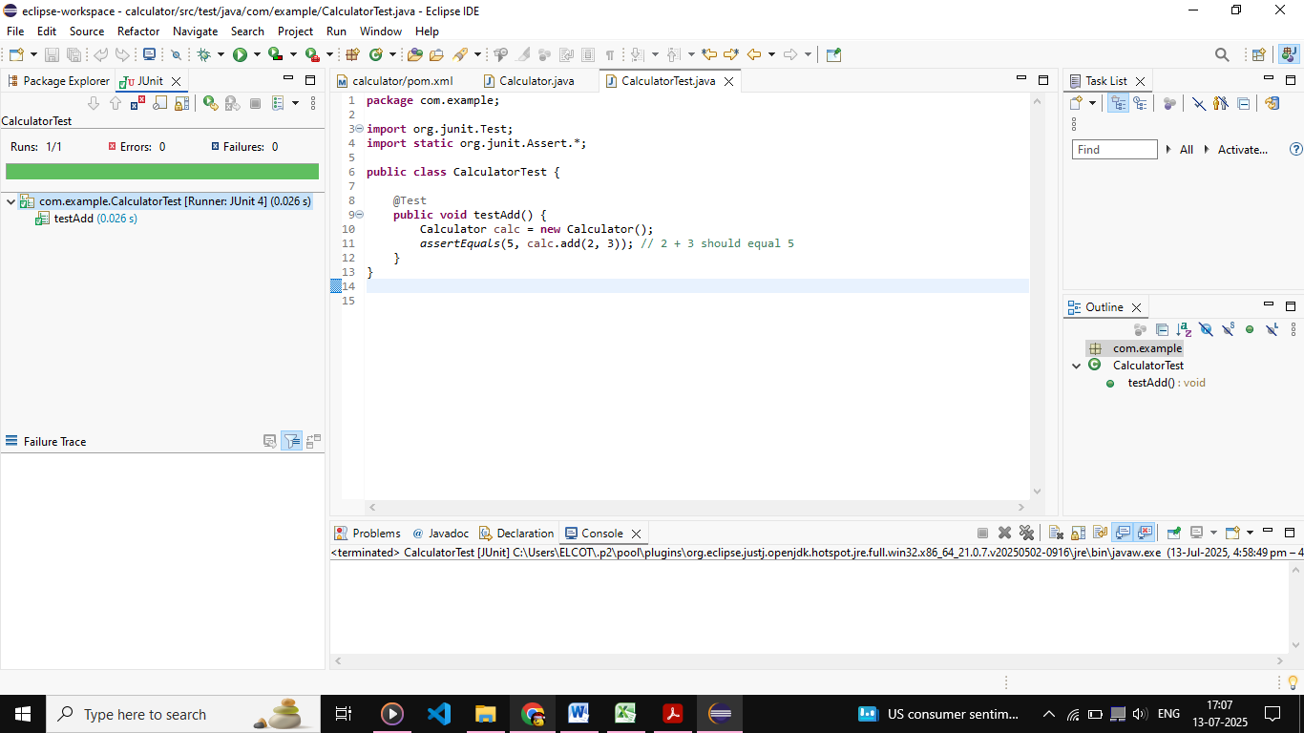

**Exercise 3: Assertions in JUnit**

**AssertionsTest.java**

package com.example;

import org.junit.Test;

import static org.junit.Assert.*;

public class AssertionsTest {

@Test

public void testAssertions() {

assertEquals(5, 2 + 3);

assertTrue(5 > 3);

assertFalse(5 < 3);

assertNull(null);

assertNotNull(new Object());

}

}

**OUTPUT:**

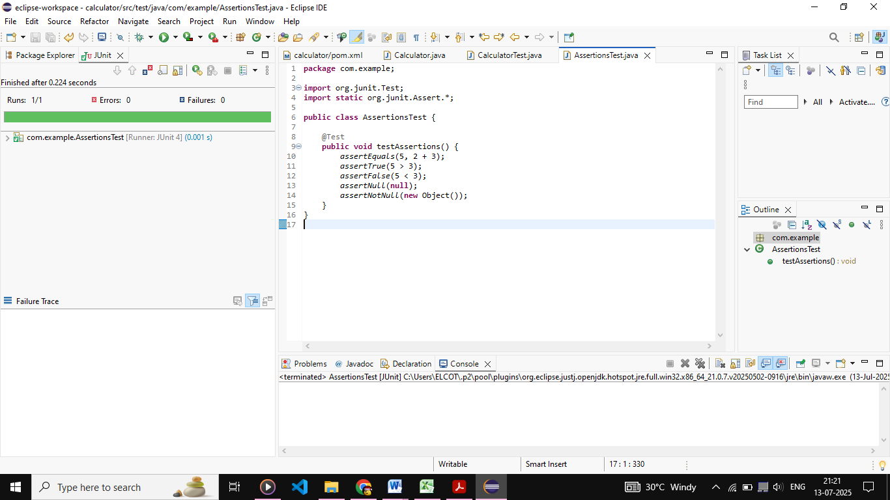

**Exercise 4: Arrange-Act-Assert (AAA) Pattern, Test Fixtures, Setup and Teardown Methods in JUnit**

**Calculator.java**

package com.example;

public class Calculator {

public int add(int a, int b) {

return a + b;

}

public int subtract(int a, int b) {

return a - b;

}

}

**CalculatorTestAAA.java**

package com.example;

import org.junit.After;

import org.junit.Before;

import org.junit.Test;

import static org.junit.Assert.*;

public class CalculatorTestAAA {

private Calculator calculator;

@Before

public void setUp() {

System.out.println("Setting up...");

calculator = new Calculator();

}

@After

public void tearDown() {

System.out.println("Cleaning up...");

calculator = null;

}

@Test

public void testAddition() {

int result = calculator.add(10, 5);

assertEquals(15, result);

}

@Test

public void testSubtraction() {

int result = calculator.subtract(10, 5);

assertEquals(5, result);

}

}

**OUTPUT:**

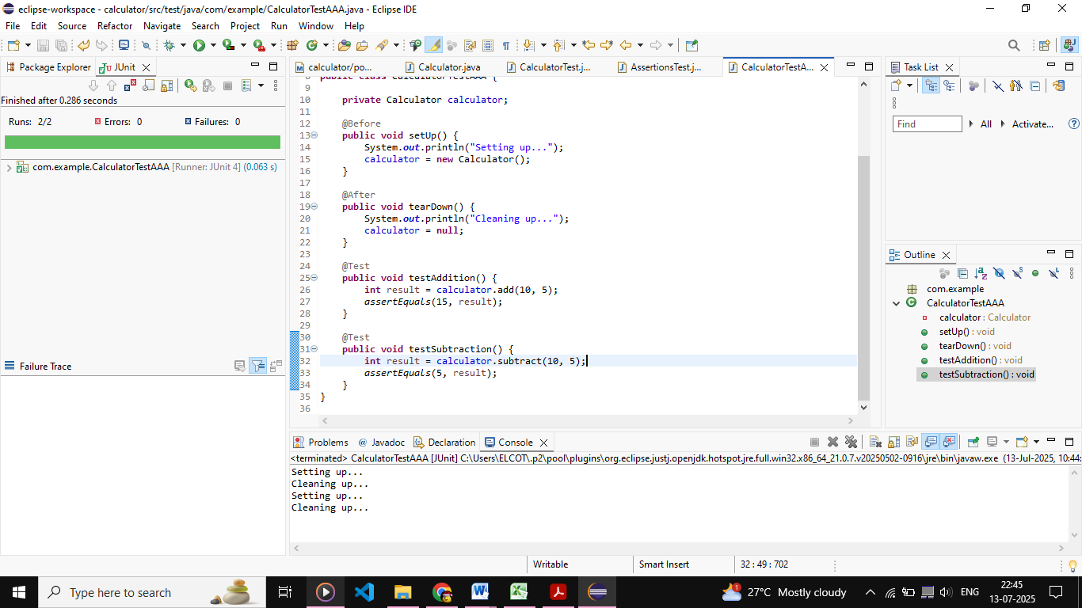

**Exercise 1: Mocking and Stubbing**

**ExternalApi.java**

package com.example;

public interface ExternalApi {

String getData();

}

**MyService.java**

package com.example;

public class MyService {

private ExternalApi api;

public MyService(ExternalApi api) {

this.api = api;

}

public String fetchData() {

return api.getData();

}

}

**MyServiceTest.java**

package com.example;

import org.junit.jupiter.api.Test;

import static org.junit.jupiter.api.Assertions.*;

import static org.mockito.Mockito.*;

public class MyServiceTest {

@Test

public void testExternalApi() {

ExternalApi mockApi = mock(ExternalApi.class);

when(mockApi.getData()).thenReturn("Mock Data");

MyService service = new MyService(mockApi);

String result = service.fetchData();

assertEquals("Mock Data", result);

}

}

**OUTPUT:**

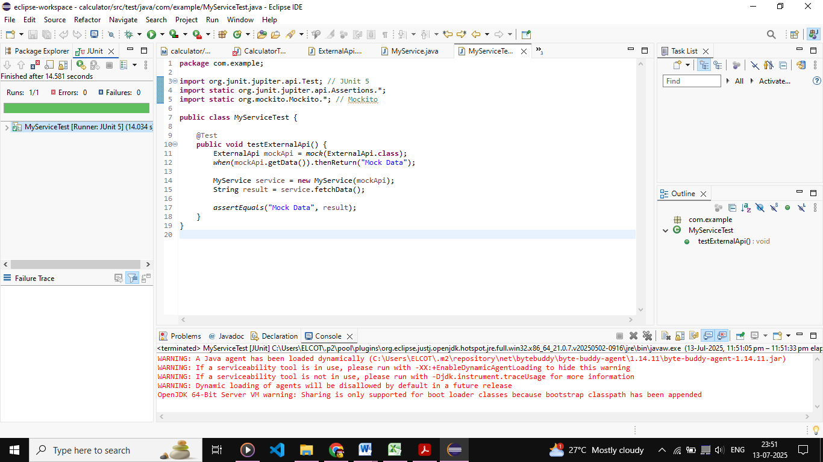

**Exercise 2: Verifying Interactions**

**ExternalApi.java**

package com.example;

public interface ExternalApi {

String getData();

}

**MyService.java**

package com.example;

public class MyService {

private ExternalApi api;

public MyService(ExternalApi api) {

this.api = api;

}

public String fetchData() {

return api.getData();

}

}

**MyServiceTest.java**

package com.example;

import org.junit.jupiter.api.Test;

import static org.mockito.Mockito.*;

import static org.junit.jupiter.api.Assertions.*;

public class MyServiceTest {

@Test

public void testExternalApi() {

ExternalApi mockApi = mock(ExternalApi.class);

when(mockApi.getData()).thenReturn("Mock Data");

MyService service = new MyService(mockApi);

String result = service.fetchData();

assertEquals("Mock Data", result);

}

@Test

public void testVerifyInteraction() {

ExternalApi mockApi = mock(ExternalApi.class);

MyService service = new MyService(mockApi);

service.fetchData();

verify(mockApi).getData();

}

}

**OUTPUT:**

