**Ex 1**

**1. What is SPA?**

SPA stands for **Single-Page Application**. It is a web application that interacts with the user by dynamically rewriting the current page rather than loading entire new pages from the server.

**Benefits of SPA**

1. Faster navigation and better user experience
2. Less data transfer between client and server
3. Easier to convert into a mobile app (using frameworks like React Native)

**2. What is MPA?**

MPA stands for **Multi-Page Application**. In MPAs, each interaction loads a new page from the server.

**Differences: SPA vs MPA**

| **Feature** | **SPA** | **MPA** |
| --- | --- | --- |
| Page Reload | No | Yes |
| Speed | Faster after first load | Slower due to full page reload |
| SEO Support | Less optimal | Better |
| Example | Gmail, Facebook | Amazon, Flipkart |

**3. What is React?**

React is a **JavaScript library** developed by Facebook for building **user interfaces**, especially SPAs. It helps create **reusable UI components**.

**4. What is Virtual DOM?**

The **Virtual DOM** is a lightweight copy of the real DOM. React uses it to:

1. Detect changes
2. Minimize direct DOM manipulation
3. Update only what’s necessary in the real DOM

**5. Features of React**

1. **Component-based**
2. **Virtual DOM**
3. **Declarative UI**
4. **Unidirectional Data Flow**
5. **Fast Rendering**
6. **JSX Syntax**

**Code :**

function App() {

return (

<div style={{ display: 'flex', justifyContent: 'center', alignItems: 'center', height: '100vh' }}>

<h1>Welcome to the first session of React</h1>

</div>

);

}

export default App;

**Output** : 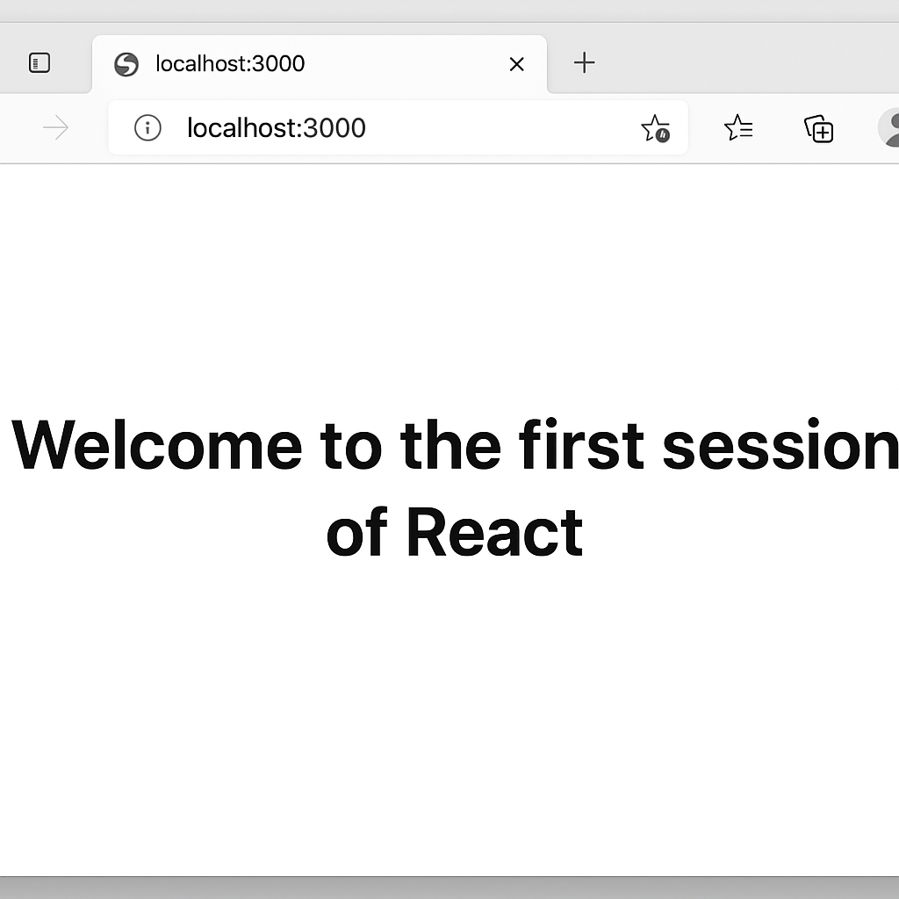

**Ex 2 :**

**What are React Components?**

React Components are **reusable blocks of code** used to build UI elements.

**Components vs JavaScript Functions**

| **Feature** | **React Component** | **JS Function** |
| --- | --- | --- |
| Purpose | UI building block | General logic |
| Returns | JSX / HTML | Data / Value |
| Lifecycle methods | Yes (class components) | No |

**Types of Components**

1. **Class Components**
2. **Function Components**

**Class Component**

Uses class and must include:

1. A constructor (optional)
2. A render() method to return JSX

**Function Component**

Simpler. A JavaScript function that returns JSX.

**Code :**

**App.js**

import React from 'react';

import Home from './Components/Home';

import About from './Components/About';

import Contact from './Components/Contact';

function App() {

  return (

    <div style={{ textAlign: 'center', marginTop: '50px' }}>

      <Home />

      <About />

      <Contact />

    </div>

  );

}

export default App;

**About.js**

import React, { Component } from 'react';

class About extends Component {

  render() {

    return (

      <h2>Welcome to the About page of the Student Management Portal</h2>

    );

  }

}

export default About;

**Contact.js**

import React, { Component } from 'react';

class Contact extends Component {

  render() {

    return (

      <h2>Welcome to the Contact page of the Student Management Portal</h2>

    );

  }

}

export default Contact;

**Home.js**

import React, { Component } from 'react';

class Home extends Component {

  render() {

    return (

      <h2>Welcome to the Home page of Student Management Portal</h2>

    );

  }

}

export default Home;

**OUTPUT:**

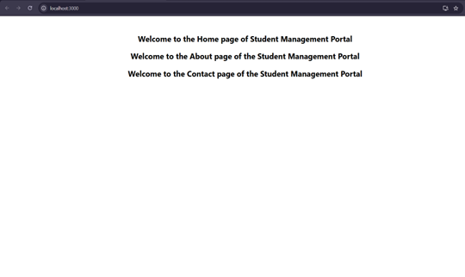

**Ex 3 :**

**CalculateScore.js**

import React from 'react';

import '../Stylesheets/mystyle.css';

function CalculateScore() {

const name = "MEIKEERTHY L";

const school = "KRCE";

const total = 546;

const goal = 600;

const average = (total / goal) * 100;

return (

<div className="score-container">

<h1>Student Score Calculator</h1>

<p><strong>Name:</strong> {name}</p>

<p><strong>School:</strong> {school}</p>

<p><strong>Total Marks:</strong> {total}</p>

<p><strong>Goal Marks:</strong> {goal}</p>

<p><strong>Average Score:</strong> {average.toFixed(2)}%</p>

</div>

);

}

export default CalculateScore;

**mystyle.css**

.score-container {

text-align: center;

margin-top: 50px;

background-color: #f5f5f5;

padding: 40px;

border-radius: 10px;

font-family: Arial, sans-serif;

box-shadow: 0px 0px 10px #ccc;

}

.score-container h1 {

color: #2b3a55;

}

.score-container p {

font-size: 18px;

color: #333;

margin: 8px 0;

}

**App.js**

import React from 'react';

import CalculateScore from './Components/CalculateScore';

function App() {

return (

<div>

<CalculateScore />

</div>

);

}

export default App;

**OUTPUT:**

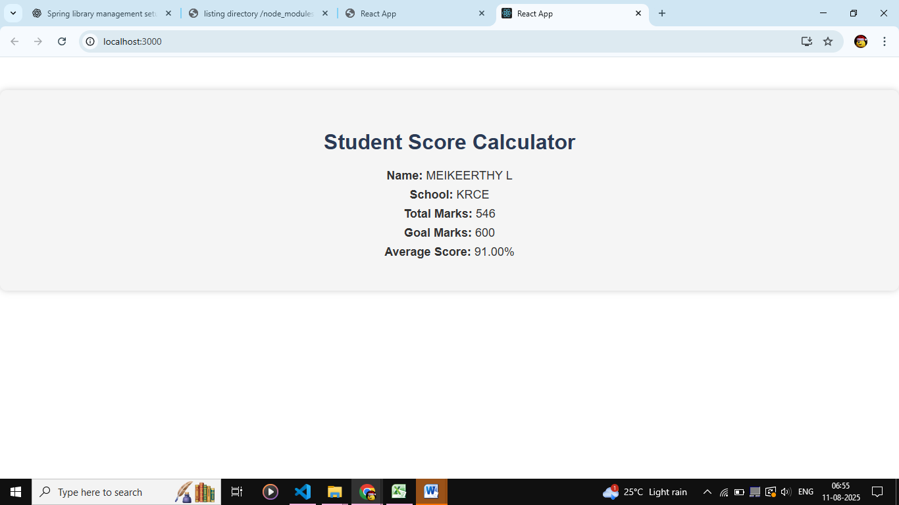

**Ex 4 :**

**Post.js**

import React from 'react';

class Post extends React.Component {

render() {

return (

<div style={{ marginBottom: '1rem', padding: '1rem', border: '1px solid #ccc' }}>

<h3>{this.props.title}</h3>

<p>{this.props.body}</p>

</div>

);

}

}

export default Post;

**Posts.js**

import React, { Component } from 'react';

import Post from './Post';

class Posts extends Component {

constructor(props) {

super(props);

this.state = {

posts: [],

hasError: false,

};

}

loadPosts = () => {

fetch('https://jsonplaceholder.typicode.com/posts')

.then((response) => response.json())

.then((data) => this.setState({ posts: data }))

.catch((err) => {

this.setState({ hasError: true });

console.error('Error loading posts:', err);

});

};

componentDidMount() {

this.loadPosts();

}

componentDidCatch(error, info) {

alert('Something went wrong: ' + error);

console.error('Error details:', info);

}

render() {

return (

<div>

<h2>Blog Posts</h2>

{this.state.posts.map((post) => (

<Post key={post.id} title={post.title} body={post.body} />

))}

</div>

);

}

}

export default Posts;

**App.js**

import React from 'react';

import Posts from './Posts';

function App() {

return (

<div className="App" style={{ padding: '2rem' }}>

<h1>Welcome to BlogApp</h1>

<Posts />

</div>

);

}

export default App;

**OUTPUT:**

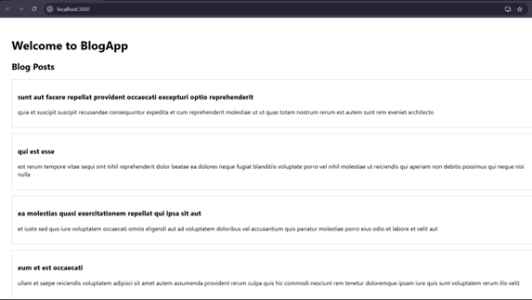

**Ex : 5**

**CohortDetails.module.css**

.box {

width: 300px;

display: inline-block;

margin: 10px;

padding: 10px 20px;

border: 1px solid black;

border-radius: 10px;

}

dt {

font-weight: 500;

}

**CohortDetails.js**

import React from 'react';

import styles from './CohortDetails.module.css';

function CohortDetails({ name, trainer, status }) {

const titleStyle = {

color: status === 'ongoing' ? 'green' : 'blue'

};

return (

<div className={styles.box}>

<h3 style={titleStyle}>{name}</h3>

<dl>

<dt>Trainer:</dt>

<dd>{trainer}</dd>

<dt>Status:</dt>

<dd>{status}</dd>

</dl>

</div>

);

}

export default CohortDetails;

**App.js**

import React from 'react';

import CohortDetails from './CohortDetails';

function App() {

return (

<div style={{ padding: '2rem' }}>

<h1>Cohort Dashboard</h1>

<CohortDetails name="React Bootcamp" trainer="John" status="ongoing" />

<CohortDetails name="Angular Sprint" trainer="Sara" status="completed" />

</div>

);

}

**OUTPUT:**

