**Ex 9 :**

**ListofPlayers.js**

import React from 'react';

const ListofPlayers = () => {

  const players = [

    { name: 'Rohit', score: 85 },

    { name: 'Gill', score: 45 },

    { name: 'Kohli', score: 95 },

    { name: 'Rahul', score: 30 },

    { name: 'Iyer', score: 77 },

    { name: 'Pandya', score: 60 },

    { name: 'Jadeja', score: 35 },

    { name: 'Ashwin', score: 68 },

    { name: 'Bumrah', score: 90 },

    { name: 'Shami', score: 40 },

    { name: 'Kuldeep', score: 50 }

  ];

  const below70 = players.filter(player => player.score < 70);

  return (

    <div>

      <h2>All Players</h2>

      {players.map((player, index) => (

        <p key={index}>{player.name} - {player.score}</p>

      ))}

      <h3>Players with Score Below 70</h3>

      {below70.map((player, index) => (

        <p key={index}>{player.name} - {player.score}</p>

      ))}

    </div>

  );

};

export default ListofPlayers;

**IndianPlayers.js**

import React from 'react';

const IndianPlayers = () => {

  const teamPlayers = ["Player1", "Player2", "Player3", "Player4", "Player5", "Player6"];

  const [odd1, even1, odd2, even2, odd3, even3] = teamPlayers;

  const T20players = ['Rohit', 'Kohli', 'Bumrah'];

  const RanjiPlayers = ['Jaiswal', 'Sarfaraz', 'Unadkat'];

  const allPlayers = [...T20players, ...RanjiPlayers];

  return (

    <div>

      <h2>Odd Team Players</h2>

      <ul>

        <li>{odd1}</li>

        <li>{odd2}</li>

        <li>{odd3}</li>

      </ul>

      <h2>Even Team Players</h2>

      <ul>

        <li>{even1}</li>

        <li>{even2}</li>

        <li>{even3}</li>

      </ul>

      <h2>Merged T20 + Ranji Players</h2>

      <ul>

        {allPlayers.map((player, index) => <li key={index}>{player}</li>)}

      </ul>

    </div>

  );

};

export default IndianPlayers;

**App.js**

import React from 'react';

import './App.css';

import ListofPlayers from './components/ListofPlayers';

import IndianPlayers from './components/IndianPlayers';

function App() {

  const flag = false;

  return (

    <div className="App">

      <h1>🏏 Cricket App</h1>

      {flag ? <ListofPlayers /> : <IndianPlayers />}

    </div>

  );

}

export default App;

**OUTPUT:**

Flag = true

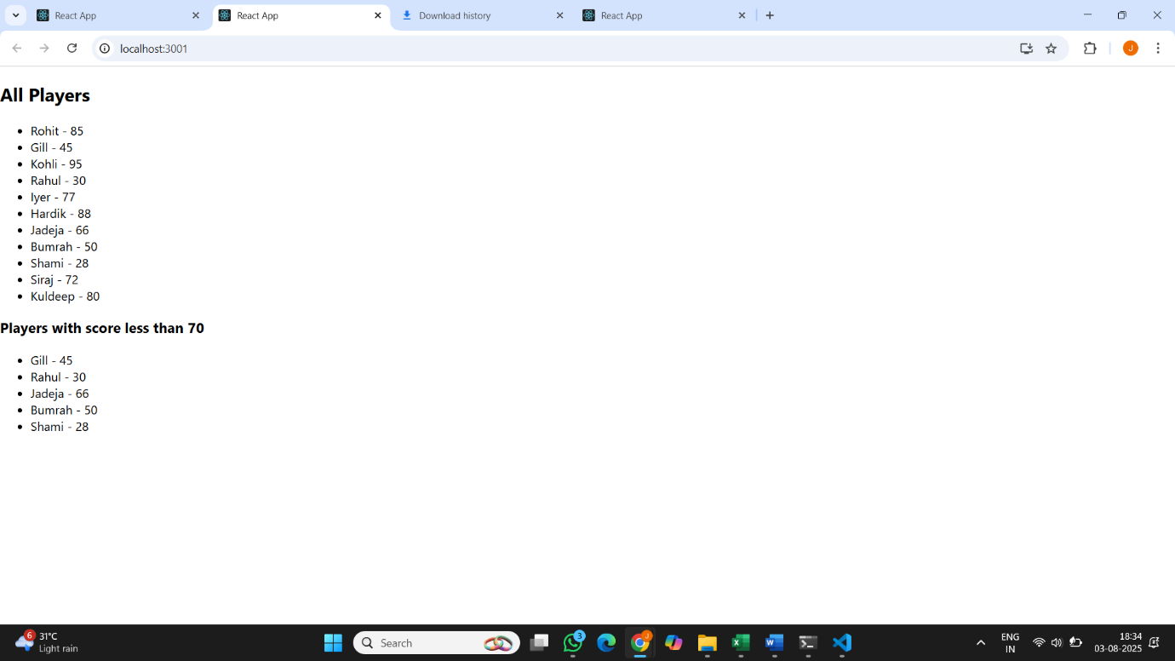

Flag = false

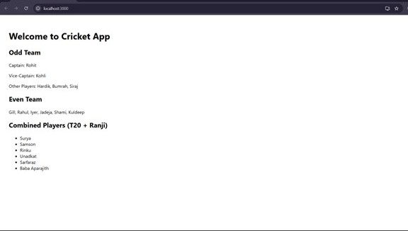

**Ex 10:**

**App.js**

import React from 'react';

const App = () => {

const title = <h1 style={{ textAlign: 'center', margin: '20px' }}>Office Space Rental App</h1>;

const officeImage = "https://images.unsplash.com/photo-1581375271042-4aa5413cde7b";

const officeDetails = {

name: "Skyline Workspace",

rent: 58000,

address: "123 MG Road, Bengaluru"

};

const officeList = [

{ id: 1, name: "Urban Desk", rent: 62000, address: "Indiranagar, Bengaluru" },

{ id: 2, name: "TechHub", rent: 55000, address: "HSR Layout, Bengaluru" },

{ id: 3, name: "EcoSpace", rent: 72000, address: "Whitefield, Bengaluru" },

{ id: 4, name: "StartZone", rent: 48000, address: "Koramangala, Bengaluru" }

];

const getRentStyle = (rent) => {

return {

color: rent > 60000 ? "green" : "red",

fontWeight: "bold"

};

};

return (

<div style={{ padding: "30px", fontFamily: "Arial" }}>

{title}

<div style={{ textAlign: 'center' }}>

<img

src={officeImage}

alt="Office"

style={{ width: "80%", height: "300px", objectFit: "cover", borderRadius: "10px" }}

/>

</div>

<h2>Featured Office</h2>

<p><strong>Name:</strong> {officeDetails.name}</p>

<p><strong>Address:</strong> {officeDetails.address}</p>

<p><strong>Rent:</strong> <span style={getRentStyle(officeDetails.rent)}>{officeDetails.rent}</span></p>

<h2>Other Available Spaces</h2>

{officeList.map((office) => (

<div key={office.id} style={{ borderBottom: "1px solid #ccc", marginBottom: "10px" }}>

<p><strong>Name:</strong> {office.name}</p>

<p><strong>Address:</strong> {office.address}</p>

<p>

<strong>Rent:</strong>{' '}

<span style={getRentStyle(office.rent)}>{office.rent}</span>

</p>

</div>

))}

</div>

);

};

export default App;

**OUTPUT:**

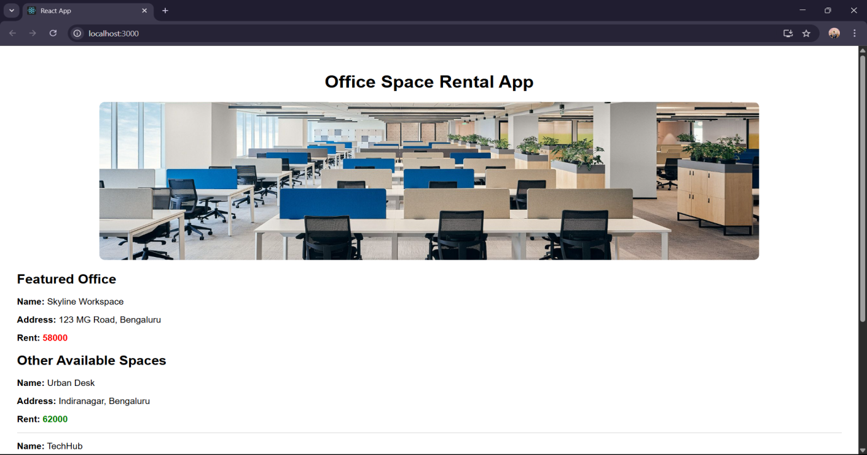

**Ex 11:**

**App.js**

import React, { useState } from 'react';

import CurrencyConvertor from './CurrencyConvertor';

const App = () => {

const [count, setCount] = useState(0);

const increment = () => {

setCount(prev => prev + 1);

sayHello();

};

const decrement = () => {

setCount(prev => prev - 1);

};

const sayHello = () => {

console.log("Hello Abishek! Keep clicking!");

};

const sayWelcome = (msg) => {

alert(msg);

};

const handleClick = (event) => {

alert("I was clicked");

console.log("Synthetic Event:", event);

};

return (

<div style={{ padding: "40px", fontFamily: "Arial" }}>

<h1>React Event Examples</h1>

<h2>Counter: {count}</h2>

<button onClick={increment}>Increment</button>

<button onClick={decrement} style={{ marginLeft: "10px" }}>Decrement</button>

<div style={{ marginTop: "20px" }}>

<button onClick={() => sayWelcome("Welcome Abishek!")}>Say Welcome</button>

</div>

<div style={{ marginTop: "20px" }}>

<button onClick={handleClick}>Synthetic Event OnPress</button>

</div>

<hr style={{ margin: "30px 0" }} />

<CurrencyConvertor />

</div>

);

};

export default App;

**CurrencyConvertor.js**

import React, { useState } from 'react';

const CurrencyConvertor = () => {

const [rupees, setRupees] = useState('');

const [euros, setEuros] = useState(null);

const handleSubmit = (e) => {

e.preventDefault();

const conversionRate = 0.011; // Roughly 1 INR = 0.011 EUR

const converted = (parseFloat(rupees) * conversionRate).toFixed(2);

setEuros(converted);

};

return (

<div>

<h2>Currency Convertor</h2>

<form onSubmit={handleSubmit}>

<input

type="number"

value={rupees}

onChange={(e) => setRupees(e.target.value)}

placeholder="Enter amount in ₹"

/>

<button type="submit" style={{ marginLeft: "10px" }}>Convert</button>

</form>

{euros !== null && (

<p style={{ marginTop: "15px" }}>

{rupees} INR = <strong>{euros} EUR</strong>

</p>

)}

</div>

);

};

export default CurrencyConvertor;

**OUTPUT:**

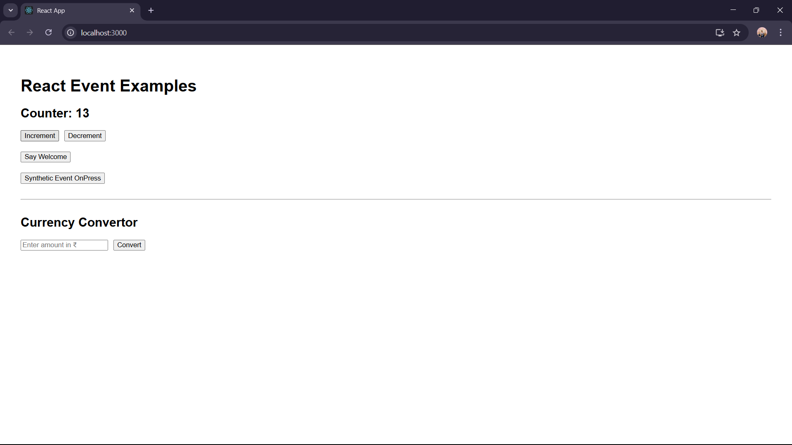

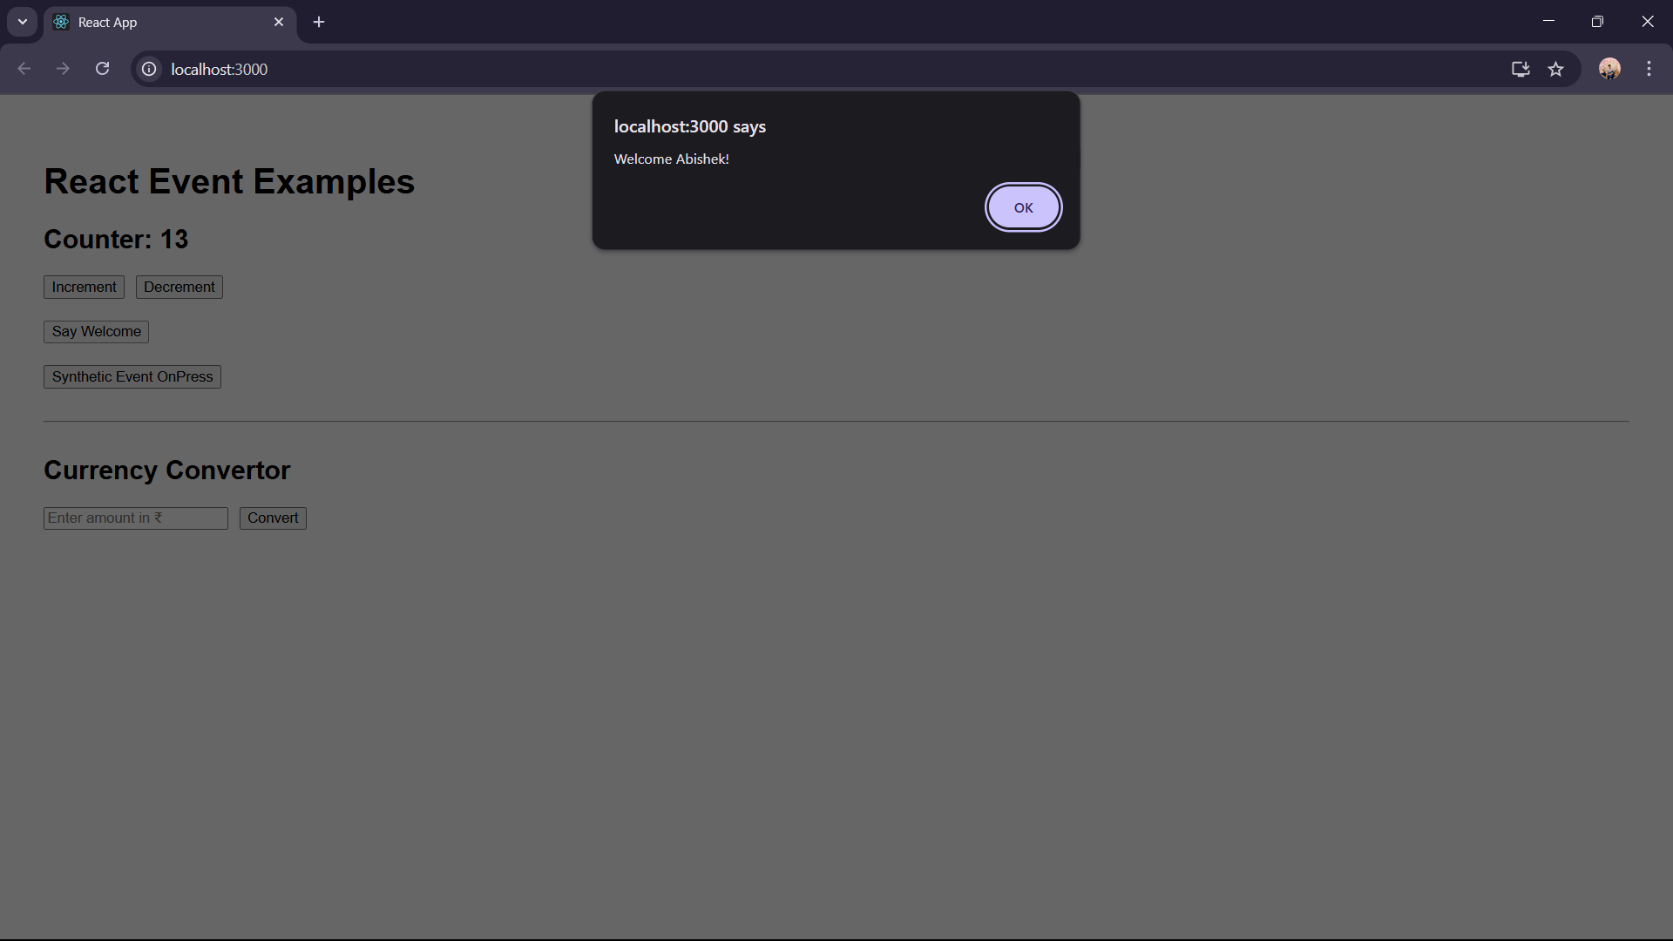

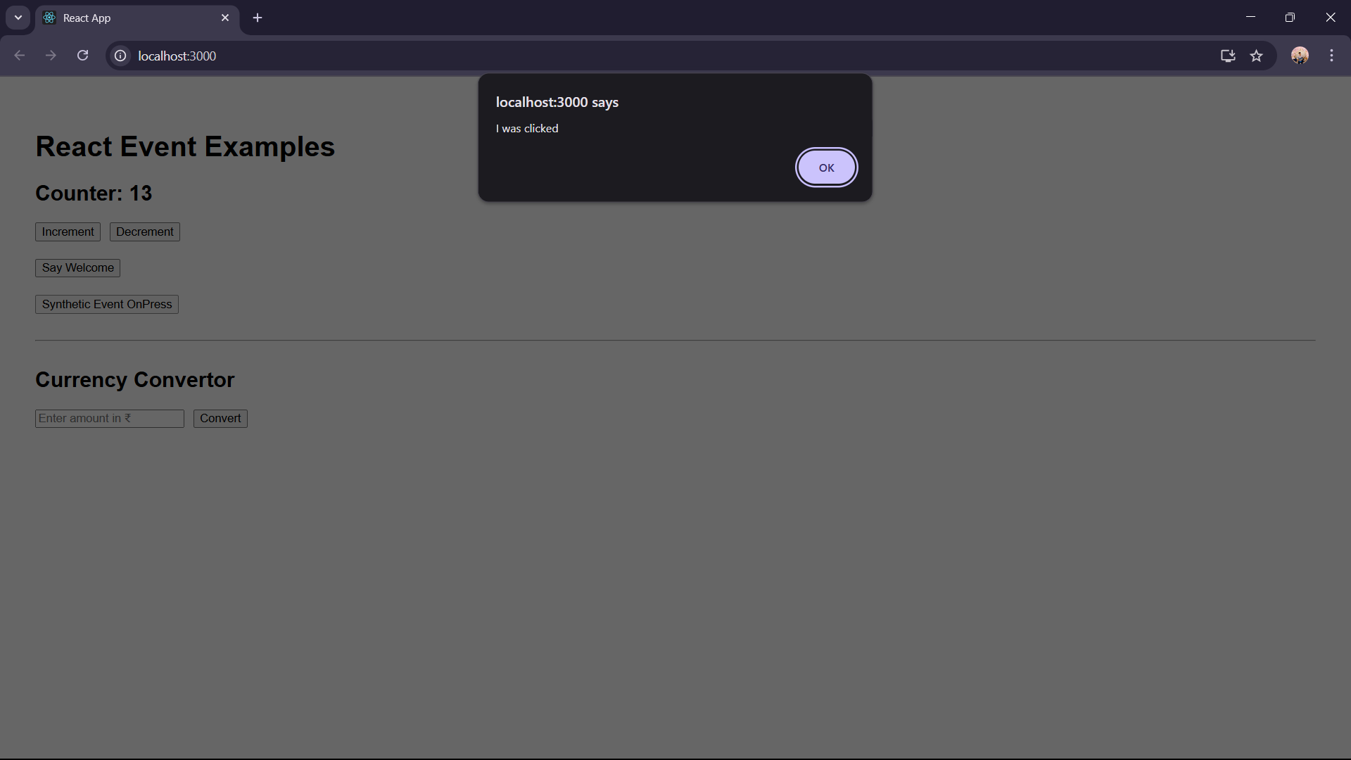

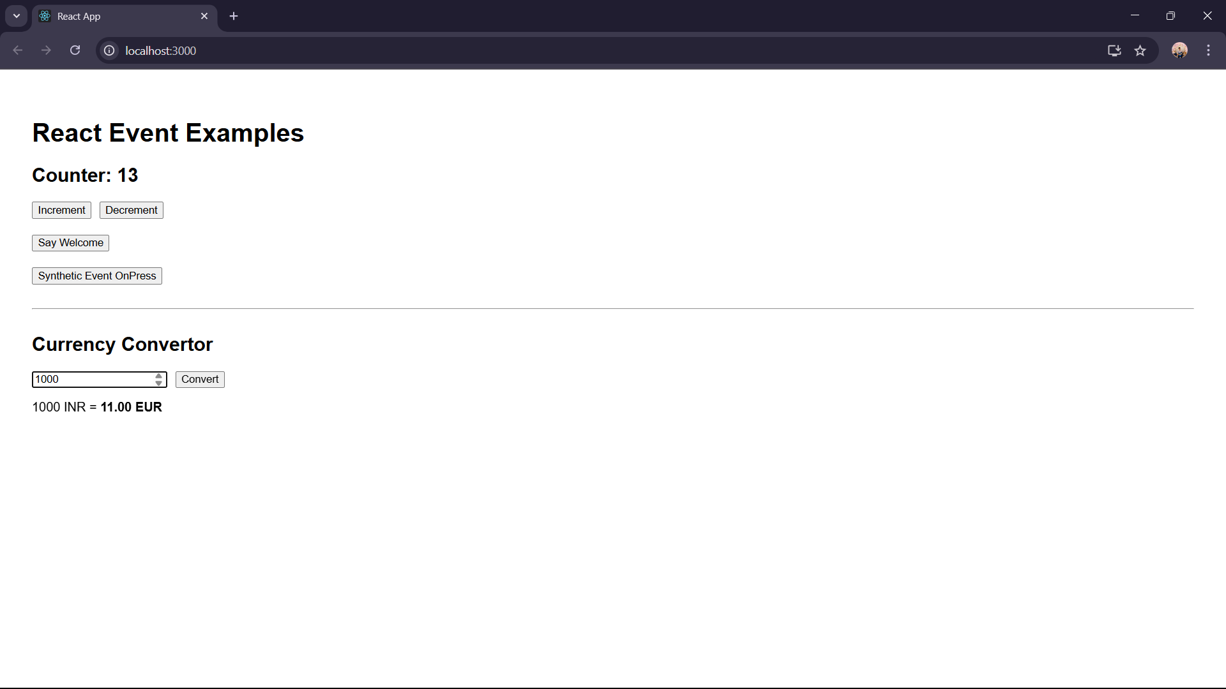

**Ex 12:**

**App.js**

import React, { useState } from 'react';

import GuestPage from './GuestPage';

import UserPage from './UserPage';

const App = () => {

const [isLoggedIn, setIsLoggedIn] = useState(false);

const handleLogin = () => {

setIsLoggedIn(true);

};

const handleLogout = () => {

setIsLoggedIn(false);

};

let pageContent;

if (isLoggedIn) {

pageContent = <UserPage onLogout={handleLogout} />;

} else {

pageContent = <GuestPage onLogin={handleLogin} />;

}

return (

<div style={{ fontFamily: "Arial", padding: "30px" }}>

<h1>Welcome to Ticket Booking App</h1>

{pageContent}

</div>

);

};

export default App;

**GuestPage.js**

import React from 'react';

const GuestPage = ({ onLogin }) => {

return (

<div>

<h2>Flight Details (Guest View)</h2>

<ul>

<li>Flight: AI101 | Chennai → Delhi | Time: 10:00 AM</li>

<li>Flight: SG303 | Bangalore → Mumbai | Time: 3:30 PM</li>

</ul>

<button onClick={onLogin}>Login to Book Tickets</button>

</div>

);

};

export default GuestPage;

**UserPage.js**

import React from 'react';

const UserPage = ({ onLogout }) => {

return (

<div>

<h2>Book Your Ticket</h2>

<form>

<label>

Flight Number:

<input type="text" placeholder="Enter flight number" />

</label>

<br /><br />

<label>

Passenger Name:

<input type="text" placeholder="Enter name" />

</label>

<br /><br />

<button type="submit">Book Ticket</button>

</form>

<br />

<button onClick={onLogout}>Logout</button>

</div>

);

};

export default UserPage;

**OUTPUT:**

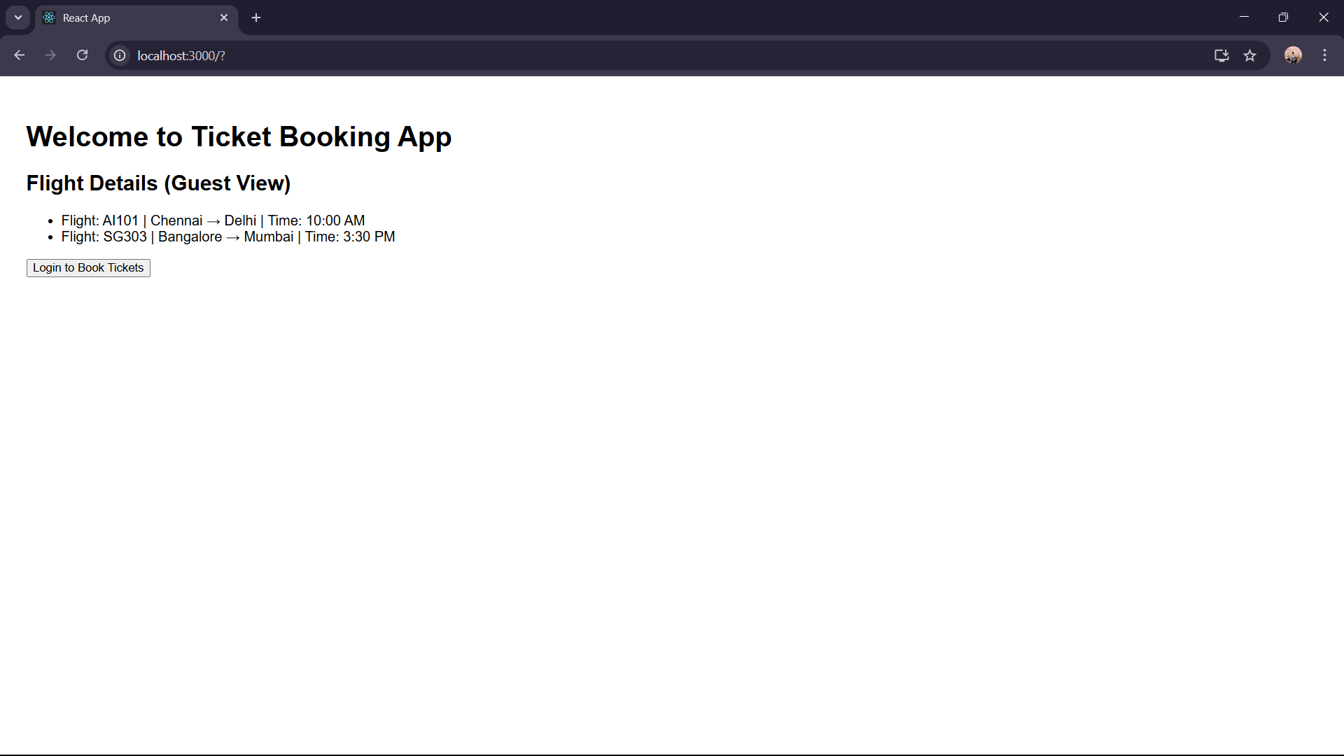

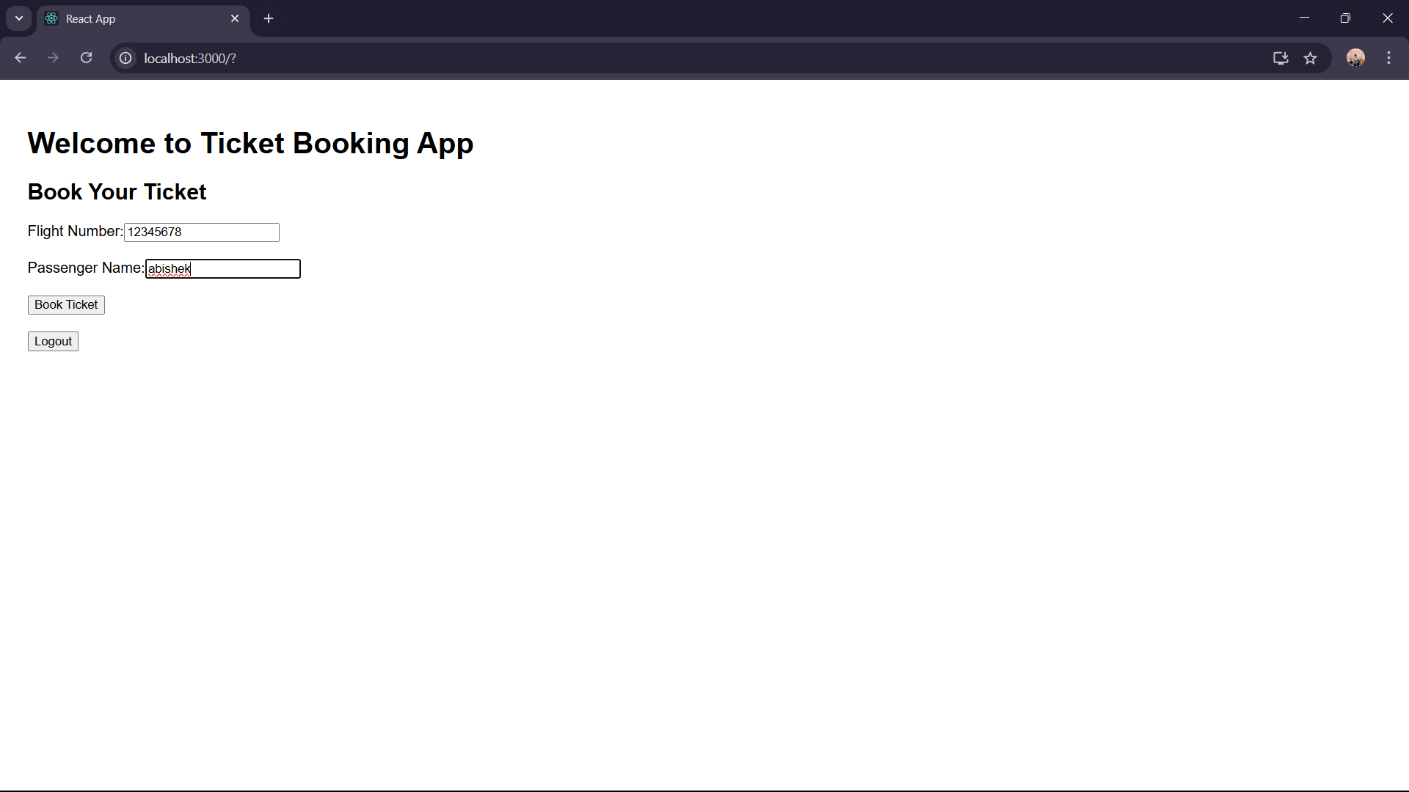

**Ex 13:**

**App.js**

import React, { useState } from 'react';

import BookDetails from './BookDetails';

import BlogDetails from './BlogDetails';

import CourseDetails from './CourseDetails';

const App = () => {

const [activeComponent, setActiveComponent] = useState("book");

const renderComponent = () => {

if (activeComponent === "book") {

return <BookDetails />;

} else if (activeComponent === "blog") {

return <BlogDetails />;

} else if (activeComponent === "course") {

return <CourseDetails />;

} else {

return <h3>Select an option</h3>;

}

};

return (

<div style={{ padding: "30px", fontFamily: "Arial" }}>

<h1>📘 Blogger App</h1>

<button onClick={() => setActiveComponent("book")}>Show Books</button>

<button onClick={() => setActiveComponent("blog")}>Show Blogs</button>

<button onClick={() => setActiveComponent("course")}>Show Courses</button>

<hr />

{renderComponent()}

</div>

);

};

export default App;

**BookDetails.js**

import React from 'react';

const books = [

{ id: 1, title: "You Can Win", author: "Shiv Khera" },

{ id: 2, title: "Atomic Habits", author: "James Clear" },

{ id: 3, title: "The Alchemist", author: "Paulo Coelho" }

];

const BookDetails = () => {

return (

<div>

<h2>Book List</h2>

{books.length > 0 ? (

books.map(book => (

<div key={book.id} style={{ marginBottom: '10px' }}>

<strong>{book.title}</strong> by {book.author}

</div>

))

) : (

<p>No books available</p>

)}

</div>

);

};

export default BookDetails;

**CourseDetails.js**

import React from 'react';

const isLoggedIn = true;

const enrolledCourses = ["React", "Node.js", "MongoDB"];

const CourseDetails = () => {

return (

<div>

<h2>Courses</h2>

{isLoggedIn ? (

<div>

<p>Welcome! You are enrolled in:</p>

<ul>

{enrolledCourses.map((course, idx) => (

<li key={idx}>{course}</li>

))}

</ul>

</div>

) : (

<p>Please login to view courses</p>

)}

</div>

);

};

export default CourseDetails;

**OUTPUT:**

