**Ex 1: GIT**

**Step 1: Setup Git Configuration**

**Description:**  
Installed Git Bash and configured username and email.

**Commands Used:**

git --version

git config --global user.name "MEIKEERTHY L"

git config --global user.email "meikeerthy4lmk@gmail.com"

git config --global --list

**Screenshot(s):**  
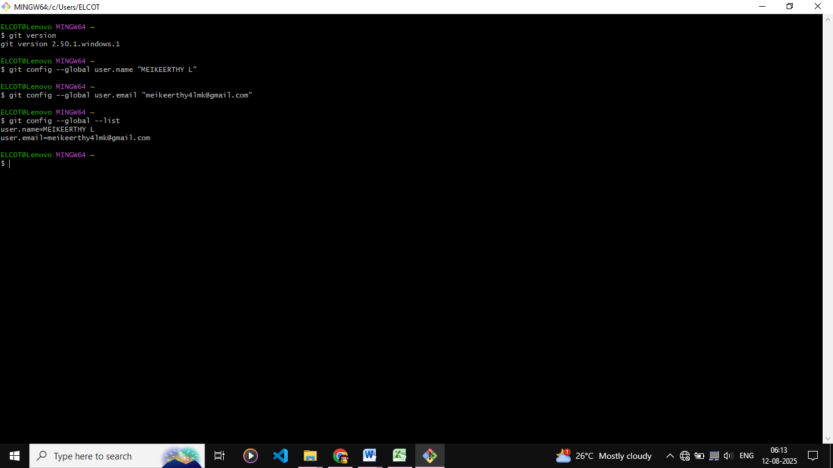

**Step 2: Integrate Notepad++ with Git**

**Description:**  
Configured Notepad++ as the default Git editor.

**Commands Used:**

notepad++

git config --global core.editor "notepad++ -multiInst -notabbar -nosession -noPlugin"

git config --global -e

**Step 3: Create Local Repository**

**Description:**  
Created a folder GitDemo and initialized it as a Git repository.

**Commands Used:**

mkdir GitDemo

cd GitDemo

git init

**Screenshot(s):**  
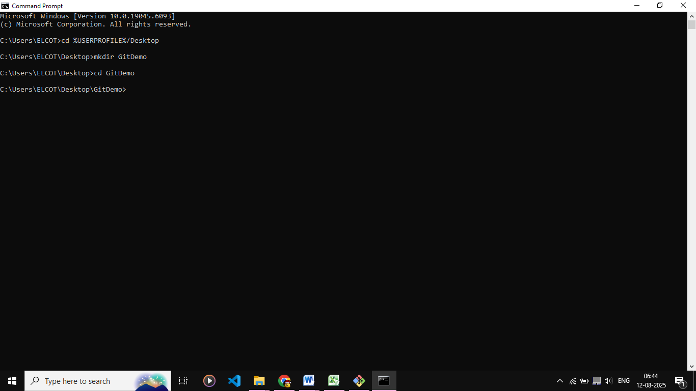

**Step 4: Add File to Repository**

**Description:**  
Created welcome.txt file and committed it.

**Commands Used:**

echo "Welcome to Git" > welcome.txt

git add welcome.txt

git commit

**Step 5: Push to Remote Repository**

**Description:**  
Created GitLab repository and pushed local commits to it.

**Commands Used:**

git remote add origin https://github.com/Meikeerthy/GitDemo.git

git pull origin master

git push origin master

**Ex 2: GIT**

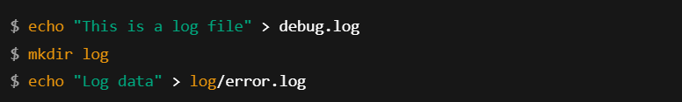

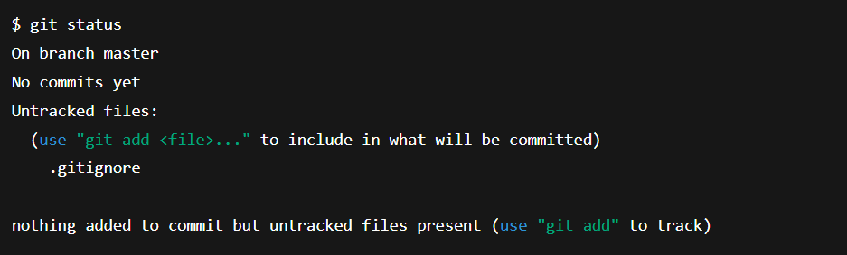

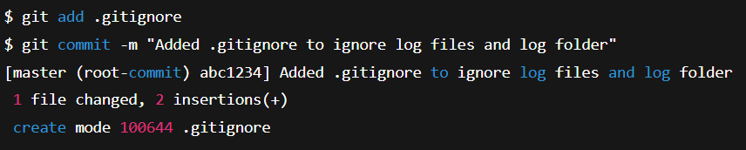

**Ex 3: GIT**

  
  
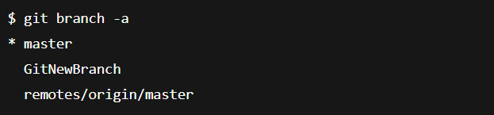  
  
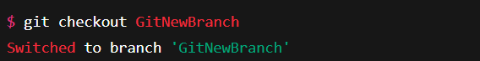  
  
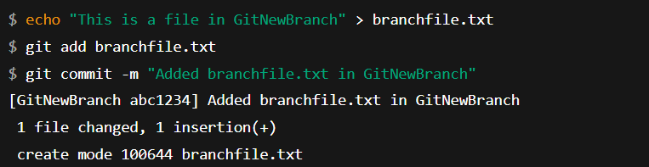  
  
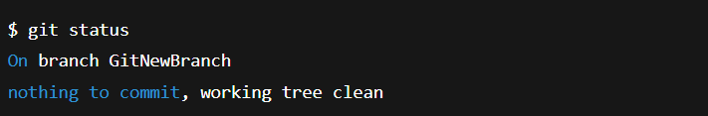  
  
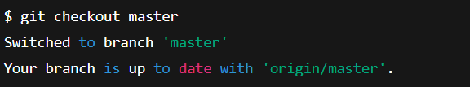  
  
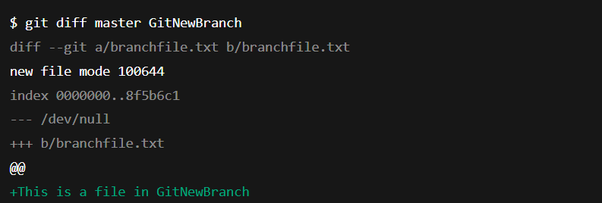  
  
  
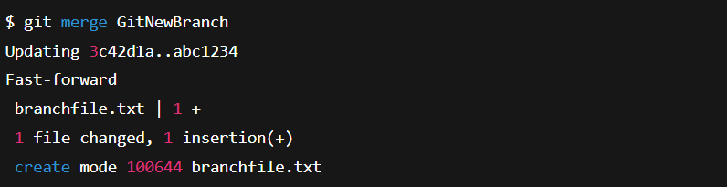  
  
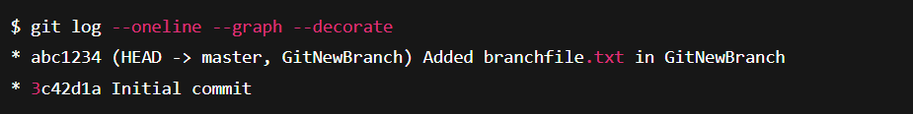  
  
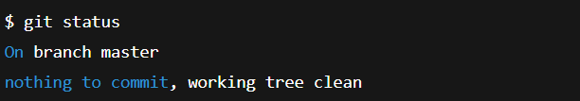

**Ex 4: GIT**

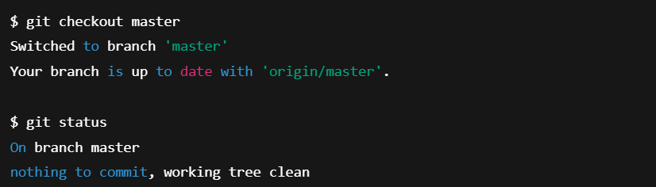  
  
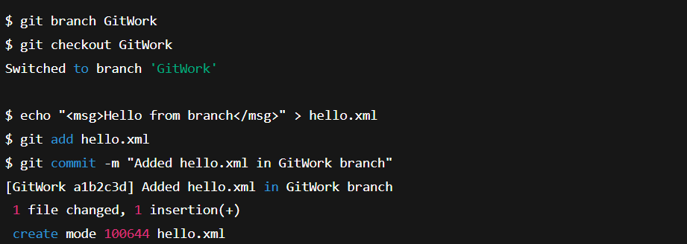  
  
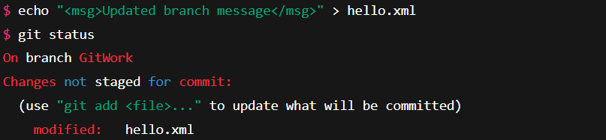  
  
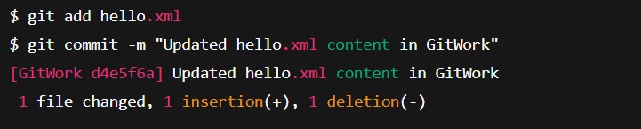  
  
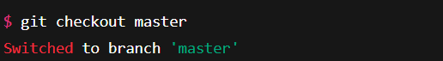  
  
  
  
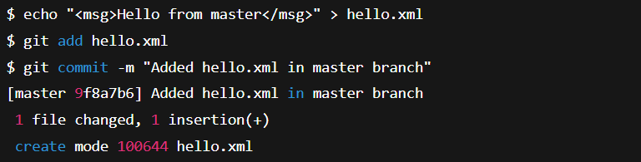  
  
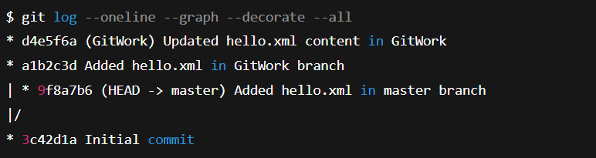  
  
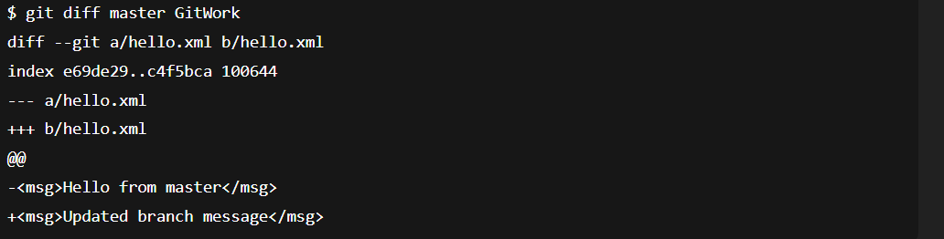  
  
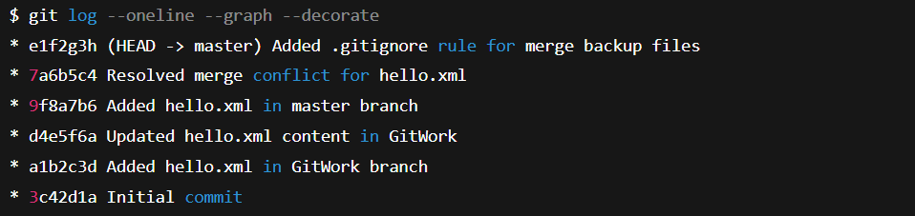

**Ex 5: GIT**

