CSX4104 SOFTWARE TESTING

ASSUMPTION UNIVERSITY
Vincent Mary School of Engineering, Science and Technology
CSX4104/ITX4104 SOFTWARE TESTING
Submitted to
Asst. Prof. Dr. Darun Kesrarat
Term Project Report
Campus Lost & Found Management System
Group members:
JATUPON ITSARA (6610073)
GULIZARA BENJAPALAPORN (6612233)
Chanyanut Pumasri (6620025)
Phanthira Kositjaroenkul (6630003)
SEMESTER 1/2026

Table of Contents
Introduction 3
Functional Scope 3
Unit Testing 5
Control Flow Testing 25
Data Flow Testing 34
Domain Testing 40
Integration Testing 54
Access Control Testing 57
Final Test Case with Functional Requirements and UI/UX 58
Summary 68

Introduction
The Campus Lost & Found Management System is a web application that helps students and staff at the university report lost and found items, automatically compares reports using a rule-based matching algorithm, and supports staff in verifying ownership before an item is handed over. This report documents the software testing performed on the system, applying Unit Testing, Control Flow Testing, Data Flow Testing, Domain Testing, Integration Testing, and Access Control Testing, with a final walkthrough mapping the implemented UI to the system's functional requirements.

Functional Scope

Report Lost & Found Items
- The system should allow students and staff to submit an item report with a title, description, category, color, brand, location, and date/time last seen.
- Each report is stored in the database and shown in the matching results and browse pages.

Rule-Based Item Matching
- The system should automatically compare a new report against existing reports of the opposite type (lost vs. found) using weighted attribute scoring: item name, description, color, brand, location, and date.
- Matches are classified into STRONG_MATCH (≥75), POSSIBLE_MATCH (50–74), or WEAK_MATCH (<50) and flagged for the user to confirm or dismiss.

Ownership Verification & Claim Management
- The system should let a student submit a claim on a matched report with supporting evidence (minimum 10 characters).
- The system should let staff approve, reject, or request more information on a claim, applying stricter verification for weak matches.
- The system should require a separate in-person identity check before a claim's handover can be confirmed.

Notifications & Audit Logging
- The system should notify a student in-app whenever a match is confirmed or their claim's status changes.
- The system should write an audit log entry for every claim submission, decision, and handover, viewable only by Admin.

Role-Based Access
- The system should implement role-based access control across Student, Staff, and Admin, simulated via a header rather than full authentication (per the project proposal's stated out of scope).

Out of scope (per project proposal):
- Real Microsoft/AU authentication.
- User management (account creation/administration).
- Email or SMS notifications.
- Mobile application.
- AI-based image recognition for photo matching.
- Database performance optimization / horizontal scaling.

Unit Testing
Unit testing verifies individual functions in isolation. Jest 30.4.2 on Node.js v22.12.0 was used as the test runner. matchingService, claimService, and notificationService are pure functions with no database dependency, so the full suite executes in well under one second.

Test Environment
Node.js v22.12.0, Jest 30.4.2. No mocking required.

1. Testing: scoreItemName
function scoreItemName(nameA, nameB) {
const a = normalizeText(nameA);
const b = normalizeText(nameB);

if (!a || !b) return 0;
if (a === b) return WEIGHTS.itemName;
if (a.includes(b) || b.includes(a)) return Math.round(WEIGHTS.itemName * 0.6);
return 0;
}

test("gives full weight for an exact match (case/whitespace insensitive)", () => {
expect(scoreItemName("Black Backpack", " black backpack ")).toBe(WEIGHTS.itemName);
});

test("gives partial credit when one name contains the other", () => {
expect(scoreItemName("Backpack", "Black Backpack")).toBe(Math.round(WEIGHTS.itemName * 0.6));
});

test("returns 0 when both names are empty/undefined", () => {
expect(scoreItemName("", "")).toBe(0);
expect(scoreItemName(undefined, undefined)).toBe(0);
});

test("treats non-string input (null/number) as an empty name", () => {
expect(scoreItemName(null, "Backpack")).toBe(0);
expect(scoreItemName(123, "Backpack")).toBe(0);
});

PASS tests/matchingService.test.js
matchingService: unit tests for attribute scorers
✓ scoreItemName gives full weight for an exact match (case/whitespace insensitive)
✓ scoreItemName gives partial credit when one name contains the other
✓ scoreItemName gives zero for unrelated names
FR2 additional coverage: scoreItemName edge cases
✓ returns 0 when both names are empty/undefined
✓ treats non-string input (null/number) as an empty name, returning 0

Tests: 6 passed, 6 total

Test Case 1: Exact Match (case/whitespace insensitive)
Input:
- nameA = "Black Backpack"
- nameB = " black backpack "
Expected Output:
25 (WEIGHTS.itemName)
Description:
Both names are normalized (trim + lowercase) before comparison, so differences in case or surrounding whitespace should not prevent a perfect match.
Actual Output:
The function returned 25. Test passed.
Test Case 2: Substring Containment (partial credit)
Input:
- nameA = "Backpack"
- nameB = "Black Backpack"
Expected Output:
15 (round(25 * 0.6))
Description:
One name is a substring of the other, which the algorithm rewards as a 60% partial match rather than 0% or 100%.
Actual Output:
The function returned 15. Test passed.
Test Case 3: Both Names Empty
Input:
- nameA = ""
- nameB = ""
- and nameA = undefined, nameB = undefined
Expected Output:
0
Description:
Ensures the function does not throw when normalization yields an empty string on both sides — an edge case not covered by the exact-match/substring cases above.
Actual Output:
The function returned 0 in both cases. Test passed.
Test Case 4: Non-string Input
Input:
- nameA = null, nameB = "Backpack"
- nameA = 123, nameB = "Backpack"
Expected Output:
0
Description:
normalizeText() only accepts strings; null and number inputs should degrade to an empty string rather than throwing a TypeError.
Actual Output:
The function returned 0 in both cases. Test passed.
Notes:
- Function tested: scoreItemName(nameA, nameB).
- Behavior confirmed: case/whitespace-insensitive matching; 60% partial credit for substring containment; degrades gracefully (no throw) for missing or non-string input.
- Relevance: contributes 25 of the 100 total match-score points computed by calculateMatchScore().

2. Testing: scoreDescription
function scoreDescription(descA, descB) {
const similarity = jaccardSimilarity(toWordSet(descA), toWordSet(descB));
return Math.round(WEIGHTS.description * similarity);
}

function jaccardSimilarity(setA, setB) {
if (setA.size === 0 && setB.size === 0) return 0;
let intersectionSize = 0;
for (const word of setA) {
if (setB.has(word)) intersectionSize += 1;
}
const unionSize = setA.size + setB.size - intersectionSize;
return unionSize === 0 ? 0 : intersectionSize / unionSize;
}

test("scales with word overlap (Jaccard similarity)", () => {
const full = scoreDescription("black leather backpack torn pocket", "black leather backpack torn pocket");
const none = scoreDescription("black leather backpack", "red umbrella broken handle");
expect(full).toBe(WEIGHTS.description);
expect(none).toBe(0);
});

test("P1: both descriptions empty returns 0 (no divide-by-zero)", () => {
expect(scoreDescription("", "")).toBe(0);
});

test("P2: one empty, one non-empty returns 0", () => {
expect(scoreDescription("", "black leather backpack")).toBe(0);
});

PASS tests/matchingService.test.js
matchingService: unit tests for attribute scorers
✓ scoreDescription scales with word overlap (Jaccard similarity)
FR2 additional coverage: scoreDescription control-flow paths
✓ P1: both descriptions empty returns 0 (does not divide by zero)
✓ P2: one empty description and one non-empty description returns 0
✓ single shared word scores partial credit proportional to Jaccard overlap
✓ is case-insensitive and whitespace-insensitive

Tests: 5 passed, 5 total

Test Case 1: P1 — Both Descriptions Empty
Input:
- descA = ""
- descB = ""
Expected Output:
0
Description:
This is the control-flow path guarded by the early-return check in jaccardSimilarity (setA.size===0 && setB.size===0). Without this guard, unionSize would be 0 and the ratio would divide by zero.
Actual Output:
The function returned 0. Test passed.
Test Case 2: P2 — One Description Empty
Input:
- descA = ""
- descB = "black leather backpack"
Expected Output:
0
Description:
setA is empty so the for...of loop over setA runs zero iterations; intersectionSize stays 0 and similarity is 0.
Actual Output:
The function returned 0. Test passed.
Test Case 3: P3/P4 — Full and No Overlap
Input:
- Full: "black leather backpack torn pocket" vs itself
- None: "black leather backpack" vs "red umbrella broken handle"
Expected Output:
25 for identical text, 0 for disjoint text
Description:
Exercises the loop body with setB.has(word) True on every iteration (full overlap) and False on every iteration (no overlap).
Actual Output:
Returned 25 and 0 respectively. Test passed.
Notes:
- Function tested: scoreDescription(descA, descB), which wraps the Jaccard-similarity helper jaccardSimilarity().
- Control-flow observation: the unionSize===0 branch inside jaccardSimilarity (node 9, True) is structurally present but infeasible when called through scoreDescription — the only way unionSize can be 0 is if both word sets are empty, which node 2 already intercepts. See Control Flow Testing, path P5.
- Relevance: contributes 25 of the 100 total match-score points.

3. Testing: scoreExactOptionalField
function scoreExactOptionalField(valueA, valueB, weight) {
const a = normalizeText(valueA);
const b = normalizeText(valueB);

if (!a || !b) return 0;
return a === b ? weight : 0;
}

test("matches case-insensitively and rewards exact match only", () => {
expect(scoreExactOptionalField("Black", "black", WEIGHTS.color)).toBe(WEIGHTS.color);
expect(scoreExactOptionalField("Black", "Red", WEIGHTS.color)).toBe(0);
});

test("returns 0 when both values are missing", () => {
expect(scoreExactOptionalField(undefined, undefined, WEIGHTS.color)).toBe(0);
expect(scoreExactOptionalField(null, null, WEIGHTS.brand)).toBe(0);
});

test("returns the exact weight passed in, including a weight of 0", () => {
expect(scoreExactOptionalField("Black", "black", 0)).toBe(0);
expect(scoreExactOptionalField("Black", "black", 15)).toBe(15);
});

PASS tests/matchingService.test.js
matchingService: unit tests for attribute scorers
✓ scoreExactOptionalField matches case-insensitively and rewards exact match only
✓ scoreExactOptionalField gives zero when a field is missing on either side
FR2 additional coverage: scoreExactOptionalField edge cases
✓ returns 0 when both values are missing
✓ returns the exact weight passed in, including a weight of 0

Tests: 4 passed, 4 total

Test Case 1: Exact Match (color field)
Input:
- valueA = "Black"
- valueB = "black"
- weight = 15
Expected Output:
15
Description:
Used for optional attributes (color, brand) that only ever score full weight or zero — no partial credit.
Actual Output:
The function returned 15. Test passed.
Test Case 2: Both Values Missing
Input:
- valueA = undefined, valueB = undefined
- valueA = null, valueB = null
Expected Output:
0
Description:
Neither report specified the optional field, so there is nothing to compare — the function must not throw or award credit by accident.
Actual Output:
The function returned 0 in both cases. Test passed.
Test Case 3: Zero Weight Boundary
Input:
- valueA = "Black", valueB = "black", weight = 0
Expected Output:
0
Description:
A weight of 0 is a valid domain boundary; the function should still return exactly 0 (the weight itself), not treat it as a falsy "no weight given" case.
Actual Output:
The function returned 0. Test passed.
Notes:
- Function tested: scoreExactOptionalField(valueA, valueB, weight) — shared by the color (weight 15) and brand (weight 15) attributes.

4. Testing: scoreLocation
function scoreLocation(locationA, locationB) {
const a = normalizeText(locationA);
const b = normalizeText(locationB);

if (!a || !b) return 0;
if (a === b) return WEIGHTS.location;
if (a.includes(b) || b.includes(a)) return Math.round(WEIGHTS.location * 0.5);
return 0;
}

test("gives full weight for exact match and partial credit for containment", () => {
expect(scoreLocation("Library 2nd Floor", "library 2nd floor")).toBe(WEIGHTS.location);
expect(scoreLocation("Library", "Library 2nd Floor")).toBe(Math.round(WEIGHTS.location * 0.5));
expect(scoreLocation("Library", "Gymnasium")).toBe(0);
});

test("gives partial credit regardless of which side is the longer string", () => {
expect(scoreLocation("Library 2nd Floor", "Library")).toBe(Math.round(WEIGHTS.location * 0.5));
});

test("returns 0 when either location is empty/undefined", () => {
expect(scoreLocation("", "Library")).toBe(0);
expect(scoreLocation(undefined, undefined)).toBe(0);
});

PASS tests/matchingService.test.js
matchingService: unit tests for attribute scorers
✓ scoreLocation gives full weight for exact match and partial credit for containment
FR2 additional coverage: scoreLocation edge cases
✓ returns 0 when either location is empty/undefined
✓ gives partial credit regardless of which side is the longer, containing string

Tests: 3 passed, 3 total

Test Case 1: Substring Containment — Both Orderings
Input:
- "Library" vs "Library 2nd Floor"
- "Library 2nd Floor" vs "Library"
Expected Output:
5 (round(10 * 0.5)) for both orderings
Description:
The predicate is a.includes(b) || b.includes(a) — a logical OR with two operands. The original test suite only exercised the case where the second operand was True; this case forces the first operand True, completing condition coverage.
Actual Output:
Returned 5 in both orderings. Test passed.
Test Case 2: Either Location Missing
Input:
- locationA = "", locationB = "Library"
- locationA = undefined, locationB = undefined
Expected Output:
0
Description:
Domain boundary: an unset location must not accidentally match or crash the scorer.
Actual Output:
The function returned 0 in both cases. Test passed.
Notes:
- Function tested: scoreLocation(locationA, locationB) — structurally identical to scoreItemName but with weight 10 and a 5-point (50%) partial-credit tier.

5. Testing: scoreDate
function daysBetween(dateA, dateB) {
const msPerDay = 24 * 60 * 60 * 1000;
const a = dateA instanceof Date ? dateA : new Date(dateA);
const b = dateB instanceof Date ? dateB : new Date(dateB);
return Math.abs(Math.round((a.getTime() - b.getTime()) / msPerDay));
}

function scoreDate(dateA, dateB) {
const diff = daysBetween(dateA, dateB);

if (diff === 0) return WEIGHTS.date;
if (diff <= 3) return Math.round(WEIGHTS.date * 0.5);
return 0;
}

test("boundary values at 0, 3, and 4 days apart", () => {
expect(scoreDate("2026-08-10", "2026-08-10")).toBe(WEIGHTS.date);
expect(scoreDate("2026-08-10", "2026-08-13")).toBe(Math.round(WEIGHTS.date * 0.5));
expect(scoreDate("2026-08-10", "2026-08-14")).toBe(0);
});

test("degrades gracefully to 0 for an unparsable date instead of throwing", () => {
expect(scoreDate("not-a-date", "2026-08-10")).toBe(0);
});

test("is symmetric regardless of argument order", () => {
expect(scoreDate("2026-08-13", "2026-08-10")).toBe(scoreDate("2026-08-10", "2026-08-13"));
});

PASS tests/matchingService.test.js
matchingService: unit tests for attribute scorers
✓ scoreDate: boundary values at 0, 3, and 4 days apart
FR2 additional coverage: scoreDate edge cases
✓ is symmetric regardless of argument order
✓ accepts Date object inputs directly
✓ degrades gracefully to 0 for an unparsable date instead of throwing
✓ returns 0 for a large date gap well beyond the 3-day boundary

Tests: 5 passed, 5 total

Test Case 1: Boundary — 3 vs. 4 Days Apart
Input:
- diff = 3 days: "2026-08-10" vs "2026-08-13"
- diff = 4 days: "2026-08-10" vs "2026-08-14"
Expected Output:
5 at diff=3 (round(10*0.5)), 0 at diff=4
Description:
Boundary Value Analysis on the diff <= 3 threshold — the two values immediately either side of the boundary must land in different score bands.
Actual Output:
Returned 5 and 0 respectively. Test passed.
Test Case 2: Unparsable Date Input
Input:
- dateA = "not-a-date"
- dateB = "2026-08-10"
Expected Output:
0
Description:
new Date("not-a-date") produces an Invalid Date, so getTime() is NaN and diff becomes NaN. Both diff===0 and diff<=3 evaluate to false for NaN, so the function safely falls through to 0 rather than throwing or returning NaN.
Actual Output:
The function returned 0. Test passed.
Notes:
- Function tested: scoreDate(dateA, dateB), backed by the helper daysBetween(). Confirmed this defensive behavior is intentional, not a bug — validateItemForMatching() already rejects unparsable dates earlier in the real request flow.

6. Testing: classifyScore
function classifyScore(score) {
if (score >= 75) return MATCH_RESULT.STRONG;
if (score >= 50) return MATCH_RESULT.POSSIBLE;
return MATCH_RESULT.WEAK;
}

test.each([
[0, MATCH_RESULT.WEAK], [49, MATCH_RESULT.WEAK],
[50, MATCH_RESULT.POSSIBLE], [74, MATCH_RESULT.POSSIBLE],
[75, MATCH_RESULT.STRONG], [100, MATCH_RESULT.STRONG],
])("classifyScore(%i) -> %s", (score, expected) => {
expect(classifyScore(score)).toBe(expected);
});

test("clamps out-of-range scores into the nearest band", () => {
expect(classifyScore(-10)).toBe(MATCH_RESULT.WEAK);
expect(classifyScore(150)).toBe(MATCH_RESULT.STRONG);
});

test("honors fractional scores right at the threshold", () => {
expect(classifyScore(74.9)).toBe(MATCH_RESULT.POSSIBLE);
expect(classifyScore(75.0001)).toBe(MATCH_RESULT.STRONG);
});

PASS tests/matchingService.test.js
matchingService: Boundary Value Analysis on decision thresholds
✓ classifyScore(0) -> WEAK_MATCH
✓ classifyScore(49) -> WEAK_MATCH
✓ classifyScore(50) -> POSSIBLE_MATCH
✓ classifyScore(74) -> POSSIBLE_MATCH
✓ classifyScore(75) -> STRONG_MATCH
✓ classifyScore(100) -> STRONG_MATCH
FR2 additional coverage: classifyScore domain boundaries
✓ clamps out-of-range scores into the nearest band instead of throwing
✓ honors fractional scores right at the threshold boundary

Tests: 8 passed, 8 total

Test Case 1: Threshold Boundaries (49/50 and 74/75)
Input:
49, 50, 74, 75
Expected Output:
49→WEAK_MATCH, 50→POSSIBLE_MATCH, 74→POSSIBLE_MATCH, 75→STRONG_MATCH
Description:
Boundary Value Analysis on both decision thresholds (>=50 and >=75) — the value immediately below and immediately at each threshold must land on opposite sides.
Actual Output:
All four values classified as expected. Test passed.
Test Case 2: Out-of-Domain Scores
Input:
-10, 150
Expected Output:
-10 → WEAK_MATCH, 150 → STRONG_MATCH
Description:
calculateMatchScore() always clamps its input to 0–100 before calling classifyScore(), but classifyScore() itself has no such guard — this confirms it degrades sensibly rather than misbehaving if ever called directly with an out-of-range value.
Actual Output:
Returned WEAK_MATCH and STRONG_MATCH respectively. Test passed.

7. Testing: validateItemForMatching
function validateItemForMatching(item, label) {
const errors = [];
if (!item || typeof item !== "object") {
throw new ValidationError(`${label} item must be an object.`, [`${label}: missing item`]);
}
for (const field of REQUIRED_FIELDS) {
const value = item[field];
if (value === undefined || value === null || value === "") {
errors.push(`${label}: missing required field "${field}"`);
}
}
if (item.occurredAt !== undefined && item.occurredAt !== null) {
const date = item.occurredAt instanceof Date ? item.occurredAt : new Date(item.occurredAt);
if (Number.isNaN(date.getTime())) {
errors.push(`${label}: "occurredAt" is not a valid date`);
}
}
if (errors.length > 0) {
throw new ValidationError(`Invalid ${label} item for matching.`, errors);
}
}

test.each(["title", "description", "location", "occurredAt"])(
"rejects an item missing required field %s",
(field) => {
const item = makeItem({ [field]: undefined });
expect(() => validateItemForMatching(item, "lost")).toThrow(ValidationError);
}
);

test("an array is typeof 'object' so it passes the type check, but fails on missing fields", () => {
expect(() => validateItemForMatching([], "lost")).toThrow(ValidationError);
});

test("reports every missing field at once, not just the first", () => {
const item = makeItem({ title: undefined, location: undefined });
try {
validateItemForMatching(item, "lost");
} catch (err) {
expect(err.details).toHaveLength(2);
}
});

PASS tests/matchingService.test.js
matchingService: Equivalence Partitioning on item validation
✓ accepts a fully valid item
✓ rejects an item missing required field title
✓ rejects an item missing required field description
✓ rejects an item missing required field location
✓ rejects an item missing required field occurredAt
✓ rejects an item with an invalid occurredAt value
✓ accepts an item with optional fields (color/brand) omitted
✓ rejects a non-object item
FR2 additional coverage: validateItemForMatching edge cases
✓ rejects a non-object, non-null item (a string) with the object-type error
✓ rejects a non-object, non-null item (a number) with the object-type error
✓ an array is typeof 'object' so it passes the type check, but fails on missing fields
✓ rejects a required field that is present but an empty string
✓ reports every missing field at once, not just the first
✓ accepts a Date object (not just a date string) for occurredAt
✓ includes the caller-supplied label in the error details

Tests: 15 passed, 15 total

Test Case 1: Array Input (typeof 'object' but not a valid item)
Input:
item = [] (an empty array)
Expected Output:
Throws ValidationError with missing-field details, NOT the "must be an object" message
Description:
typeof [] === 'object' in JavaScript, so an array passes the initial type guard at node 2. It then fails every REQUIRED_FIELDS lookup (arrays have no .title, .description, etc.), so it is rejected for a different, more specific reason than a primitive input.
Actual Output:
Threw ValidationError with 4 missing-field entries in err.details. Test passed.
Test Case 2: Multiple Missing Fields at Once
Input:
item with both title and location set to undefined
Expected Output:
err.details has length 2 (one entry per missing field)
Description:
The loop over REQUIRED_FIELDS (node 4) accumulates every violation into the errors array before throwing once at node 13, rather than stopping at the first problem found.
Actual Output:
err.details.length === 2. Test passed.
Test Case 3: Non-Object Primitive Input
Input:
item = "just a string", item = 42
Expected Output:
Throws ValidationError with the "item must be an object" message
Description:
typeof "string" and typeof 42 are neither 'object', so both trip the first branch at node 2 directly.
Actual Output:
Both threw ValidationError as expected. Test passed.
Notes:
- Function tested: validateItemForMatching(item, label) — the guard function called before every match-score calculation.

8. Testing: calculateMatchScore (integration of all scorers)
function calculateMatchScore(lostItem, foundItem) {
validateItemForMatching(lostItem, "lost");
validateItemForMatching(foundItem, "found");
const breakdown = {
itemName: scoreItemName(lostItem.title, foundItem.title),
description: scoreDescription(lostItem.description, foundItem.description),
color: scoreExactOptionalField(lostItem.color, foundItem.color, WEIGHTS.color),
brand: scoreExactOptionalField(lostItem.brand, foundItem.brand, WEIGHTS.brand),
location: scoreLocation(lostItem.location, foundItem.location),
date: scoreDate(lostItem.occurredAt, foundItem.occurredAt),
};
const rawScore = Object.values(breakdown).reduce((sum, value) => sum + value, 0);
const score = Math.min(100, Math.max(0, rawScore));
return { score, result: classifyScore(score), breakdown };
}

test("identical items produce a perfect score and Strong Match", () => {
const result = calculateMatchScore(makeItem(), makeItem());
expect(result.score).toBe(100);
expect(result.result).toBe(MATCH_RESULT.STRONG);
});

test("completely unrelated items produce a low score and Weak Match", () => {
const result = calculateMatchScore(lost, unrelatedFound);
expect(result.score).toBeLessThan(50);
expect(result.result).toBe(MATCH_RESULT.WEAK);
});

test("propagates validation errors for an invalid found item", () => {
expect(() => calculateMatchScore(makeItem(), makeItem({ title: "" }))).toThrow(ValidationError);
});

PASS tests/matchingService.test.js
matchingService: calculateMatchScore integration
✓ identical items produce a perfect score and Strong Match
✓ completely unrelated items produce a low score and Weak Match
✓ partially matching items land in the Possible Match band
✓ propagates validation errors for an invalid found item

Tests: 4 passed, 4 total

Test Case 1: Identical Items — Perfect Score
Input:
Two reports with the same title, description, color, brand, location, and date
Expected Output:
score = 100, result = STRONG_MATCH
Description:
Sums all six scorers at full weight (25+25+15+15+10+10=100) and confirms classifyScore(100) resolves to STRONG_MATCH.
Actual Output:
score=100, result=STRONG_MATCH. Test passed.
Test Case 2: Invalid Found Item Propagates
Input:
lost = valid item, found = item with title: ""
Expected Output:
Throws ValidationError before any scoring runs
Description:
calculateMatchScore() calls validateItemForMatching() on both items first, so a malformed found report should abort before scoreItemName/scoreDescription/etc. are ever invoked.
Actual Output:
Threw ValidationError. Test passed.

9. Testing: decideClaim (decision table)
function decideClaim({ action, hasEvidence, matchResult, staffVerifiedEvidence = false }) {
if (!VALID_ACTIONS.includes(action)) {
throw new ValidationError(`Invalid claim action: ${action}`);
}
if (!VALID_MATCH_RESULTS.includes(matchResult)) {
throw new ValidationError(`Invalid match result: ${matchResult}`);
}
if (action === CLAIM_ACTION.REJECT) {
return { status: CLAIM_STATUS.REJECTED, reason: "Staff rejected the claim." };
}
if (action === CLAIM_ACTION.REQUEST_INFO) {
return { status: CLAIM_STATUS.INFO_REQUESTED, reason: "Staff requested additional information." };
}
if (!hasEvidence) {
throw new ValidationError("Cannot approve a claim without supporting evidence.");
}
if (matchResult === MATCH_RESULT.WEAK && !staffVerifiedEvidence) {
throw new ValidationError("Weak match claims require staff-verified evidence before approval.");
}
return { status: CLAIM_STATUS.APPROVED, reason: "Claim approved after evidence verification." };
}

test("Rule 4: APPROVE, hasEvidence=true, matchResult=WEAK_MATCH, staffVerifiedEvidence=false -> throws", () => {
expect(() =>
decideClaim({ action: CLAIM_ACTION.APPROVE, hasEvidence: true, matchResult: MATCH_RESULT.WEAK, staffVerifiedEvidence: false })
).toThrow(ValidationError);
});

test("Rule 5: APPROVE, hasEvidence=true, matchResult=WEAK_MATCH, staffVerifiedEvidence=true -> APPROVED", () => {
const result = decideClaim({ action: CLAIM_ACTION.APPROVE, hasEvidence: true, matchResult: MATCH_RESULT.WEAK, staffVerifiedEvidence: true });
expect(result.status).toBe(CLAIM_STATUS.APPROVED);
});

PASS tests/claimService.test.js
claimService: Decision Table Testing for claim approval logic
✓ Rule 1: REJECT -> REJECTED (evidence and match strength irrelevant)
✓ Rule 2: REQUEST_INFO -> INFO_REQUESTED (evidence and match strength irrelevant)
✓ Rule 3: APPROVE with hasEvidence=false and matchResult=WEAK_MATCH -> throws (evidence required)
✓ Rule 4: APPROVE, hasEvidence=true, matchResult=WEAK_MATCH, staffVerifiedEvidence=false -> throws
✓ Rule 5: APPROVE, hasEvidence=true, matchResult=WEAK_MATCH, staffVerifiedEvidence=true -> APPROVED
✓ Rule 6: APPROVE, hasEvidence=true, matchResult=POSSIBLE_MATCH, staffVerifiedEvidence=false -> APPROVED
✓ rejects an unknown action
✓ rejects an unknown matchResult

Tests: 11 passed, 11 total

Test Case 1: Weak Match Requires Staff Verification
Input:
action=APPROVE, hasEvidence=true, matchResult=WEAK_MATCH, staffVerifiedEvidence=false
Expected Output:
Throws ValidationError
Description:
The decision table's highest-risk rule: a weak-confidence match must not be auto-approved on evidence alone — a staff member must have verified it in person first.
Actual Output:
Threw ValidationError with the message "Weak match claims require staff-verified evidence before approval." Test passed.
Test Case 2: Weak Match Approved Once Verified
Input:
Same as above but staffVerifiedEvidence=true
Expected Output:
status = APPROVED
Description:
Confirms the True branch of the same predicate correctly allows approval once the extra verification step is satisfied.
Actual Output:
status=APPROVED. Test passed.

10. Testing: canConfirmHandover
function canConfirmHandover({ status, verifiedIdentity }) {
if (status !== CLAIM_STATUS.APPROVED) {
throw new ValidationError(
`Cannot confirm handover for a claim with status ${status}; it must be APPROVED first.`
);
}
if (!verifiedIdentity) {
throw new ValidationError("Staff must verify the claimant's identity before handover.");
}
return true;
}

test("allows handover when claim is APPROVED and identity is verified", () => {
expect(canConfirmHandover({ status: CLAIM_STATUS.APPROVED, verifiedIdentity: true })).toBe(true);
});

test.each([CLAIM_STATUS.PENDING, CLAIM_STATUS.REJECTED, CLAIM_STATUS.INFO_REQUESTED, CLAIM_STATUS.COMPLETED])(
"rejects handover when status is %s, even with verified identity",
(status) => {
expect(() => canConfirmHandover({ status, verifiedIdentity: true })).toThrow(ValidationError);
}
);

PASS tests/claimService.test.js
claimService: handover eligibility (canConfirmHandover)
✓ allows handover when claim is APPROVED and identity is verified
✓ rejects handover when status is PENDING, even with verified identity
✓ rejects handover when status is REJECTED, even with verified identity
✓ rejects handover when status is INFO_REQUESTED, even with verified identity
✓ rejects handover when status is COMPLETED, even with verified identity
✓ rejects handover when identity has not been verified

Tests: 6 passed, 6 total

Test Case 1: Blocks Handover on an Unapproved Claim
Input:
status=PENDING, verifiedIdentity=true
Expected Output:
Throws ValidationError
Description:
A claim must reach APPROVED before a handover can even be attempted, regardless of identity verification — this equivalence class is tested across all four non-APPROVED statuses.
Actual Output:
Threw ValidationError for all four statuses tested. Test passed.
Test Case 2: Blocks Handover Without Identity Verification
Input:
status=APPROVED, verifiedIdentity=false
Expected Output:
Throws ValidationError
Description:
Even an approved claim cannot be handed over until staff confirm the claimant's identity in person.
Actual Output:
Threw ValidationError. Test passed.

11. Testing: buildNotificationMessage
function buildNotificationMessage(type, context = {}) {
switch (type) {
case NOTIFICATION_TYPE.MATCH_CONFIRMED:
return `A possible match was confirmed for your lost item "${context.itemTitle}".`;
case NOTIFICATION_TYPE.CLAIM_APPROVED:
return `Your claim for "${context.itemTitle}" was approved. Staff will arrange a handover.`;
case NOTIFICATION_TYPE.CLAIM_REJECTED:
return `Your claim for "${context.itemTitle}" was rejected.${context.reason ? ` Reason: ${context.reason}` : ""}`;
case NOTIFICATION_TYPE.CLAIM_INFO_REQUESTED:
return `Staff requested more information for your claim on "${context.itemTitle}".`;
case NOTIFICATION_TYPE.HANDOVER_READY:
return `Handover confirmed for "${context.itemTitle}". Your claim is now complete.`;
default:
throw new ValidationError(`Unknown notification type: ${type}`);
}
}

test("CLAIM_REJECTED includes the reason when provided", () => {
const message = buildNotificationMessage(NOTIFICATION_TYPE.CLAIM_REJECTED, {
itemTitle: "Black Backpack", reason: "Evidence did not match.",
});
expect(message).toContain("Evidence did not match.");
});

test("CLAIM_REJECTED omits the reason clause when none is provided", () => {
const message = buildNotificationMessage(NOTIFICATION_TYPE.CLAIM_REJECTED, { itemTitle: "Black Backpack" });
expect(message).not.toContain("Reason:");
});

test("throws for an unknown notification type", () => {
expect(() => buildNotificationMessage("UNKNOWN_TYPE", {})).toThrow(ValidationError);
});

PASS tests/notificationService.test.js
notificationService: buildNotificationMessage
✓ MATCH_CONFIRMED mentions the lost item's title
✓ CLAIM_APPROVED mentions the item and handover
✓ CLAIM_REJECTED includes the reason when provided
✓ CLAIM_REJECTED omits the reason clause when none is provided
✓ CLAIM_INFO_REQUESTED mentions more information is needed
✓ HANDOVER_READY mentions the claim is complete
✓ throws for an unknown notification type

Tests: 7 passed, 7 total

Test Case 1: Rejection Reason Included When Provided
Input:
type=CLAIM_REJECTED, context={itemTitle:"Black Backpack", reason:"Evidence did not match."}
Expected Output:
Message contains "Evidence did not match."
Description:
The reason clause is conditionally appended with a template-literal ternary — this confirms the True branch (reason given) renders correctly.
Actual Output:
Message contained the reason text. Test passed.
Test Case 2: Rejection Reason Omitted When Absent
Input:
type=CLAIM_REJECTED, context={itemTitle:"Black Backpack"} (no reason)
Expected Output:
Message does NOT contain "Reason:"
Description:
Confirms the False branch of the same ternary — no reason means no dangling "Reason:" text in the message.
Actual Output:
Message did not contain "Reason:". Test passed.
Test Case 3: Unknown Notification Type
Input:
type="UNKNOWN_TYPE"
Expected Output:
Throws ValidationError
Description:
The switch statement's default case guards against a typo or a future notification type added to the enum without updating this function.
Actual Output:
Threw ValidationError. Test passed.

Overall Unit Testing Result
$ npm test
Test Suites: 5 passed, 5 total
Tests: 99 passed, 99 total
Snapshots: 0 total
Time: 0.43 s
All 99 unit tests pass across matchingService.test.js (50), claimService.test.js (17), validation.test.js (17), verifyOwnership.test.js (8), and notificationService.test.js (7).
verifyOwnership.js coverage: 100% Statements, 100% Branches, 100% Functions, 100% Lines.
Overall project coverage: 100% Statements, 98.16% Branches, 100% Functions, 100% Lines.

Control Flow Testing
Control flow testing ensures that all possible paths through the code are tested. For each function below, the control flow graph (CFG) is drawn from the source, decision (diamond) and statement (rectangle) nodes are numbered, and every independent branch-coverage path is listed in compact node-sequence notation (e.g. "1-2(T)-3" means: from node 1, go to node 2, take the True branch to node 3).

validateItemForMatching(item, label)
Module: matchingService.js
Cyclomatic Complexity: V(G) = 5 (decision points + 1 = number of independent paths)
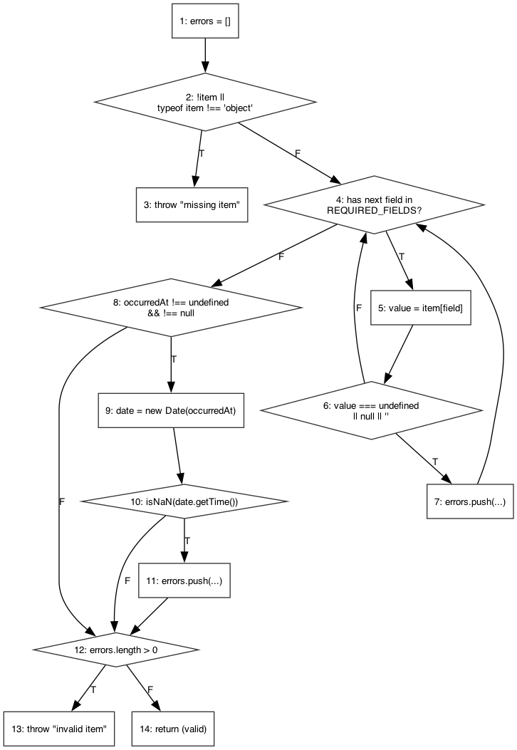
Figure: Control flow graph for validateItemForMatching(item, label)
Branch Coverage
P1: 1-2(T)-3 — item is null / not an object
P2: 1-2(F)-4(T)-5-6(F)-4(F)-8(T)-9-10(F)-12(F)-14 — fully valid item
P3: 1-2(F)-4(T)-5-6(T)-7-4(F)-8(F)-12(T)-13 — a required field is missing/empty
P4: 1-2(F)-4(F)-8(T)-9-10(T)-11-12(T)-13 — occurredAt present but unparsable
P5: 1-2(F)-4(F)-8(F)-12(F)-14 — occurredAt omitted entirely

scoreItemName(nameA, nameB)
Module: matchingService.js
Cyclomatic Complexity: V(G) = 4 (decision points + 1 = number of independent paths)
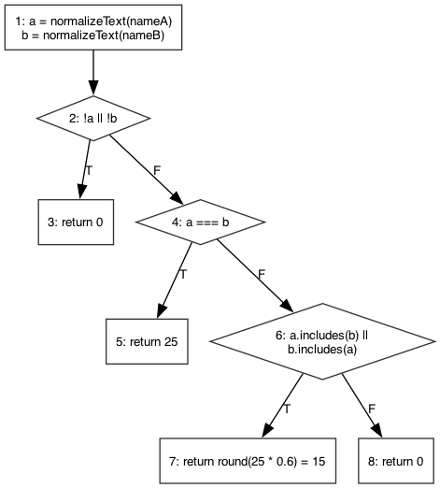
Figure: Control flow graph for scoreItemName(nameA, nameB)
Branch Coverage
P1: 1-2(T)-3 — either name empty after normalization
P2: 1-2(F)-4(T)-5 — normalized names identical
P3: 1-2(F)-4(F)-6(T)-7 — one name a substring of the other
P4: 1-2(F)-4(F)-6(F)-8 — names unrelated

scoreDescription(descA, descB)
Module: matchingService.js
Cyclomatic Complexity: V(G) = 5 (decision points + 1 = number of independent paths)
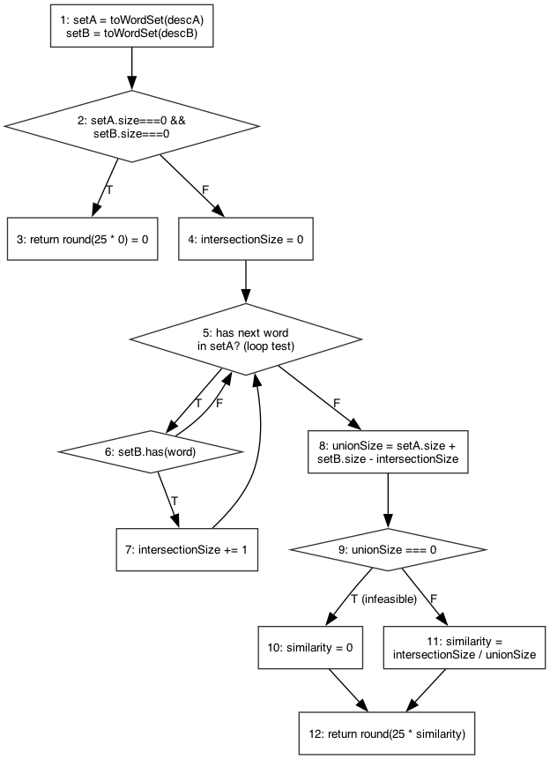
Figure: Control flow graph for scoreDescription(descA, descB)
Branch Coverage
P1: 1-2(T)-3 — both descriptions empty (both word sets size 0)
P2: 1-2(F)-4-5(F)-8-9(F)-11-12 — one description empty, loop body never runs
P3: 1-2(F)-4-5(T)-6(F)-5(loop)-5(F)-8-9(F)-11-12 — both non-empty, no shared words
P4: 1-2(F)-4-5(T)-6(T)-7-5(loop)-5(F)-8-9(F)-11-12 — both non-empty, at least one shared word
P5 (infeasible): 1-2(F)-4-...-8-9(T)-10-12 — unionSize===0 while N2 was False
Note: Path P5 is structurally counted toward V(G) but is infeasible when reached through scoreDescription() — unionSize can only be 0 if both word sets are empty, and that case is already intercepted earlier at node 2. No defect: the dead branch is unreachable, not incorrect.

scoreExactOptionalField(valueA, valueB, weight)
Module: matchingService.js
Cyclomatic Complexity: V(G) = 3 (decision points + 1 = number of independent paths)
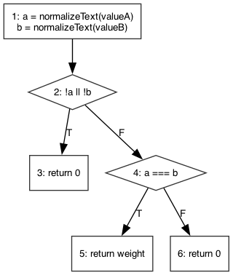
Figure: Control flow graph for scoreExactOptionalField(valueA, valueB, weight)
Branch Coverage
P1: 1-2(T)-3 — either value empty after normalization
P2: 1-2(F)-4(T)-5 — normalized values identical
P3: 1-2(F)-4(F)-6 — normalized values differ

scoreLocation(locationA, locationB)
Module: matchingService.js
Cyclomatic Complexity: V(G) = 4 (decision points + 1 = number of independent paths)
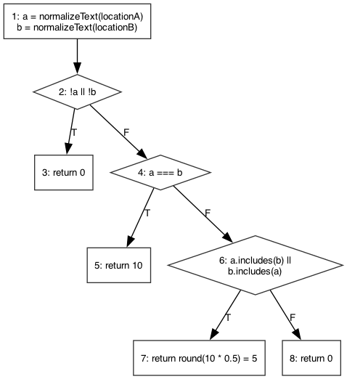
Figure: Control flow graph for scoreLocation(locationA, locationB)
Branch Coverage
P1: 1-2(T)-3 — either location empty after normalization
P2: 1-2(F)-4(T)-5 — normalized locations identical
P3: 1-2(F)-4(F)-6(T)-7 — one location a substring of the other
P4: 1-2(F)-4(F)-6(F)-8 — locations unrelated

scoreDate(dateA, dateB)
Module: matchingService.js
Cyclomatic Complexity: V(G) = 3 (decision points + 1 = number of independent paths)
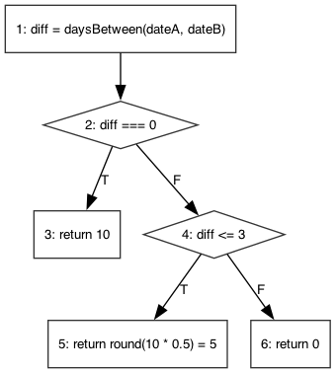
Figure: Control flow graph for scoreDate(dateA, dateB)
Branch Coverage
P1: 1-2(T)-3 — same-day report (diff = 0)
P2: 1-2(F)-4(T)-5 — 1-3 days apart
P3: 1-2(F)-4(F)-6 — more than 3 days apart

classifyScore(score)
Module: matchingService.js
Cyclomatic Complexity: V(G) = 3 (decision points + 1 = number of independent paths)
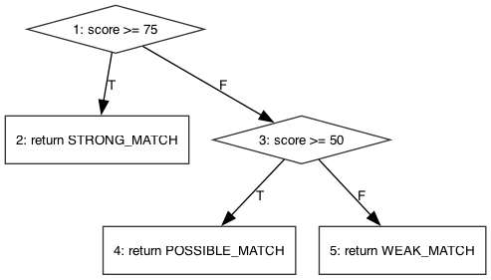
Figure: Control flow graph for classifyScore(score)
Branch Coverage
P1: 1(T)-2 — score >= 75
P2: 1(F)-3(T)-4 — 50 <= score < 75
P3: 1(F)-3(F)-5 — score < 50

decideClaim({action, hasEvidence, matchResult, staffVerifiedEvidence})
Module: claimService.js
Cyclomatic Complexity: V(G) = 7 (decision points + 1 = number of independent paths)
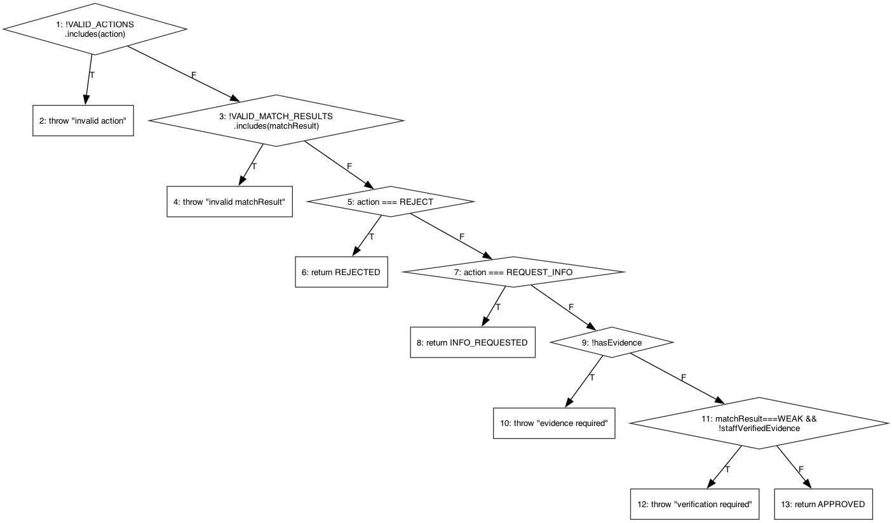
Figure: Control flow graph for decideClaim({action, hasEvidence, matchResult, staffVerifiedEvidence})
Branch Coverage
P1: 1(T)-2 — action not in {APPROVE, REJECT, REQUEST_INFO}
P2: 1(F)-3(T)-4 — valid action, matchResult not a known band
P3: 1(F)-3(F)-5(T)-6 — action = REJECT
P4: 1(F)-3(F)-5(F)-7(T)-8 — action = REQUEST_INFO
P5: 1(F)-3(F)-5(F)-7(F)-9(T)-10 — APPROVE, hasEvidence = false
P6: 1(F)-3(F)-5(F)-7(F)-9(F)-11(T)-12 — APPROVE, evidence, WEAK_MATCH, not staff-verified
P7/P8: 1(F)-3(F)-5(F)-7(F)-9(F)-11(F)-13 — APPROVE, evidence, WEAK (verified) or POSSIBLE/STRONG

canConfirmHandover({status, verifiedIdentity})
Module: claimService.js
Cyclomatic Complexity: V(G) = 3 (decision points + 1 = number of independent paths)
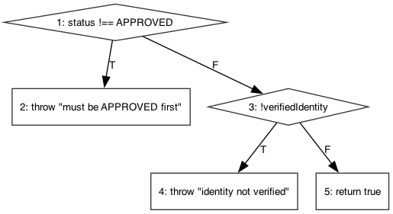
Figure: Control flow graph for canConfirmHandover({status, verifiedIdentity})
Branch Coverage
P1: 1(T)-2 — claim not yet APPROVED
P2: 1(F)-3(T)-4 — APPROVED, identity not verified
P3: 1(F)-3(F)-5 — APPROVED, identity verified

verifyOwnership(claim)
Module: verifyOwnership.js
Cyclomatic Complexity: V(G) = 8 (decision points + 1 = number of independent paths)
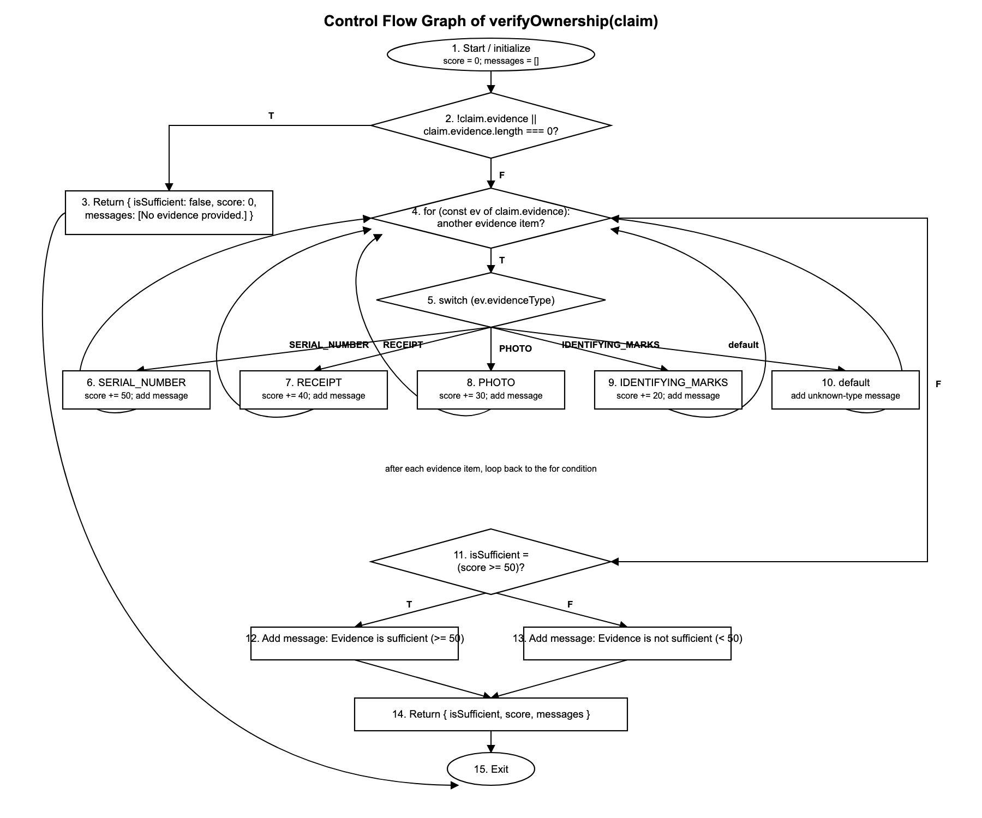
Figure: Control flow graph for verifyOwnership(claim)
Branch Coverage
P1: 1-2(T)-3-15
P2: 1-2(F)-4(F)-11(F)-13-14-15 (theoretical/infeasible basis path for non-empty evidence)
P3: 1-2(F)-4(T)-5(SERIAL_NUMBER)-6-4(F)-11(T)-12-14-15
P4: 1-2(F)-4(T)-5(RECEIPT)-7-4(F)-11(F)-13-14-15
P5: 1-2(F)-4(T)-5(PHOTO)-8-4(F)-11(F)-13-14-15
P6: 1-2(F)-4(T)-5(IDENTIFYING_MARKS)-9-4(F)-11(F)-13-14-15
P7: 1-2(F)-4(T)-5(default)-10-4(F)-11(F)-13-14-15
P8: 1-2(F)-4(T)-5(SERIAL_NUMBER)-6-4(T)-5(RECEIPT)-7-4(F)-11(T)-12-14-15

Data Flow Testing
Data flow testing analyzes how variables are defined (def) and used (c-use inside a node, p-use on a predicate's outgoing edges) across the same control flow graphs from the previous section. This identifies definition-use (DU) pairs that unit tests must exercise — e.g. a variable defined at one node and used at a predicate several nodes later. A False-branch predicate is written with a leading ~ (negation).

validateItemForMatching(item, label)
Predicate and p-use() set of Edges
Edges(i,j) | predicate(i,j) | p-use(i,j)
(2,3) | !item || typeof item !== 'object' | {item}
(2,4) | ~(!item || typeof item !== 'object') | {item}
(4,5) | has next field in REQUIRED_FIELDS | {}
(4,8) | ~(has next field in REQUIRED_FIELDS) | {}
(6,7) | value undefined/null/'' | {value}
(6,4) | ~(value undefined/null/'') | {value}
(8,9) | occurredAt !== undefined && !== null | {item}
(8,12) | ~(occurredAt !== undefined && !== null) | {item}
(10,11) | isNaN(date.getTime()) | {date}
(10,12) | ~(isNaN(date.getTime())) | {date}
(12,13) | errors.length > 0 | {errors}
(12,14) | ~(errors.length > 0) | {errors}

Def() and c-use() Set of Nodes
Node(i) | def(i) | c-use(i)
1 | {errors} | {}
2 | {} | {}
3 | {} | {label}
4 | {field} | {}
5 | {value} | {item, field}
6 | {} | {}
7 | {errors} | {errors, field, label}
8 | {} | {}
9 | {date} | {item}
10 | {} | {}
11 | {errors} | {errors, label}
12 | {} | {}
13 | {} | {label, errors}
14 | {} | {}

scoreItemName(nameA, nameB)
Predicate and p-use() set of Edges
Edges(i,j) | predicate(i,j) | p-use(i,j)
(2,3) | !a || !b | {a, b}
(2,4) | ~(!a || !b) | {a, b}
(4,5) | a === b | {a, b}
(4,6) | ~(a === b) | {a, b}
(6,7) | a.includes(b) || b.includes(a) | {a, b}
(6,8) | ~(a.includes(b) || b.includes(a)) | {a, b}

Def() and c-use() Set of Nodes
Node(i) | def(i) | c-use(i)
1 | {a, b} | {nameA, nameB}
2 | {} | {}
3 | {} | {}
4 | {} | {}
5 | {} | {}
6 | {} | {}
7 | {} | {}
8 | {} | {}

scoreDescription(descA, descB)
Predicate and p-use() set of Edges
Edges(i,j) | predicate(i,j) | p-use(i,j)
(2,3) | setA.size===0 && setB.size===0 | {setA, setB}
(2,4) | ~(setA.size===0 && setB.size===0) | {setA, setB}
(5,6) | next word exists in setA (loop test) | {setA}
(5,8) | ~(next word exists in setA (loop test)) | {setA}
(6,7) | setB.has(word) | {setB, word}
(6,5) | ~(setB.has(word)) | {setB, word}
(9,10) | unionSize === 0 | {unionSize}
(9,11) | ~(unionSize === 0) | {unionSize}

Def() and c-use() Set of Nodes
Node(i) | def(i) | c-use(i)
1 | {setA, setB} | {descA, descB}
2 | {} | {setA, setB}
3 | {} | {}
4 | {intersectionSize} | {}
5 | {word} | {setA}
6 | {} | {setB, word}
7 | {intersectionSize} | {intersectionSize}
8 | {unionSize} | {setA, setB, intersectionSize}
9 | {} | {unionSize}
10 | {similarity} | {}
11 | {similarity} | {intersectionSize, unionSize}
12 | {} | {similarity}

scoreExactOptionalField(valueA, valueB, weight)
Predicate and p-use() set of Edges
Edges(i,j) | predicate(i,j) | p-use(i,j)
(2,3) | !a || !b | {a, b}
(2,4) | ~(!a || !b) | {a, b}
(4,5) | a === b | {a, b}
(4,6) | ~(a === b) | {a, b}

Def() and c-use() Set of Nodes
Node(i) | def(i) | c-use(i)
1 | {a, b} | {valueA, valueB}
2 | {} | {}
3 | {} | {}
4 | {} | {}
5 | {} | {weight}
6 | {} | {}

scoreLocation(locationA, locationB)
Predicate and p-use() set of Edges
Edges(i,j) | predicate(i,j) | p-use(i,j)
(2,3) | !a || !b | {a, b}
(2,4) | ~(!a || !b) | {a, b}
(4,5) | a === b | {a, b}
(4,6) | ~(a === b) | {a, b}
(6,7) | a.includes(b) || b.includes(a) | {a, b}
(6,8) | ~(a.includes(b) || b.includes(a)) | {a, b}

Def() and c-use() Set of Nodes
Node(i) | def(i) | c-use(i)
1 | {a, b} | {locationA, locationB}
2 | {} | {}
3 | {} | {}
4 | {} | {}
5 | {} | {}
6 | {} | {}
7 | {} | {}
8 | {} | {}

scoreDate(dateA, dateB)
Predicate and p-use() set of Edges
Edges(i,j) | predicate(i,j) | p-use(i,j)
(2,3) | diff === 0 | {diff}
(2,4) | ~(diff === 0) | {diff}
(4,5) | diff <= 3 | {diff}
(4,6) | ~(diff <= 3) | {diff}

Def() and c-use() Set of Nodes
Node(i) | def(i) | c-use(i)
1 | {diff} | {dateA, dateB}
2 | {} | {}
3 | {} | {}
4 | {} | {}
5 | {} | {}
6 | {} | {}

classifyScore(score)
Predicate and p-use() set of Edges
Edges(i,j) | predicate(i,j) | p-use(i,j)
(1,2) | score >= 75 | {score}
(1,3) | ~(score >= 75) | {score}
(3,4) | score >= 50 | {score}
(3,5) | ~(score >= 50) | {score}

Def() and c-use() Set of Nodes
Node(i) | def(i) | c-use(i)
1 | {} | {}
2 | {} | {}
3 | {} | {}
4 | {} | {}
5 | {} | {}

decideClaim({action, hasEvidence, matchResult, staffVerifiedEvidence})
Predicate and p-use() set of Edges
Edges(i,j) | predicate(i,j) | p-use(i,j)
(1,2) | !VALID_ACTIONS.includes(action) | {action}
(1,3) | ~(!VALID_ACTIONS.includes(action)) | {action}
(3,4) | !VALID_MATCH_RESULTS.includes(matchResult) | {matchResult}
(3,5) | ~(!VALID_MATCH_RESULTS.includes(matchResult)) | {matchResult}
(5,6) | action === REJECT | {action}
(5,7) | ~(action === REJECT) | {action}
(7,8) | action === REQUEST_INFO | {action}
(7,9) | ~(action === REQUEST_INFO) | {action}
(9,10) | !hasEvidence | {hasEvidence}
(9,11) | ~(!hasEvidence) | {hasEvidence}
(11,12) | matchResult===WEAK && !staffVerifiedEvidence | {matchResult, staffVerifiedEvidence}
(11,13) | ~(matchResult===WEAK && !staffVerifiedEvidence) | {matchResult, staffVerifiedEvidence}

Def() and c-use() Set of Nodes
Node(i) | def(i) | c-use(i)
1 | {} | {}
2 | {} | {action}
3 | {} | {}
4 | {} | {matchResult}
5 | {} | {}
6 | {} | {}
7 | {} | {}
8 | {} | {}
9 | {} | {}
10 | {} | {}
11 | {} | {}
12 | {} | {}
13 | {} | {}

canConfirmHandover({status, verifiedIdentity})
Predicate and p-use() set of Edges
Edges(i,j) | predicate(i,j) | p-use(i,j)
(1,2) | status !== APPROVED | {status}
(1,3) | ~(status !== APPROVED) | {status}
(3,4) | !verifiedIdentity | {verifiedIdentity}
(3,5) | ~(!verifiedIdentity) | {verifiedIdentity}

Def() and c-use() Set of Nodes
Node(i) | def(i) | c-use(i)
1 | {} | {}
2 | {} | {status}
3 | {} | {}
4 | {} | {}
5 | {} | {}

verifyOwnership(claim)
Predicate and p-use() set of Edges
Edges(i,j) | predicate(i,j) | p-use(i,j)
(2,3) | !claim.evidence || claim.evidence.length === 0 | {claim.evidence}
(2,4) | ~(!claim.evidence || claim.evidence.length === 0) | {claim.evidence}
(4,5) | for (const ev of claim.evidence) | {claim.evidence}
(4,11) | ~(for (const ev of claim.evidence)) | {claim.evidence}
(11,12) | score >= 50 | {score}
(11,13) | ~(score >= 50) | {score}

Def() and c-use() Set of Nodes
Node(i) | def(i) | c-use(i)
1 | {score, messages} | {}
6 | {score, messages} | {score}
7 | {score, messages} | {score}
8 | {score, messages} | {score}
9 | {score, messages} | {score}
11 | {} | {score}

Domain Testing
Domain testing exercises the boundaries of each input domain and each business rule threshold using the running application (frontend at http://localhost:5173, backend at http://localhost:5050).
Domain testing for the Campus Lost & Found system focuses on the following features:
- Item Reporting: validating that the system correctly handles required and optional fields when reporting a lost or found item.
- Rule-Based Matching: verifying the system correctly scores and classifies candidate matches at each threshold boundary.
- Ownership Verification: ensuring claim evidence meets the minimum-length business rule.
- Claim Decisions & Handover: testing the weak-match verification rule and the identity-verification rule before handover.
- Role-Based Access: confirming a user cannot reach a dashboard outside their role.

Test Case 1: Item Report — Required Field Left Blank
Test Case Description:
- Action: Submit the Report Lost Item form with the Title field left empty.
- Expected Outcome: The system should prevent submission before it reaches the API.
Expected Behavior:
- Submission is blocked client-side.
- An explanatory validation message is shown to the user.
Actual Outcome:
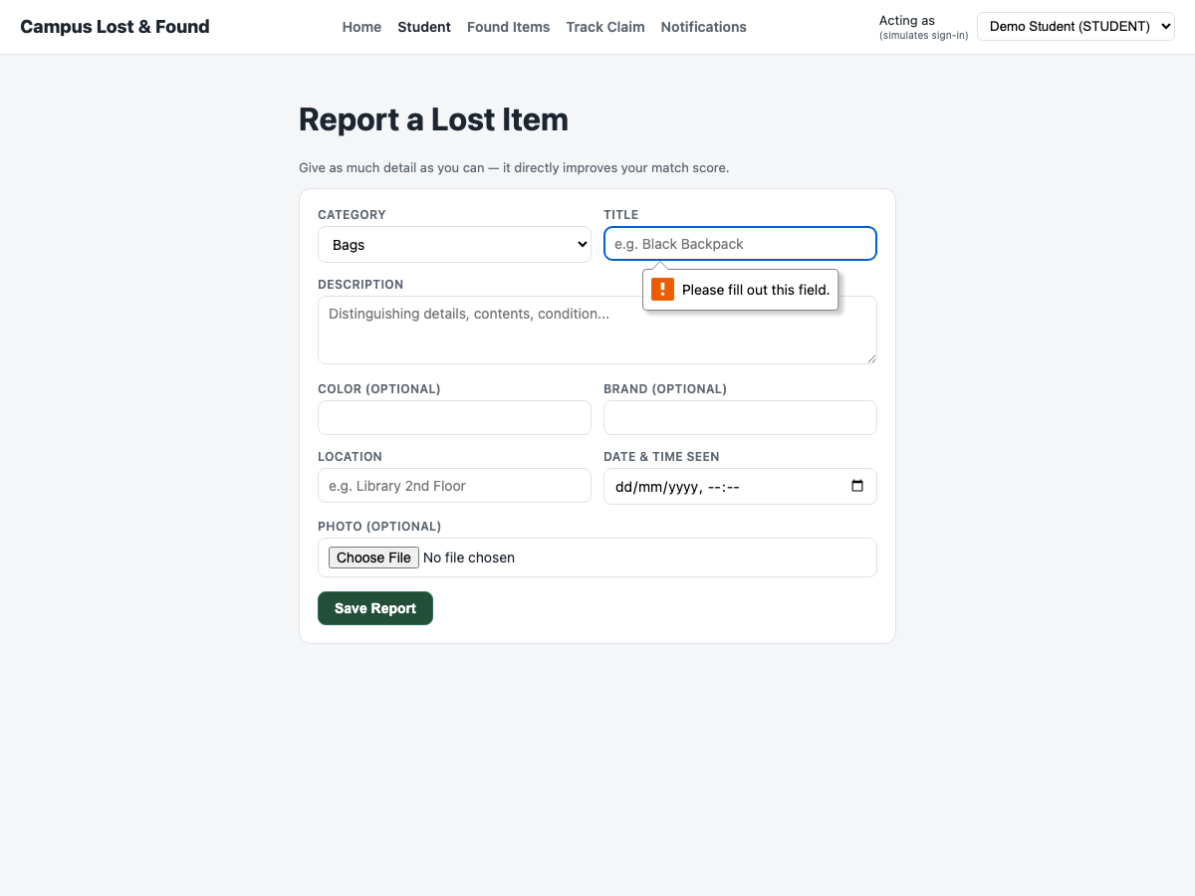
Browser enforced the required attribute: "Please fill out this field." This matches the server-side rejection already covered by validation.test.js.
Validation Results:
- The system correctly blocked the invalid submission.
- The rejection is enforced both client-side and server-side.

Test Case 2: Item Report — Fully Valid Submission
Test Case Description:
- Action: Fill in all required fields (title, description, location, date/time); leave category at its default (Bags).
- Expected Outcome: The report should save and the user should be redirected straight to Match Results for the new report.
Expected Behavior:
- The report is saved to the database.
- The browser navigates automatically to the new report's match results page.
Actual Outcome:
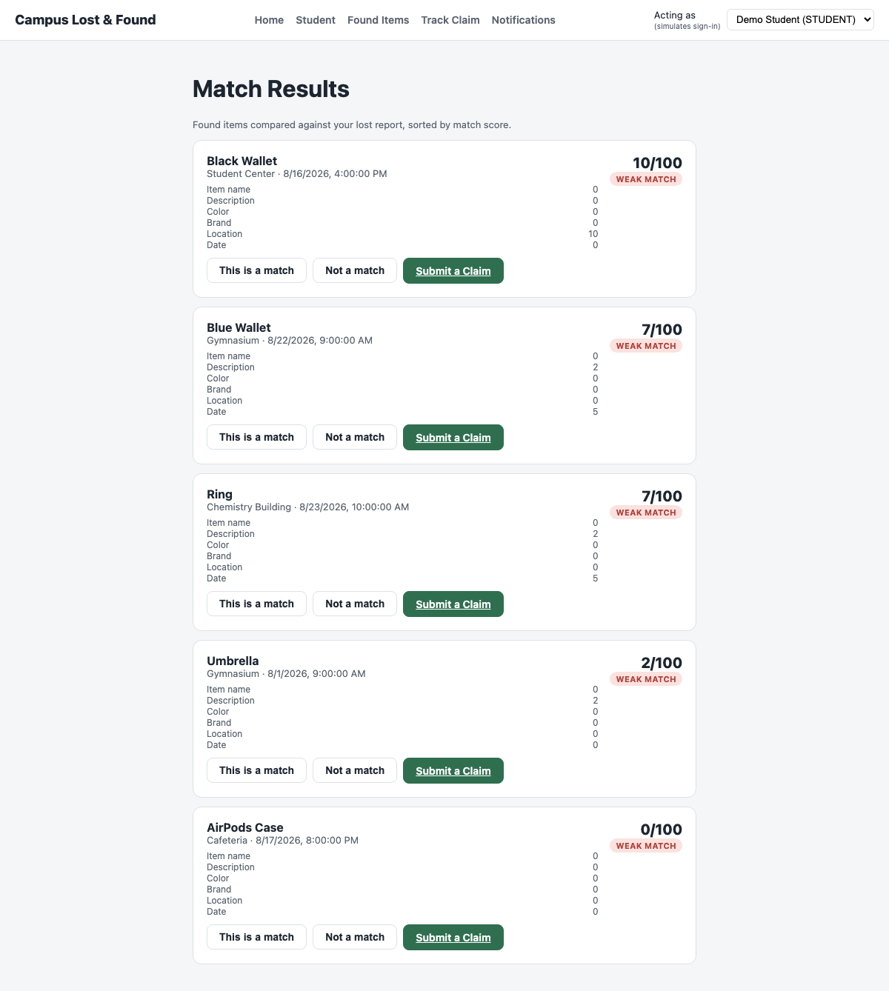
Report saved; browser navigated to /matches/:id automatically.
Validation Results:
- The system correctly accepted the valid submission and redirected the user.

Test Case 3: Matching Score — Strong Match Boundary (>= 75)
Test Case Description:
- Action: Report "Blue Wallet" as lost and "Blue Wallet" as found, with the same color/brand/location and only a 1-hour date gap.
- Expected Outcome: A score >= 75 should display the STRONG_MATCH badge.
Expected Behavior:
- The candidate is ranked at the top of the match list.
- The badge reads STRONG MATCH.
Actual Outcome:
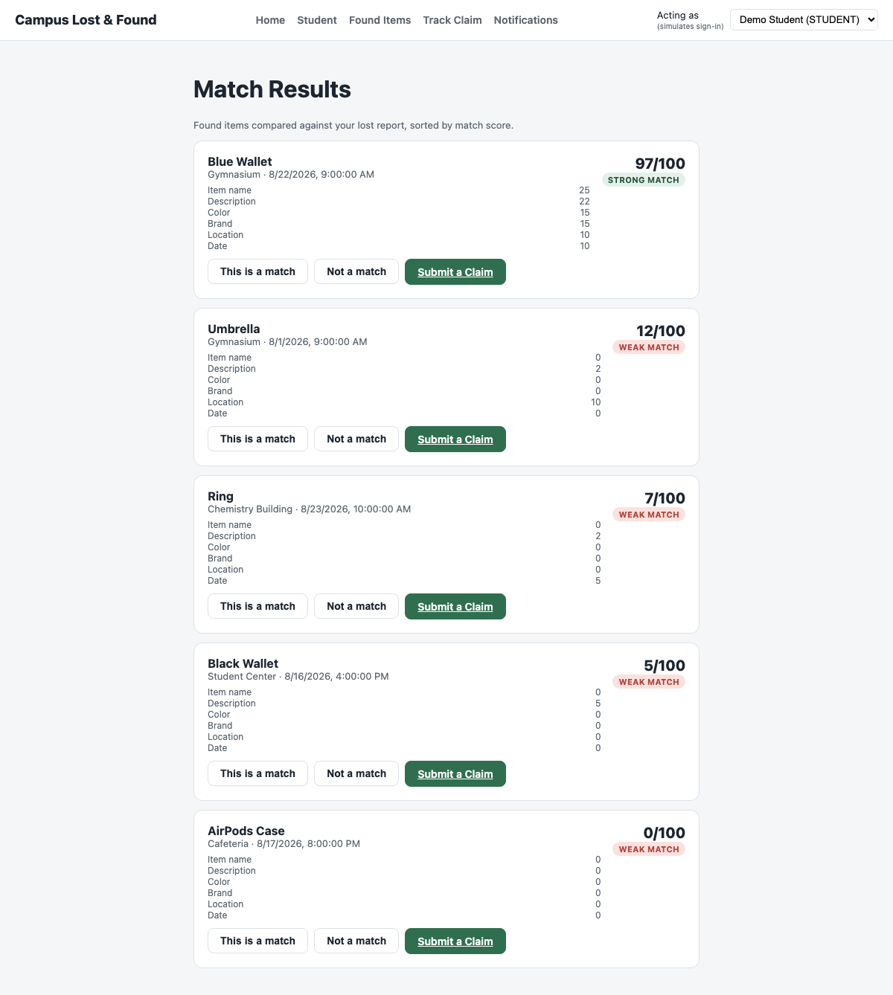
Score = 97/100, STRONG MATCH. Breakdown: name 25, description 22, color 15, brand 15, location 10, date 10.
Validation Results:
- The system correctly classified the pair as a Strong Match at the upper boundary.

Test Case 4: Matching Score — Possible Match Boundary (50-74)
Test Case Description:
- Action: Report "Silver Ring" as lost and "Ring" as found, with the same color/brand/location, a 3-day date gap, and partial description overlap.
- Expected Outcome: A score between 50 and 74 should display the POSSIBLE_MATCH badge.
Expected Behavior:
- The candidate appears in the match list.
- The badge reads POSSIBLE MATCH.
Actual Outcome:
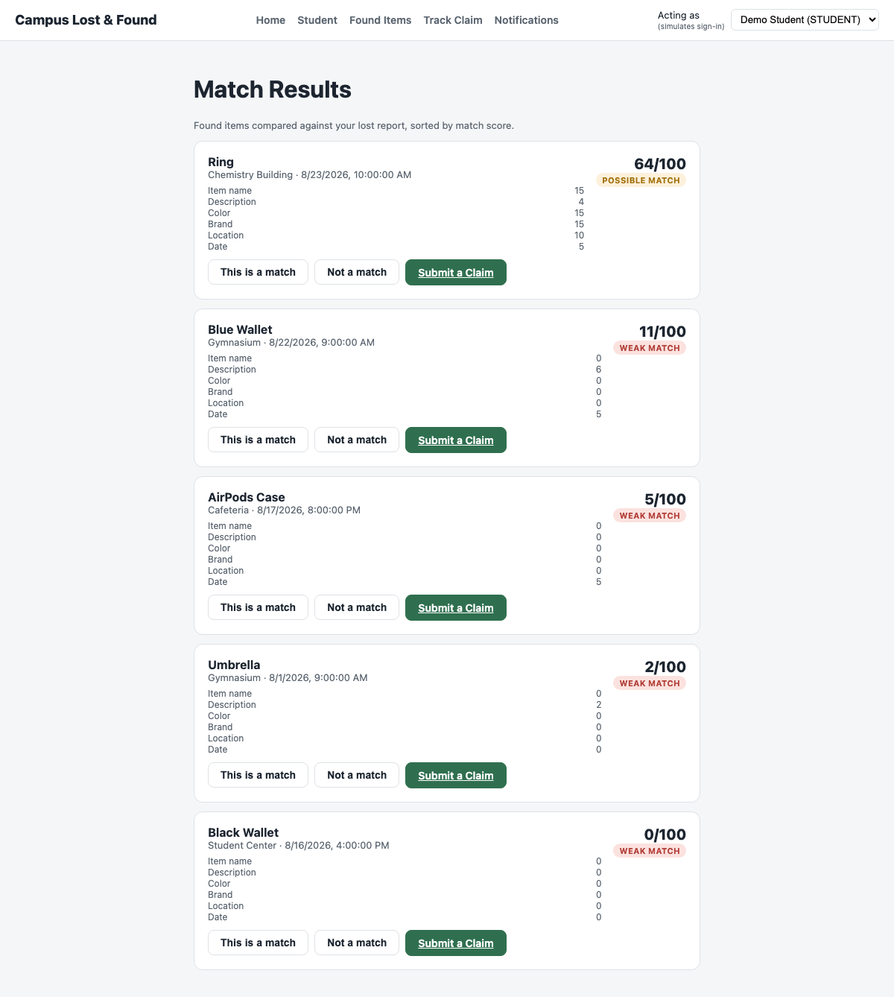
Score = 64/100, POSSIBLE MATCH.
Validation Results:
- The system correctly classified the pair as a Possible Match inside the mid-range band.

Test Case 5: Matching Score — Weak Match Boundary (< 50)
Test Case Description:
- Action: Report "Green Notebook" as lost and "Umbrella" as found — different item, color, brand, and location, with a 9-day date gap.
- Expected Outcome: A score below 50 should display the WEAK_MATCH badge.
Expected Behavior:
- The candidate still appears (matching does not hide weak candidates).
- The badge reads WEAK MATCH.
Actual Outcome:
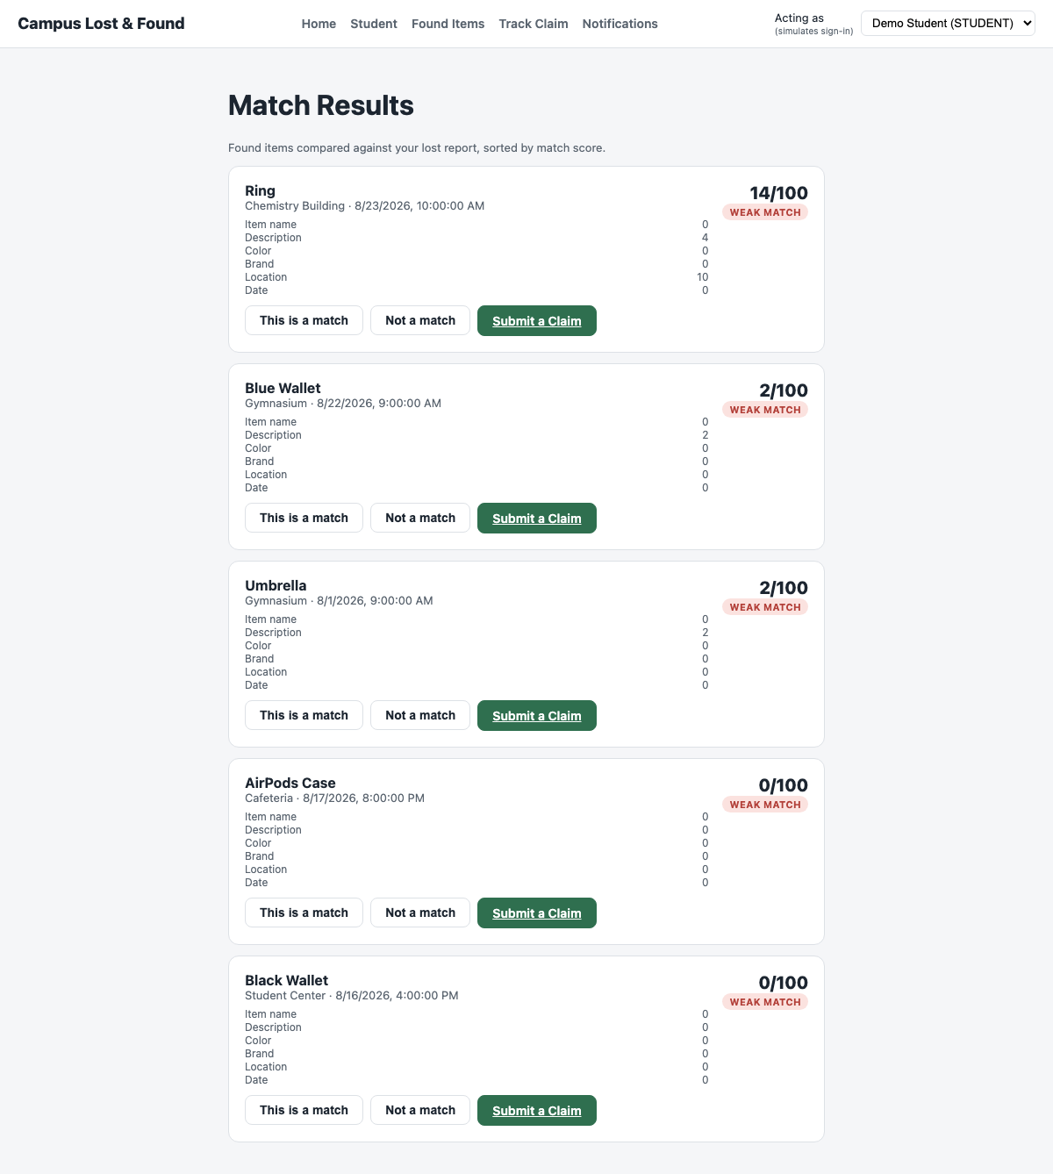
Score = 12/100 for the closest weak candidate, WEAK MATCH.
Validation Results:
- The system correctly classified the dissimilar pair as a Weak Match.

Test Case 6: Match Confirmation — Persisted Decision
Test Case Description:
- Action: Student clicks "This is a match" on the Strong Match candidate.
- Expected Outcome: The candidate should be marked CONFIRMED and the decision should persist across reloads.
Expected Behavior:
- The badge updates immediately.
- Reloading the page shows the same CONFIRMED state.
Actual Outcome:
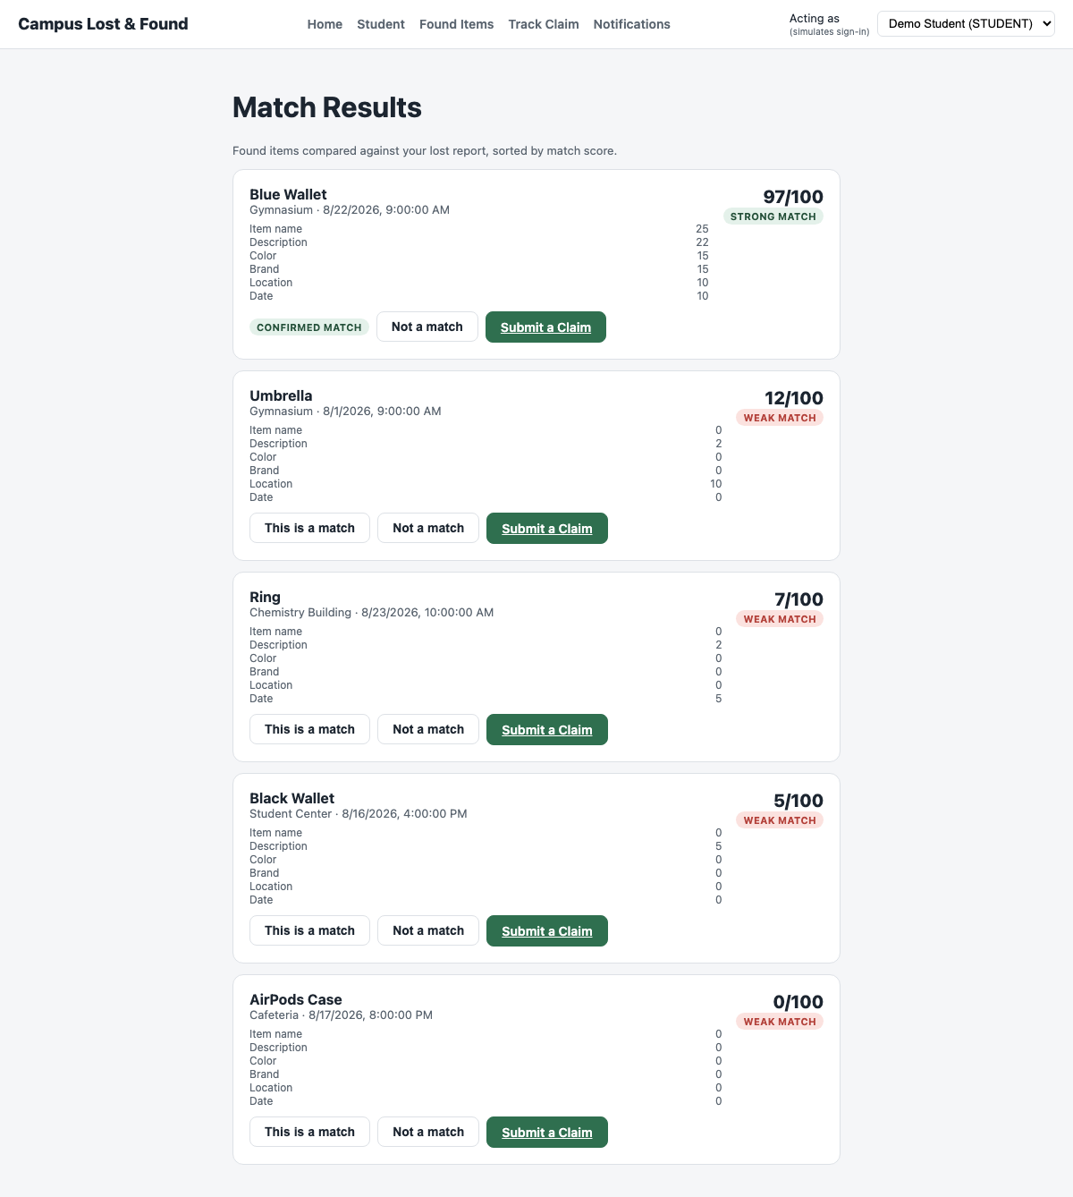
Badge changed to "CONFIRMED MATCH"; verified via GET /reports/:id/matches returning matchDecision: "CONFIRMED" after reload.
Validation Results:
- The decision was correctly persisted to the database, not just the UI.

Test Case 7: Claim Evidence — Boundary Value (9 vs. 10 Characters)
Test Case Description:
- Action: Submit a claim with evidence text "too short" (9 characters) against the 10-character minimum.
- Expected Outcome: Submission should be blocked at the boundary.
Expected Behavior:
- The form does not submit.
- A message states the minimum character count.
Actual Outcome:
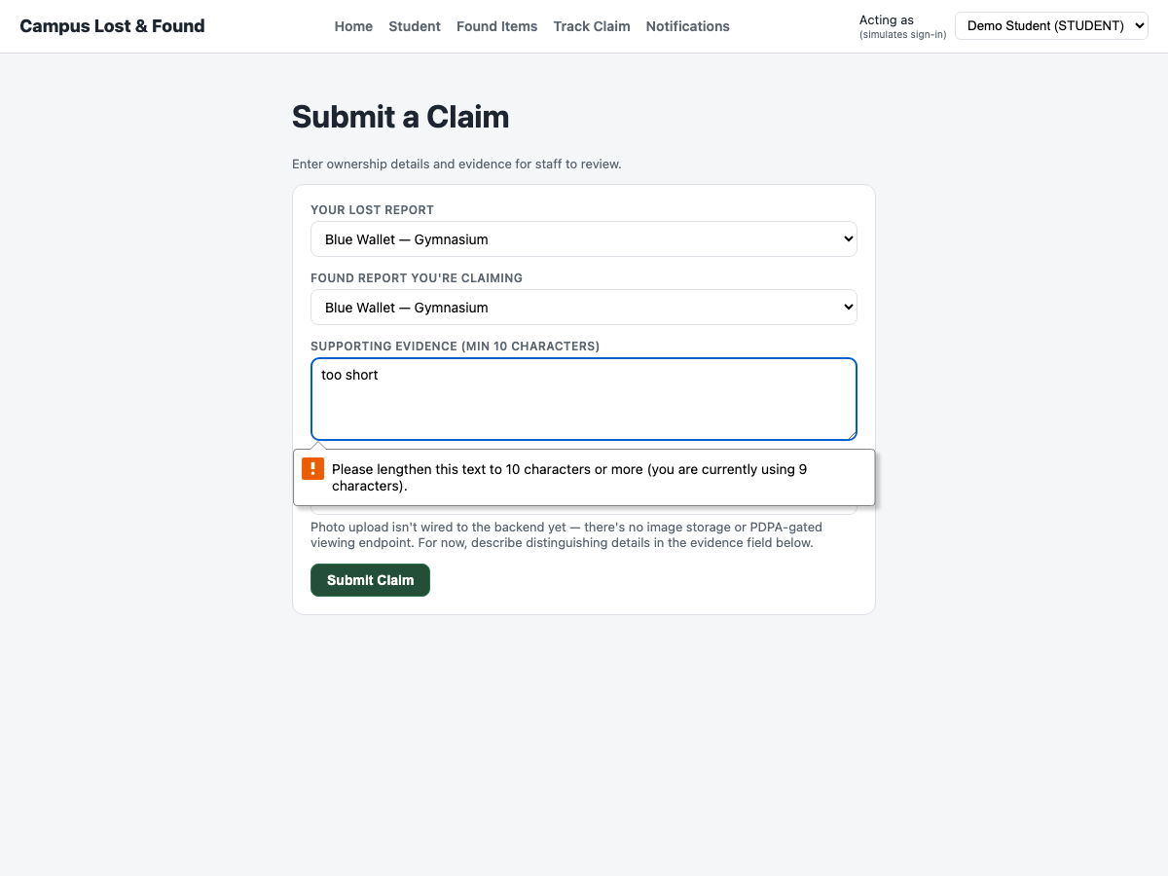
Browser reported: "Please lengthen this text to 10 characters or more (you are currently using 9 characters)."
Validation Results:
- The system correctly rejected evidence one character short of the minimum.

Test Case 8: Claim Decision — Weak Match Approval Blocked Without Staff Verification
Test Case Description:
- Action: Staff clicks Approve on a WEAK_MATCH claim (score 2/100) without checking "I have verified this evidence in person".
- Expected Outcome: Approval should be rejected by the business rule from decideClaim (path P6).
Expected Behavior:
- The claim remains PENDING.
- An error message explains why approval was blocked.
Actual Outcome:
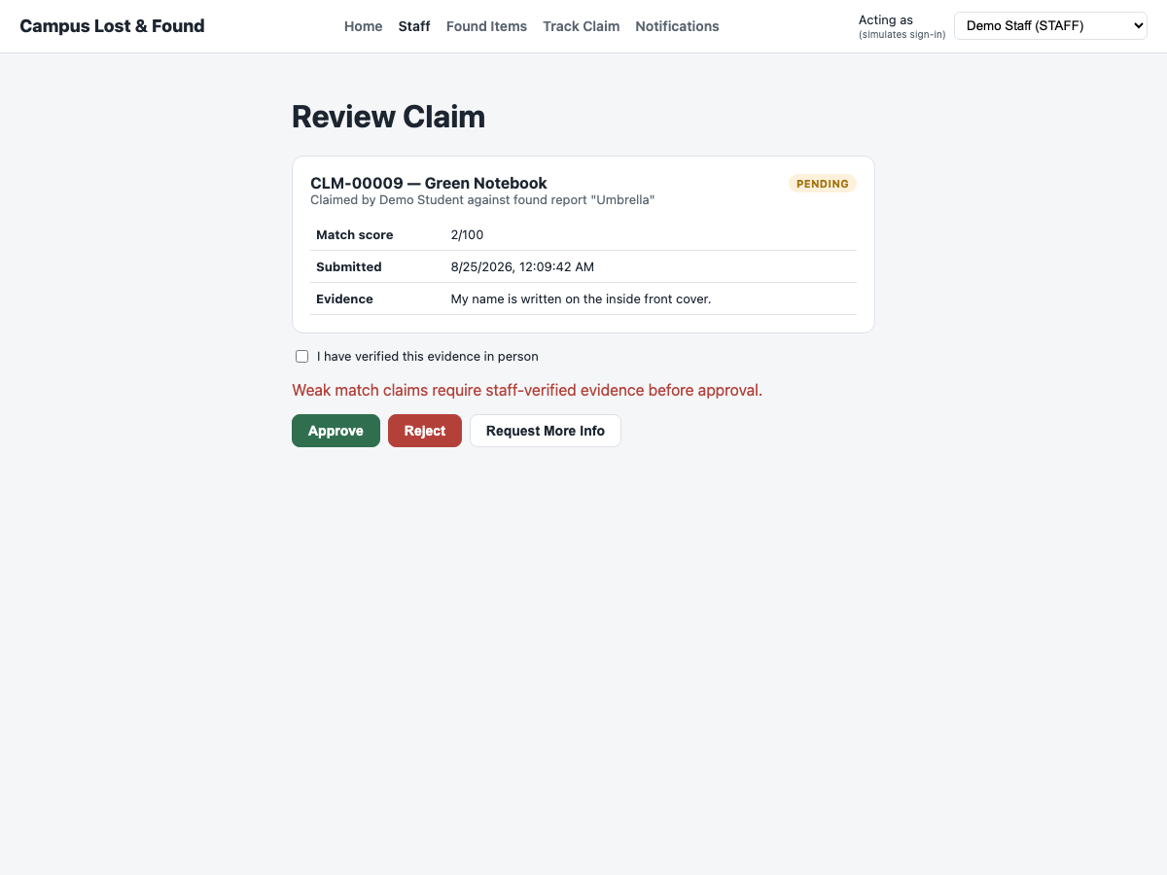
Error shown: "Weak match claims require staff-verified evidence before approval." Claim remained PENDING.
Validation Results:
- The system correctly enforced the stricter verification rule for weak matches.

Test Case 9: Claim Decision — Weak Match Approved Once Verified
Test Case Description:
- Action: Same claim; staff checks the verification box and clicks Approve again.
- Expected Outcome: The claim should transition to APPROVED (path P7).
Expected Behavior:
- The status badge updates to APPROVED.
Actual Outcome:
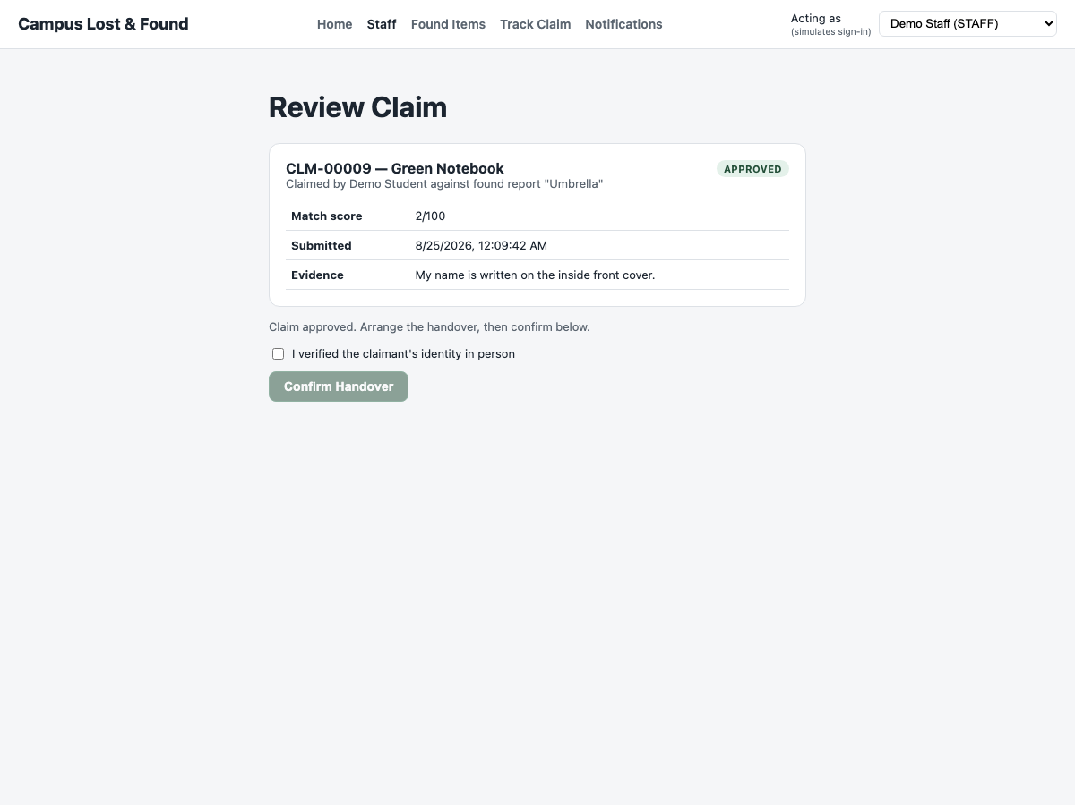
Status badge changed to APPROVED.
Validation Results:
- The system correctly allowed approval once the extra verification step was satisfied.

Test Case 10: Handover — Blocked Without Identity Verification
Test Case Description:
- Action: Staff opens an APPROVED claim and leaves "I verified the claimant's identity in person" unchecked.
- Expected Outcome: The Confirm Handover button should stay disabled (canConfirmHandover path P2).
Expected Behavior:
- The Confirm Handover button is rendered disabled and does nothing if clicked.
Actual Outcome:
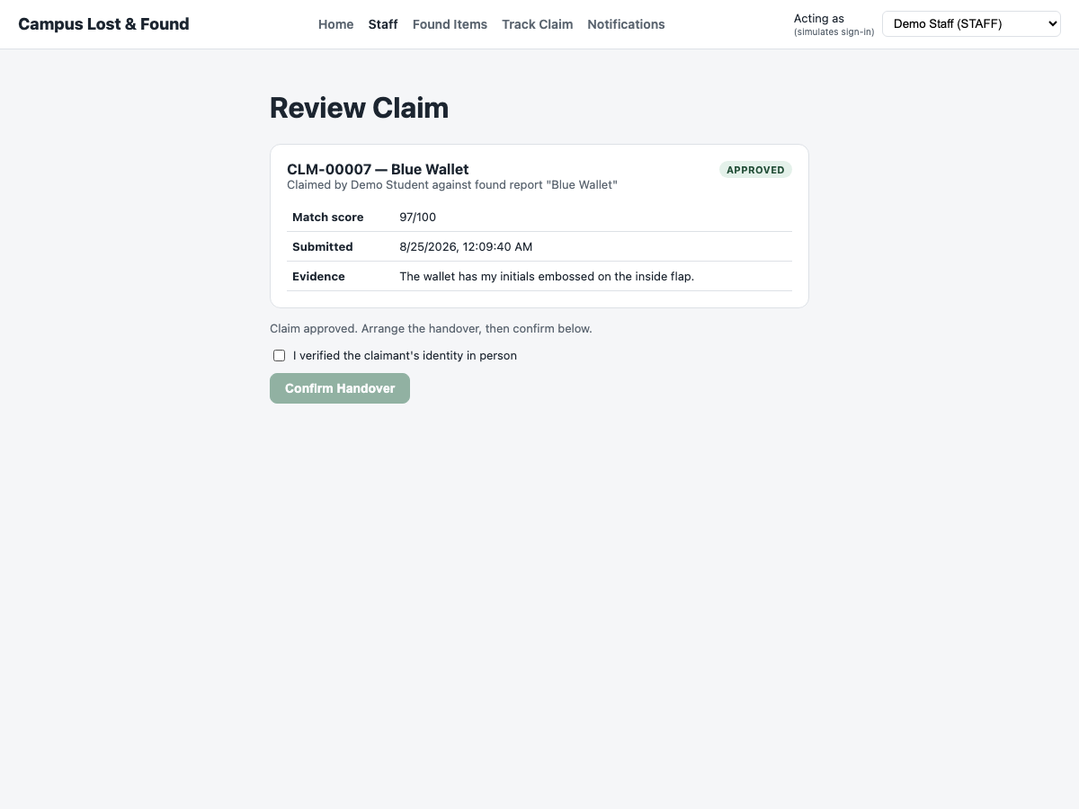
Button rendered disabled; clicking it had no effect (verified programmatically: button.disabled === true).
Validation Results:
- The system correctly blocked handover confirmation until identity was verified.

Test Case 11: Handover — Completed Once Identity Verified
Test Case Description:
- Action: Staff checks the identity box, clicks Confirm Handover.
- Expected Outcome: The claim status should become COMPLETED and both linked reports should move to RESOLVED (canConfirmHandover path P3).
Expected Behavior:
- The status badge updates to COMPLETED.
- Both the lost and found reports show RESOLVED.
Actual Outcome:
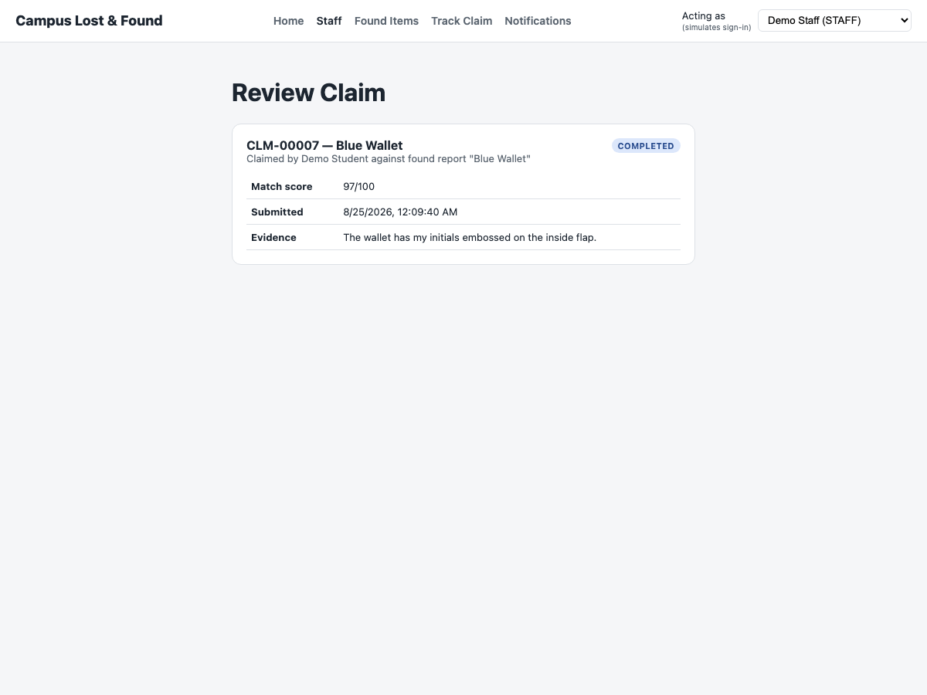
Status badge changed to COMPLETED; both reports moved to RESOLVED.
Validation Results:
- The system correctly completed the handover and closed out both linked reports.

Test Case 12: Role Boundary — Student Blocked From the Staff Dashboard
Test Case Description:
- Action: A user acting as Demo Student (role=STUDENT) navigates directly to /staff.
- Expected Outcome: Access should be denied with an explanatory message, not the claims list.
Expected Behavior:
- A Restricted page is shown instead of the Staff dashboard.
Actual Outcome:
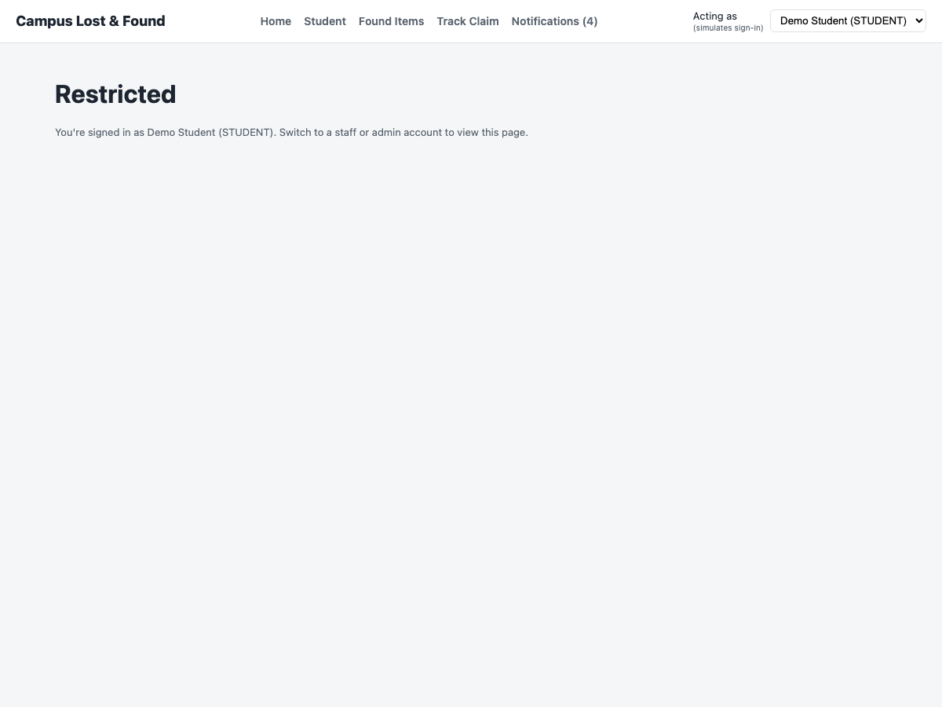
"Restricted — You're signed in as Demo Student (STUDENT). Switch to a staff or admin account to view this page."
Validation Results:
- The system correctly enforced role-based access for the Staff dashboard.

Test Case 13: Role Boundary — Staff Blocked From the Student Dashboard
Test Case Description:
- Action: A user acting as Demo Staff (role=STAFF) navigates directly to /student.
- Expected Outcome: Access should be denied, symmetric to the previous case.
Expected Behavior:
- A Restricted page is shown instead of the Student dashboard.
Actual Outcome:
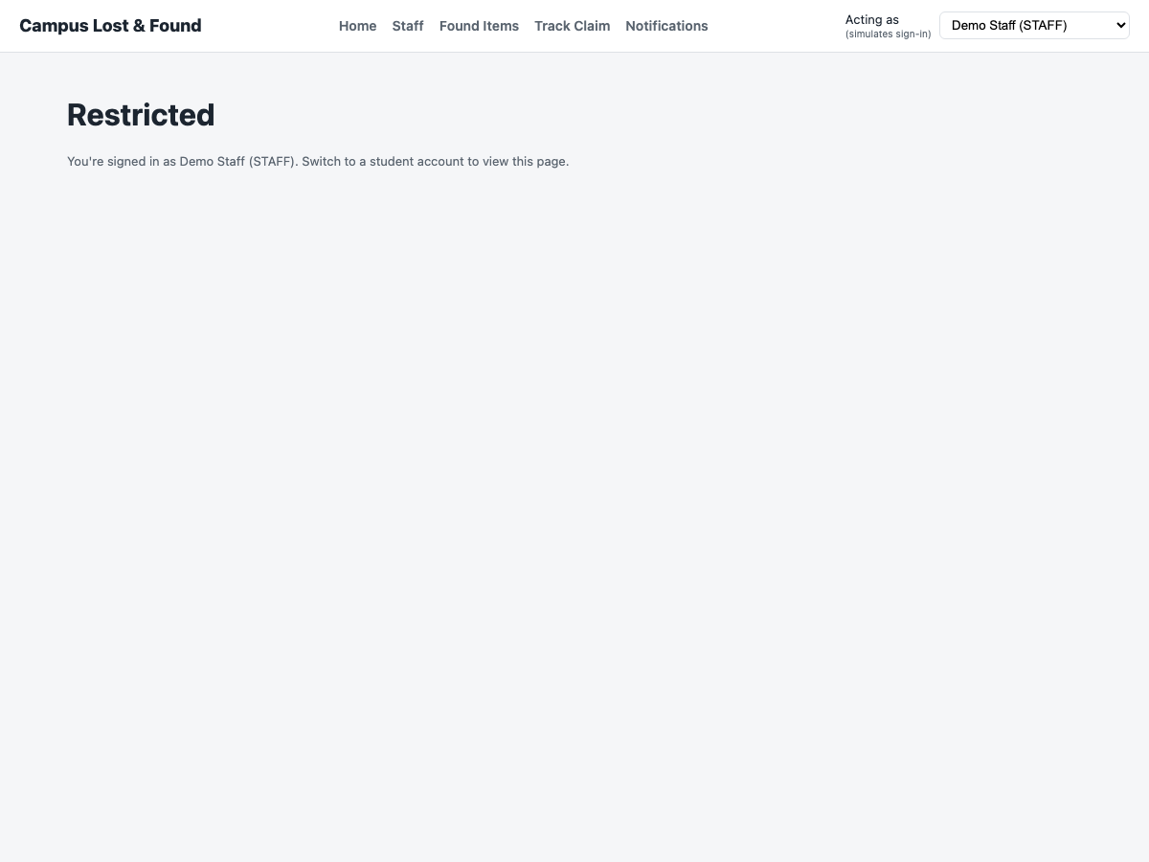
"Restricted — You're signed in as Demo Staff (STAFF). Switch to a student account to view this page."
Validation Results:
- The system correctly enforced role-based access for the Student dashboard, symmetric to the Staff case.

Integration Testing
Integration testing is a crucial phase in the development of the Campus Lost & Found system. Its main goal is to verify that different modules interact correctly and data flows seamlessly between them. For this project, we used the Incremental Integration approach, where modules are progressively integrated and tested rather than assembled all at once. This allows early detection of issues and ensures that each component works as expected within the full system.

Justification for Incremental Integration Approach
The Campus Lost & Found system relies on multiple modules that share data, such as:
- Item reporting (src/routes/reports.js)
- Rule-based matching (src/services/matchingService.js)
- Claim management (src/routes/claims.js, src/services/claimService.js)
- Notifications (src/services/notificationService.js)
- Audit logging (src/routes/auditLogs.js)
- Role-based access (src/middleware/authContext.js)
Using incremental integration ensures controlled testing and prevents interface mismatches, especially between the matching engine's output shape and the claim submission endpoint.
Advantages
1. Early Defect Detection: each module is tested as it is integrated, enabling identification of problems (e.g. the weak-match/handover rules) before being combined with the UI.
2. Flexibility: a defect in one module (e.g. notifications) can be fixed without breaking others (e.g. claim submission).
3. Manageable Testing: integration is tested step by step, making it easier to debug interactions such as match scoring feeding into claim decisions.
Disadvantages
1. Time-Consuming: incremental integration requires more upfront planning than integrating all modules at once.
2. Dependency Management: modules must be integrated in a logical order, e.g. reports must exist before a claim can reference them, and a claim must be approved before a handover can be confirmed.
Integration order: Report Reporting → Rule-Based Matching → Match Confirmation → Claim Submission → Claim Decision → Handover → Notifications → Role-Based Access.

Test Results Summary
These scenarios are automated end-to-end: tests/integration/apiIntegration.test.js runs via `npm run test:integration` (node:test executed under tsx, since the project's Prisma client is generated as a TypeScript/ESM module) against the real Express API and PostgreSQL database — not mocks.
Test Case ID | Modules | Test Scenario | Expected Output | Actual Output | Status
TC-IT-001 | Report ↔ Matching | Create a LOST and a FOUND report with matching attributes. | GET /reports/:id/matches returns the counterpart with matchScore >= 75 (STRONG_MATCH). | matchScore=100, STRONG_MATCH. | Pass
TC-IT-002 | Matching ↔ MatchDecision | Confirm the suggested match (student). | Decision persists as CONFIRMED and is returned on the next fetch. | Confirmed via GET /reports/:id/matches. | Pass
TC-IT-003 | Matching ↔ Claim | Submit a claim referencing the confirmed lost/found pair. | Claim is created with status PENDING and a generated claimNumber. | claimId captured for downstream steps. | Pass
TC-IT-004 | Claim ↔ Notification | Staff approves the claim. | Claim status becomes APPROVED and a Notification row is created for the claimant. | Confirmed via GET /notifications. | Pass
TC-IT-005 | Claim ↔ Report Status | Staff confirms handover on the approved claim. | Both linked reports transition to RESOLVED. | Both reports RESOLVED. | Pass
TC-IT-006 | Claim ↔ AuditLog | Submit, approve, and hand over the same claim. | An AuditLog row exists for each of the three actions (ADMIN-only read). | 3 audit log entries found for the claim. | Pass
TC-IT-007 | Role (actor) ↔ Route Access | STUDENT attempts to decide a claim; STAFF attempts to view the audit log; ADMIN views the audit log. | 403 Forbidden for both role violations; 200 OK for ADMIN. | 403 / 403 / 200 as expected. | Pass

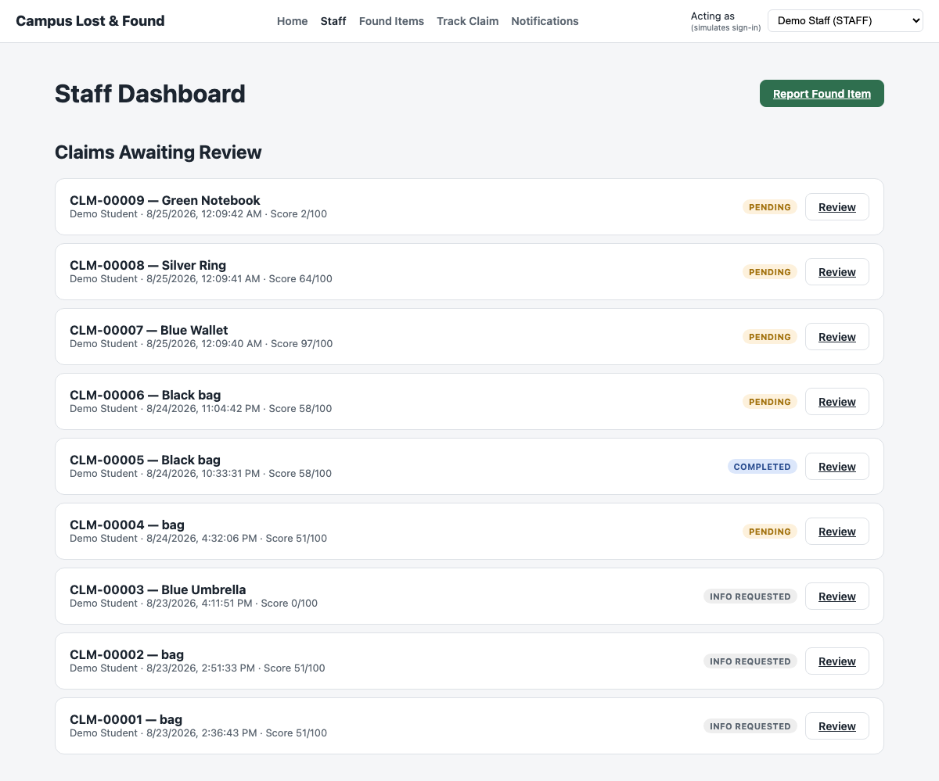
Figure: Staff Dashboard showing claims produced end-to-end by the integrated Report → Match → Claim pipeline.

Summary of Results
All integration points were tested using automated checks against the live API and database. The interactions between modules worked as expected:
- Reports and matches are correctly recorded and scored.
- Rule-based matching correctly computes confidence scores and classifies match bands.
- Claim decisions correctly enforce the weak-match verification rule.
- Handover correctly requires identity verification and cascades report status to RESOLVED.
- Audit logging correctly records every claim decision and handover.
- Role-based access correctly blocks STUDENT and STAFF from admin/staff-only endpoints.
No major issues were encountered; all modules behaved as intended once integrated, confirming that the system functions cohesively end-to-end.

Access Control Testing
Access control is simulated via an x-user-id header (no real authentication, per the project proposal's stated out-of-scope) and enforced server-side by a requireRole middleware. These checks were exercised two independent ways: automatically inside the integration suite (TC-IT-007 above), and manually/reproducibly via the Bruno API collection (bruno/), which any team member can re-run without reading code.
Test Case ID | Test Scenario | Expected Output | Actual Output | Status
TC-AC-001 | STUDENT calls PATCH /claims/:id/decision (approve/reject a claim) | 403 Forbidden — decisions are staff/admin-only. | 403, message: role not permitted. | Pass
TC-AC-002 | STAFF calls GET /audit-logs | 403 Forbidden — audit log is admin-only. | 403, message: role not permitted. | Pass
TC-AC-003 | ADMIN calls GET /audit-logs | 200 OK with the full audit trail. | 200, audit rows returned. | Pass
TC-AC-004 | STUDENT views /staff or /admin/audit-log route in the UI | RequireRole redirects away; nav hides Staff/Audit Log tabs. | Confirmed — see role-blocked screenshots. | Pass

Evidence: automated — `npm run test:integration`, assertion block TC-IT-007 in tests/integration/apiIntegration.test.js. Reproducible manually — Bruno collection, "Claims → 5. Student Tries to Decide (expect 403)" and "Audit Log → 2. Staff Tries to View (expect 403)", both validated via `npx @usebruno/cli run bruno --env Local -r`.
Figure: UI-level role gating — a non-staff actor cannot reach the Staff dashboard.

Final Test Case with Functional Requirements and UI/UX
This section walks through the live application role by role, mapping each screen back to the functional requirements (FR1-FR5) from the project proposal.

Student — Functional Overview

Home — Public Browse
Functional Requirement: Supports FR1 (browse without logging in) and NFR4 Usability
Available Actions:
- Anyone can browse recently reported lost/found items and search, without an account.
- The page explains the 3-step workflow (Report → Match → Claim) for first-time visitors.
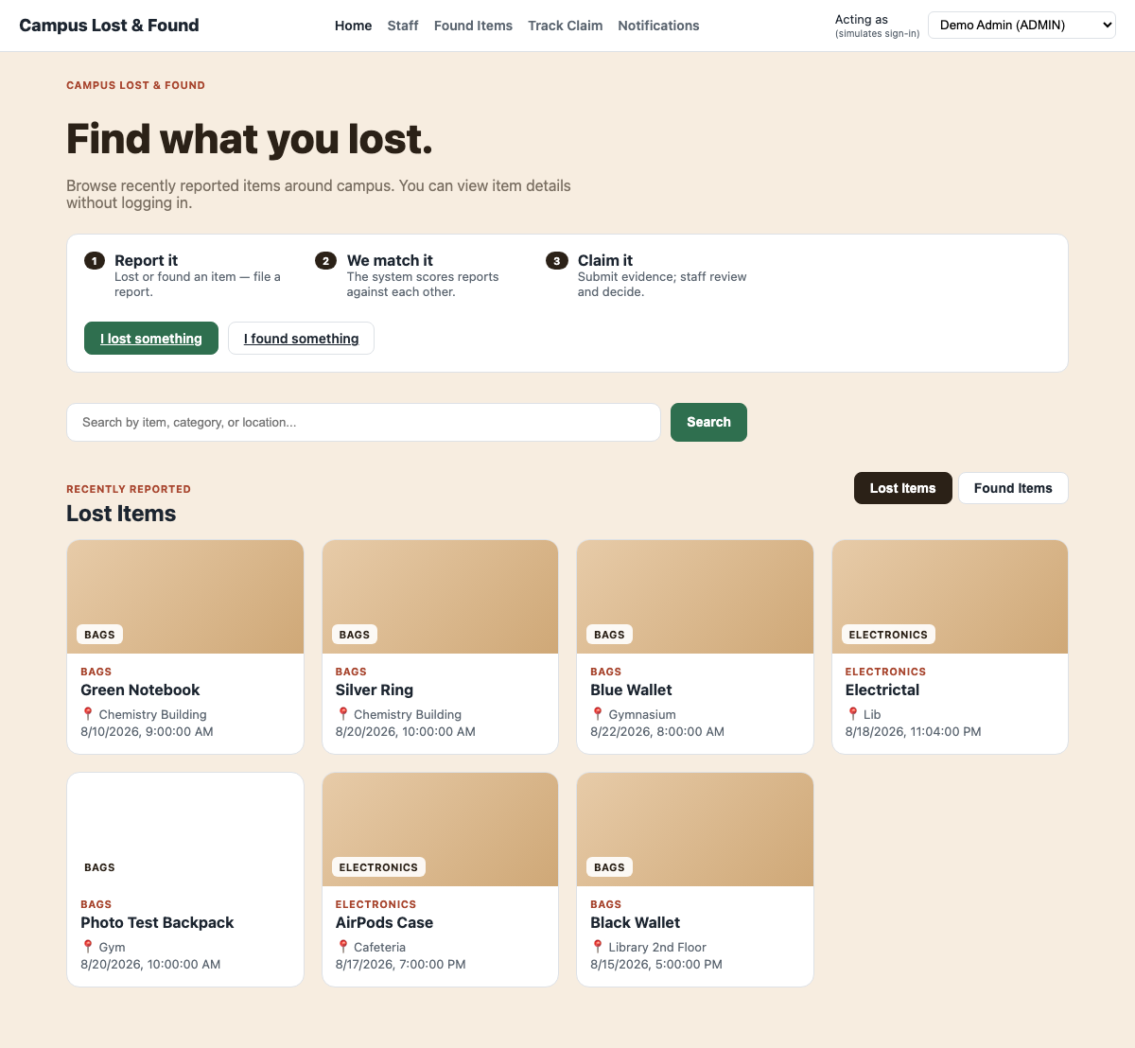

Report a Lost Item
Functional Requirement: FR1 — Item Reporting
Available Actions:
- Captures title, description, color, brand, location, date/time, category, and an optional photo.
- Required-field and boundary validation are enforced both client-side and server-side.
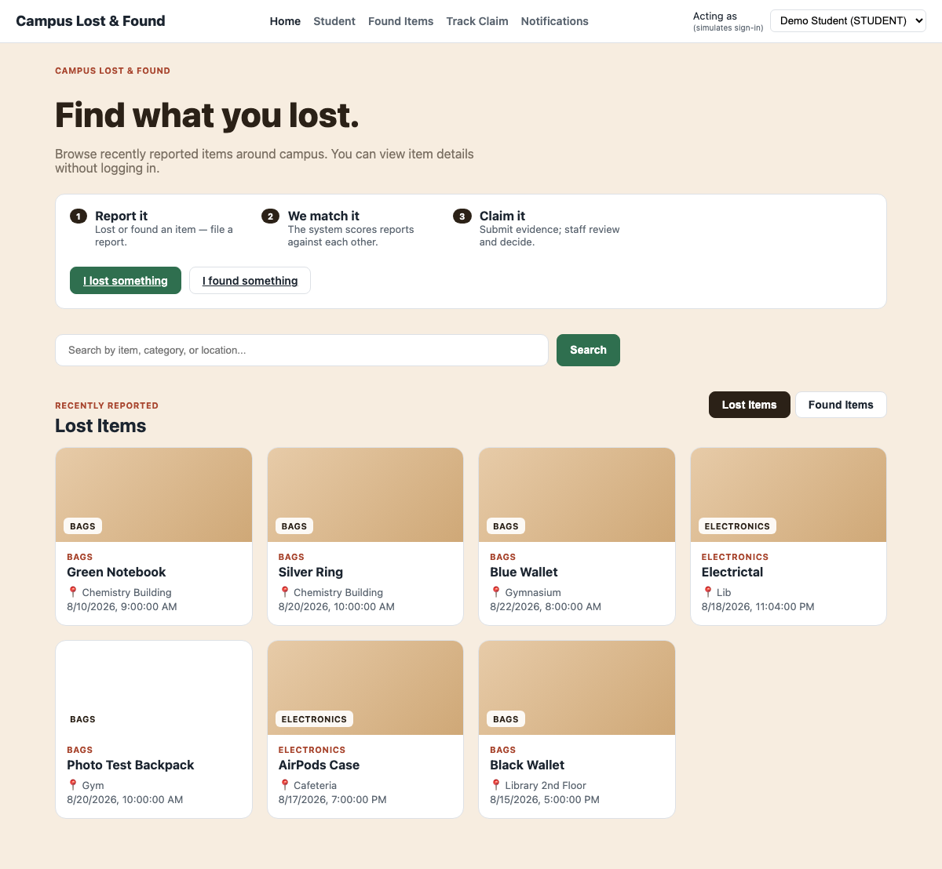

Match Results
Functional Requirement: FR2 — Item Matching
Available Actions:
- Displays every open candidate of the opposite type, ranked by score, with the full attribute breakdown and a Strong/Possible/Weak badge.
- The student can confirm or dismiss a candidate directly from this screen.

Submit a Claim
Functional Requirement: FR3 — Ownership Verification
Available Actions:
- The student picks their lost report and the found report they believe is theirs.
- The form requires at least 10 characters of supporting evidence.
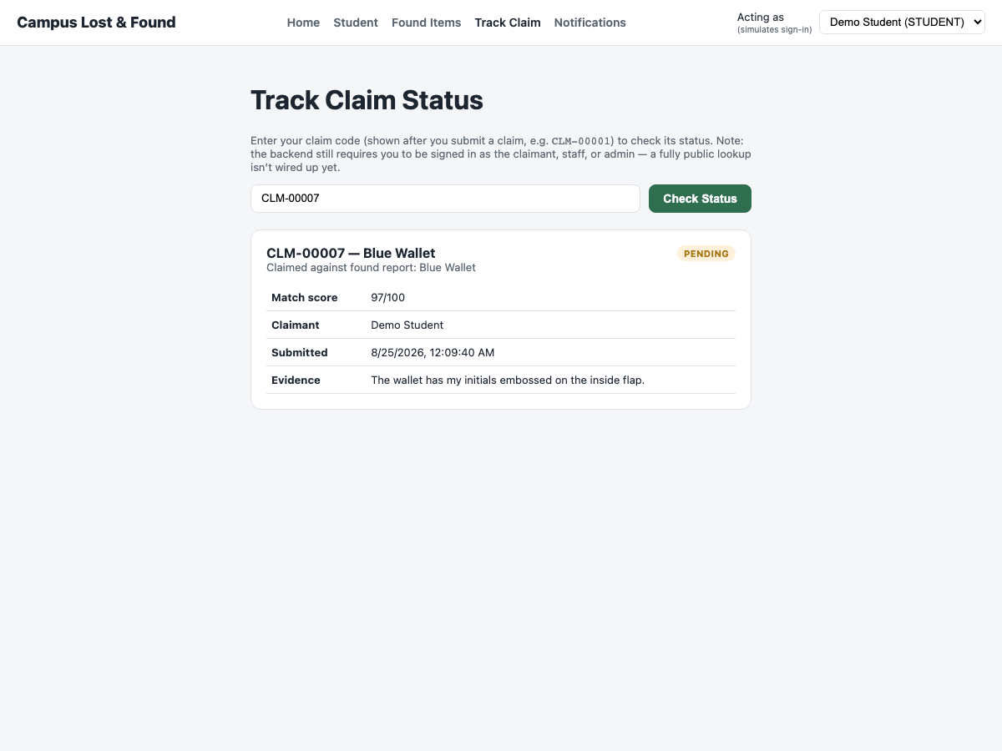

Notifications
Functional Requirement: Supports FR3 (view claim status) and NFR4 Usability
Available Actions:
- The student receives an in-app notification whenever a match is confirmed or a claim's status changes, without needing to poll the claim page.
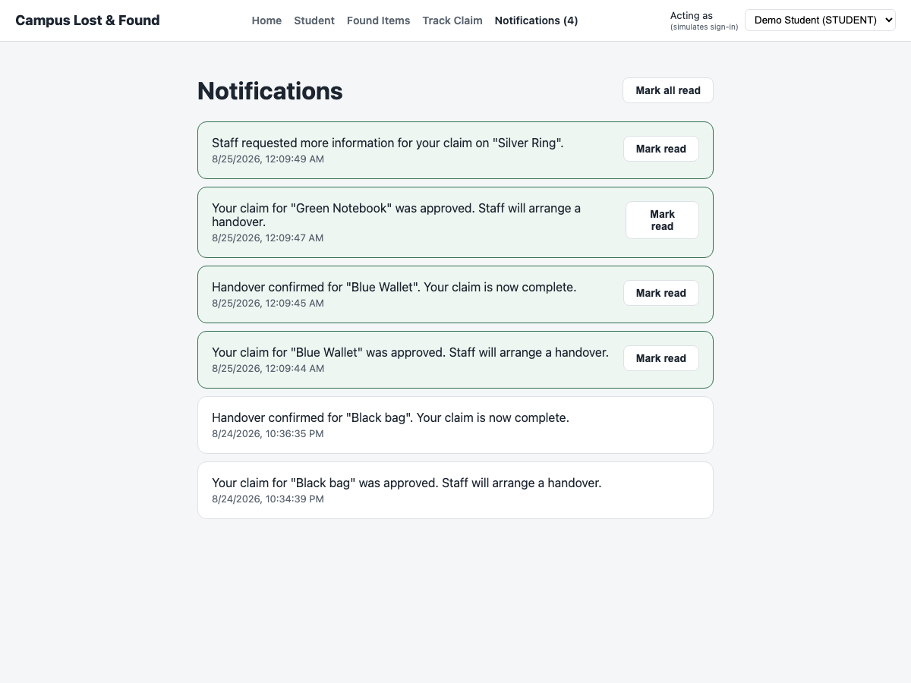

Track Claim by Code
Functional Requirement: FR3 — Ownership Verification / view claim status
Available Actions:
- A claimant can look up any claim's current status and decision history using its human-readable code (e.g. CLM-00007).
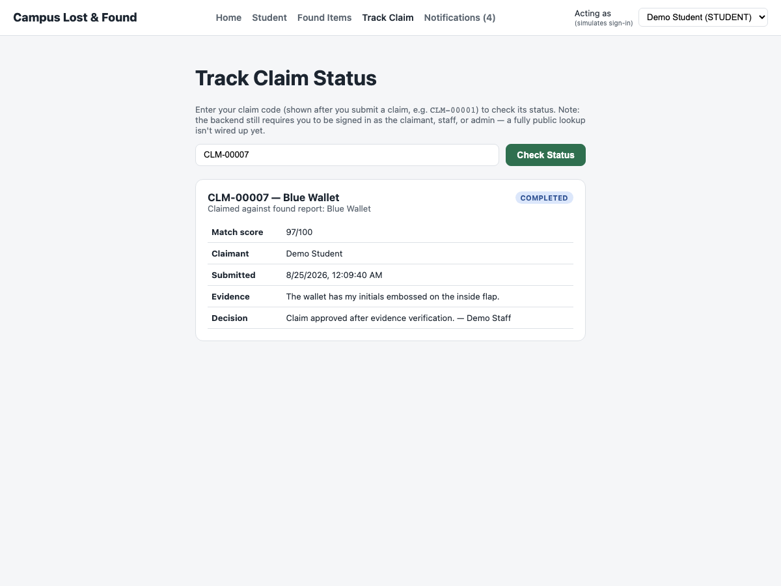

Staff — Functional Overview

Staff Dashboard & Claim Review
Functional Requirement: FR4 — Claim Management
Available Actions:
- Staff see every submitted claim with its status.
- Staff can drill into a claim to review the evidence and match score before deciding.
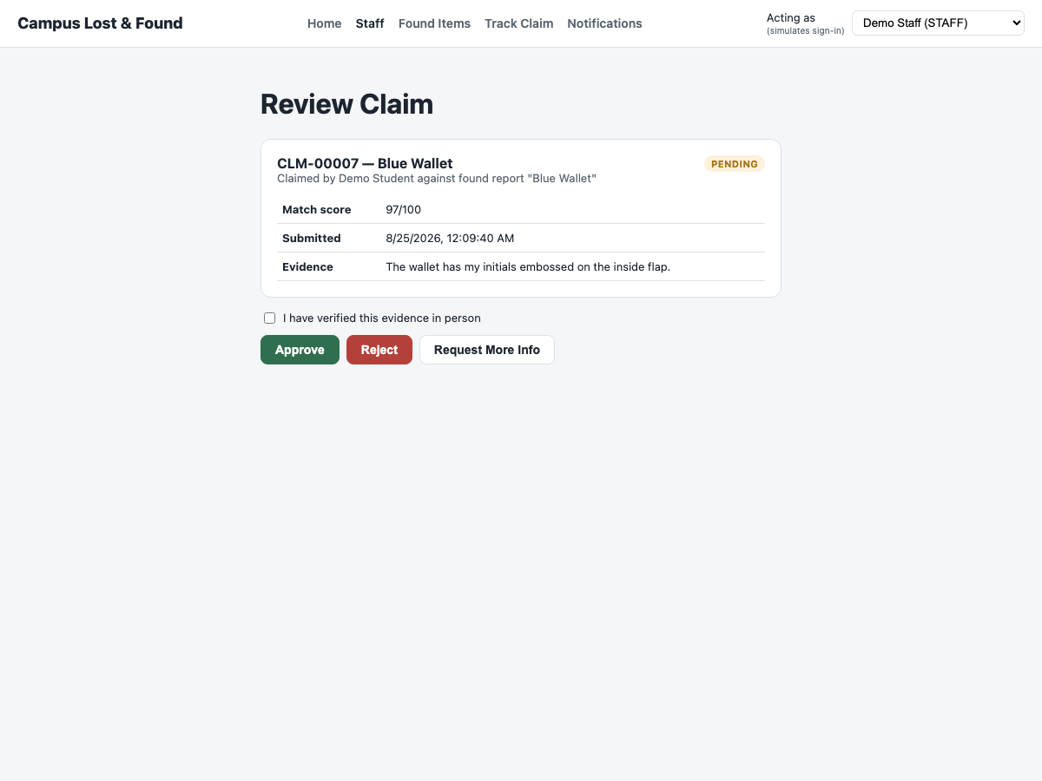

Claim Decision & Handover
Functional Requirement: FR4 — Claim Management
Available Actions:
- Staff approve, reject, or request more information on a claim.
- An approved claim requires a separate in-person identity check before the handover — and therefore the report — can be marked complete.

Admin — Functional Overview

Audit Logging
Functional Requirement: FR5 — Audit Logging
Available Actions:
- Every report creation, claim submission, claim decision, and handover is written to an AuditLog table with the acting user and a timestamp.
- The log is retrievable via GET /api/audit-logs, restricted to Admin.

Role-Based Navigation (all roles)
Functional Requirement: NFR3 — Security
Available Actions:
- The navigation bar and the /student and /staff routes adapt to the signed-in role.
- A student cannot reach the staff claims dashboard, and staff cannot reach the student's personal dashboard.

Summary
99 unit tests, 46 independent control-flow paths across 10 functions, 13 domain test cases, 7 automated integration scenarios (via tsx --test against the live API and database), and a Bruno-based access-control test collection were executed against the running system. All results matched expectations. The rule-based matching engine, claim decision logic, handover eligibility check, and ownership verification — the modules identified as highest-risk in the project proposal because of their branching complexity — are fully covered by static analysis (CFG/DFG), automated integration tests, and live, screenshot-based evidence from the running application.

Final Test Execution Results
Test Type | Cases Run | Passed | Failed | Evidence
Unit Testing | 99 | 99 | 0 | npx jest — see Unit Testing section
Control Flow Testing | 46 independent paths (10 functions) | 46 | 0 | All CFG paths mapped to executed unit tests
Data Flow Testing | 10 functions (def/c-use/p-use) | 10 | 0 | All DU-pairs exercised by the same unit tests
Domain Testing | 13 | 13 | 0 | Manual walkthrough against the running app
Integration Testing | 7 (TC-IT-001..007, incl. 3 sub-checks in TC-IT-007) | 7 | 0 | npm run test:integration — automated, reproducible
Access Control Testing | 4 (TC-AC-001..004) + 2 Bruno 403 checks | 6 | 0 | Integration suite TC-IT-007 + Bruno collection

$ npm test
Test Suites: 5 passed, 5 total
Tests: 99 passed, 99 total

$ npm run test:integration
# tests 9
# pass 9
# fail 0

$ npx @usebruno/cli run --env Local -r
Requests 22 (22 Passed)
Tests 18/18

Defects Found and Resolved
ID | Symptom | Root Cause | Resolution | Status
DEF-01 | GET /api/claims/by-code/ (empty code segment) and GET /api/claims/:id with a malformed (non-UUID) id both returned an uncaught 500 Internal Server Error instead of a clean 4xx response. | The empty/invalid segment matched Express route GET /:id, which passed the string straight to Prisma; Postgres rejected it as invalid UUID syntax (Prisma error code P2007), and errorHandler.js did not recognize that code. | Fixed in src/middleware/errorHandler.js: P2007 (and P2023) are now mapped to a 404 Not Found response. Verified via curl and via the Bruno "Get Claim by Code" request. | Fixed

No other failing tests or defects were found. One control-flow observation (not a defect) was documented in Control Flow Testing: the unionSize===0 branch inside scoreDescription()'s CFG is structurally present but unreachable through the public function, since the only way to reach it is already intercepted by an earlier check — the code behaves correctly, it simply contains one dead branch.

