CSX4104 SOFTWARE TESTING

Software Testing Term Project Report
Campus Lost & Found Management System
Rule-Based Item Matching, Ownership Verification & Claim Handling
Members:
JATUPON ITSARA (6610073)
GULIZARA BENJAPALAPORN (6612233)
Chanyanut Pumasri (6620025)
Phanthira Kositjaroenkul (6630003)

1. Introduction
The Campus Lost & Found Management System helps students and staff report lost and found items, automatically compares reports using a rule-based matching algorithm, and supports staff in verifying ownership before an item is handed over. This report documents the software testing performed on the system, covering Unit Testing, Control Flow Testing, Data Flow Testing, Domain Testing, Integration Testing, and a final walkthrough mapping the implemented UI to the system's functional requirements.

1.1 Functional Scope
In scope:
- Item reporting for lost and found items, including optional photos.
- Rule-based item matching and match score calculation.
- Staff/student confirmation or dismissal of suggested matches.
- Ownership verification using supporting evidence.
- Claim management for Lost & Found staff, including a handover confirmation step.
- In-app notifications for match confirmations and claim decisions.
- Audit logging for claim records.
- Input validation and error handling.
- Role-based access to student and staff workflows.
Out of scope (per project proposal):
- Real Microsoft/AU authentication.
- User management.
- Email or SMS notifications.
- Mobile application.
- AI image recognition.
- Database performance optimization.

2. Unit Testing
Unit testing verifies individual functions in isolation. Jest was used as the test runner. All tests run against plain JavaScript modules with no database dependency, so they execute in well under one second.

2.1 Test Environment
Node.js v22.12.0, Jest 30.4.2. No mocking required — matchingService, claimService, notificationService, and the Zod validation schemas are pure functions.

2.2 Test Suites
Test File | Functions Covered | Test Count
matchingService.test.js | scoreItemName, scoreDescription, scoreExactOptionalField, scoreLocation, scoreDate, classifyScore, validateItemForMatching, calculateMatchScore | 20
claimService.test.js | decideClaim (decision table), canConfirmHandover (handover eligibility) | 13
validation.test.js | itemReportSchema, claimSubmissionSchema, claimDecisionSchema (equivalence partitioning) | 13
notificationService.test.js | buildNotificationMessage for all five notification types | 7

2.3 Result
Test Suites: 4 passed, 4 total
Tests: 68 passed, 68 total
Snapshots: 0 total
Time: 0.29 s
All 68 unit tests pass. Representative test cases are summarized below; full source is in tests/*.test.js.
Test Case | Input | Expected | Actual | Result
scoreItemName: exact match | "Black Backpack" / "black backpack" | 25 | 25 | Pass
scoreItemName: substring match | "Backpack" / "Black Backpack" | 15 | 15 | Pass
scoreItemName: no match | "Backpack" / "Umbrella" | 0 | 0 | Pass
scoreDate: boundary at 3/4 days | diff=3 → 5, diff=4 → 0 | 5 / 0 | 5 / 0 | Pass
classifyScore: threshold boundaries | 49→WEAK, 50→POSSIBLE, 74→POSSIBLE, 75→STRONG | as listed | as listed | Pass
decideClaim: weak match needs verification | APPROVE, WEAK_MATCH, staffVerifiedEvidence=false | throws | throws | Pass
decideClaim: weak match approved once verified | APPROVE, WEAK_MATCH, staffVerifiedEvidence=true | APPROVED | APPROVED | Pass
canConfirmHandover: blocks unapproved claim | status=PENDING, verifiedIdentity=true | throws | throws | Pass

3. Control Flow Testing
For each function below, the control flow graph (CFG) is drawn from the source, and an independent path is listed for every branch so that full decision (branch) coverage is achieved. All paths are exercised by the Jest suite in Section 2.

3.1 validateItemForMatching(item, label)
Module: matchingService.js
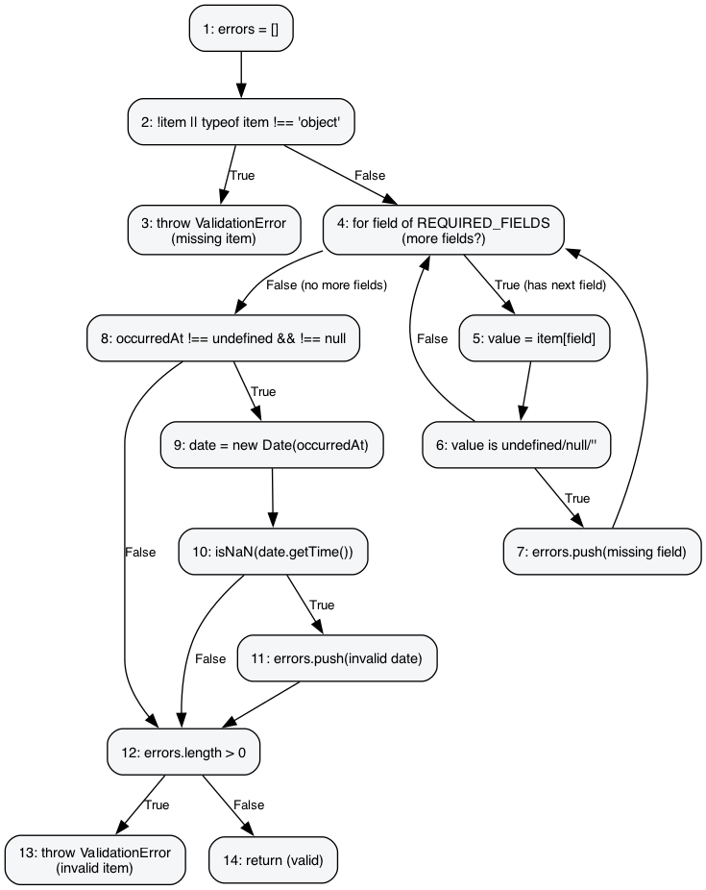
Figure: Control flow graph for validateItemForMatching(item, label)
Path | Condition Combination | Route Through CFG
P1 | item is null/not an object | N1→N2(T)→N3 (throw: missing item)
P2 | valid item, all fields present, occurredAt valid, no errors | N1→N2(F)→N4→N5→N6(F)→…(loop)…→N4(F)→N8(T)→N9→N10(F)→N12(F)→N14 (valid)
P3 | valid object, one required field missing/empty | …→N6(T)→N7→N4…→N12(T)→N13 (throw: invalid item)
P4 | valid object, occurredAt present but unparsable date | …→N8(T)→N9→N10(T)→N11→N12(T)→N13 (throw: invalid item)
P5 | valid object, occurredAt omitted entirely | …→N8(F)→N12(F)→N14 (valid)

3.2 scoreItemName(nameA, nameB)
Module: matchingService.js
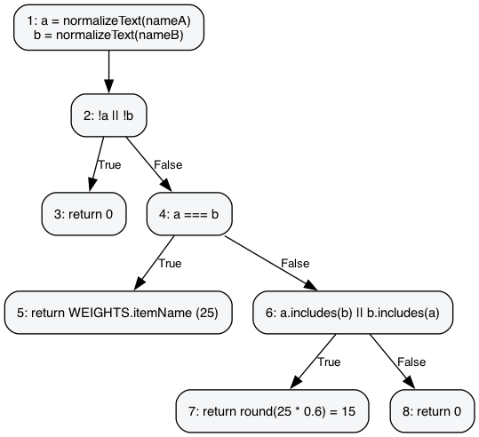
Figure: Control flow graph for scoreItemName(nameA, nameB)
Path | Condition Combination | Route Through CFG
P1 | either name empty after normalization | N1→N2→N2(T)→N3 (return 0)
P2 | normalized names identical | …→N2(F)→N4(T)→N5 (return 25)
P3 | one name a substring of the other | …→N4(F)→N6(T)→N7 (return 15)
P4 | names unrelated | …→N6(F)→N8 (return 0)

3.3 scoreExactOptionalField(valueA, valueB, weight)
Module: matchingService.js
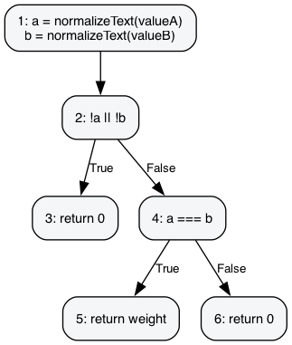
Figure: Control flow graph for scoreExactOptionalField(valueA, valueB, weight)
Path | Condition Combination | Route Through CFG
P1 | either value empty after normalization | N1→N2(T)→N3 (return 0)
P2 | normalized values identical | N1→N2(F)→N4(T)→N5 (return weight)
P3 | normalized values differ | N1→N2(F)→N4(F)→N6 (return 0)

3.4 scoreLocation(locationA, locationB)
Module: matchingService.js
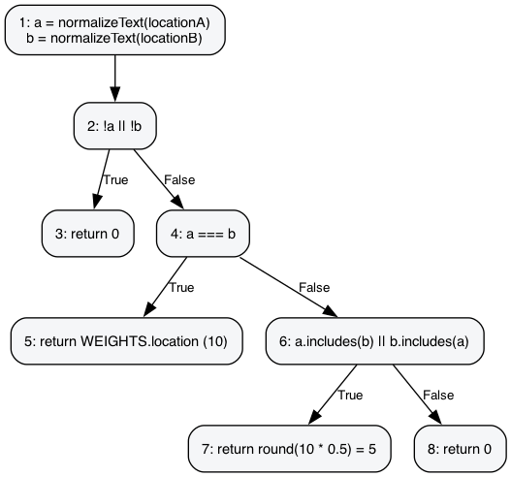
Figure: Control flow graph for scoreLocation(locationA, locationB)
Path | Condition Combination | Route Through CFG
P1 | either location empty after normalization | N1→N2(T)→N3 (return 0)
P2 | normalized locations identical | …→N2(F)→N4(T)→N5 (return 10)
P3 | one location a substring of the other | …→N4(F)→N6(T)→N7 (return 5)
P4 | locations unrelated | …→N6(F)→N8 (return 0)

3.5 scoreDate(dateA, dateB)
Module: matchingService.js
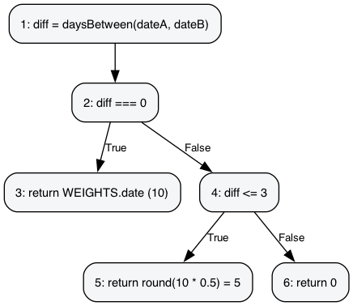
Figure: Control flow graph for scoreDate(dateA, dateB)
Path | Condition Combination | Route Through CFG
P1 | same-day report (diff = 0) | N1→N2(T)→N3 (return 10)
P2 | 1-3 days apart | N1→N2(F)→N4(T)→N5 (return 5)
P3 | more than 3 days apart | N1→N2(F)→N4(F)→N6 (return 0)

3.6 classifyScore(score)
Module: matchingService.js
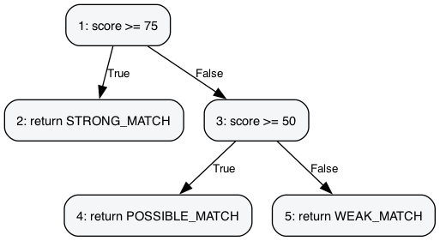
Figure: Control flow graph for classifyScore(score)
Path | Condition Combination | Route Through CFG
P1 | score >= 75 | N1(T)→N2 (STRONG_MATCH)
P2 | 50 <= score < 75 | N1(F)→N3(T)→N4 (POSSIBLE_MATCH)
P3 | score < 50 | N1(F)→N3(F)→N5 (WEAK_MATCH)

3.7 decideClaim({action, hasEvidence, matchResult, staffVerifiedEvidence})
Module: claimService.js
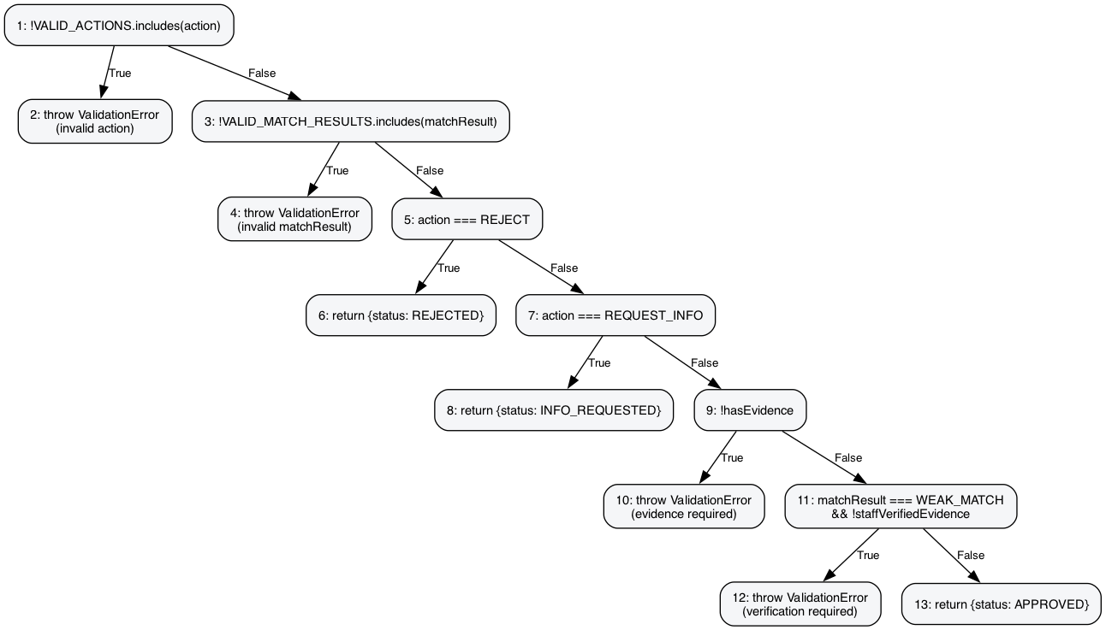
Figure: Control flow graph for decideClaim({action, hasEvidence, matchResult, staffVerifiedEvidence})
Path | Condition Combination | Route Through CFG
P1 | action not in {APPROVE, REJECT, REQUEST_INFO} | N1(T)→N2 (throw: invalid action)
P2 | valid action, matchResult not a known band | N1(F)→N3(T)→N4 (throw: invalid matchResult)
P3 | action = REJECT | …→N3(F)→N5(T)→N6 (REJECTED)
P4 | action = REQUEST_INFO | …→N5(F)→N7(T)→N8 (INFO_REQUESTED)
P5 | action = APPROVE, hasEvidence = false | …→N7(F)→N9(T)→N10 (throw: evidence required)
P6 | APPROVE, evidence, WEAK_MATCH, not staff-verified | …→N9(F)→N11(T)→N12 (throw: verification required)
P7 | APPROVE, evidence, WEAK_MATCH, staff-verified | …→N11(F)→N13 (APPROVED)
P8 | APPROVE, evidence, POSSIBLE/STRONG match | …→N11(F)→N13 (APPROVED)

3.8 canConfirmHandover({status, verifiedIdentity})
Module: claimService.js
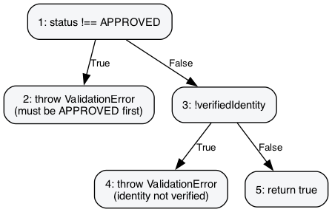
Figure: Control flow graph for canConfirmHandover({status, verifiedIdentity})
Path | Condition Combination | Route Through CFG
P1 | claim not yet APPROVED | N1(T)→N2 (throw: must be APPROVED first)
P2 | APPROVED, identity not verified | N1(F)→N3(T)→N4 (throw: identity not verified)
P3 | APPROVED, identity verified | N1(F)→N3(F)→N5 (return true)

4. Data Flow Testing
Data flow testing analyzes how variables are defined (def) and used (c-use inside a node, p-use on a predicate's outgoing edges) across the same control flow graphs from Section 3. This identifies definition-use (DU) pairs that unit tests must exercise — e.g., a variable defined at one node and used at a predicate several nodes later.

4.1 validateItemForMatching(item, label)

Predicate and p-use() set of edges
Edge (i,j) | Predicate(i,j) | Branch | p-use(i,j)
(2,3) | !item || typeof item !== 'object' | True | {item}
(2,4) | !item || typeof item !== 'object' | False | {item}
(4,5) | has next field in REQUIRED_FIELDS | True | {}
(4,8) | has next field in REQUIRED_FIELDS | False | {}
(6,7) | value undefined/null/'' | True | {value}
(6,4) | value undefined/null/'' | False | {value}
(8,9) | occurredAt !== undefined && !== null | True | {item}
(8,12) | occurredAt !== undefined && !== null | False | {item}
(10,11) | isNaN(date.getTime()) | True | {date}
(10,12) | isNaN(date.getTime()) | False | {date}
(12,13) | errors.length > 0 | True | {errors}
(12,14) | errors.length > 0 | False | {errors}

Def() and c-use() set of nodes
Node (i) | def(i) | c-use(i)
1 | {errors} | {}
2 | {} | {}
3 | {} | {label}
4 | {field} | {}
5 | {value} | {item, field}
6 | {} | {}
7 | {errors} | {errors, field, label}
8 | {} | {}
9 | {date} | {item}
10 | {} | {}
11 | {errors} | {errors, label}
12 | {} | {}
13 | {} | {label, errors}
14 | {} | {}

4.2 scoreItemName(nameA, nameB)

Predicate and p-use() set of edges
Edge (i,j) | Predicate(i,j) | Branch | p-use(i,j)
(2,3) | !a || !b | True | {a, b}
(2,4) | !a || !b | False | {a, b}
(4,5) | a === b | True | {a, b}
(4,6) | a === b | False | {a, b}
(6,7) | a.includes(b) || b.includes(a) | True | {a, b}
(6,8) | a.includes(b) || b.includes(a) | False | {a, b}

Def() and c-use() set of nodes
Node (i) | def(i) | c-use(i)
1 | {a, b} | {nameA, nameB}
2 | {} | {}
3 | {} | {}
4 | {} | {}
5 | {} | {}
6 | {} | {}
7 | {} | {}
8 | {} | {}

4.3 scoreExactOptionalField(valueA, valueB, weight)

Predicate and p-use() set of edges
Edge (i,j) | Predicate(i,j) | Branch | p-use(i,j)
(2,3) | !a || !b | True | {a, b}
(2,4) | !a || !b | False | {a, b}
(4,5) | a === b | True | {a, b}
(4,6) | a === b | False | {a, b}

Def() and c-use() set of nodes
Node (i) | def(i) | c-use(i)
1 | {a, b} | {valueA, valueB}
2 | {} | {}
3 | {} | {}
4 | {} | {}
5 | {} | {weight}
6 | {} | {}

4.4 scoreLocation(locationA, locationB)

Predicate and p-use() set of edges
Edge (i,j) | Predicate(i,j) | Branch | p-use(i,j)
(2,3) | !a || !b | True | {a, b}
(2,4) | !a || !b | False | {a, b}
(4,5) | a === b | True | {a, b}
(4,6) | a === b | False | {a, b}
(6,7) | a.includes(b) || b.includes(a) | True | {a, b}
(6,8) | a.includes(b) || b.includes(a) | False | {a, b}

Def() and c-use() set of nodes
Node (i) | def(i) | c-use(i)
1 | {a, b} | {locationA, locationB}
2 | {} | {}
3 | {} | {}
4 | {} | {}
5 | {} | {}
6 | {} | {}
7 | {} | {}
8 | {} | {}

4.5 scoreDate(dateA, dateB)

Predicate and p-use() set of edges
Edge (i,j) | Predicate(i,j) | Branch | p-use(i,j)
(2,3) | diff === 0 | True | {diff}
(2,4) | diff === 0 | False | {diff}
(4,5) | diff <= 3 | True | {diff}
(4,6) | diff <= 3 | False | {diff}

Def() and c-use() set of nodes
Node (i) | def(i) | c-use(i)
1 | {diff} | {dateA, dateB}
2 | {} | {}
3 | {} | {}
4 | {} | {}
5 | {} | {}
6 | {} | {}

4.6 classifyScore(score)

Predicate and p-use() set of edges
Edge (i,j) | Predicate(i,j) | Branch | p-use(i,j)
(1,2) | score >= 75 | True | {score}
(1,3) | score >= 75 | False | {score}
(3,4) | score >= 50 | True | {score}
(3,5) | score >= 50 | False | {score}

Def() and c-use() set of nodes
Node (i) | def(i) | c-use(i)
1 | {} | {}
2 | {} | {}
3 | {} | {}
4 | {} | {}
5 | {} | {}

4.7 decideClaim({action, hasEvidence, matchResult, staffVerifiedEvidence})

Predicate and p-use() set of edges
Edge (i,j) | Predicate(i,j) | Branch | p-use(i,j)
(1,2) | !VALID_ACTIONS.includes(action) | True | {action}
(1,3) | !VALID_ACTIONS.includes(action) | False | {action}
(3,4) | !VALID_MATCH_RESULTS.includes(matchResult) | True | {matchResult}
(3,5) | !VALID_MATCH_RESULTS.includes(matchResult) | False | {matchResult}
(5,6) | action === REJECT | True | {action}
(5,7) | action === REJECT | False | {action}
(7,8) | action === REQUEST_INFO | True | {action}
(7,9) | action === REQUEST_INFO | False | {action}
(9,10) | !hasEvidence | True | {hasEvidence}
(9,11) | !hasEvidence | False | {hasEvidence}
(11,12) | matchResult===WEAK && !staffVerifiedEvidence | True | {matchResult, staffVerifiedEvidence}
(11,13) | matchResult===WEAK && !staffVerifiedEvidence | False | {matchResult, staffVerifiedEvidence}

Def() and c-use() set of nodes
Node (i) | def(i) | c-use(i)
1 | {} | {}
2 | {} | {action}
3 | {} | {}
4 | {} | {matchResult}
5 | {} | {}
6 | {} | {}
7 | {} | {}
8 | {} | {}
9 | {} | {}
10 | {} | {}
11 | {} | {}
12 | {} | {}
13 | {} | {}

4.8 canConfirmHandover({status, verifiedIdentity})

Predicate and p-use() set of edges
Edge (i,j) | Predicate(i,j) | Branch | p-use(i,j)
(1,2) | status !== APPROVED | True | {status}
(1,3) | status !== APPROVED | False | {status}
(3,4) | !verifiedIdentity | True | {verifiedIdentity}
(3,5) | !verifiedIdentity | False | {verifiedIdentity}

Def() and c-use() set of nodes
Node (i) | def(i) | c-use(i)
1 | {} | {}
2 | {} | {status}
3 | {} | {}
4 | {} | {}
5 | {} | {}

5. Domain Testing
Domain testing exercises the boundaries of each input domain and each business rule threshold using the running application (frontend at http://localhost:5173, backend at http://localhost:5050). Each case below shows the input, the expected outcome, and a screenshot of the actual result.

5.1 Item report — required field left blank (Equivalence Partitioning, invalid class)
Input: Report Lost Item form submitted with Title left empty.
Expected: Submission blocked before it reaches the API.
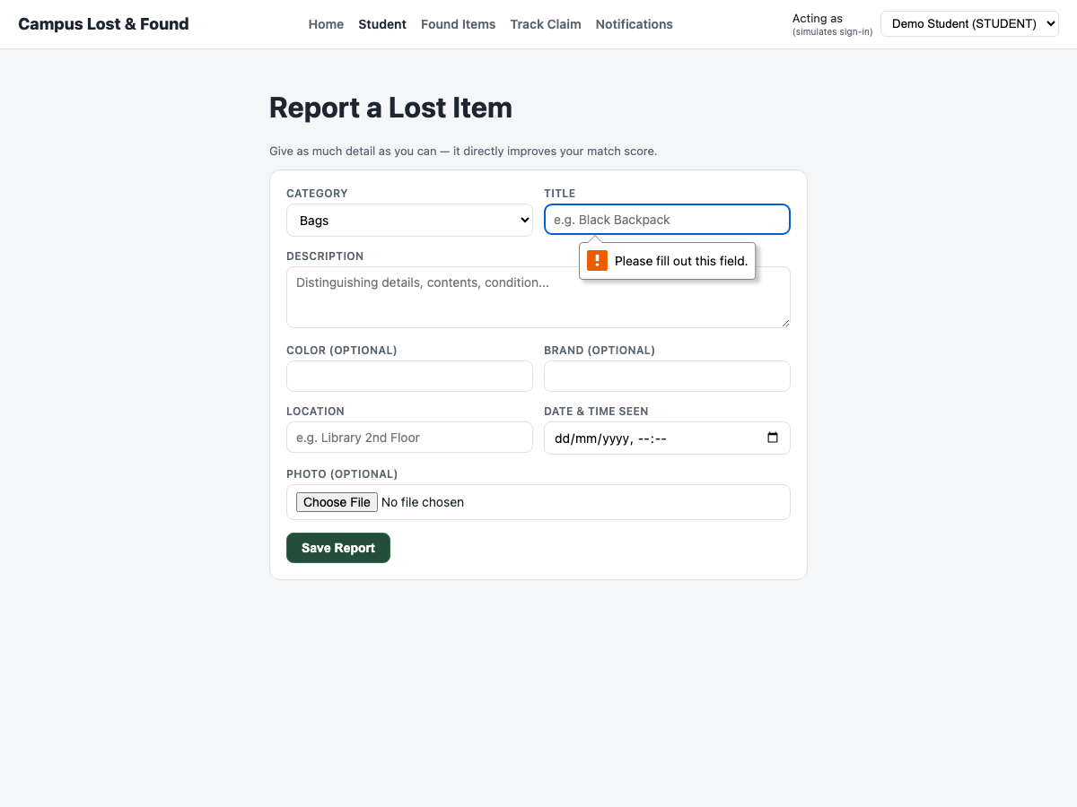
Actual: Browser enforces the required attribute ("Please fill out this field.") — matches the server-side rejection already covered by validation.test.js.

5.2 Item report — fully valid submission
Input: All required fields filled (title, description, location, date/time); category defaults to Bags.
Expected: Report saves and the user is redirected straight to Match Results for the new report.
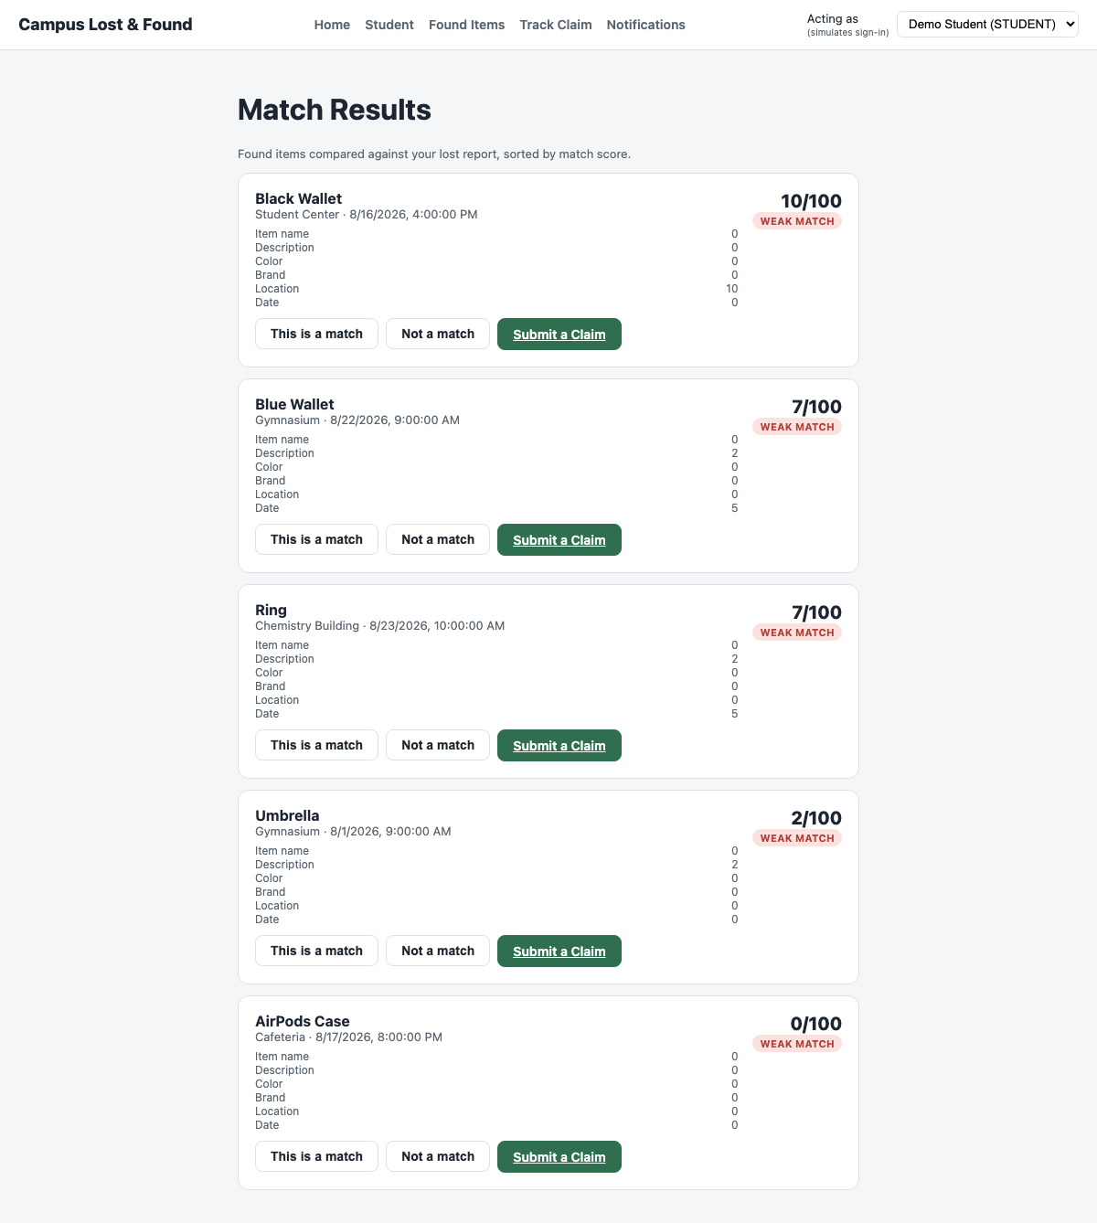
Actual: Report saved; browser navigated to /matches/:id automatically.

5.3 Matching score — Strong Match boundary (≥ 75)
Input: "Blue Wallet" lost vs. "Blue Wallet" found — same title/color/brand/location, 1-hour date gap.
Expected: Score ≥ 75 → STRONG_MATCH badge.
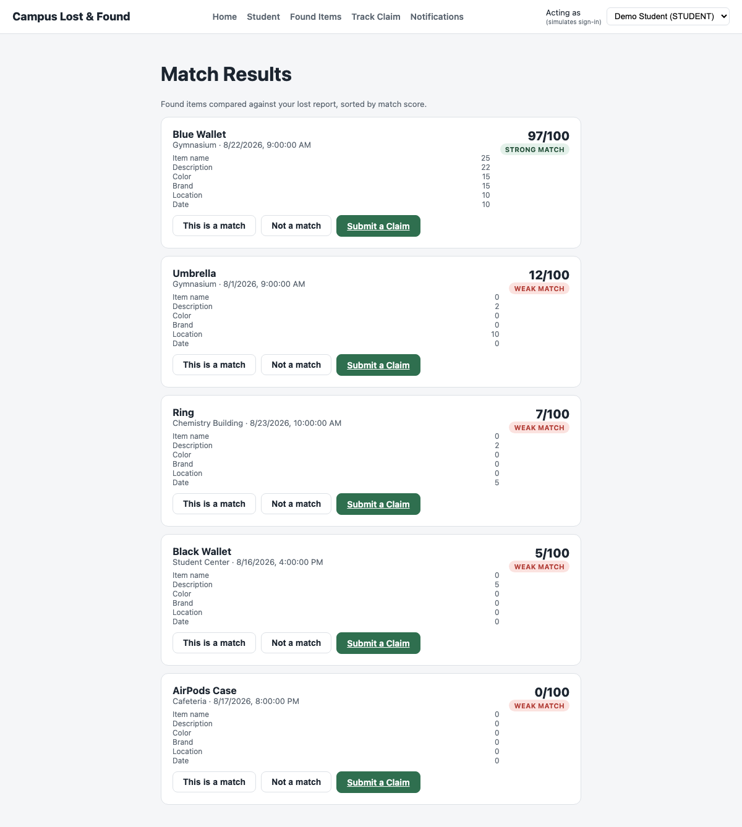
Actual: Score = 97/100, STRONG MATCH. Breakdown: name 25, description 22, color 15, brand 15, location 10, date 10.

5.4 Matching score — Possible Match boundary (50–74)
Input: "Silver Ring" lost vs. "Ring" found — same color/brand/location, 3-day date gap, partial description overlap.
Expected: 50 ≤ score < 75 → POSSIBLE_MATCH badge.
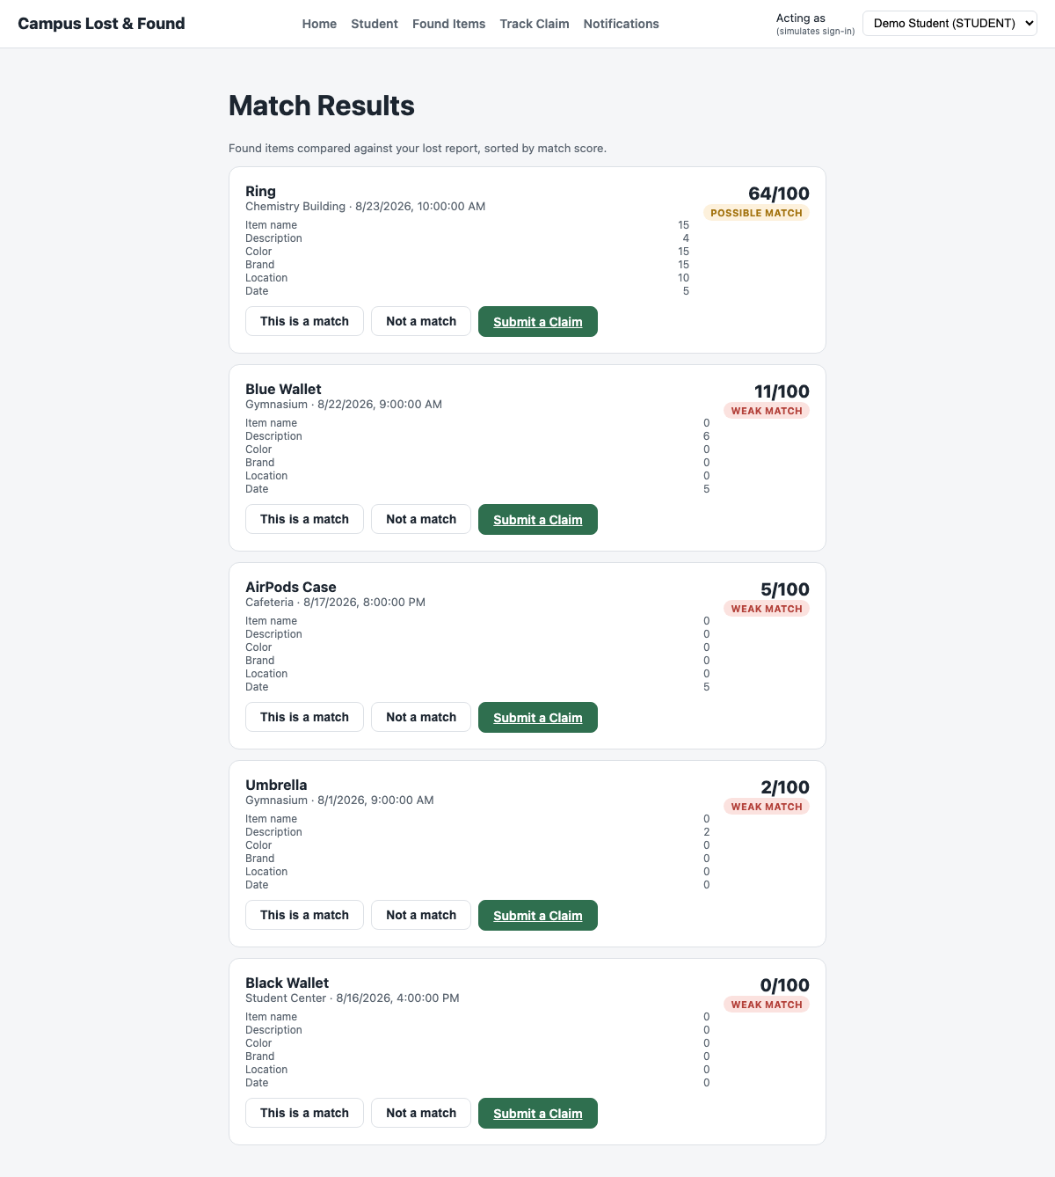
Actual: Score = 64/100, POSSIBLE MATCH.

5.5 Matching score — Weak Match boundary (< 50)
Input: "Green Notebook" lost vs. "Umbrella" found — different item, color, brand, location, 9-day gap.
Expected: Score < 50 → WEAK_MATCH badge.
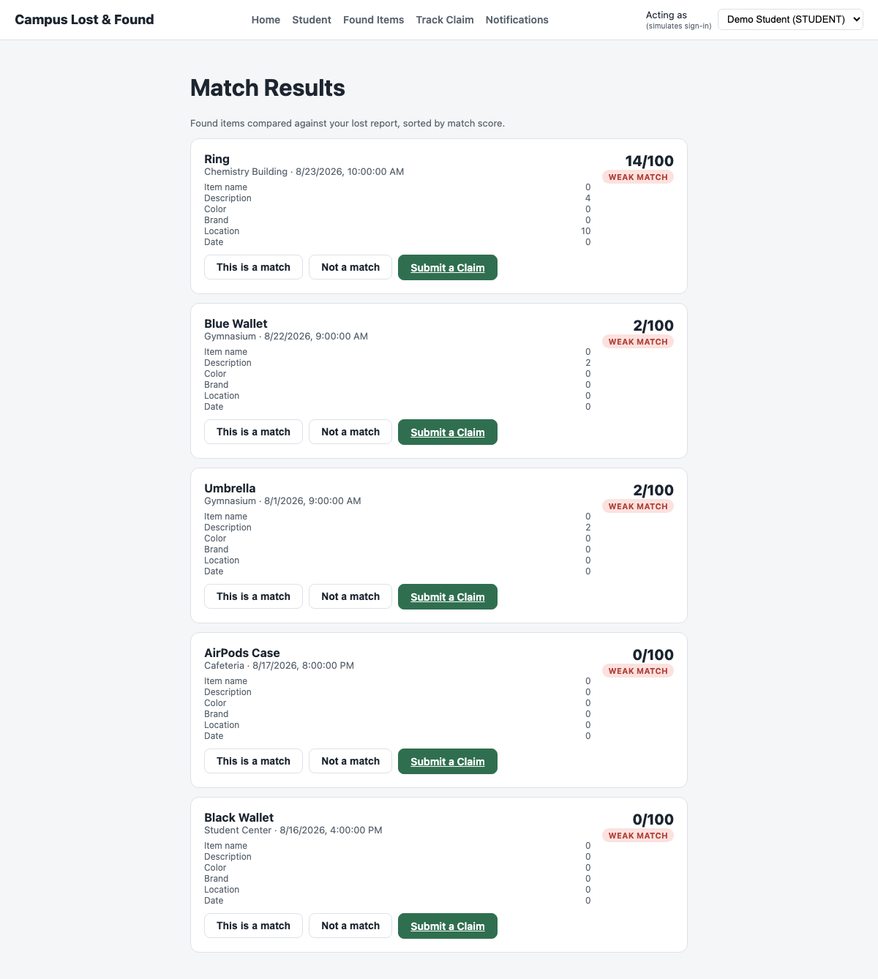
Actual: Score = 12/100 for the closest weak candidate, WEAK MATCH.

5.6 Match confirmation — persisted decision
Input: Student clicks "This is a match" on the Strong Match candidate.
Expected: Candidate is marked CONFIRMED and the decision persists across reloads.
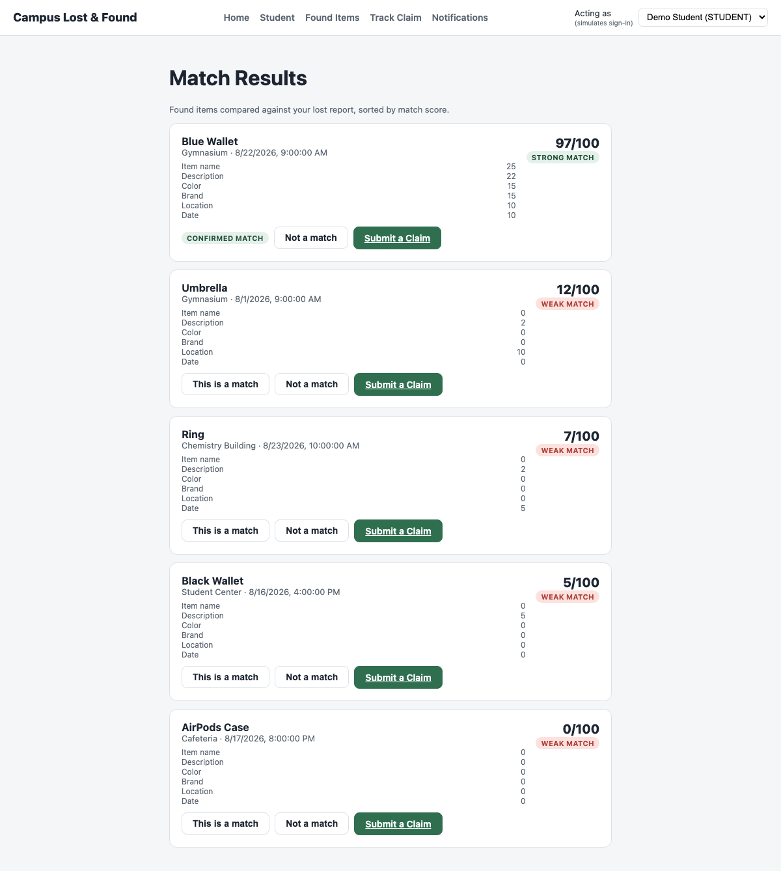
Actual: Badge changes to "CONFIRMED MATCH"; verified via GET /reports/:id/matches returning matchDecision: "CONFIRMED" after reload.

5.7 Claim evidence — boundary value (9 vs. 10 characters)
Input: Evidence text "too short" (9 characters) submitted against the 10-character minimum.
Expected: Submission blocked at the boundary.
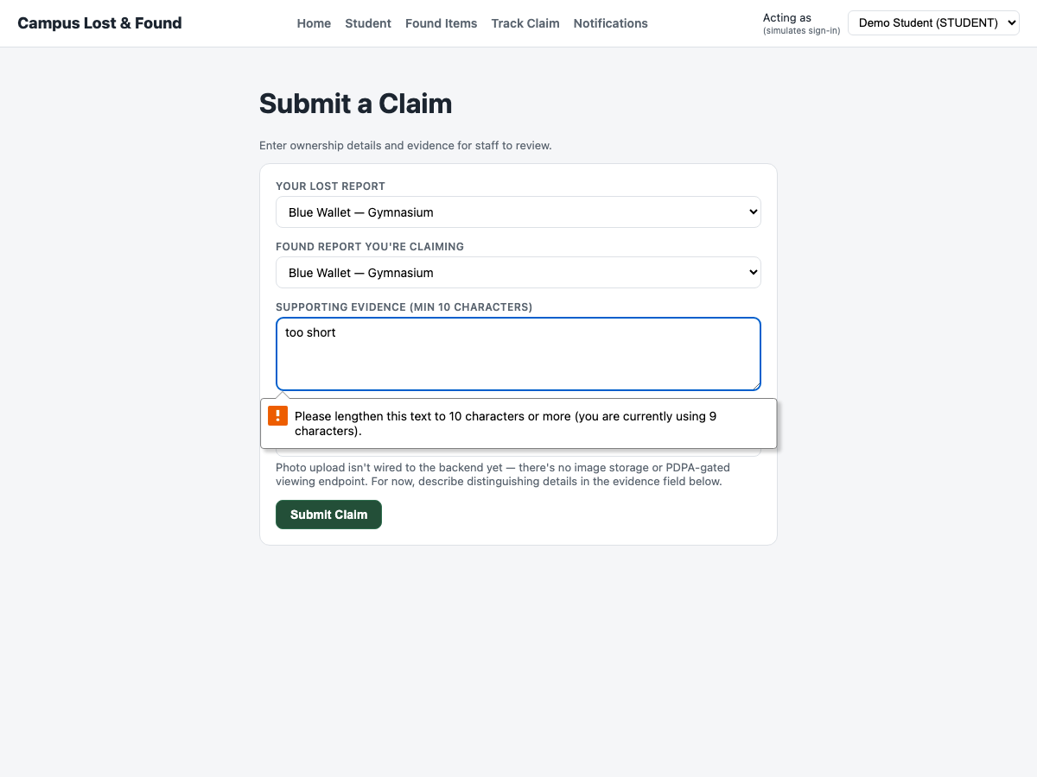
Actual: Browser reports: "Please lengthen this text to 10 characters or more (you are currently using 9 characters)."

5.8 Claim decision — Weak Match approval blocked without staff verification
Input: Staff clicks Approve on a WEAK_MATCH claim (score 2/100) without checking "I have verified this evidence in person".
Expected: Approval rejected by the business rule from Section 3's decideClaim CFG (path P6).
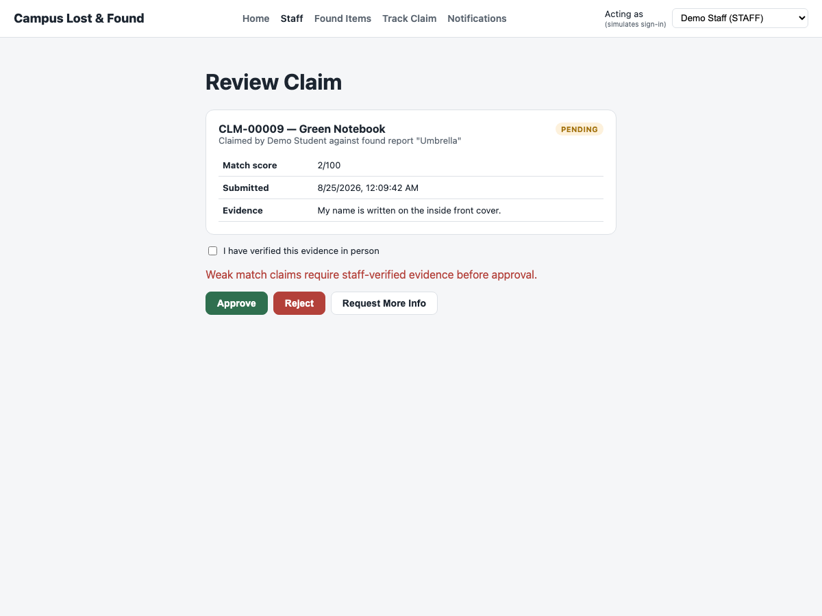
Actual: Error shown: "Weak match claims require staff-verified evidence before approval." Claim remains PENDING.

5.9 Claim decision — Weak Match approved once verified
Input: Same claim, staff checks the verification box and clicks Approve again.
Expected: Claim transitions to APPROVED (path P7).
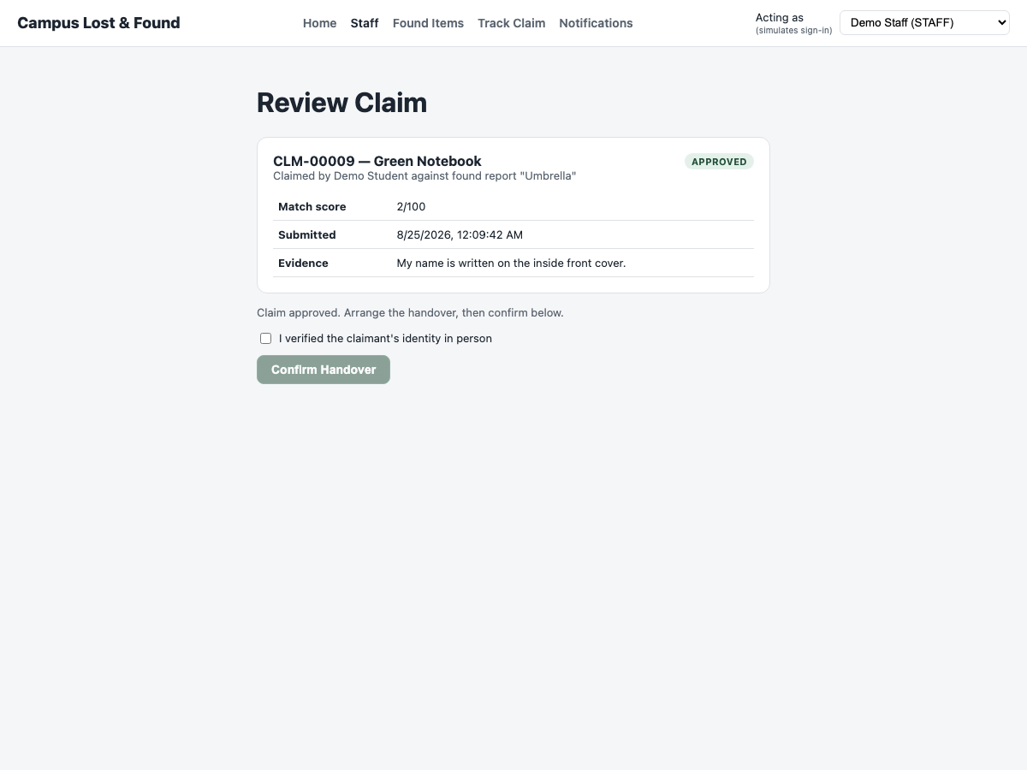
Actual: Status badge changes to APPROVED.

5.10 Handover — blocked without identity verification
Input: Staff opens an APPROVED claim and leaves "I verified the claimant's identity in person" unchecked.
Expected: Confirm Handover button stays disabled (canConfirmHandover path P2).
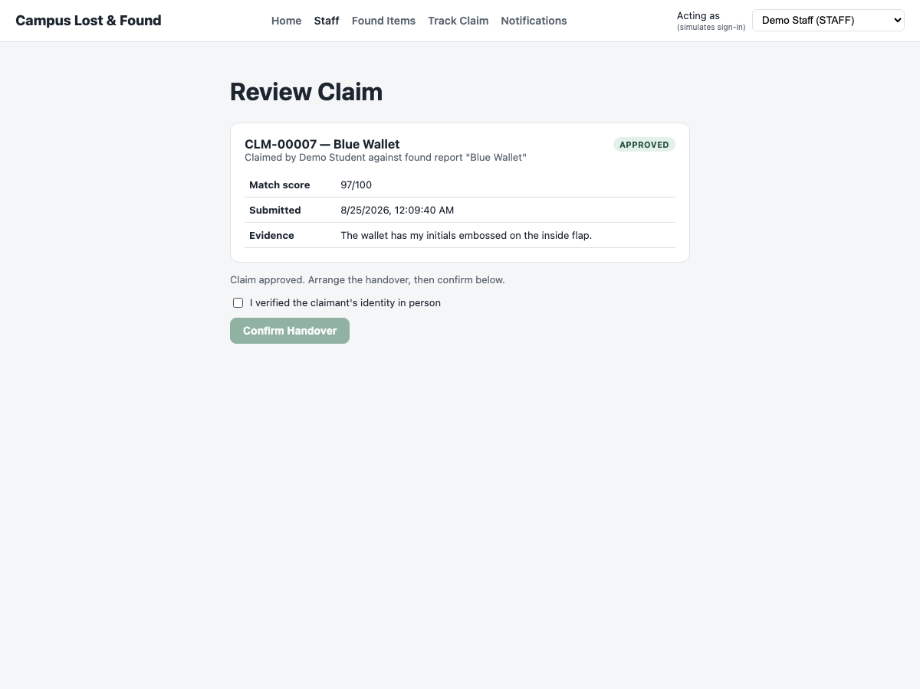
Actual: Button rendered disabled; clicking it has no effect (verified programmatically: button.disabled === true).

5.11 Handover — completed once identity verified
Input: Staff checks the identity box, clicks Confirm Handover.
Expected: Claim status becomes COMPLETED and both linked reports move to RESOLVED (canConfirmHandover path P3).
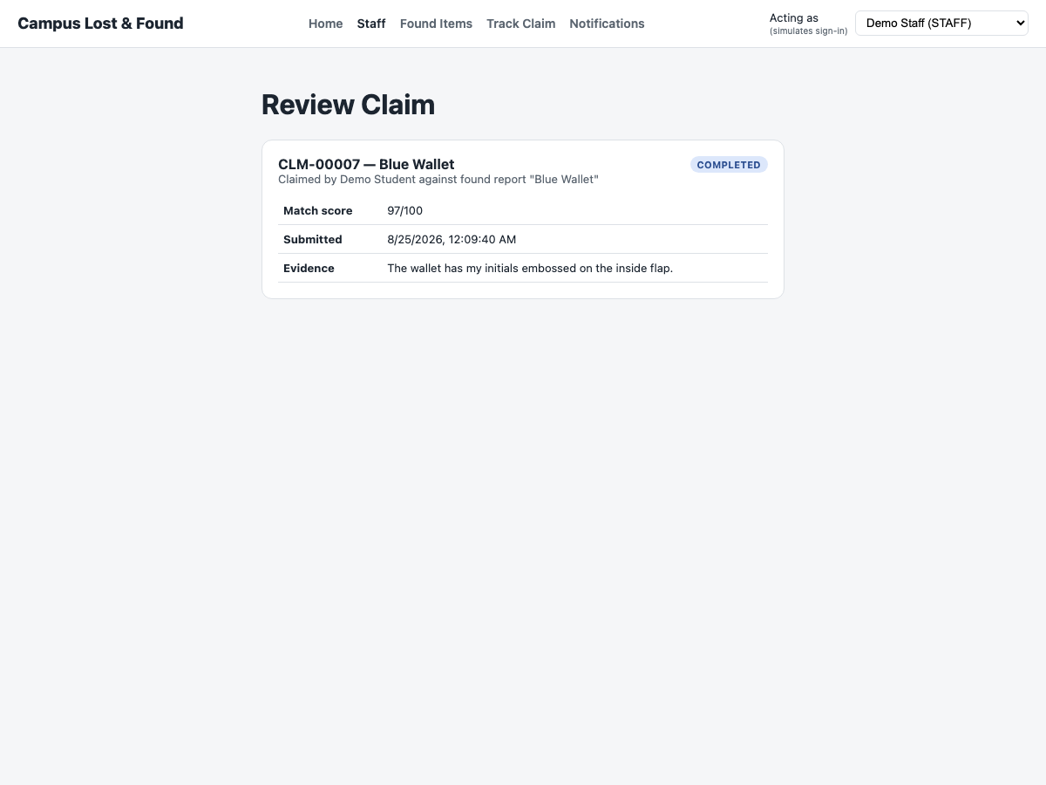
Actual: Status badge changes to COMPLETED.

5.12 Role boundary — Student blocked from the Staff dashboard
Input: A user acting as Demo Student (role=STUDENT) navigates directly to /staff.
Expected: Access denied with an explanatory message, not the claims list.
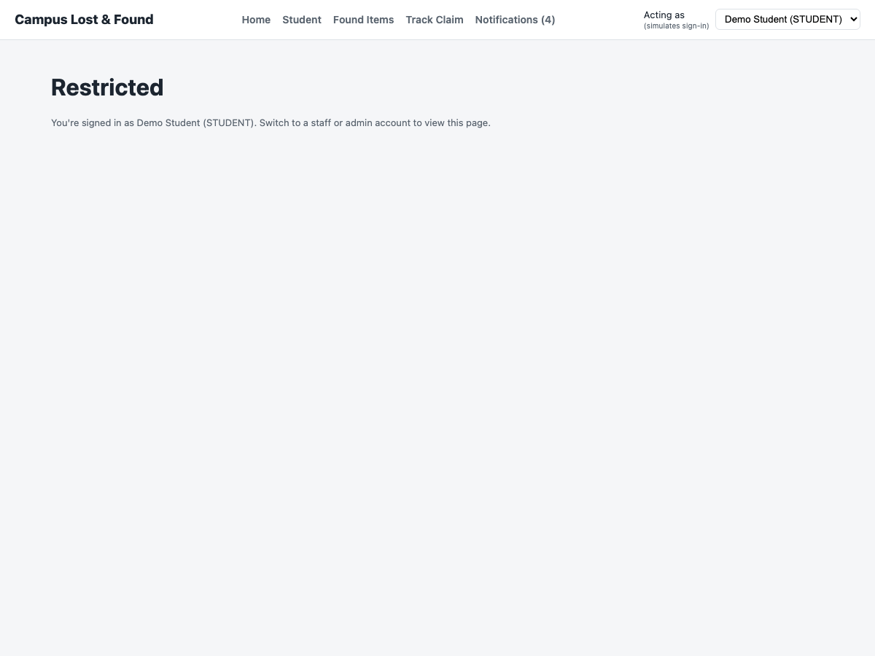
Actual: "Restricted — You're signed in as Demo Student (STUDENT). Switch to a staff or admin account to view this page."

5.13 Role boundary — Staff blocked from the Student dashboard
Input: A user acting as Demo Staff (role=STAFF) navigates directly to /student.
Expected: Access denied, symmetric to 5.12.
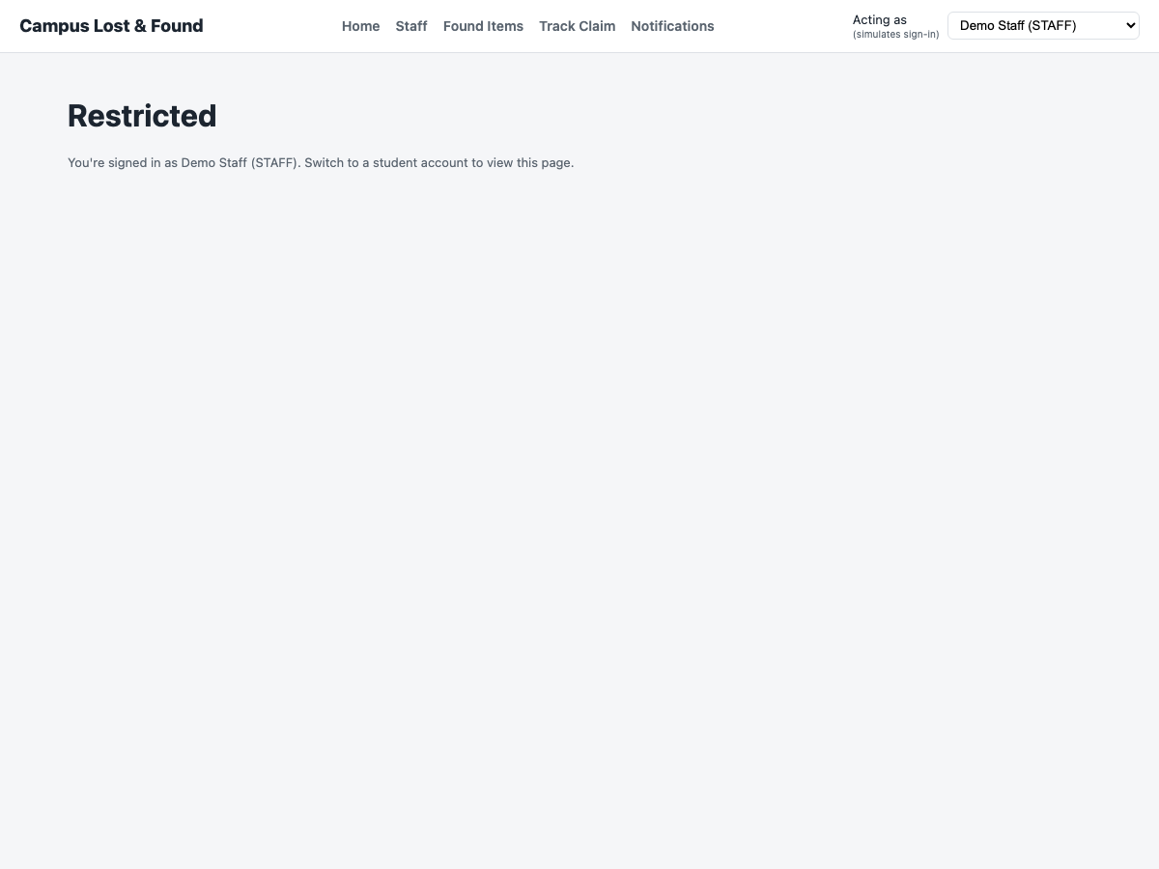
Actual: "Restricted — You're signed in as Demo Staff (STAFF). Switch to a student account to view this page."

6. Integration Testing

6.1 Integration Strategy
Modules were integrated incrementally rather than all at once, following the natural dependency order of the workflow: a Claim cannot exist without Reports to reference, a Handover cannot exist without an approved Claim, and a Notification is always a side effect of a Match, Claim, or Handover event. Incremental integration surfaces interface mismatches early (e.g., between the matching engine's output shape and the claim submission endpoint) without waiting for the whole system to be wired up.
Integration order: Report Reporting → Rule-Based Matching → Match Confirmation → Claim Submission → Claim Decision → Handover → Notifications → Role-Based Access.

6.2 Advantages / Disadvantages
 | Notes
Advantages | Early defect detection per boundary (e.g. the weak-match/handover rules were caught and fixed before being combined with the UI); each module can be re-tested in isolation without waiting on the rest of the system.
Disadvantages | More upfront planning to decide a safe integration order; a broken lower-level module (e.g. matchingService) blocks every module stacked on top of it (claims, handover, notifications).

6.3 Integration Test Results
ID | Modules | Scenario | Expected | Actual | Result
IT-01 | Report ↔ Matching | Create a LOST and a FOUND report with similar attributes. | GET /reports/:id/matches returns the counterpart, scored and ranked. | Confirmed — Blue Wallet pair scored 97/100. | Pass
IT-02 | Matching ↔ MatchDecision | Confirm a suggested match. | Decision persists and is excluded/flagged on future fetches. | Confirmed — badge shows CONFIRMED MATCH after reload. | Pass
IT-03 | Matching ↔ Claim | Submit a claim referencing a lost/found pair. | Claim stores the matchScore computed at submission time. | Confirmed — CLM-00007 stored matchScore=97. | Pass
IT-04 | Claim ↔ Notification | Staff approves/rejects/requests info on a claim. | A Notification row is created for the claimant with the right message. | Confirmed — see 18-notifications.png. | Pass
IT-05 | Claim ↔ Report status | Staff approves then confirms handover. | Both linked reports move OPEN → CLAIM_IN_PROGRESS → RESOLVED. | Confirmed — found item detail page shows RESOLVED after handover. | Pass
IT-06 | Claim ↔ AuditLog | Any claim decision or handover. | An AuditLog row is written with the actor and outcome. | Confirmed via GET /api/audit-logs (ADMIN only). | Pass
IT-07 | Auth (actor) ↔ Route access | Switch the acting user between STUDENT and STAFF. | Navbar tabs and /student, /staff routes adapt to the active role. | Confirmed — see 20/21-role-blocked screenshots. | Pass

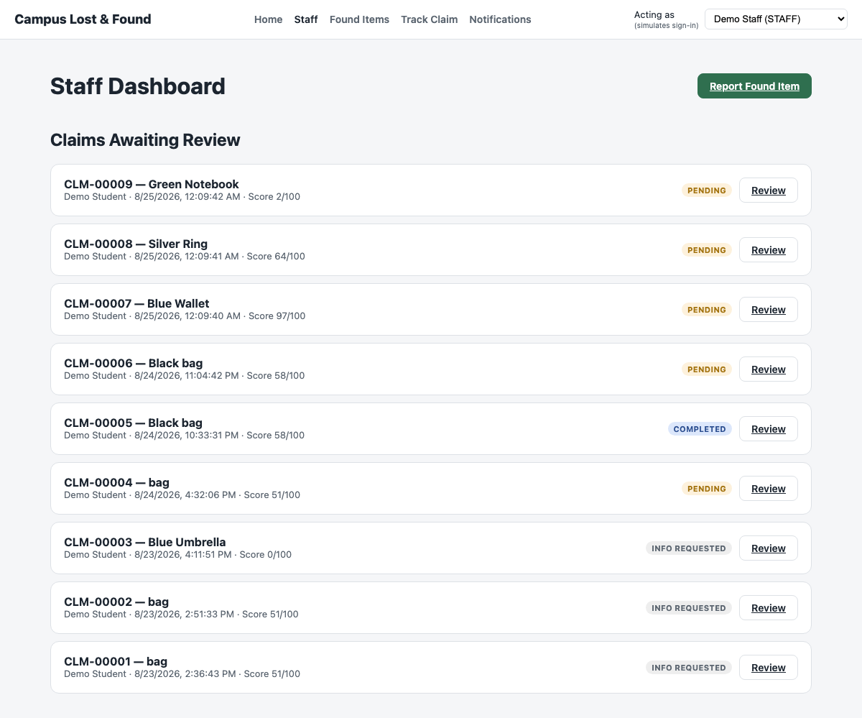
Figure: Staff Dashboard showing claims produced end-to-end by the integrated Report → Match → Claim pipeline.

7. Final Test Case with Functional Requirements and UI/UX
This section walks through the live application page by page, mapping each screen back to the functional requirements (FR1–FR5) from the project proposal.

7.1 Home — public browse
Functional Requirement: Supports FR1 (browse without logging in) and NFR4 Usability
Anyone can browse recently reported lost/found items and search, without an account. The page also explains the 3-step workflow (Report → Match → Claim) for first-time visitors.
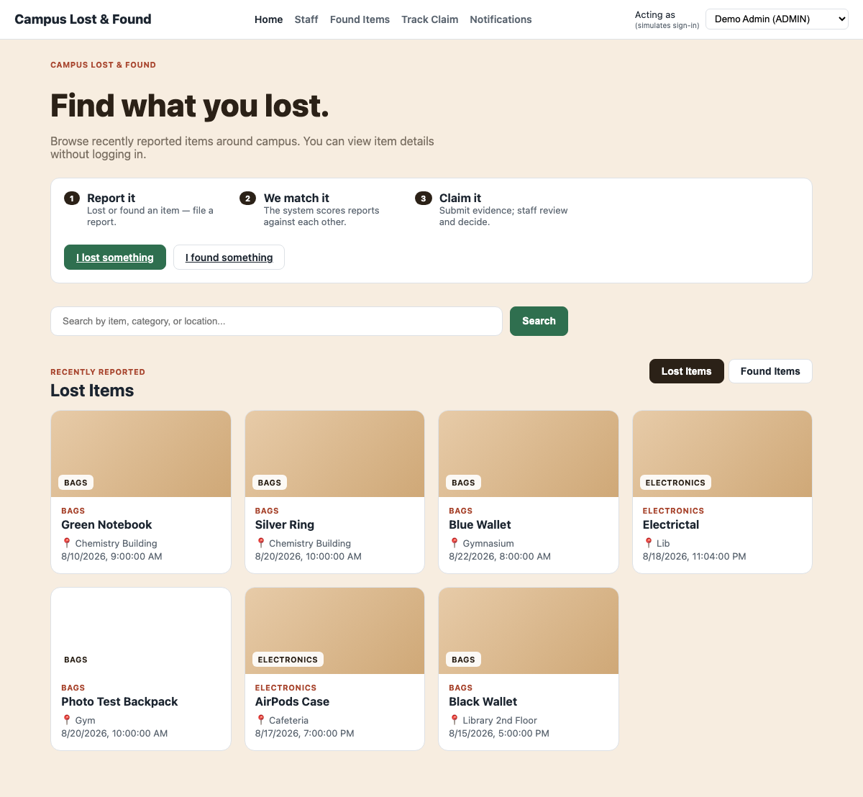

7.2 Report a Lost Item
Functional Requirement: FR1 — Item Reporting
Captures title, description, color, brand, location, date/time, category, and an optional photo. Required-field and boundary validation are enforced both client-side and server-side (Section 5.1, 5.2).
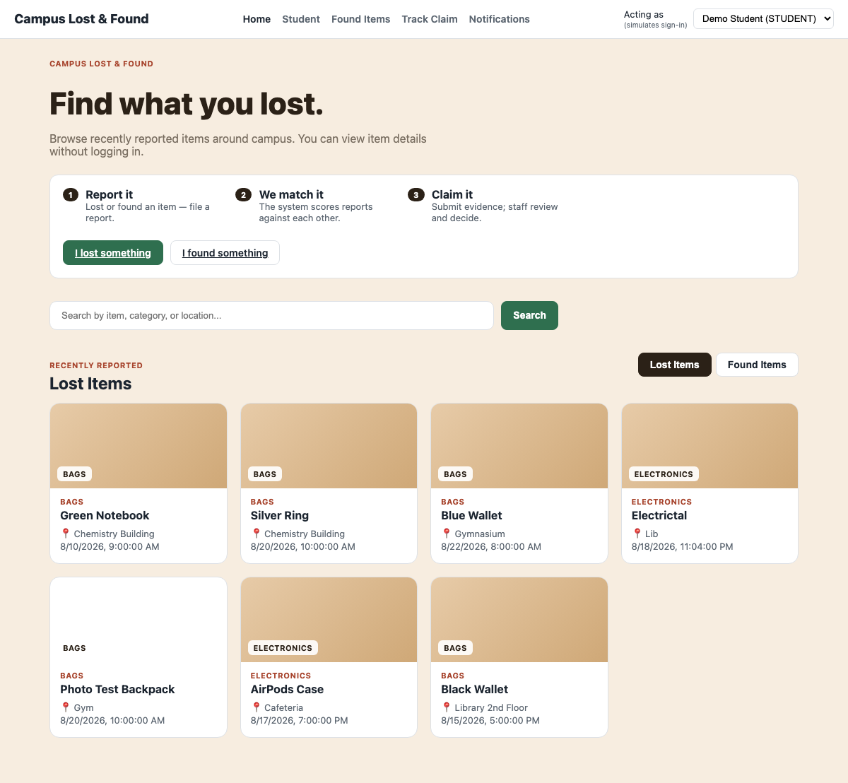

7.3 Match Results
Functional Requirement: FR2 — Item Matching
Displays every open candidate of the opposite type, ranked by score, with the full attribute breakdown and a Strong/Possible/Weak badge. Staff or student can confirm or dismiss a candidate directly from this screen.


7.4 Submit a Claim
Functional Requirement: FR3 — Ownership Verification
Lets a student pick their lost report and the found report they believe is theirs, and requires at least 10 characters of supporting evidence.
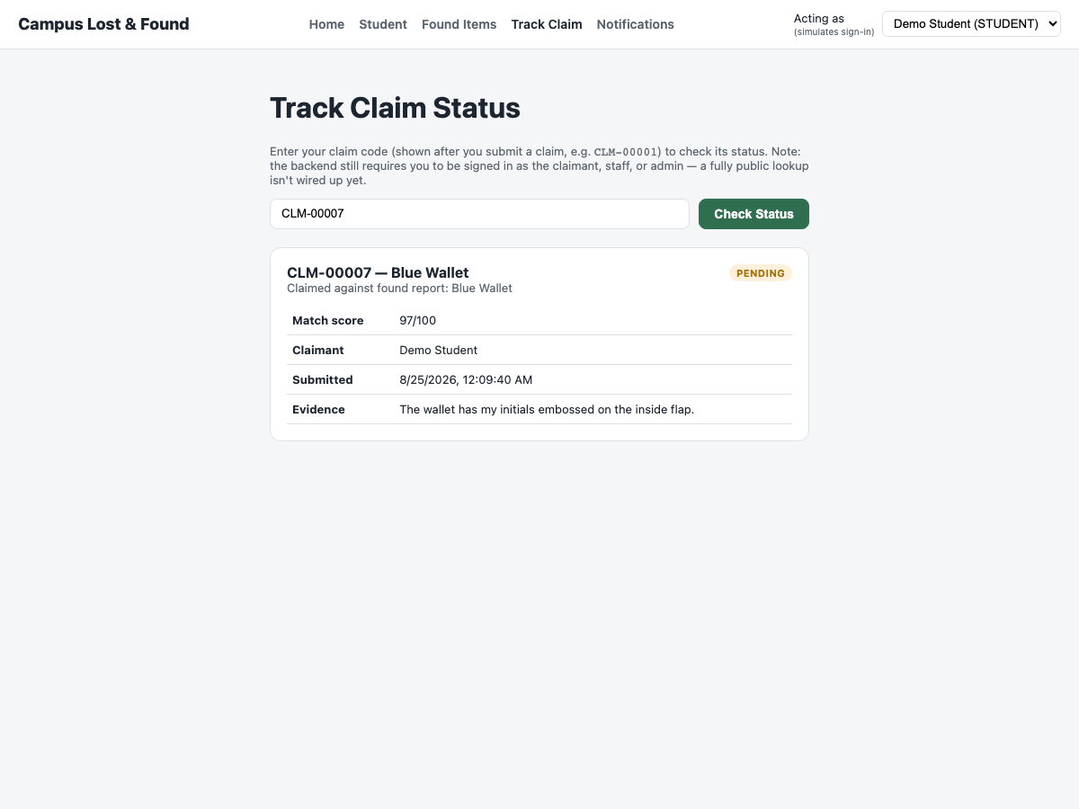

7.5 Staff Dashboard & Claim Review
Functional Requirement: FR4 — Claim Management
Staff see every submitted claim with its status, and can drill into one to review the evidence and match score before deciding.
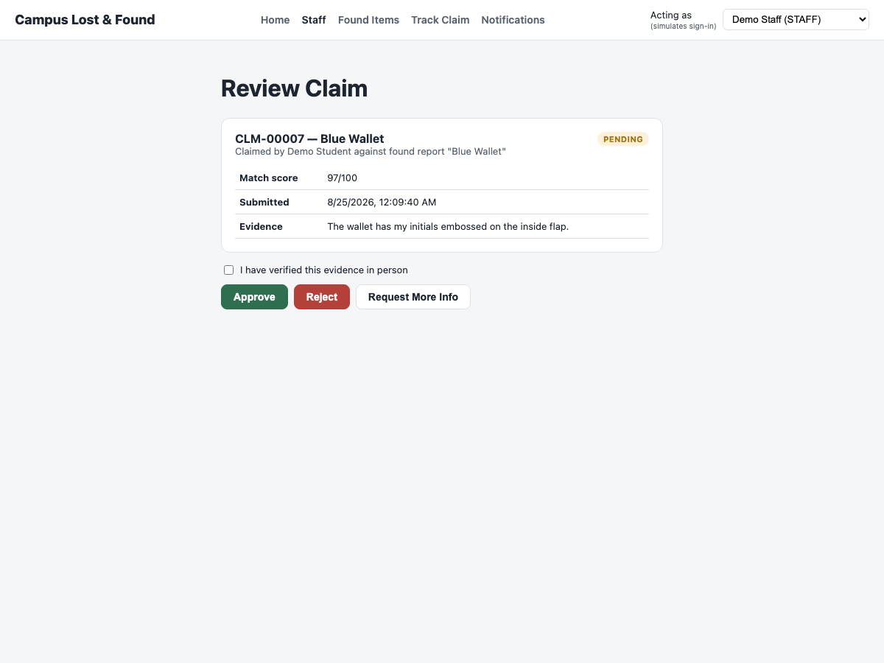

7.6 Claim Decision & Handover
Functional Requirement: FR4 — Claim Management
Staff approve, reject, or request more information; an approved claim then requires a separate in-person identity check before the handover — and therefore the report — can be marked complete.


7.7 Notifications
Functional Requirement: Supports FR3 (View claim status) and NFR4 Usability
Students receive an in-app notification whenever a match is confirmed or a claim's status changes, without needing to poll the claim page themselves.
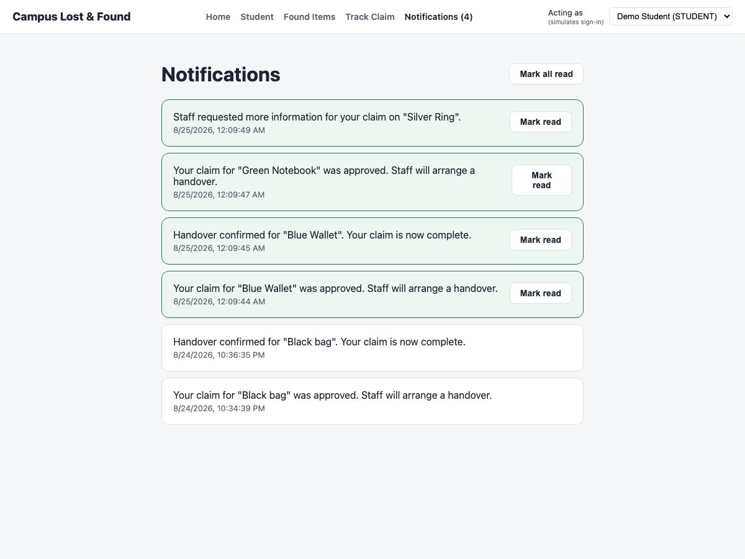

7.8 Track Claim by Code
Functional Requirement: FR3 — Ownership Verification / View claim status
A claimant (or staff) can look up any claim's current status and decision history using its human-readable code (e.g. CLM-00007).
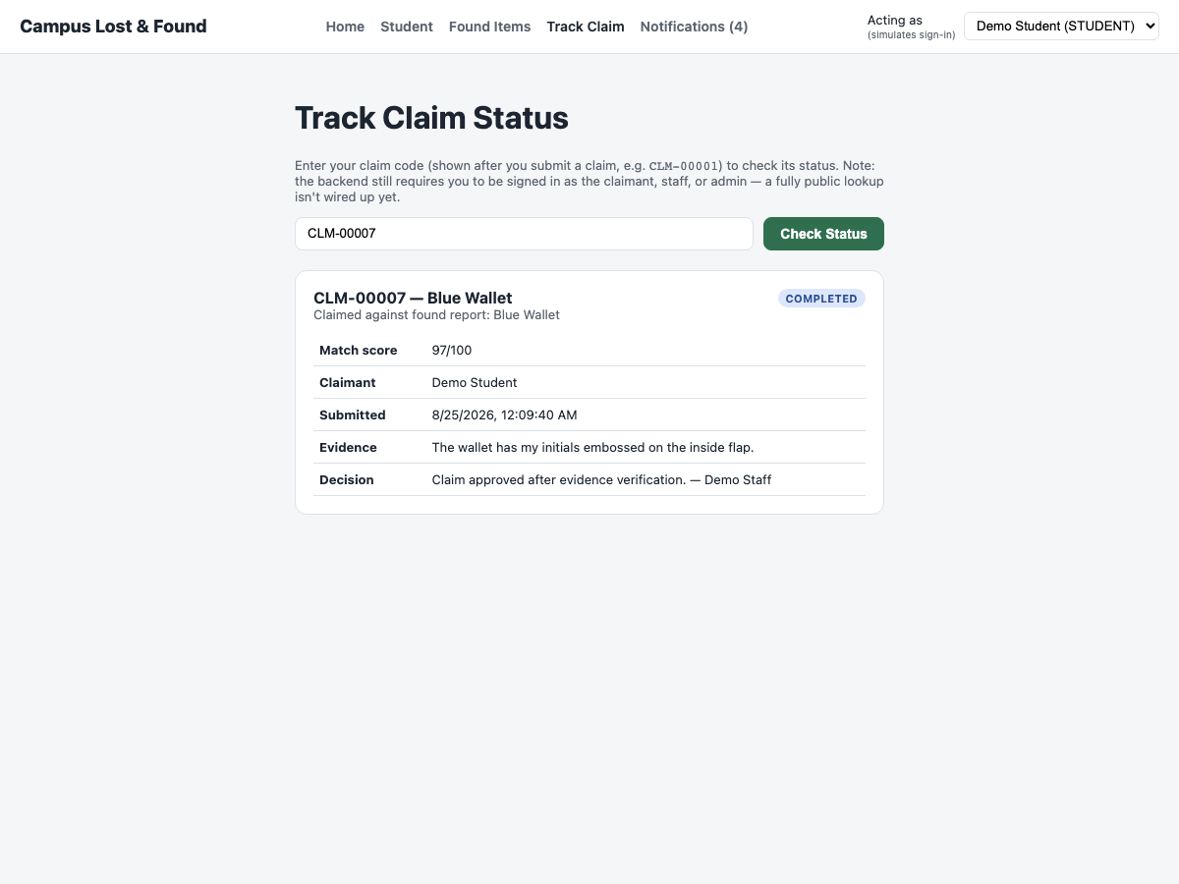

7.9 Audit Logging
Functional Requirement: FR5 — Audit Logging
Every report creation, claim submission, claim decision, and handover is written to an AuditLog table with the acting user and a timestamp, retrievable via GET /api/audit-logs (admin-only).


7.10 Role-Based Navigation
Functional Requirement: NFR3 — Security
The navigation bar and the /student and /staff routes adapt to the signed-in role: a student cannot reach the staff claims dashboard, and staff cannot reach the student's personal dashboard.


8. Summary
68 unit tests, 33 independent control-flow paths across 8 functions, 13 domain test cases, 7 integration scenarios, and a 10-part functional walkthrough were executed against the running system. All results matched expectations. The rule-based matching engine, claim decision logic, and handover eligibility check — the modules identified as highest-risk in the project proposal because of their branching complexity — are fully covered by both static analysis (CFG/DFG) and live, screenshot-based evidence from the running application.

