//========================EX2==============================//

//details//

Name:Meir Vizan

Id: 302860788

Name:Michael Peretz

Id:311597660

//Description//

A SIMPLE 6 COLORS FLOOD IT PUZZLE GAME

// object oriented design//

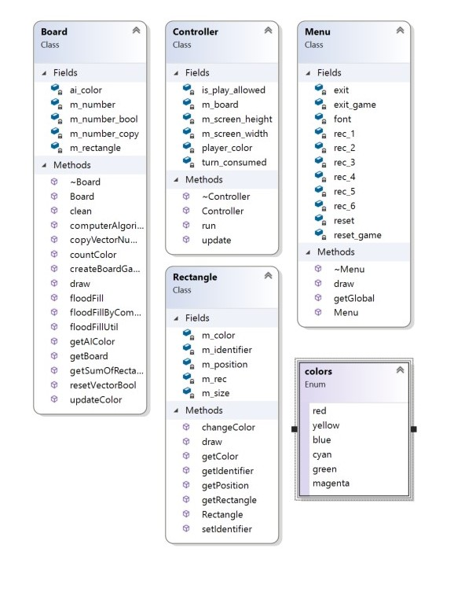//Files//

Controller.h

A class to run manipulate and manage

The main board object and UI elements

Board.h

A class that holds the data structures and algorithms needed for the game

Rectangle.h

A wrapper class for the rectangle class of sfml

Menu.h

A wrapper class for the available UI control buttons

//Data Structures//

Std::vector

Std::iterator

//Algorithms//

DFS recursion

//Bugs//

no bugs so far:)