*# 1.1*

numbers = [4, 8, 15, 16, 23, 42]

print(*numbers, sep=' ') 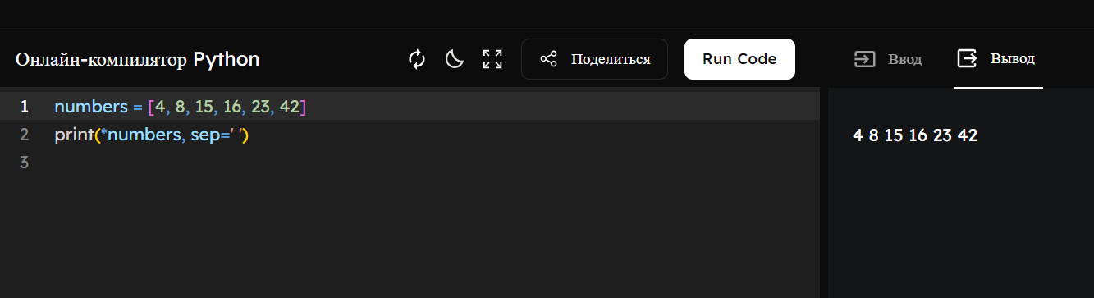

*# 1.2*

numbers = [4, 8, 15, 16, 23, 42]

for num in numbers:

*# 1.3*

first_number = int(input("Enter the first number: "))

print(first_number)

print(first_number + 1)

print(first_number + 2)

*# 1.4*

num1 = int(input("Enter the first number: "))

num2 = int(input("Enter the second number: "))

num3 = int(input("Enter the third number: "))

sum = num1 + num2 + num3

print(sum)

*# 1.5*

edge_length = int(input("Enter the edge length of the cube: "))

volume = edge_length ** 3

surface_area = 6 * edge_length ** 2

print("Volume =", volume)

print("Total surface area =", surface_area)

*# 2.1*

N = int(input("Enter the number of schoolchildren: "))

K = int(input("Enter the number of tangerines: "))

tangerines_per_student = K // N *# Integer division for whole tangerines*

remaining_tangerines = K % N *# Remainder after division*

print(tangerines_per_student)

print(remaining_tangerines)

*# 2.2*

number = int(input("Enter a four-digit number: "))

thousands_digit = number // 1000

hundreds_digit = (number % 1000) // 100

tens_digit = (number % 100) // 10

units_digit = number % 10

print(f"The digit in the thousands position is {thousands_digit}")

print(f"The digit in the hundreds position is {hundreds_digit}")

print(f"The digit in the tens position is {tens_digit}")

print(f"The digit in the units position is {units_digit}")

*# 2.3*

universe_population = int(input("Enter the population of the universe: "))

survivors = universe_population // 2

if universe_population % 2 != 0: *# Odd number, Thanos shows mercy*

survivors += 1

print(survivors)