**Project Report: Phone Builder**

Student:Yerkebay Meirzhan

Group:SE-2409

Github: https://github.com/Meirzhan1/Pattern.git

**1.Introduction**

In this assignment I should to create the system that show the building of the phone. And we need to use the pattern builder. The main object Phone and we know that phone has a several components like model, os, year of creation, screensize, color, storage. The goal of the project that to construct the different types of the phone step by step.

**2.Why we use Builder Pattern and Director?**

Because the **Builder** pattern organizes object construction into a set of steps.And Builder pattern is good for the readability and clean code. And we use the **Director** class because director class might be a good place to put various construction routines so you can reuse them across your program.

**3.Clean code**

I tried to use the principles of clean code like don’t repeating code, encapsulation. The construction of the phone written only in class Builder and don’t repeat anywhere. Every type of the phone has own constructing method in the Director.

**4.Results**

For the demonstrating the result I create the three types of the phone: Budget, Gaming, Foldable.

* Budget phone has a little storage and not a big screen size.
* Gaming phone constructor creates a gaming focused model with a big storage for the games. The new year of creation has a big screen size for the good playing games.
* Foldable phone constructor creates a foldable device with the middle storage.

Output of the program:

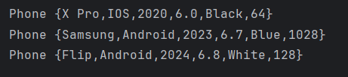

**5.Conclusion**

This assignment was very interesting and it is also good experience for using the builder pattern. After this assignment I understand the importance of the pattern builder. Why we use them and why we use the Director. Before I know about the Builder pattern my code was not very useful for the more creating object types. And now my code more clean and flexible.