Design and Implementation of a Context-Aware Tourist Guide System Incorporating Machine Learning Recommendations and Generative AI
Architecture and Diagrams

7.1 Purpose
This chapter presents a consistent set of three diagrams and an architectural description: the system context, the use cases and a draft component diagram. They are aligned with the requirements (Chapter 6) and the technology choices (Chapter 5). Editable sources (Graphviz DOT files) and exported images (PNG, SVG) are stored in the repository folder diagrams/. The component diagram is a draft and will be refined as implementation proceeds.

7.2 System Context Diagram
Figure 7.1 shows GeoGuide as one system with two human actors and three external services. The tourist provides photographs, questions, interests and settings and receives explanations, answers, notifications and recommendations. The content administrator supplies the verified places, knowledge-base passages and reference photographs on which both recognition and answers depend. The language-model provider receives only the question and the retrieved verified passages. The cloud landmark-detection API is used only as a baseline for evaluation and as a possible fallback. Mobile operating-system services provide position and geofence events and display notifications.
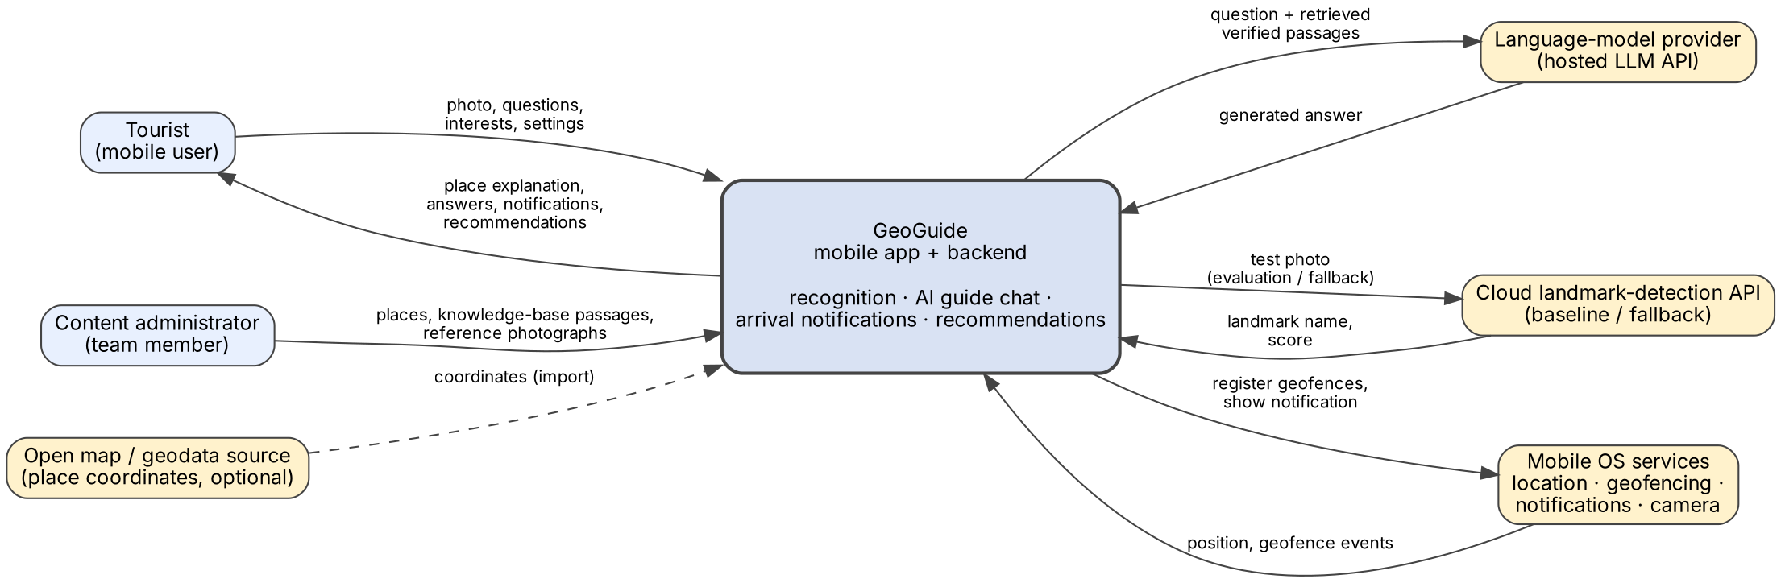
Figure 7.1 System context diagram
Table 7.1 External interfaces
External entity | Data exchanged | Constraint or risk
Tourist | Photos, questions, interests, settings; explanations, answers, notifications. | Photographs and location are personal data; handling must match the privacy text (NFR-02).
Content administrator | Places, passages with sources, reference photographs. | Content preparation effort; every passage needs a source (NFR-08).
Language-model provider | Question and retrieved passages out; generated answer in. | Availability, cost, data terms; replaceable behind an interface.
Cloud landmark-detection API | Test photograph out; landmark name and score in. | Baseline only; coverage of Kazakhstani landmarks unverified.
Mobile OS services | Position, geofence enter/exit events; notification display. | Limits on background location, 20 regions on iOS, latency of minutes (Chapter 5.9).
Open map / geodata source | Place coordinates (import). | Optional; coordinates are checked manually.

7.3 Use Case Diagram
Figure 7.2 shows the twelve use cases. "Handle low-confidence recognition" extends recognition, and "Ask AI guide" always includes retrieval of verified passages, which is the mechanism that keeps answers grounded. "Receive arrival notification" includes viewing the place details, which is the screen the notification opens.
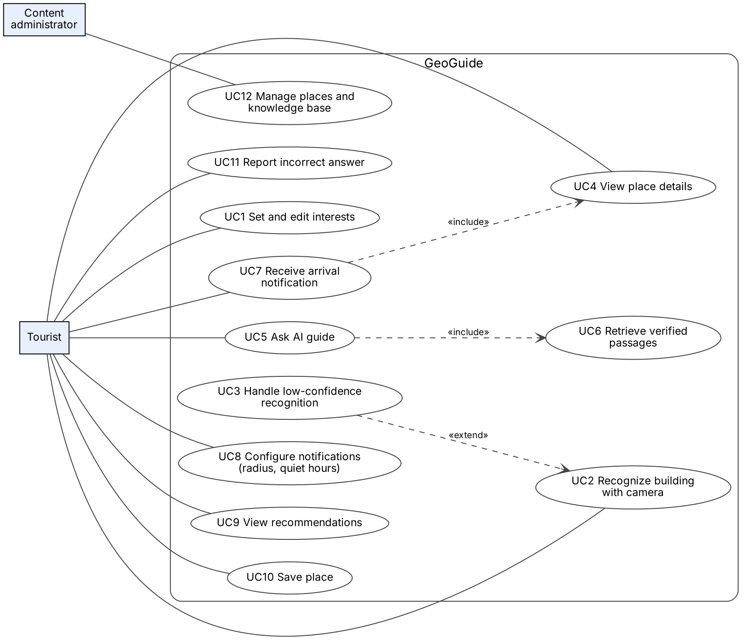
Figure 7.2 Use case diagram
Table 7.2 Use cases and requirements
Use case | Description | Requirements
UC1 | Choose and edit interests used for recommendations. | FR-11
UC2 | Photograph a building and receive candidates, name and explanation. | FR-01, FR-02, FR-04
UC3 | When confidence is low, offer retry, manual search and chat. | FR-03
UC4 | Open the place page with description, hours and facts. | FR-05
UC5 | Ask free-form questions about the current place. | FR-06, FR-07, FR-08
UC6 | Retrieve verified passages that support an answer (included in UC5). | FR-07, NFR-08
UC7 | Receive a notification on arrival and open the place page. | FR-09, NFR-09
UC8 | Set notification radius (100–500 m), quiet hours, on/off. | FR-10
UC9 | See recommended places with reasons. | FR-12
UC10 | Save and remove places. | FR-13
UC11 | Report an incorrect answer. | FR-15
UC12 | Add or correct places, passages and reference photographs. | FR-16

7.4 Component Diagram (Draft)
Figure 7.3 shows the draft decomposition into a mobile application, a backend, data stores and external services. The recognition service, knowledge retrieval and chat orchestrator are separate components so that each can be evaluated against a baseline. The chat orchestrator sends the language model only the question and retrieved passages and applies the grounding check and refusal rule before returning an answer. The geofence service in the mobile app keeps a small set of the nearest places registered with the operating system and opens the place page from a local notification, so arrival alerts do not depend on a server round trip.
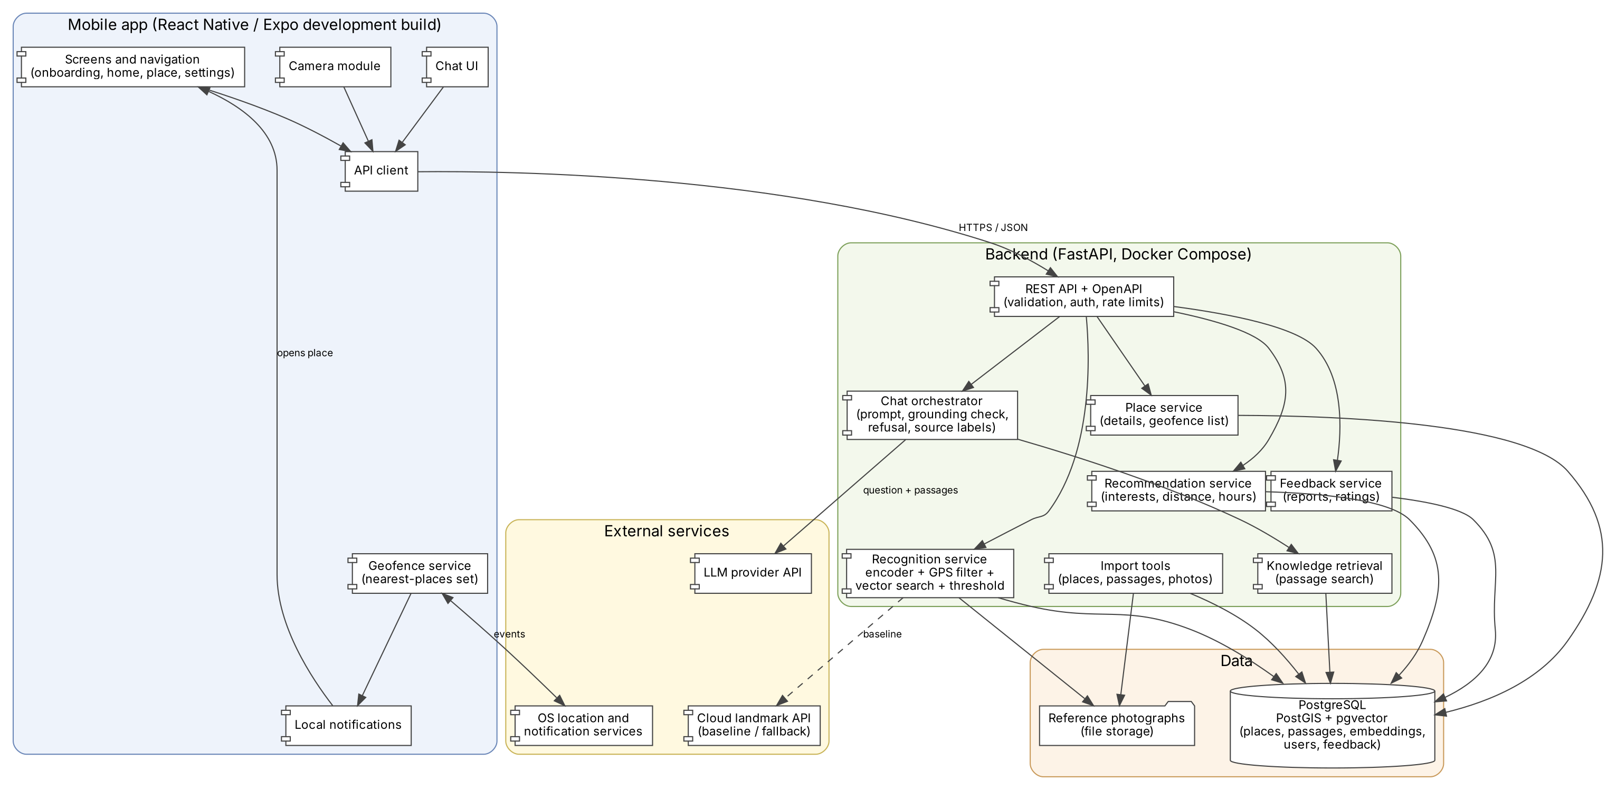
Figure 7.3 Component diagram (draft)

Table 7.3 Components and responsibilities
Component | Responsibility | Main requirements
Screens and navigation | Onboarding, home, place, settings, saved and profile screens. | FR-11, FR-13, FR-14, FR-17
Camera module | Capture or select a photograph and send it with position. | FR-01
Chat UI | Show conversation, source labels and report button. | FR-06, FR-08, FR-15
Geofence service | Register the nearest places (at most 20), refresh as the user moves, respect radius and quiet hours. | FR-09, FR-10, NFR-09
Local notifications | Display the arrival notification and open the place page. | FR-09
REST API | Validation, authentication, rate limits and OpenAPI documentation. | NFR-03, NFR-06
Recognition service | Compute image embedding, filter candidates by GPS, search reference embeddings, apply confidence threshold. | FR-01 to FR-03
Knowledge retrieval | Find the passages of the current place that match the question. | FR-07, NFR-08
Chat orchestrator | Build the prompt from retrieved passages, call the language model, check grounding, refuse when unsupported, attach sources. | FR-06 to FR-08, NFR-05
Recommendation service | Rank places by interests, distance and opening hours with a reason. | FR-12
Place service | Place details and the geofence list for the mobile app. | FR-04, FR-05
Feedback service | Store incorrect-answer reports and ratings. | FR-15
Import tools | Load places, passages and reference photographs from data files. | FR-16
PostgreSQL (PostGIS, pgvector) | Places, passages, embeddings, users, saved places, feedback. | NFR-02, NFR-08

7.5 Key Scenarios

Scenario A: recognize a building
- The tourist takes a photograph; the app sends it with the current position to the API.
- The recognition service selects the reference objects within a distance of the position, computes the image embedding and finds the nearest reference embeddings.
- If the best score is below the calibrated threshold, the API returns a "not recognized" result and the app shows retry, search and chat options.
- Otherwise the API returns up to three candidates with the place summary from the knowledge base; the tourist can open the place page or ask a question.

Scenario B: ask the AI guide
- The tourist writes a question; the app sends it with the place identifier.
- Knowledge retrieval returns the most relevant passages of that place.
- The chat orchestrator sends the question and passages to the language model and checks that the answer is supported by them.
- If the passages do not support an answer, the guide replies that no verified information is available; otherwise it returns the answer with its sources.

Scenario C: arrival notification
- After permission, the geofence service registers the nearest places with the operating system using the selected radius.
- When the device enters a radius, the operating system reports the event; outside quiet hours the app shows a local notification.
- Tapping the notification opens the place page; the tourist can start a chat from it.

7.6 Draft Data Model
Table 7.4 Main entities
Entity | Main attributes | Notes
place | id, name (en, ru, kk), category, coordinates, opening hours, summary, status | Spatial index (PostGIS)
passage | id, place id, language, text, source reference, verification date | Only passages with a source are served
reference_image | id, place id, file path, viewpoint, embedding | Vector index (pgvector)
user_profile | id, interests, language, notification settings | No location history stored
saved_place | user id, place id, time
feedback | id, place id, question, answer, report type, time | Reviewed by the administrator
evaluation_run | id, component, configuration, metrics, date | Supports reproducible evaluation

7.7 Architectural Decisions and Open Issues
- Recognition, retrieval and generation are separate components so each can be compared with a baseline (Chapter 9).
- Facts such as opening hours and coordinates come from stored data, not from the language model.
- Arrival notifications use operating-system geofencing with a dynamic nearest-places set because of platform limits (Chapter 5.9).
- Open: choice of embedding model, language-model provider, pilot object list and geofence refresh rule (Chapter 5.12).

7.8 Diagram Sources
File | Content
diagrams/01_system_context.dot, .png, .svg | System context diagram (editable DOT source and exports).
diagrams/02_use_case.dot, .png, .svg | Use case diagram.
diagrams/03_component_draft.dot, .png, .svg | Component diagram (draft).

