SYI Report ABB Robot

Introduction
The ABB robot subsystem is responsible for automated part handling and quality control at the end of the production line. Its main scope is to pick parts from a conveyor, position them under a camera for visual inspection, and coordinate with the vision system to determine product quality. After receiving an evaluation signal from the vision laptop, the robot returns faulty parts to the conveyor or places verified parts into storage. This subsystem serves as both the control and storage instance within the overall system, with primary objectives of executing reliable visual inspection, precise part movement, and preparing accepted parts for storage.

Subsystem Overview
The subsystem is composed of an ABB IRB 4400/60 industrial robot, a Basler camera for visual inspection, a Windows laptop running the inspection Python script, and a Beckhoff PLC for system control. The hardware components are arranged as illustrated in the following sketch, with all connection protocols indicated on the arrows.
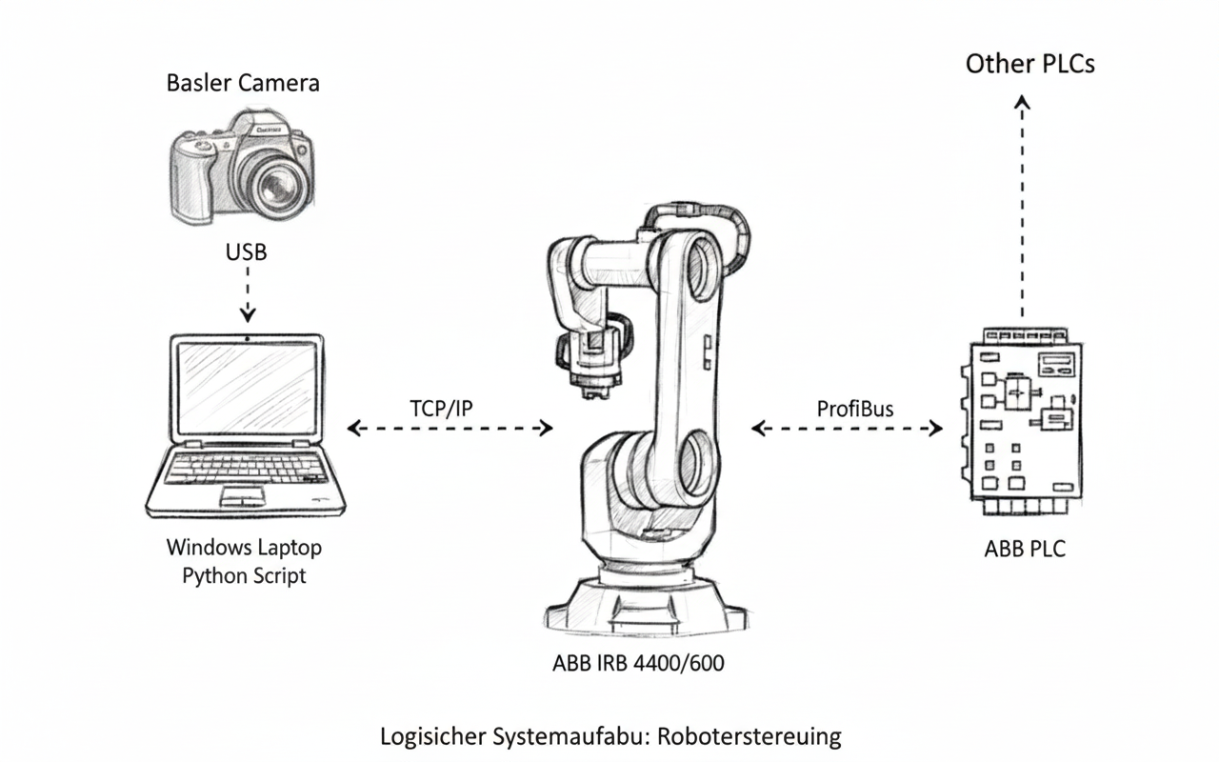
Figure 1 - ABB Subsystem overview sketch. Images are not replicas of the real system and act as a logical overview. (Source: Gemini banana nano)

The ABB PLC is connected to the other PLCs in the System. The ABB Robot waits for key signals form the PLC and uses the Python Script on the windows Laptop as a Tool to do the evaluation. The Python script acts as a server, handling every request the Client (Robot) has.

Implementation
This chapter outlines the realization of the ABB robot subsystem, detailing its primary communication methods, motion sequencing, and integrated vision system. Each subcomponent is described individually. The full code implementation is attached to this file.

Communication Interfaces
The subsystem relies on two primary communication links: TCP/IP over Ethernet between the ABB robot and the vision laptop, and Profibus between the ABB robot and the Beckhoff PLC. The vision laptop runs a Python script acting as a TCP server; the robot connects as a client at program start. After a quick initialization handshake, all further exchanges are event-driven. Commands are sent as simple strings (“ready”, “evaluate”, “complete”, “bad part”), triggering the needed actions. The server waits for evaluation requests from the robot, processes the camera image, and responds with the result. All exceptions and connection errors are handled as specified in the communication code. The code does not feature a timeout logic. The Profibus link to the Beckhoff PLC is used for major control signals such as system startup and part verification status. Communication is direct and relies on signal definitions on both sides, with no additional protocol layers.

Robot Motion
The Robot motion is controlled via a structured sequence, implemented in ABB RAPID. The Code features modular procedures for setup, execution, pause interrupts, and reset. The robot begins by moving to a home position and then opens the gripper. After that, it executes a pick-and-place operation to transfer a part from the conveyor to the camera for inspection. Major decisions such as when to start, pause, or reset are controlled by signals received from the PLC via Profibus, or can be triggered manually for testing. The process supports operation with or without PLC or vision system integration, configurable by constants. After inspection, motion logic routes the part either to storage (if verified) or back to the conveyor (if rejected), based on evaluation results from the vision system. The gripper is controlled with simple open/close logic; positioning safety is handled by specific robot movements. For part placement, the robot pushes objects into place to mitigate risk if the landing area is obstructed. The flowchart for the Robot motion is visible on the following graphic.
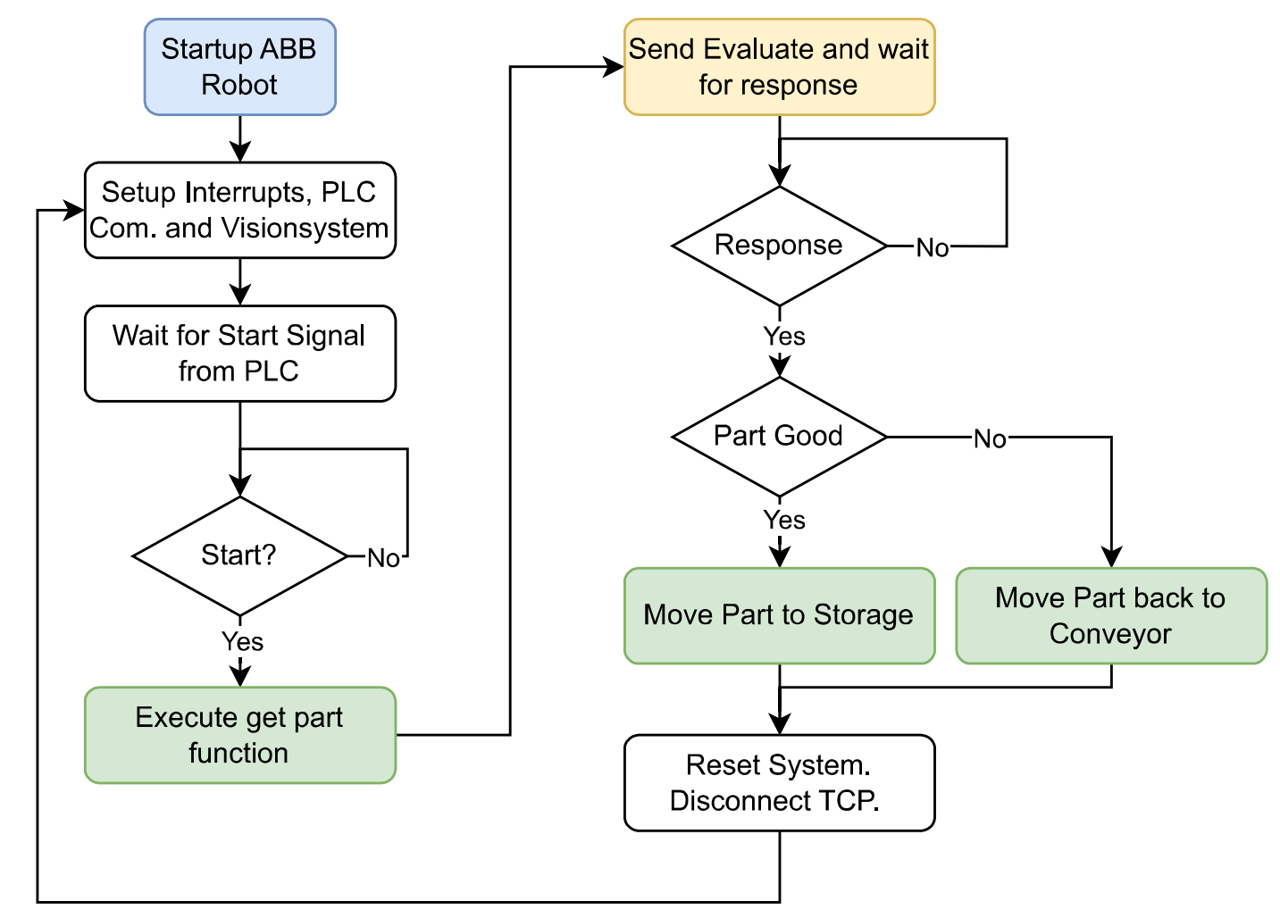
Figure 2 - Simplified flowchart of ABB Robot code

Vision System
The vision subsystem uses a Basler camera connected via USB to a Windows laptop. All image capturing and processing are performed using the python scripts on the laptop. The core solution consists of a supervised machine learning classification pipeline built on top of a ResNet18 model. It is pre-trained on ImageNet and fine-tuned for the project’s assembly verification task. For training, 902 labelled images were collected, and an additional 230 images were taken and reserved for validation. For the model, each sample was split into two regions of interest (ROI): top main and bottom main regions of the assembly. The classifier was trained to categorize each region into one of four classes: complete yellow, complete red, complete blue, and incomplete/mix. Both the training and evaluation pipelines involved cropping the ROIs using coordinates calibrated for the camera setup, followed by image preprocessing as needed for the model training. The final model got trained with an image resolution of 512x512, ignoring the original aspect ratio of the ROIs.

The final system runs a Python-based server on the laptop, waiting for TCP requests from the robot. When an “evaluate” command is received, the server captures the latest image from the Basler camera, extracts and preprocesses the relevant ROIs, and applies the trained model to classify them. If both regions are detected as complete and matching in colour, the part is accepted; otherwise, it is flagged as incomplete or mixed. The result is returned to the robot in real time as a simple string message. After tuning, model accuracy reached nearly 100% when using or testing it. Following the forceful and unauthorized removal of the camera, model accuracy fell by some unknown percentage, which could not be restored even when adjusting preprocessing and other source code. The solution leverages PyTorch for model inference, OpenCV for image handling, and pylon for camera integration. In the diagram below, the main code flow for the vision script is described.

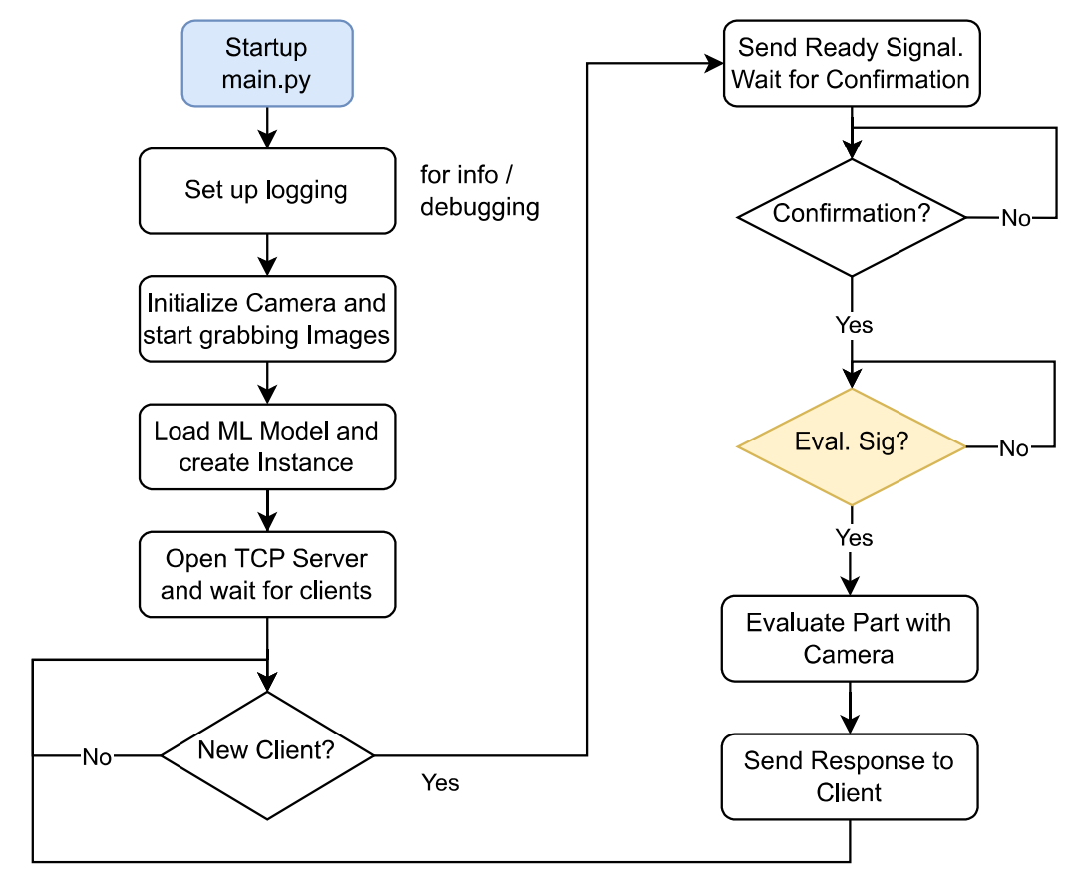
Figure 4 - Simplified flowchart of python vision script
Furthermore, the most relevant classes from the Vision Script are defined as presented in the graphic below.
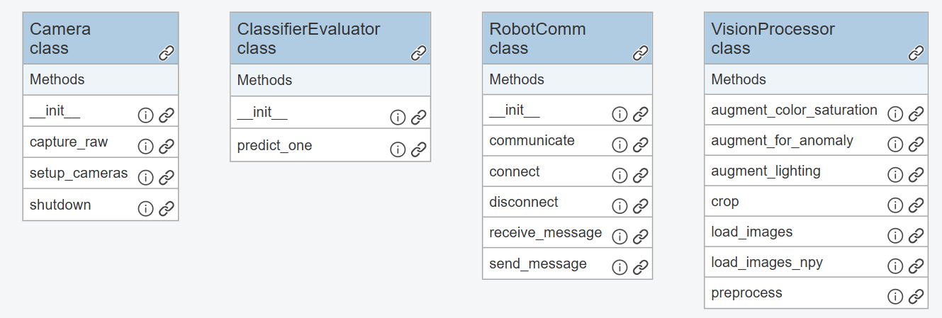
Figure 3 - Class diagram of most relevant python files

Integration & Testing
Subsystem components were integrated and tested iteratively. Robot positions and logic were taught and validated interactively using ABB teach pendant and Robot Studio. Vision system and Python socket code were developed, tested independently, and refined during lab operation. All code was versioned and backed up using GitHub for reliable change management. All code parts were tested separately (when possible), and with the full system to ensure proper functionality.

Results & Discussion
The subsystem achieved reliable pick-and-place handling, synchronized communication, and automated visual inspection. Classification accuracy reached nearly 100% before equipment changes, and core system functions operated as intended during lab testing. A main challenge was the drop in model performance after the camera was forcefully removed and reattached, which was not fully recoverable despite further adjustments. In general, training the supervised classifier is easy, but the results depend heavily on training data and correct preprocessing. Overall, the system proved robust for its primary tasks, with version-controlled code enabling effective troubleshooting and updates. A short video, presenting the subsystem without the other systems is available to check out here.

