Research Plan
1. Brief description of the subject and of the scientific and technological background
Synaptic transmission is a multi-step process mediated by fusion of synaptic vesicles and is regulated by many synaptic proteins ^{[1-5]}. Interestingly, changes in the levels of synaptic proteins alter specific steps in synaptic transmission, and affect synaptic plasticity processes ^{[6-8]} and animal behavior. Despite the extensive knowledge existing today regarding synaptic transmission, the molecular mechanisms of these processes and the exact link to synaptic plasticity are still unclear ^{[1,2,4,9]}. Moreover, our knowledge regarding the roles of these proteins in animal behavior is rather incomplete ^{[10-13]}. By manipulating proteins levels in sub-areas of the brain and by analyzing behavior in genetically modified mice, this proposal aims to study the role of specific synaptic proteins in synaptic physiology and animal behavior.
Tomosyn-1 is a syntaxin binding partner ^{[14]} that inhibits the vesicle maturation step called priming ^{[15-17]} and its distribution partly overlaps with that of syntaxin-1 in nerve terminals ^{[14]}. From the two known mammalian tomosyn genes that are expressed in the brain ^{[18,19]}, only Tomosyn-1’s function was studied. Tomosyn-1 is predicted to inhibit SNARE complex formation via its C-terminus coiled-coil SNARE domain and its N-terminus WD-40 repeats domain ^{[20-26]}. Overexpression of tomosyn causes a significant reduction in exocytosis and inhibition of synaptic transmission ^{[17,23,27-30]}. The role of the endogenous tomosyn is less clear as several studies yielded conflicting results. Tomosyn knockdown in superior cervical ganglion neurons reduced synaptic transmission ^{[27]} while in tomosyn-1 knockout (KO) mice synaptic transmission was enhanced ^{[26]}. The notion that tomosyn acts as a negative regulator of synaptic transmission is supported by a C. elegans tomosyn null mutant that showed increased levels of neurotransmitter release ^{[31-33]}. In light of the contradicting effects of tomosyn’s down regulation, it is important to perform a thorough study to elucidate the involvement of tomosyn in transmitter release and plasticity. We aim to determine how manipulations of tomosyn-1 and tomosyn-2 alter synaptic transmission at fast CNS mammalian synapses.
As shown in our preliminary studies, tomosyn is enriched in the mossy fibers (mf) area and the most pronounced decline in the levels of tomosyn following enriched environment treatment occurs in this area (Fig. 1). Moreover, overexpression of tomosyn in the mf terminals altered mice behavior. Synapses of mf to CA3 pyramidal cells (mf-CA3) exhibit pre-synaptic long-term potentiation and depression (LTP/LTD) ^{[34]}. In addition, protein kinase A (PKA) activation is required to trigger mf-LTP ^{[6,34-36]}, while PKA down-regulation likely underlies mf-LTD ^{[9]}. While PKA is believed to mediate these forms of plasticity by targeting pre-synaptic proteins of the transmitter release machinery, the identity of such proteins remains unclear ^{[37]}. Interestingly, tomosyn is phosphorylated by PKA ^{[27]} and this can release syntaxin from the complex with tomosyn and would build a larger pool of free syntaxin molecules that would be available to form SNARE complexes, enhancing priming and exocytosis. These findings make tomosyn a very promising candidate for modulating PKA-dependent synaptic plasticity or synaptic enhancement. Thus, we aim to investigate the contribution of PKA-dependent tomosyn-1 and tomoyn-2 phosphorylation to LTP/LTD. The knowledge regarding the roles of synaptic proteins in adult animals and especially in animal behavior is rather incomplete ^{[10-13]}, due to the difficulties to manipulate the genes in the brains of adult animals. We have recently developed a unique system to manipulate gene expression in specific sub-brain areas (Fig. 2), and we will use this experimental approach to investigate the involvement of tomosyn in animal behavior.
2. Objectives and expected significance of the research
Our long-term goal is to elucidate the role of tomosyn in synaptic transmission and plasticity and in learning and memory. Specifically, we will examine the physiological significance of tomosyn-1 and tomosyn-2 in basal synaptic transmission using quantitative electrophysiological measurements from cultured hippocampal neurons from tomosyn KO and control mice. Furthermore, we will test the hypothesis that tomosyn levels regulate learning and memory. Moreover, because mf-LTP and LTD are mediated via PKA ^{[6,34-36]} and that tomosyn’s activity is regulated by PKA ^{[27]}, it makes tomosyn a very promising candidate for modulating PKA-dependent synaptic plasticity at this synapse. We therefore aim to reveal how tomosyn-1 and tomosyn-2 phosphorylation affects synaptic transmission and PKA-dependent synaptic plasticity. Moving from single cells level to the effects of tomosyn phosphorylation on synaptic function in brain slices, up to the level of learning and memory in behaving animals, will facilitate our understanding of the mechanisms of LTP/LTD and learning and memory. Our ability to manipulate proteins levels in sub-areas of the brain and to elucidate the performance in behavioral tests of these genetically-modified animals will likely provide significant breakthroughs in the field of brain plasticity.
3. Preliminary Studies
A
B
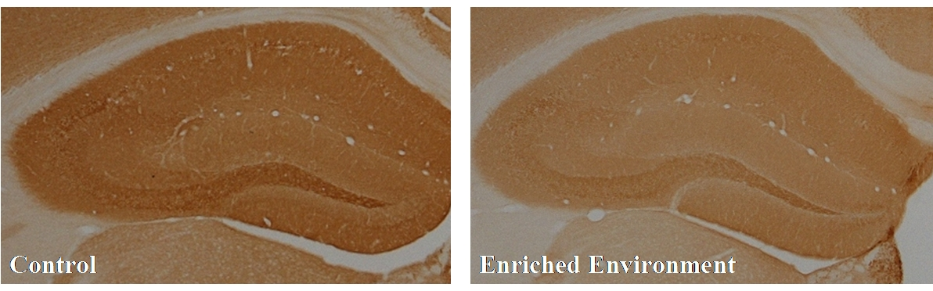
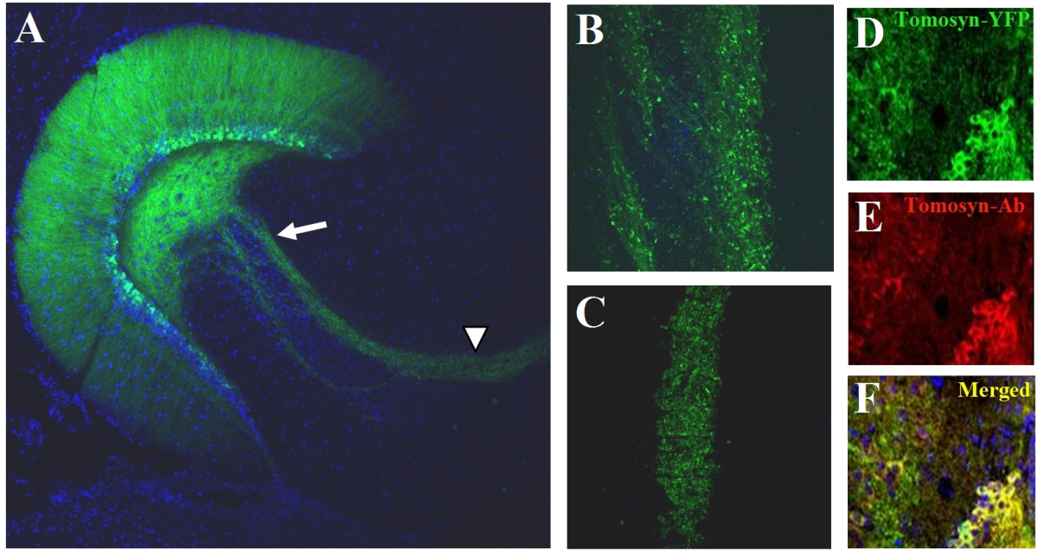
Tomosyn levels decrease following enriched environment treatment: The motivation for the present proposal came from our findings that tomosyn levels are reduced in the brains of mice that were exposed to an enriched environment (EE) treatment. In mice exposed to 8 weeks of EE, the level of tomosyn in the CA1 area, dentate gyrus (DG) and mossy fibers was significantly lower compared to the level in control mice. Since this treatment is known to improve synaptic plasticity and cognition ^{[38]}, we hypothesize that tomosyn's expression pattern and level are involved in learning and memory.
Figure 1. Tomosyn expression is reduced in mice subjected to enriched environment: Immunohistochemical staining of tomosyn protein in slices of mouse hippocampi. A) In control animals, the highest level of tomosyn expression occurs in the mossy fibers pathway (arrows). B) In animals subjected to enriched environment, tomosyn levels were significantly lower than in control animals, predominantly in the mossy fibers pathway. The same animals that were exposed to enriched environment showed an increase in the expression of various synaptic markers such as synaptophysin.
Long-term overexpression of tomosyn-1 specifically in the DG of the hippocampus improves learning and memory:
We implemented the lentivirus expression system to express (or knockdown) tomosyn in the hippocampus of mice ^{[39]}. To achieve this, we generated YFP-tomosyn coding third-generation lentiviruses and infused virus particles bi-laterally into the posterior and anterior DG area of P45 mice by stereotaxic injection. Slices obtained 2 weeks later showed that the majority of infected cells were granule cells of the DG and expression of tomosyn-1-YFP and staining with tomosyn antibody was detected in the mossy fibers’ terminals (Fig. 2).
Figure 2. Horizontal slice of mice hippocampus expressing tomosyn-1-YFP specifically at the DG neurons 2 weeks after lentivirus injection: Fluorescence images showing A) YFP fluorescence in the hilus, mf and the dentritic tree of the granular cells. Arrow and arrowhead: mf area enlarged in B and in C, respectively. D) Tomosyn-1-YFP expression in subset of granule cells in the DG. E) Anti tomosyn antibody. F) Co-localization of tomosyn-YFP and anti tomosyn antibody.
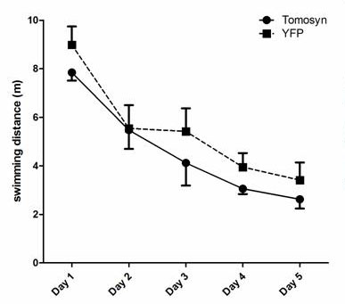
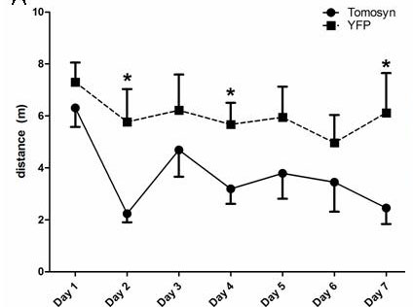
Behavior tests after lentivirus injection to the DG: 3 weeks after lentivirus injection, behavior tests were performed. During a 5 training days (4 swim trials/day) both tomosyn-1 and YFP overexpressing mice showed typical improvement learning curves (Fig. 3A). Tomosyn-1 overexpressing mice had the tendency to learn better, however this was not significant. We therefore suggested that if tomosyn-1 overexpressing mice learn better, a more stringent experiment composing of only two learning trials per day with new platform location, would accentuate tomosyn’s learning skills’ advantage. Thus, we performed an additional, reversed memory test, allowing only 2 trials per day for 7 days. During the training, tomosyn-1 overexpressing mice performed better than control mice. This improvement was reflected in a smaller total distance traveled to the hidden platform (Fig. 3B). More behavioral experiments as well as electrophysiological slice recording from these mice, as detailed in the current proposal, are needed to clarify and explain these results.
Figure 3. Tomosyn overexpressing mice performed better in Morris water maze:
A) Tomosyn-1 expressing mice swam shorter distance to the platform in 4 trials per day experiment. B) Same mice in a reversal experiment with 2 trials per day showed significant improved learning curves. No significant difference was measured in mean swimming speed (data not shown).
A
B
Tomosyn knockdown/overexpression in hippocampal cultured neuronal preparation:
We have established protocols for working with the hippocampal neurons plated on astrocytes grown on microdots (Fig. 4A) and measured synaptic transmission at 15-17 days in vitro based on previously published work ^{[8,40-45]} (Fig. 4B). Next we optimized the knockdown sequences and engineered 3 RNAi sequences that knocked down tomosyn levels by 70-80% (Fig. 4C) as determined by immunofluorescence (IF). The vector was designed to express short hairpin RNAs (shRNAs) capable of carrying out gene specific silencing sequences (i.e. tomosyn-1 and -2 or both). The plasmids expressed also GFP, enabling us to identify transfected cells according to their green fluorescence and perform the experiments on a single, infected-cell level. Infected neurons were found to be healthy and can be used for electrophysiological experiments. This system will be used in aim #1.
Figure 4. Hippocampal neuron electrophysiology and tomosyn-1+2 knockdown. A) Single neuron (arrow) on an astrocyte. B) Excitatory post-synaptic currents from hippocampal neuron. Bars: 1nA, 20ms. C) 3 different shRNA sequences (2-4) knockdown efficient, compared to scrambled sequence (1).
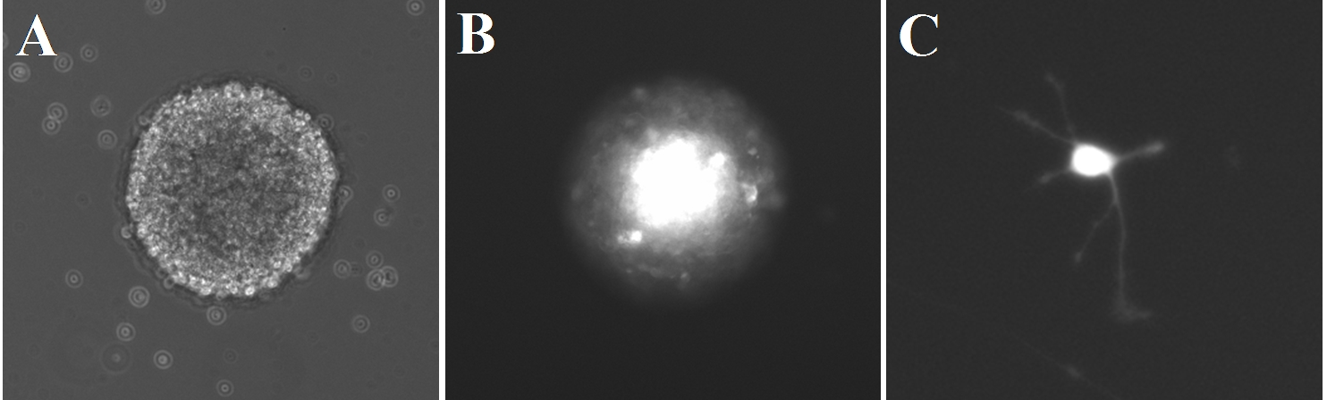
Tomosyn’s role in neurites’ elongation:
Figure 5. Neuronal progenitor cells system:
A) Bright-field image of neurosphere. B) Fluorescence image of a tomosyn-YFP infected neurosphere. C) Fluorescence image of differentiated neuron expressing tomosyn-YFP derived from the neurosphere in B.
Neurites’ elongation will be examined in cultured hippocampal neurons after lentivirus infection or with neurons derived from tomosyn KO mice. As the expression of tomosyn using lentivirus can take 1-2 days, and in order not to miss the first 1-2 days we will use an alternative system (Fig. 5). Neuronal progenitor cells from cortices of E11-E12 mice embryo were prepared and cultured in conditions that promote proliferation. These cells proliferate and form neurospheres (Fig. 5A). Then, we infected neurospheres with tomosyn-1-YFP lentivirus, and after several cycles of splitting most neurospheres expressed tomosyn-1-YFP (Fig. 5B). We then splitted the neurospheres and plated the cells in differentiating medium. All cells at that stage expressed tomosyn-1-YFP (or YFP), allowing us to track neurites’ extension at early stages of the neurons’ differentiation (Fig. 5C). These cells extended neurites, matured to a neuronal fate ^{[46,47]} and created neuronal networks, which are indistinguishable from those plated from newborn mice (not shown). We will use this system to follow the fluorescently labeled neurons and measure neurites’ length, number and branching.

  - Specific Aim #1: Identify the Physiological Roles of Tomosyn-1 and Tomosyn-2 in Hippocampal Neurons
4.1.1 Examining tomosyn’s involvement in neurites’ elongation
Tomosyn was suggested to inhibit axon elongation in neurons ^{[48]}. However, our preliminary results and the lack of morphological aberrations in the tomosyn KO animals do not support this finding ^{[26,32]}. Given the relevance that tomosyn could affect neurite growth, we will re-examine this hypothesis and utilize this information in the planning and interpreting the in-vitro and in-vivo experiments. We will overexpress tomosyn-1 or tomosyn-2 in hippocampal neuronal culture that will be plated at low density. Neurons will be infected with lentiviruses expressing tomosyn+XFP marker or expressing only XFP, and neurites’ length, number and branching will be compared in both experimental conditions. In addition we will compare neurite elongation of neurons derived from the tomosyn KO and wildtype mice. Finally, at 15-17 days in vitro (DIV) we will verify that similar neuronal networks are created in the different tomosyn manipulations by comparing the number and density of synapses in the cultures using FM dyes and various synapse markers like synaptophysin, piccolo and post synaptic markers like PSD-95.
Potential pitfalls: As the lentivirus-infected neurons start to express within 24-48 hrs after infection, we will miss the first 1-2 days of growth. The use of tomosyn KO mice will bypass part of this pitfall. In addition, we will use a novel system of neuronal progenitor cells differentiation ^{[46,47]}. This system allows tracking elongation in neurons expressing the gene of interest from the stage of neuronal progenitor cells during the differentiation and elongation ^{[46,47]} (see preliminary results section and Fig. 5 for more details).
4.1.2 The effect of tomosyn-1 and tomosyn-2 on synaptic transmission:
In this aim we will study the roles of tomosyn-1 and tomosyn-2 by overexpression, KO or knockdown strategies in autaptic hippocampal neurons and determine the effects on synaptic transmission and STP. Hippocampal neurons will be used to investigate tomosyn isoforms's effects on synaptic transmission in mammalian synapses that participate in processes like learning and memory. Using selective and appropriate pharmacological tools, and taking advantage that neuronal cultures contain both excitatory and inhibitory neurons, we will determine whether the effect of tomosyn-1 and tomoyn-2 on synaptic transmission differs between these types of neurons ^{[8]}. Neurons will be activated with several stimulation protocols to determine the number of fusion-competent vesicles using EPSC and sucrose application ^{[42]}, vesicular release probability, extent of paired-pulse facilitation and depression and replenishment kinetics ^{[8,41-45]}. We will examine if manipulating the expression levels of tomosyn isoforms in neurons alters these parameters. This system constitutes a very efficient experimental approach that we have been using for several years ^{[6,17,22,41,49-56]}.
Growing autaptic hippocampal neurons: Hippocampal neurons will be isolated from postnatal day 1 newborn mice (from tomosyn-1 KO mice or matched wildtype as control) and will be plated on astrocytes that were plated on microdots, as described elsewhere ^{[8,40-45]} (Preliminary results). Experiments will be performed at 15-17 days in vitro (DIV). Depending on the specific aim, experiments will be done following overexpression or knockdown of tomosyn-1 or tomosyn-2.
Overexpression of tomosyn: Hippocampal neurons grown on astrocytes that were plated on microdots will be infected 4-5 days before the measurements with lentivirus encoding the brain specific m-tomosyn-1 or m-tomosyn-2 isoforms ^{[41,49]}. The vector will also code for expression of GFP so that positively transfected cells can be confirmed microscopically ^{[41,49]}. The degree of overexpression will be quantified by retrospect-IF ^{[17},^{57]}.
Lentiviral constructs. We will prepare lentiviral constructs to express either full-length tomosyn-1 or tomosyn-2 encoding or shRNA sequences against tomosyn-1 or tomosyn-2. Tomosyn constructs are already in-hand ^{[46]} and were checked for their performances (see preliminary results). For a typical preparation, we will use titer of 2 x 10⁸ infection units (IU)/ml.
Given that changes in P_{r} can modify the mode of short-term synaptic plasticity from facilitation to depression, it is important to reveal how tomosyn-1 or tomosyn-2 changes P_{r} in neurons. Thus, we will calculate the vesicle release probability from the sucrose application experiments ^{[44]} and confirm it by analyzing the progressive block of NMDA receptor-mediated synaptic currents in the presence of the open-channel blocker MK-801 and by analyzing paired-pulse facilitation at different stimulation intervals.
To characterize the effect of tomosyn-1 or tomosyn-2 on short term plasticity, trains of up to 50 APs will be given at various stimulation frequencies (1-40 Hz) ^{[44,58-60]} and the synaptic depression kinetics, the level of depression and the recovery kinetics will be calculated ^{[59,60]}. All results will be correlated with tomosyn levels as will be reflected by IF ^{[17,57]}.
Outcome: The above set of experiments will provide the most quantitative information about the effect of tomosyn-1 or tomosyn-2 overexpression on neurotransmitter release from hippocampal neurons in vitro. In particular, we expect to pinpoint the exact step in the synaptic vesicle cycle in which tomosyn isoforms function. We expect to observe a statistically significant decrease in the above synaptic parameters in tomosyn-overexpressing neurons. These results will provide a framework for our behavior studies and the first information about the role of tomosyn-2 in synaptic transmission.
Potential Pitfalls: The degree of tomosyn overexpression may be different between cells. We will therefore quantify by retrospect-IF the level of tomosyn in the neurons that were used for the measurements ^{[57]}. Depending on the outcome of section 4.1.1, if we will found out that tomosyn affects neurite outgrowth, we will use Semliki Forest Virus (SFV) instead of the lentivirus and infect 5 hours before starting the measurements at 15-17 DIV. The SFV system provides an advantage as expression starts 5 hours post infection, bypassing any developmental effects on neurite elongation that might occur with the lentiviruses. In this case, we will ascertain that the protein distribution 5 hours post infection includes expression in the terminals (e.g. using FM dyes).
4.1.3 Investigating the role of endogenous tomosyn-1 and tomosyn-2 on synaptic transmission
To gain insight on the role of tomosyn-2 and to resolve between the conflicting reports about the role of tomosyn-1 ^{[26,27,30,32,33,61]}, we will first compare synaptic parameters (as described for tomosyn overexpression) between neurons derived from tomosyn-1 KO and control mice. Next we will knockdown tomosyn-2 on the background of neurons derived from tomosyn-1 KO mice and compare the parameters to those of KOs. We will also compare tomosyn-2 knockdown from wildtype neurons. In this way, we will explore for redundancy between tomosyn-1 and tomosyn-2 and identify the relative contribution of each of the isoforms. As tomosyn-1 knockdown and KO gave conflicting evidence ^{[26-27]}, we will compare between tomosyn-1 knockdown and tomosyn-1 KO.
Knocking down tomosyn: RNAi vectors were prepared to achieve simultaneous knockdown of tomosyn-1 and -2 or either knockdown of tomosyn-1 or tomosyn-2. The shRNA sequences were designed according to Reynolds' et al. algorithm ^{[62]} to have the highest probability of knockdown (Fig. 4C). The sequences are cloned into a lentivirus plasmid containing H1 promoter and also GFP as a marker and hippocampal cultures will be infected 5 days before measurements to allow sufficient silencing. As a control, we will infect cells with a construct containing scrambled tomosyn shRNA with GFP. Infected cells will be identified by expression of GFP, allowing us to perform experiments on a single cell level. The level of residual tomosyn levels will be quantified by IF.
Elucidating the specific effect of tomosyn knockdown on synaptic transmission: We will compare EPSC and IPSC amplitudes, readily releasable pool (RRP) size, refilling rate and P_{r} between control neurons and those in which tomosyn-1 or tomosyn-2 will be knocked down using similar protocols as in section 4.1.2.
Outcome: These experiments will clarify a long-lasting debate about the role for endogenous tomosyn-1. Moreover, it will provide the first information about tomosyn-2. Depending on time limitation we will perform rescue experiments, overexpressing various tomosyn mutants ^{[22]}, which will allow us identifying domains that are responsible for tomosyn effects ^{[22]}. These mutants are already cloned into plasmids and are ready to be examined.
4.2 Specific Aim #2: Tomosyn-mediated PKA-dependent synaptic-enhancement and pre-synaptic forms of plasticity in the hippocampus
Rationale: The cAMP/PKA signaling cascade facilitates neurotransmitter release at several excitatory and inhibitory CNS synapses. This facilitation is particularly robust at mf-CA3 synapses ^{[63]}, where phosphorylation of pre-synaptic protein(s) by PKA likely promotes a long-lasting enhancement of glutamate release ^{[63,64]}. The cAMP/PKA cascade also targets the release machinery at hippocampal inhibitory synapses ^{[65-67]}. The identity of the PKA target(s) mediating these actions remains elusive ^{[68]}. One of the leading candidates is RIM1α. Unexpectedly, the adenylyl cyclase activator forskolin induces normal facilitation in RIM1α-knockout mice ^{[6]}. Moreover, a knockin mice harboring a mutation in the PKA phosphorylation site of RIM1α suggests that phosphorylation of RIM1α at serine-413 by protein kinase A is not required for presynaptic long-term plasticity ^{[37]}. These results strongly suggest that other presynaptic protein mediates the forskolin-induced potentiation and long-term synaptic plasticity. Interestingly, forskolin treatment results in PKA-dependent phosphorylation of tomosyn at serine 724. This reduces tomosyn’s interaction with syntaxin ^{[27]} and can generate a larger pool of free syntaxin molecules that could enhance vesicle priming and exocytosis (but see ^{[26]}). These data make tomosyn a good candidate as a target of PKA. Using a combination of mutagenesis and PKA pharmacology, we will determine whether tomosyn participates in the PKA-dependent facilitation of transmitter release. mf-CA3 synapses also exhibit a PKA-dependent, pre-synaptic LTP/LTD ^{[34]}. As tomosyn is highly expressed in the mf area and its expression alters mice behavior, we will also examine the effect of tomosyn-1 and tomosyn-2 levels and the interaction with PKA, on long-term synaptic plasticity.

4.2.1 Testing the involvement of tomosyn in PKA-dependent synaptic enhancement
To test whether tomosyn is a necessary and sufficient mediator in the cAMP/PKA synaptic facilitation pathway, we will perform two sets of experiments in acute hippocampal slices: 1) Examine if the adenylyl cyclase activator forskolin and the phosphodiesterase-resistant PKA-activator Sp-8-Br-cAMPS, enhances excitatory and inhibitory synaptic transmission in slices derived from tomosyn-1 KO mice and in slices expressing the non-phosphorylatable tomosyn-1 mutant, tomosyn-1^{S724A}. 2) Investigate if a constitutively phosphorylated tomosyn-1 (tomosyn-1^{S724D}) may bypass and occlude PKA-mediated synaptic enhancement. Both mutants are available and all experiments will be performed on the background of tomosyn-1 KO mice.
4.2.1.1 Is tomosyn-1 necessary to induce enhancement by PKA?
Here, we will investigate the effects of knocking out tomosyn on PKA-induced enhancement of mf-CA3 synaptic transmission.
Electrophysiological measurements will be performed on hippocampal slices obtained from 1-month old KO mice. Hippocampi will be dissected and after at least 1 hour, slices will be transferred to a submerged recording chamber where they will be maintained at 25º_{C} under oxygen perfusion.
Slices obtained from KO or control mice will be stimulated at the mf-CA3 pathway: Whole-cell recordings of CA3 pyramidal cells will be obtained using standard techniques ^{[6,69,70]}. The baseline stimulation frequency will be 0.05 Hz. To confirm that post-synaptic responses resulted from monosynaptic mossy fibers input, we will use previously developed criteria ^{[34,35,71]} (i.e., fast rise time, short delay, robust frequency facilitation, and large paired-pulse facilitation and group II mGluR sensitivity).
EPSCs will be measured before, during, and after bath application of forskolin (10 µM for 15 min) or Sp-8-Br-cAMPS (100-300 μM). These activators of the cAMP/PKA signaling cascade cause a massive, long-lasting enhancement of glutamate release at mf synapses ^{[6,63]}.
In the second set of experiments, we will investigate if forskolin and/or Sp-8-Br-cAMPS induce synaptic enhancement in neurons expressing the non-phosphorylatable mutant tomosyn^{S724A [27]}. Experiments will be done on slices that overexpress tomosyn^{S724A} on the background of tomosyn-1 KO animals. Briefly, viruses expressing tomosyn^{S724A} and XFP will be prepared and intracranially injected into the DG of 1-month old tomosyn-1 KO mice (as shown in Fig. 2). As a control, we will infect with lentivirus carrying only XFP. Acute hippocampal slices from these mice will be prepared 2 weeks following the injection and used for electrophysiological measurements.
We hypothesize that if phosphorylation of tomosyn by PKA plays a major role in this PKA-dependent enhancement, forskolin should not have a significant effect on synaptic transmission in tomosyn^{S724A} expressing synapses or in tomosyn KO mice.
4.2.1.2 Is tomosyn phosphorylation by PKA sufficient to induce synaptic-enhancement?
To learn if phosphorylation of tomosyn causes synaptic-enhancement similar to that induced with PKA activation, we will overexpress tomosyn^{S724D} in the mouse brain. This will be done on the background of tomosyn-1 KO mice and achieved by lentiviral expression of tomosyn^{S724D} as described for tomosyn^{S724A}. Specifically, we will compare the degree of synaptic enhancement following application of PKA activators between slices expressing tomosyn^{S724D} and slices expressing wildtype tomosyn derived from KO mice (or slices derived from KO mice). If tomosyn phosphorylation is sufficient for induction of synaptic-enhancement, overexpressing tomosyn^{S724D} will at least partially occlude forskolin-mediated potentiation.
Outcomes: These experiments will guide our future directions in the search for potential PKA targets and will assist in solving potential obstacles in the LTP experiments in section 4.2.2.
Potential Pitfalls and Alternatives: Due to its constitutively active state, tomosyn^{S724D} might also potentiate basal levels of synaptic transmission. Thus, we will assess any changes in the basal levels of synaptic transmission by measuring 1) the paired-pulse ratio at a series of inter-stimulus intervals, 2) coefficient of variation, 3) the ratio of fiber volley to the EPSP slope over a range of fiber volley sizes, and 4) the rate at which MK-801 blocks mf transmission ^{[6]}. Similar experiments will be performed following knockdown of tomosyn-2 in the DG (following stereotaxic lentivirus injection) to elucidate the contribution of tomosyn-2 to these processes.
4.2.2 Does tomosyn modulate mossy fiber LTP/LTD?
Rationale: Our preliminary studies suggest an important role for tomosyn in learning and memory processes, and one possibility is that tomosyn effects presynaptic mf-CA3 LTP/LTD ^{[34]}. Since these processes depend on cAMP/PKA ^{[6,51,72]}, this region constitutes an excellent model system for studying the exciting possibility that tomosyn levels affect plasticity. While mf-LTP in tomosyn-1 seems to be normal in KO mice ^{[26]}, redundancy and compensatory adjustments could account for this phenotype. Our main objective is to examine the effects of overexpression of tomosyn-1 or the tomosyn-1 phospho-mutant on LTP/LTD from acute hippocampal slices.
Methods: We will compare the magnitude of mf-CA3 LTP/LTD in control animals, KO animals and animals pre-expressing constitutively phosphorylated tomosyn-1. We will also examine the effect of tomosyn-2 knockdown in the DG area following in vivo lentivirus injection. Baseline stimulation frequency will be 0.05 Hz for all experiments. We will stimulate mf using standard mf-LTP and mf-LTD induction protocols ^{[6]}. mf-LTP will be induced by tetanic stimulation including 2 trains (20s interval) each containing 125 pulses at 25 Hz in presence of 50 µM D-APV. mf-LTD will be induced by a stimulating train of 900 pulses at 1 Hz ^{[6,51]}. We will also assess potential changes in basal synaptic transmission induced by any of these treatments ^{[6]}. Finally, we will confirm the level of overexpression by IF.
To learn about the effect of phospho-mutants, tomosyn-1^{S724D} and tomosyn-1^{S724A} will be prepared and intracranially injected into the DG of 1-month old tomosyn-1 KO mice, as described in the preliminary studies (Fig. 2). As a control, we will infect with lentivirus carrying only XFP. Acute hippocampal slices from these mice will be prepared 2 weeks following the injection and used for electrophysiological measurements. Finally, we will perform similar experiments following silencing of tomosyn-2 using similar protocols as were described above.
Outcomes: If phosphorylation of tomosyn is necessary and sufficient to induce mf-LTP, overexpression of the constitutively phosphorylated tomosyn^{S724D} will substantially occlude mf-LTP and prevent induction of mf-LTD. If our expectation of mf-LTP occlusion is correct, we would expect corresponding changes in basal synaptic transmission (described above), reflecting an increased release probability. Identifying a major role for tomosyn-1 or tomosyn-2 in these forms of synaptic plasticity will help resolve important questions raised by previous studies and it may identify a direct link between PKA and changes in release machinery. Finding a selective blockade of mf-LTD in this mutant may also explain the anomalous enhancement of mf-LTD in the RIM1α KO mouse ^{[6]}.
Potential Pitfalls: Following overexpression, higher levels of tomosyn were found in the dendtritic tree of the DG neurons (in addition to high levels in the mf terminals (Fig. 2). Recent publications suggest that insertion of AMPA-R and NMDA-R, which are necessary for LTP, are inhibited by a SNARE dependent mechanism post synaptically ^{[70]}. It is therefore possible that tomosyn might inhibit LTP postsynaptically in the perforated path-DG synapses by inhibiting AMPA-R/NMDA-R insertion. We will directly examine this possibility by measuring LTP in the perforated path-DG synapses from tomosy-1 or tomosyn-2 manipulated mice. This might show a new and exciting role for tomosyn as a post-synaptic regulator of AMPA-R insertion.
4.3. Specific Aim # 3: Involvement of tomosyn-1 and tomosyn-2 in learning and memory
Our preliminary results suggest a possible role for tomosyn in modifying learning and memory (see preliminary results Fig. 1 and Fig. 3). We have therefore designed experiments to directly determine whether tomosyn-1 and tomosyn-2 affect learning and memory ability in adult mice.
We will compare mice behavior between tomosyn-1 KO mice and following manipulation of tomosyn-1 and tomosyn-2 levels using lentivirus injections. The proteins will be either overexpressed of knockdown using the lentivirus stereotaxic injection system. The use of high viral titers together with double injections (to the anterior and posterior of each hippocampus) will ensure high level of infection of hippocampal neurons. All of the manipulations will be done on 1-month old male C57BL/6 or tomosyn-1 KO mice using stereotaxic surgery methods as described in previous sections ^{[39,73,74]}. We have shown that this array of injections covers most part of the hippocampus and more importantly, induces behavioral changes that are specific for tomosyn-1 and not for the injection or viral expression. Mice will be used for behavioral tests 2-3 weeks after the injections. At the end of the behavioral tests, hippocampal sections will be prepared for Western blot or will be immunostained with an antibody against tomosyn to establish the efficacy of the overexpression or knockdown. This will be assessed for each individual mouse and a correlation of behavioral performance and changes in tomosyn levels will be made. To learn about the role of tomosyn-1 phosphorylation, we will overexpress the phospho-mutants in tomosyn-1 KO mice.
Behavioral tests. We will perform several behavioral tests to examine both hippocampal and non-hippocampal dependent effects of tomosyn manipulations and also examine non-cognitive effects. This will include Morris water maze, Rotarod, Open field exploration, Fear condition, Novel object recognition and Barnes maze test ^{[75-79]}. The experiments will be done using the established protocols ^{[75-79]} and a minimum of 15 animals will be used for each group. Depending on the outcome of these experiments we will change the experimental protocol or perform more stringent tests to accentuate tomosyn’s learning skills’ advantage (see preliminary results Fig. 3B).
Outcome: Although we assume that tomosyn is a negative regulator of hippocampal synaptic transmission, it is almost impossible to predict how manipulations of tomosyn-1 or tomosyn-2 levels will alter animal’s behavior, especially in light of our preliminary findings that tomosyn overexpression improves learning abilities. The behavioral data obtained in these experiments will be considered in light of the electrophysiological data obtained in specific aims 1 and 2, in order to establish the function of tomosyn in synaptic plasticity and learning and memory.
Potential Pitfalls: To ensure specificity of tomosyn overexpression is specific neurons and if time limitation allows, we will use specific promoters for glutamatergic neurons or for inhibitory neurons (CamKII and GAD67 promoters ^{[80-82]}, respectively). If we find in section 4.1.1 that tomosyn-1 or tomosyn-2 alter neurite elongation, we will perform stereological electron microscopy ^{[83]} to examine changes in synapses type and number, and interpretation of the results will be done accordingly.

5. Available resources: In Israel a Ph.D. student, a postdoc and the PI will perform the research work. The equipment in the Israeli lab includes: two electrophysiological setups and all devices for molecular biology, biochemistry, cell culture and facility to produce viruses. Animal facility, an animal approval certificate (L-08-021), a new behavioral facility and interdepartmental equipment are available too. In USA a postdoc and the PI will perform the research work. The equipment in the American lab includes: fully equipped electrophysiological setup for slice recording, and all devices for molecular biology, biochemistry and cell culture. Machine shops, animal houses, ultracentrifuges and offices are also available for the two labs.

