TRAVEL AGENCY

Submitted as Mini Project for Special Topics: Programming with C++ Semester III

BACHELOR OF TECHNOLOGY

in

Computer Science and Engineering

MEISHTY PANDE

PES1201700224

SAMPREETHA V

PES1201701542

Under Guidance of

Prof. Jamuna S Murthy

BE (CSE), M.Tech (SSE)

Assistant Professor

Aug 2018- Dec 2018

Department of Computer Science and Engineering

PES UNIVERSITY

Outer Ring Rd, Banashankari 3rd Stage, Banashankari, Bengaluru, Karnataka 560085

www.pes.edu

TRAVEL AGENCY

Research Focus: Object Oriented Programming in C++

ReadMe

TRAVEL AGENCY

The project is based on C++ Trip advising.

This program features hotel booking and transport reservation.

The first page is the homepage with a please wait message. The second is an animation of Travel India on the screen.

The program consists of menu with options:  
1.View tourist places  
2.Reserve accomodation  
3.Reserve transportation  
4.View Records   
5.Exit

1.For the first option selected, user will get the page where he can choose among the particular part of INDIA. This is followed by the page listing out all the states available in that particular package selected.

2.When the user moves forward with the reserve accomodation, the user is given the options to choose the hotels available along with their per night tarrif mentioned.It can either be a normal hotel or a star hotel.Only Breakfast is provided. The user is again asked to fill the details , such as username, destination, name of the hotel, no. of days to stay, a deluxe room or a non-deluxe room. The following page asks to pay the amount and the reservation is booked.

3.When the user moves forward with the reserve transport, the user is again get to choose by air, train or by road. Then the user is again asked to fill the details like username, from address, destination , mode of transport, type of ticket,etc.The following page displays the amount to be paid for the ticket confirmation.

4.In the view records page, data about user’s previous actions are stored.The user get to search, edit and delete the previous actions if interested. If user gives the username, it provides the previous records of the user, if there is any. The username should be given as it was given during reservation and it is case sensitive.

5.Once the action is completed, the user is given the option to quit or perform an action again.

#WELCOME PAGE

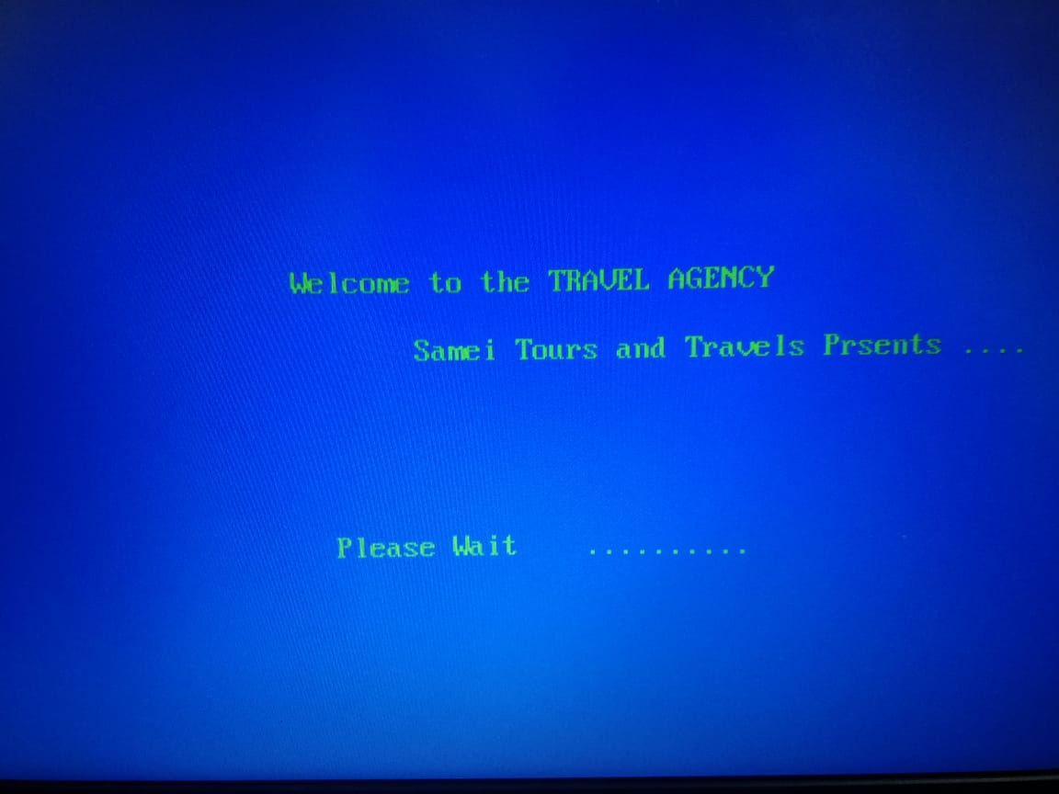

#TRAVEL INDIA ANIMATION

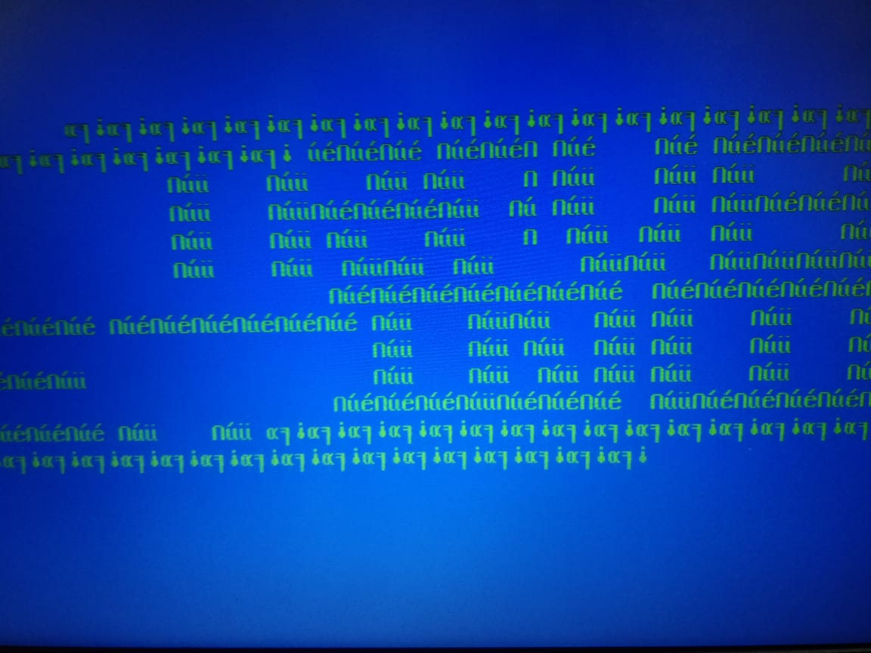

#WELCOME PAGE

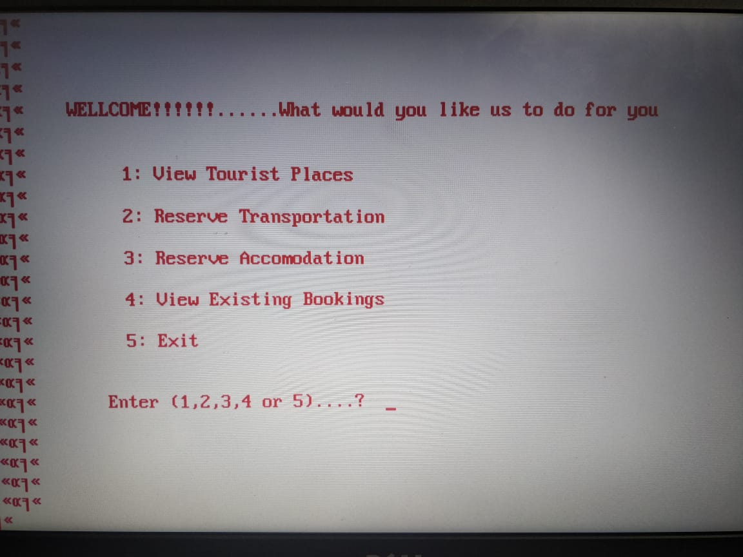

#PACKAGES AVAILABLE

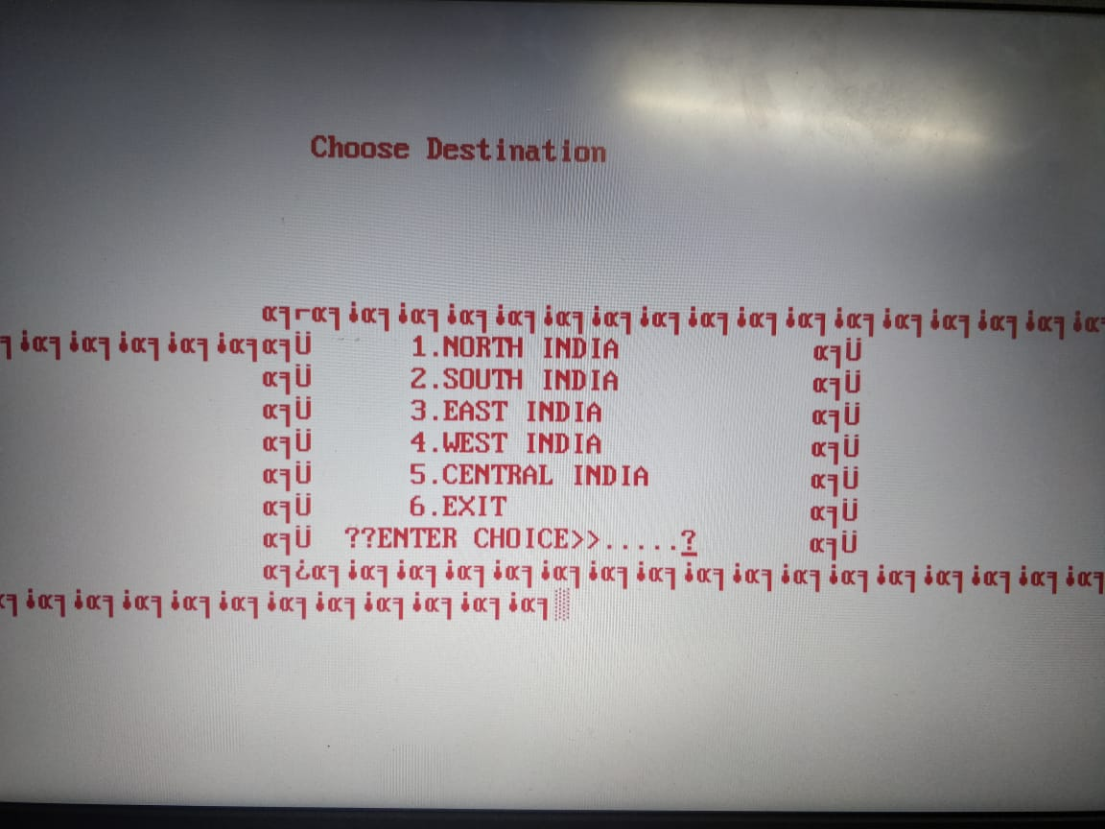

#DESTINATIONS AVAILABLE

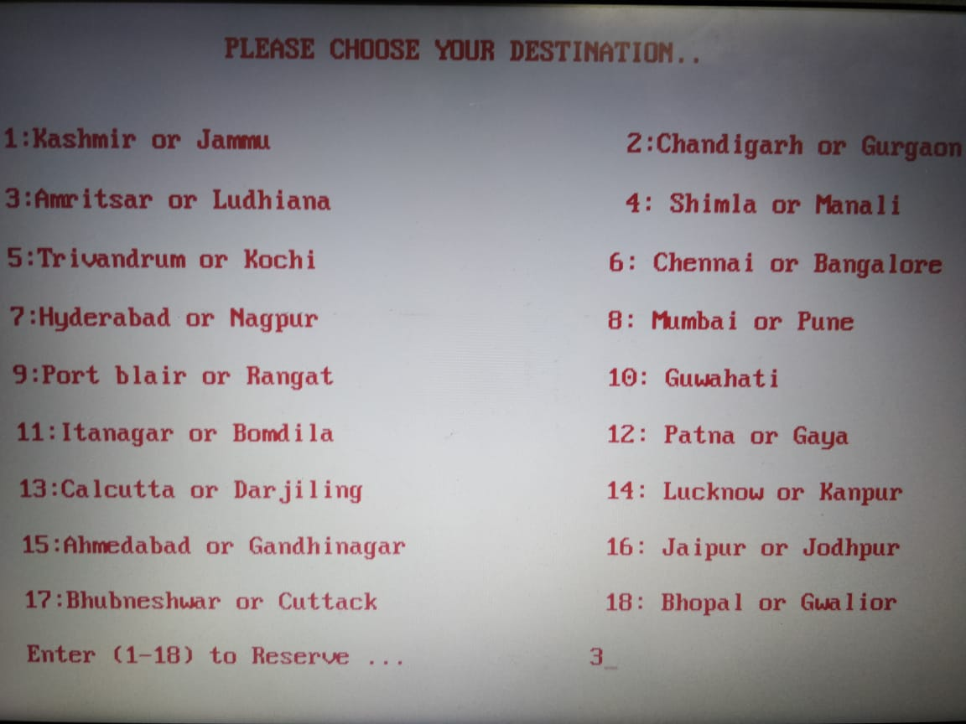

#PLACES TO VISIT

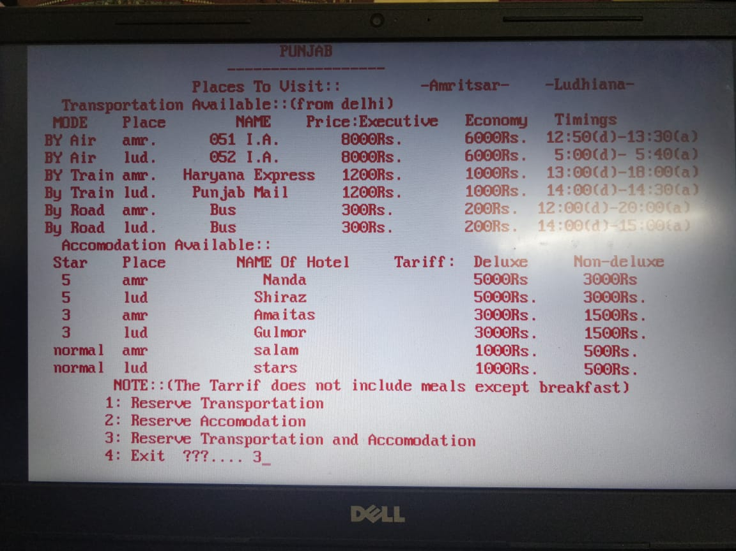

#DETAILS REQUIRED FOR HOTEL ACCOMODATION

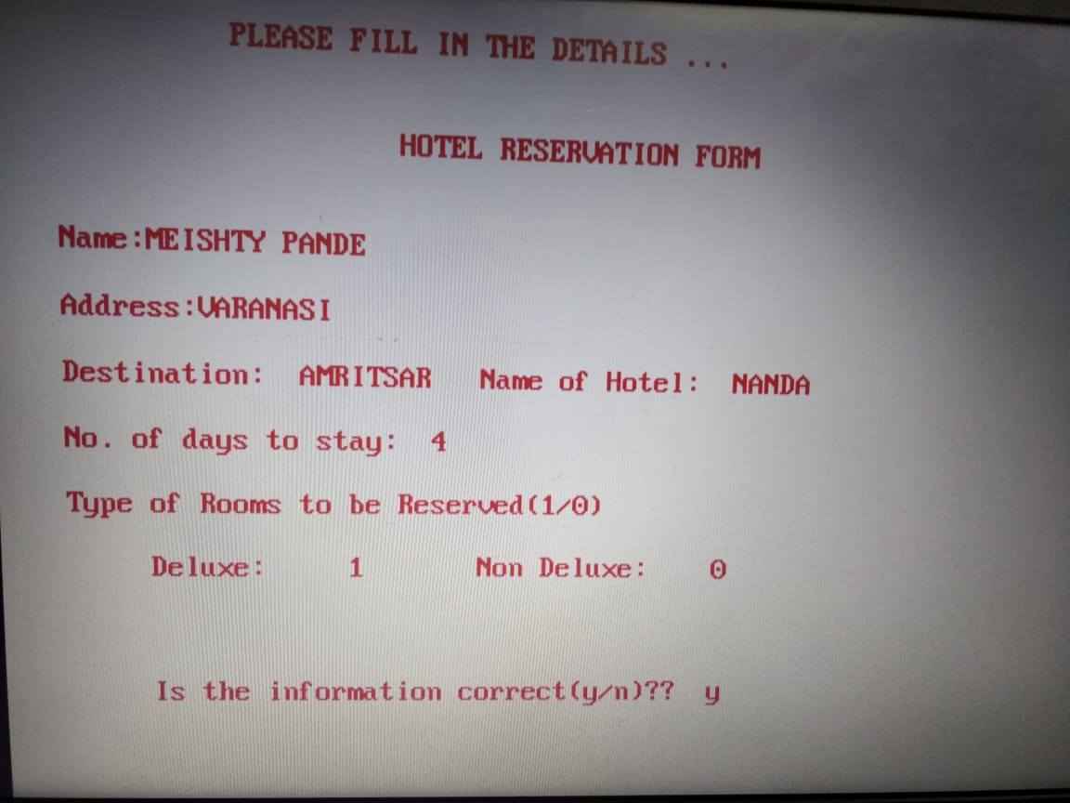

#PAID CONFIRMATION

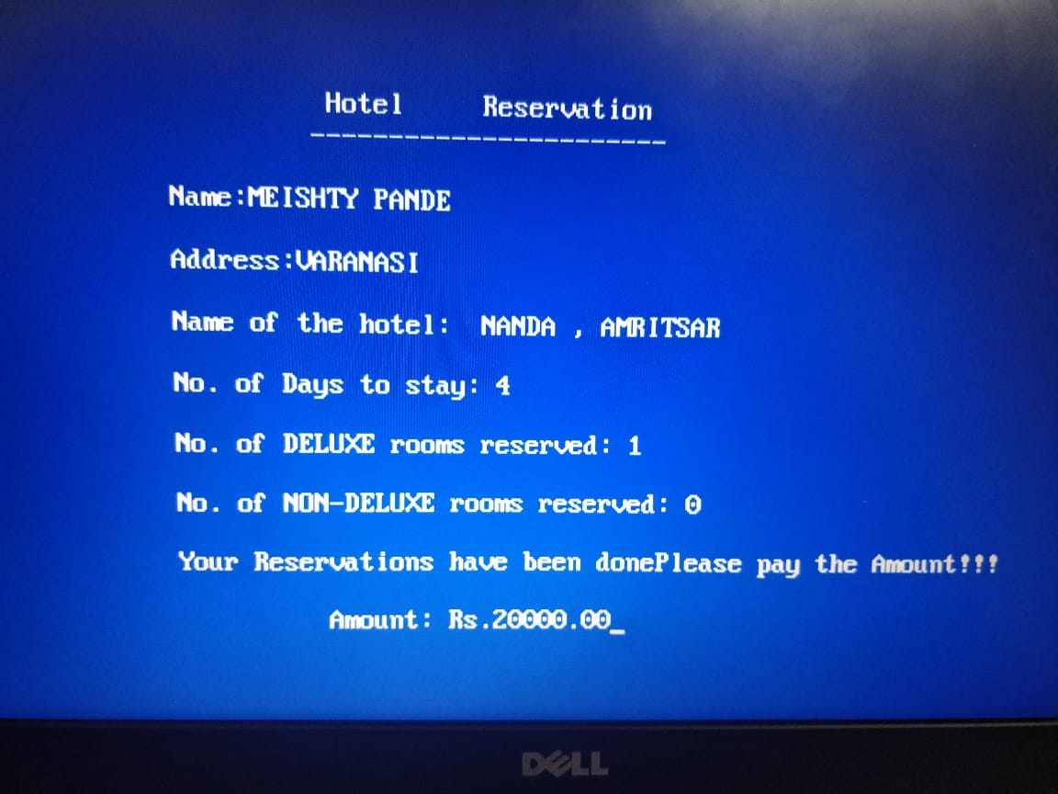

#MODE OF TRANSPORTATION

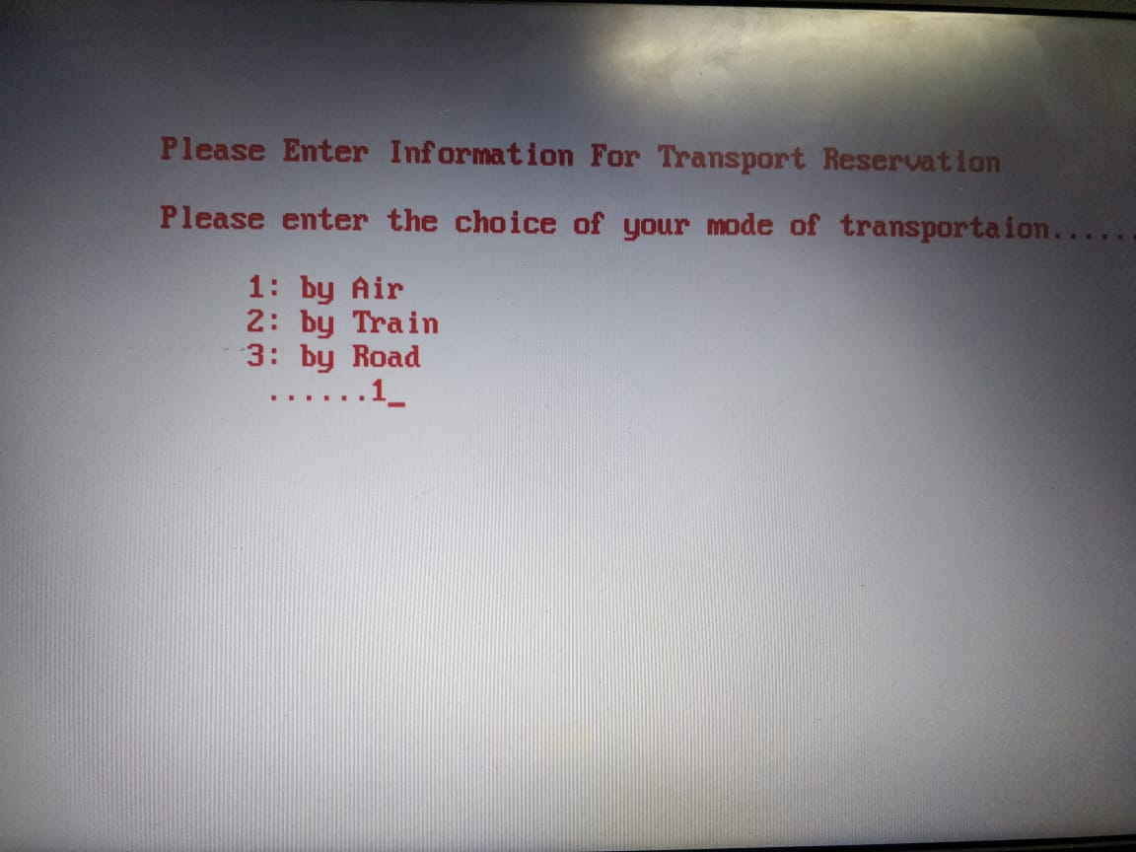

#DETAILS REQUIRED

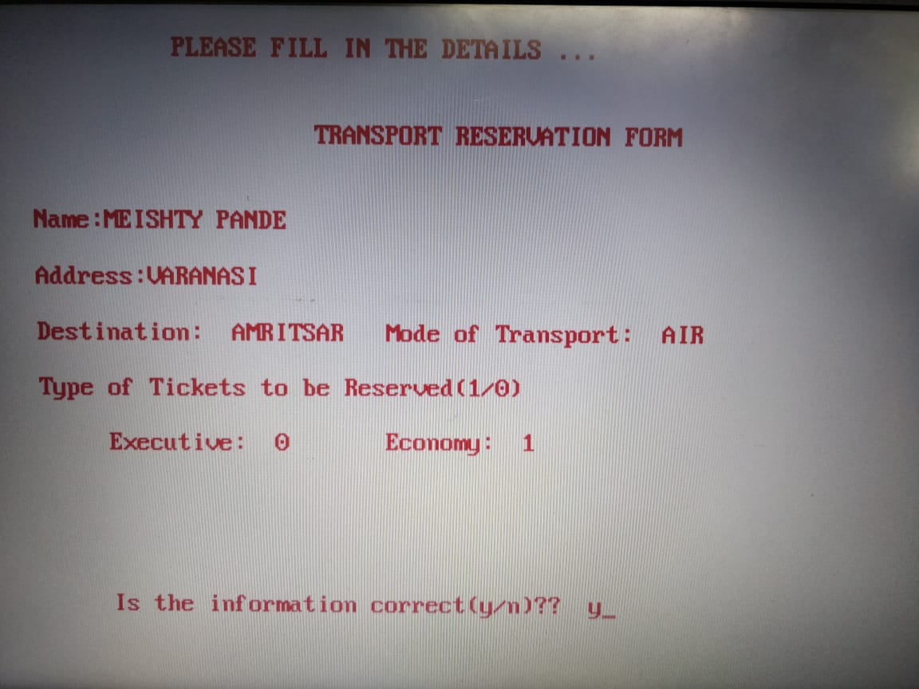

#AMOUNT TO BE PAID

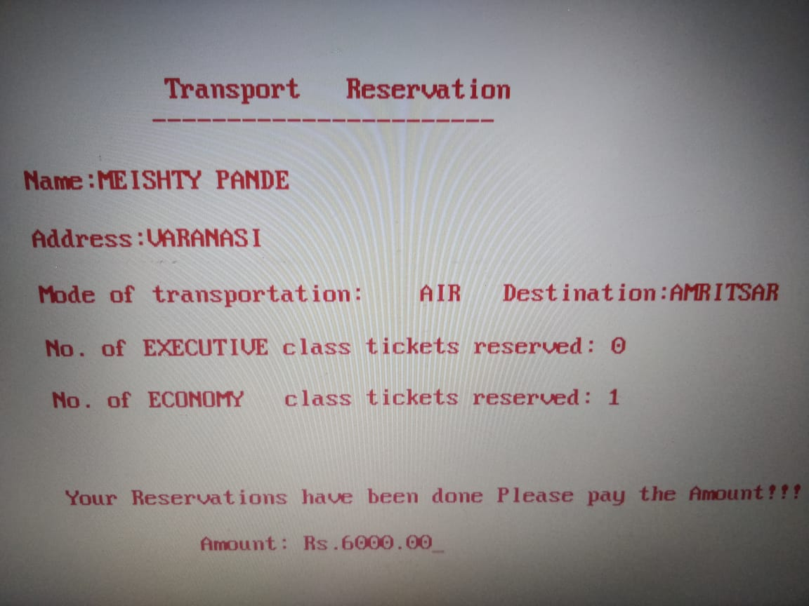

#SEARCH FOR THE PREVIOUS RECORD

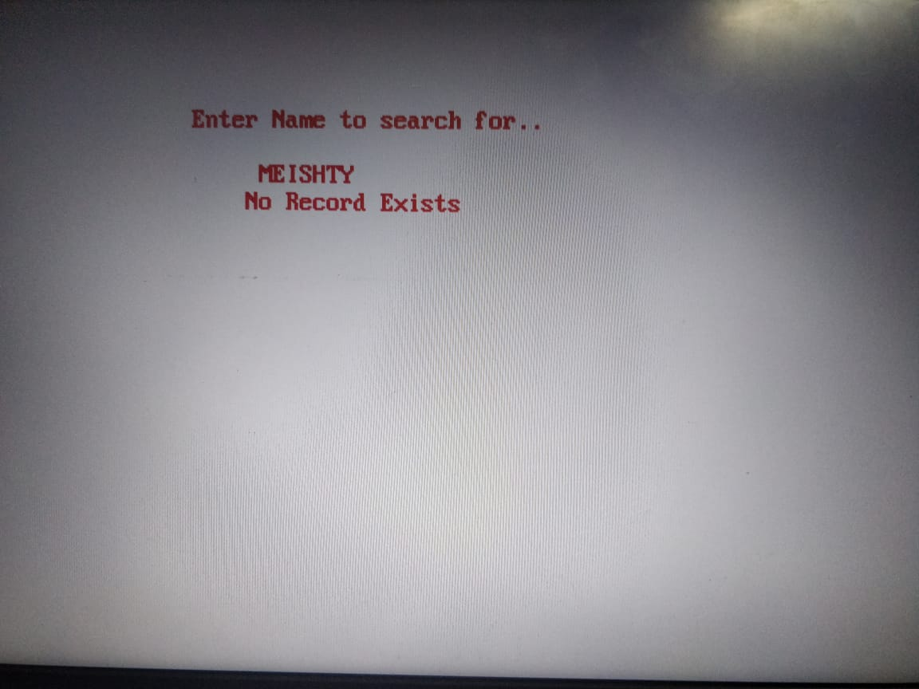

#ERROR WHEN USERNAME IS NOT VALID

THANK YOU