~~~~~~~~~~~~~~~~~~Lab6~~~~~~~~~~~~~~~~~

Exercise 1: Understanding the Impact of Network Dynamics on Routing

Question 1. Which nodes communicate with which other nodes? Which route do the packets follow? Does it change over time?
Communication:
Node 0: 1
Node 1: 0, 2, 4
Node 2: 1, 3
Node 3: 2, 5
Node 4: 1, 5
Node 5: 3, 4
Route: Node 0 → node 1 → node 4 → node 5
The routes do not change over time.

Question 2: What happens at time 1.0 and at time 1.2? Does the route between the communicating nodes change as a result of that?
At time 1.0, link 1-4 is link-down and the route does not change. Packets cannot transmitt from node 0 to node 5.
At time 1.2, link 1-4 is link-up and the route does not change. Packets waiting at node 1 go to node 4 and then node 5.

Question 3: Did you observe any additional traffic as compared to Step 3 above? How does the network react to the changes that take place at time 1.0 and time 1.2 now?
At time 1.0, link 1-4 is link-down. The routing protocol discovered a different route (0->1->2->3->5) and that is used to transmit the packets.
At time 1.2, link 1-4 is link-up. Because the cost of original route (0->1->4->5) is lower than the discovered route (0->1->2->3->5), the routing protocal used the origial route.

Question 4: How does this change affect the routing? Explain why.
This change means the cost of link 1-4 is 3. Thus, the route is 0->1->2->3->5 as it is lower than the cost of link 0->1->4->5.

Question 5: Describe what happens and deduce the effect of the line you just uncommented.
It changes the cost of link 1-4 to 2. The route 0-1-4-5 and route 0-1-2-3-5 now have equal cost. Thus, the traffic would be spilted to both routes when the flow reaches node 1.

Exercise 2: Setting up NS2 simulation for measuring TCP throughput
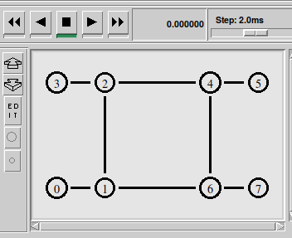
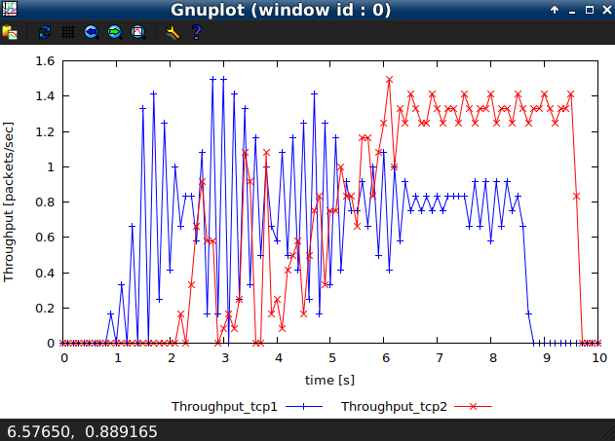

Exercise 3: Understanding IP Fragmentation

Question 1: Which data size has caused fragmentation and why? Which host/router has fragmented the original datagram? How many fragments have been created when data size is specified as 2000?
The data size that caused fragmentation is 2000 and 3500. The screenshot shows the link between two routers runs a 1500 MTU. If the size of one packet exceeds the MSS(Maximum Segment Size) or MTU(Maximum Tranbsmission Unit) of TCP, the only way sending the packet is going to fragment it.
The IP fragmentation occurs at the IP layer. Not only the source host has fragmented the original datagram, but also the router probably have fragmented the original datagram. Because the MTU in different networks is different. If the MTU of a certain network on the transmission path is smaller than the MTU of the source network, the router may fragment the IP datagram again. In here, only the source host(192.168.1.103) has fragmented the original datagram.
9 fragments. (RUN PING?)

Question 2: Did the reply from the destination 8.8.8.8. for 3500-byte data size also get fragmented? Why and why not?
No. The destination host will receive the fragments that their data size(except header and payload) are smaller than the MTU of the current network. It is not necessary to fragmented again.

Question 3: Give the ID, length, flag and offset values for all the fragments of the first packet sent by 192.168.1.103 with data size of 3500 bytes?

No | ID | Length | Flag | Offset
1 | 0xa13d | 1500 | 0x01 | 0
2 | 0xaaf2 | 1500 | 0x01 | 0
3 | 0x4a07 | 1500 | 0x01 | 0
4 | 0x7a7b | 1500 | 0x01 | 0
5 | 0x7a7b | 1500 | 0x01 | 1480
6 | 0x377e | 1500 | 0x01 | 0
7 | 0x377e | 1500 | 0x01 | 1480
8 | 0x8fa9 | 1500 | 0x01 | 0
9 | 0x8fa9 | 1500 | 0x01 | 1480

Question 4: Has fragmentation of fragments occurred when data of size 3500 bytes has been used? Why and why not?
No. Each fragment is smaller than the size of MUT and they all have its corresponing reply from 8.8.8.8.
No. There are no “Fragments count” title for all fragments. The “Fragments count” title means one IP fragment has been fragmented.
Yes. The 3500-byte size data is bigger than 1500 MTU. They have to be fragmented.

Question 5: What will happen if for our example one fragment of the original datagram from 192.168.1.103 is lost?
The reorganization of fragmented data will only occur at the IP layer of the destination host. When one fragment is lost,

