**Securing a CISCO Switch**

**You will need the following tools:**

* A laptop or desktop with a functioning serial port
* A console cable (serial to RJ45)
* A terminal emulation program such as PuTTY

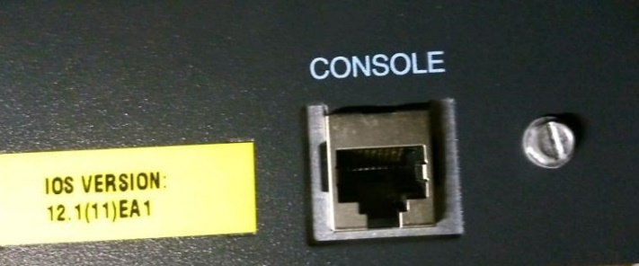**Setting up before configuration**

Figure

1. Hook the RJ45 end of the console cable into the console port of the switch pictured in figure 1
2. Plug the serial end of the cable into your computer

**Configuring your switch for the first time**

1. Open PuTTY by double clicking the icon on your desktop
2. Select the “serial” option highlighted in figure 2
3. Click the “open” button

*Note:* If you get lost at any point you can type “help” at the command prompt and you will receive a list of available commands

1. 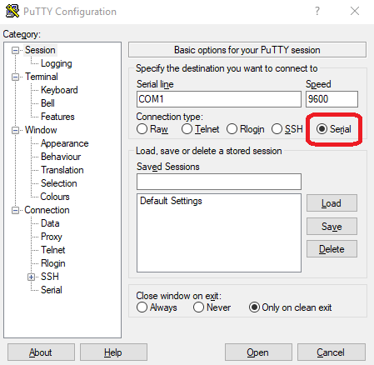The switch will prompt you to perform first time setup. Type no.

Figure

*Note:* If your switch has previously been configured or otherwise modified you may not get this prompt.

1. Type “enable”
2. Type “Configure Terminal”
3. Type “enable secret” followed by your password of choice. This will keep people from configuring your switch without a password
4. Type “line console 0”
5. Type “password” followed by your password of choice
6. Type “login” This will keep people from accessing your switch at all without a password
7. Type “exit”
8. Type “line vty 0 4”
9. Type the same commands you used in steps 9 and 10.

**Congratulations! You now have a secure CISCO Switch!**