**Game World**

The world in which **Rebound** takes place is bright, amusing, and full of colors. This should give the player a pleasant feeling while he is in it. The game world consist of several different arenas, which have no explicit theme. Whether classical football stadium, in the Caribbean or at the North Pole, since each arena stands alone, they offer the possibility to represent many different worlds. This results in a large variety on impressions, for the player.

The various arenas are not linked in the game world itself and thus the player has no chance to enter another level while staying in the game. The levels can only be started directly from the menu and, as previously mentioned, are self-sufficient in terms of environment and mood. However, the basic mood of the game should not diverge too much in the levels, but there is still plenty of scope in which the individual levels can be designed.

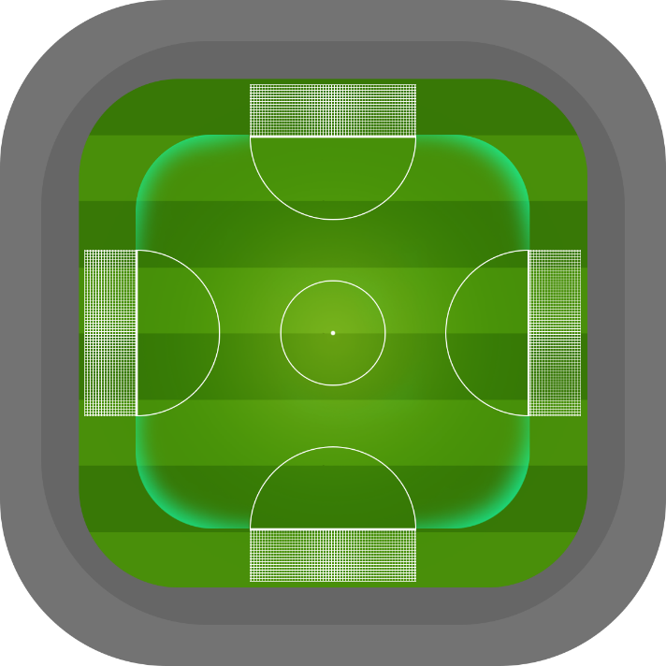The arena themselves basically have all the same structure. There are four goals, centered on all four sides of the square playing field. The field is primarily flat and there is a height limit, such as a roof.

As one of the first arenas, the classical football stadium is to be realized with a well-known grass field. The mood of a sports event will be conveyed, which is underpinned by the music. Sounds and music should motivate the player and he should feel the center of attention during outstanding ball parades or scoring the winning goal.

In general, the music, as well as the graphics, should cause the same positive mood in the player, but it should also be able to clearly distinguish between the different locations here. Each world thus stands out from all other worlds by combining visual and auditory. This will leave a unique impression on the player.