|  |  |
| --- | --- |
| Rebound  Game Design Document | Summary  Rebound is an entertaining multiplayer game. This document will describe and explain each part of the game and accentuate it with some visual examples.  Julian Stockmann, Samuel Wunderlich, Tom Haeschke, Michael Häglsperger  Game Design WS 18/19 |

Inhalt

Story 1

Interface and Startup 2

Screen 1 – Profile Selection 2

Screen 2 – Match Finder 3

Screen 3 – Lobby 3

Game World 4

Character(s) and Controls 5

Characters 5

Controls 6

Main Gameplay Concept 8

Power-ups 9

Optional Features 10

# Story

The supercontinent Klobertiose is ruled by four factions since the year 1.5k. Trangufeil, Drensbal, Lanaretio and Frestrost. Since the destruction of almost the whole population 436 years ago, the factions decided to not wage war amongst them. To display their power anyway there are relentless arena fights. These fights have different rules depending on where they are held.

Trangufeil is a split country. The monarchs, who follow Trangufeil II and believe in the strength of a single processing unit, fight the anarchist, who believe in parallel processing of all citizens. The fight was even until the anarchists proved P = NP and gained the upper hand.

Drensbal is a country composed of multiple tribes, who either build large cities and stayed there or live as nomads and move across the country. The Drensbal are a proud people. Their reputation is not prestigious though, since they are thought of as arrogant and pretentious because of their superior technology. But since the people don't care about the needs of others, they seldomly have something to say about that.

The country of Lanaretio was founded about 400 years ago. Robots who died in the destruction were brought here. A few could reassemble themselves from spare parts of other robots and founded the country. The other factions don't think much of this land, they consider them abominations. There are a few robots doing administrative jobs, however there is no specified hierarchy.

Frestrost is a war hungry land. If their access rights were not prohibited by the other countries, they would start a war immediately. Hence, they created a Random Generator, that selects the hierarchical structures every quarter year, so that every permutation comes up at least once until the same hierarchy can be selected twice. That’s how everybody can be a tyrant, but has to be oppressed at some point too.

# Interface and Startup

This chapter provides information about the starting process of the game and some of the concepts behind. It contains the navigation screens the player must navigate through before the game starts.

The flow chart looks as follows:

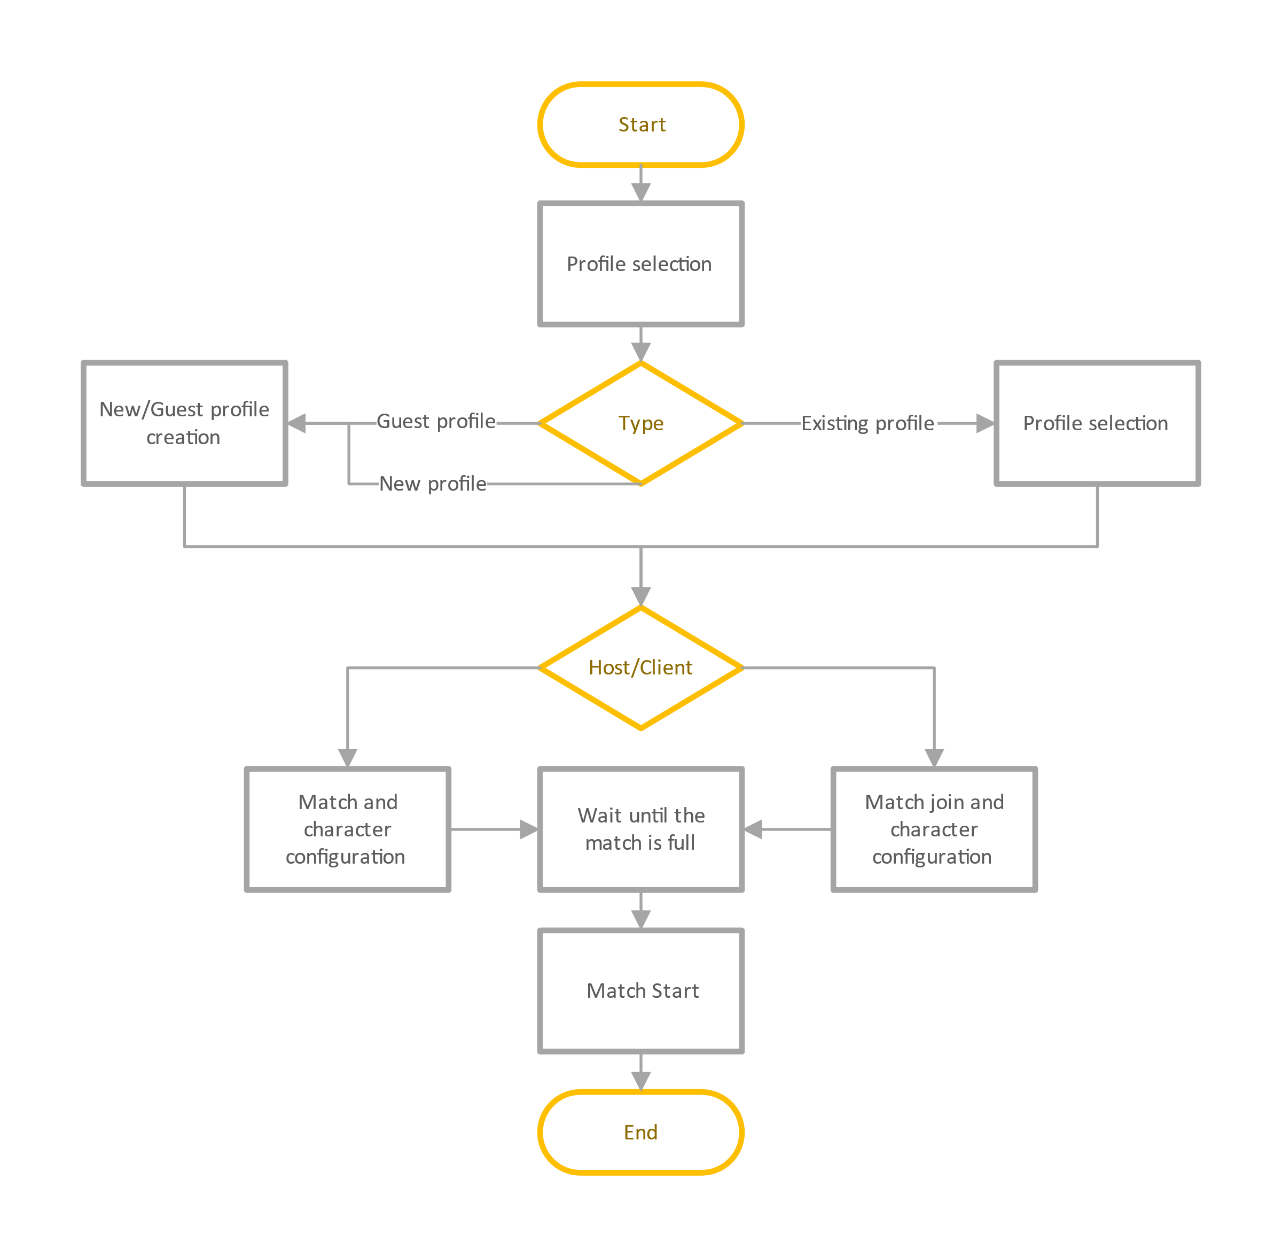

## Screen 1 – Profile Selection

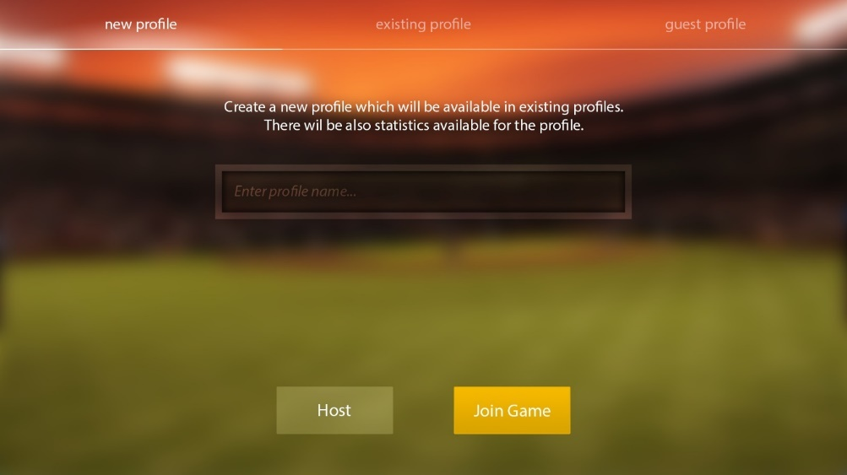When starting a game instance, the user must select a profile. The first screen loads all the local player profiles and displays them in a nice view with more information about statistic values from the past such as the number of won/lost matches. Since this game is a multiplayer within the local area network and without a server, the profiles cannot be stored on a server and are different on each device. Profiles are identified by username. The user has the possibility to create a new profile or to delete old profiles. After the profile selection the user must decide whether he wants to join or host a game. Depending on this decision he will be forwarded to the next screen.

## Screen 2 – Match Finder

If the user decided to join a game, he will be forwarded to the match finding screen. It displays a list of open matches in the local area network. Each entry in the list displays information about the host and the match including the hosts player name, his IP address and the number of free slots in the match. A refresh button enables the user to update the results list and to find newly created matches. If he is not able to find the match he is looking for, he can enter the hosts IP address directly in an edit box and join this way. After the match selection the player will be forwarded to the match lobby.

## Screen 3 – Lobby

If the user decided to be the host or he selected an existing match, he will be forwarded to the lobby screen. It contains an area for each of the four players. Every player can change his own robot character and must hit a button when he is ready. The screen will remain opened until the match is full, and every player is ready. In addition, the host can configure the teams and sees his own IP address for sharing in the LAN. 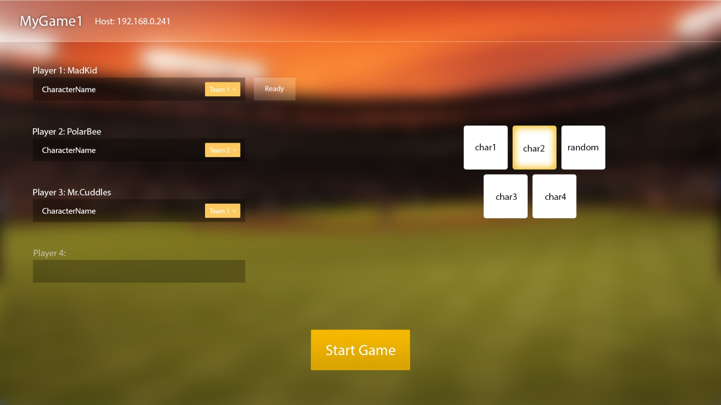

# Game World

The world in which **Rebound** takes place is bright, amusing, and full of colors. This should give the player a pleasant feeling while he is in it. The game world consist of several different arenas, which have no explicit theme. Whether classical football stadium, in the Caribbean or at the North Pole, since each arena stands alone, they offer the possibility to represent many different worlds. This results in a large variety on impressions, for the player.

The various arenas are not linked in the game world itself and thus the player has no chance to enter another level while staying in the game. The levels can only be started directly from the menu and, as previously mentioned, are self-sufficient in terms of environment and mood. However, the basic mood of the game should not diverge too much in the levels, but there is still plenty of scope in which the individual levels can be designed.

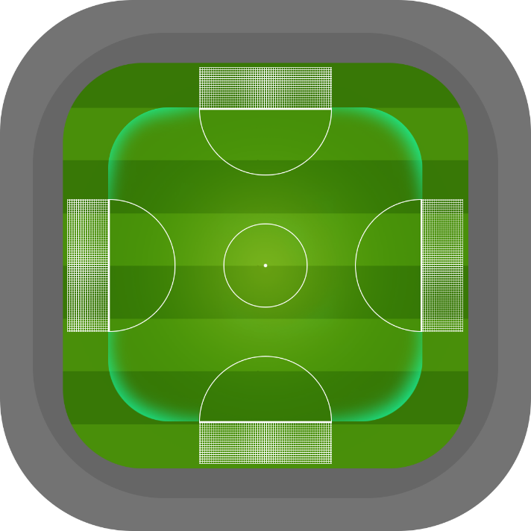The arena themselves basically have all the same structure. There are four goals, centered on all four sides of the square playing field. The field is primarily flat and there is a height limit, such as a roof.

As one of the first arenas, the classical football stadium is to be realized with a well-known grass field. The mood of a sports event will be conveyed, which is underpinned by the music. Sounds and music should motivate the player and he should feel the center of attention during outstanding ball parades or scoring the winning goal.

The arena is located in the middle of the four factions and so it’s the “neutral ground”. As a result of this it follows no theme of one of the four lands.

In general, the music, as well as the graphics, should cause the same positive mood in the player, but it should also be able to clearly distinguish between the different locations here. Each world thus stands out from all other worlds by combining visual and auditory. This will leave a unique impression on the player.

# Character(s) and Controls

This chapter will introduce the four different characters and their abilities which will be the first available in the game. Afterwards this will go into detail about the ingame character controls.

## Characters

**Br3tz1n00-2**

The agile Br3tz1n00-2 was a control unit of the base production of Trangufeil Empire Robot Troops. His kind is distinguished by his extreme fast decision-making process, which is not only caused by his unusually big primary memory. When the war seemed lost, all Units of his series were disassembled and scrapped for parts. Br3tz1n00-2 got notice of this plan by luck and tried to save as many Control units as possible. Unfortunately, he was stopped and captured by L00rd-4p1, the right hand of Trangufeil II. Instead of destroying Br3tz1n00-2 immediately, he was sent to fight in the Arenas because of his abilities, to restore the reputation of the Empire.

Abilities:

* Dash into a direction of choice.
* By holding the Jump button, he can slowly descend instead of falling back down.
* Can throw his shield forwards, but after that it takes a few seconds for the shield to return to him

**D-1005**

The Land of Drensbal has been peaceful for 400 years now. This is by courtesy of D-1005, the leader of the D-r3-n5 and other Robots of his production Line, which got so strong and robust because of T-P-Hydraulic Technology that no body dares to start a fight with their kind. The Researchers of the Land took it upon them to develop Tungsten-Nanotubes. After a lot of generations, they finally succeeded. They built the first space elevator and were able to colonize most of the Moon and its satellites. Since they soon want to leave planet Earth completely, Overlord Bal wants to leave one last mark by sending D-1005 in the Arenas to display his strength.

Abilities:

* Can hydraulically extend his shield in three directions where it stays for as long as he holds the button but inhibits movement.
* Can hold the ball for a short duration if the timing of the button press is right
* Can block dangerous shots if the timing is right

**M1nk3rts-IO**

M1nk3rts-IO lost another wheel. Doesn't matter, she always finds a new one. In Lanaretio there are enough scrap piles to loot. Besides, her home is filled to the roof with chips, joints and other parts of destroyed robots from all over the World. M1nk3rts-IO is one of many recycling units that have been tasked to repurpose the trash of a civilization that continues to throw functioning hardware away. These robots are the property of a Company and as such, they don't have any rights of their own. When M1nk3rts-IO tried to speak up for this, she was removed from the scrapyard and thrown into the arena as a punishment.

Abilities:

* Leave the shield standing in a position while moving on with a smaller shield; also, can pick the old shield up again.
* Unleashes a few small robots in an approximate direction which inhibit the movement of robots near them.
* Splatters oil in a certain direction, leaving a puddle that makes other robots slide around in it

**Er0-s10-n**

Left or right. Er0-s10-n wants to put a robot-bird nest back onto a tree but he doesn't know with which arm. The cryo arm would freeze the bird immediately, which would increase the flow-speed of electrons in its body, however it would burst its hydraulic system. The plasma arm can overcharge its energy cores in a way that it doesn't have to reload for the whole day, however it would melt its outer layers. Er0-s10-n stays a while next to the bird, folding his arms and causing a lot of steam to rise.   
Hmm.  
Hmmm.  
Before he could finish his thought a bright flash shines from his hands followed by an explosion, which destroys everything in a 10 meter radius. A big gap got blown into the wall of the prison camp, through which many robots who were sent to the Arenas fled. Er0-s10-n stays where he is. The guards shouted he should stay, so he does.

Abilities:

* Can use the ball he is moving on to shoot and score goals, but stays unable to move for a few seconds.
* Ice over the ball or an enemy with a ray of ice. The ball gets heavier and slower, just as hit enemies.
* Shoot plasma at an enemy or the ball, making the ball unable to be held and locking the rotation of hit enemies

## Controls

Movement is controlled via the left stick on the controller or the WASD keys. The direction the robot is facing is controlled by the right stick or the mouse. By pressing the stick or pressing the mouse wheel the view can be locked onto the ball. The characters can jump by use of A on the controller or the space bar. Abilities and Powerups are activated via the shoulder buttons or the number keys on the keyboard. To add additional momentum to the ball, the players can click the left mouse key or the right bumper on the controller. The menu can be navigated via the left stick and the A and B buttons.

# Main Gameplay Concept

The Game is an entertaining, round-played multiplayer game. One round is limited to a maximum duration of 20 – 30 minutes and is played by four players at the same time. Several players can play in a team while the team size is variable. But there is a maximum size at three players as there are only four players in the game. The game is basically to get the ball into the opponent’s goal to score points, but you always have to watch out for your own goal to prevent the opponent from scoring. At the end of a round, the player or the team with the most points have won. During the game, the participants can also move freely in a certain area in front of their own goal, but not leave this.

In the game is a ball, which can be steered by the player specifically in one direction. To do so, every player has a shield which can be rotated and tilted in all directions. The angle of the shield thus determines the trajectory of the impinging ball, in addition the player has the opportunity to give the ball an additional speed boost by a good timing. This demands attention and good responsiveness from the opponent.

To make the gameplay more varied, each level will have its own mechanics. This could be special events, unique power-ups or similar. The goal is that each level plays different and has the main focus on different priorities.

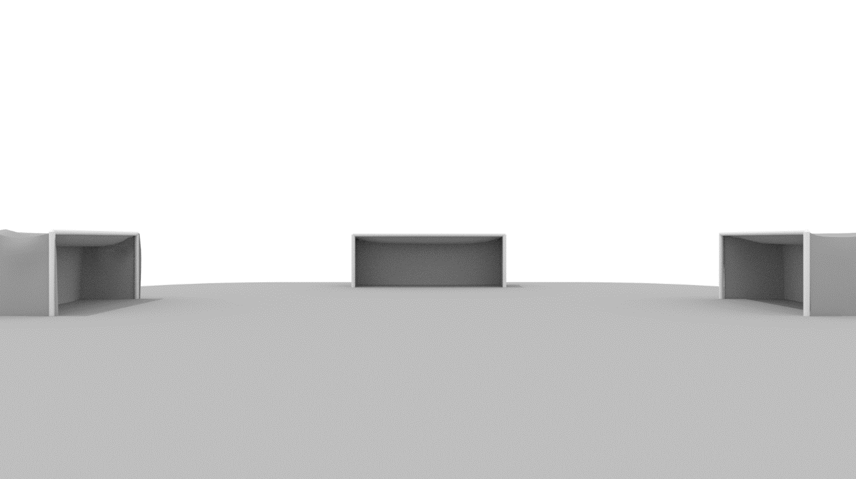Another point that makes each played match unique is the power-up system. These power-ups can be accumulated during the game and give the player special abilities which are used within the hit of the next ball of can be activated at any time during the game. These abilities can be used strategically to play out the opponent.

# Power-ups

Powerups randomly spawn during the duration of the game. They can be collected by stepping on them or shooting the ball at them. Once collected they can be used by pressing a button on the controller, unleashing their individual effects that either hinder the opponents or help the caster.

The first planned Powerups are:

* **Enlarge Shield:**

Grants the user a bigger shield for a certain duration, which makes it easier to block and deflect the ball.

* **Increase speed:**

Increases the Movement speed of the character, so that he can more easily deflect the ball.

* **Mine:**

Lets the user place a mine on the field, that either pushes enemies in the proximity away or can be used to redirect the ball when it is near the mine. The mine can be activated by pressing the button a second time.

* **Black hole:**

Attracts everything in proximity and can alter the direction the ball is moving. Stays active for about 10 seconds before disappearing. The location of the black hole is chosen by the user via a birds eye view of the arena win which the user quickly aims a crosshair on the ground.

# Optional Features

For the first release we decided to provide only one pvp mode where players can play against each other with different team sizes.

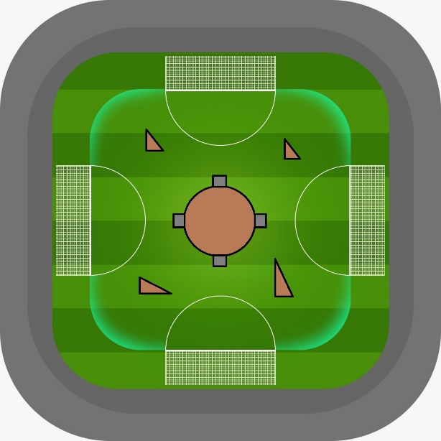  
For the future we are thinking about pve content. That could lead to large canon towers and other obstacles that must be destroyed for victory. This mode could be some kind of survival, because the canon tower would be able to shoot balls inside the goals, too. The center would not be limited to a canon tower. There could also be other enemies.

Another changeable aspect is the gravity. There could be modes with very low or high gravity which would lead to a different behavior of the flying balls.

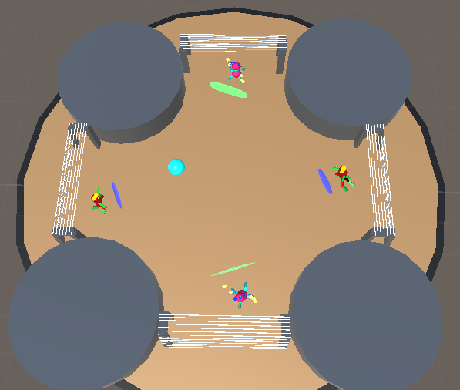We are also thinking about to provide various arenas. The difference could be the location of the arena like wide desert, fire or ice landscapes that fit into the robot story. Furthermore the are possibilities to provide differently shaped arenas. For example with a hollow in the center or a completely rounded border.

We must remark that these optional features are only ideas at the moment and open for discussion. The implementation depends on feedback and the speed of the development process.