**Goal of this project**

Simulating the motion of N objects in the universe, accounting for the gravitational forces mutually affecting each object.

**Body.java**

1. Have Body class to do the physics calculation jobs, and it has not main method.
2. Constructors (Yes, we have two constructors. I understand the purpose of the first constructor but not the second)

public Body(Body b){

xxPos = b.xxPos;

yyPos = b.yyPos;

xxVel = b.xxVel;

yyVel = b.yyVel;

mass = b.mass;

imgFileName = b.imgFileName;

}

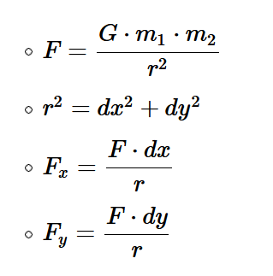

Methods to find r 🡪 find F 🡪Fx, Fy 🡪 Fnet,x Fnet,y

Given time interval dt, along with finding the acceleration, we get new_velocity 🡪 new_positions

Method to draw a body

**NBody.java**

This is the class to do the simulation. It reads the files to create objects(bodies).

1. Collecting all information needed
2. Drawing background and bodies
3. Animation

Outer loop: different time interval

Inner loops (2): update all bodies positions (loop the bodies[]);

draw all bodies (loop the bodies[])