**UNIVERSITY OF SANTO TOMAS**

**College of Information and Computing Sciences**

**Department of Computer Science**

**2nd Term A/Y 2024-2025**

**Thesis Group Advisorship Agreement**

**Thesis Title: Developing a Hybrid Deep Learning Model Combining CNNs and Graph Neural Networks for Enhanced Glaucoma Detection in OCT Images by Integrating Local and Global Context.**

This agreement is made among the thesis group, the thesis adviser, and the thesis

Coordinator. The thesis group shall work under the technical guidance of the technical adviser

in Thesis 1 and 2. The group is responsible for actively seeking advice and requesting assistance

that the adviser may be able to extend to improve the quality of their thesis.

The thesis adviser shall, in good faith, provide technical expertise and direction to the

thesis group with regard to the thesis content in Thesis 1 and 2. Because of the contributions of

the thesis adviser to the success of the thesis, the group must acknowledge the adviser in the

thesis cover as their thesis adviser. Should the thesis be submitted for inclusion in conferences,

publications, and the like, the adviser should be listed as a co-author of the thesis group members.

The thesis coordinator shall monitor the partnership between the group and the adviser

and the timely completion of thesis deliverables. The detailed tasks of each party are listed in the

thesis manual.

Proponents: Conforme:

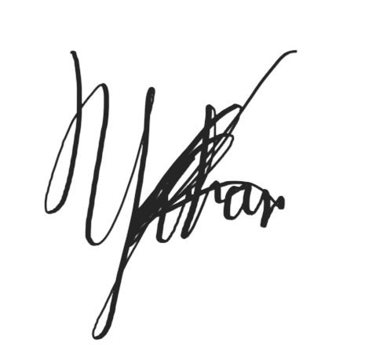

1.Alvear, Mark Josh ____________________________

2.Fermin, Raudmon Yvhan ____________________________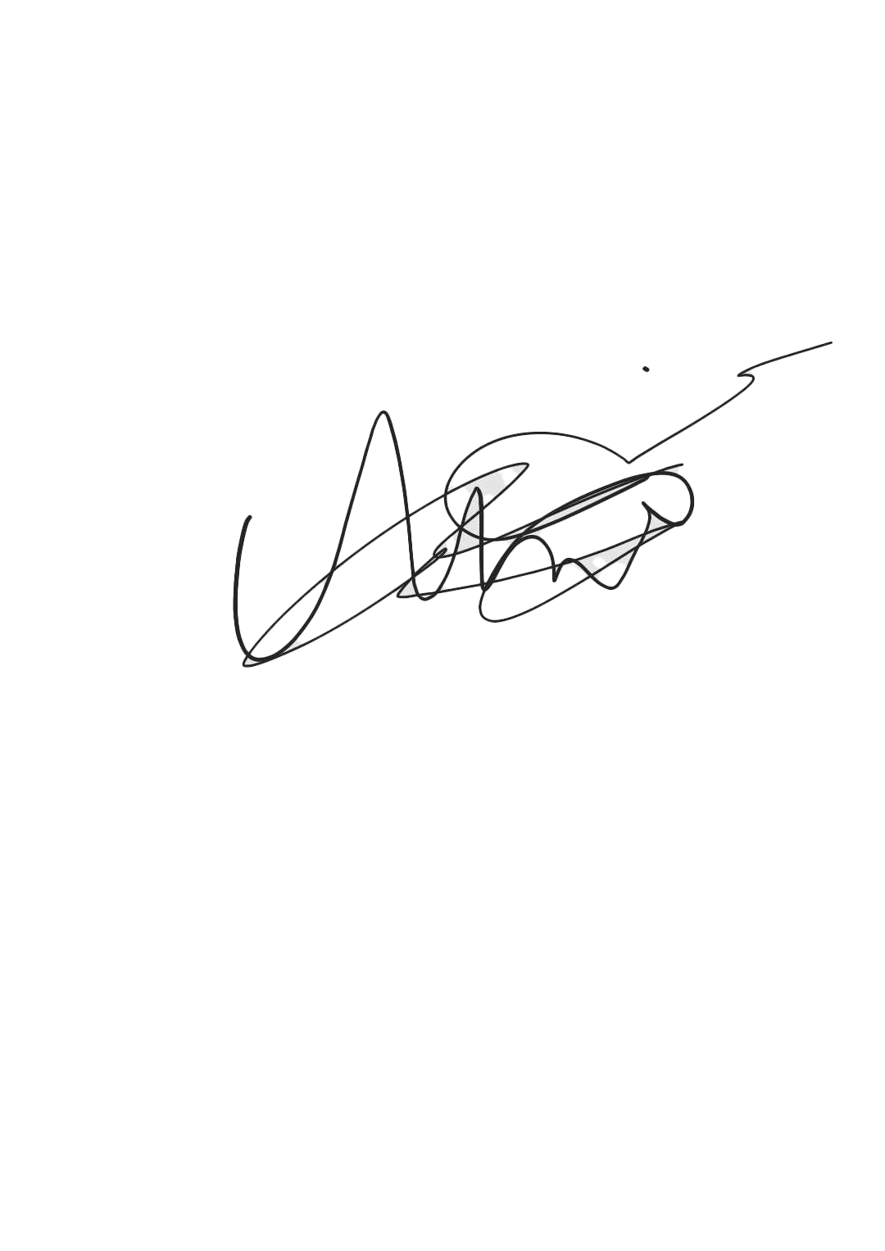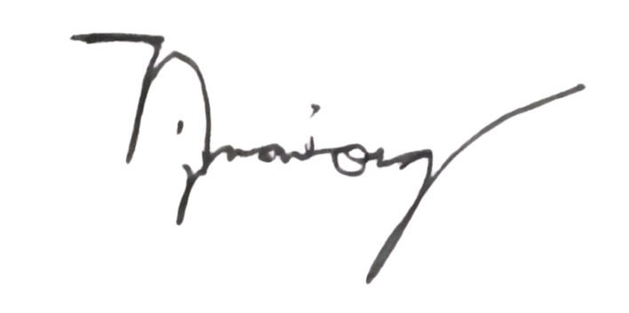

3. Naniong, Nigel Jan. ____________________________

4. Tonido, Andrei Christian ____________________________

Thesis Adviser:

Mr. Red M Castilla. ____________________________

Thesis Coordinator:

Assoc. Prof. Donata D. Acula, PhD Math Ed ____________________________